Toronto power Plant social and Economic Impact Study – June 30, 2025
ADOPTED BY THE LOCAL REVIEW COMMITTEE ON juNE 30, 2025
TORONTO POWER PLANT social and economic impact study

Table of Contents

Executive Summary 2
1 – Housing Supplies 4
2 – Educational Facilities and Workforce 9
3 – Waste Supply and Distribution 12
4 – Wastewater treatment and collection 15
5 – Solid Waste Disposal and Collection 17
6 – Law Enforcement 18
7 – Transportation 20
8 – Fire Protection 24
9 – Health 26
10 – Recreation 27
11 – Government 29
12 – Energy 32
List of Appendices 35

Executive Summary

Western Minnesota Municipal Power Agency (WMMPA) proposes to construct, own and operate an energy conversion facility consisting of four combustion turbine (CT) gensets at around 36 MW each with an estimated total project cost of $378,000,000. The CT gensets will be housed inside of a turbine hall approximately 80 feet wide by 212 feet long, and 40 feet tall with an attached office facility measuring 68 feet wide and 104 feet long. The expected generation is approximately 144 megawatts of power during periods of high energy demand. Associated facilities will include natural gas piping anticipated to be less than 450 feet and a 345 kV transmission line to connect with the Astoria 345 kV substation. The energy conversion facility, known as the Toronto Power Plant (Project), is proposed to be located in the SE ¼ of Section 7, Township 113N, Range 48W in Toronto Township, Deuel County, approximately 3 miles north of Toronto, South Dakota. The following map shows the Project’s location and the six-mile study area.

Map 1 – Toronto Power Plant Location and 6-Mile Study Area

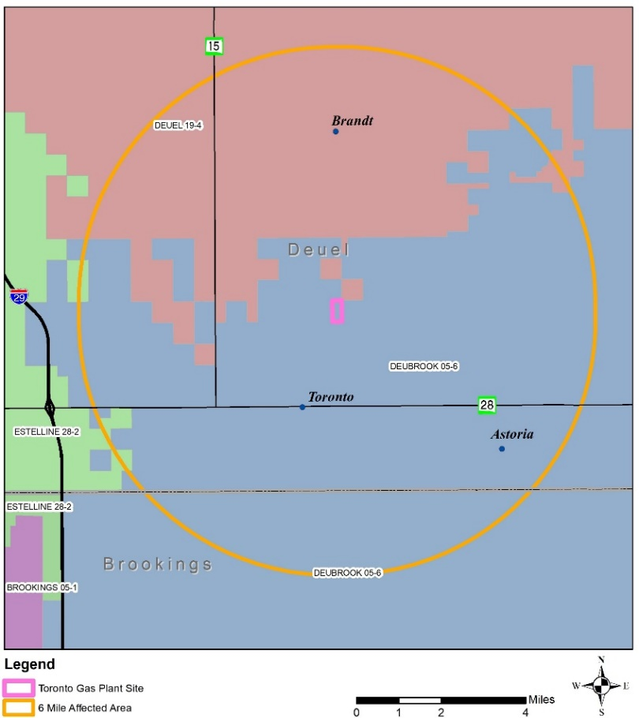
Source: First District Association of Local Governments

The purpose of this Social and Economic Impact Study is to aid the Local Review Committee in addressing the impact the proposed Project will have in the 12 areas identified in South Dakota Codified Law 49-41B-7 within the six-mile study area as defined by the South Dakota Public Utilities Commission. While mitigation measures have been proposed in five of the 12 study areas, the recommended mitigation measures will not create a significant impact within the study area.

Recommended mitigation measures can be addressed by sharing project information before the start of construction, developing agreements with local governments, or by securing required federal, state, and local permits prior to the start of construction.

Operational staffing is expected to consist of 4-6 new employees while construction staffing is expected to peak at about 200 employees. Construction is expected to last approximately 20 months and start in the spring of 2027. Commercial operation is expected to begin in the spring of 2029.

The methodology for this study includes a description of existing conditions within a study area, assessing future conditions during project construction and operation, and identifying any measures that may need to be implemented to mitigate negative impacts. Impacts are based upon construction activities and the number of additional workers that the study area will likely need to serve and whether the existing conditions can absorb the anticipated demand created by the Project.

If the existing conditions can absorb the anticipated demand created by the Project, then a determination of ‘no significant impact’ is made and no mitigation measures are proposed. If the existing conditions cannot absorb the anticipated demand created by the Project, then a determination of ‘mitigation recommended’ is made and mitigation measures are proposed. Table 1 summarizes the determinations made for each study area.

Table 1 – Determinations

Study Area | Determination
1 – Housing Supplies | No Significant Impact
2 – Educational Facilities and Manpower | Mitigation Recommended – Safety Coordination with Bus Drivers and Student Traffic
3 – Waste Supply and Distribution | No Significant Impact
4 – Wastewater Treatment and Collection | Mitigation Recommended – Wastewater Permits
5 – Solid Waste Disposal and Collection | No Significant Impact
6 – Law Enforcement | Mitigation Recommended – Informational Meetings with Law Enforcement
7 – Transportation | Mitigation Recommended – Dust Mitigation, Haul Road Agreements, and Transportation Permits
8 – Fire Protection | Mitigation Recommended – Annual Training for Fire Protection
9 – Health | Mitigation Recommended – Responder Training for Hospitals and Ambulance Services
10 – Recreation | No Significant Impact
11 – Government | Mitigation Recommended – Acquire State and Local Government Permits
12 - Energy | No Significant Impact

Based upon the contents of this Social and Economic Impact Study, it is the professional opinion of the First District Association of Local Governments that the construction and operation of the Project will have no significant impact on the social and economic environment within the SDPUC defined six-mile study area after informational meetings have been held, dust mitigation measures have been adopted, haul road agreements are executed, and all required permits are secured.

1 – Housing Supplies

While it is reasonable to assume that some of the Project’s employees and construction workers will seek housing within the six-mile study area, it is highly unlikely that all of the estimated 4-6 operational employees and 200 construction workers needed during peak construction will seek housing only within the six-mile study area. Therefore, a larger commuting area will be used to determine the impact on housing supplies for operational and construction workers. This analysis is based on 2021 U.S. Census data for Brookings County and Deuel County.

According to 2021 U.S. Census data, 7,544 of the 18,064 employees working in Brookings County commute to work from another county and 4,815 employees experience a commuting distance greater than 50 miles. In Deuel County 743 of the 1,459 employees working in Deuel County commute to work from another county and 287 employees experience a commuting distance greater than 50 miles. Based upon this information Brookings (22,056 population – 2020 Census) and Watertown (21,482 population – 2020 Census) are within commuting distance of the project site.

The following data analysis will identify where the Project’s workers are likely to seek housing, how many homes and rental units are available within the Project’s commuting area, and if the existing inventory of available homes and rental units can absorb the increased demand created by approximately 200 workers required during peak construction and 4-6 permanent operational workers moving into the area.

Chart 1 – Job Counts by Distance/Direction – Brookings County

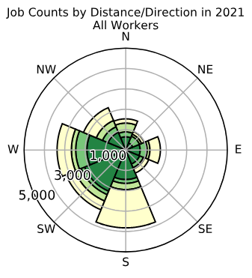
Source: https://onthemap.ces.census.gov/

Map 2 – Brookings County Employee Inflow/Outflow Map

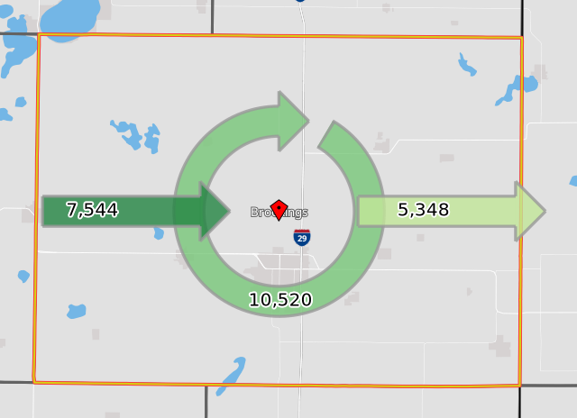
Source: https://onthemap.ces.census.gov/

Chart 2 – Job Counts by Distance/Direction – Deuel County

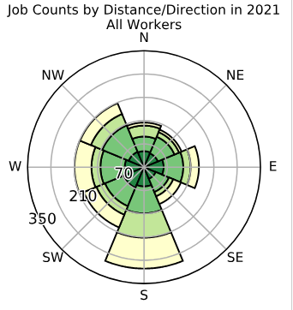
Source: https://onthemap.ces.census.gov/

Map 3 – Deuel County Employee Inflow/Outflow Map

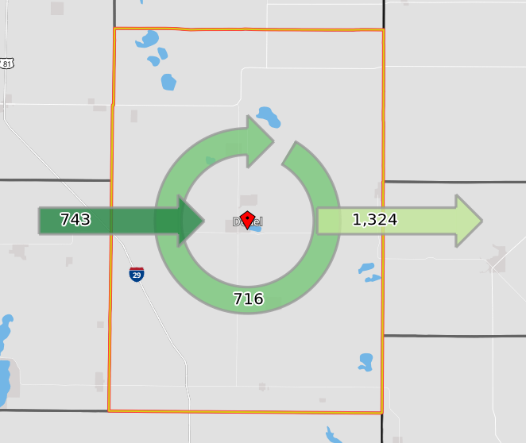
Source: https://onthemap.ces.census.gov/

To address the housing inventory issue for construction and operational workers, housing supplies within the following geographies have been examined: Brookings and Deuel counties, and Astoria, Brandt, Toronto, Brookings and Watertown. The following charts track owner-occupied and renter-occupied information within a 50-mile commuting area of the Project’s site.

Table 2 – Available Vacant Housing Units

Location | Occupied Housing Units | Vacant Housing Units
Town of Astoria | 63 | 5
Town of Brandt | 44 | 5
Town of Toronto | 93 | 11
Brookings County | 13,120 | 1,729
Deuel County | 1,132 | 346
City of Brookings | 8,861 | 1,170
City of Watertown | 10,878 | 979
Totals | 34,191 | 4,245
Source: https://data.census.gov/

The three municipalities within the six-mile study area (Astoria, Brandt and Toronto) have 21 vacant housing units. There are a total of 4,245 available housing units within a 50-mile commuting radius from the project site. This existing supply of available housing units is more than sufficient to meet the demands of 200 temporary construction workers and 4-6 new operational workers.
Labor Force

The Project site is located approximately 2 miles northeast of Toronto, South Dakota, in Deuel County. The labor source identified in this section includes workers in Deuel County and the four South Dakota counties that border Deuel County: Brookings, Codington, Grant, and Hamlin Counties.

The labor force in those five counties consists of 46,606 workers and includes 2,265 construction, extraction, and maintenance workers as well as 1,692 management, professional, and related workers. Approximately 200 construction workers (8.8% of area construction, extraction, and maintenance workers) are expected to be working at the project site during peak construction. Approximately 4-6 operational workers (0.296% of area management, professional, and related workers) are expected to work at the Project’s facility after construction is complete and operation of the facility commences.

Based upon current labor force and resident occupations, there appears to be a sufficient number of workers within the area to meet the construction and operational workforce demands created by the Project. Construction will require a workforce with a variety of skills including, but not limited to, general carpenters, iron workers, millwrights, and electricians. It is expected that a portion of the construction workforce will be hired locally. Recruitment of additional construction personnel from outside the affected area will usually include specialists and supervisory personnel who will temporarily relocate to the area.

Table 3 – August 2024 County Labor Force

Area | Labor Force | Employment | Unemployment | Rate
Brookings County | 19,104 | 18,648 | 456 | 2.4%
Deuel County | 2,429 | 2,378 | 51 | 2.1%
Codington County | 16,626 | 16,329 | 297 | 1.8%
Grant County | 4,573 | 4,480 | 93 | 2.0%
Hamlin County | 3,874 | 3,817 | 57 | 1.5%
Source: http://dlr.sd.gov/lmic/lbtables/countylf.aspx

Table 4 – August 2024 County Labor Supply

Area | Unemployed | Underemployed | Discouraged  Workers | Total  Labor  Supply
Brookings County | 456 | 1,525 | 20 | 1,995
Deuel County | 51 | 160 | 15 | 225
Codington County | 297 | 1,395 | 15 | 1,705
Grant County | 95 | 265 | 15 | 375
Hamlin County | 57 | 230 | 10 | 295
Source: http://dlr.sd.gov/lmic/lbtables/laborsupply.aspx

Table 5 – 2023 Occupational Breakdown – Brookings, Codington, Deuel,
Grant and Hamlin Counties

 | Custom Region | Pct. of Total
Employed civilian pop. 16 years and over | 15,173 | 100
Management, professional, and related | 1,692 | 11.15%
Service | 452 | 2.98%
Sales and office | 4,281 | 28.21%
Farming, fishing, and forestry | 711 | 4.69%
Construction, extraction, and maintenance | 2,265 | 14.93%
Production, transportation, and material moving | 5,772 | 38.04%
Source: https://analyst.lightcast.io/

Determination: No Significant Impact

2 – Educational Facilities and Workforce

There are three school districts within the study area:

- Deubrook 05-6
- Deuel 19-4
- Estelline 28-2

Deubrook School District

The 2022-2023 enrollment in the Deubrook School District was 398 students and their previous peak enrollment reached 391 in 2021-2022. A reduction of seven students would need to occur to reach previous peak enrollment numbers.

Table 6 – Deubrook 2022 Payable 2023 Taxable Valuations

Agricultural | $308,202,512
Owner Occupied | $103,940,312
Other Non-Ag/Utilities | $70,997,410
Total | $483,140,234
Source: SD Department of Education (Appendix A)

Table 7 – Deubrook 2022 Payable 2023 Levy per Thousand

Agricultural | $1.525
Owner Occupied | $3.413
Other Non-Ag/Utilities | $7.063
Special Education | $1.599
Capital Outlay | $3.000
Bond Redemption | $0.000
Pension Fund | $0.000
Source: SD Department of Education (Appendix A)

The Project will be constructed within the boundaries of the Deubrook School District and will have a positive impact on the taxable valuation of the school district.

According to Dr. Kimberly Kludt, Deubrook School District Superintendent, it is not known what impact the Project would create on the Deubrook School District during construction or operational phases.

Deuel School District

The 2022-2023 enrollment in the Deuel School District was 510 students and their previous peak enrollment was 547 in 2010-2011. 37 new students would need to be added to the district to reach previous peak enrollment numbers.

Table 8 – Deuel 2022 Payable 2023 Taxable Valuations

Agricultural | $451,285,680
Owner Occupied | $159,833,339
Other Non-Ag/Utilities | $115,664,212
Total | $726,783,231
Source: S.D. Department of Education (Appendix B)

Table 9 – Deuel 2022 Payable 2023 Levy per Thousand

Agricultural | $1.362
Owner Occupied | $3.048
Other Non-Ag/Utilities | $6.308
Special Education | $1.016
Capital Outlay | $2.212
Bond Redemption | $0.000
Pension Fund | $0.000
Source: SD Department of Education (Appendix B)

According to Deuel School District Superintendent Chad Schiernbeck, the Project would create no impact on the Deuel School District during construction or operational phases.

Estelline School District

The 2022-2023 enrollment in the Estelline School District was 265 students and their previous peak enrollment 271 in 2020-2021. 6 new students would need to be added to the district to reach previous peak enrollment numbers.

Table 10 – Estelline 2022 Payable 2023 Taxable Valuations

Agricultural | $208,218,961
Owner Occupied | $90,997,844
Other Non-Ag/Utilities | $110,118,428
Total | $409,336,233
Source: SD Department of Education (Appendix C)

Table 11 – Estelline 2022 Payable 2023 Levy per Thousand

Agricultural | $1.902
Owner Occupied | $4.256
Other Non-Ag/Utilities | $8.809
Special Education | $1.599
Capital Outlay | $0.932
Bond Redemption | $0.000
Pension Fund | $0.000
Source: SD Department of Education (Appendix C)

According to Dr. Paul Von Fischer, Estelline School District Superintendent, the Project would create no impact on the Estelline School District during construction or operational phases.

Total additional student capacity of the three school districts within the study area: 36.

According to the 2020 Census, the average size of the U.S. household unit is approximately 2.53 members per household unit. The .53 represents the average number of children per household unit.

Based upon the assumption that each member of the projected construction labor force peak of approximately 200 new workers would fall within the parameter of .53 children per household unit, the projected maximum number of additional new students would peak at approximately 106 new students during the construction phase of this project. However, nearby school districts experienced no significant increase in enrollment during construction of the nearby Astoria Station power plant.

Based upon the assumption that each member of the operational labor force peak of 4-6 new workers would fall within the parameter of .53 children per household unit, the projected maximum number of additional new students would be approximately 3 new students after the construction phase of this project is complete and the operational stage begins.

This figure is below the additional student capacity of 36 new students identified to reach peak enrollment of the school districts within the study area.

Determination: No Significant Impact

3 – Waste Supply and Distribution

Construction Waste

Waste generated during construction activities will be disposed of at a properly permitted waste site in accordance with the laws of South Dakota. Construction waste disposal will be the responsibility of the prime construction contractor responsible for construction of the Project under the direction of WMMPA.

Operational Waste

Waste generated during operational activities will be disposed of at a properly permitted waste site in accordance with the laws of South Dakota. Operational waste disposal will be the responsibility of WMMPA and will likely be handled by a private waste collection and disposal company.

Landfill Sites

While there are no properly permitted waste sites within the six-mile project area, there are two municipal solid waste landfill sites located nearby. The Brookings Landfill and the Watertown Landfill are both within approximately 30 minutes of the Project. Map 4 shows the locations of municipal solid waste landfill permitted by the State of South Dakota.

Map 4 – Permitted Municipal Solid Waste Landfills in South Dakota
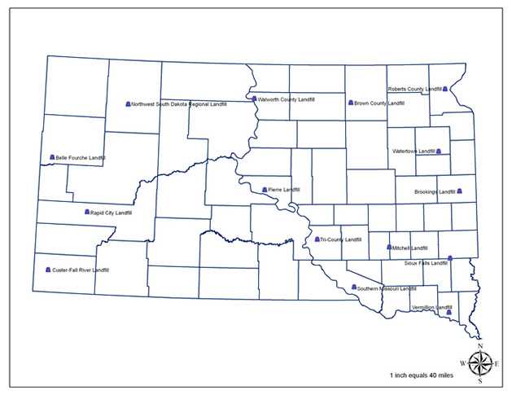
Source: https://denr.sd.gov/des/wm/landfillmaps/lfstate.aspx
http://www.epa.gov/cleanenergy/energy-and-you/affect/sw-generation.html - According to the U.S. Environmental Protection Agency:
Some electricity generation technologies result in the creation of solid waste. In some cases, this waste is disposed of in landfills. In other cases, this waste may contain toxic and hazardous elements and materials that require special handling, treatment, and disposal, as described below. Certain electricity generation technologies, however, produce no solid waste, or very insubstantial amounts. The specific solid waste impacts for each energy generation technology are described below.

Coal
The burning of coal creates solid waste, called ash, which is composed primarily of metal oxides and alkali. On average, the ash content of coal is 10%. Solid waste is also created at coal mines when coal is cleaned and at power plants when air pollutants are removed from the stack gas. Much of this waste is deposited in landfills and abandoned mines, although some amounts are now being recycled into useful products, such as cement and building materials.
Oil
Oil refining produces wastewater sludge and other solid waste that can contain high levels of metals and toxic compounds. Also, when oil is burned at power plants, residues that are not completely burned can accumulate, forming another source of solid waste that must be disposed.
Nuclear Energy
Every 18 to 24 months, nuclear power plants must shut down to remove and replace the "spent" uranium fuel. This spent fuel has released most of its energy because of the fission process and has become radioactive waste.
Combined, nuclear power plants in the U.S. produce about 2,000 metric tons per year of radioactive waste. Currently, the radioactive waste is stored at the nuclear plants at which it is generated, either in steel-lined, concrete vaults filled with water or in above-ground steel or steel-reinforced concrete containers with steel inner canisters. In addition to the fuel waste, much of the equipment in the nuclear power plants becomes contaminated with radiation and will become radioactive waste after the plant is closed. These wastes will remain radioactive for many thousands of years.
Uranium processing produces radioactive wastes that must be adequately stored and isolated to minimize the risk of radioactive release. The management, packaging, transport, and disposal of this waste is strictly regulated and carefully controlled by the U.S. Nuclear Regulatory Commission and the U.S. Department of Transportation.

Municipal Solid Waste (MSW)
The burning of MSW in boilers creates a solid waste called ash, which can contain any of the elements that were originally present in the waste. MSW power plants reduce the need for landfill capacity because disposal of MSW ash requires less land area than does unprocessed MSW. However, because ash and other residues from MSW operations may contain toxic materials, the power plant wastes must be tested regularly to assure that the wastes are safely contained to prevent toxic substances from migrating into groundwater supplies. Under current regulations, MSW ash must be sampled and analyzed regularly to determine if it is hazardous. Hazardous ash must be managed and disposed of as hazardous waste. Non-hazardous ash may be disposed of in an MSW landfill or recycled for use in roads, parking lots, or daily covering for sanitary landfills.
Natural Gas
The use of natural gas to create electricity does not produce substantial amounts of solid waste.

The above waste generation summaries from the U.S. Environmental Protection Agency leads to the following conclusion: the natural gas-powered Toronto Power Plant will not produce substantial amounts of solid waste as it operates to generate electricity.

Determination: No Significant Impact

4 – Wastewater treatment and collection

The Project’s operational workers are anticipated to consume less than one gallon per minute of potable water during normal operations of the facility. The source of potable water at the site will originate from either an on-site groundwater well or Brookings-Deuel Rural Water. Both sources are anticipated to have sufficient water supply and distributional capacities to meet the projected potable water usage needs.

While operating, the Project is expected to consume water at a rate of 40 gallons per minute during periods of warm ambient temperatures. The source of process water at the site will originate from either an on-site groundwater well or Brookings-Deuel Rural Water. Brookings-Deuel Rural Water cannot currently supply the anticipated volume of water via pipeline without costly improvements to their distribution system. Therefore, it is anticipated that water from an on-site well supplied by ground water, or trucking of water off-site from Brookings-Deuel Rural Water, will be utilized to meet the operational needs of the project. If an on-site well is used, it is anticipated that water will be transferred into a 200,000-gallon water firefighting storage tank at a rate of up to 100 gallons per minute.

As previously stated, 4-6 new operational workers are projected to work at the Project. The average family size in the U.S. is 2.53 persons (2020 Census). If 6 new operational employees move into the area with average sized families then 13 new inhabitants will increase water usage by approximately 39,000 gallons per month. This figure is calculated using the US Geological Survey estimate of 100 gallons per person per day as an average for individual water usage (source: https://water.usgs.gov/edu/qa-home-percapita.html).

Approximately 200 construction workers are projected to work at the Toronto Power Plant facility during peak construction. The average family size in the US is 2.53 persons (2020 Census). If 200 construction workers move into the area with average-sized families, then 506 new inhabitants will temporarily increase water usage by approximately 1,518,000 gallons per month. This figure is calculated using the U.S. Geological Survey estimate of 100 gallons per person per day as an average for individual water usage (source: https://water.usgs.gov/edu/qa-home-percapita.html).

Increases in residential water usage will result in corresponding increases in wastewater volumes where workers live during construction and operation of the Project. The communities of Brookings (2020 Census Population 23,377) and Watertown (2020 Census Population 22,655) are within commuting distance of the project site, and an increase of 506 persons will increase their total populations by approximately 1.195%. This increase does not represent a significant population expansion that would adversely impact municipal wastewater collection and treatment systems at either location.

Wastewater generated by the Project’s operation from process and potable water is anticipated to be treated entirely on-site. Any off-site disposal of wastewater will be completed in accordance with state law. The following wastewater treatment and collection permits for the Project may be issued by the South Dakota Department of Agriculture and Natural Resources (DANR):

1. National Pollution Discharge Elimination System (NPDES)/Surface Water Discharge
2. On-site Septic System
3. Storm Water Discharge

- NPDES/Surface Water Discharge
No process water is anticipated to be discharged. Presently the Project plans to utilize ground water that will undergo treatment by a mobile demineralizer. By having the supplier perform off-site regeneration to remove the undesirable salts/minerals that occur naturally, this enables the Project to operate in a zero-discharge mode for process water.

Should circumstances change such that the process water would be required to be disposed or discharged, the project would arrange for off-site disposal.

- On-site Septic Systems
There will be an on-site wastewater septic system that incorporates a drain field. The water will originate from sinks, showers, toilets etc.-no process water will flow into this system.

- Storm Water Discharge
There will be a storm water pond to collect rainfall/snowmelt etc. from the areas that are paved or impacted by the facility. A Storm Water Discharge Permit will be acquired prior to the construction of the pond. Should storm water accumulate in the pond, the water will be sampled, analyzed, and discharged according to the permit’s parameters.

Determination: Mitigation Recommended – wastewater permits must be acquired from the DANR before construction begins. Links to the surface water discharge permits available at: https://danr.sd.gov/officeofwater/surfacewaterquality/swdpermitting/IndustrialWW.aspx

5 – Solid Waste Disposal and Collection

Construction Waste

Waste generated during construction activities will be disposed of at a properly permitted municipal solid waste landfill site in accordance with the laws of South Dakota. Construction waste disposal will be the responsibility of the prime construction contractor responsible for construction of the Project under the direction of WMMPA.

Operational Waste

Waste generated during operational activities will be disposed of at a properly permitted solid waste landfill site in accordance with the laws of South Dakota. Arrangements for operational waste collection and disposal will be the responsibility of WMMPA and will likely be handled by a private waste collection and disposal company.

Landfill Sites

While there are no properly permitted waste sites within the six-mile project area there are two municipal solid waste landfill sites located nearby. The Brookings Landfill and the Watertown Landfill are both within approximately 30 minutes of the Project. Map 5 shows the locations of municipal solid waste landfill permitted by the State of South Dakota.

Map 5 – Permitted Municipal Solid Waste Landfills in South Dakota
Source: https://denr.sd.gov/des/wm/landfillmaps/lfstate.aspx

Determination: No Significant Impact

6 – Law Enforcement

Two law enforcement agencies, the Brookings County Sheriff’s Department and the Deuel County Sheriff’s Department, are located within the six-mile project area, and were contacted to provide Project. Sheriff Marty Stanwick was in office during the construction of the Deer Creek Station facility in Brookings County and the nearby Astoria Station facility that is located east of the Project site. Sheriff Cory Borg was in office during the construction of the nearby Astoria Station facility that is located east of the Project site.

Brookings County, South Dakota Sheriff’s Department

Marty Stanwick, Sheriff 605-696-8300

Full Time Officers – 16
Part Time Officers – 1

24-hour protection – yes

Dispatch location – City of Brookings

Capacity to handle existing caseload – yes

Any problems associated with Deer Creek Station – yes (dust, detours, speeding and reckless driving)

Any problems associated with Astoria Station - no

Any perceived impacts resulting from the Toronto Power Plant project – none

Deuel County, South Dakota Sheriff’s Department

Cory Borg, Sheriff 605-874-8212

Full Time Officers – 5
Part Time Officers – 0

24-hour protection – yes

Dispatch location – City of Watertown

Capacity to handle existing caseload – yes

Any problems associated with Astoria Station – yes (traffic, assault reports, and drug offenses)

Any perceived impacts resulting from the Toronto Power Plant project – none

Total Number of Full- and Part-Time Law Enforcement Officers, by Agency

Brookings County Sheriff’s Department 17
Deuel County Sheriff’s Department 6

Total South Dakota County Full- and Part-Time Law Enforcement
Officers in the Two Surveyed Law Enforcement Agencies 23

Brookings County Sheriff Stanwick noted that his office received multiple traffic-related complaints from within the Deer Creek Station project area relating to dust created by people driving on gravel roads, high amounts of traffic on roads used for detours, and construction workers either speeding or driving recklessly on rural roads and that he was not aware of any complaints received by his department during the construction of the Astoria Station Facility.

Deuel County Sheriff Borg noted that his office received traffic-related complaints, an increase in the number of reported assaults, and an increase in drug-related offenses during the construction of the Astoria Station facility. There were also two wind turbine projects under construction while the Astoria Station facility was being built and some of the increased caseload experienced by his office could be traced back to wind turbine project workers. He did not anticipate significant adverse impacts resulting from the construction or operation of the Project.

While neither law enforcement agency anticipated any significant adverse impacts resulting from the construction or operation of the Project, effective communications between all parties impacted by the project would be the most effective means to avoid potential conflicts before they arise. Prior to the commencement of construction of the Deer Creek Station and Astoria Station facilities the project developers invited local law enforcement agencies to participate in a preconstruction meeting to familiarize them with the projects and to facilitate communications between all parties. A similar meeting prior to the start of construction on the Project would be beneficial to all parties.

Determination: Mitigation Recommended – Informational Meetings with Law Enforcement

7 – Transportation

The primary mode of transportation used to bring shipments of construction equipment, workers and materials as well as operational workers to the Project’s site will be via state highway and township roads. Construction-related traffic to the site and operational-related traffic will travel to the site primarily on S.D. Highway 28 and gravel roads maintained by Scandinavia Township. A secondary traffic route impacts both Scandinavia Township and Deuel County roads. No roads maintained by Brookings County are likely to be impacted by the Project.

SD Highway 28

Approximately 12 miles of S.D. Highway 28, from just west of the intersection of S.D. Highway 15 and S.D. Highway 28 to the border of South Dakota and Minnesota, falls within the study area. Shipments trucked to the site are expected to travel on S.D. Highway 28 prior to entering the road network maintained by Scandinavia Township.

S.D. Highway 28 carries a six-inch thick bituminous surface that is 26 feet in width except for approximately one half of a mile of surface that is 54 feet wide located within the corporate boundaries of Toronto. Detailed surface information can be found on pages 111 and 112 of the South Dakota Department of Transportation (SDDOT) Surfacing Log (Appendix D)

There is one bridge, located at MRM 375.67 on S.D. Highway 28 within the study area.

Table 12 – Bridge Information

Structure  Number | MRM | ADT | Fed  Sufficiency  Rating
20201280 | 375.67 | 478 | 79.9
Source: SDDOT State Owned Structures Report (Appendix E)

Data from two traffic count segments on S.D. Highway 28 provides average daily traffic information broken down by total traffic volume and total truck volume. One of the traffic count segments is from the S.D. Highway 15 and S.D. Highway 28 intersection east to Toronto and the other is located between Toronto and the South Dakota and Minnesota border. Traffic count information was taken from the South Dakota Traffic Flow Map (Appendix F).

- Average daily traffic between the intersection of S.D. Highway 15 and S.D. Highway 28 and Toronto
    - 1,013 – Total traffic volume
    - 158 – Total truck volume
- Average daily traffic from Toronto and the South Dakota and Minnesota border
    - 478 – Total traffic volume
    - 168 – Total truck volume

S.D. Highway 15

Approximately seven miles of S.D. Highway 15, from the intersection of S.D. Highway 15 and S.D. Highway 28 then north two miles, falls within the study area. No construction shipments trucked to the site are anticipated to travel over S.D. Highway 15. Construction and operational workers may utilize S.D. Highway 15 to access the site.

S.D. Highway 15 carries a 6.8-inch thick bituminous surface that is 24 feet in width. Detailed surface information can be found on page 47 of the SDDOT Surfacing Log (Appendix D). There are no bridges on S.D. Highway 15 within the study area (Appendix E).

Data from one traffic count segment on S.D. Highway 15 provides average daily traffic information broken down by total traffic volume and total truck volume. Traffic count information was taken from the 2016 South Dakota Traffic Flow Map (Appendix F).

- Average daily traffic from the intersection of S.D. Highway 15 and S.D. Highway 28 then north two miles
    - 1,257 – Total traffic volume
    - 221 – Total truck volume

Deuel County Roads

Approximately two and a half miles of the Deuel County road system may see the greatest increase in usage because of the Project. The county road on 479th Avenue from S.D. Highway 28 north approximately 2.5 miles is likely to be used as the primary route for construction and operational workers to access the Project’s site. There are no bridges on the above-mentioned Deuel County road.

Township Roads

Approximately three miles of the township road system may see an increase in usage because of the Project. 192nd Street from SD Highway 15 east to 479th Avenue may be used by construction workers as a route to get to and from the Project site. Two miles of this stretch of 192nd Street are located in Blom Township and one mile is located in Scandinavia Township. There are no bridges on the above-mentioned township roads.

South Dakota Department of Motor Carrier Services Permits

Single-Trip Permits

Temporary Licensing - Single-trip commercial license, temporary fuel, or temporary PUC (single state registration) permits.

Oversize / Overweight - Allows for the movement on state highways of a vehicle transporting a non-divisible load that exceeds size, weight, or size and weight limitations.

Over 80K on the interstate - Single-trip permits that allow a motor vehicle to exceed 80,000 pounds when traveling on the interstate highways. The permit does not allow a motor vehicle to exceed its legal axle weight, legal tire weight, or the weight as allowed by the Bridge Gross Weight Formula.

Movement to scale site - Single-trip permit to allow a motor vehicle to move to the nearest available public or private scale to determine whether a load is properly placed on the motor vehicle. Before a single-trip permit is requested, the operator moving a load in question must obtain approval from the private scale operator to weigh the vehicle and its load. A motor vehicle operator issued a permit to move to a weigh scale may not leave the scale site unless his load conforms to all legal weight limits, or he obtains an overweight permit.

Books of 10 – Self-issue books of permits for over 80k on the interstate, single-trip commercial licensing, telephonic coupons, and construction plate permits.

Extended Length Permits

Booster Axle - Allows the movement on state trunk highways of a cement truck equipped with an overweight booster axle (not a variable load or lift axle) before July 1, 1996, whose loaded weight exceeds that allowed by SDCL 32-22-21 but does not exceed 600 pounds per inch of tire width.

Non-divisible Loads - Allows for the movement of a non-divisible oversize but not overweight load being hauled on a single unit or combination of two units up to a width of 14 feet 6 inches. Side overhang may not exceed 3 feet 3 inches. Total combined front and rear overhang may not exceed 30 feet. Total length of a single unit is limited to 60 feet, including load overhang. Total length for a two-unit combination is limited to 85 feet, including load overhang, and the second unit's wheelbase may not exceed 43 feet. The vehicle operator must keep a trip log. Trip authorization is required if the load exceeds a width of 12 feet.

Lift Axle/ Variable Load Axle - Allows a motor vehicle to be overweight when making a turn due to the lifting of a lift axle or variable load axle to make the turn. This permit allows the raising of the lift axle 100 feet before beginning a turn provided the axle is lowered within 100 feet after completing the turn. Not available for trailers.
Oversize Trailer - Allows for the movement of a semi-trailer manufactured for moving oversize equipment up to 10 feet wide and up to 110 feet long, but not over height or overweight. Can be assigned to a trailer or the power unit.

Overlength semi-trailer - Allows for the movement of a semitrailer manufactured before July 1, 1998, over 53 feet long but not longer than 60 feet. The overall length of the tractor and semitrailer may not exceed 80 feet.

Slow on Interstate - This permit is valid only when no parallel route is available. Allows the movement of a vehicle that cannot maintain a speed of 40 miles per hour on interstate highways. The vehicle must display flashing warning lights and must be driven as far to the right as possible.

Deuel County Road Agreements

Deuel County requires the execution of a haul road agreement between the county and the contractor prior to the beginning of construction. The haul road agreement identifies haul roads, the condition of haul roads prior to construction, and sets forth the responsibilities of the contractor to make road-related improvements or to restore roadbeds and appurtenances to the condition they were in prior to the start of construction.

The Project will not be the first construction project within the study area to require a haul road agreement with Deuel County. The County has developed previous haul road agreements for wind and natural gas electrical generation projects and can use those agreements when developing a haul road agreement for the Project.

Construction Traffic

The impact of construction traffic will be addressed in permits issued by the State of South Dakota and by Haul Road Agreements issued by Brookings County and Deuel County. The greatest impact of construction traffic will be experienced on Deuel County roads because they are not designed for the amount of heavy traffic that will occur during the construction of the Project. This issue will be addressed in the Deuel County Haul Road Agreement and will require pre-and post-construction inspections to be completed to determine what must be done to improve haul roads prior to construction and what must be done to return haul roads to preconstruction conditions.

Dust mitigation measures should also be implemented on 192nd Street if dust resulting from construction traffic becomes an issue for residents. These measures could include applying water, calcium chloride, magnesium chloride, or another type of dust suppressant.

Operational Traffic

The impact of operational traffic will be minimal as it will consist largely of motor vehicle traffic to and from the facility. The expected 4 to 6 employees will have no significant impact on traffic patterns or traffic safety. No mitigation is recommended for operational traffic.

Determination: Mitigation Recommended – Dust Mitigation, Haul Road Agreements, and Transportation Permits

8 – Fire Protection

There are three fire departments located in Astoria, Brandt and Toronto that provide fire protection services within the six-mile study area. All three are staffed exclusively by volunteer firefighters. A total of 60 volunteer firefighters provide fire protection services within the survey area. All three fire departments have mutual aid agreements that allow neighboring firefighters to respond to events should the need arise.

Astoria, South Dakota
Fire Chief – Jason Landmark (605-690-0923)
Assistant Fire Chief – Sheldon Crooks (605-832-3351)
Volunteer Fire Department Staff 20 Firefighters
Community Fire Rating “Rural Rating”

Equipment:
2 Pumper (1 @ 1,000 gpm and 1 @ 800 gpm)
1 Tanker (1,800 gallons)
1 Grass Rig (250 gallons/200 gpm)
1 One-Ton Chevrolet 4 x 4

Ambulance Service: Hendricks, Minnesota, Gary, and Clear Lake, South Dakota

Brandt, South Dakota

Fire Chief – Andrew Johnson (605) 695-1781
Assistant Fire Chief – Marty Brown (605-520-3675)
Volunteer Fire Department Staff 17 Firefighters
Community Fire Rating “Rural Rating”

Equipment:
1 Pumper (1,000 gallons)
2 Tanker (1 @ 1,000 gallons, 1 @ 1,200 gallons and 1 @ 750 gallons)
3 Grass Rig (all @ 250 gallons/200 gpm)

Ambulance Service: Hendricks, Minnesota, Gary, and Clear Lake, South Dakota

Toronto, South Dakota

Fire Chief – Doyle Trooien (605-794-2921)
Volunteer Fire Department Staff 23 Firefighters
Community Fire Rating “Rural Rating”

Equipment:
2 Pumper (1 @ 1,200 gpm and 1 @ 1,000 gpm)
2 Brush Rig (all 300 gallons @ 200 gpm)
1 Rescue Van

Ambulance Service: Hendricks, Minnesota, Gary, and Clear Lake, South Dakota

The South Dakota State Fire Marshal’s office was contacted and asked to share their thoughts about the Project’s impact to area fire departments. They suggested that local fire departments should be contacted by WMMPA prior to the start of construction to provide early education and response training to impacted fire departments and to determine the capacities of each department to respond to a fire call at the Project’s site.

Cory Borg, Deuel County Emergency Manager, was also contacted and asked to share his thoughts about the Project. He echoed the recommendations of the State Fire Marshall to provide early education and response training to impacted fire departments and to determine the capacities of each department to respond to a fire call at the project site. He also expressed the importance of effective communication between WMMPA and the fire departments during planning, construction and operation of the Project.

He noted that none of the area fire departments should experience any significant adverse impacts as a result of this proposed project.

Determination: Mitigation Recommended – Annual Training for Fire Protection

9 – Health

There are no healthcare facilities located within the six-mile study area. The construction and operation of the Project will have no impact on area healthcare facilities.

Determination: No Significant Impact

10 – Recreation

Existing recreational facilities that will be impacted by the construction and operation of the Projeft are located inside of the city limits of the three municipalities that fall within the six-mile study area. A summary of the impact to recreational facilities from the Astoria Station Social and Economic Impact Study can be found below.

Astoria

Existing Recreational Opportunities:
- City park with picnic tables, gazebo, and playground equipment
- Lighted softball complex

Existing Camper Hook-ups (both privately owned and operated):
- Crooks Family Site – 7 hook-ups north of Astoria
- Hulsebus Family Site – 6 hook-ups south of Astoria

    - The Astoria Station project has had no adverse impact on existing recreational facilities.

Brandt

Existing Recreational Opportunities:
- City park with picnic tables, playground equipment, and restrooms
- Lighted softball complex

Camper Hook-ups:
- Brandt has discussed installing camper hook-ups in the past. Available municipally owned property to the south of the city park could be developed for this purpose at a reasonable cost.

    - The Astoria Station project has had no adverse impact on existing recreational facilities.

Clear Lake

Existing Recreational Opportunities
- City Park with picnic tables, playground equipment, and restrooms

Camper Hook-ups:
- Clear Lake owns and operates two caper hook-up areas. One in town with 18 sites and one at the lake with 24 sites

Estelline

Existing Recreational Opportunities
- City Park with picnic tables, playground equipment, and restrooms

Camper Hook-ups:
- Estelline owns and operates one camper hook-up areas with 6 sites.

Toronto

Existing Recreational Opportunities:
- City park with picnic shelter, playground equipment and restrooms
- Lighted softball complex
- Tennis courts

Camper Hook-ups:
- Toronto owns and operates four camper hook-ups at the city park.

    - The Astoria Station project had no adverse impact on existing recreational facilities.

One of the only noticeable impacts to recreational facilities associated with the construction of the Astoria Station project was a temporary increase in the demand for camper hook-ups. Many Astoria Station construction workers utilized campers as their means of housing during the duration of project construction. This resulted in existing camper hook-up sites within commuting distance of the construction site being occupied for extended periods of time.

A portion of the Project’s construction workers are likely to occupy camper hook-up sites for the duration of project construction. This will create a short-term increase in the demand for camper hook-up sites. The anticipated 13-month long construction timeframe will not result in a long-term impact to recreational facilities within the project area.

Determination: No Significant Impact

11 – Government

Governmental entities located within the six-mile study area (Appendix G)

- Brookings County
- Deuel County
- Town of Astoria
- Town of Brandt
- Town of Toronto
- Deubrook School District 19-4
- Deuel School District 05-6
- Estelline School District 28-2

Governmental Entity Permits Summary

The proposed project site is located outside of any municipal boundaries and Deuel County will be the primary governmental entity impacted by the Project for permitting purposes. WMMPA will need to work closely with Deuel County officials to ensure compliance with all ordinances pertaining to the construction of the Project.

Deuel County zoning ordinances must be followed to obtain building permits for the Project. Meeting Deuel County’s noise ordinance requirements, adopted in 2024, must be addressed as part of the overall design of the Project (Appendix H).

Executing haul road agreements with Brookings County and Deuel County may be necessary if any of the construction materials needed to construct the Project are offloaded from rail and trucked to the project site meet or exceed the requirements of the impacted counties.

Executing a haul road agreement with Deuel County to ensure that the roads impacted by project construction are returned to a condition that meets or exceeds the condition of the impacted roads before the start of construction.

Governmental Entity Taxation Summary

The governmental entities that the Astoria Station facility project construction and operation impacted had either no impact or a positive impact to taxation within their jurisdiction. No perceived negative impacts on taxation were experienced by the Astoria Station project and no negative impacts on taxation are anticipated from the Toronto Power Project.

Sales Tax

WMMPA would be eligible for sales/tax relief for the project under South Dakota’s Reinvestment Payment Program. Applications approved under the program allow project owners to receive a reinvestment payment that does not exceed the sales/use tax paid on project costs. If WMMPA applies for sales/tax relief the application will be reviewed by the South Dakota Board of Economic Development.
Land Values

Land values within the platted property improved by the Toronto Power Plant project will increase substantially. It is expected that property taxes paid on the Project will be in excess of $1 million per year and may be similar to that of Astoria Station, once the facility is fully operational and 100% of property taxes are being collected.

Land values outside of the platted property improved by the Project are not expected to increase or decrease noticeably. Adjacent properties are agricultural in nature and use, and are located within the agricultural zoning district. Land values of properties located near the Astoria Station facility have not been adversely impacted and the same outcome is expected as a result of the construction and operation of the Project.

Property Tax Impacts

Property tax rates and revenues are set in accordance with South Dakota State Law and can be changed by changes to the tax base or changes to the tax rates. Local governments are allowed to collect property tax revenue at a rate equal to the previous year’s revenue plus an adjustment for inflation. This increase can be no more than the lesser of three percent or the Consumer Price Index (CPI). Construction of the Project will result in an increased total taxable valuation and tax rates automatically adjust to prevent exceeding the increase defined in State Law. This will result in property tax rates stabilizing for other landowners within the taxable boundaries of the Project.

Property tax rates for the Project were not known at the time this study occurred. The Astoria Station property was used as a comparable facility to provide an estimate of potential tax revenues to the various tax collecting local government entities impacted by the Project. The information below is not meant to be reflective of the Project and the figures in Table 12 may vary significantly from actual taxes generated by the Project.

Table 13 – Astoria Station Property Tax Information

Tax Year/Year Paid | Tax  Rate | Deuel County | Deubrook School | Scandinavia Township | East Dakota Water | Rural Fire | Total Taxes Paid Each Year
2026/27 | Discretionary Year 5–100% | $284,124.29 | $1,035,006.07 | $92,162.60 | $1,930.57 | $11,482.63 | $1,424,706.16
2025/26 | Discretionary Year 4-80% | $187,491.28 | $644,261.48 | $60,044.69 | $1,259.67 | $7,592.83 | $900,649.96
2024/25 | Discretionary Year 3-60% | $123,723.95 | $401,034.23 | $39,119.61 | $821.92 | $5,020.72 | $569,720.43
2023/24 | Discretionary Year 2-40% | $816,44.42 | $249,632.26 | $25,486.75 | $536.29 | $3,319.92 | $360,619.64
2022/23 | Discretionary Year 1-20% | $420,77.08 | $151,404.74 | $13,631.88 | $285.62 | $1,700.74 | $209,100.06
2021/22 | Construction | $131,980.55 | $491,667.9 | $37,744.20 | $951.88 | $5,131.89 | $667,476.42
2020/21 | Construction | $64,921.20 | $241,938.53 | $18,763.96 | $487.65 | $2,501.86 | $328,613.20
Source: Deuel County Auditor’s Office

Property Tax Discretionary Formula

WMMPA could pursue a phasing in of property taxes known as a discretionary formula. The projected annual property taxes are expected to be approximately $1 million once the discretionary formula period ends.

Determination: Mitigation Recommended – Local Government Permits

12 – Energy

Projected increases in the consumption of electricity creates a corresponding demand for the development of new power plants. Sources of electrical generation include coal, natural gas, nuclear, renewables and petroleum. Natural gas provides a reliable and affordable source of domestically sourced power that does not produce a significant adverse to the environment.

According to the Statista Research Department, May 19, 2025: “The net summer capacity of the electric power sector in the United States was estimated at 1.2 terawatts in 2024. This figure is expected to increase by more than 97 percent in the coming three decades, reaching almost three terawatts by 2050.”

The following charts show electricity capacity and natural gas generation projections to 2050.

Chart 3: U.S. Electricity Capacity Outlook to 2050

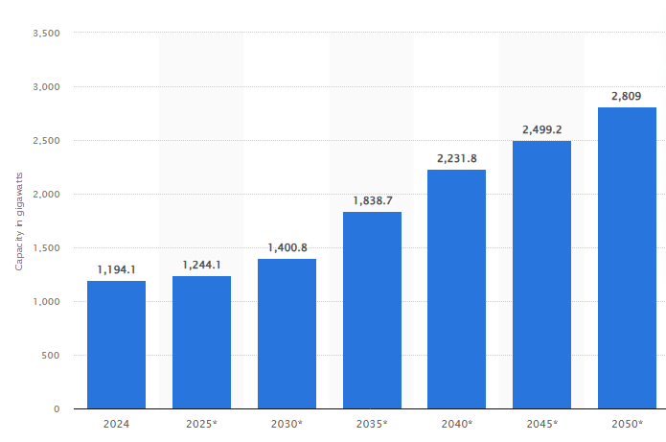
Source: U.S. electricity capacity outlook 2050| Statista

Chart 4: U.S. Net Energy Generation from Select Fuels

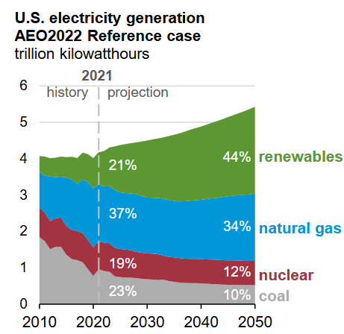
Source: U.S. Energy Information Administration – Annual Energy Outlook 2022

Chart 5: U.S. Natural Gas Consumption for Electricity Generation

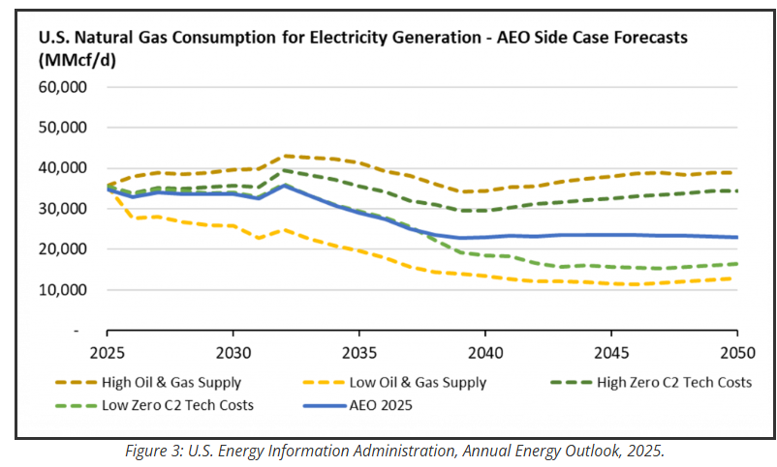
Source: U.S. Energy Information Administration – Annual Energy Outlook 2025

The proposed Project will increase the area’s capacity to generate electricity while not producing emissions that would have negatively impact the environment. WMMPA has chosen a project site that can be developed without significant disturbance to adjacent properties because the site is approximately a quarter of a mile from electrical distribution infrastructure as well as a site that intersects an existing natural gas pipeline. It would be difficult to locate a more ideal site for the development of a natural gas-fired power plant than the site chosen for the development of the Toronto Power Plant facility.

Determination: No Significant Impact

List of Appendices

Appendix A – 2022-2023 Profile of Deubrook Area School District 05-6

Appendix B – 2022-2023 Profile of Deuel School District 19-4

Appendix C – 2022-2023 Profile of Estelline School District 28-2

Appendix D – SD DOT Surfacing Log

Appendix E – SD DOT State Owned Structures

Appendix F –SD Traffic Flow Map

Appendix G – SD PUC Amended Order Designating Affected Area and Designating LRC

Appendix H – Deuel County Noise Ordinance

Appendix I – US Energy Information Administration – Annual Energy Outlook 2017

Appendix J – Local Review Committee Meeting Minutes

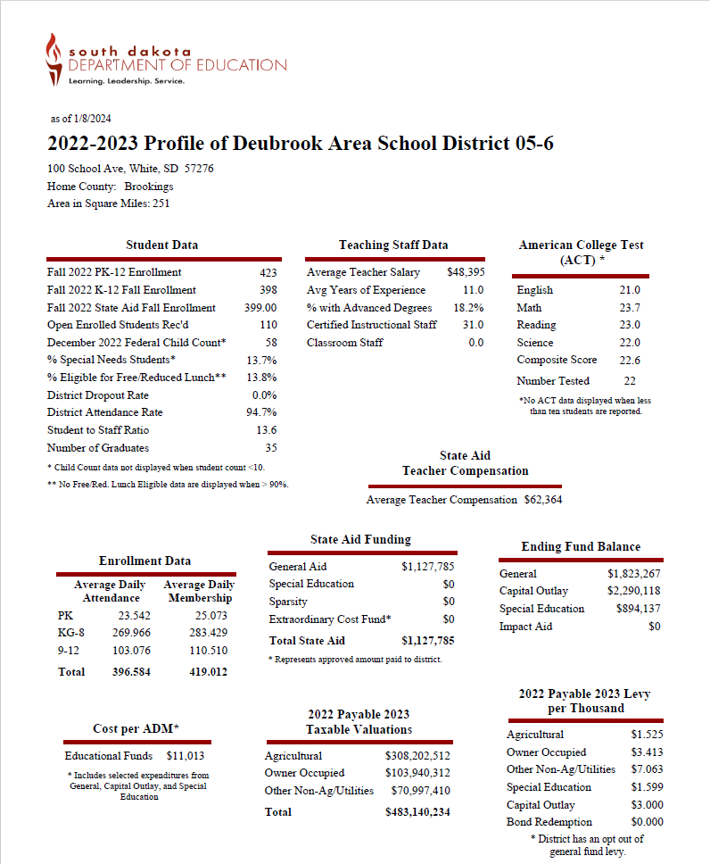
Appendix A – 2022-2023 Profile of Deubrook Area School District 05-6

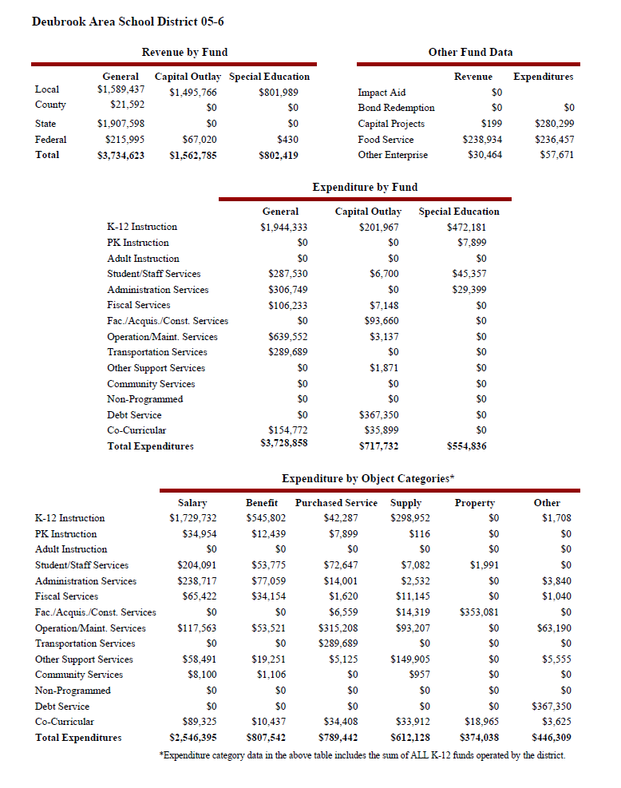
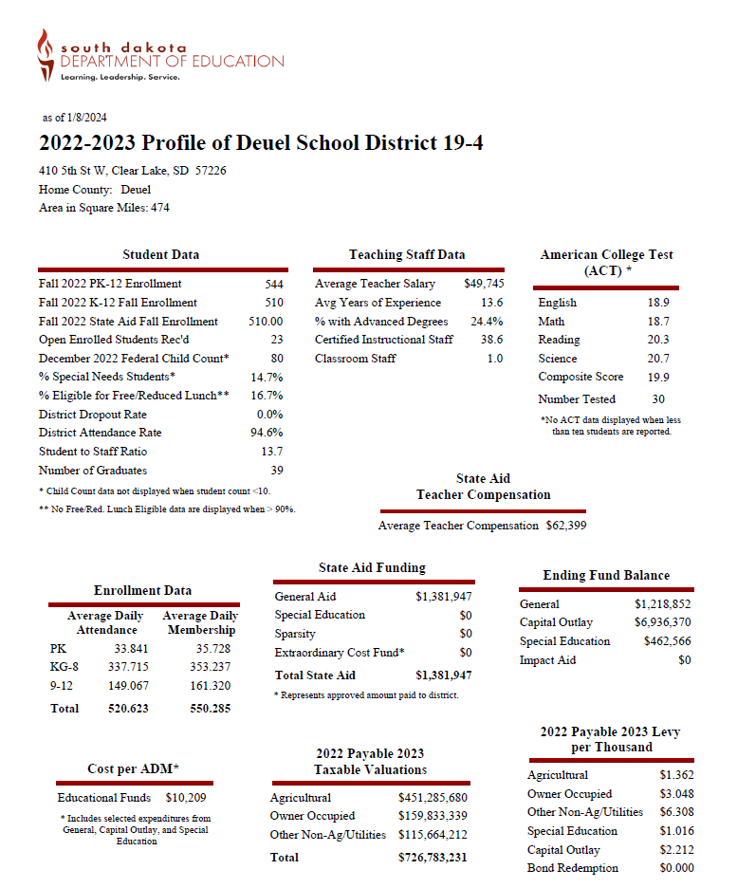
Appendix B – 2022-2023 Profile of Deuel School District 19-4

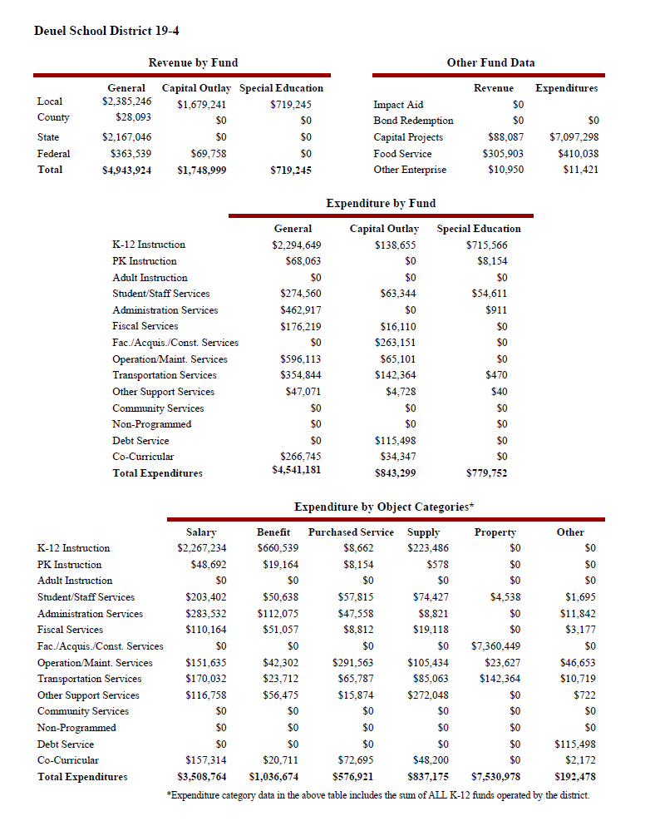
Appendix C – 2022-2023 Profile of Estelline School District 28-2

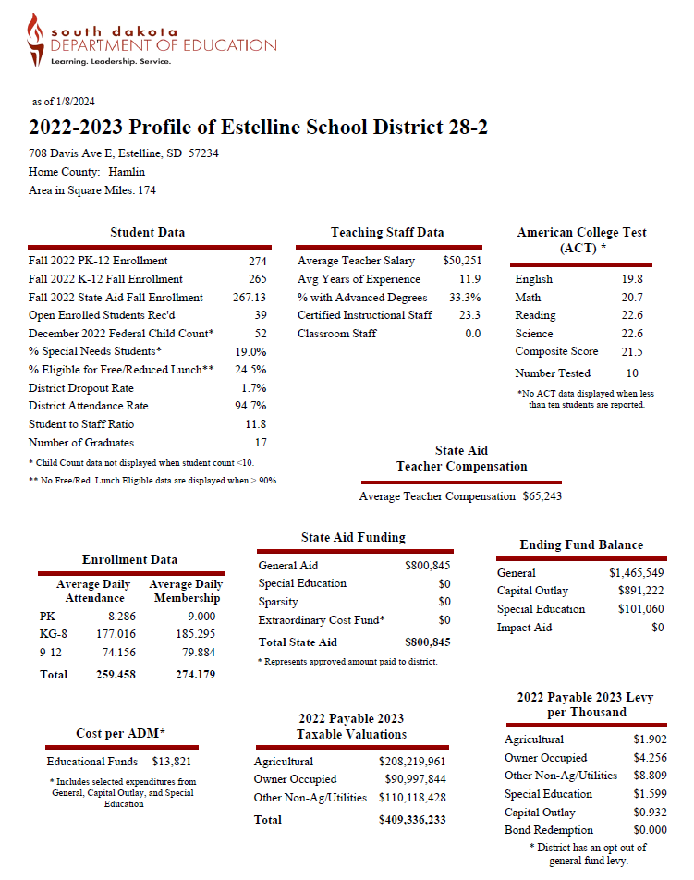

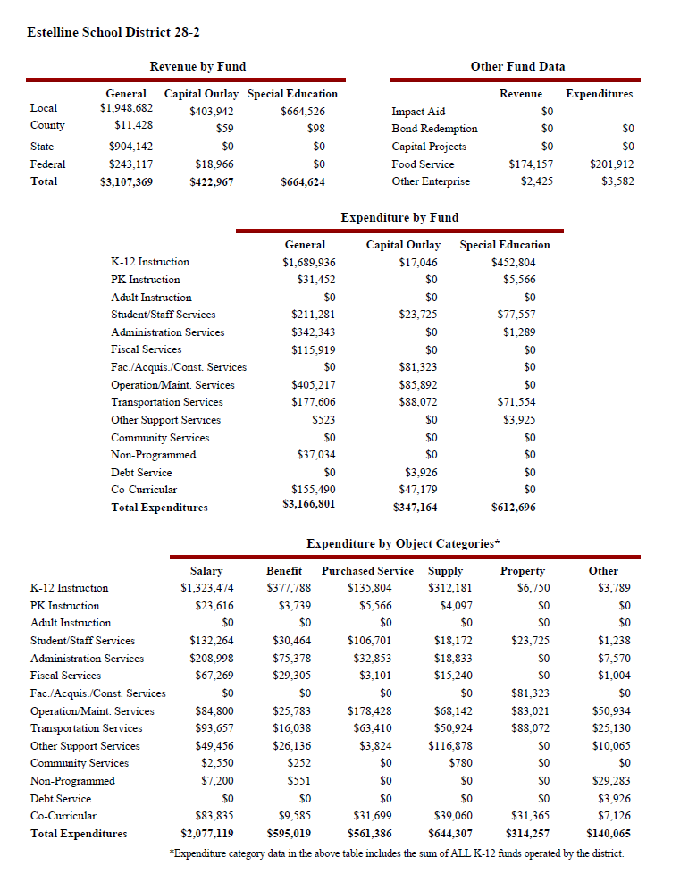
Appendix D – SD DOT Surfacing Log
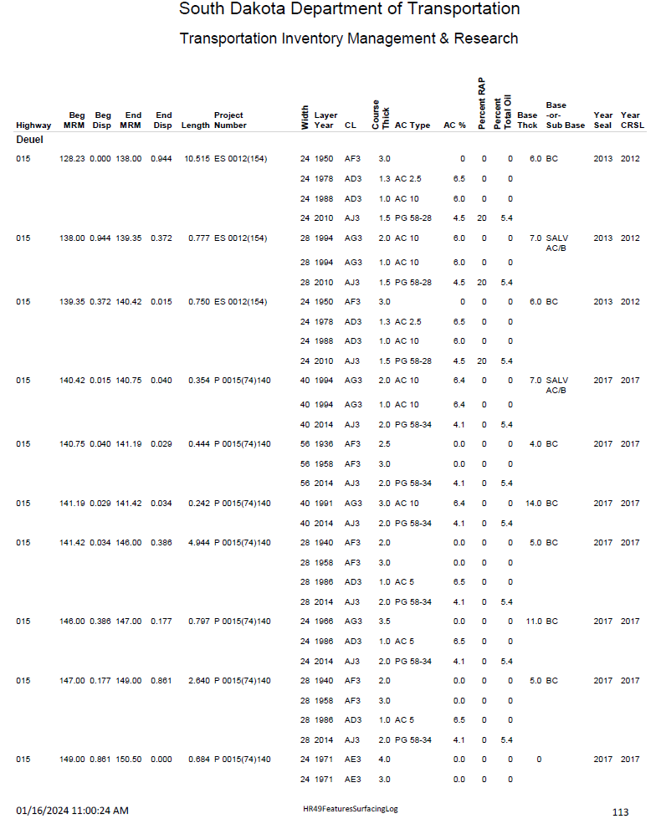
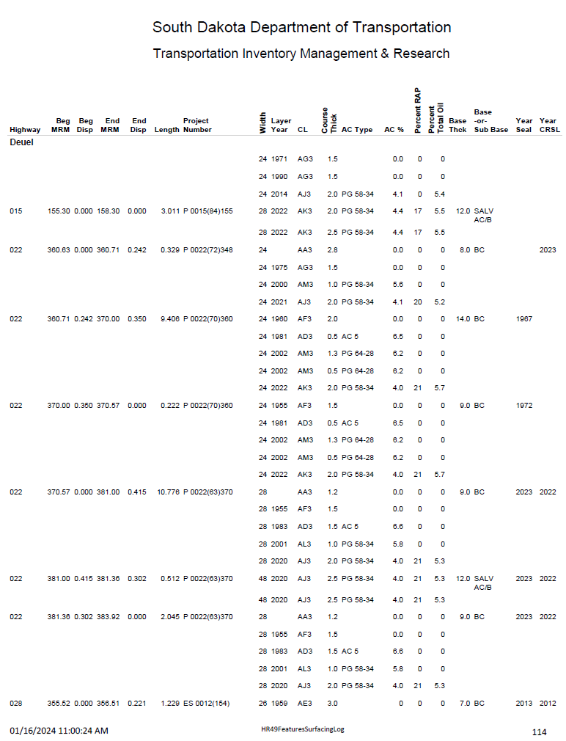
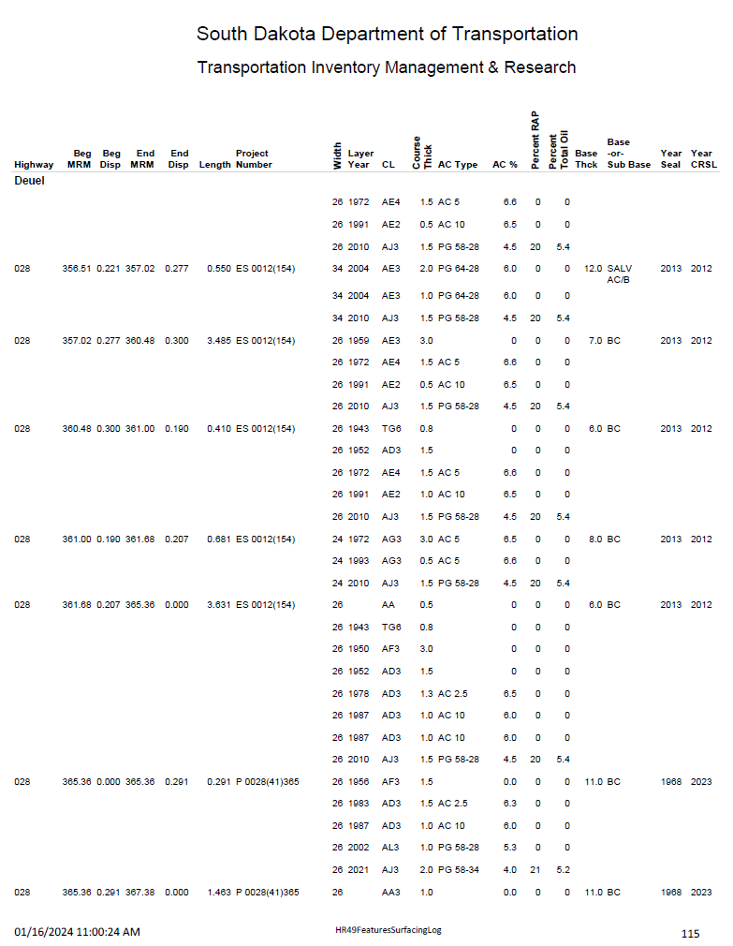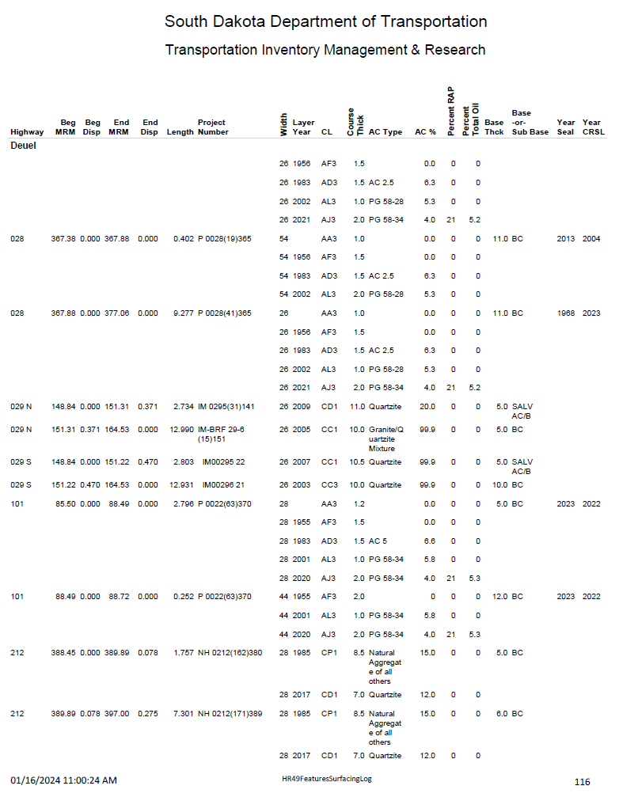
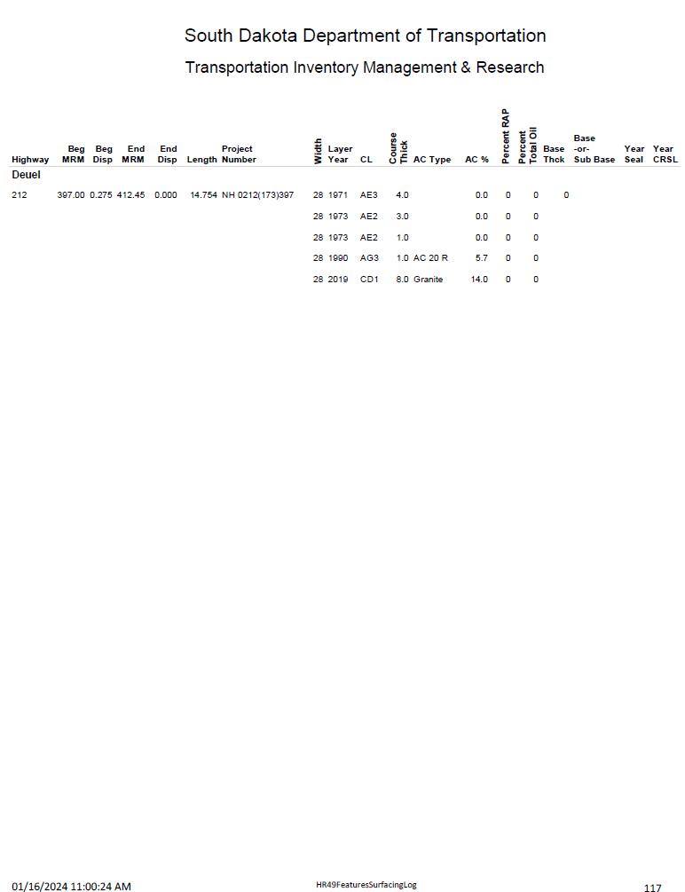
Appendix E – SD DOT State Owned Structures
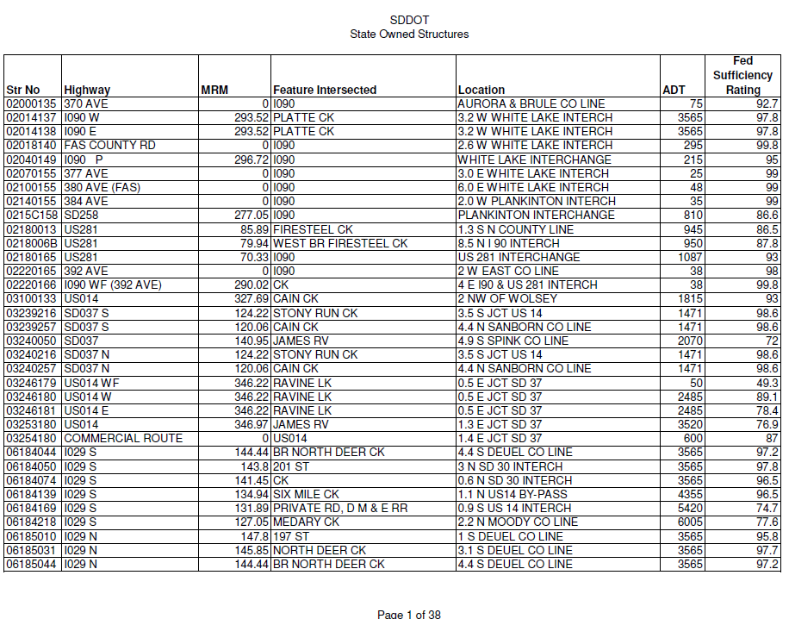

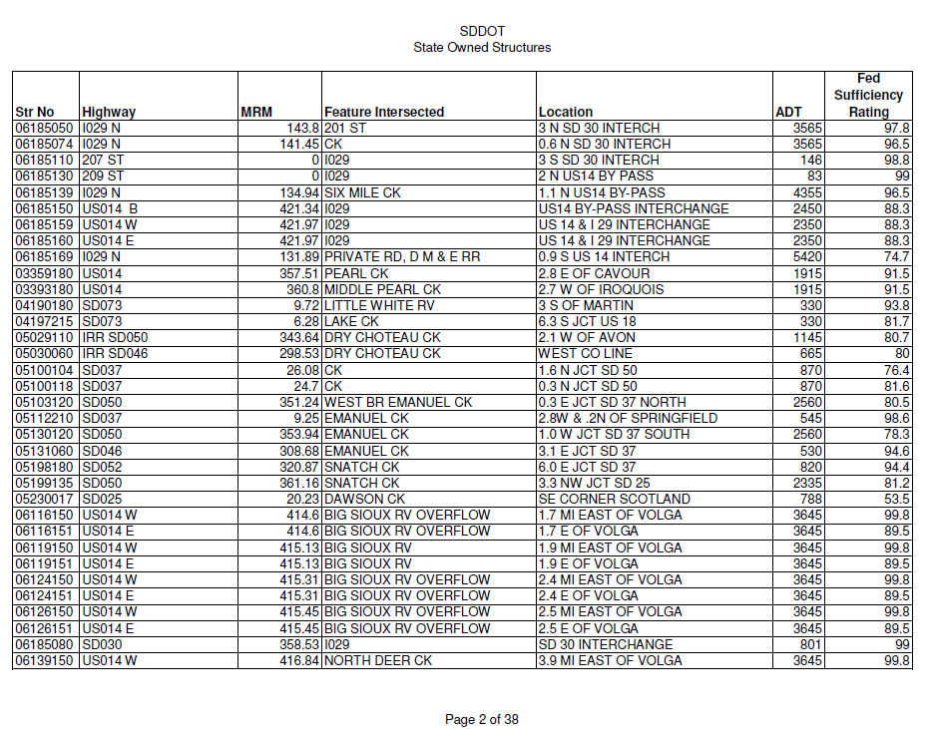
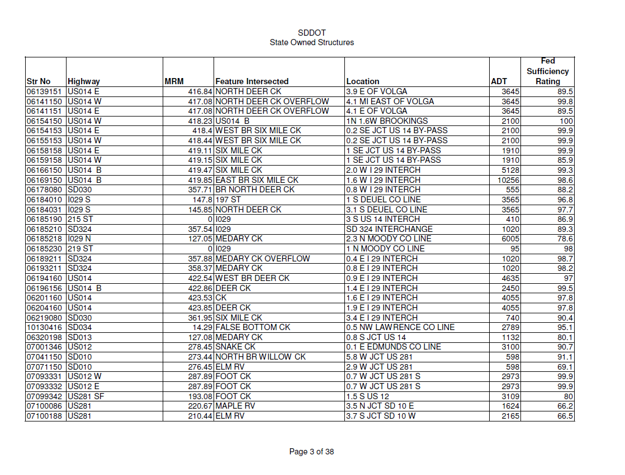
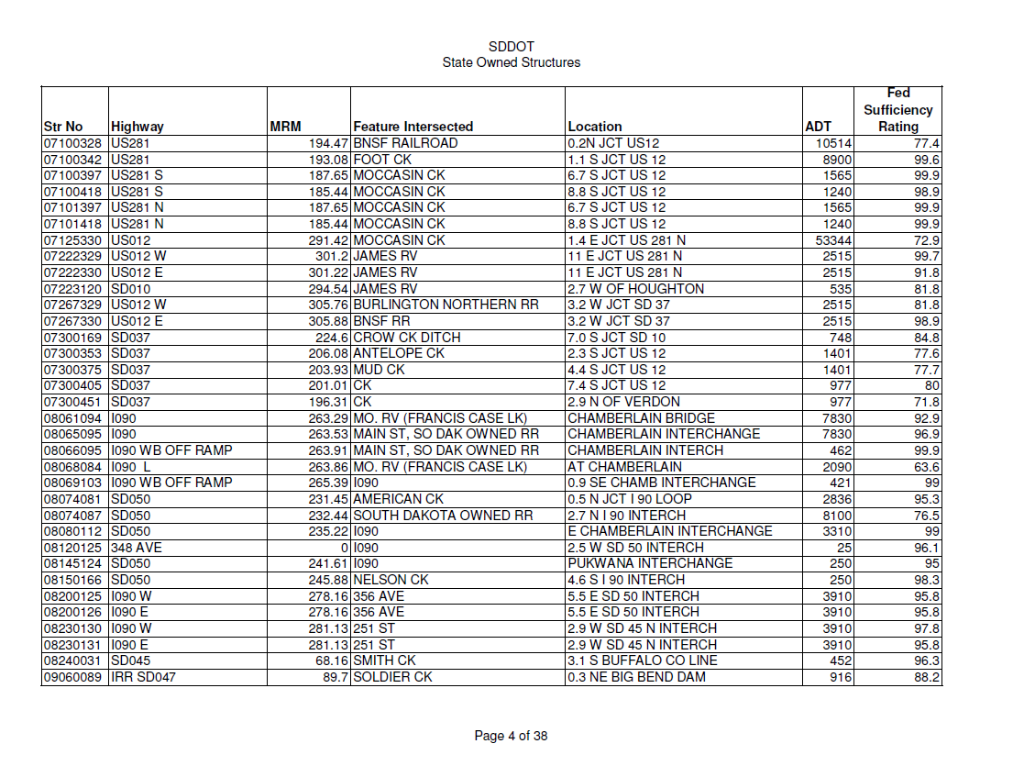
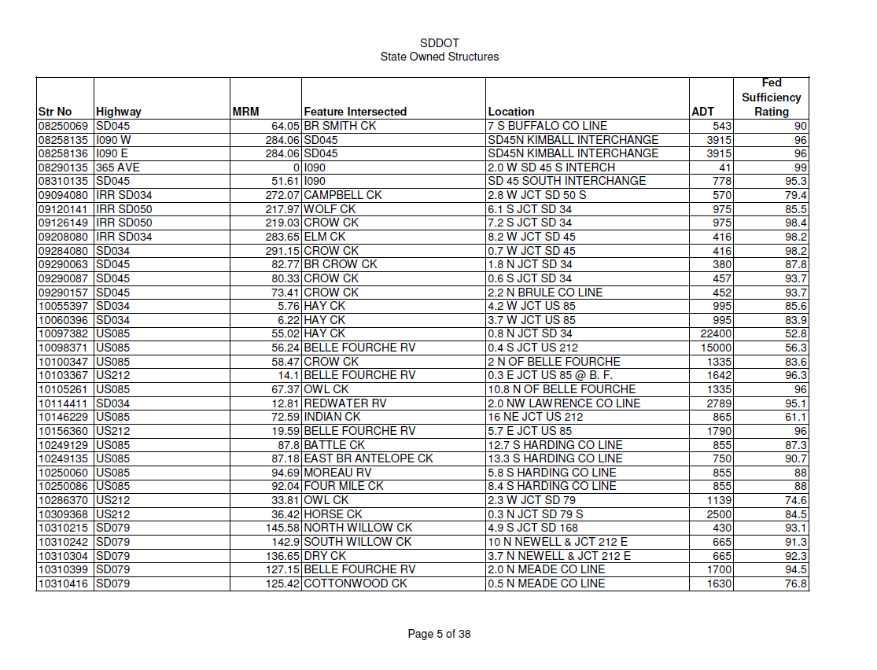
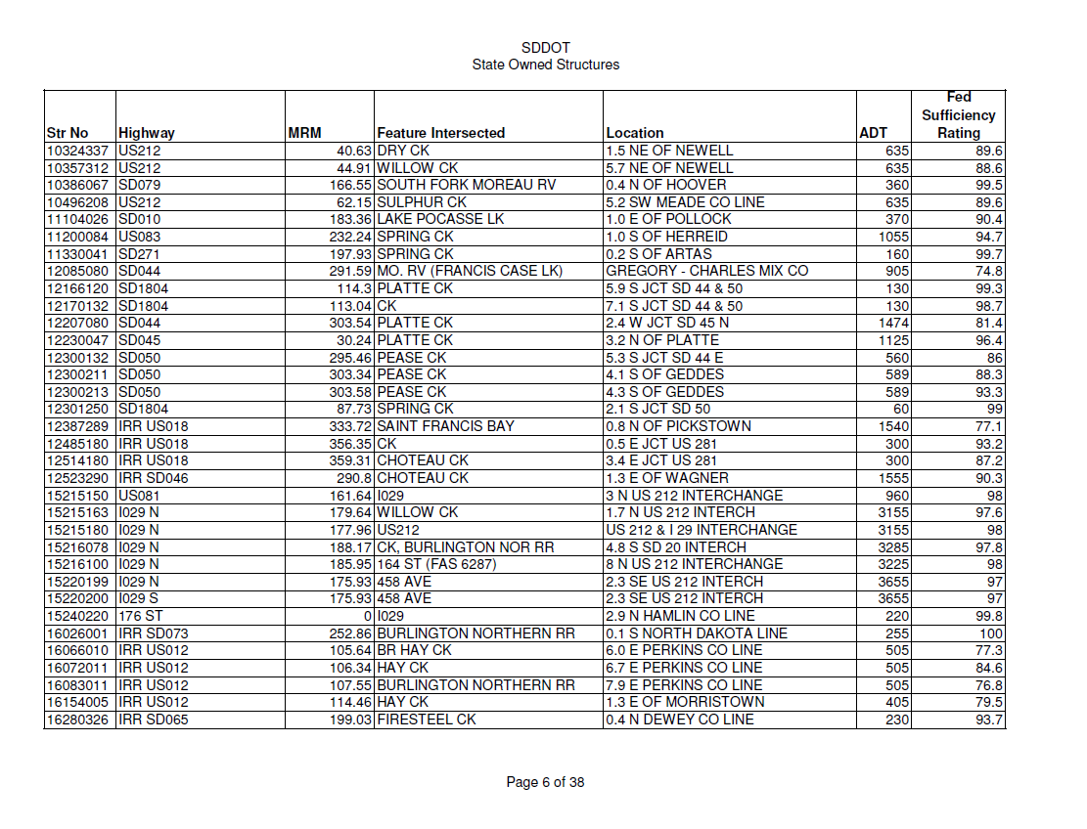
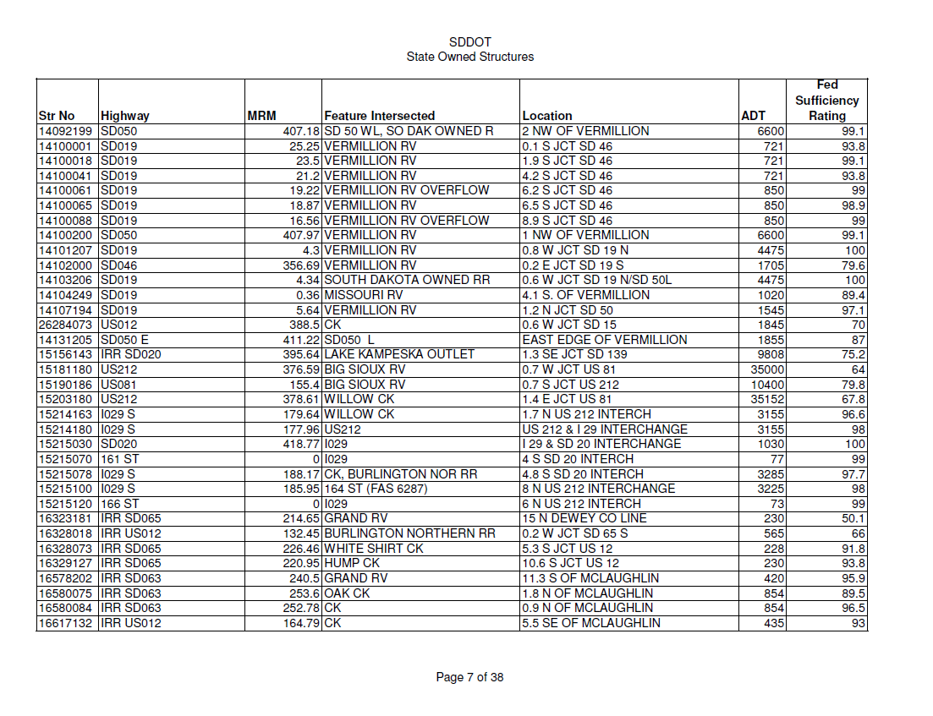
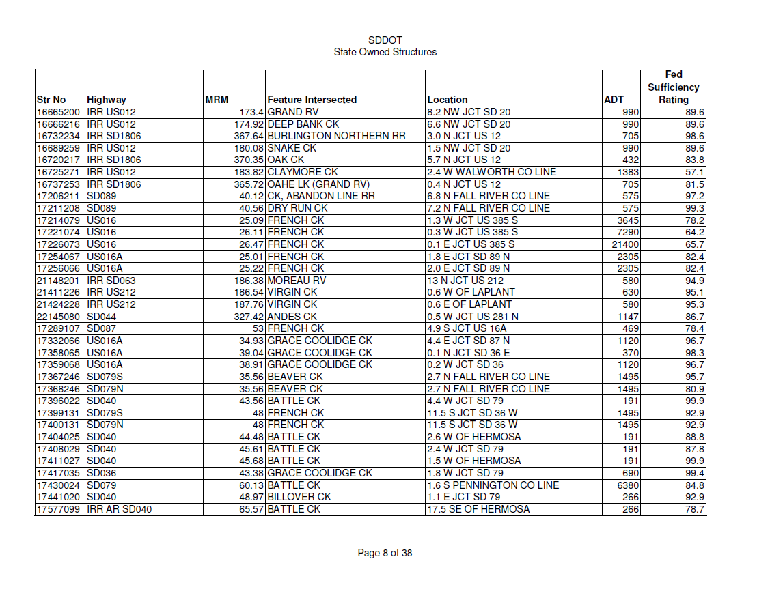
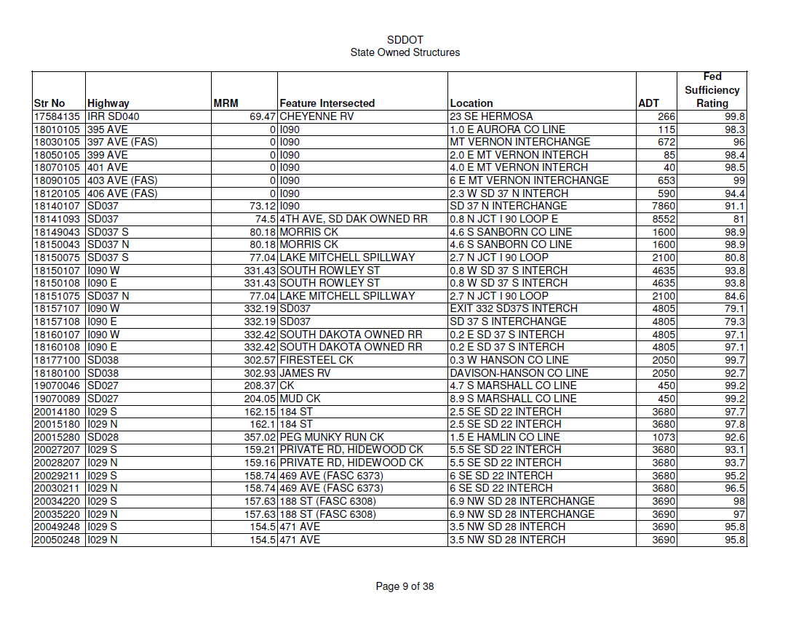
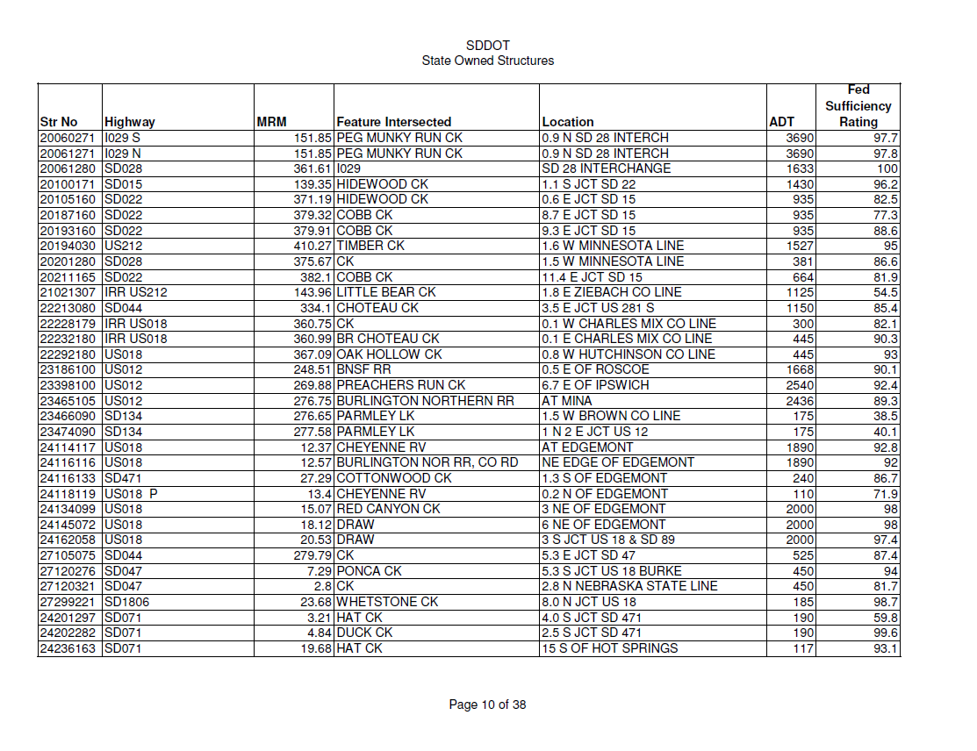
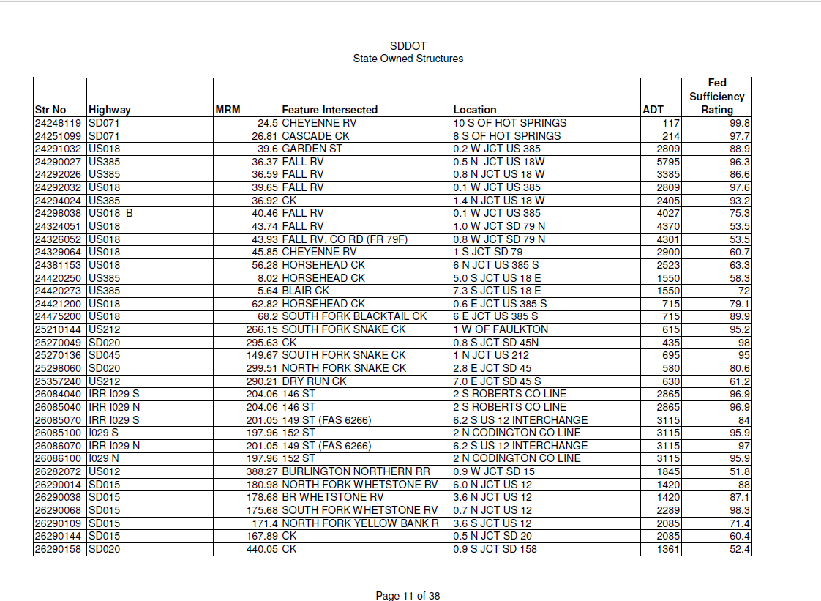
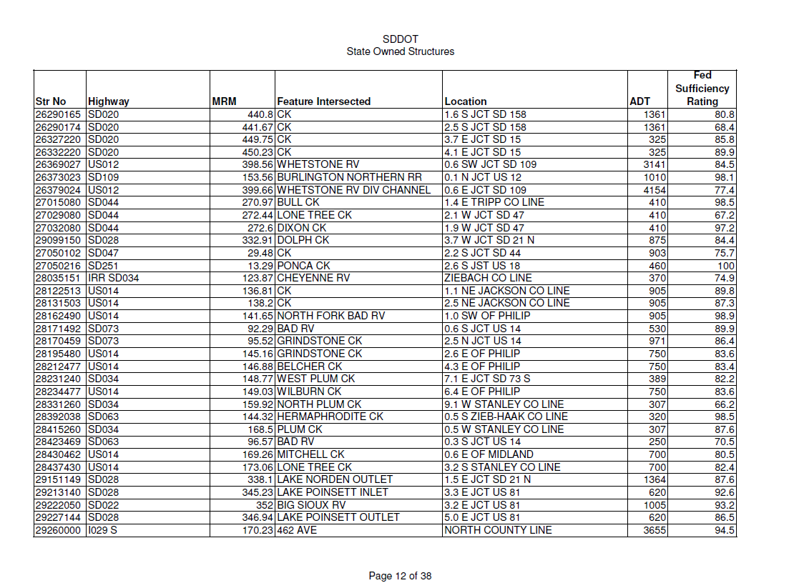
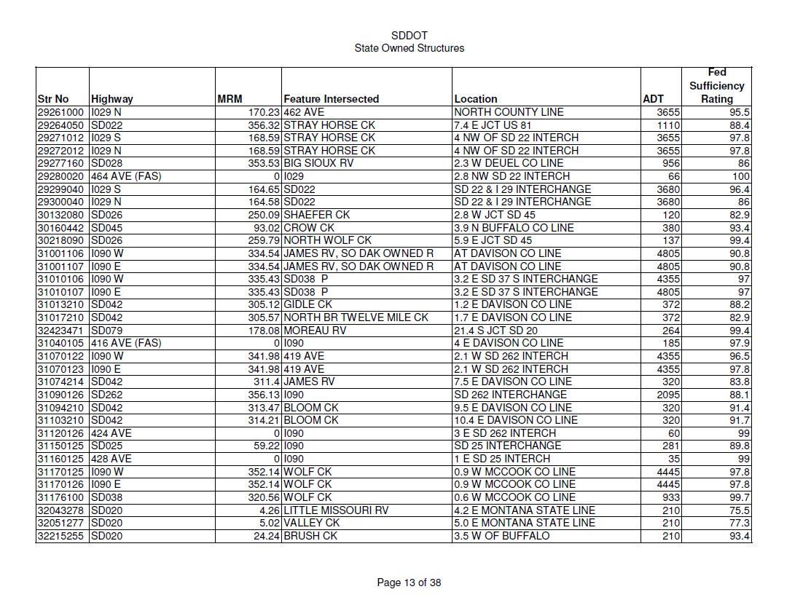
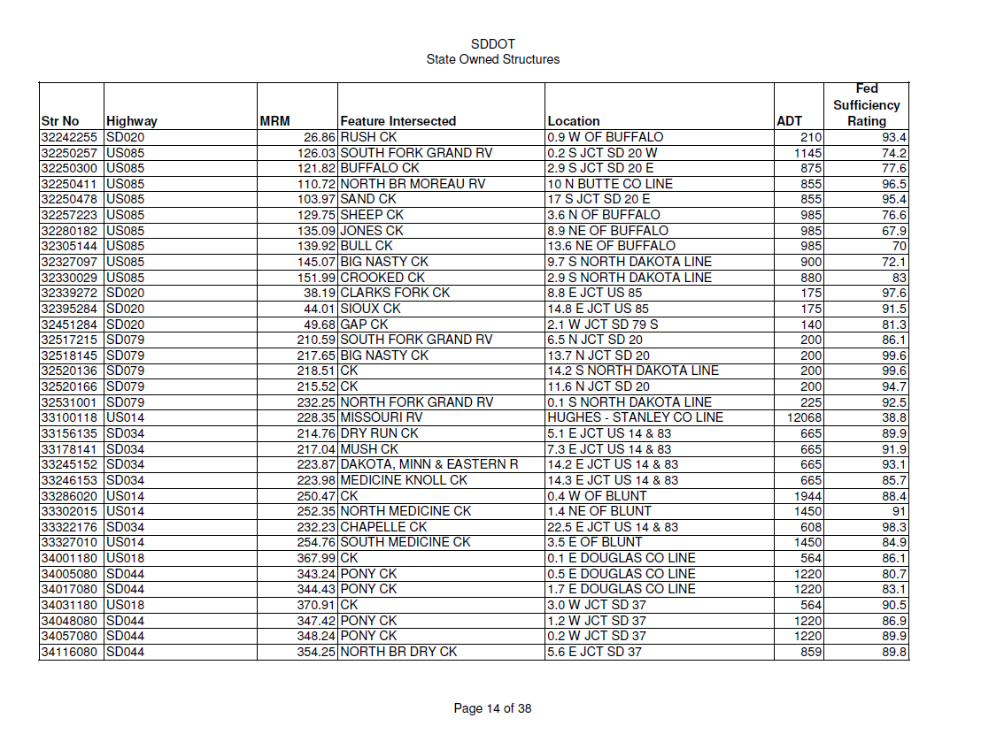
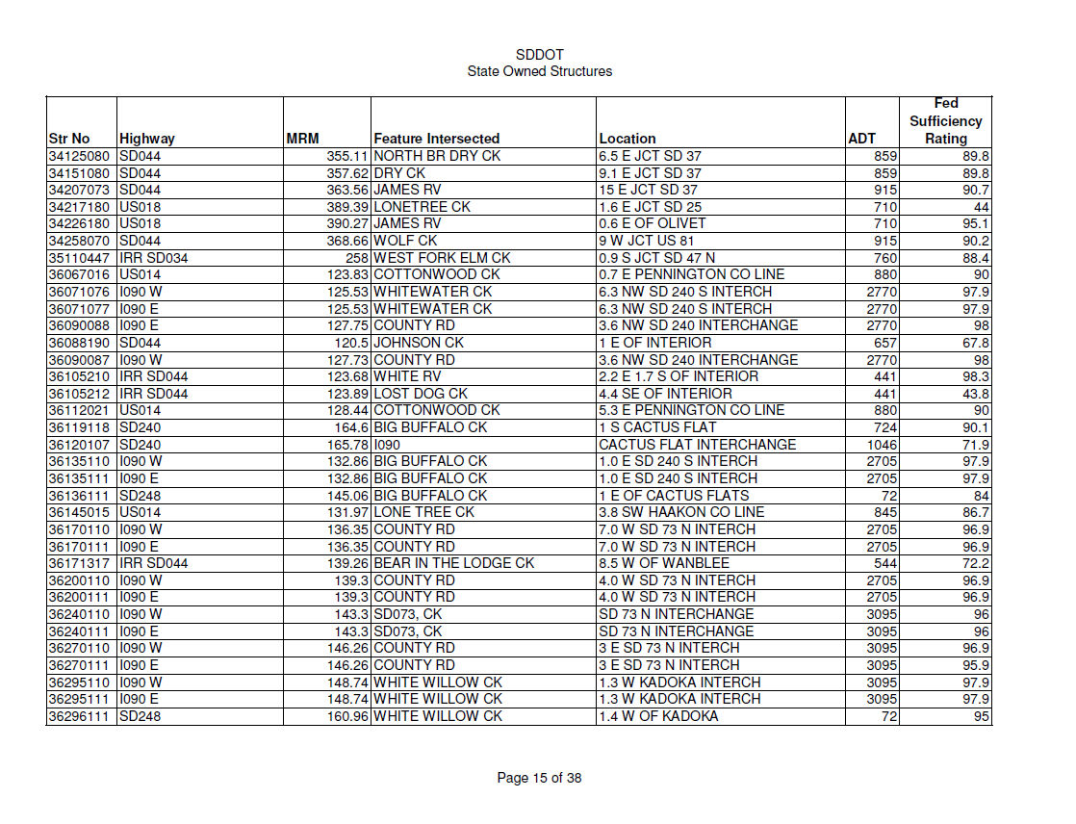
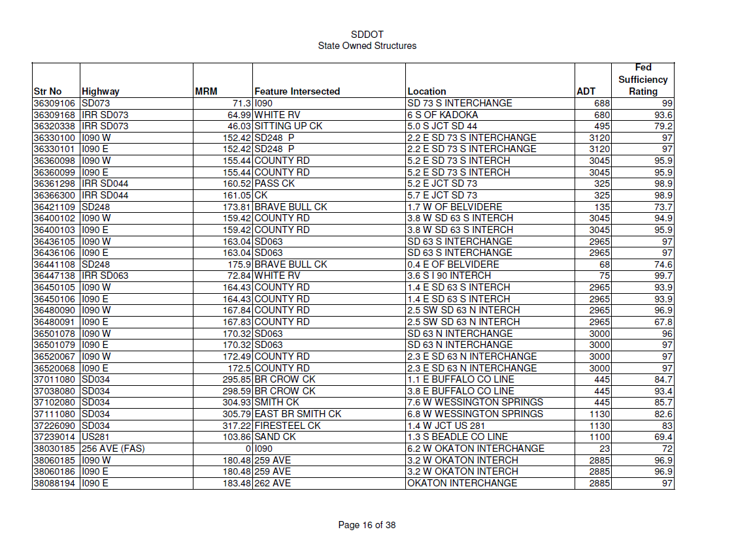
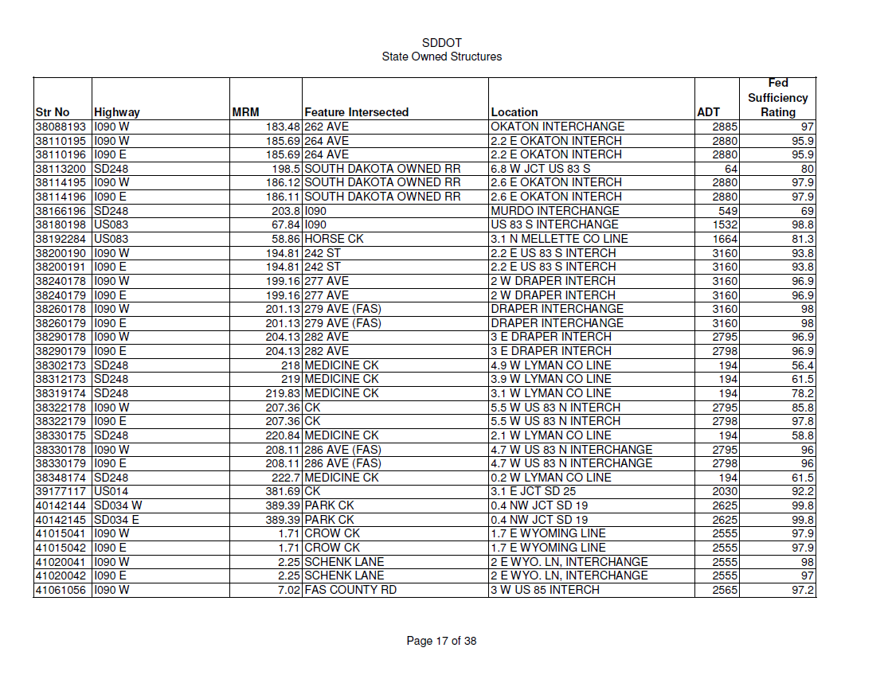
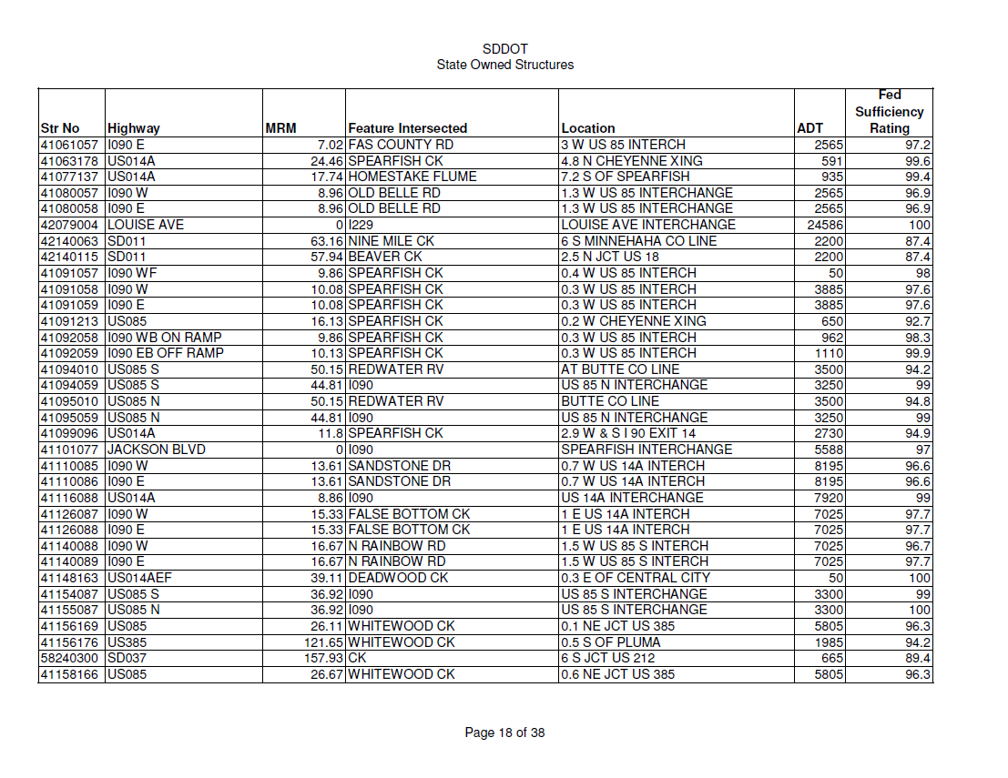
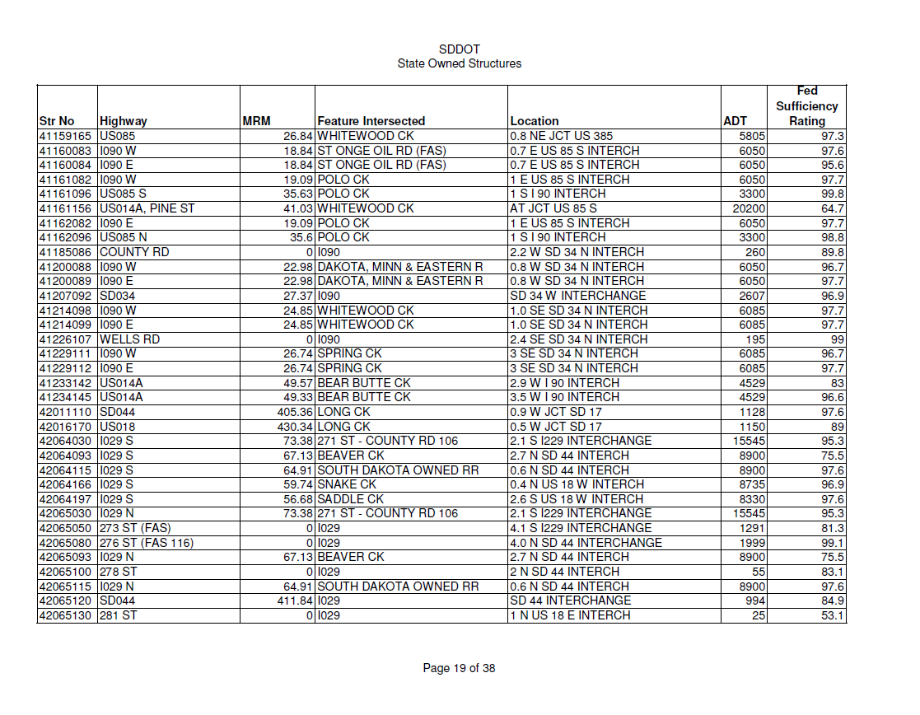
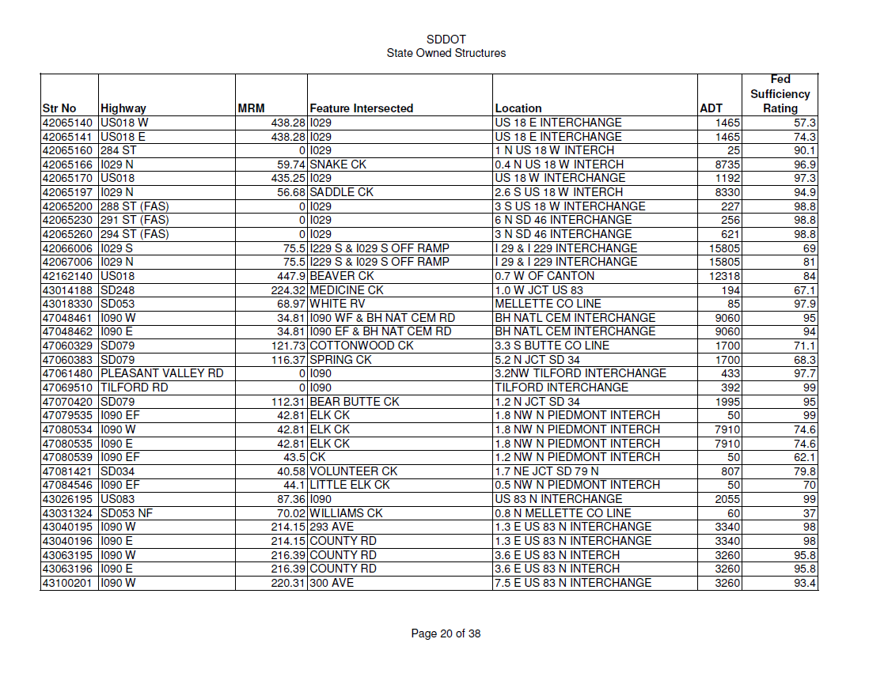
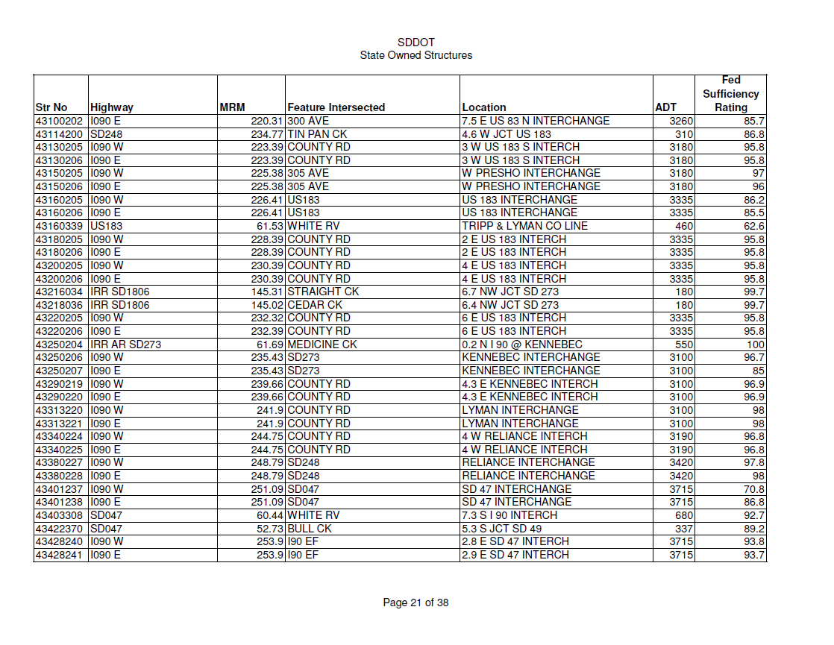
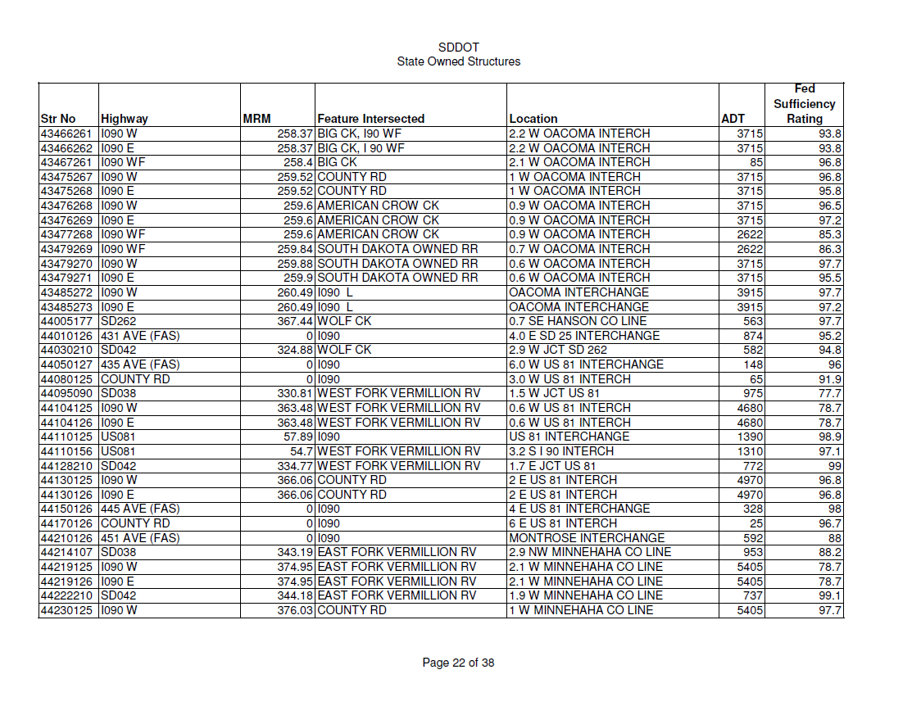
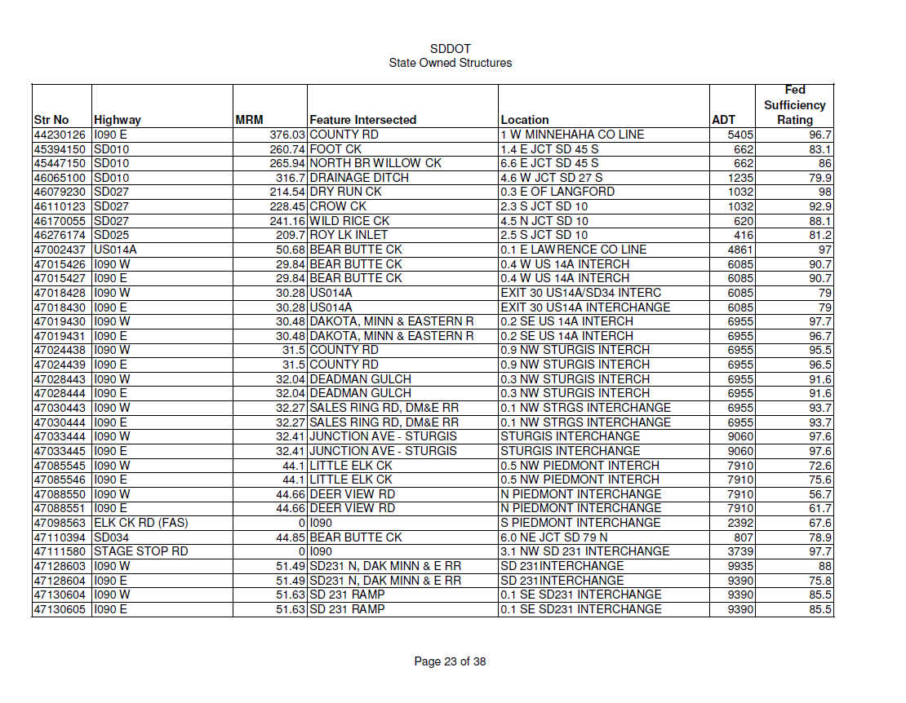
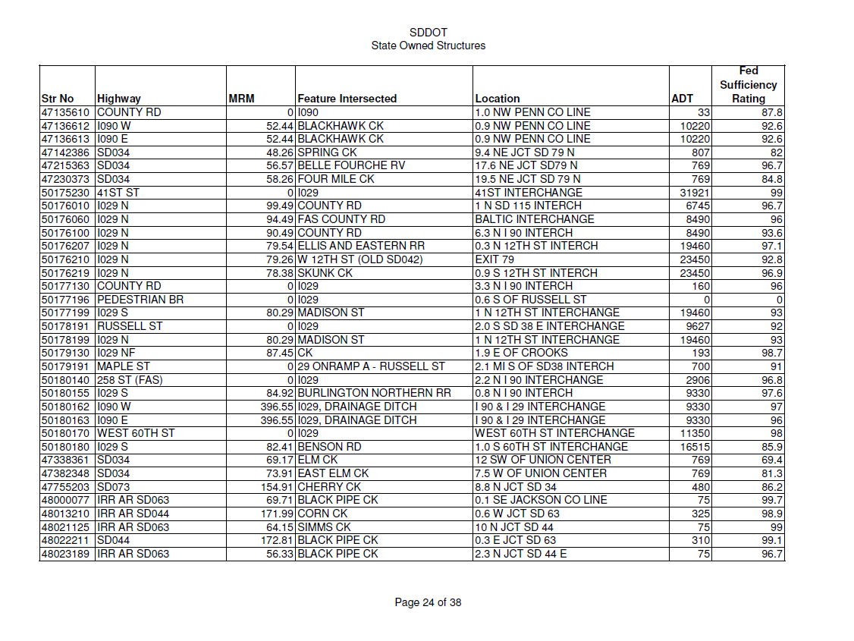
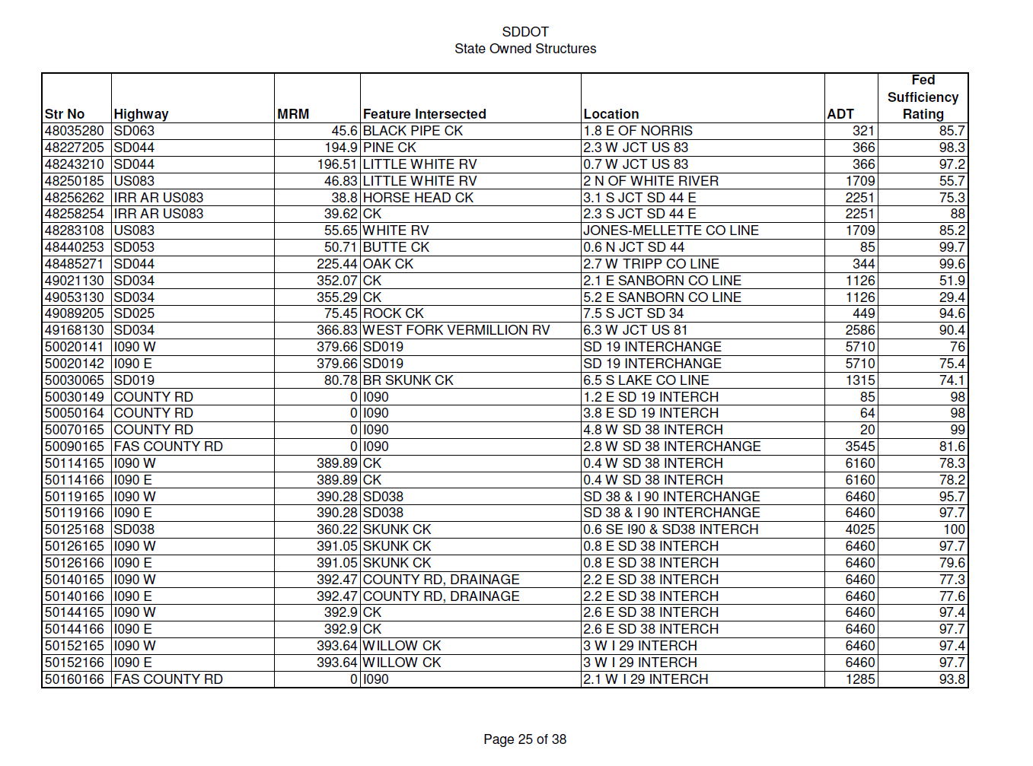
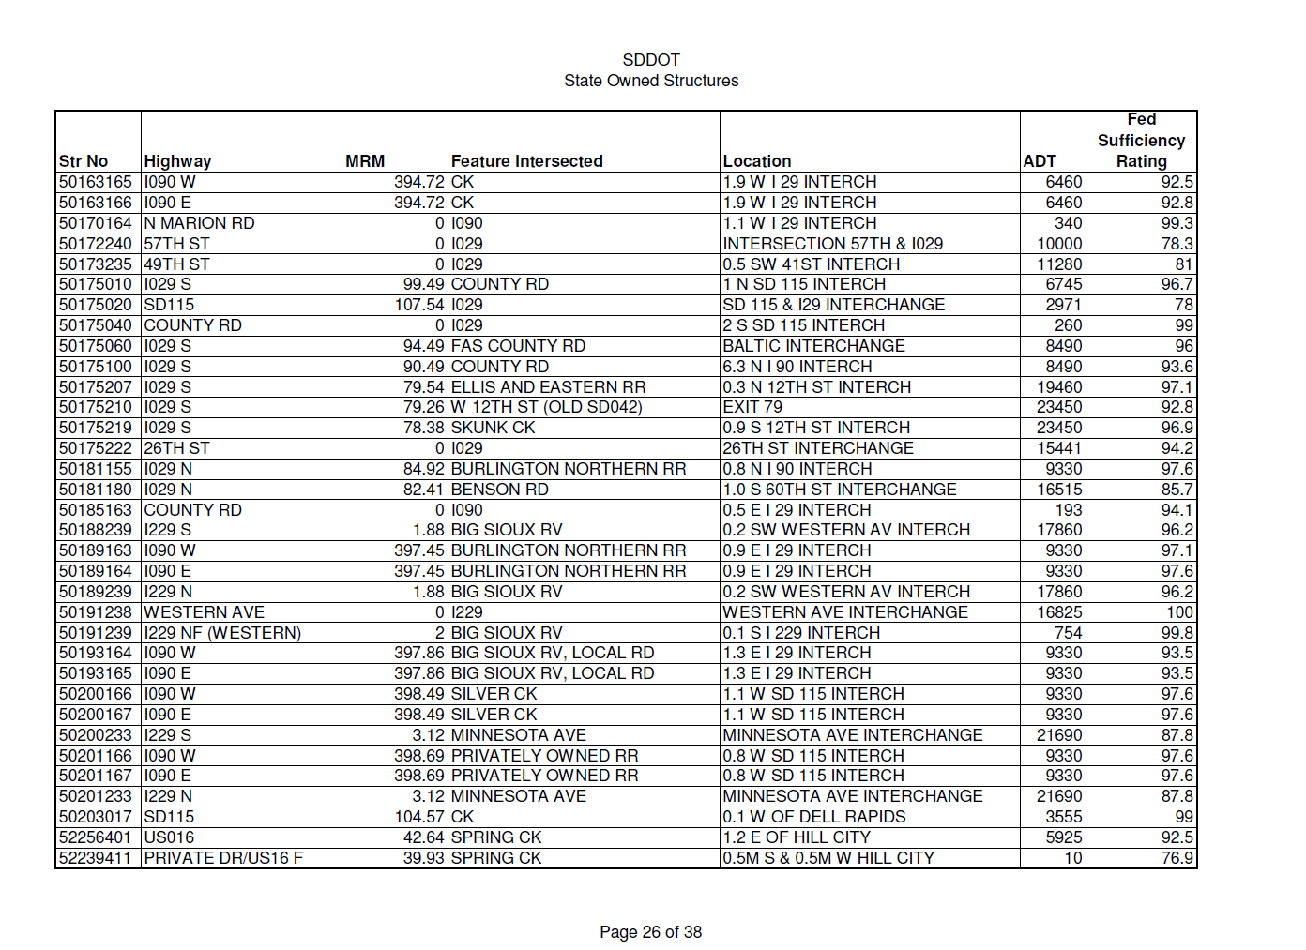
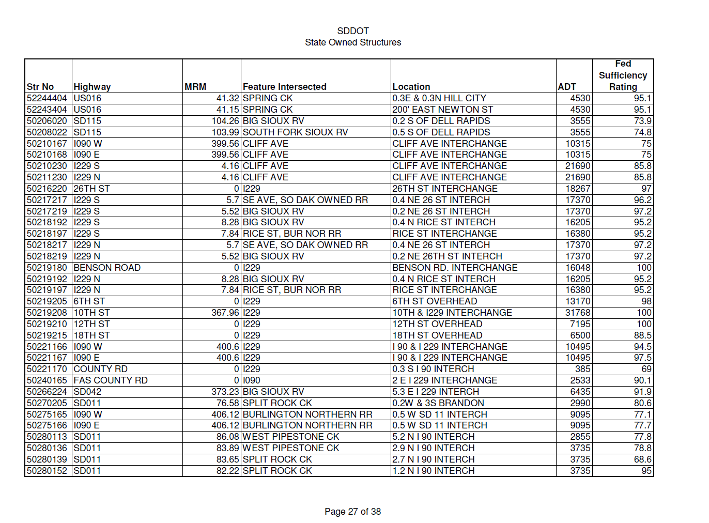

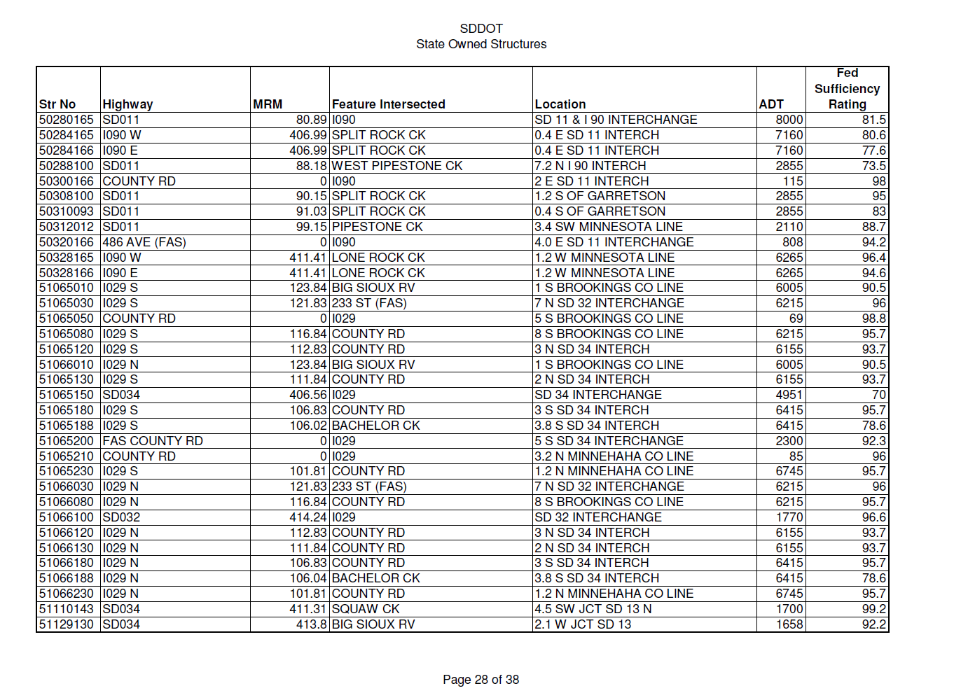

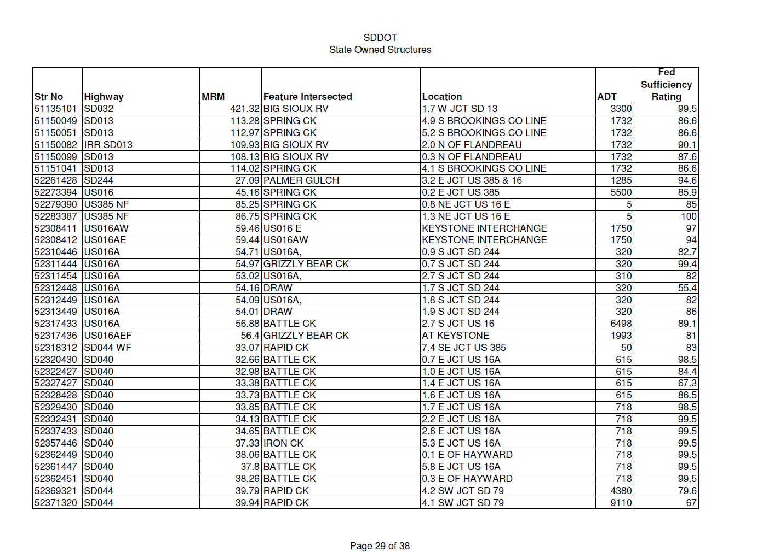
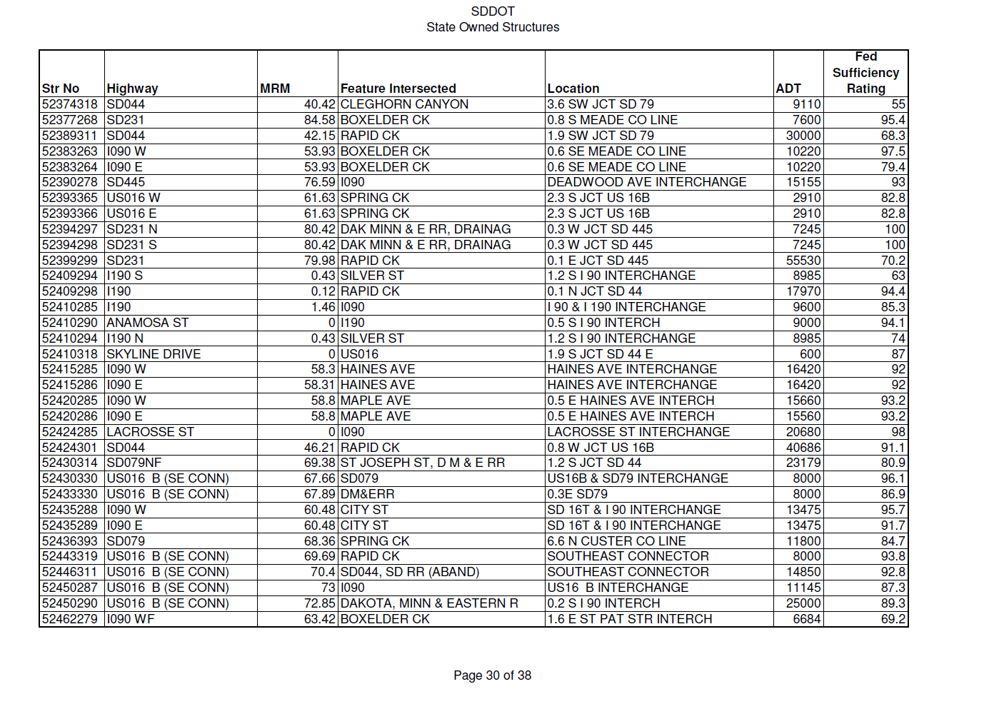
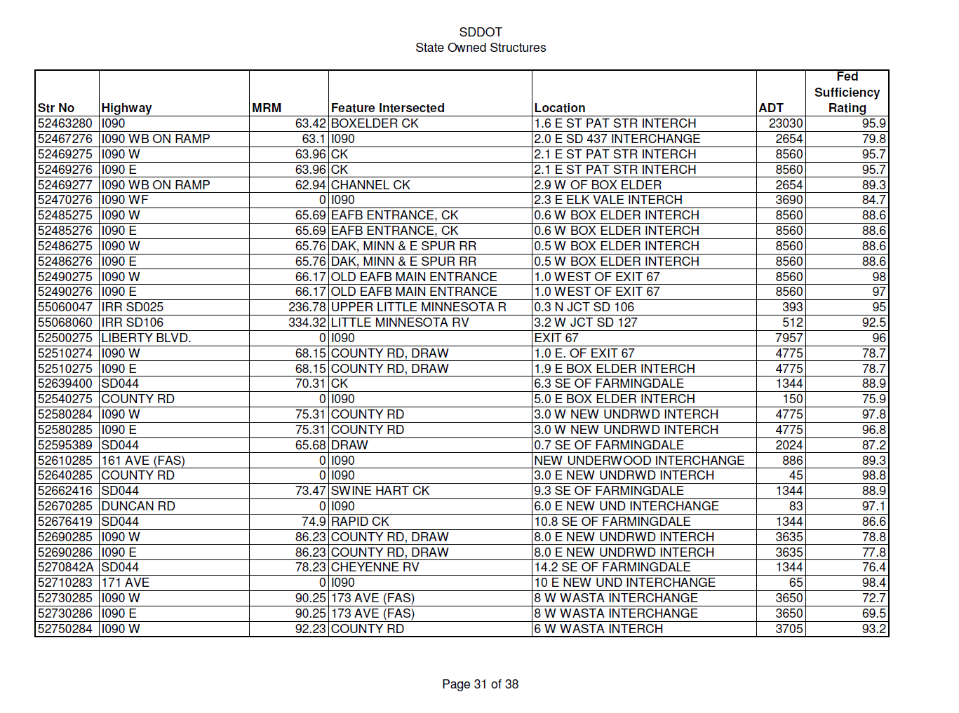
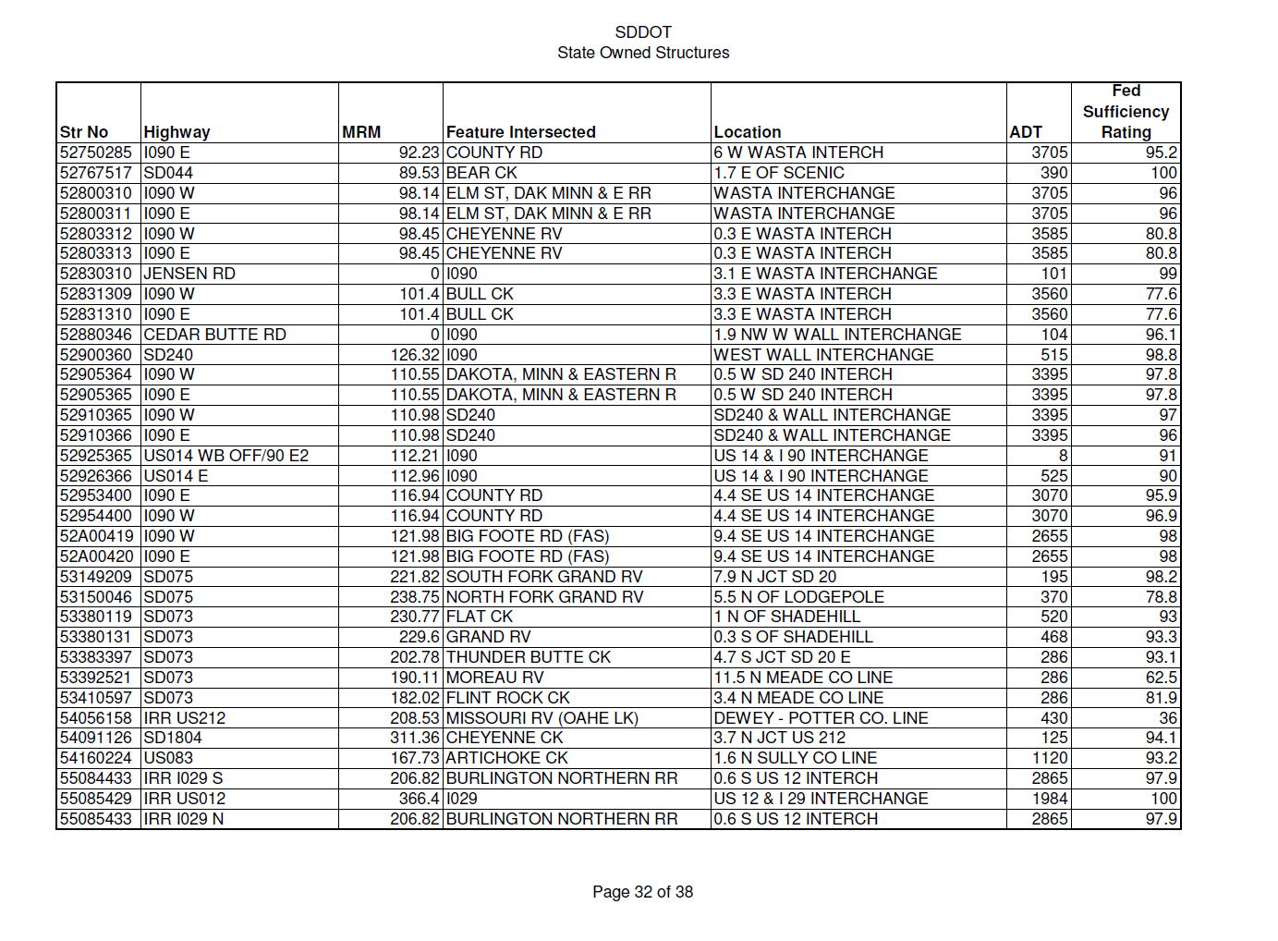

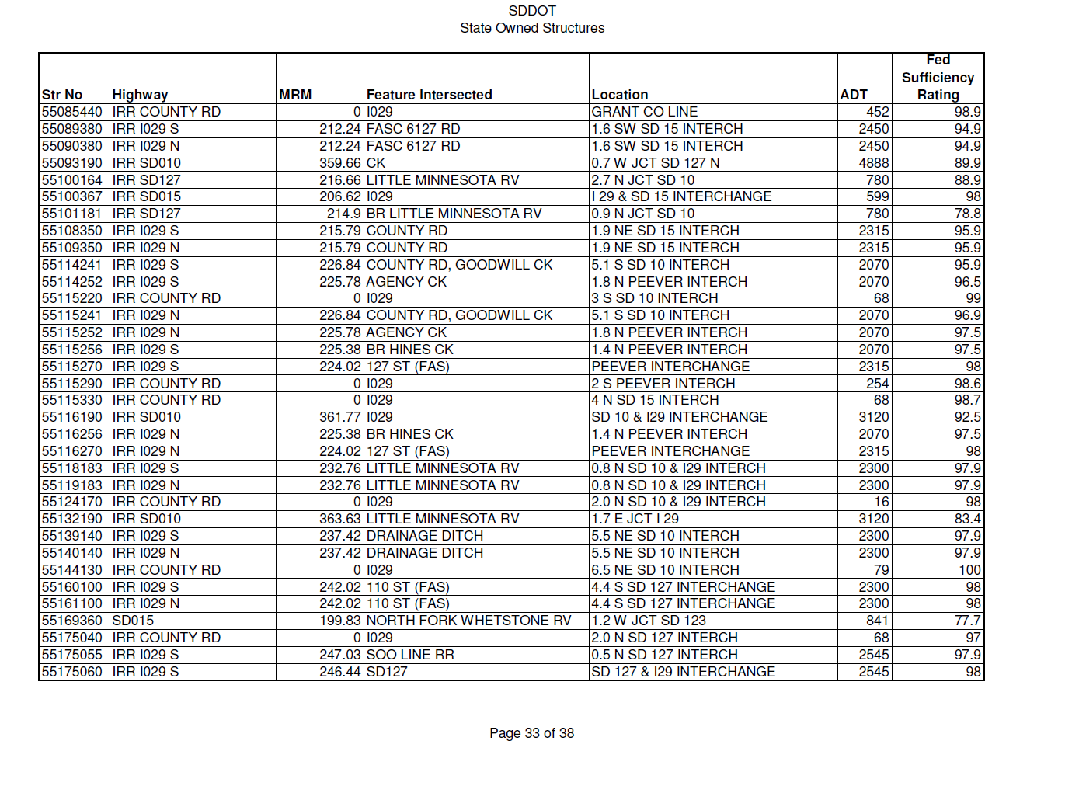
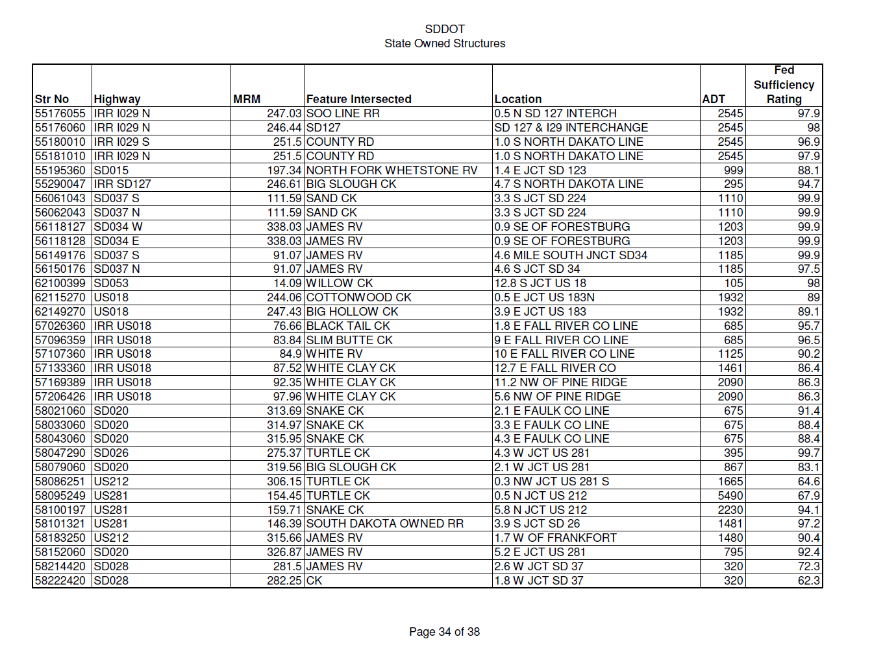

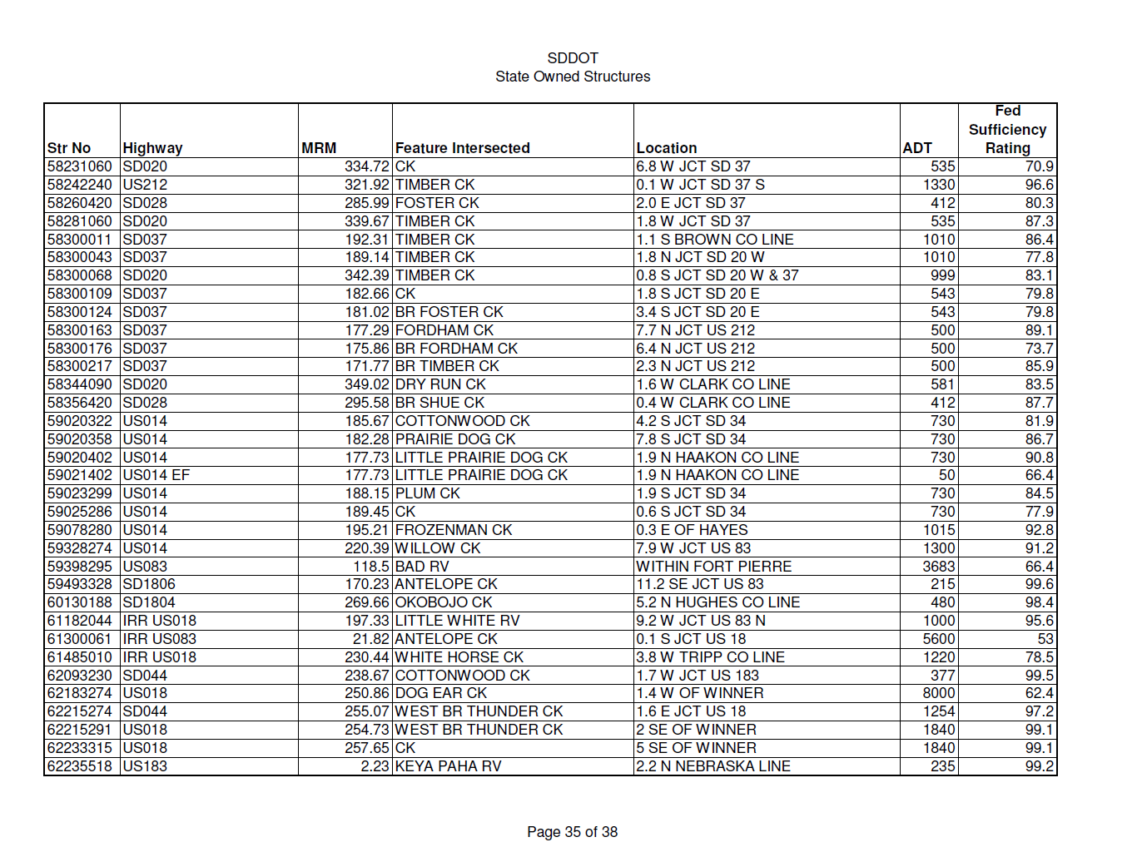
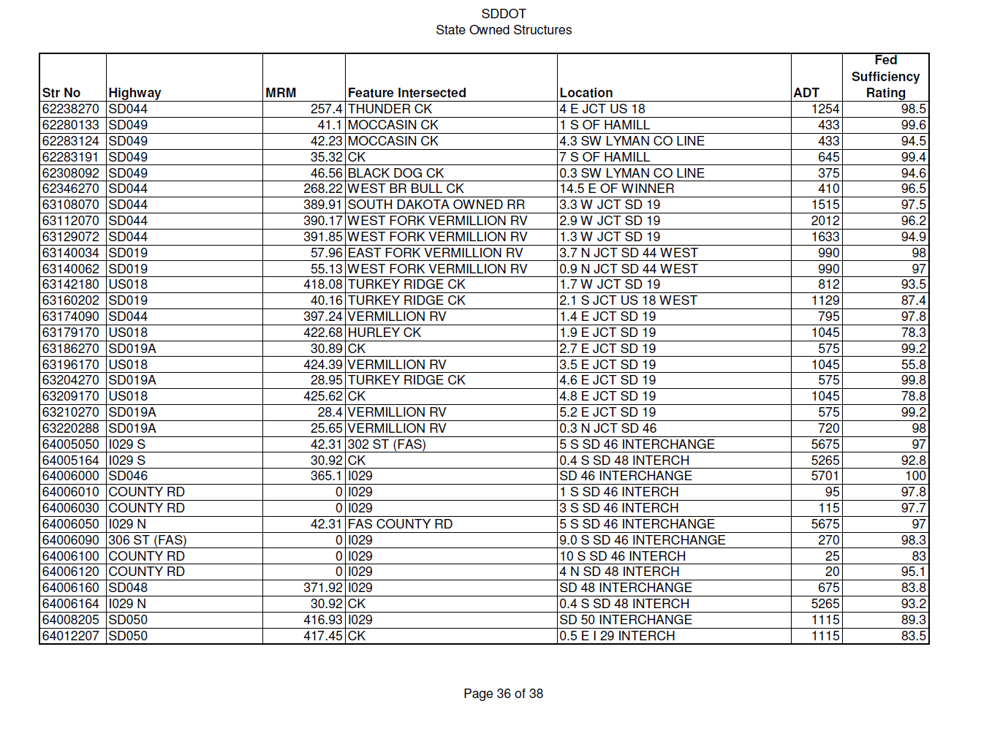
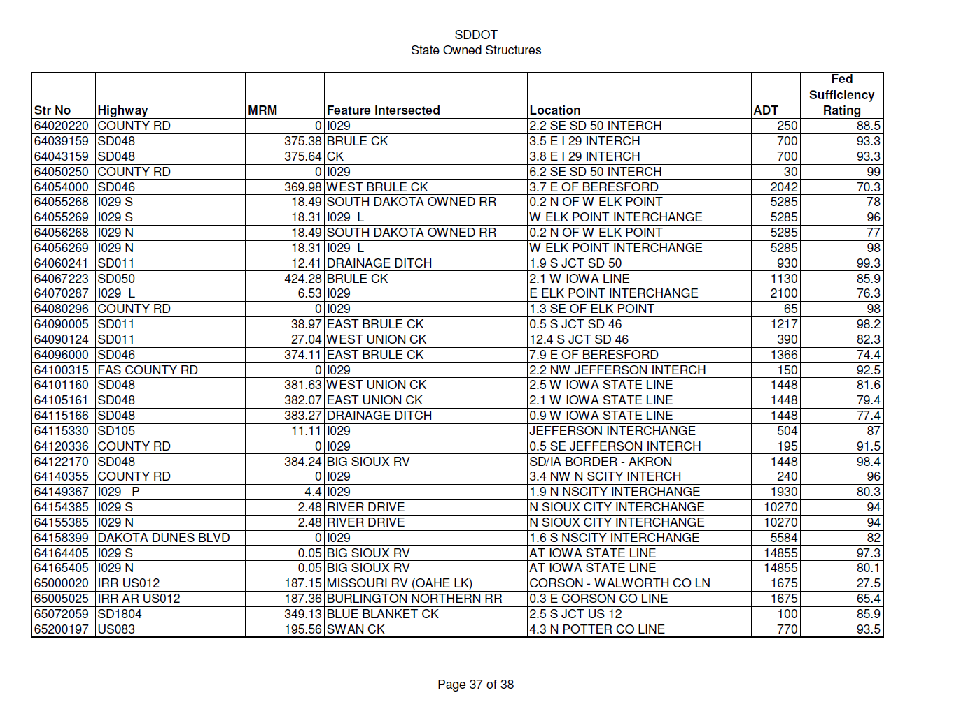
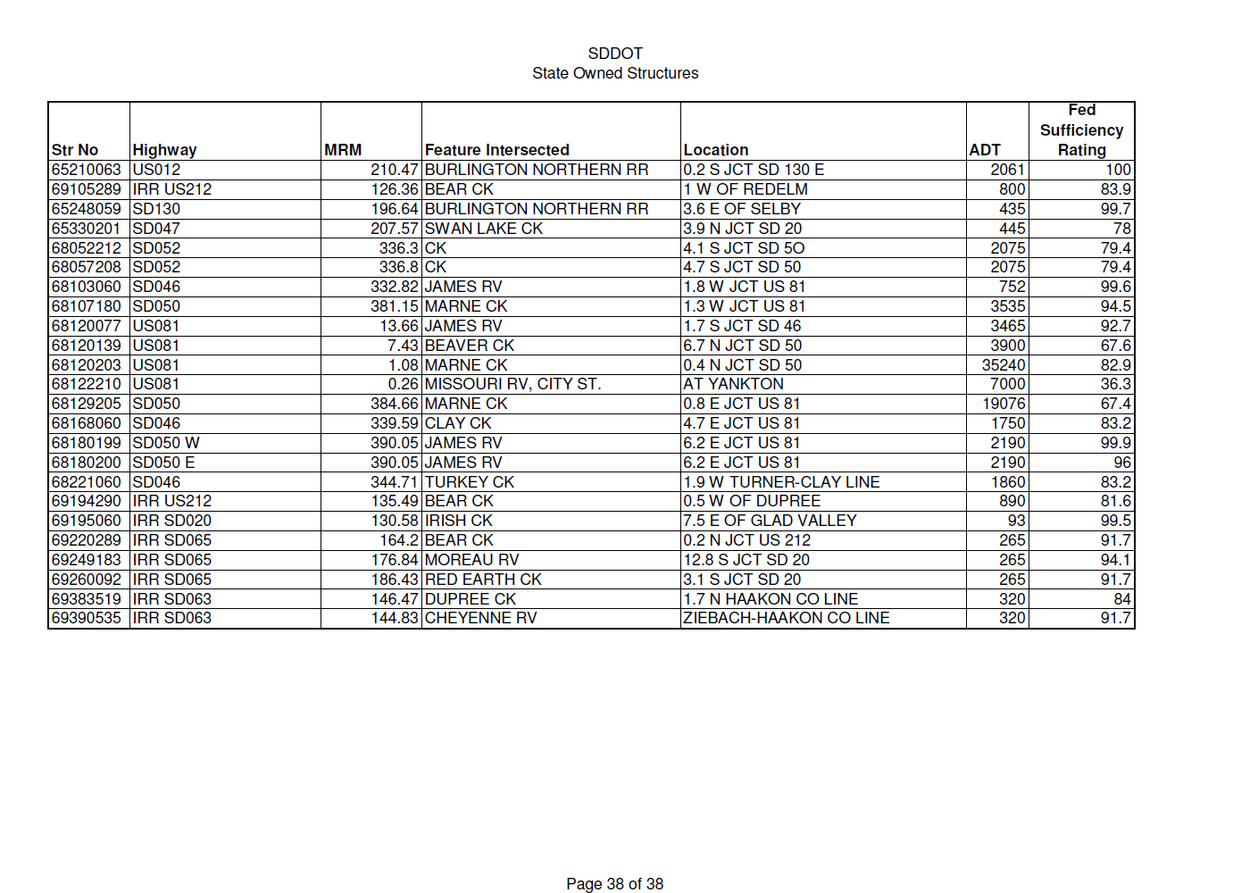

Appendix F –SD Traffic Flow Map

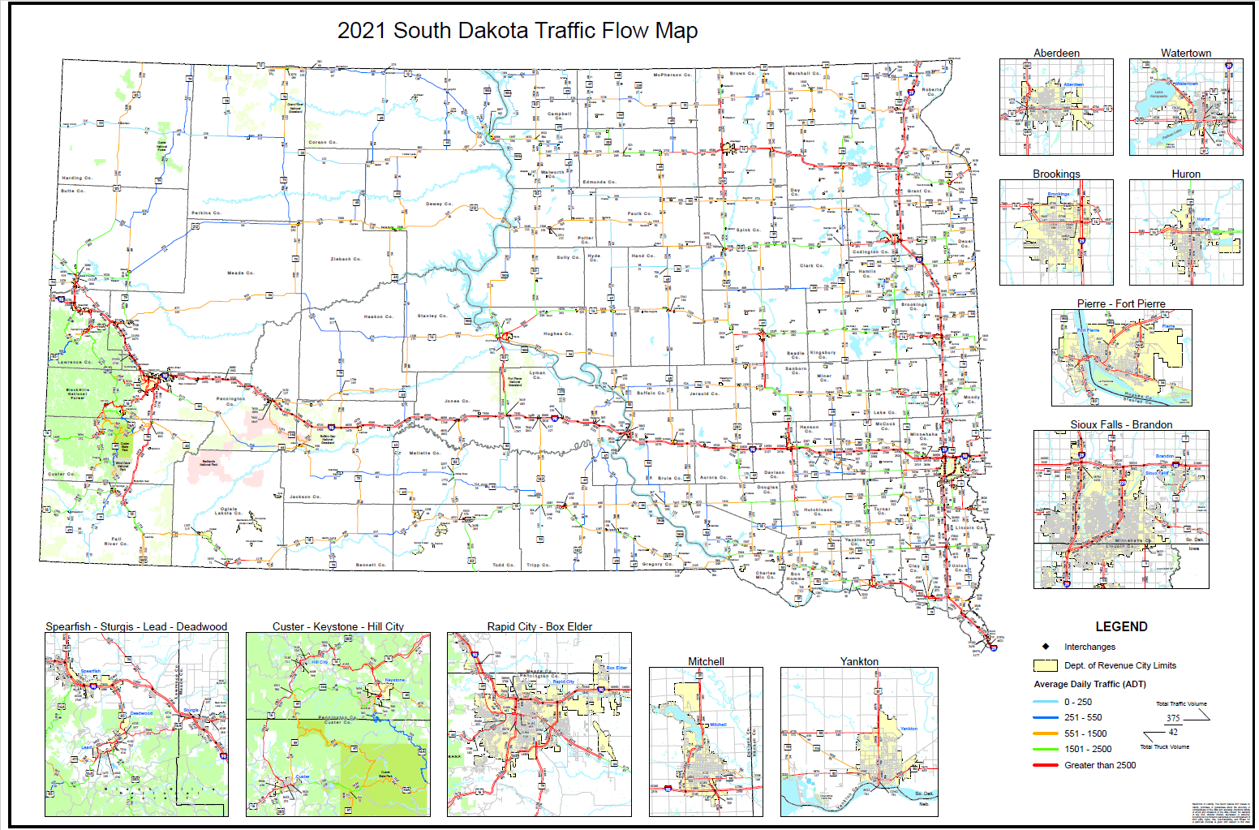

Appendix G – SD PUC Amended Order Designating Affected Area and Designating LRC
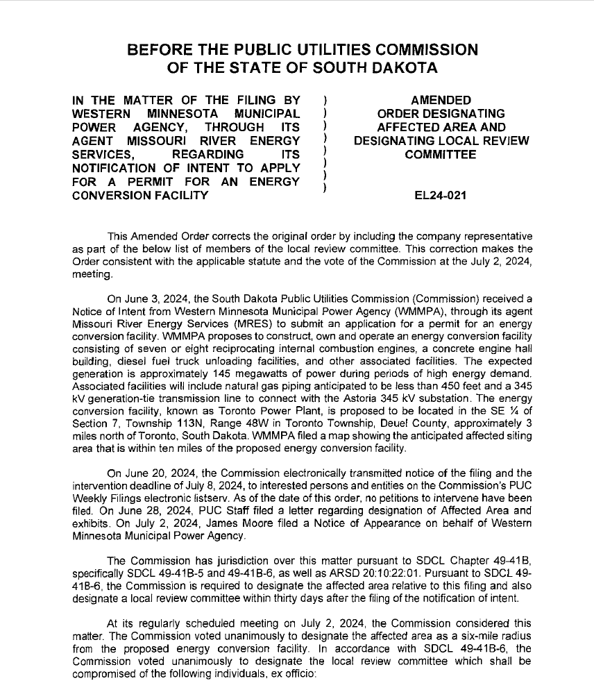

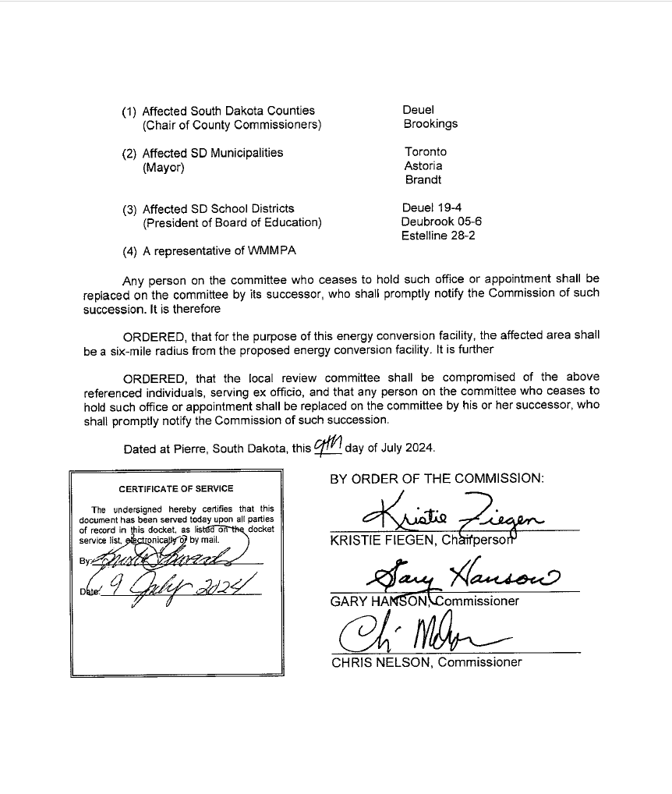
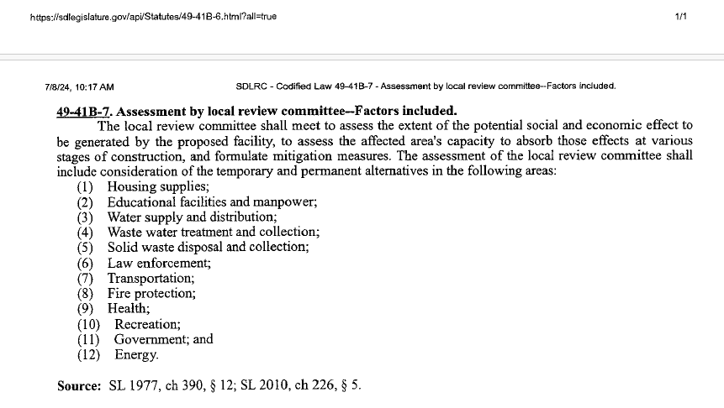
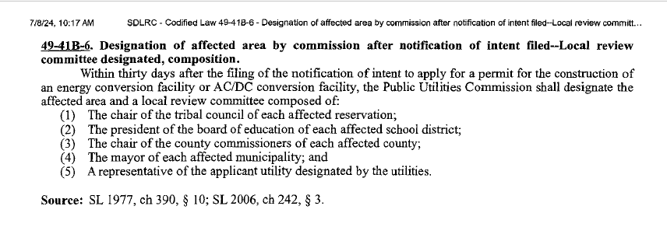

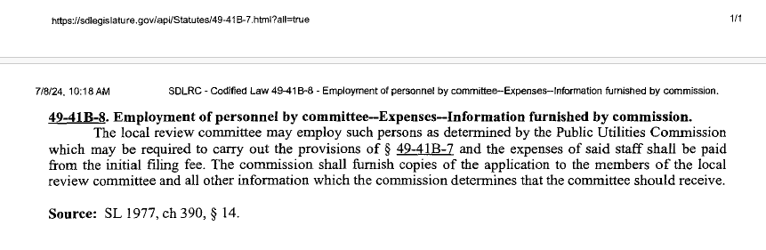
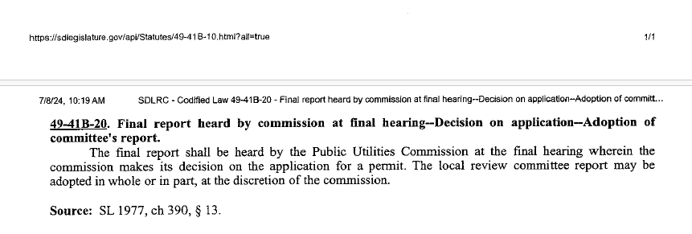
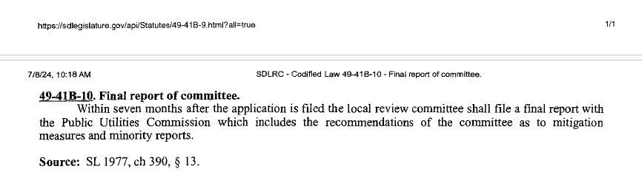
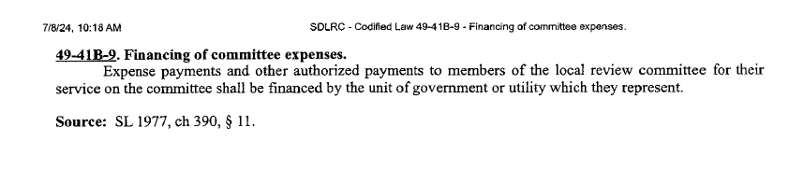
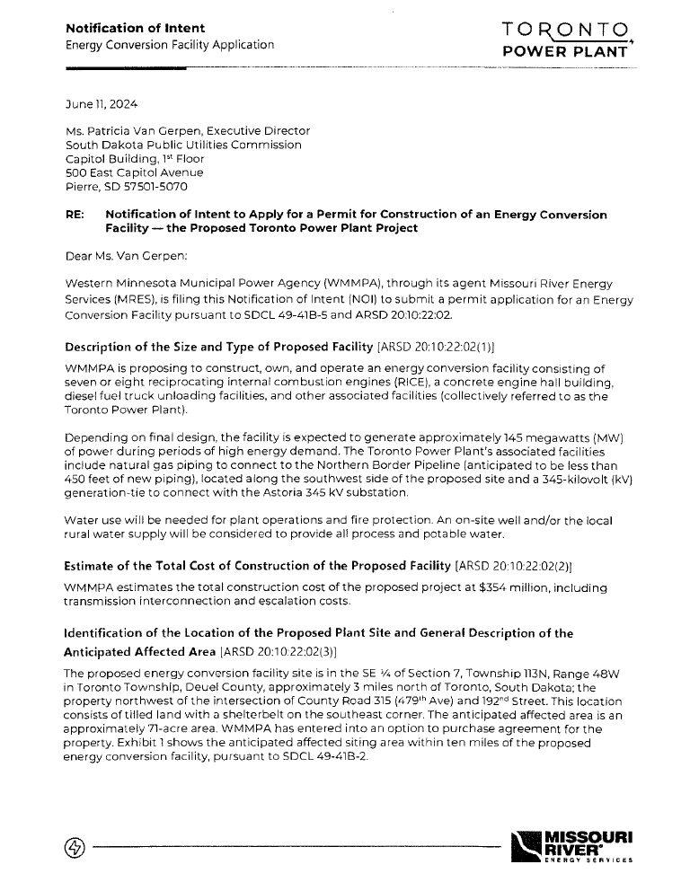

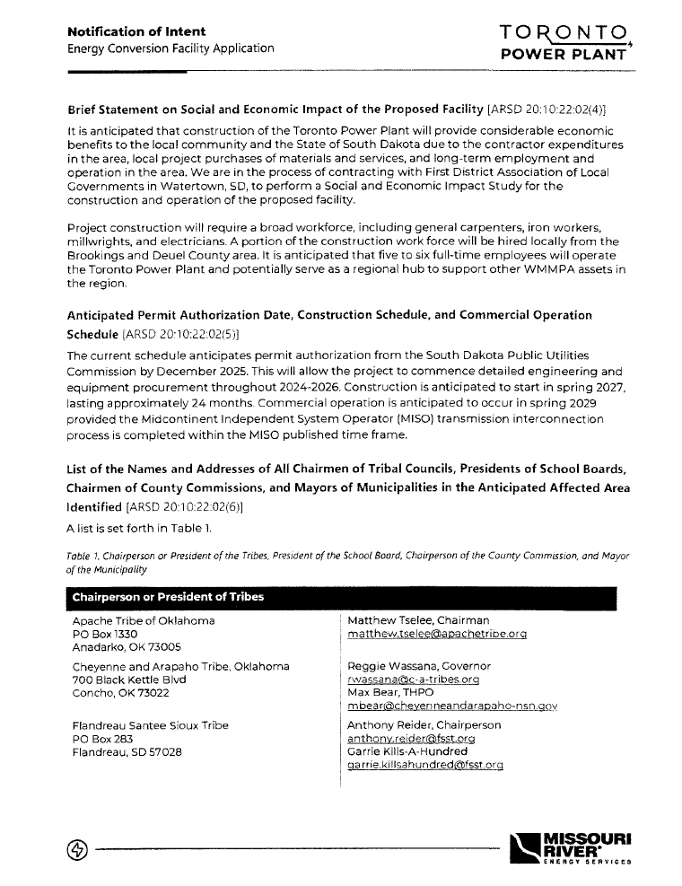
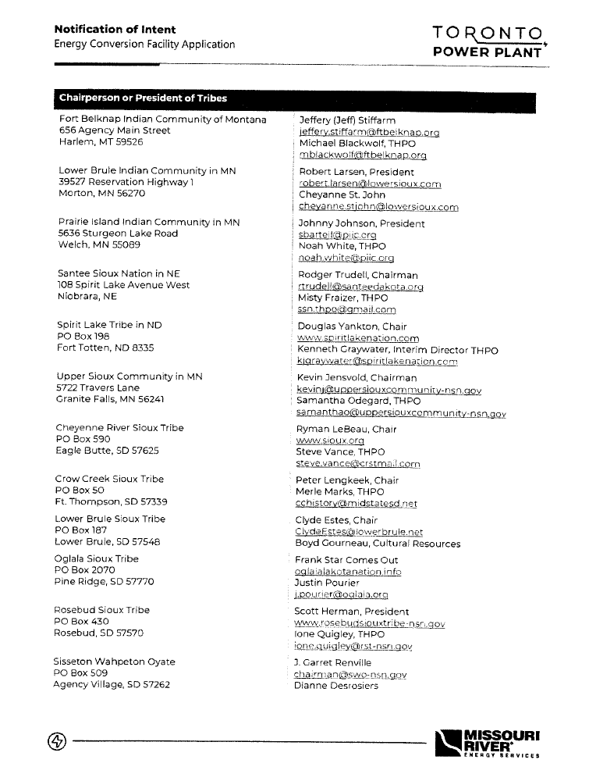
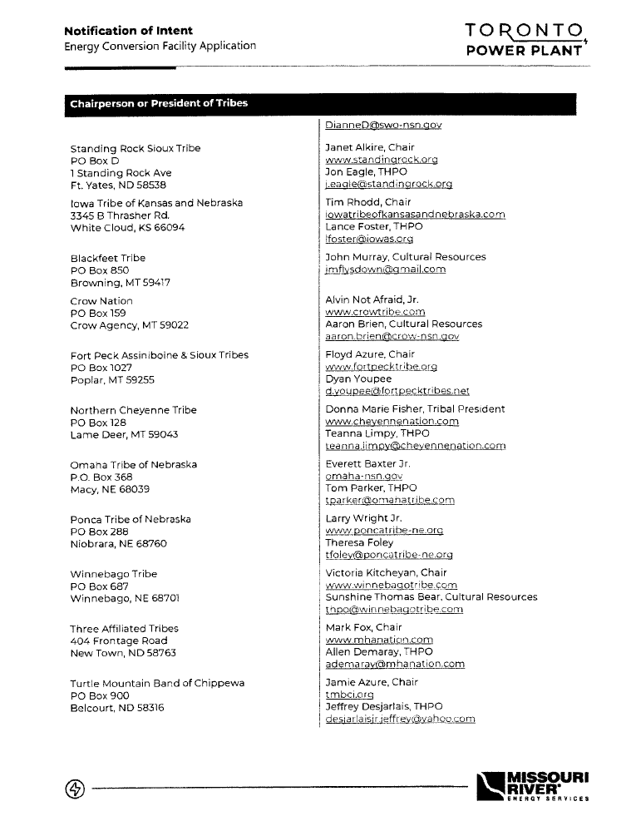

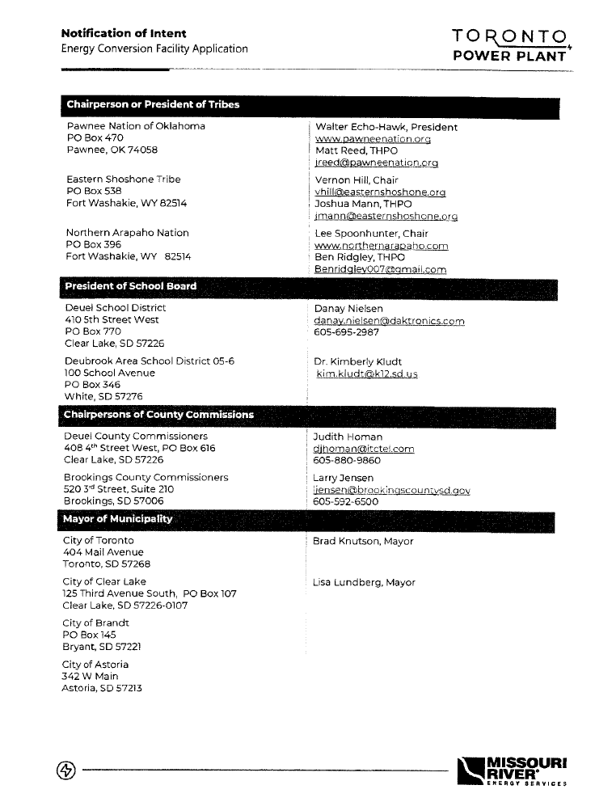

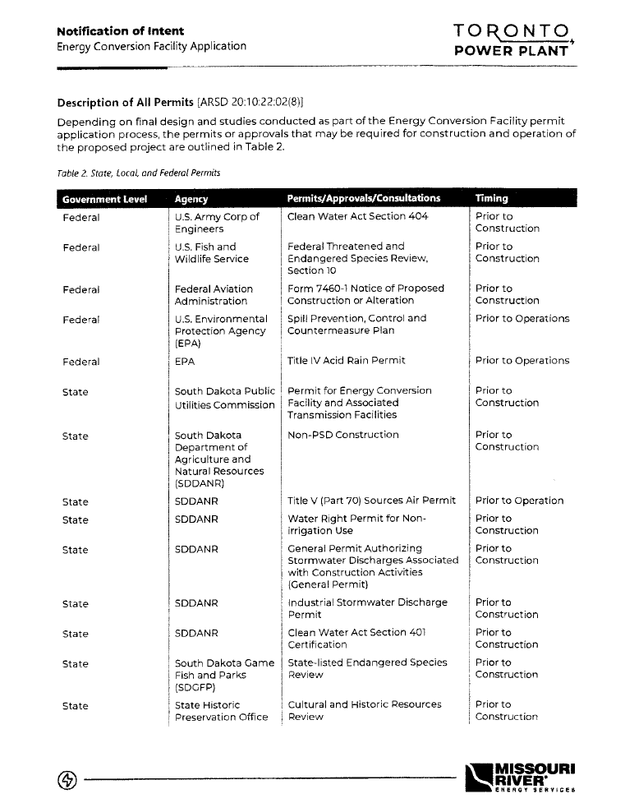

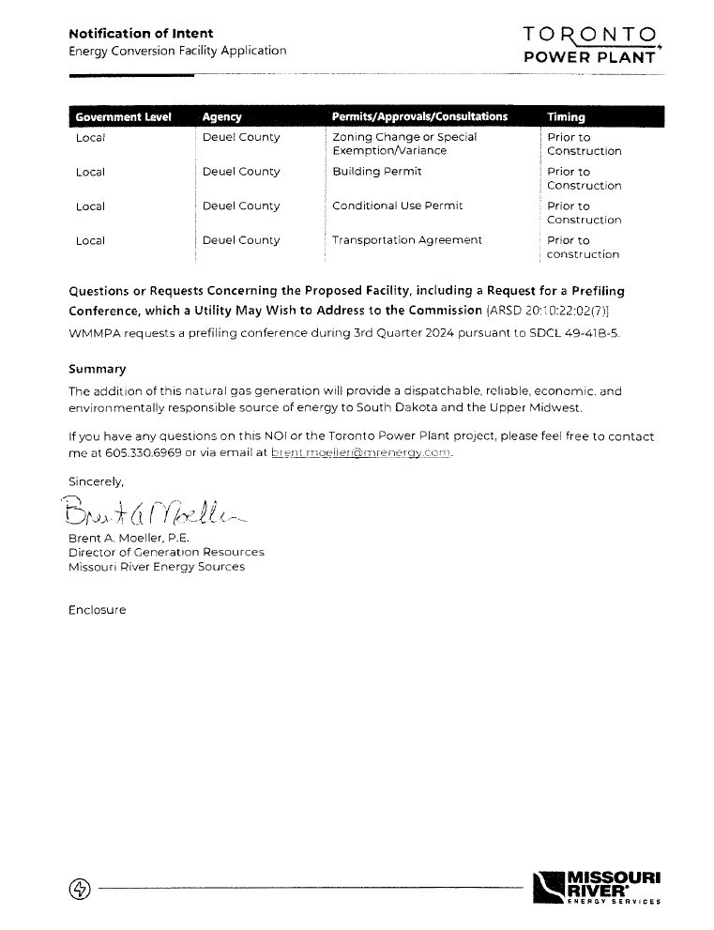

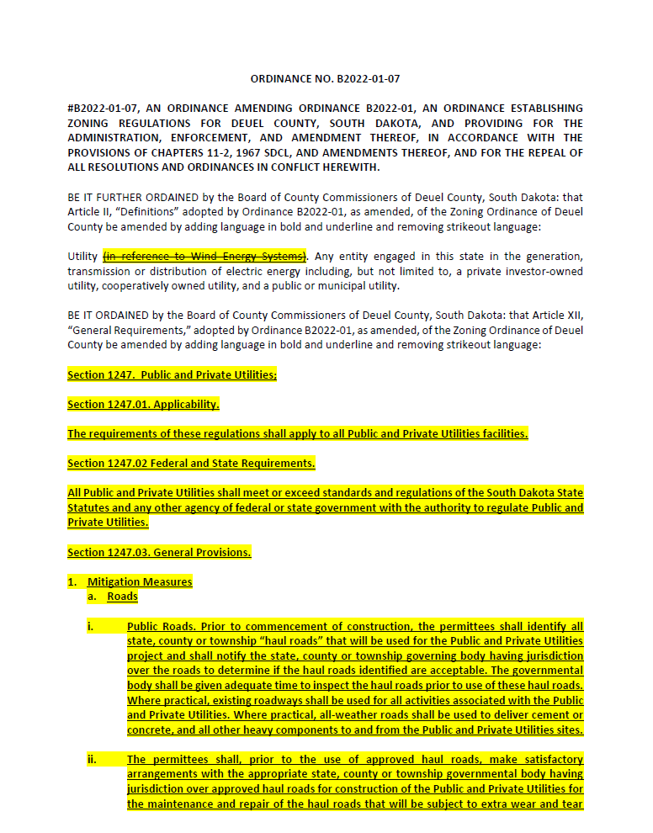
Appendix H – Deuel County Noise Ordinance

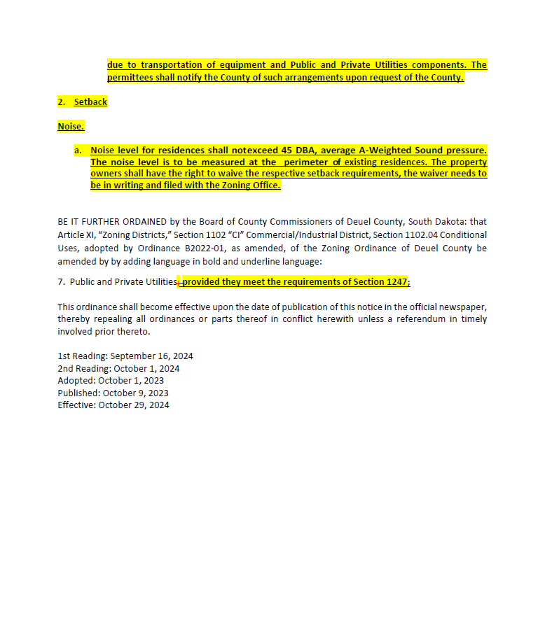

Appendix I – US Energy Information Administration – Annual Energy Outlook 2017
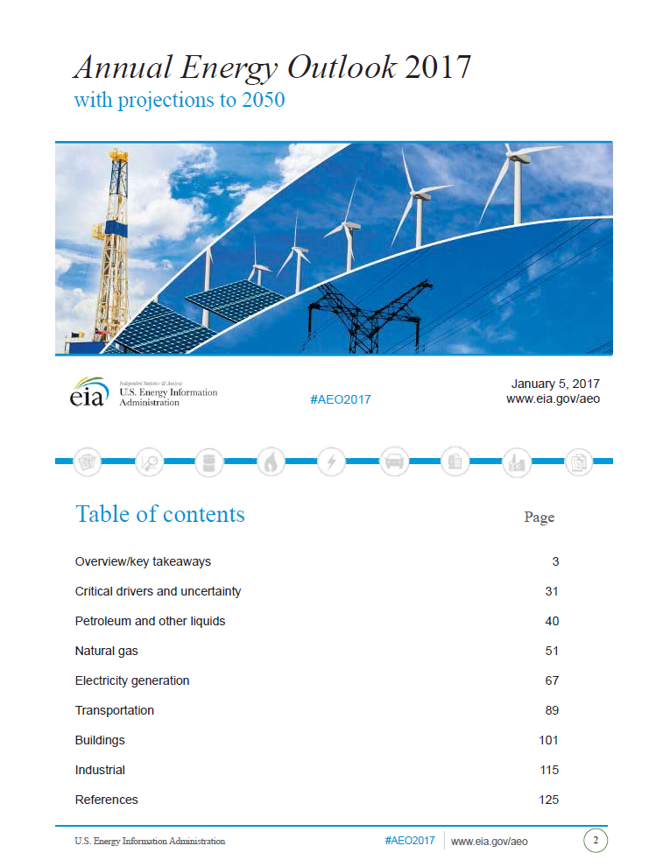

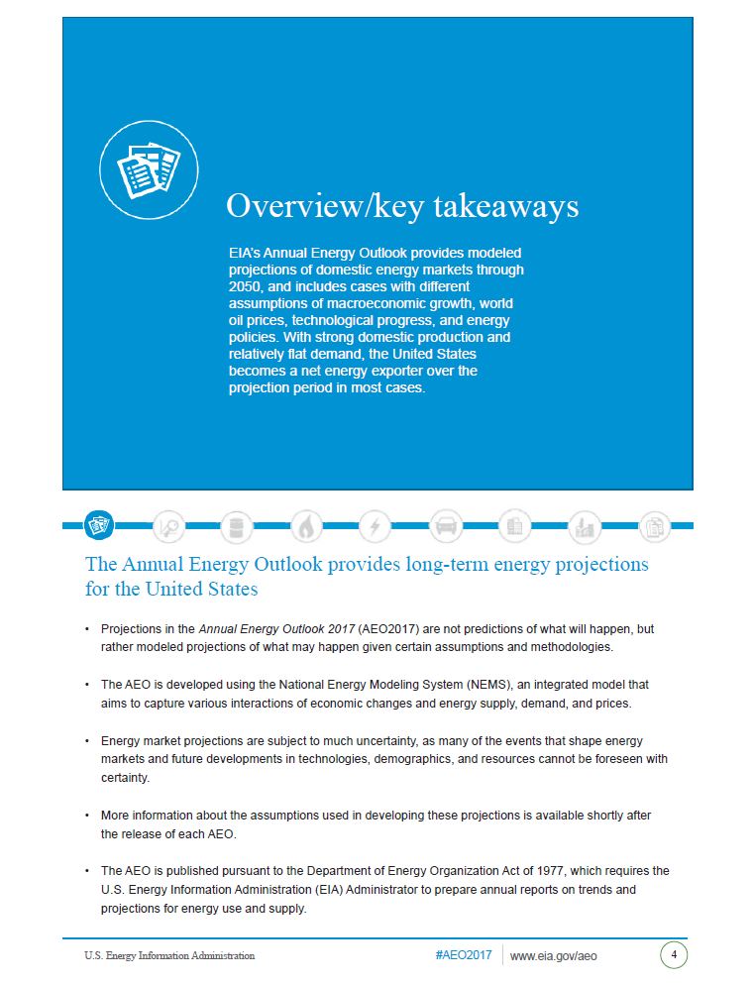

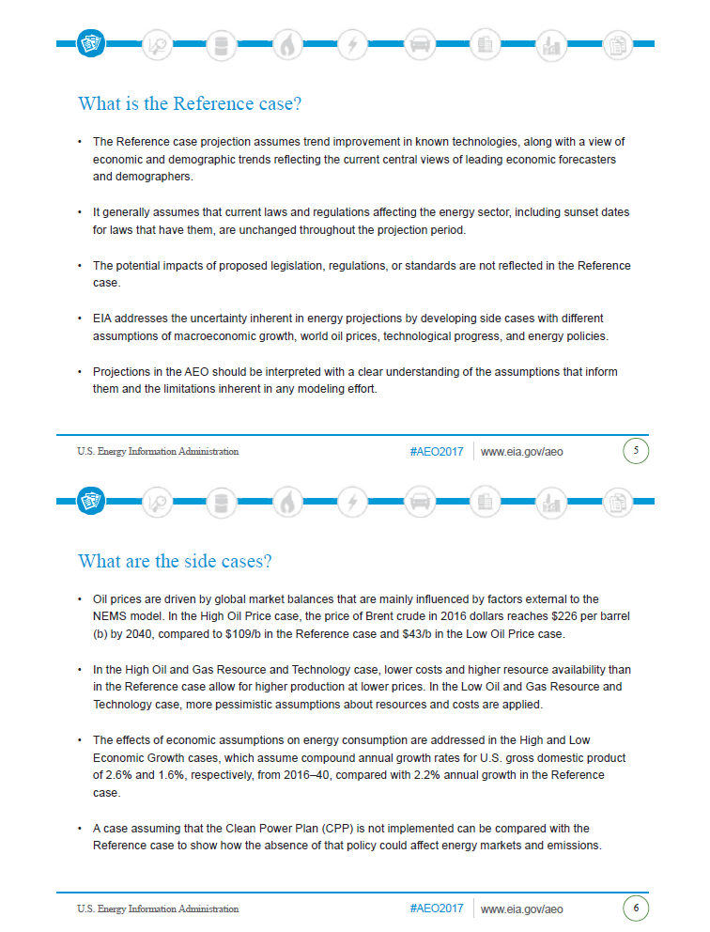

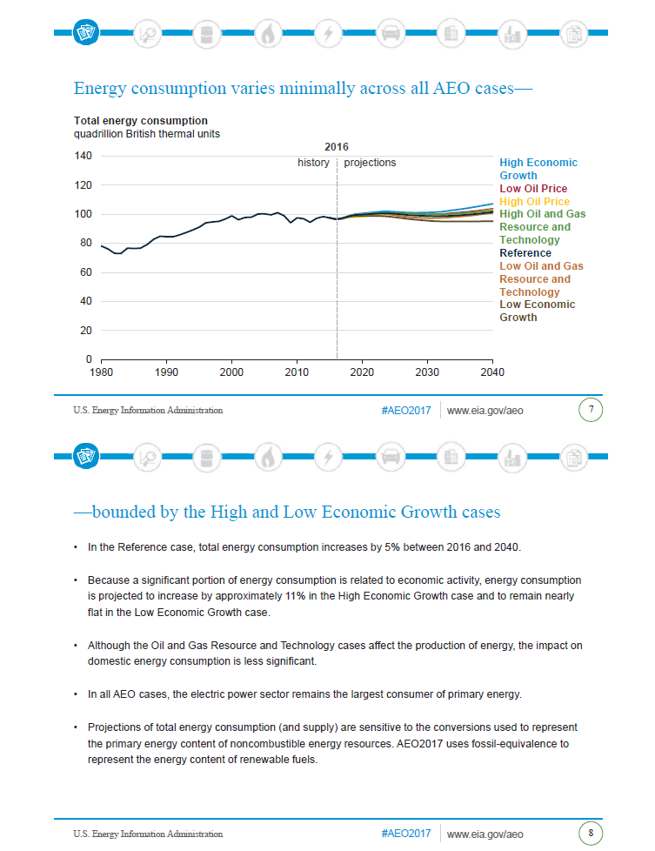

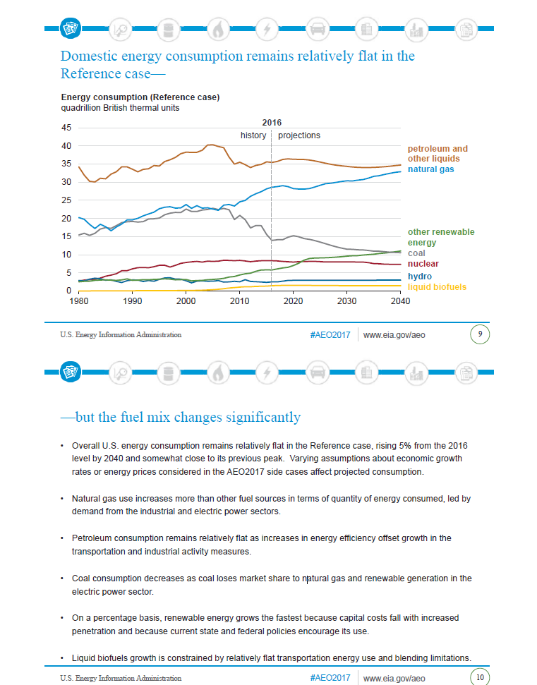

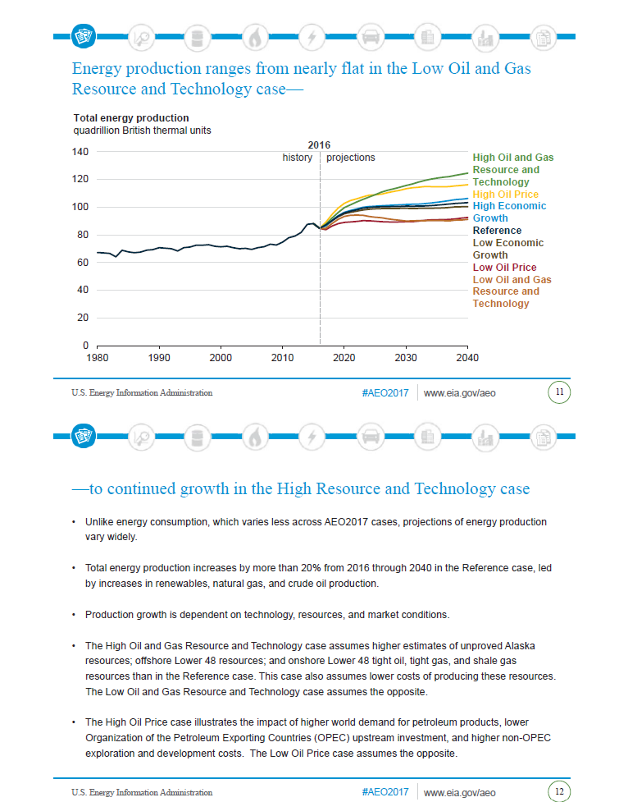

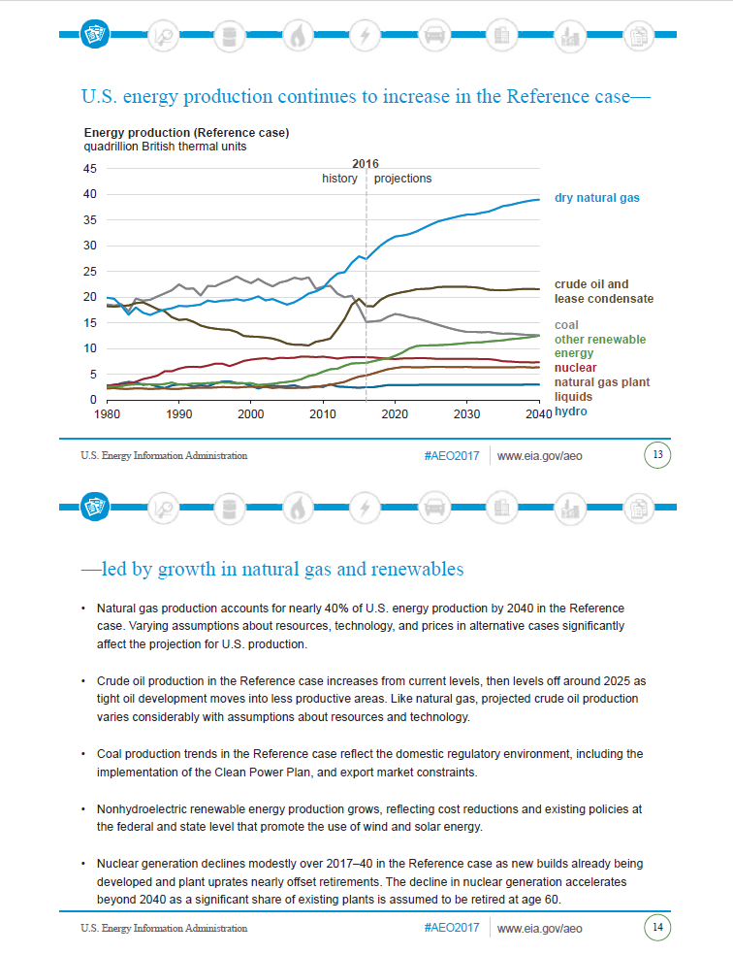

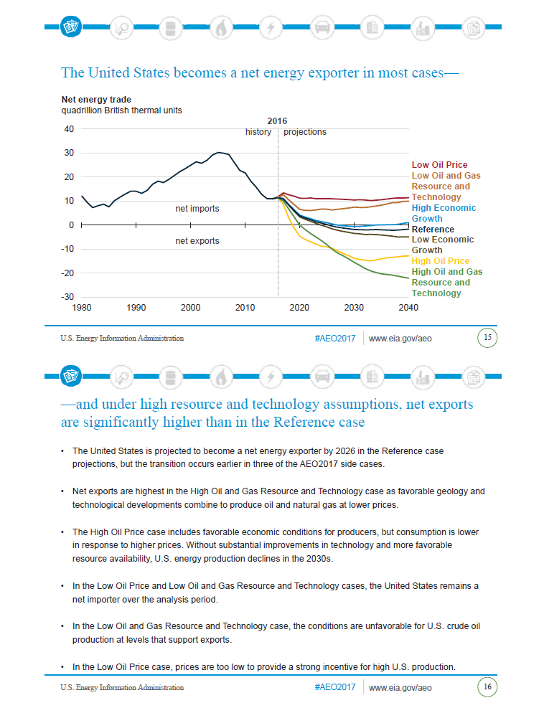

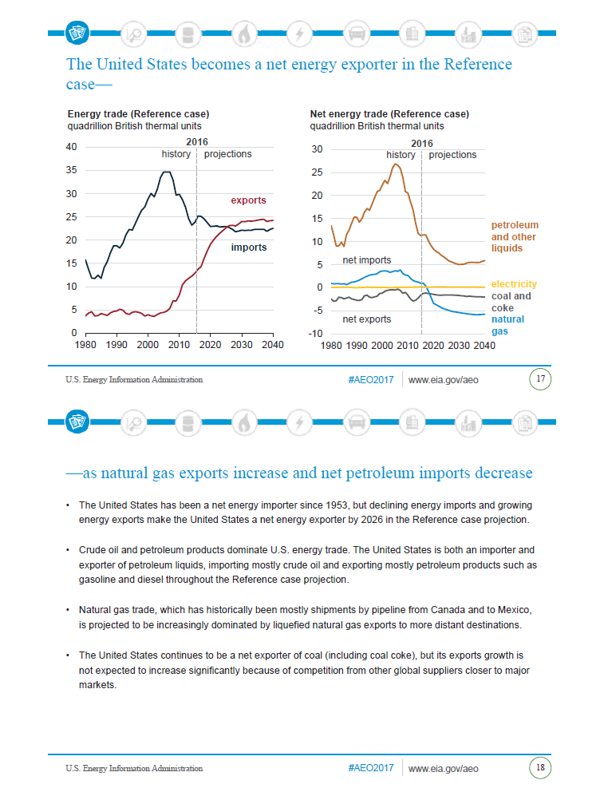
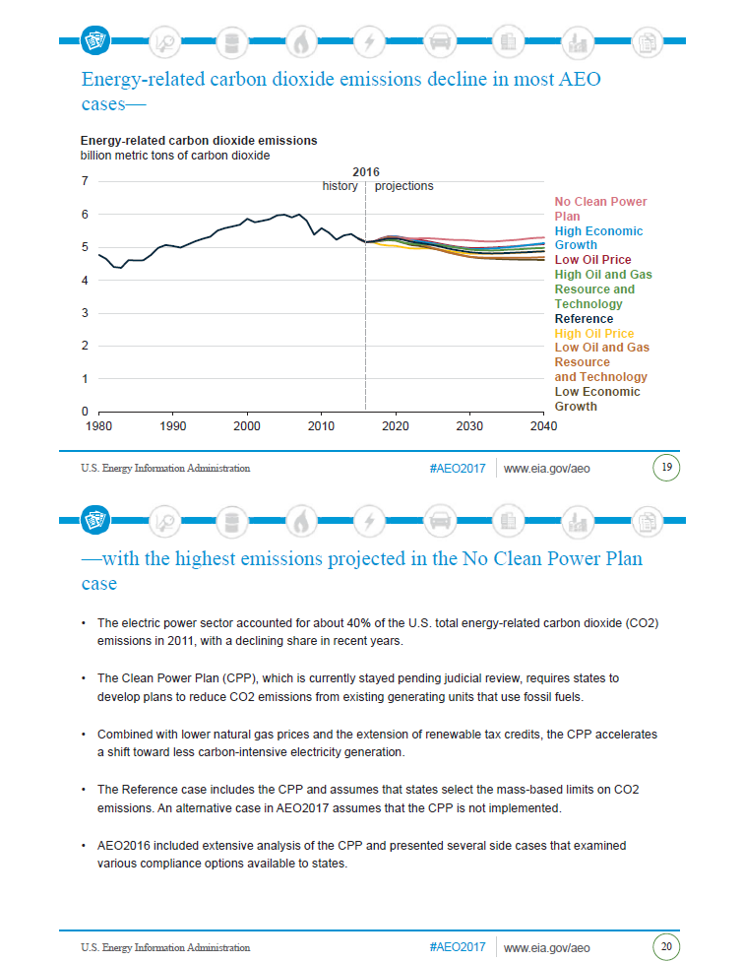
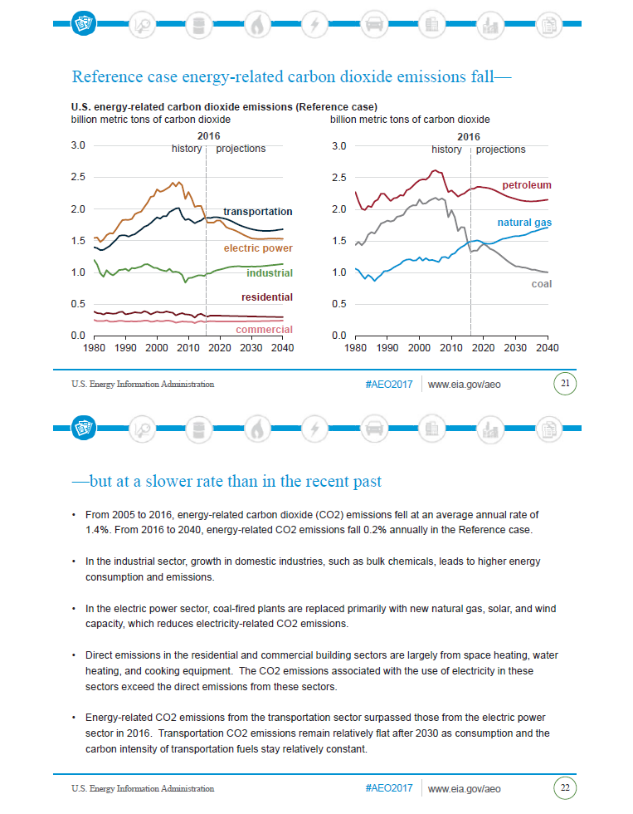
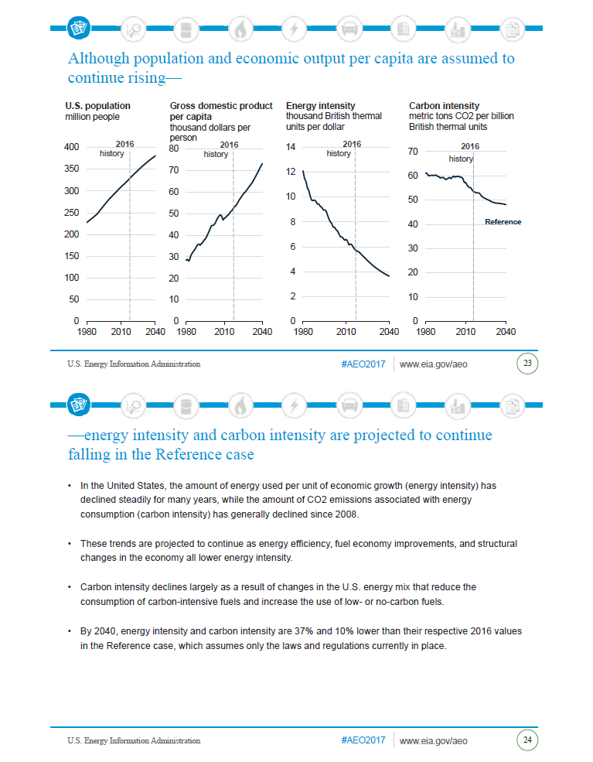
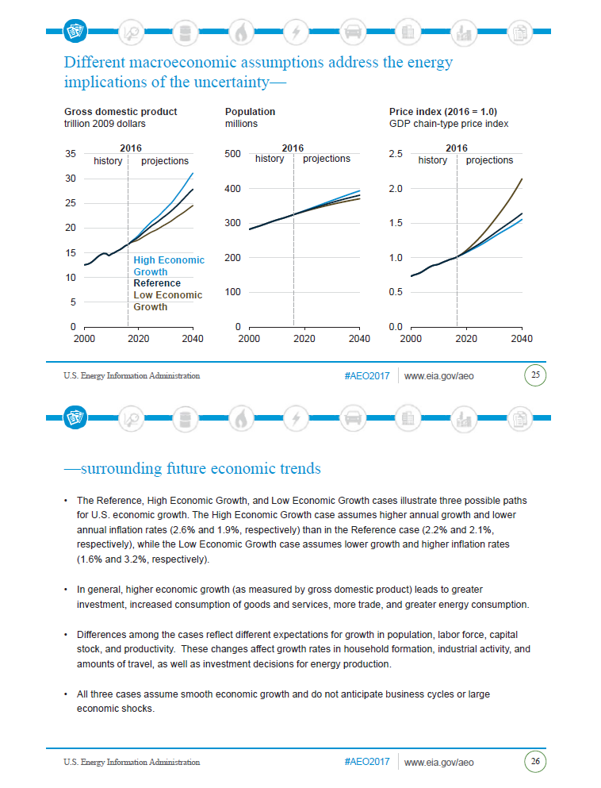
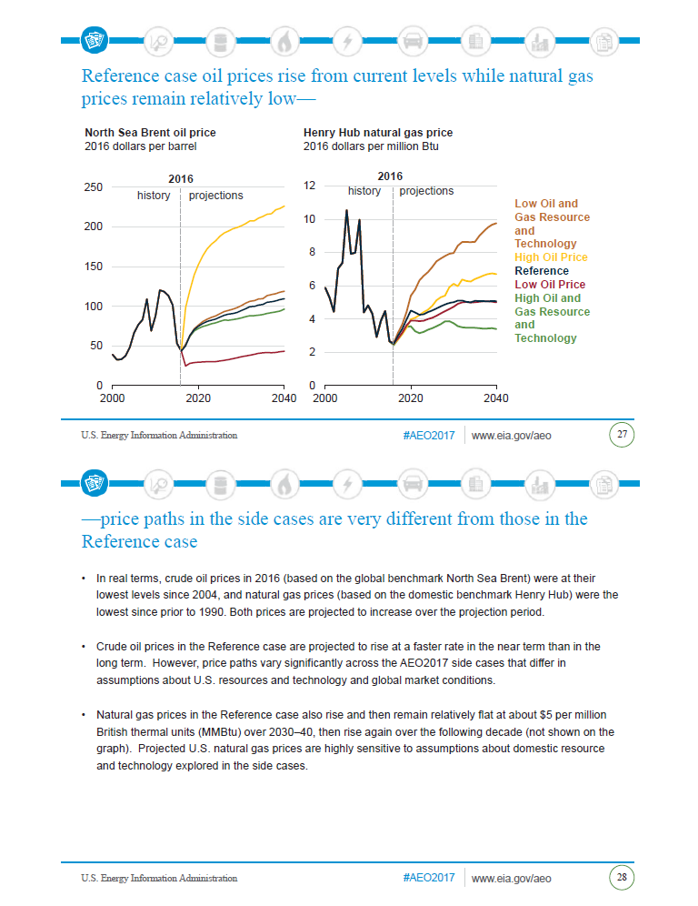
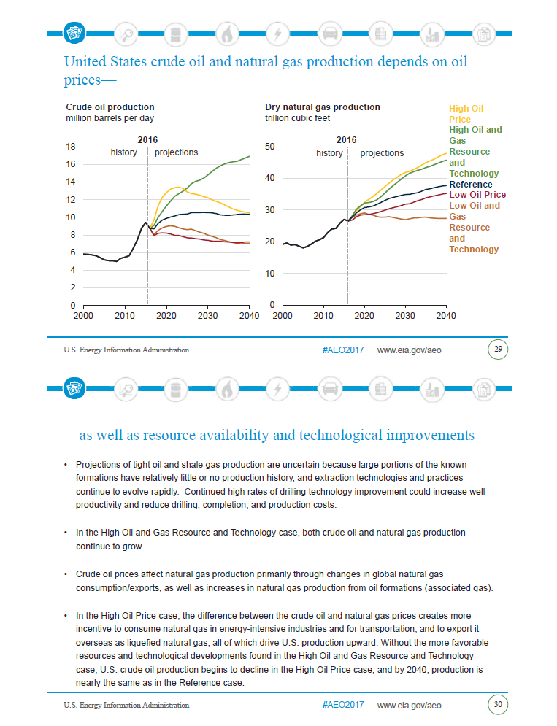
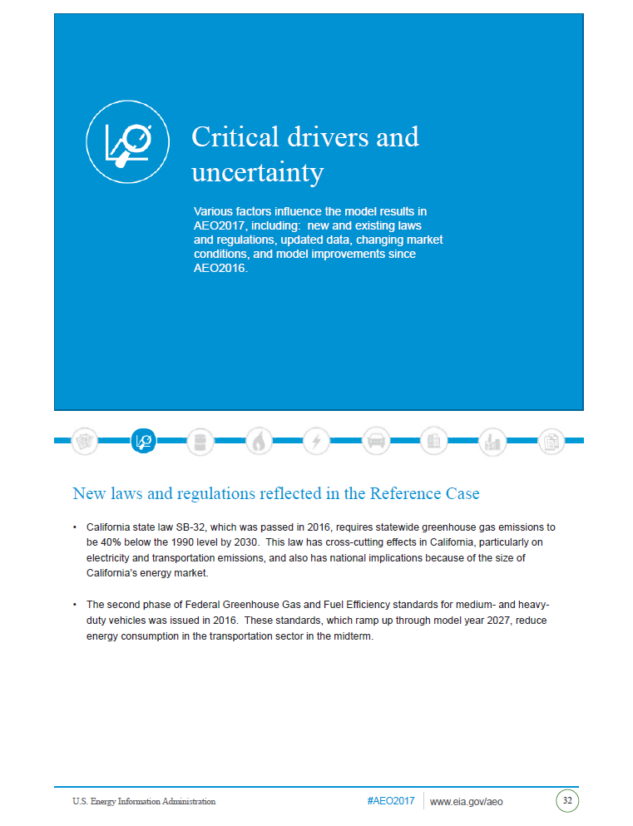
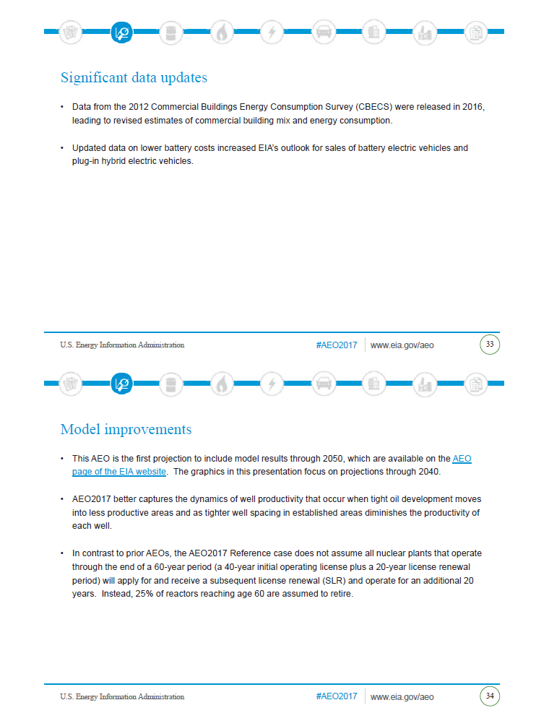
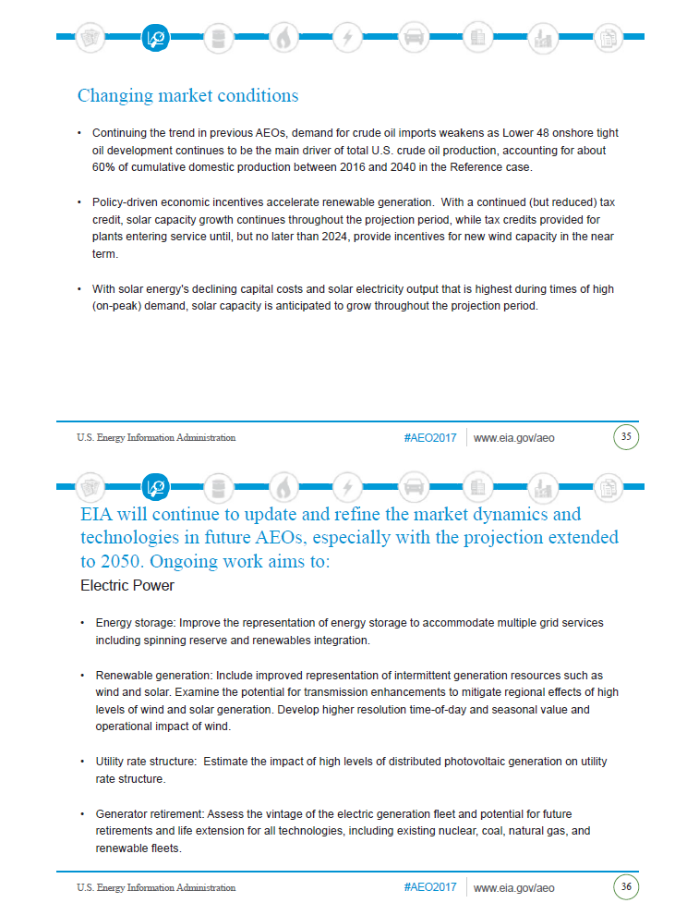
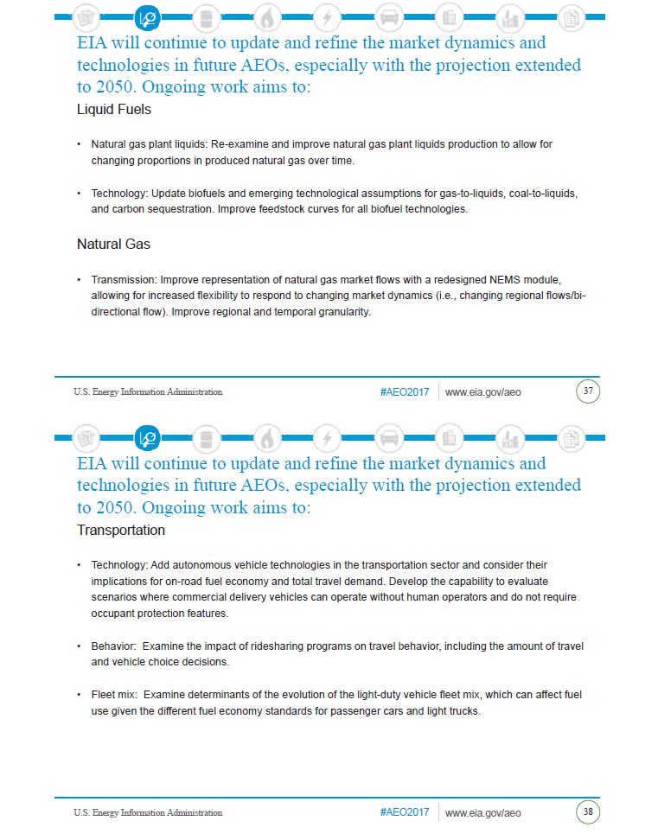
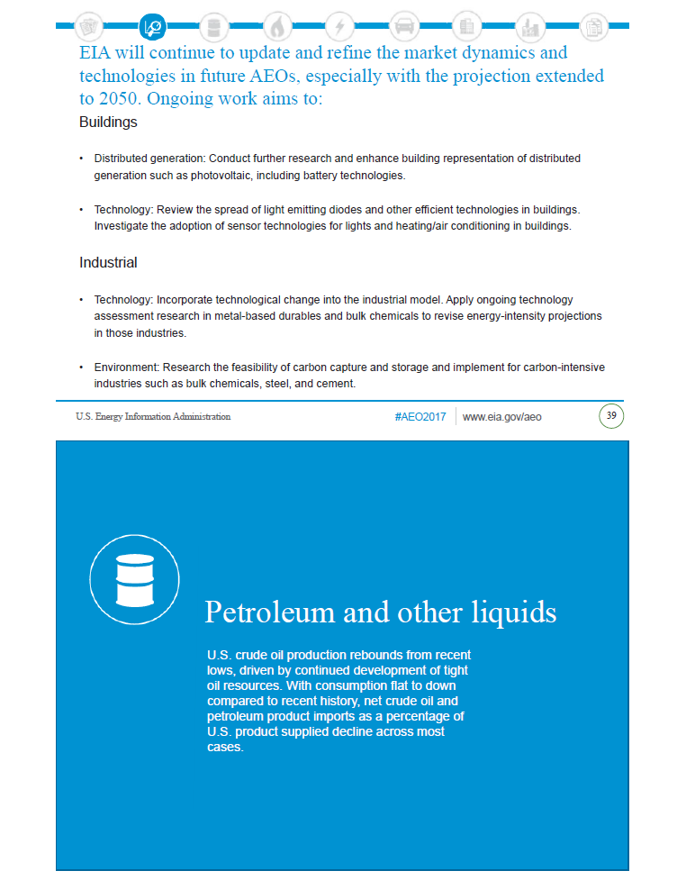
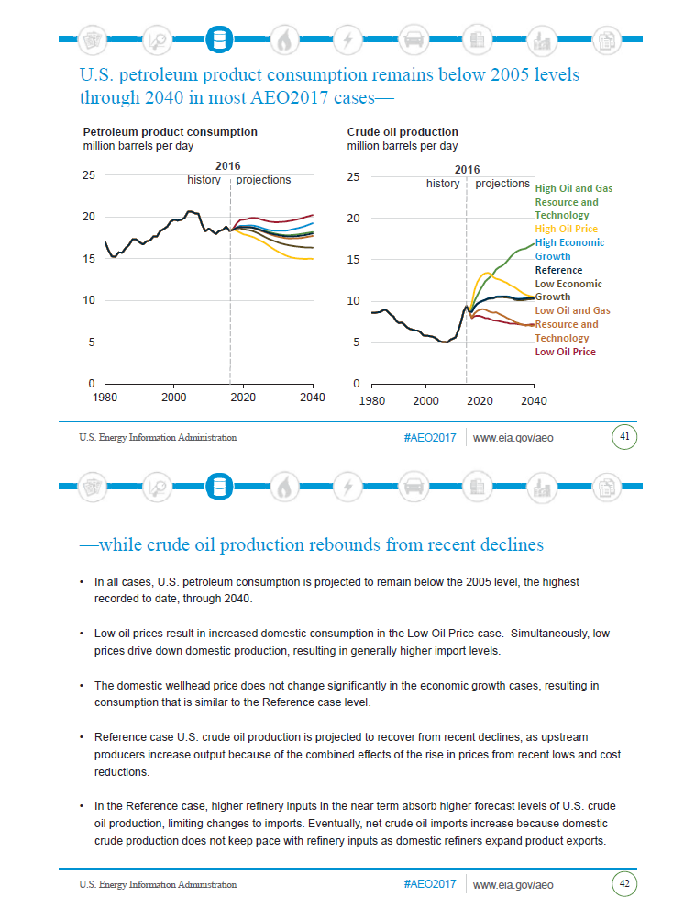
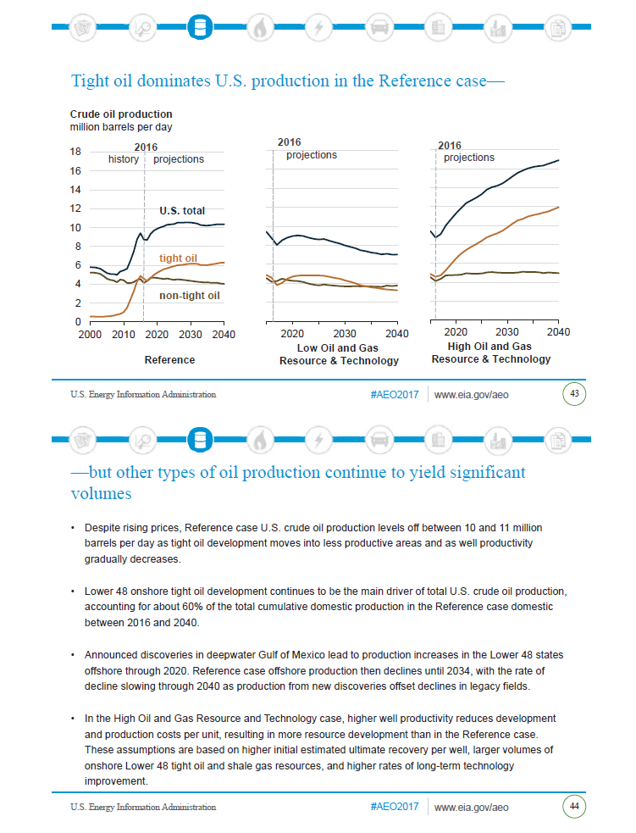
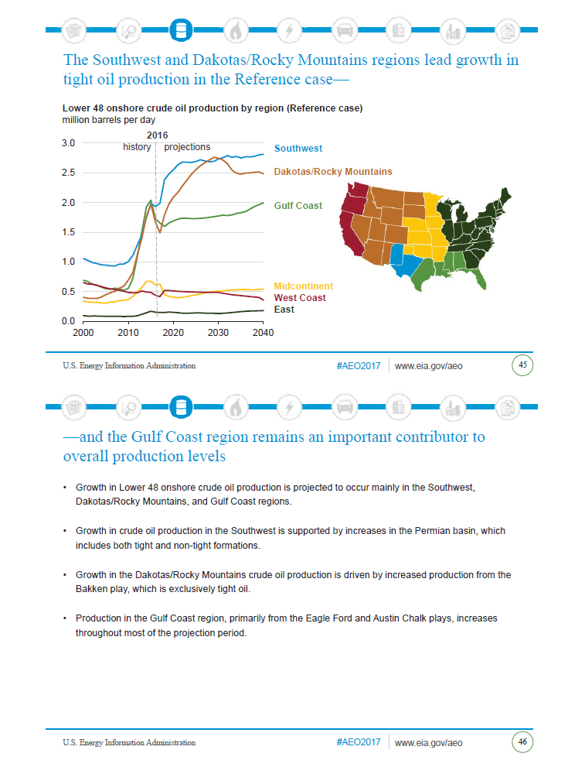
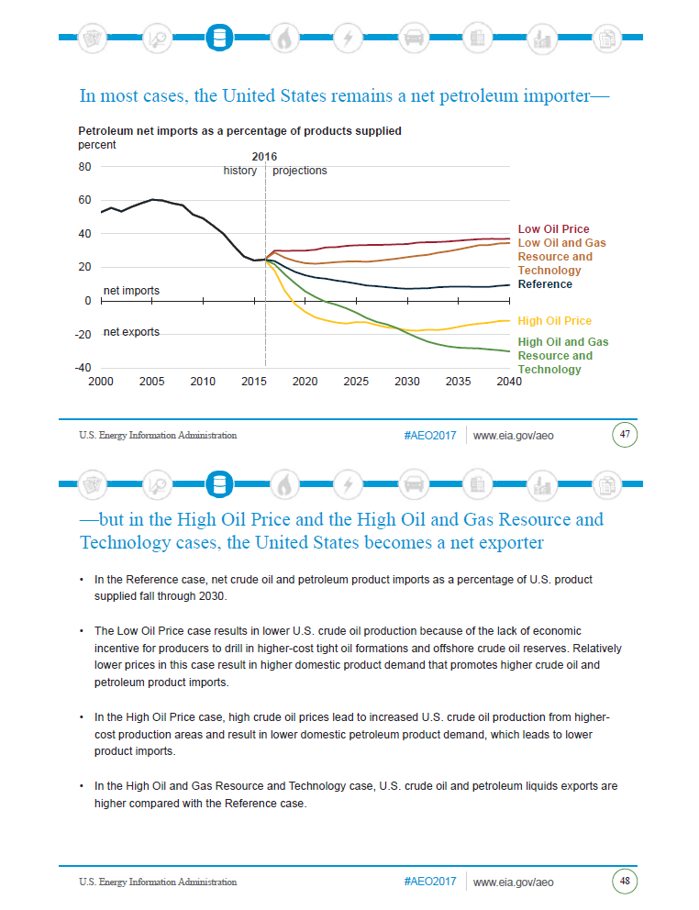
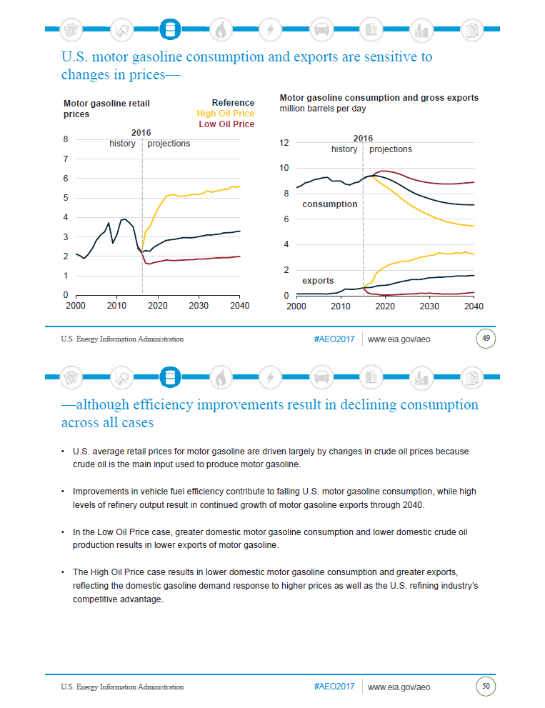

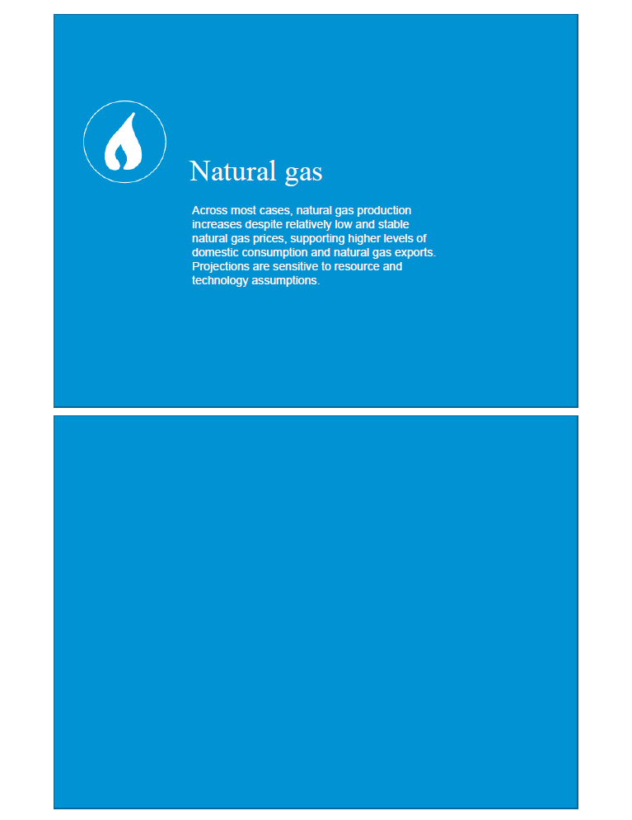
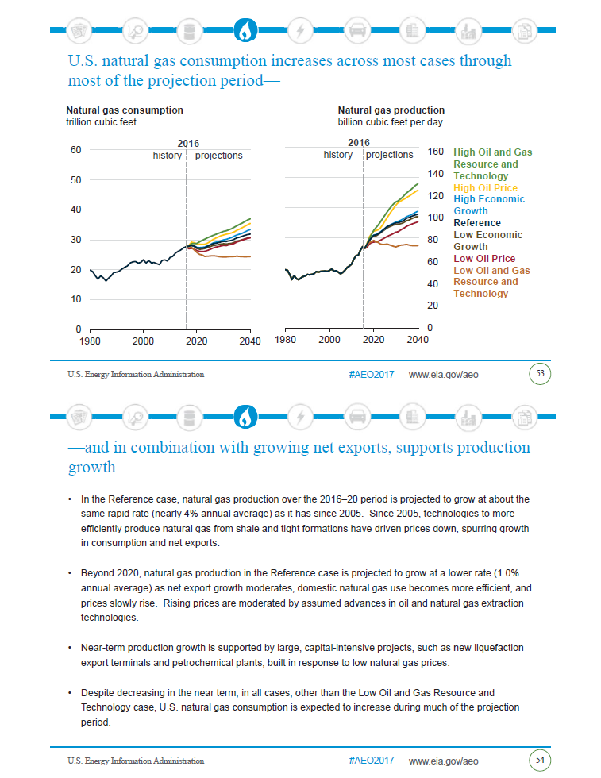

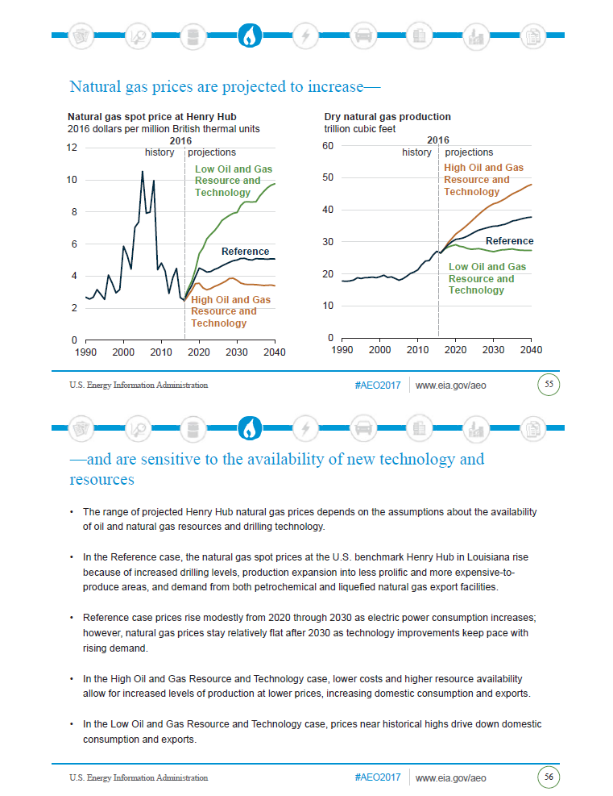
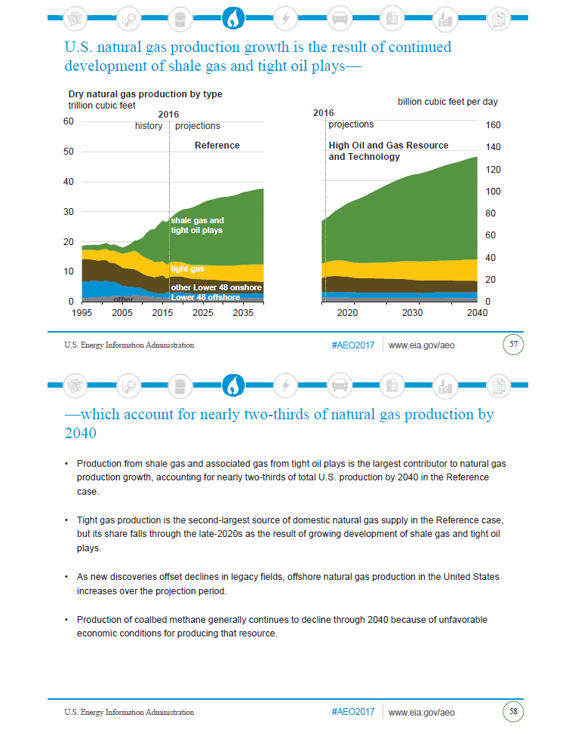
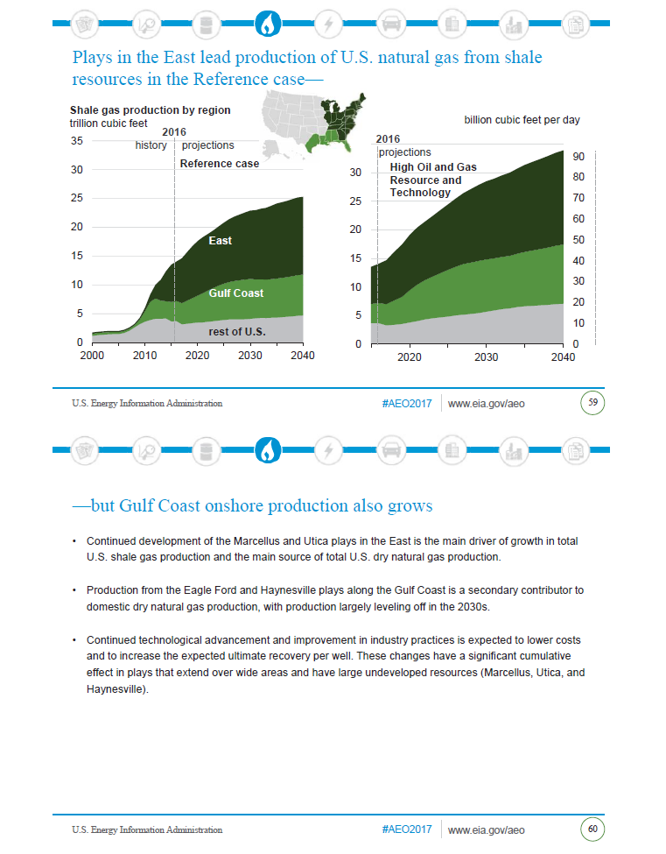
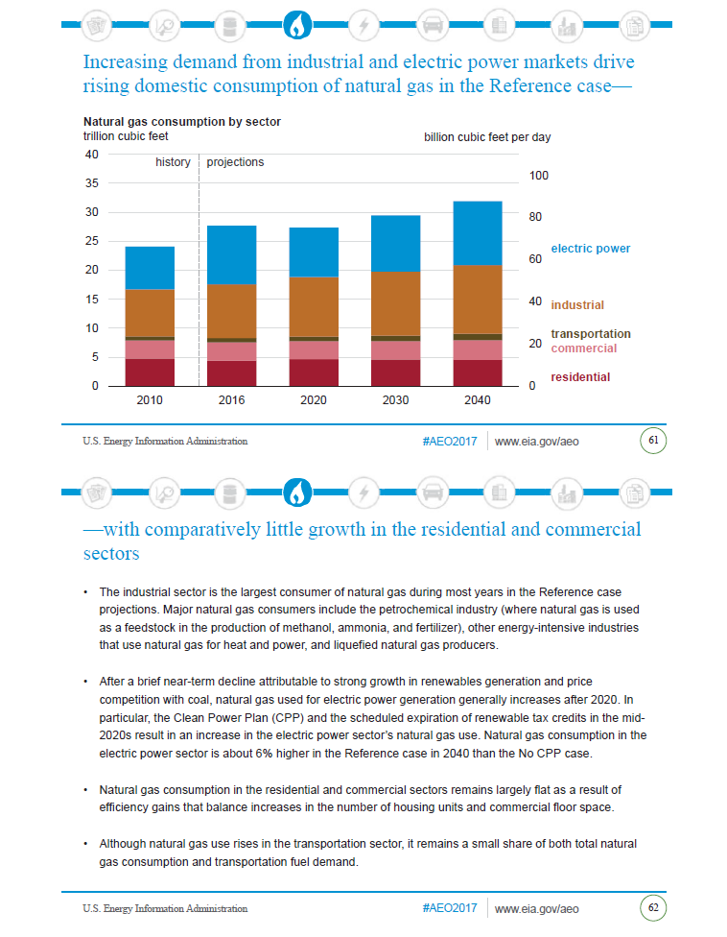
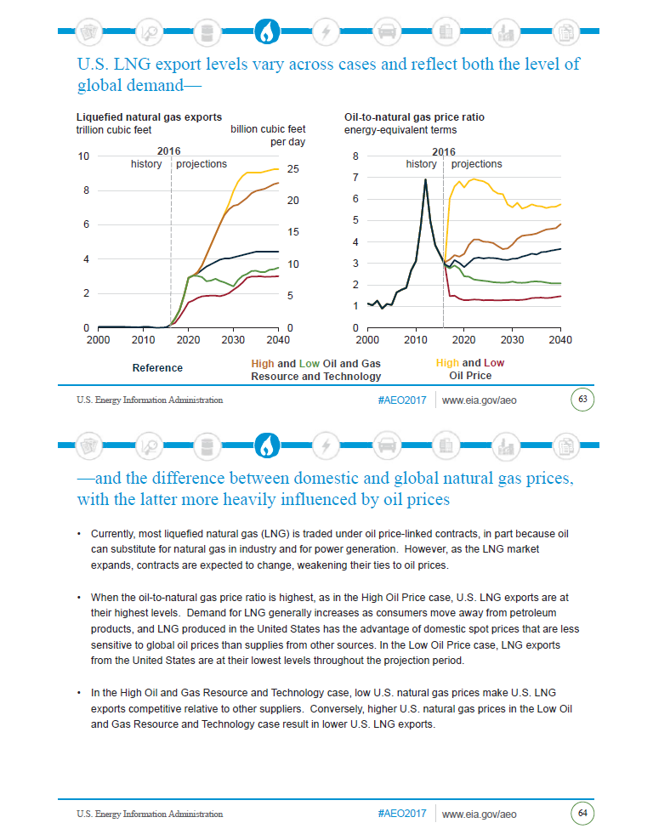
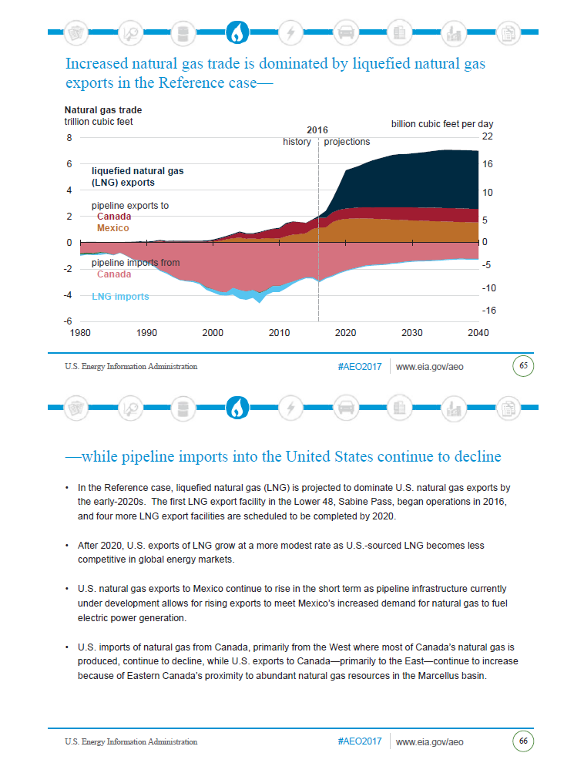

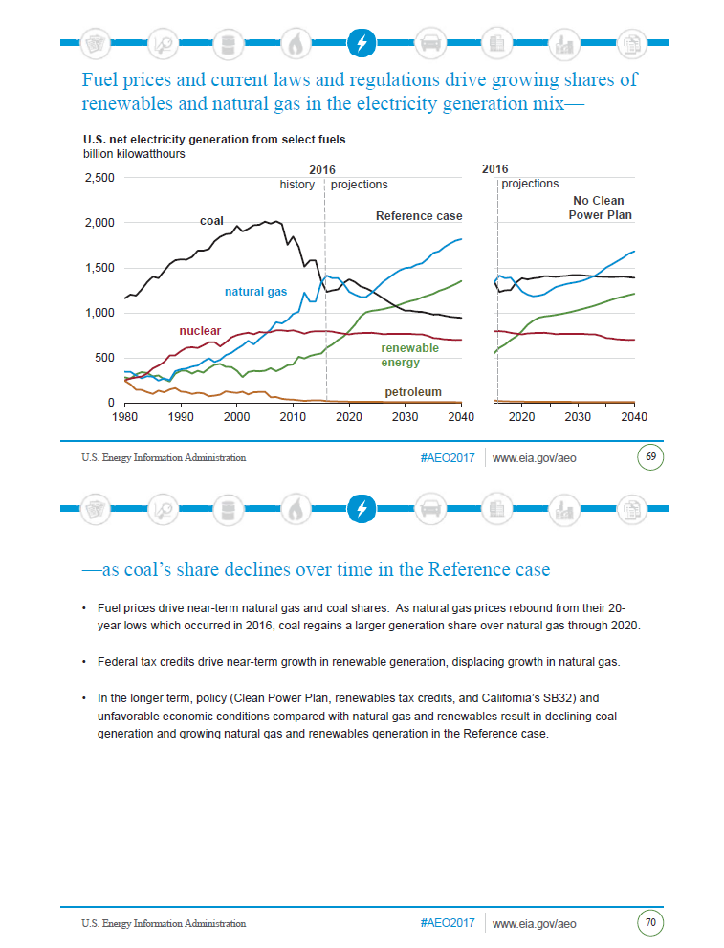
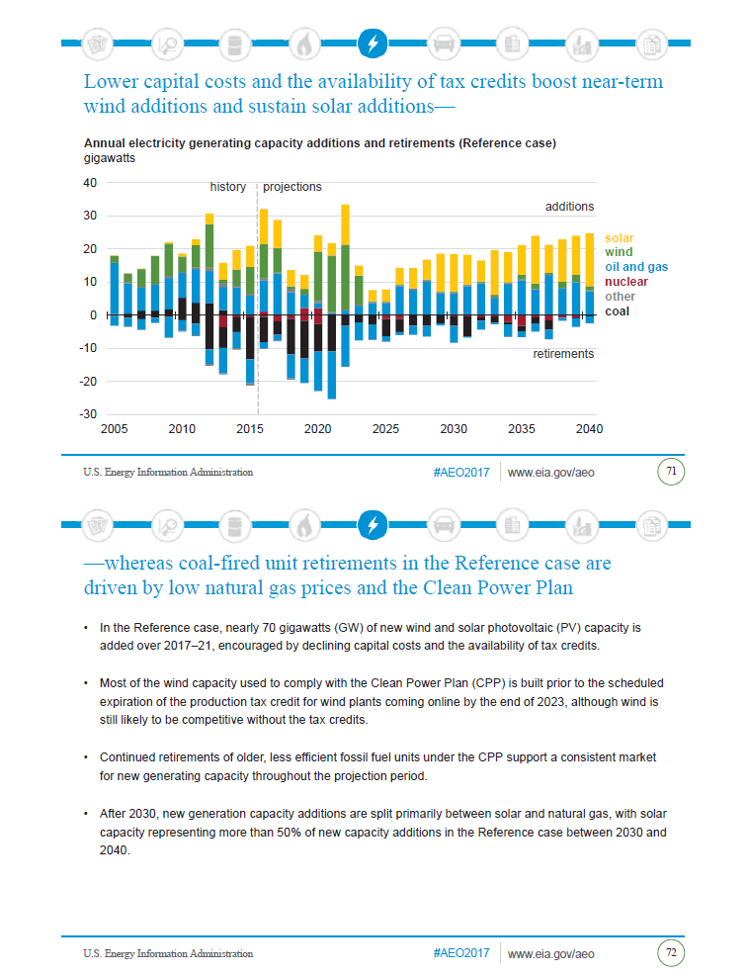
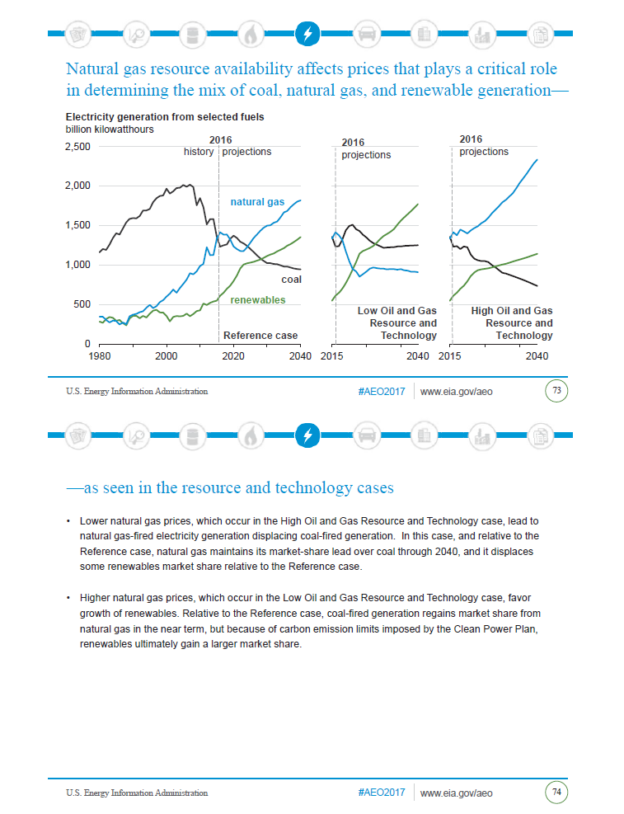
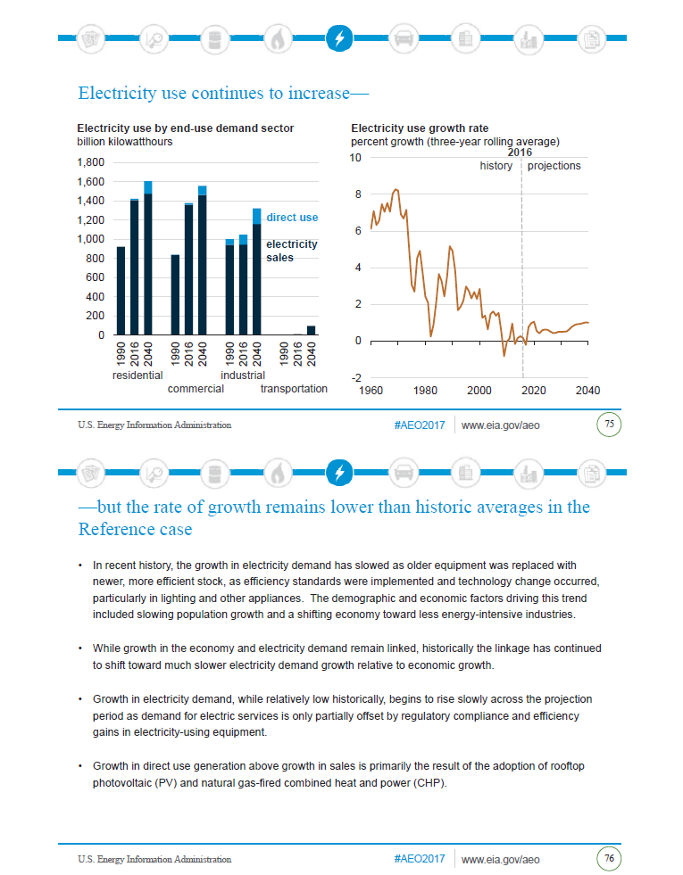
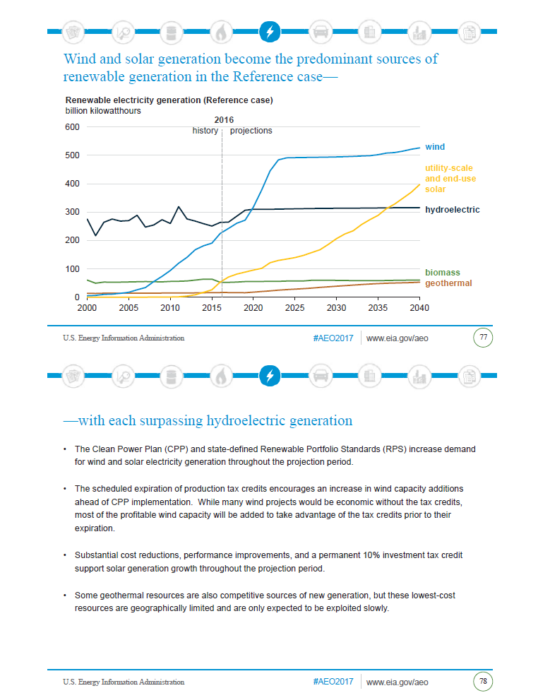
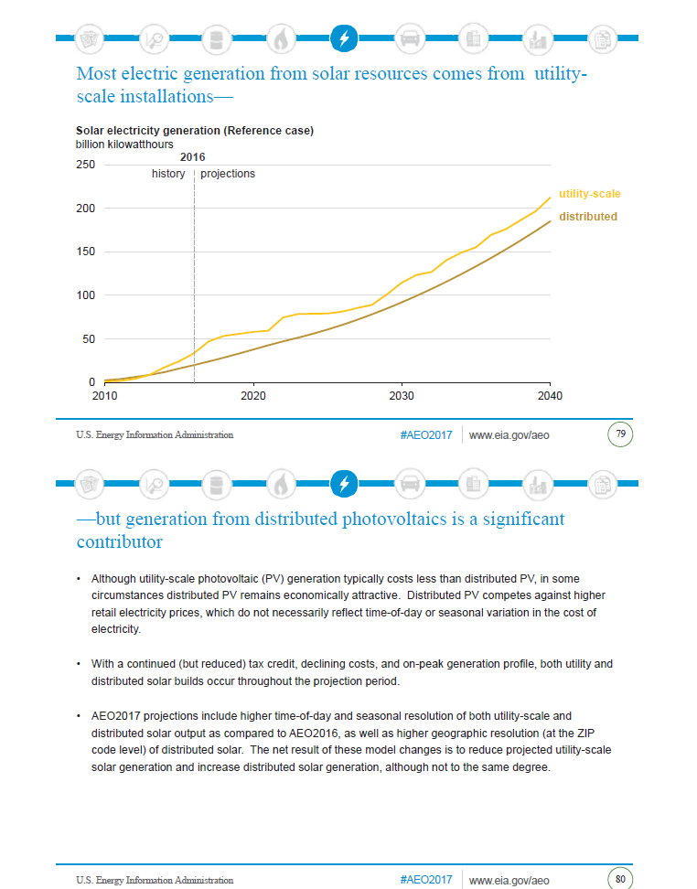
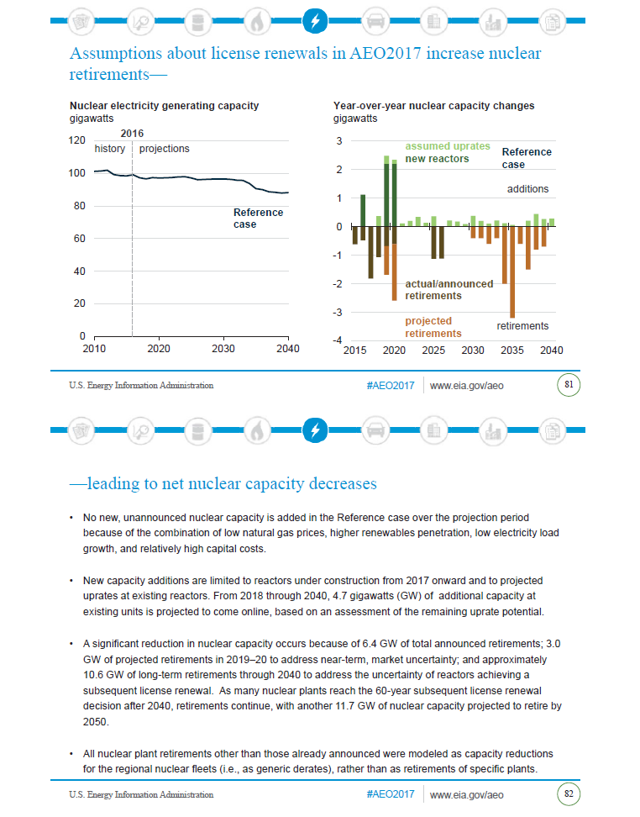
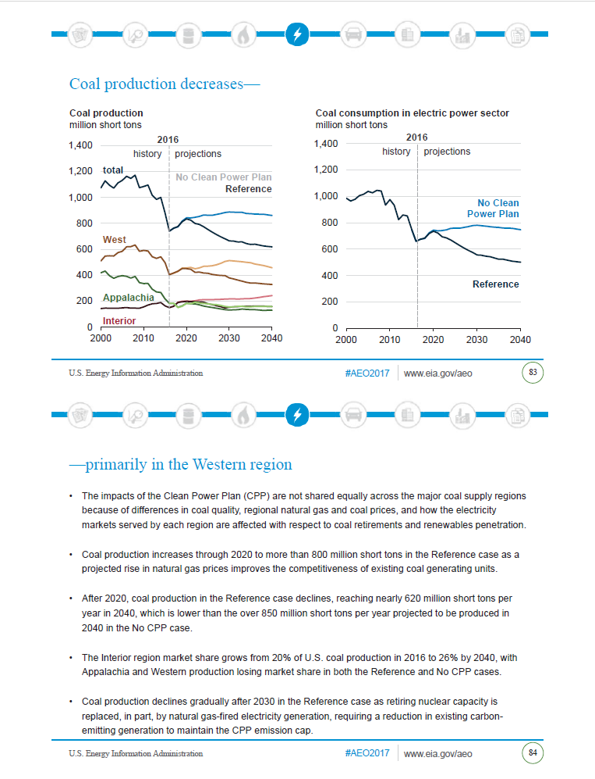
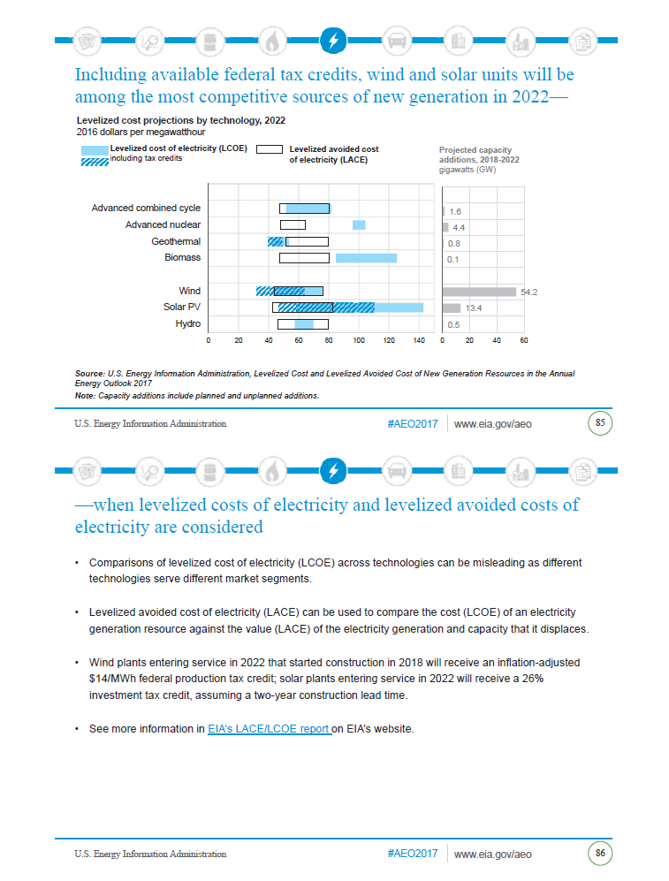
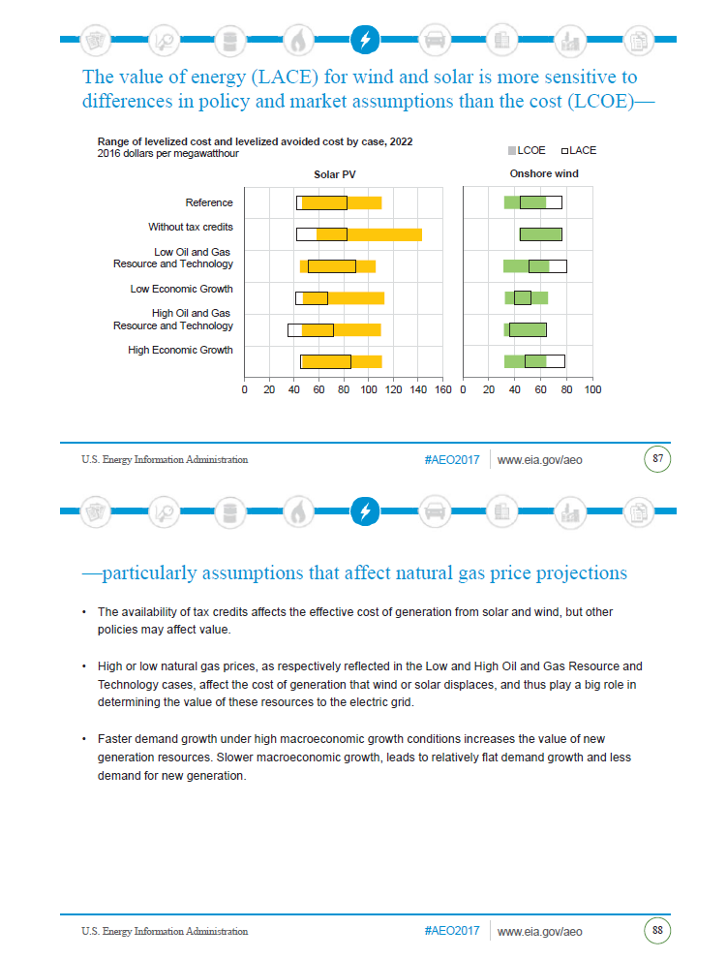
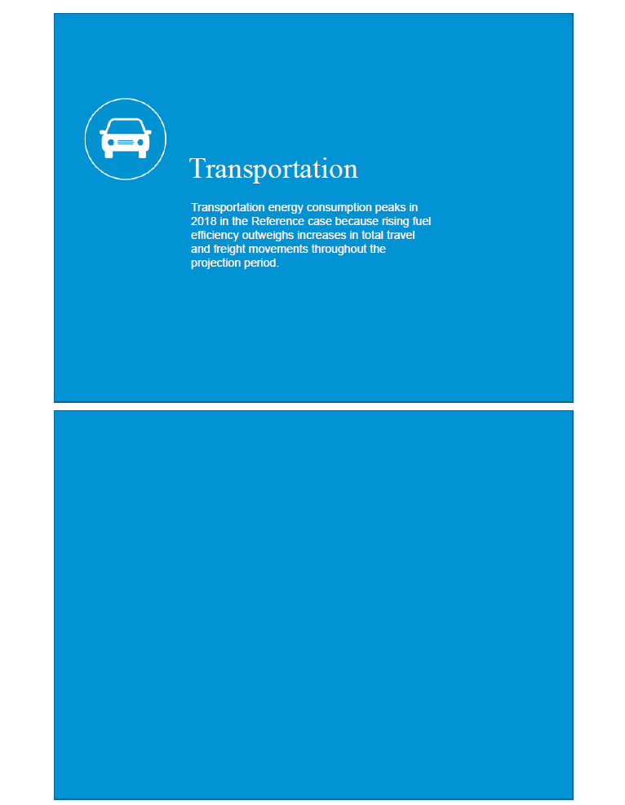
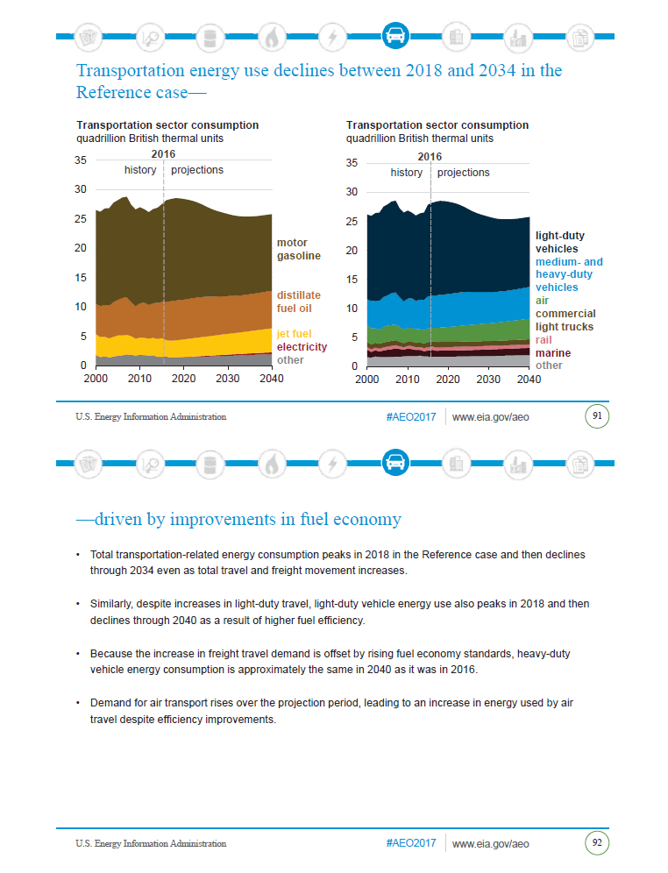
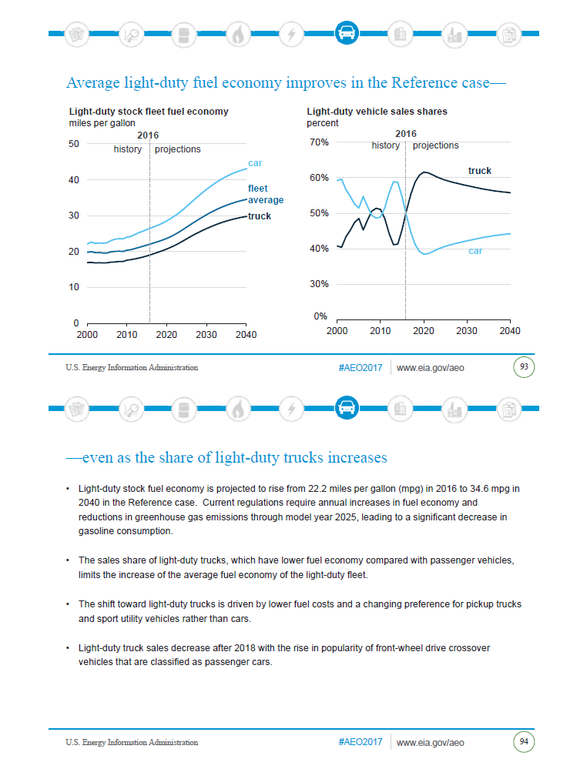
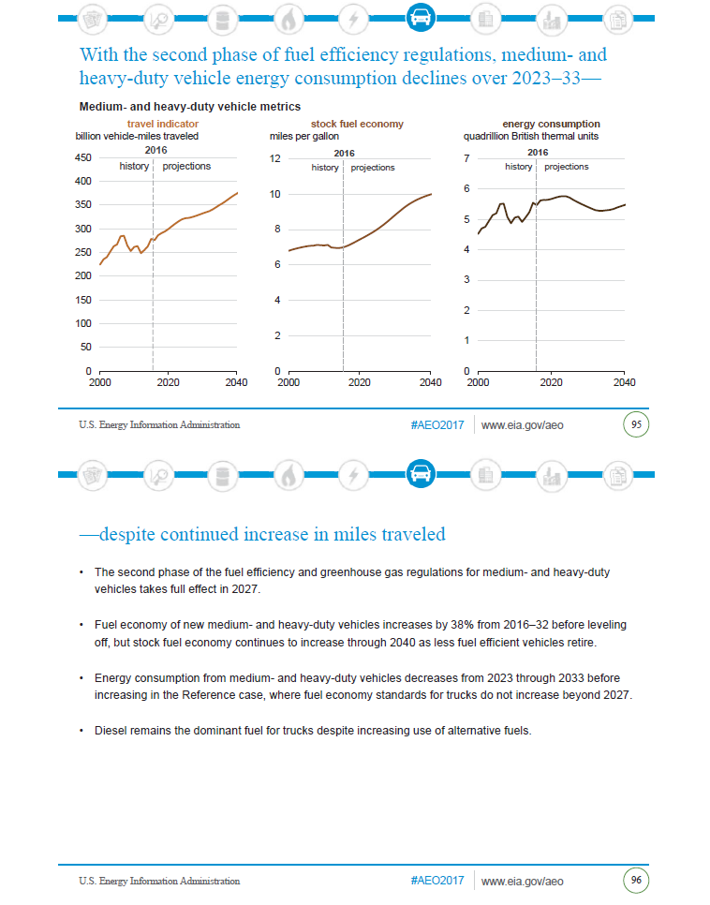
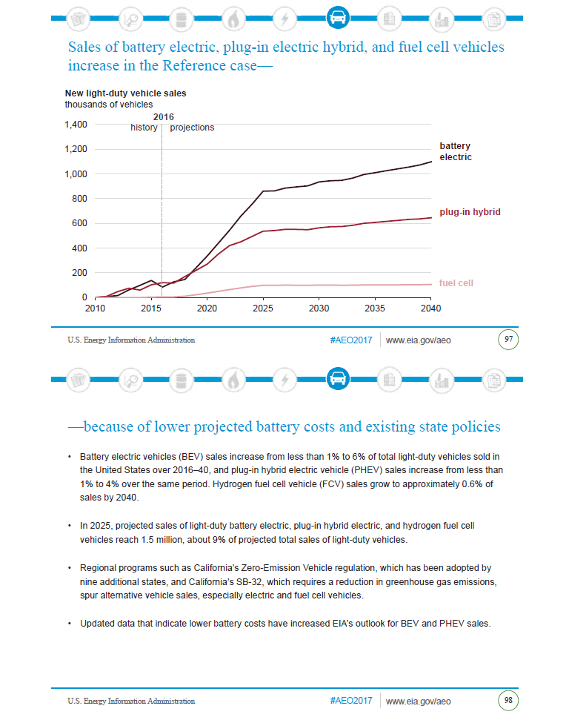
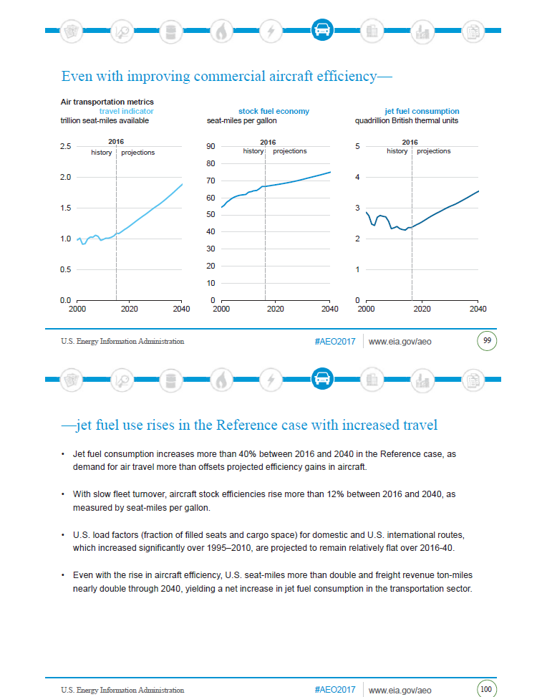
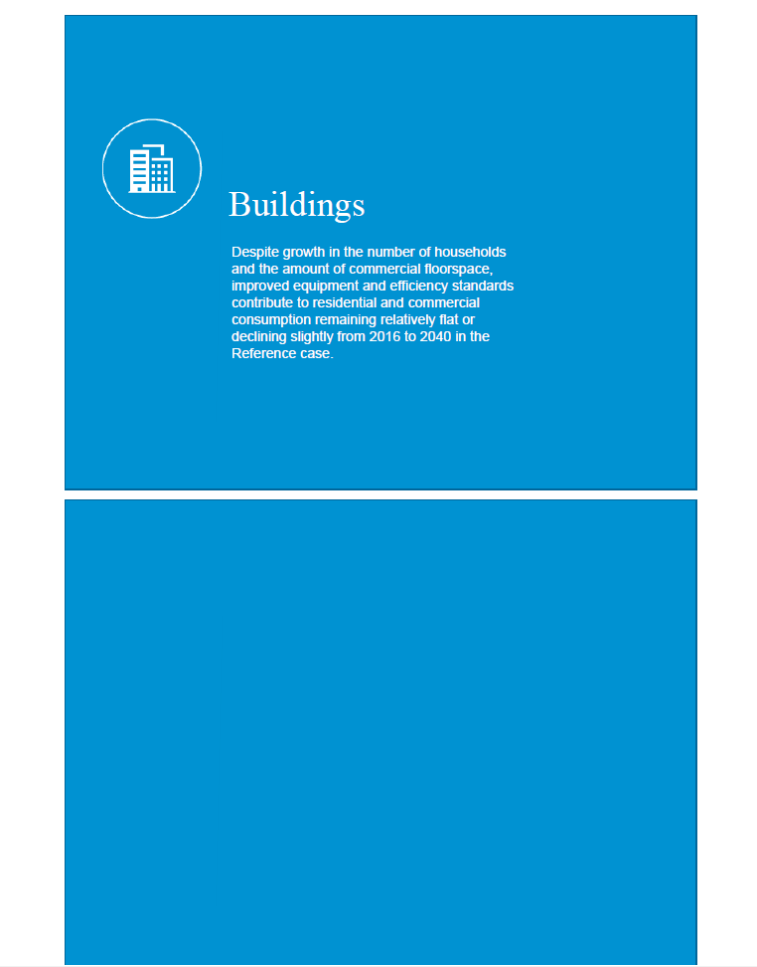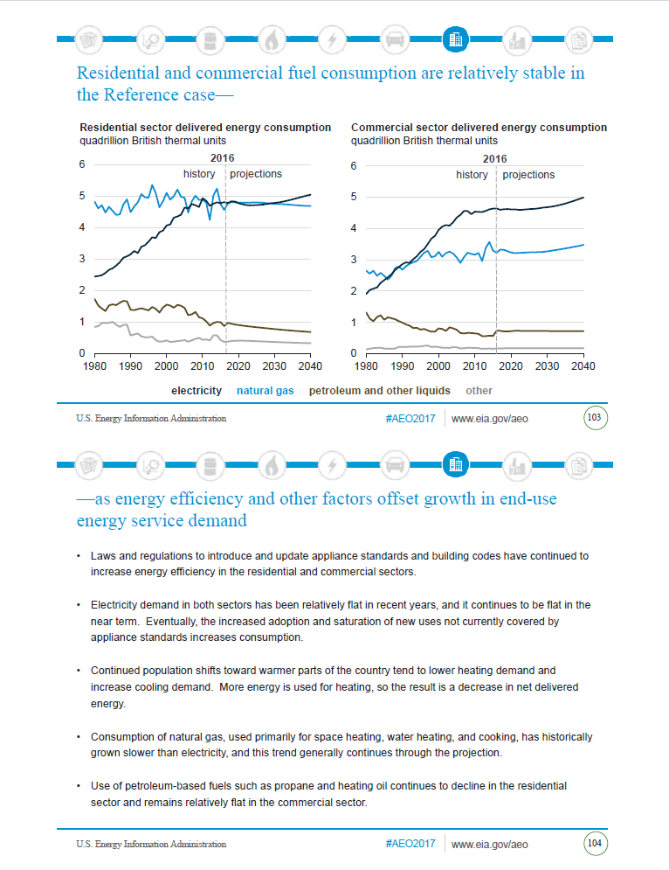
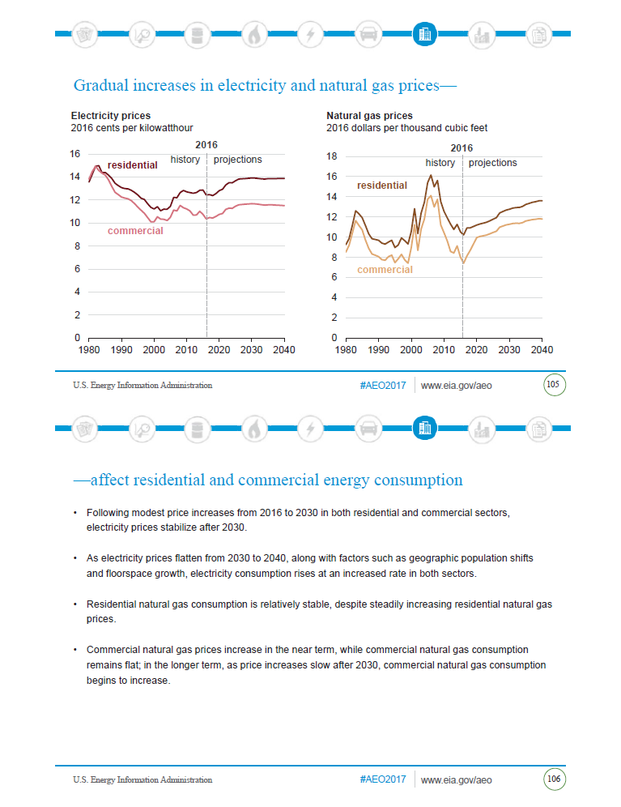
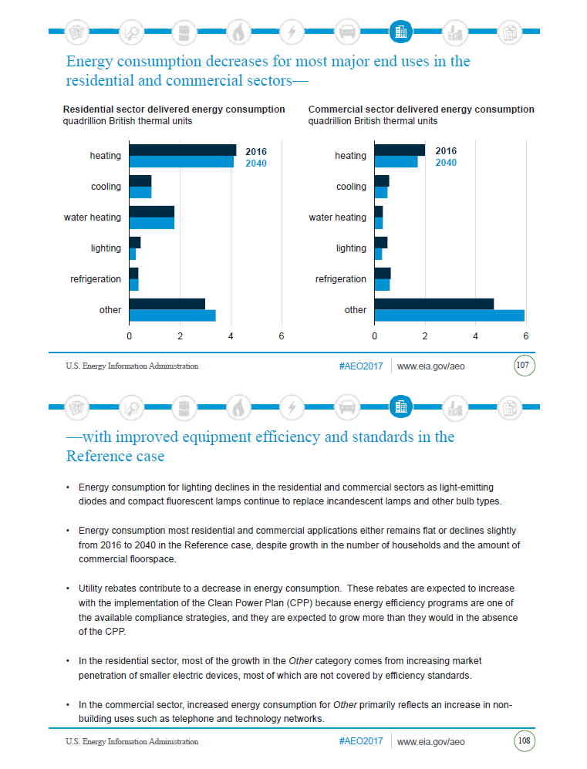
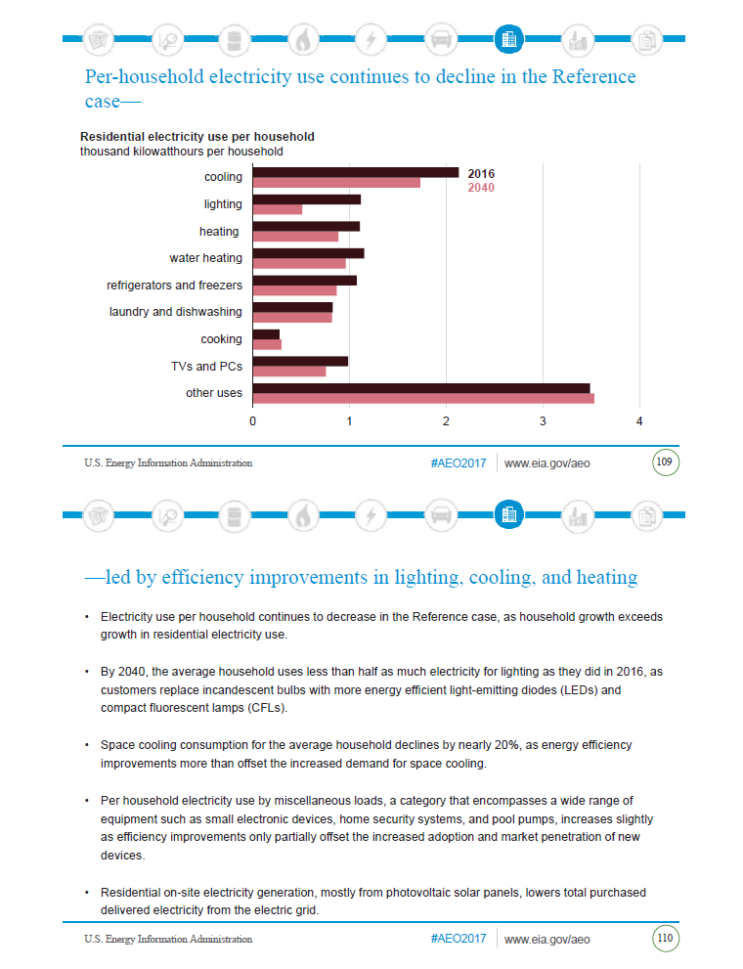
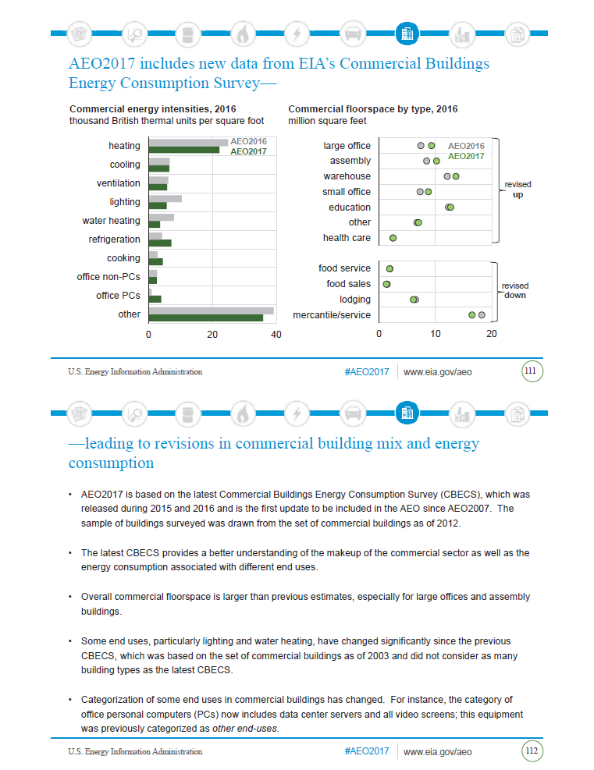

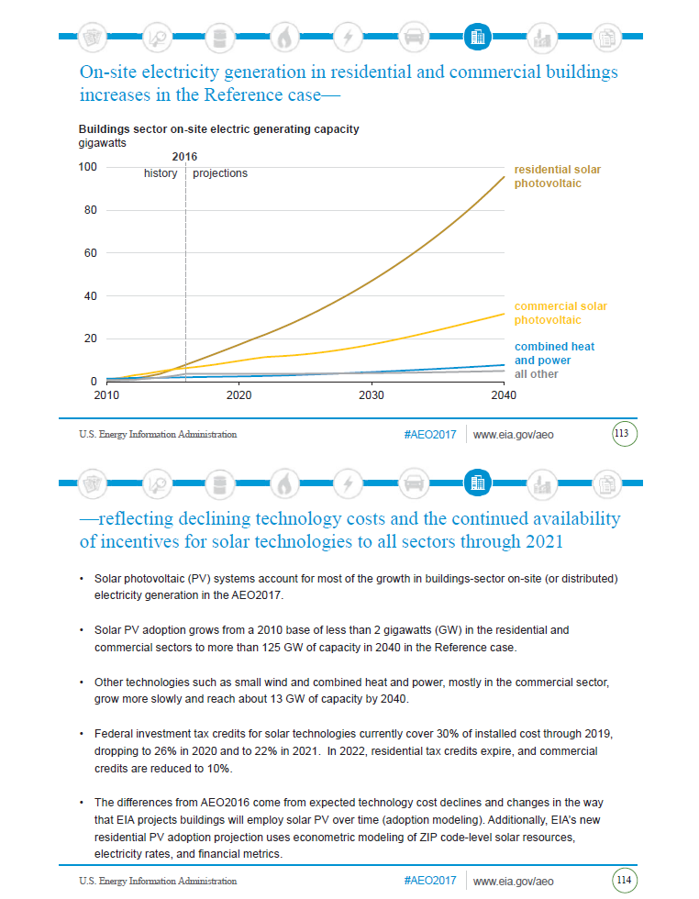

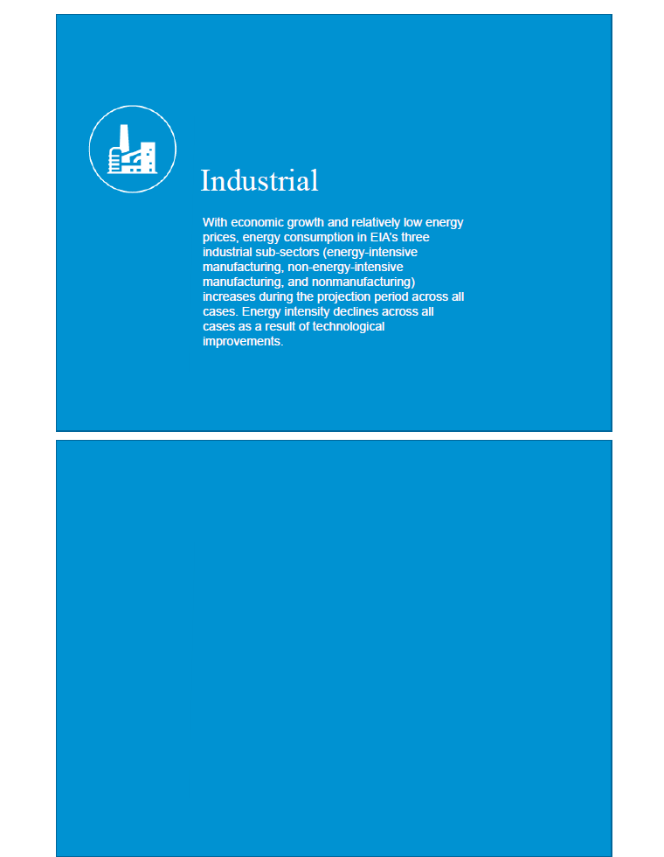
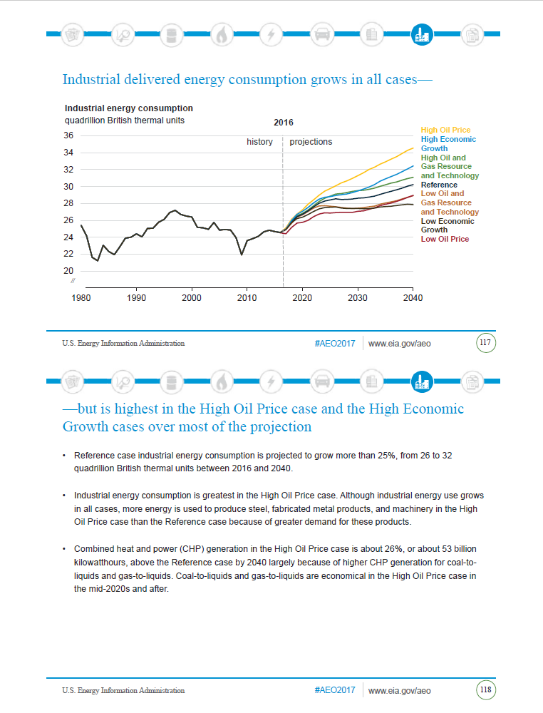

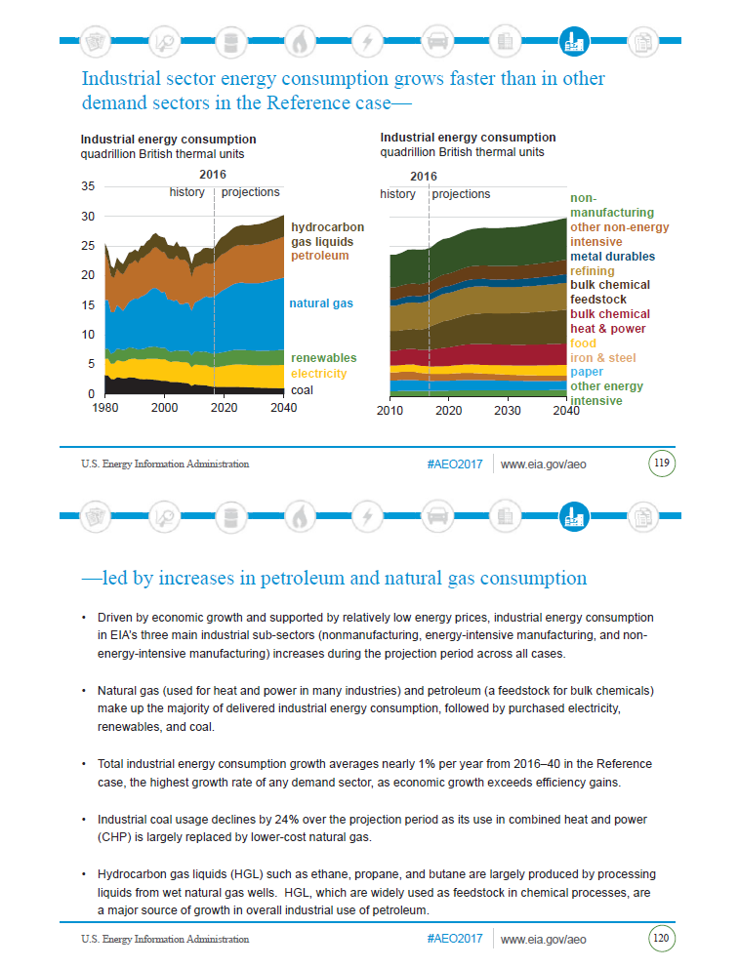

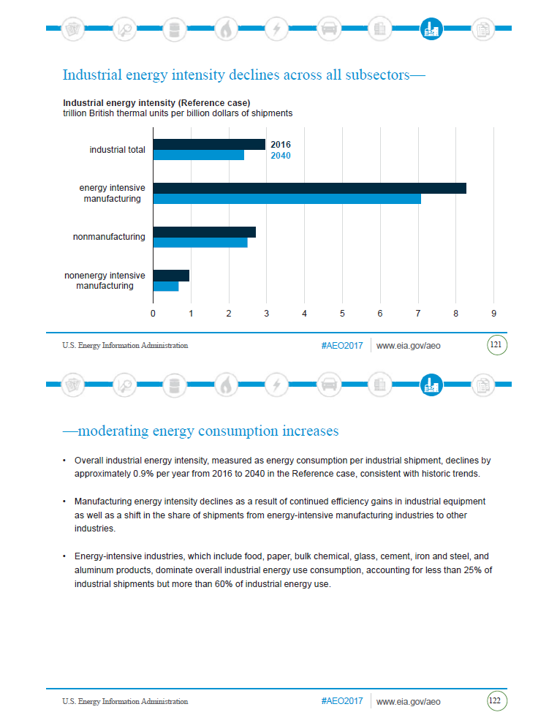
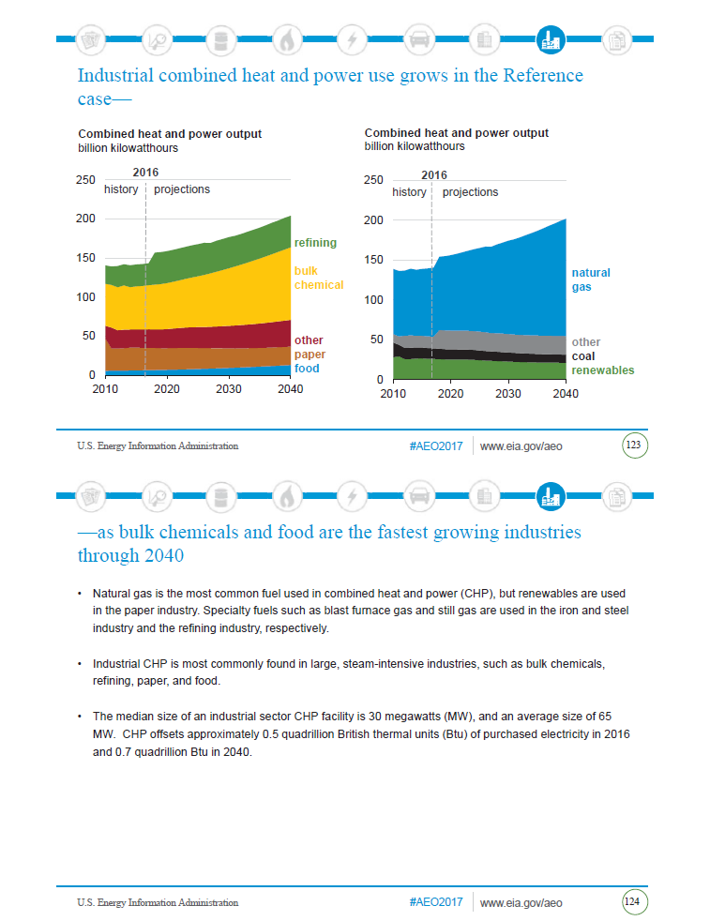
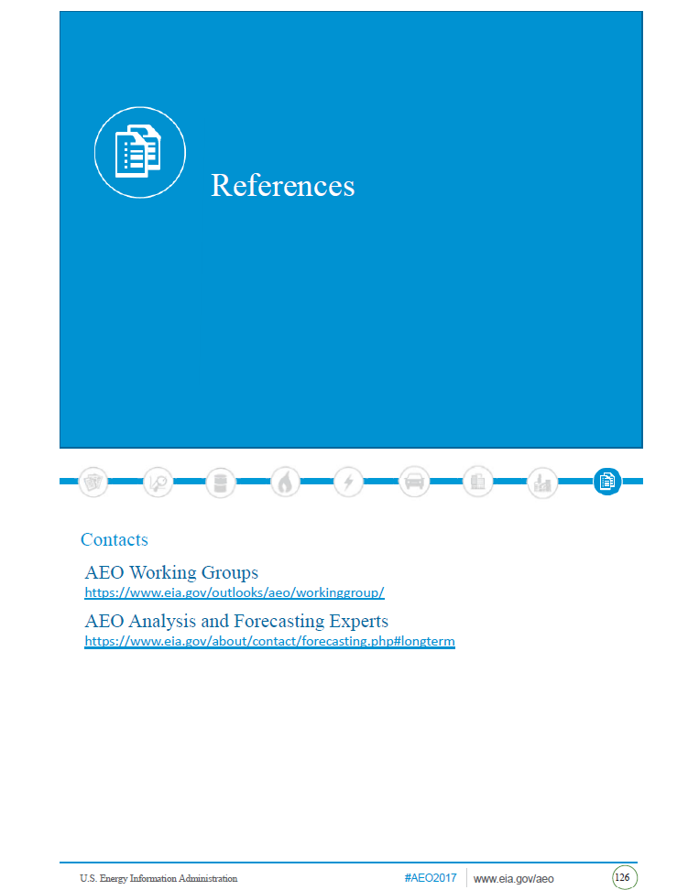
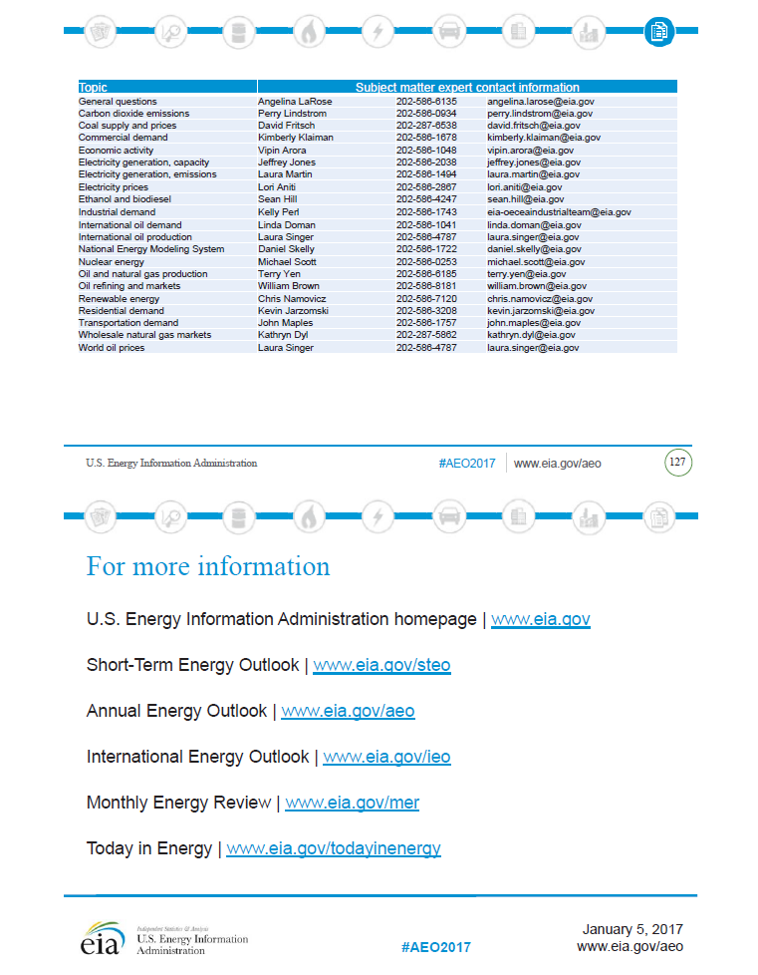
Appendix G – Local Review Committee Minutes
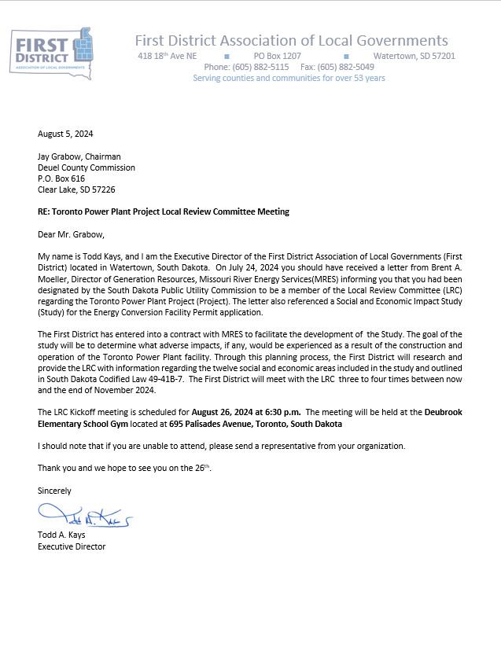

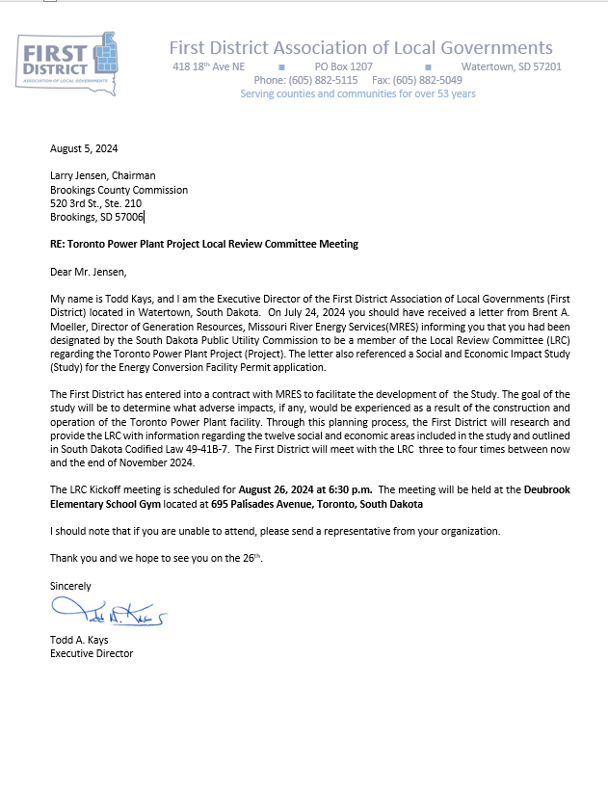
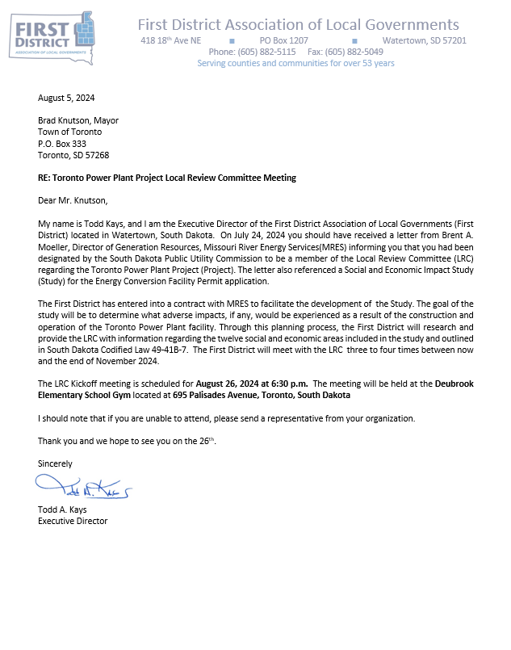
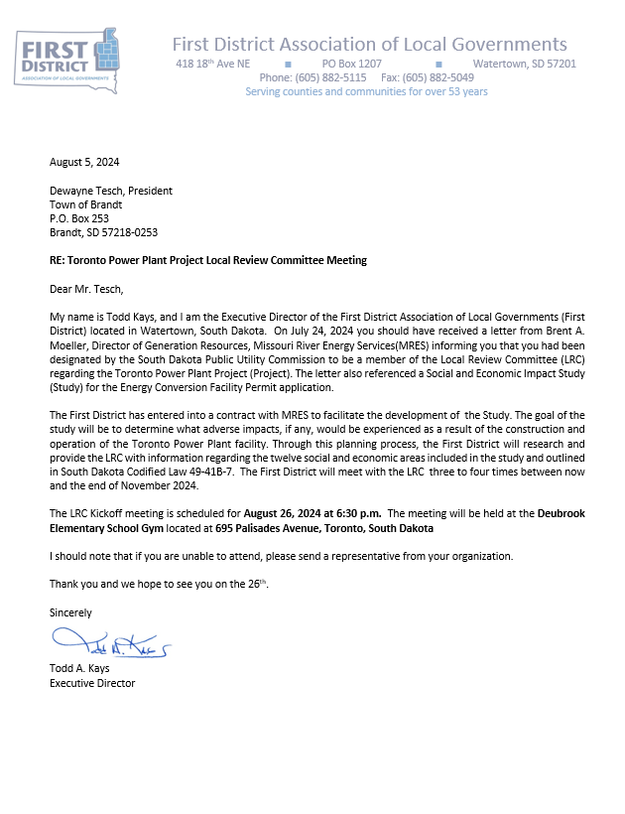
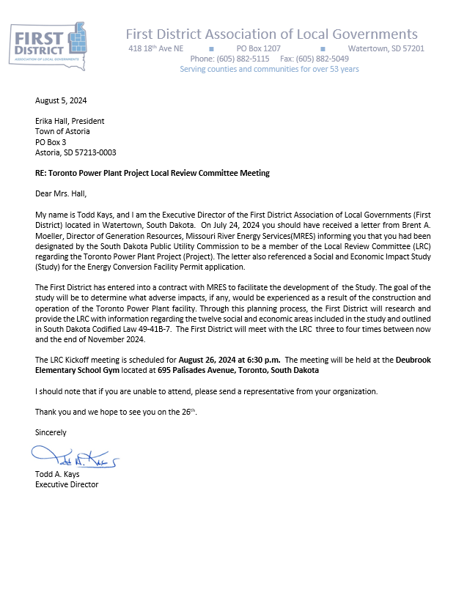
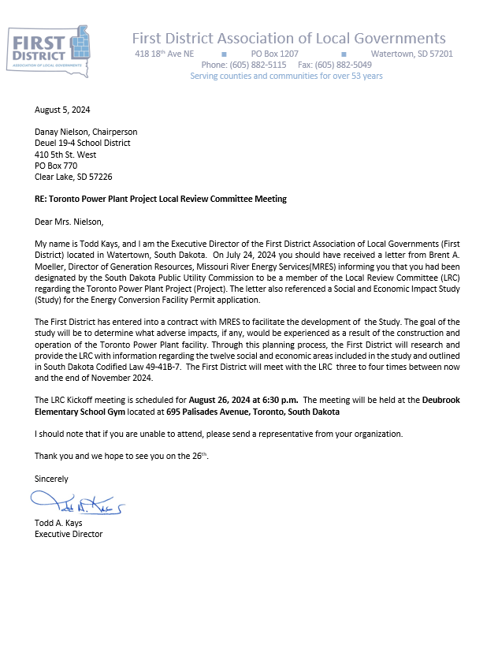
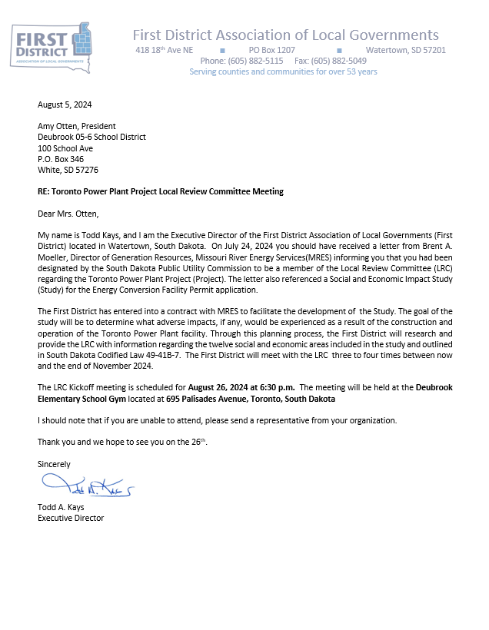
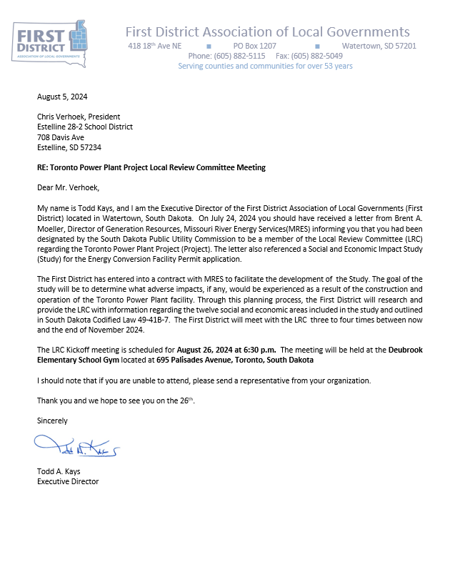
Missouri River Energy Services
Toronto Power Plant (Project)
Local Review Committee
1st Meeting
August 26, 2024 - 6:30 p.m.
Deubrook Elementary School Gym, 695 Palisades Avenue, Toronto, South Dakota
Agenda

- Welcome and Introductions – Todd Kays, First District Association of Local Governments (FDALG
- Project Description – Missouri River Energy Services
- Social and Economic Effect/Impact Study Overview – Ted Haeder
- LRC Organization
  - Elect Chairperson
  - Set second meeting date
- Adjourn

August 26, 2024 Minutes
The Toronto Power Plant Project Local Review Committee Meeting met at 6:30 on August 26, 2024 at the Deubrook Elementary School Gym, 695 Palisades Avenue, Toronto, South Dakota. In attendance were Todd Kays (First District) Ted Haeder (First District), Mason Weidenbach (First District), Harry Mewherter (Deuel County), Jay Grabow (Deuel County), Amy Otten (Deubrook School District), Larry Jensen (Brookings County), and Brent Moeller (MRES)

First District Association of Local Governments Executive Director welcomed the group and facilitated the meeting.

Brent Moeller (MRES) provided a PowerPoint presentation with an overview of the project.

Ted Haeder (First District) provided and overview of the Social and Economic Effect/Impact study that would be conducted regarding the Toronto Power Plan Project. Haeder provided information regarding the SDCL required elements of the study.

Discussion was held regarding the various components to be reviewed. Specifically noise, zoning, and taxes were brought up.

The LRC members present determined that a quorum was present and elected Jay Grabow to be the Chair. It was decided that a 2nd meeting would be held in October to discuss the initial draft of the report.

Meeting Adjourned
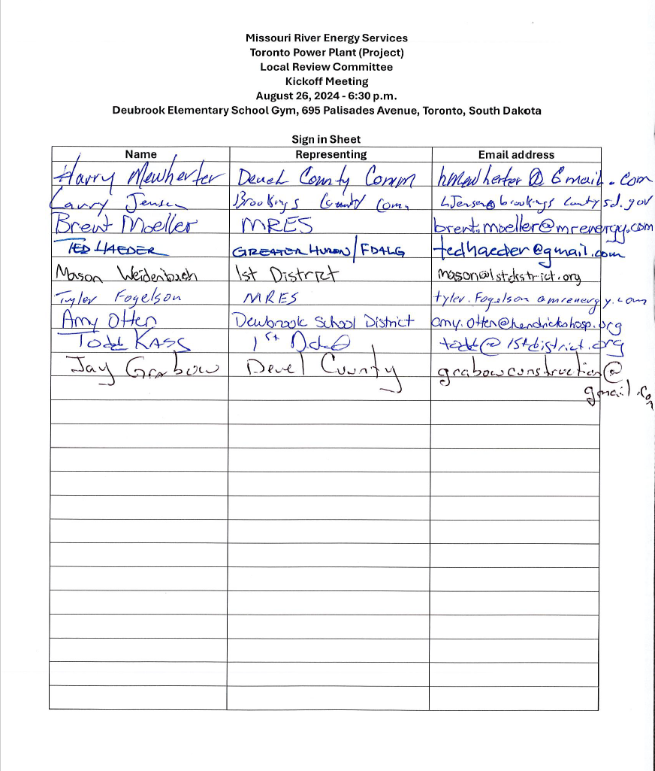

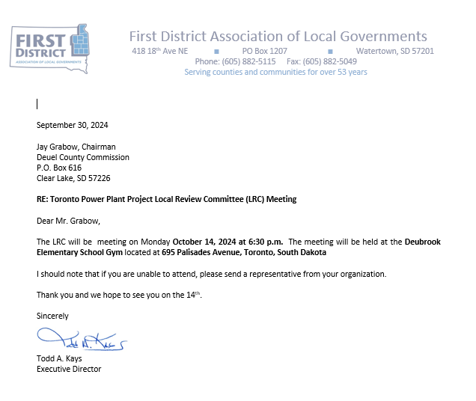

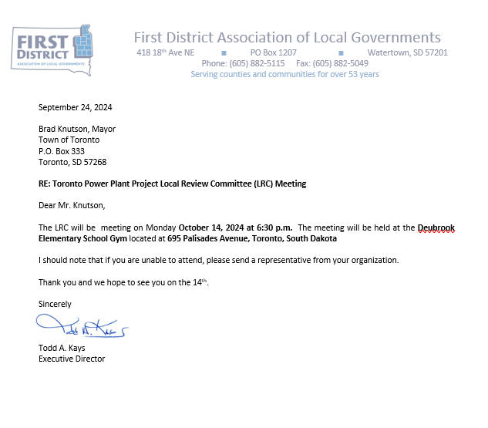
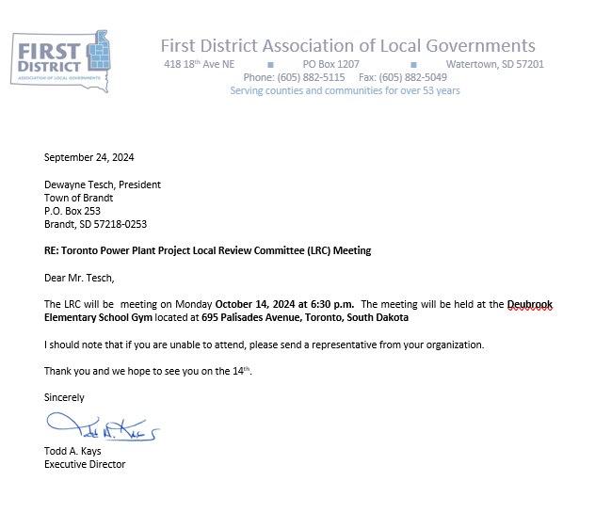
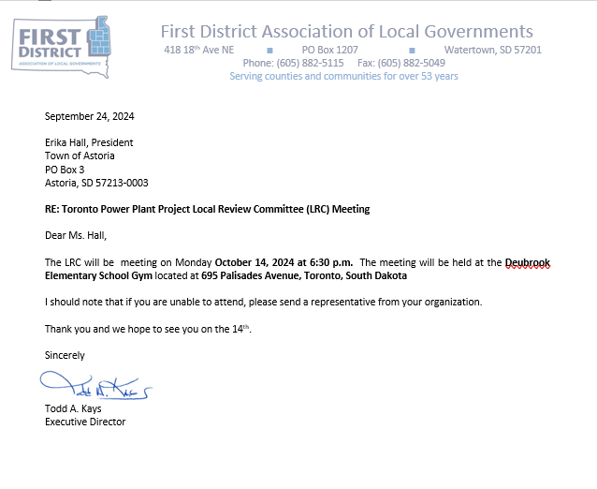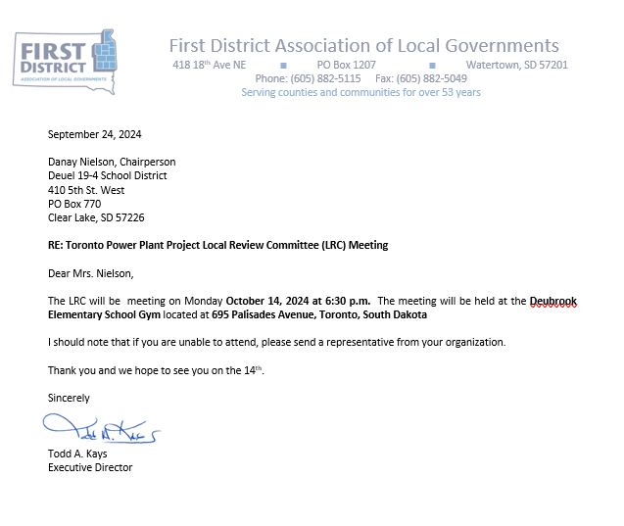

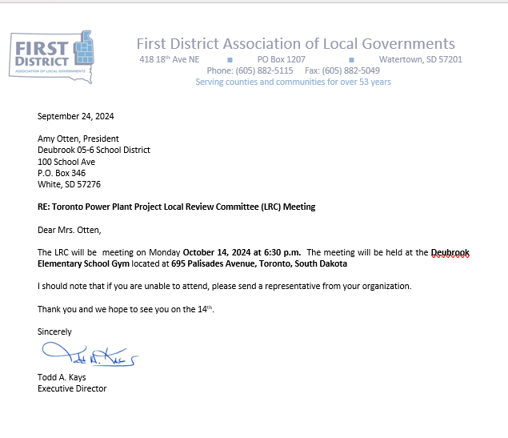
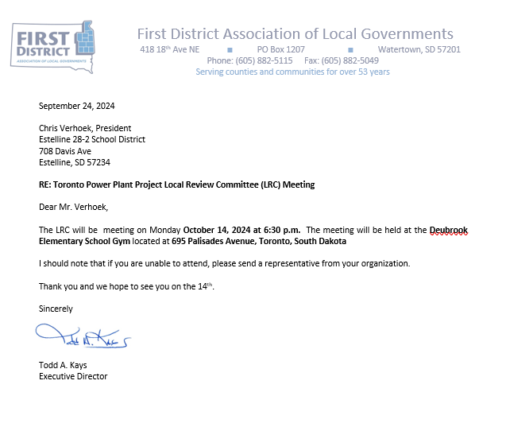
Missouri River Energy Services
Toronto Power Plant (Project)
Local Review Committee
2nd Meeting
October 14, 2024 - 6:30 p.m.
Deubrook Elementary School Gym, 695 Palisades Avenue, Toronto, South Dakota
Agenda

- Welcome and Introductions – Todd Kays, First District Association of Local Governments (FDALG)
- Approval of August 26, 2024 Minutes
- Social and Economic Effect/Impact First Draft Review – Ted Haeder
- Discussion
- Adjourn

October 14, 2024 Minutes
The Toronto Power Plant Project Local Review Committee Meeting met at 6:30 on October 14, 2024 at the Deubrook Elementary School Gym, 695 Palisades Avenue, Toronto, South Dakota. In attendance were Todd Kays (First District) Ted Haeder (First District), Harry Mewherter (Deuel County), Jay Grabow (Deuel County), Lance Gerth (Brandt), Kelly VanderWal (Brookings County), Erika Hall (Astoria), and Brent Moeller (MRES)

First District Association of Local Governments Executive Director welcomed the group and facilitated the meeting.

August 26th minutes were approved with one correction (Brent Moeller instead of Doug Moeller)

Ted Haeder (First District) provided an overview of the First Draft of the of the Social and Economic Effect/Impact study for the Toronto Power Plan Project. Haeder noted that several sections were still in development but would have information in a final draft prior to the next meeting.

Discussion was held regarding the various information provided. It was determined that each entity should take their copy of the draft report and review it and provide Haeder with comments and be prepared to discuss at next meeting. Haeder stated that the final draft should be delivered 7 to 10 days prior to the next meeting.

It was decided that a 3rd meeting would be held on November 18, 2024 to discuss the final draft of the report and possibly recommend approval of the report and forwarding it to the SDPUC

Meeting Adjourned

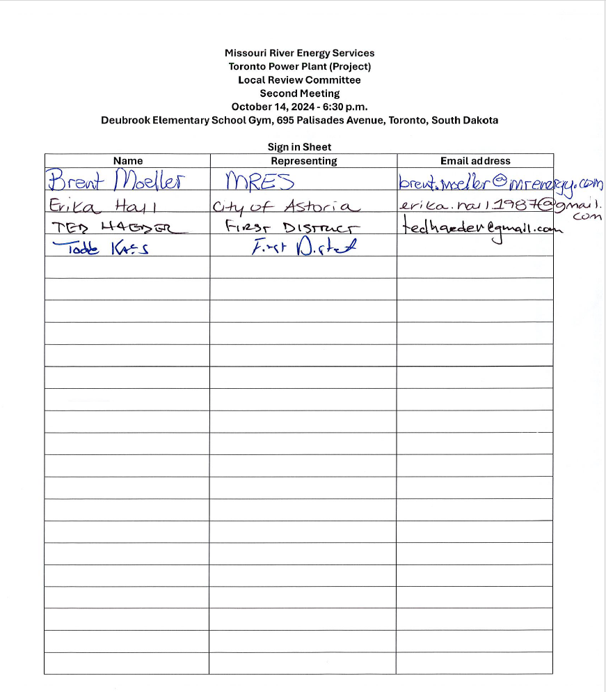

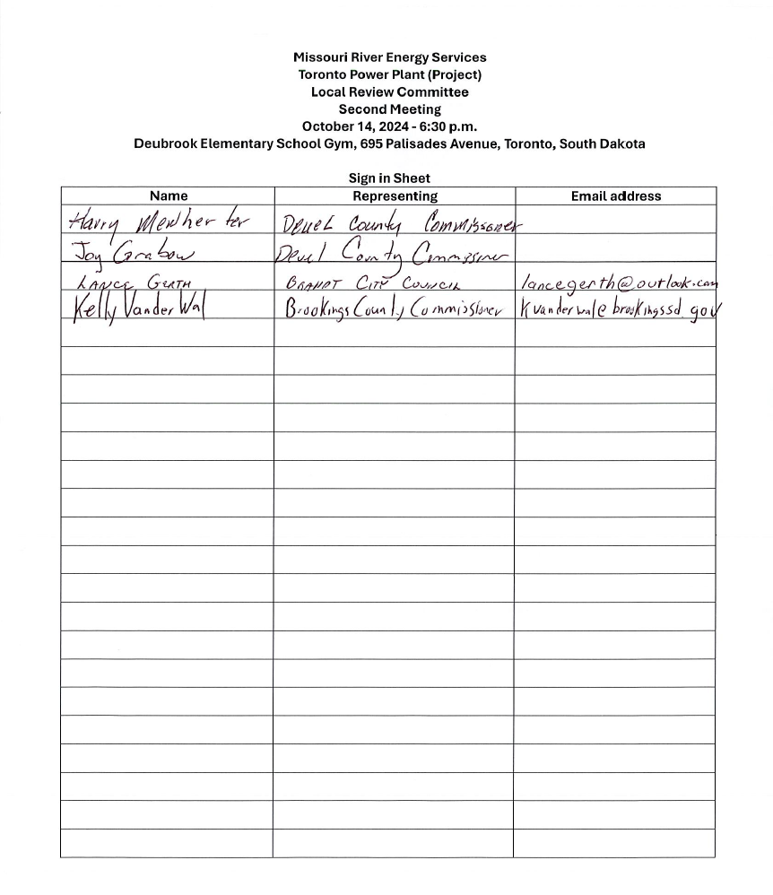
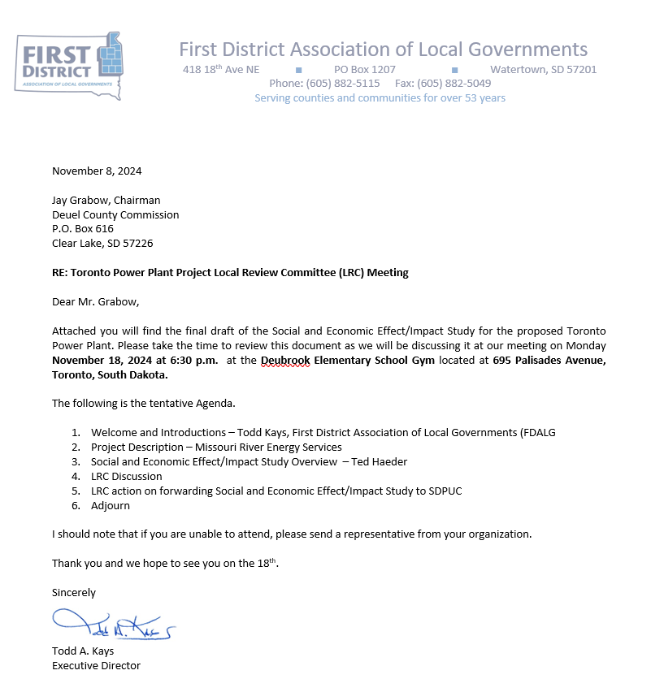
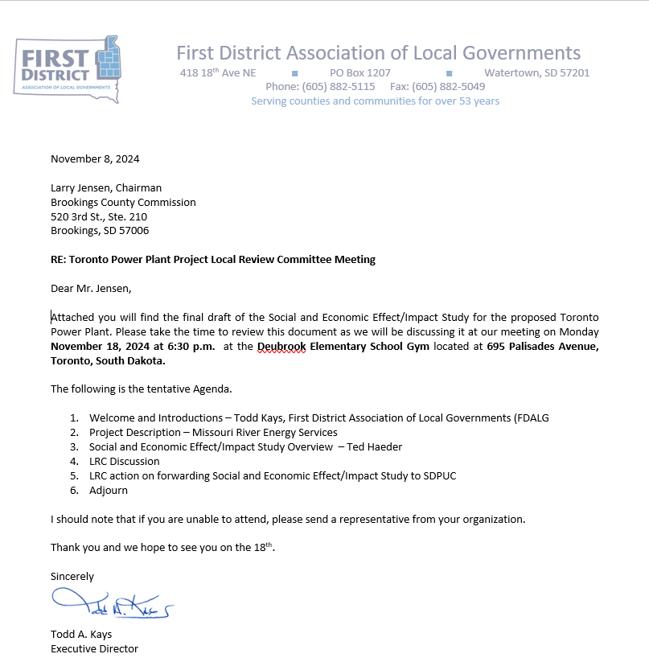
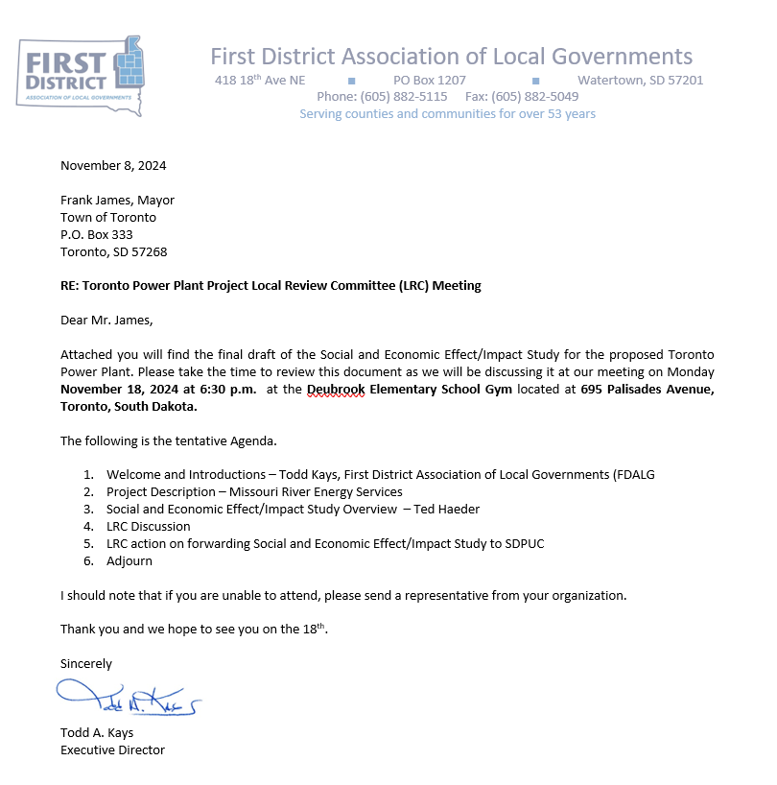
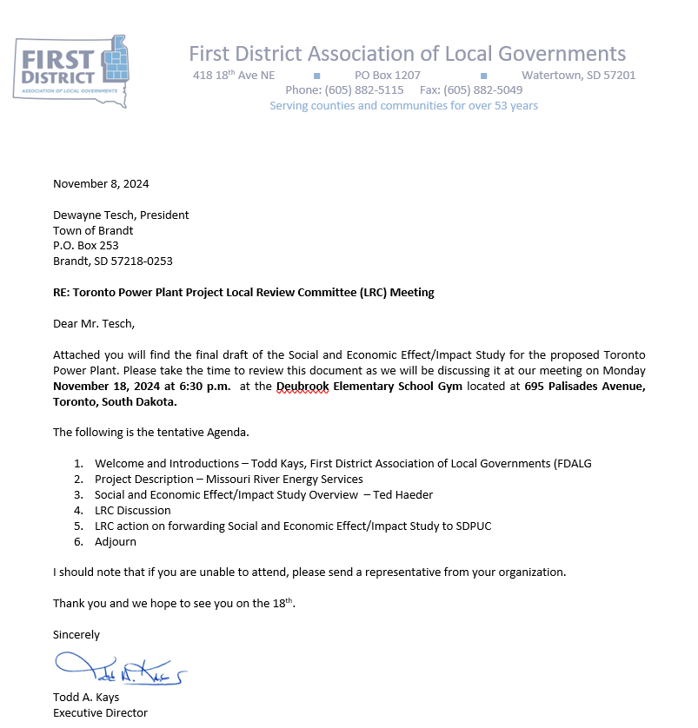
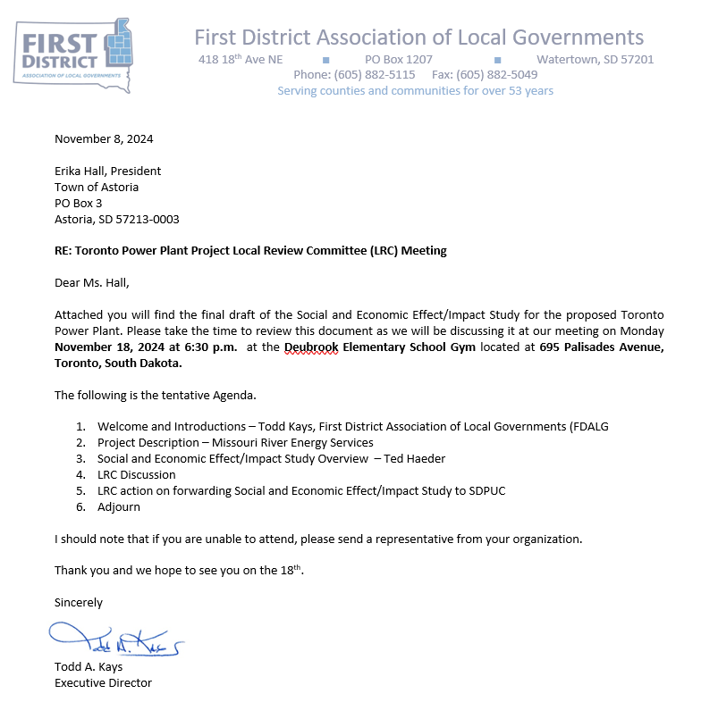
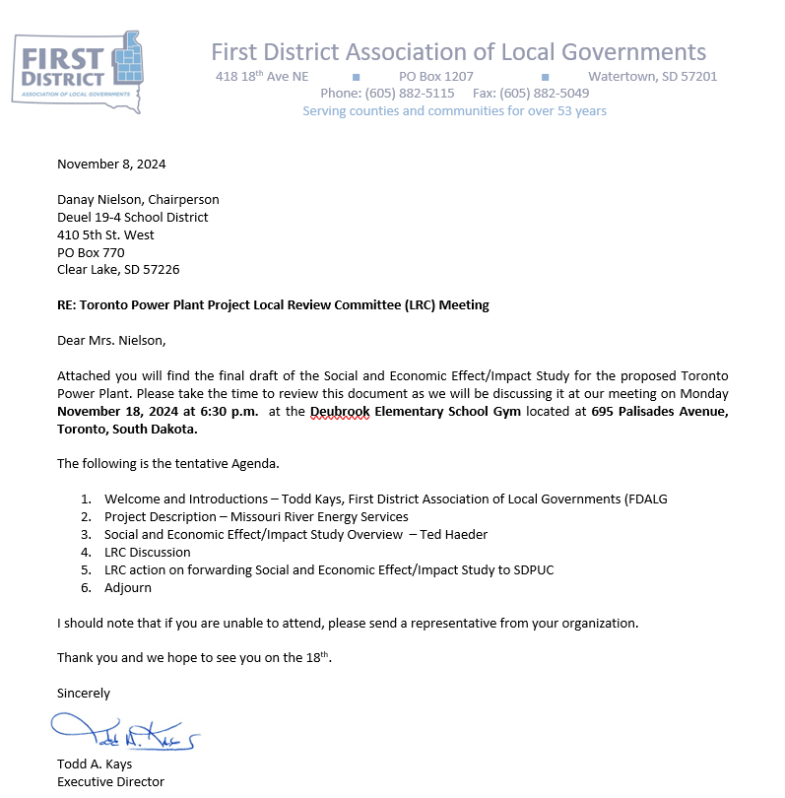
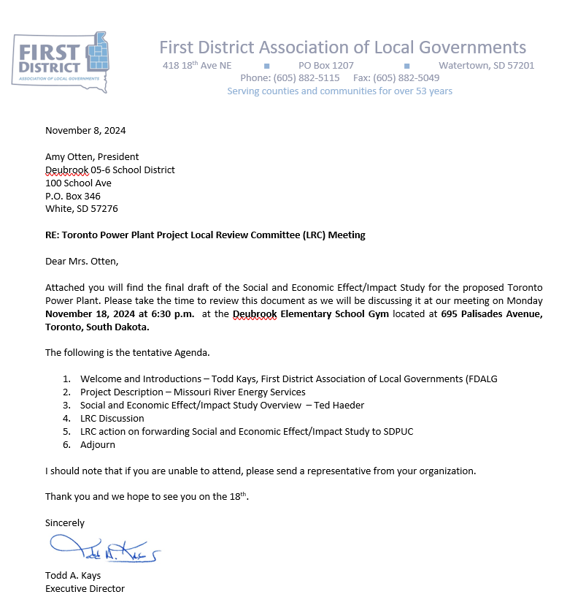
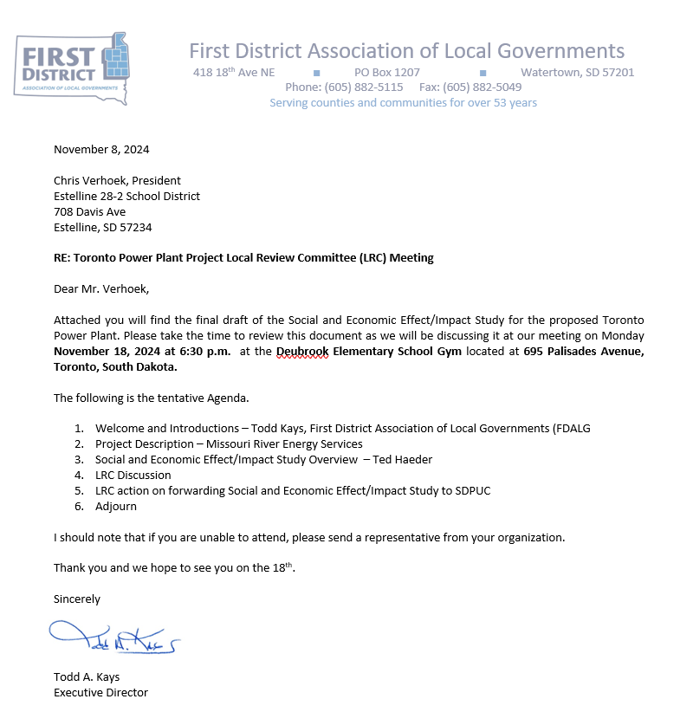
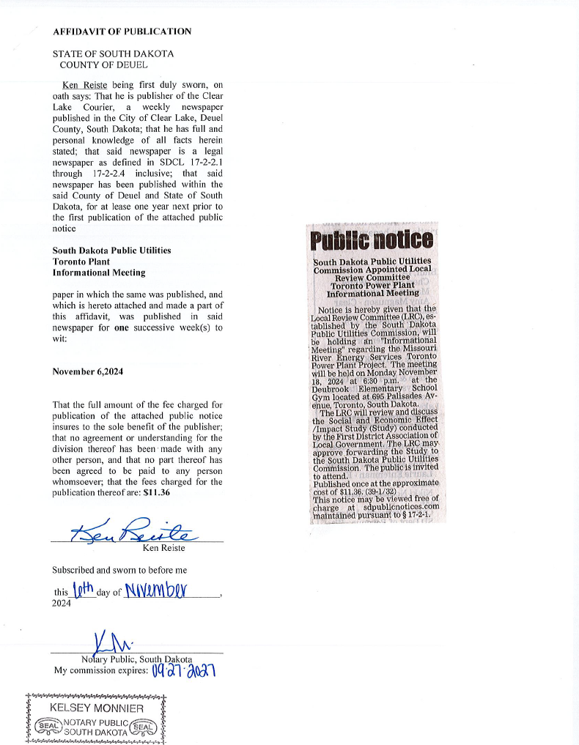
Missouri River Energy Services
Toronto Power Plant (Project)
Local Review Committee
3rd Meeting
November 18, 2024 - 6:30 p.m.
Deubrook Elementary School Gym, 695 Palisades Avenue, Toronto, South Dakota
Agenda

- Welcome and Introductions – Todd Kays, First District Association of Local Governments (FDALG
- Approval of October 14, 2024 Minutes
- Project Description – Missouri River Energy Services
- Social and Economic Effect/Impact Study Overview – Ted Haeder
- LRC Discussion
- LRC action on forwarding Social and Economic Effect/Impact Study to SDPUC
- Adjourn

November 18, 2024 Minutes
The Toronto Power Plant Project Local Review Committee Meeting met at 6:30 on November 18, 2024 at the Deubrook Elementary School Gym, 695 Palisades Avenue, Toronto, South Dakota. In attendance were Todd Kays (First District) Ted Haeder (First District), Harry Mewherter (Deuel County), Jay Grabow (Deuel County), Lance Gerth (Brandt), Larry Jensen (Brookings County), Erika Hall (Astoria), MRES Representatives: Brent Moeller, Tim Blodgett, Tyler Fogelson, Valerie Larson Holmes, Kersten Johnson; Public attendance: Gary Stave, Tony Chmeler, Kathy Kurtenbach, Wayne Kurtenbach, Sheila and Bryon Monnier, Dennis Kanengieter, Royce Harringa, Michael Crooks, Lee Crooks, Tony Quail, Allen Klappenoff, Jane Moore, Al Moore, Troy Lenning, Riley Monnier, Steve Oberde, Austin Eide, Eric Offdahl, Michelle Offdahl, Doyle Trooien, and others that did not sign in.

First District Association of Local Governments Executive Director Todd Kays welcomed the group and facilitated the meeting.

Chair Grabow and the LRC board members introduced themselves to the public

Brent Moeller (MRES) provided a power point presentation of the project for the public.

Ted Haeder (First District) provided an overview of the Final Draft of the of the Social and Economic Effect/Impact study for the Toronto Power Plan Project. Haeder reviewed the required SDCL elements contained within the report

Chair Grabow addressed the public and informed them they had the opportunity to address the LRC with questions and comments. All questions would be answered after hearing all public comments.

Tony Quale stated that his property, while not immediately adjacent to the project site, is home to threatened flora and fauna and he has concerns regarding impact of the project of animals and plants within the area.
Gary Stava asked whether or not there was potential for groundwater pollution

Steve Oberde asked about the noise generated from the facility

Sheila Monnier had questions and concerns regarding possible explosions and blast radius.

Michelle Offdahl asked whether the board not only look at the decibel readings of noise but the frequency as well.

Eric Offdahl had questions regarding training of fire departments and what the expectations of the facility were in regard to fire suppression.

Doyle Trooien wanted to know what the project will do to adjoining property values.

Tony Chmeler stated that the project may be constructed while SD Highway 28 may be either under construction or just being completed and had concerns that Highway 28 could be damaged.

Al Moor asked questions on where the project will obtain their water and how much water do they need.

Roy Negard (spelling) asked about the horsepower of the engines, how much diesel would be used and whether or not it would drain diesel supplies within the region.

Troy Lenning asked how often will the plant be in operation.

Chair Grabow had Todd Kays review the questions with Brent Moeller from MRES. Moeller provided the following responses:

Regarding impact to flora, fauna and animals – MRES will be conducting an environmental review of their 71-acre site.

Regarding groundwater – The site is designed to be a zero-discharge facility.

Regarding noise – The project will follow the County’s noise ordinance.

Regarding fire department response and training – the project will have fire suppression measures as part of its design and will provide training opportunities to local fire departments.

Regarding impact to property values – Kays and Haeder stated that their research of similar projects in Deuel County and Brookings County have not shown a decline in property values.

Regarding Highway 28 and other roads – The project will have haul road agreements as part of its local and State permits.

Regarding water – The project may dig wells, but their water needs will be very limited. Primarily need water for on-site water tanks for fire suppression.

Regarding impact on Diesel in the area. Diesel usage should be in the months of January and February where it does not conflict with planting and harvesting. There should be plenty of diesel available at either Watertown or Sioux Falls facilities.

Regarding how often the plant will be running. It will depend on need. Do not expect it to be running more than 50 percent of the time. Probably 10 to 20% of the time.

Discussion was held regarding the various information provided. The LRC elected to amend the draft report to include mitigation activities related to transportation and school bus traffic; Response training for hospitals and ambulance services, and a statement regarding a recommendation for the SDPUC to include high voltage electric fields from transmission lines and impact on health in their review. The LRC set December 10, 2024 as the next meeting to review the final draft of the report and possibly recommend approval of the report and forward it to the SDPUC

Meeting Adjourned

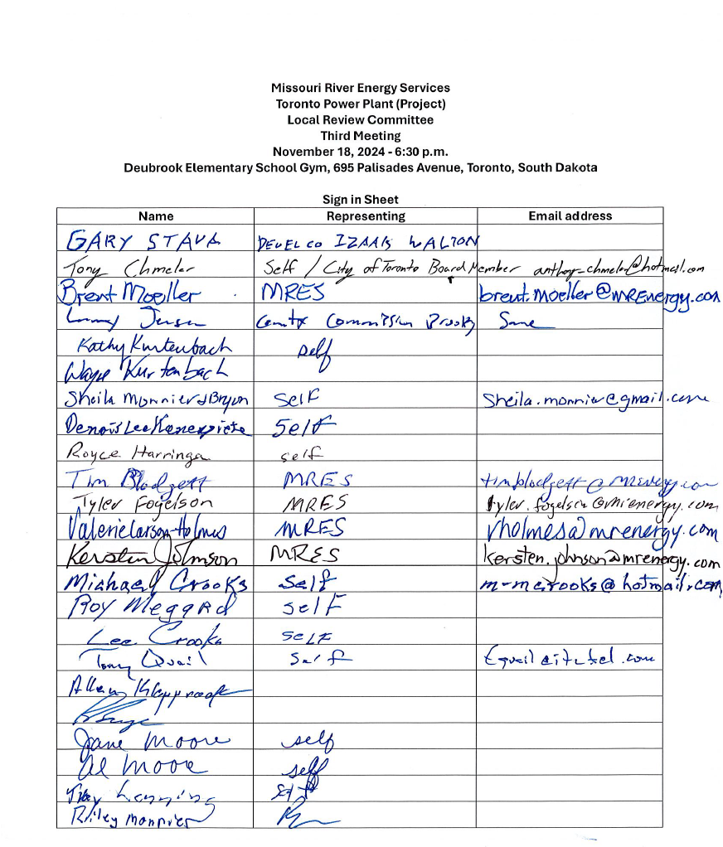
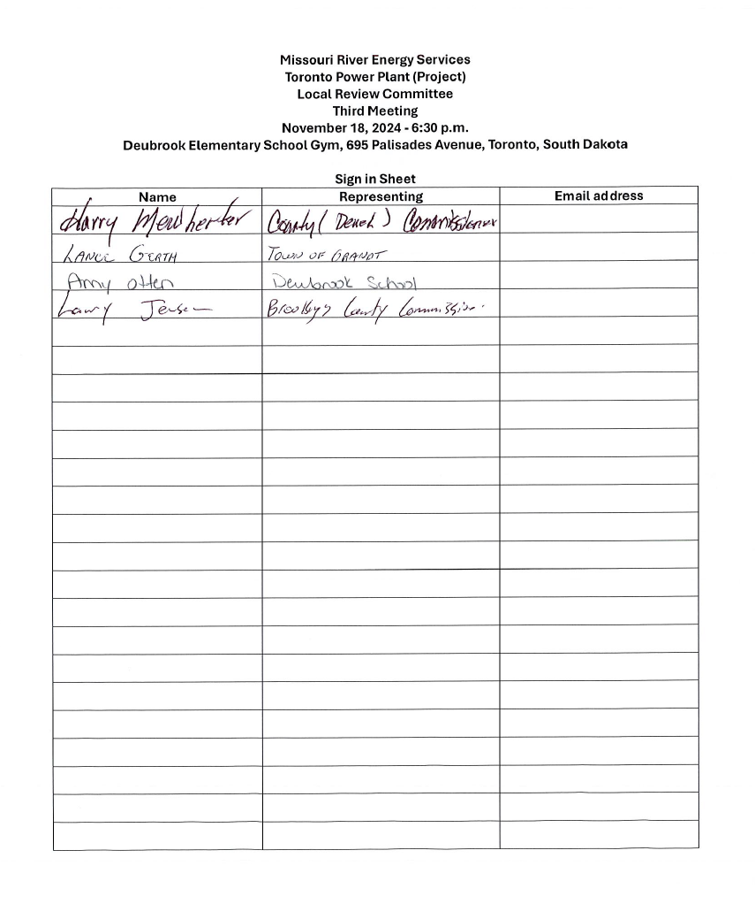

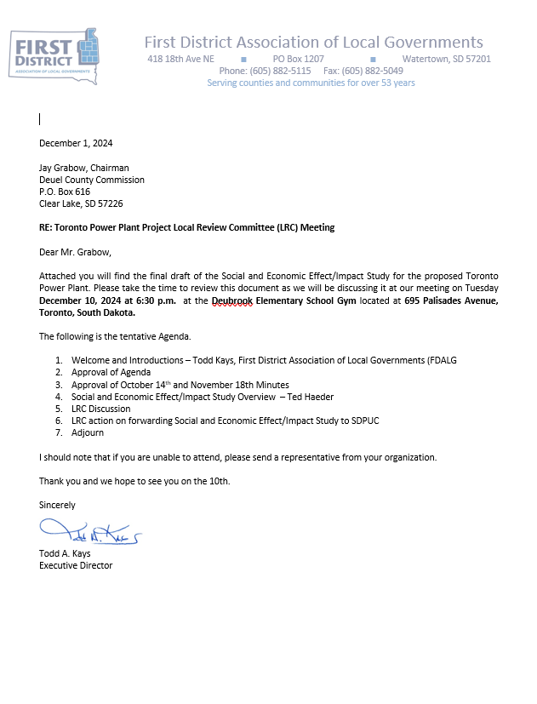
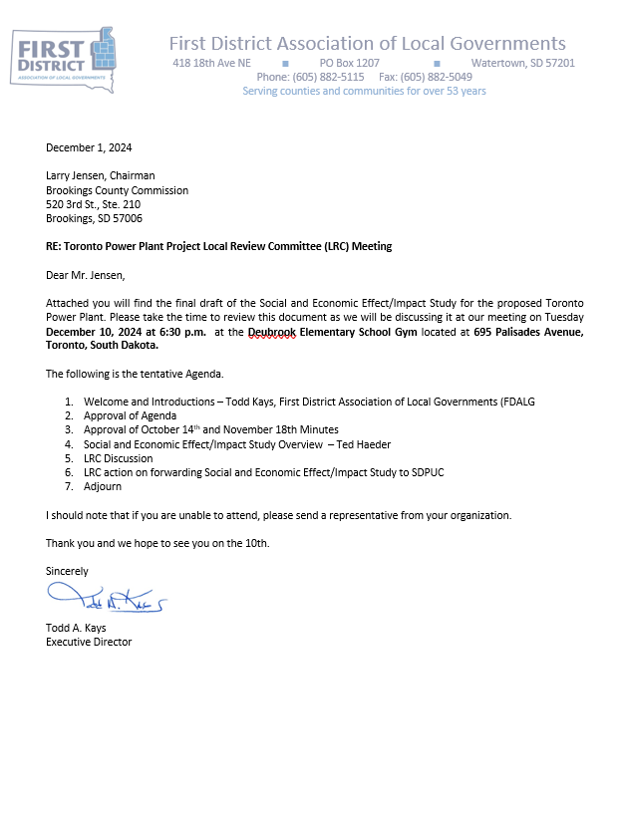
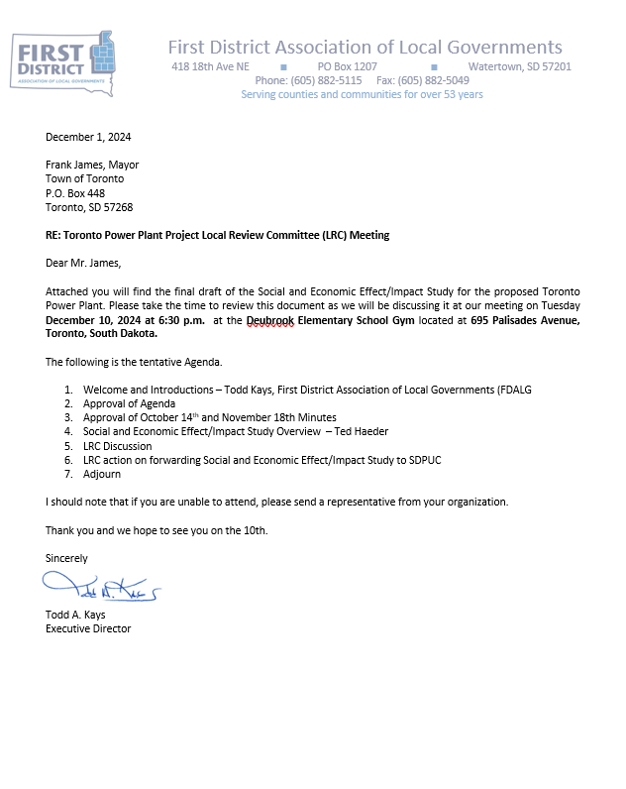
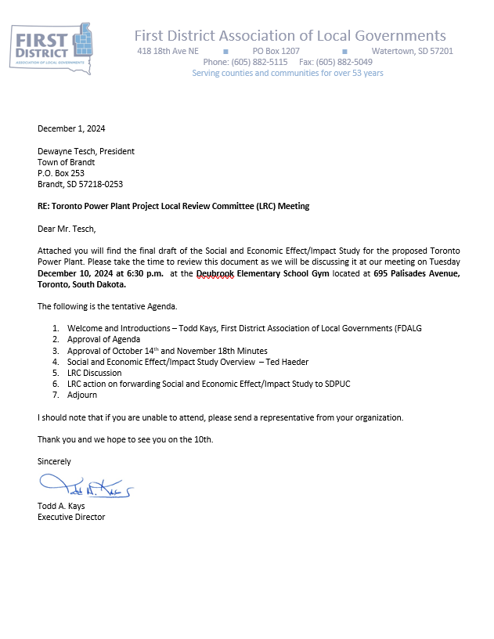
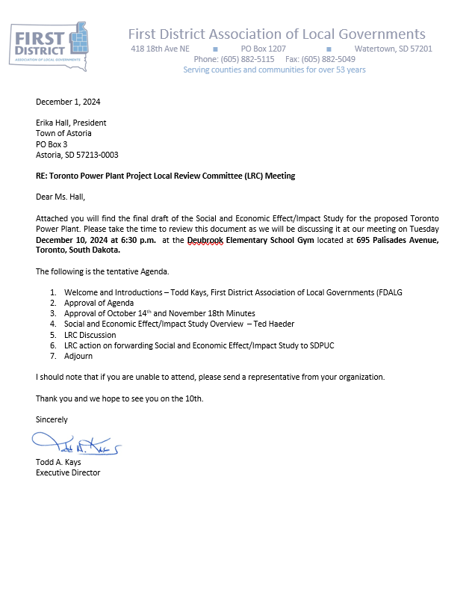
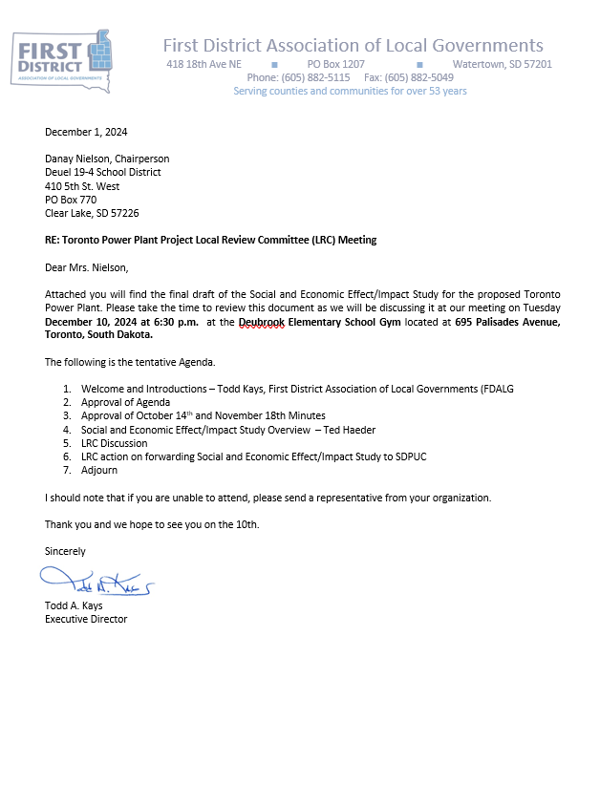
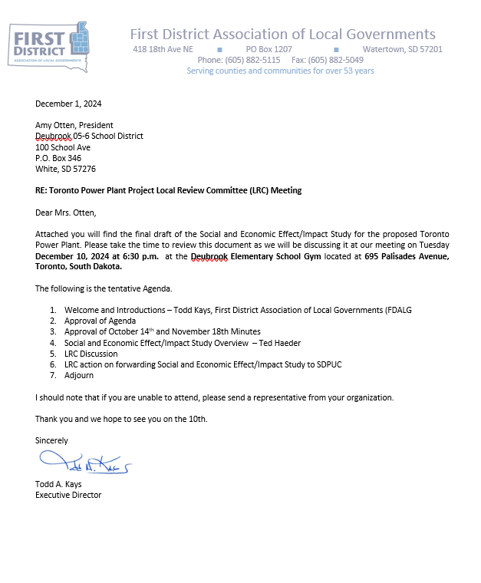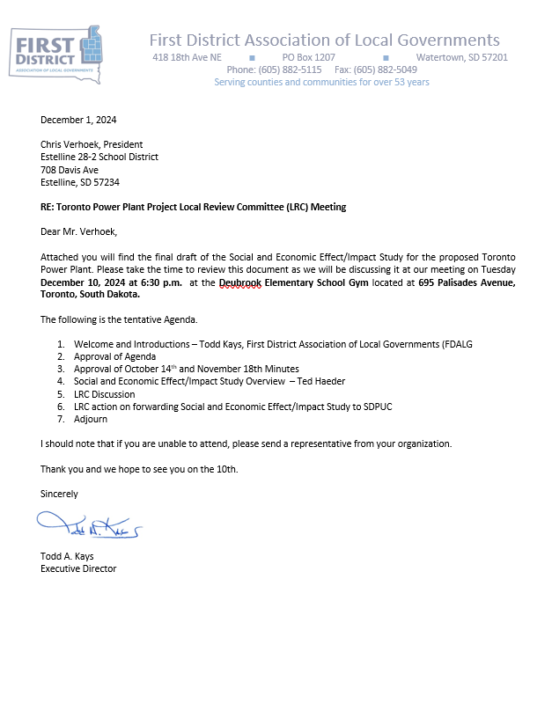
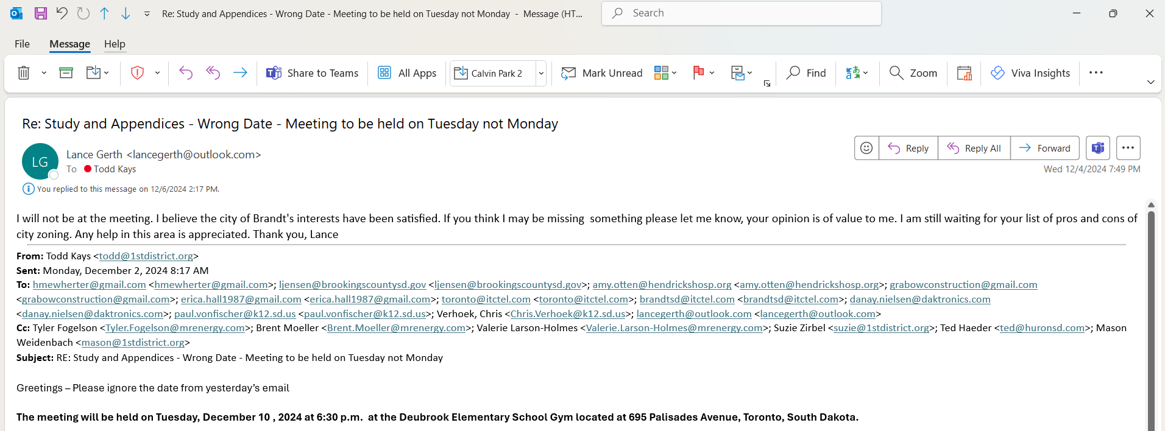
Response letters from Deubrook School District, Estelline School District and Town of Brandt concurring with Study.
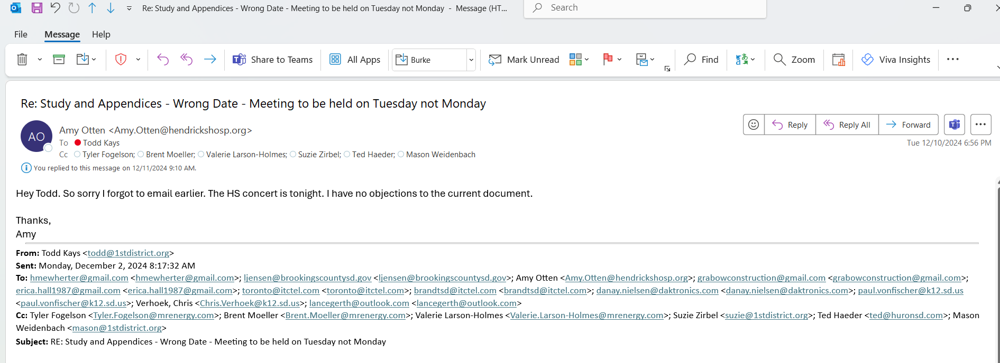
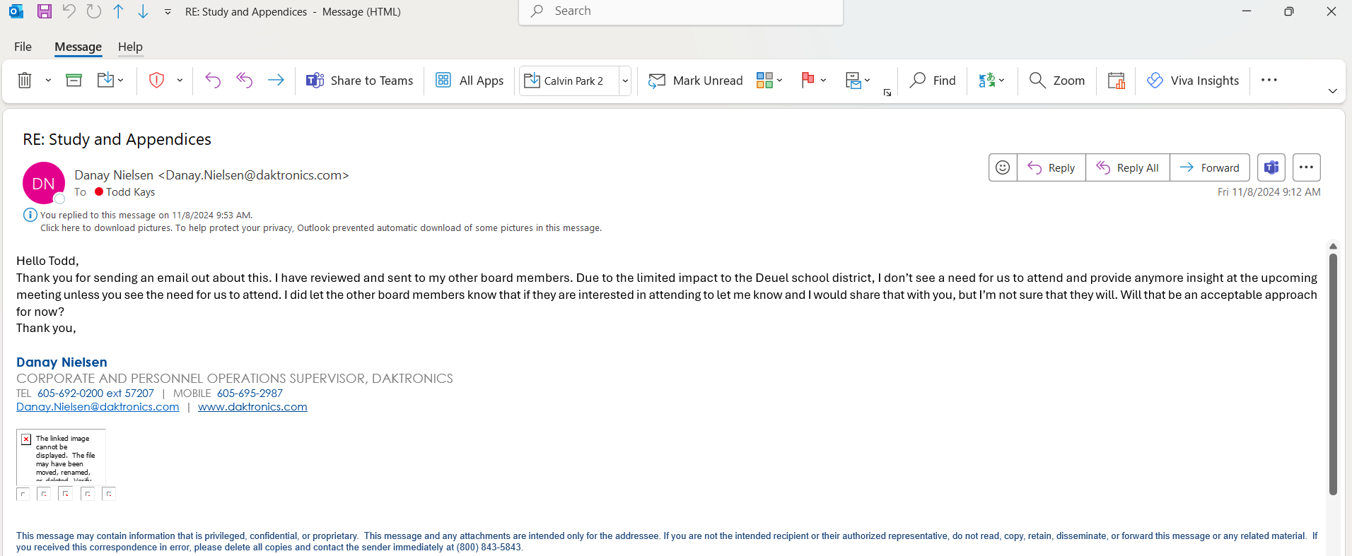
Missouri River Energy Services
Toronto Power Plant (Project)
Local Review Committee
4th Meeting
December 10, 2024 - 6:30 p.m.
Deubrook Elementary School Gym, 695 Palisades Avenue, Toronto, South Dakota
Agenda

- Welcome and Introductions – Todd Kays, First District Association of Local Governments (FDALG)
- Approval of Agenda
- Approval of October 14th and November 18th Minutes
- Social and Economic Effect/Impact Study Overview – Ted Haeder
- LRC Discussion
- LRC action on forwarding Social and Economic Effect/Impact Study to SDPUC
- Adjourn
December 10, 2024 Minutes
The Toronto Power Plant Project Local Review Committee Meeting met at 6:30 on December 10, 2024 at the Deubrook Elementary School Gym, 695 Palisades Avenue, Toronto, South Dakota. In attendance were Todd Kays (First District) Ted Haeder (First District), Harry Mewherter (Deuel County), Jay Grabow (Deuel County), Larry Jensen (Brookings County), MRES Representatives: Brent Moeller, Tim Blodgett, Tyler Fogelson, Public attendance: Corey Borg.

Chair Grabow called meeting to order.

Motion to approve Agenda: Motion by Jensen, 2nd by Mewherter – Motion approved

First District Association of Local Governments Executive Director Todd Kays welcomed the group and facilitated the meeting.

Motion to approve October 14, 2024 minutes - Motion by Mewherter, 2nd by Jensen – Motion approved

Motion to approve November 18, 2024 minutes - Motion by Jensen, 2nd by Mewherter – Motion approved

Ted Haeder (First District) provided an overview of the changes incorporated into the final draft since the November 18, 2024 meeting.

Discussion was held on the information provided.

Kays informed the LRC that he had received emails from LRC board members Amy Otten representing Deubrook School District, Lance Gerth representing Town of Brandt, and Danay Nielson representing Estelline School District stating, The emails stated that they would not be in attendance but were all comfortable with the final draft.

Brent Moeller (MRES) stated to the Board that while MRES is party to the draft and the LRC – he would not be voting on the final draft.
Motion to approve the final draft of the Social and Economic Effect/Impact Study for the Toronto Power Plant and have the First District Association of Local Governments forward the study to the SDPUC subject to an application being submitted by MRES: Motion by Jensen, 2nd by Mewherter – Motion approved.

Meeting adjourned.

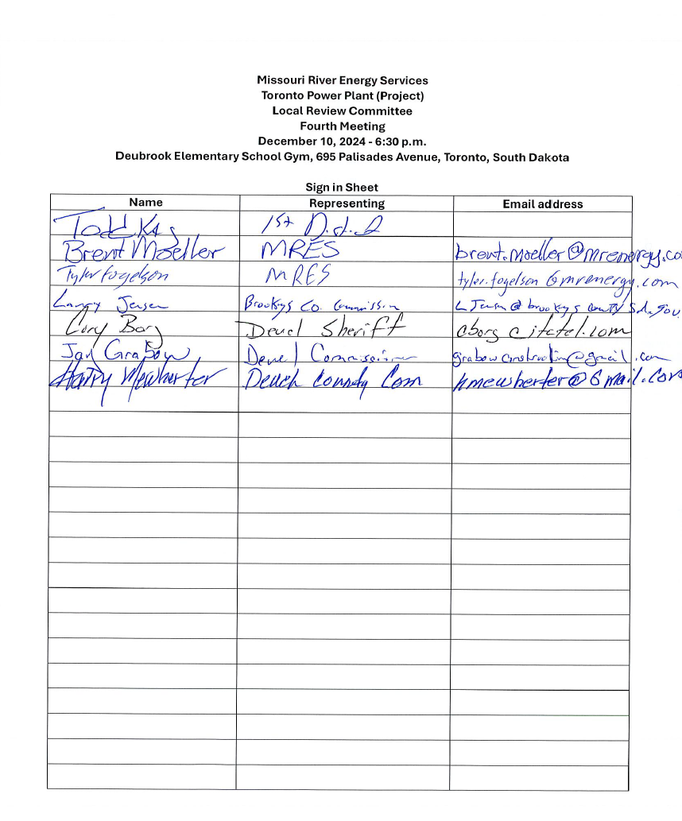
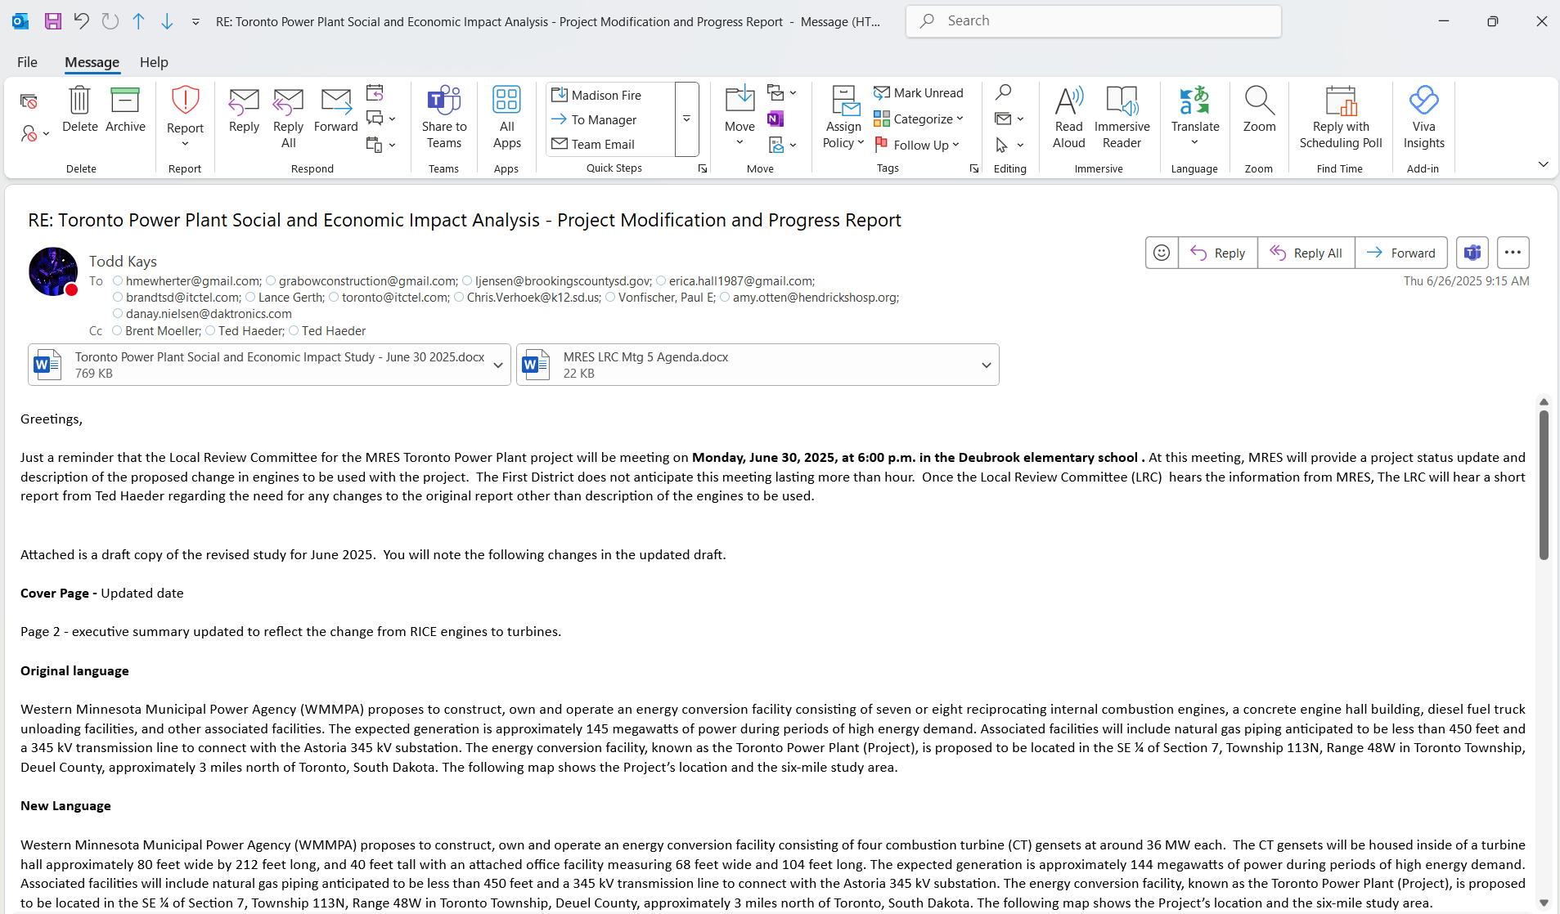
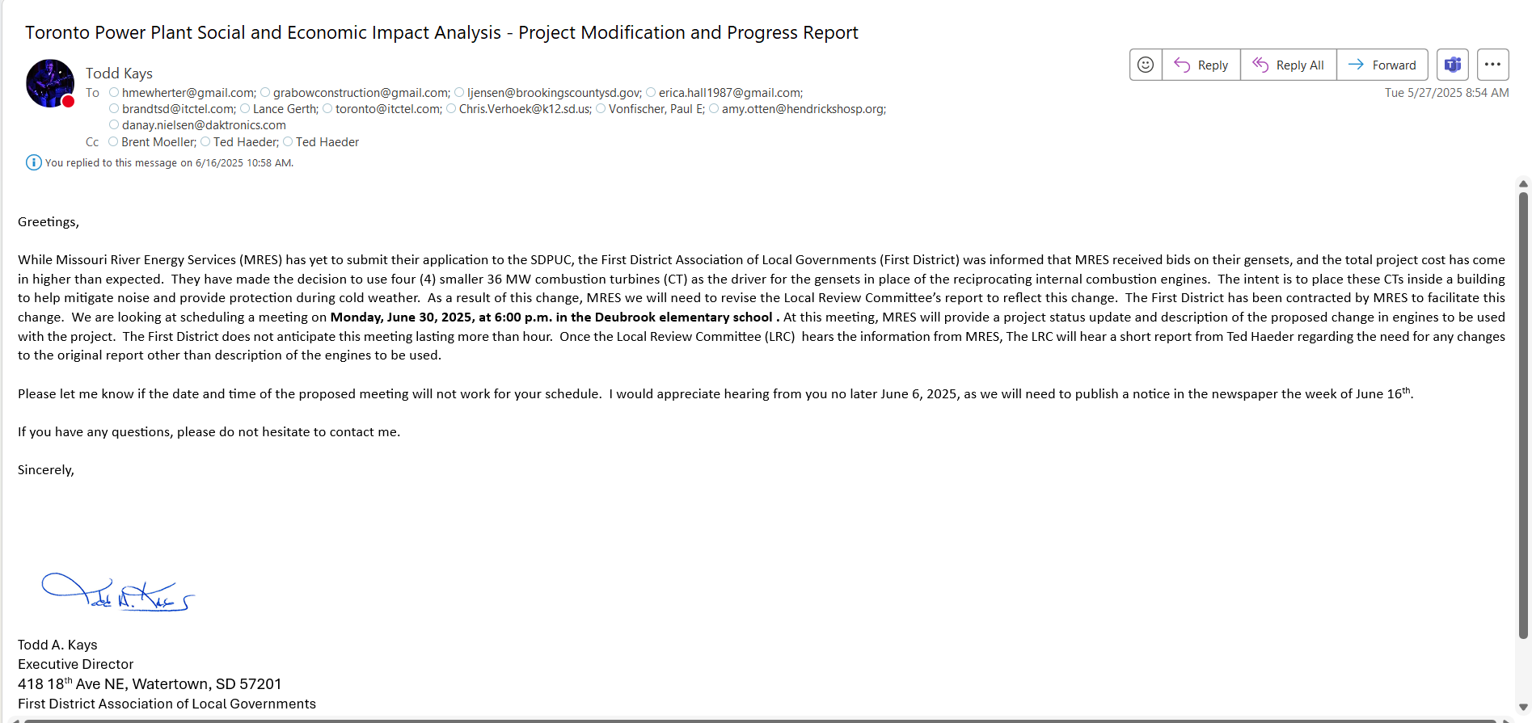

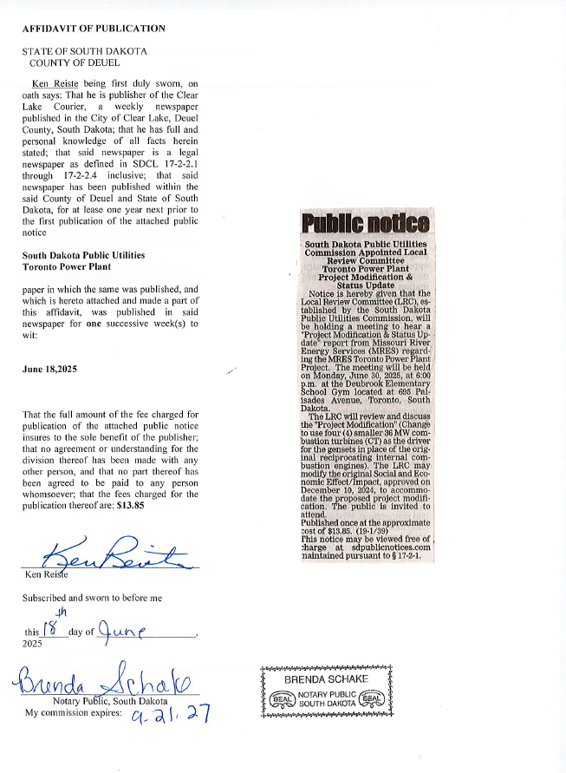
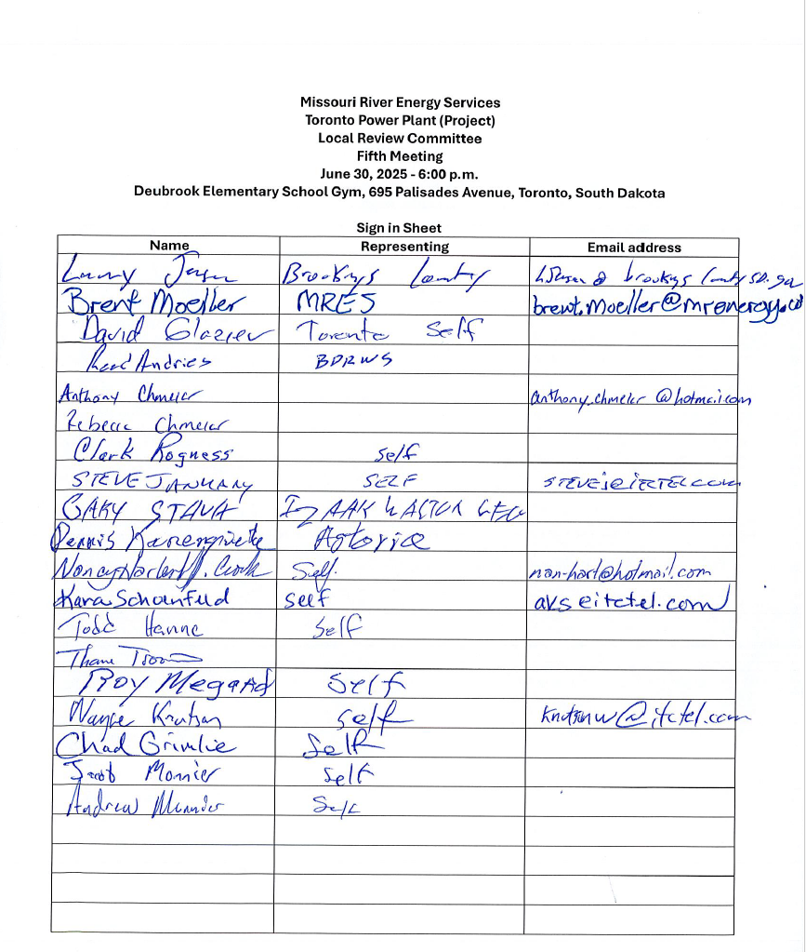

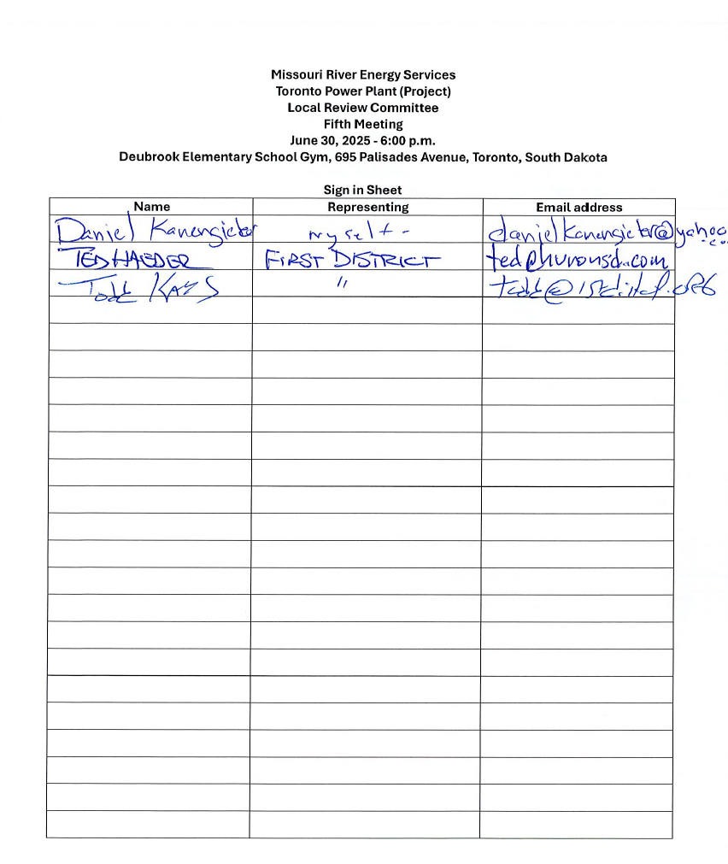
Missouri River Energy Services
Toronto Power Plant (Project)
Local Review Committee
5th Meeting
June 30, 2025 - 6:00 p.m.
Deubrook Elementary School Gym, 695 Palisades Avenue, Toronto, South Dakota

Agenda

- Welcome and Introductions – Todd Kays, First District Association of Local Governments (FDALG)
- Approval of Agenda
- Project Status Update and Description of proposed change to site layout and change of RICE engines to Internal Combustion engines as drive technology to the gensets
- Impact of proposed change on the previously approved Social and Economic Effect/Impact Study – Ted Haeder
- LRC Discussion
- LRC action on forwarding amended Social and Economic Effect/Impact Study to SDPUC
- Approve June 30, 2025 minutes
- Adjourn

