Hamlin County Planning Commission & Board of Adjustment
Staff Report
Monday October 28th, 2019 – 7:00PM
Planning Commission

Item #1: Stephanie Vetter: 10 minutes

Item #2: Zoning Question: Lake Poinsett and CUP with new lot development.

Board of Adjustment

Old Business:

ITEM #1 Conditional Use

Applicant/Owner: Schubloom Construction/Doug & Marilyn Amen
Property Description: Nitteberg Beach: E 25’ of Lot 35 & All of Lot 36 & 37 Less E 25’ of Lot 37 in Section 20, Township 113N, Range 52W of the 5th P.M., Hamlin County, South Dakota.
Action Items: Conditional Use – attached garage with dimensions greater than 36’ x 42’ with sidewalls greater than 10 ½’ (Section 3.07.05.7)
Zoning Designation: LP1 – Lake Park District 1
Request: Applicant is seeking to construct an unattached garage on their lakefront property.

Location:
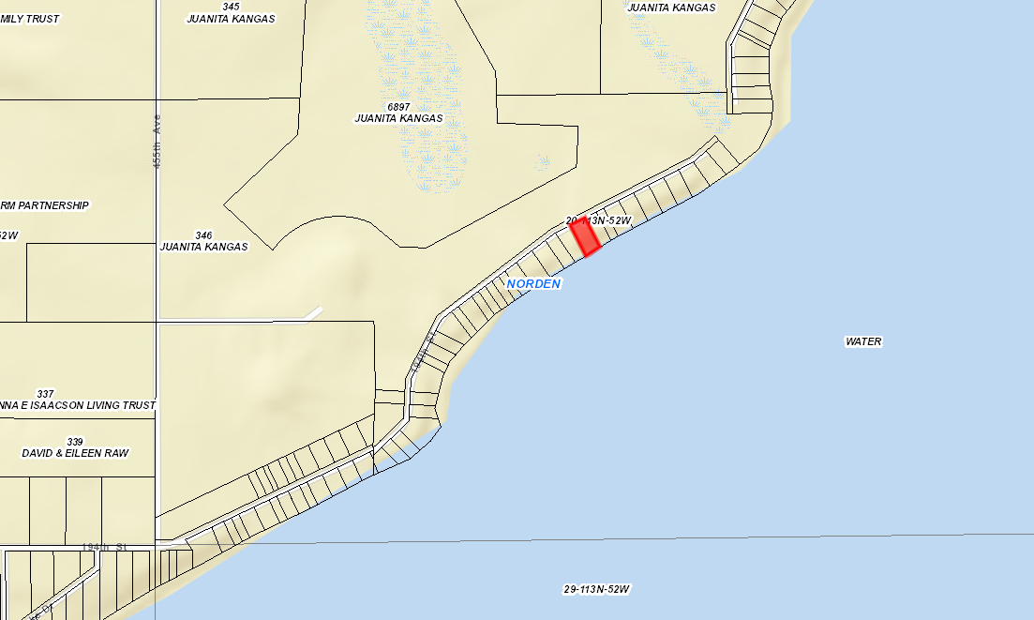

Amendment to the Conditions granted at the September 2019 BOA Meeting.
Update: I have attached a letter from the Amen’s providing a more detailed description of stated reasons for the placement of the garage in its original position. I have also included in the presentation a better look at the placement of the garage on the ground and how that will affect site lines and distances from structures and setbacks. After seeing the placement and subsequent consideration, Staff recommends the approval of the CUP on its original placement and would seek a motion to amend the conditions that were placed on the granting of the permit from the September meeting.

Issues:
- Applicant is seeking to construct a 26’ x 48’ garage with 14’ sidewalls on their lakefront property.
  - Currently there is an 8’ x 16’ lawn shed and existing house on the property with no garage on the lakefront or backlot property. Lawn shed will be moved to NW portion of the property and continue to be used.
- Zoning Ordinance requires a conditional use for unattached garages with dimensions greater than 36’ x 42’ with sidewalls greater than 10 ½’.
- Site location of the new addition onto the existing garages meets all necessary setbacks from front yard, side yard and rear yard.
  - Existing house sits 50’ from the shoreline and the garage will be setback from the house ensuring it meets the rear yard lake front setback.
- While most unattached garages larger than allowed by a building permit sit on the backlot property, the design allows for it to meet all the setbacks and sit on the lake front property.
- The property owner to the east of the current site has provided a letter which is included in your packet explaining their opposition to the proposed plans. Update: The Paulson’s have remained opposed to the proposed garage and I will let the Paulson’s explain their side.
  - There is no requirement that larger garages be placed on the backlot property in the zoning Ordinance. With no backlot property available across the road for the applicant, they believe this is the best location for their garage which they intend to use for personal storage of vehicles and materials.
- The proposed structure, compared to its immediate neighbors, would be a larger garage than on these properties. As seen across the lake, large size garages are commonplace and have been approved by the Board on numerous occasions. Neighbor objections are not a valid finding of fact for denial in this conditional use application. Similar large structures (dwellings & accessory structures) are placed along this stretch of West Lake Drive and in staff’s perspective would not decrease neighborhood building quality or form factor to this portion of Lake Poinsett.

Staff recommendation – Staff recommends approval based upon the following:
- The garage meets all necessary setback regulations.
- The garage fits in with similar sized buildings across Lake Poinsett that are used for personal storage.
- Photos from a site visit show the placement of the garage will not affect the site lines of neighboring properties.

Board Action: Conditional Use: Attached Garage with dimensions greater than 36 feet x 42 feet with sidewalls greater than 10 ½’: The Board may: 1) Postpone the decision 2) Deny the Request 3) Approve the request with or without conditions.

ITEM # 2 Conditional Use: Claremont Colony CAFO

Update:
this agenda item will proceed tonight beginning at the Board Discussion portion of the hearing. No public hearing will occur as it was closed last month before the motion to postpone was made.

After the September Meeting, Dakota Environmental made an additional soil boring/test well between the proposed site and the Uthe’s property. Based on that information, the water source for the proposed CAFO and the Uthe’s are separate. The Uthe’s get their water from a different source than what the CAFO would use. The Uthe’s well is 260’ and goes through multiple layers of clay, dirt, and rock that protects it from contamination.
To ensure the proposed CAFO would not pollute the Uthe’s well, Dakota Environmental would need to dig a test well 260’ between the two sites and use that as the basis to provide monitoring for both sites. Brian, from Dakota Environmental stated that this is not within their current capabilities and thus they would need to outsource it. The cost of providing SRW to the Uthe’s comes in at $25,000. The test well 260’ would, by estimate, cost much more than that over the long term with testing. This would be an undue burden on both ends, in Staff’s perspective, to force the applicant to make either of these payments as they would not accomplish what we all seek: protection of clean drinking water.
The issue at hand still stands that the Uthe’s well is 2100’ from the proposed dairy, this sits within the half mile setback that is required for all private wells(no distinction in use) thus a setback variance is required and with This information, we should approve a variance to a reduced setback from the well based upon the stated reasons above about different water sources and undue burdens on the applicant. Beyond this, the CUP application has all the necessary information and is recommended for approval.

Applicant/Owner: Glen Waldner/Claremont Colony Hutterian Brethren Inc.
Property Description: E ½ of Section 4, Township 114N, Range 51W of the 5th P.M., Hamlin County, South Dakota.
Action Items: Conditional Use - Class A CAFO (Section 3.04.04.9)
Zoning Designation: Agricultural
Request: The applicant seeks to develop a new 3,000 finishing swine barn and an expansion of existing swine population within existing confinement barns.

Staff Review of Application:
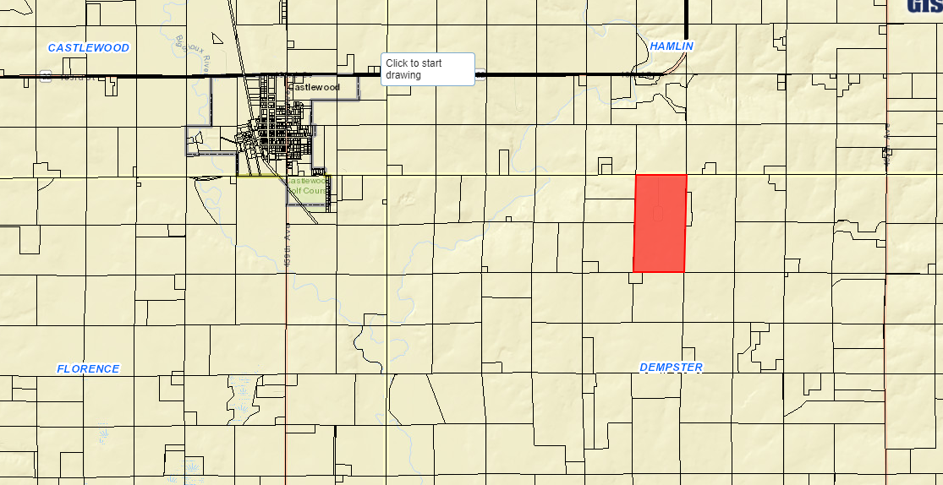
Location

Overview of Application Materials (Section 5.25.05.11)
- Claremont Colony seeks to establish a new finishing swine barn operation with 3,000 head (1,200 AU’s) as well as an expansion of existing swine operations on site. They have enlisted the help of Dakota Environmental to proper the application materials and engineering services in the construction of the proposed site.
  - In addition to the new nursery swine barn (3,000 head) the total nursery swine population will increase from 1,953 to 4,200. Finishing swine will increase from currently 5,100 head to 6,080 head. And sows would increase from 825 to 1,150 head.
    - 420 AU’s Nursery Swine, 2,432 AU’s Finishing Swine, 4,255 AU’s Sows and 3 Boars.
  - Claremont has an existing State General Permit from DENR for existing hog operations and has been approved for the expansion (9/24/2015) but construction of the expansion did not occur and thus necessitates a reapplication at the County and State level.
- Proposed new operation will have one self-contained barn with eight-foot-deep concrete pits beneath for manure storage and house the new 3,000 head (1,200 AU’s) and modifications (listed in the NMP and MMP) will be made to the existing barns to account for the increase in population.
- The initial Nutrient Management Plan has been developed using DENR General Permit requirements. They have included information concerning proposed population, storage, application methods, land available for application, crop yield projections, and soils test data. The land where manure will be applied has been approved by DENR as a part of the Main Claremont Colony CAFO for the existing operations and the NMP accounts for the increase in population in terms of land available for applications.
- The Manure Management and Operation Plan is included as well, meeting DENR General Permit standards. Site has been engineered for manure containment for over 365 days, which is more than the required minimum storage size.
  - Applicant’s operation is designed to be a zero-discharge operation.
- A Management plan for fly and odor control is also included in the application materials
- The proposed site meets all required setbacks for a Class A CAFO which include
  - ½ mile from established residences and private wells (2 waivers required and signed)
    - Well on Uthe property – recommended condition to add monitoring devices on site and on Uthe property for water quality management.
  - 150’ off Township ROW (185th Street) and 300’ off County ROW (463th Avenue)
- SD DENR will provide additional oversight and review of all submitted application materials such as engineering plans, nutrient management plan, manure management and operation plan, and the fly and odor control management plan.
  - Operation of the Class A CAFO required a certificate of compliance before stocking of the barns can occur. Approval from DENR of engineered design plans are required before Zoning Office can approve a building permit.
- All information on soils, shallow aquifers, designated wellhead protection areas, and 100-year floodplain designations have been included. The proposed site does not site above Zone B of the Aquifer Protection District or any areas designated as being a part of the FEMA Mapped floodplain.
  - Portions of the property are classified as potential floodplain in the FEMA Discovery Map.
- Dempster Township Officials and Sioux Rural Water were sent letters concerned the proposed use as they the application Road and Water Authorities. Property owners within one mile were notified of the proposed use and given the opportunity to provide their comments before the public hearing.
  - As of the time writing this report, Staff has received three comments from the public stating their opposition to the proposed expansion.

Staff Recommendation: Staff recommends approval with conditions placed in a letter of assurance as follows below:
Conditional Use Permit – Class A CAFO: The Board may postpone the decision, deny the request or approve the request. If approved, the staff recommends, at a minimum, the following conditions:

- The applicant agrees to comply with the submitted nutrient management plan, fly and odor management plan, and manure management plan.
- Applicant shall provide updated information regarding fields included in the nutrient management plans upon request by the Zoning Officer.
- This Conditional Use Permit authorizes the use of this property for a Concentrated Animal Feeding Operation consisting of 7,110 animal units. In no case shall it be implied that this permit authorizes greater than 7,110 animal units.
- Haul road agreements with Dempster Township shall be provided for the use of 185th Street as the primary haul route. Unless otherwise agreed to between the township and the applicant, Hamlin County requires the Grantor (applicant) to abide by the following terms to be included in the Agreements:
  - The Grantor shall be responsible for any costs associated with extraordinary maintenance and graveling on the portions of 185th Street designated as the primary haul road, and
  - All road work whether customary or extraordinary shall be done under the authority and supervision of the Township and meet its specifications. The work shall be done through the applicable contractor unless the Grantor receives prior authorization from the applicable road authority to conduct its own repairs or maintenance.
  - Dempster Township shall be responsible for all ordinary snow removal on its portion of 188th Street on the same basis as provided to the remainder of the Township. Any additional snow removal deemed necessary for the Grantor to continue its operations is hereby authorized to be done at Grantor’s expense.
  - The Grantor acknowledges that, to the extent already provided for by the law, and further acknowledges that it shall be responsible for any and all damages to applicable road authority roads or road right-of-ways due to the result of the Grantor’s operations (i.e. Delivery of feed, Hogs, manure disposal). Work will be done on the same basis as specified hereinabove. However, no unique standard or obligation not otherwise provided for by law is created by this acknowledgment.
  - The Grantor may have an Agreement with a contractor for hauling manure and shall notify the Township in advance of manure hauling by listing the roads that will be traveled.
  - The Township and Grantor may review and assign new haul routes on an annual basis.
  - In the event the haul road agreements hereinbefore described are not executed, the grantor, his heirs, assigns or successors in interest of the Grantor agree that all of the terms and conditions of Item “4” above are to be deemed a covenant running with the above-described property. Furthermore, it is agreed that, in accepting title to the above-described property any grantee, heir, assign, or successor in interest to the undersigned expressly agrees to be bound by the terms of Item “4”.
- The Grantor shall comply with established minimum manure application setbacks when spreading manure generated from the CAFO.
- The conditional use shall be in effect only as long as sufficient land specified for spreading purposes is available for such purposes and other provisions of the permit are adhered to.
- The Grantor, his heirs and assigns agree that the permitted number of animal units on site will be no greater than seven thousand one hundred and ten (7,110). Expansion over seven thousand one hundred and ten (7,110) animal units will require a new conditional use permit action.
- The Conditional Use Permit is transferable. Subsequent owners/operators will be required to agree to the terms of this permit.
- If there are 1) Violations of the Conditional Use Permit or other Hamlin County Zoning regulations or 2) Failure of the manure containment system, the applicant may be required to forfeit the Conditional Use Permit.
- Violation of the terms of this conditional use permit will be determined by the Hamlin County Zoning Officer.
  - The first violation substantiated by the Zoning Officer of this conditional use permit may result in a notification letter stating the violation and a prescribed period of time to remove the violation. A second violation occurring within one calendar year of the previous violation may result in a review of the validity of the conditional use permit and potential revocation of said permit. A third violation within one calendar year of the initial violation may result in revocation of the conditional use permit and cessation of all feeder operations within forty-five days (45) of notice of revocation.
  - The applicant may make appeal from the decision of the Zoning Officer or other agent of the Hamlin County Board of Adjustment to the Hamlin County Board of Adjustment. The applicant shall file with the Zoning Officer a notice of appeal specifying the grounds thereof. The Zoning Officer shall forthwith transmit to the Board of Adjustment all papers constituting the record upon which the action appealed from was taken. Such appeal shall be taken within thirty (30) days. Appeals from the Board of Adjustment shall be taken to Circuit Court.
  - Failure to comply with the decision of the Zoning Officer or other agent of the Hamlin County Board of Adjustment may be deemed a separate violation.
- All of the terms and conditions herein shall extend to and be binding upon the heirs, assigns, or successors in interest of the Grantor, and are to be deemed a covenant running with the above-described property. Furthermore, it is agreed that, in accepting title to the above-described property any grantee, heir, assign, or successor in interest to the undersigned expressly agrees to be bound by the terms of this agreement which shall, upon its execution, be recorded with the Hamlin County Register of Deeds Office.
Board Action:
The Board may: 1) Postpone the decision 2) Deny the Request 3) Approve the request with or without conditions.

Item #3: Conditional Use
Owner/Applicant: Sioux Rural Water System Inc.
Property Description: E 160’ of S 540’ of SE1/4 SW ¼ in STR 34-115N-52W
Action Item – Conditional Use: Conditional Uses in the Ag District (3.04.04.13)
Zoning Designation: Ag – Agricultural
Request: Sioux Rural Water System seeks a conditional use permit to construct an addition to the existing water treatment facility near Castlewood.

- Staff Review of Application
  - General Location
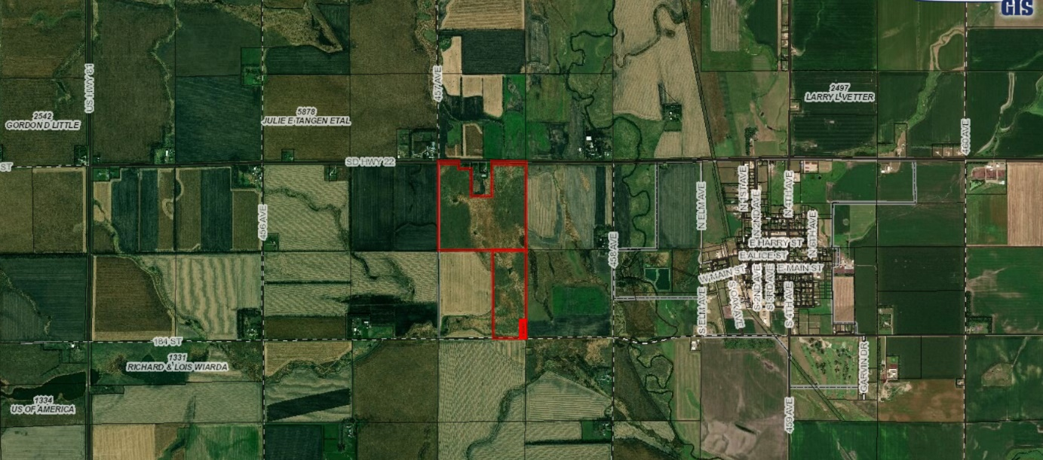

- Sioux Rural Water System seeks to construct an addition to the existing water treatment facility to provide better water quality and service to the area.
- Under the Hamlin County Zoning Ordinance, this classifies as construction under the Essential Public Service’s definition:
    - “Overhead or underground electrical, gas, steam or water transmission or distribution systems and structures, or collection, communication, supply or disposal systems and structures used by public for protection of the public health, safety or general welfare, including towers, poles, wires, mains drains, sewers, pipes, conduits, cables satellite dishes, and accessories in connection therewith.” (Section 269)
- Proposed addition meets all required setbacks from lot lines.
- Staff Recommendation: Staff recommends approval

Board Action:
The Board may after consideration of testimony and staff report: 1) Postpone the decision 2) Deny the Request 3) Approve the request with or without conditions.

