Hamlin County Board of Adjustment
Staff Report
Monday September 23rd, 2019 – 7:00PM

Item #1 Variance

Applicant/Owner: Douglas & Shanda Traffie

Property Description: S 255’ of E ½ of SE ¼ in Section 9, Township 114N, Range 55W of the 5th P.M., Hamlin County, South Dakota.

Action Item: Variance Request – Reduced Front Yard Setback (Section 3.04.06)

Zoning Designation: Ag - Agricultural

Request: Applicants are seeking a reduced front yard setback from ROW for placement of house.

Location:
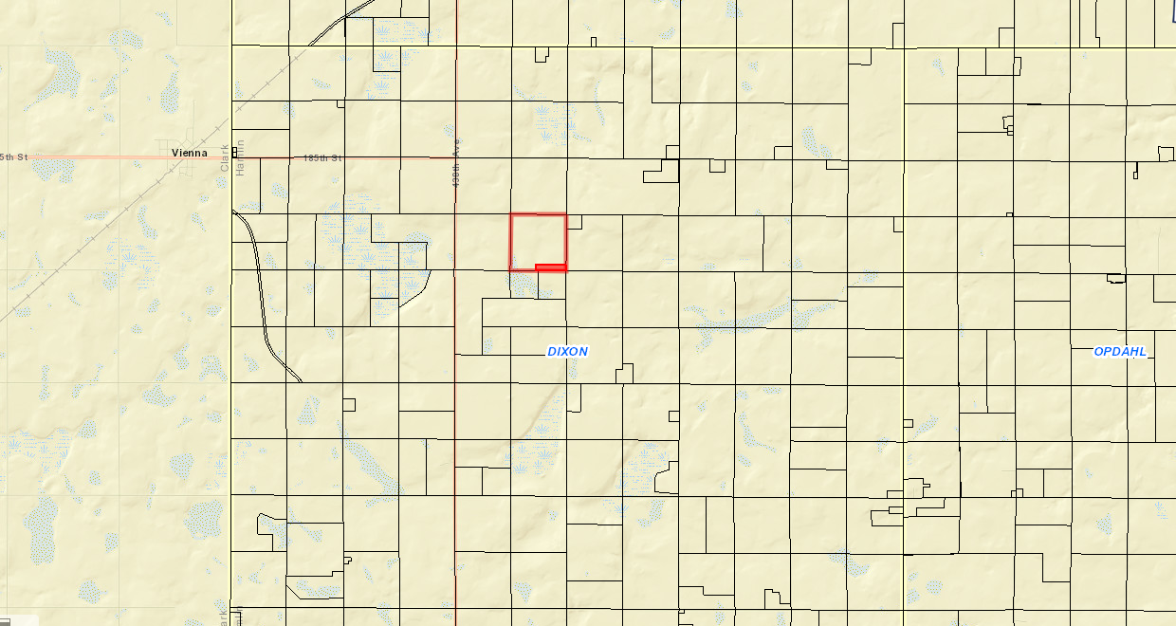

Issues:
- Applicants received a building permit on July 15 to place a house on the property.
  - Based upon Staff’s knowledge of the zoning ordinance and the proposed site location, it met all necessary setbacks and the density rules for the Agricultural District.
  - Applicant in August came back to Staff and sought to modify the building permit to account for a new structure to be used as the home. Upon further review it was determined the unused ROW to the south (Section line) would be developed and used as access for the applicant.
    - This turned the area south of the house from a side yard to a front yard in Staff’s perspective at the time. This was an incorrect assessment on Staff’s part and should have been noticed first before the building permit was issued on July 15.
    - With more information, staff was correctly told all section lines have ROW unless specifically vacated. Thus, from the initial building permit the area south of the proposed location for the house should have been determined to be a front yard and they would need to be the minimum 100’ setback from the edge of the ROW.
  - The determination of the need to meet the front yard setback was made after the applicant had begun to exercise the building permit and the foundation for the house had been poured.
- Based upon review of the variance, the placement of the house in its current location closer to the ROW is valid for the property owner to utilize the existing shelterbelt that lines the north property line for coverage purposes.

Staff recommendation –
- If approved, the Board may grant based upon:
    - The Board finds that the proposed construction does not further encroach upon any other required setback.
    - At the time of this report, staff has received no complaints from adjoining landowners.
    - Standard findings of fact being met:
      - That special conditions and circumstances exist which are peculiar to the land, structure or building involved, and which are not applicable to other land, structures, or buildings in the same district.
Board Action: Minimum Front Yard Setback: The Board may: 1) Postpone the decision 2) Deny the Request 3) Approve the request with or without conditions.

ITEM #2 Conditional Use

Applicant/Owner: Stuart & Janelle Schubloom
Property Description: The South Half (N 1/2) of Tract A, Prairie Quay 2nd Addition in Government Lot 6 in the Northeast Quarter of Section 30, Township 113 N, Range 52 West of the 5th P.M., Hamlin County, South Dakota
Action Items: Conditional Use – attached garage with dimensions greater than 36’ x 42’ with sidewalls greater than 10 ½’ (Section 3.07.05.7)
Zoning Designation: LP1 – Lake Park District 1
Request: Applicant is seeking to construct an attached garage in between two existing garages.

Location:

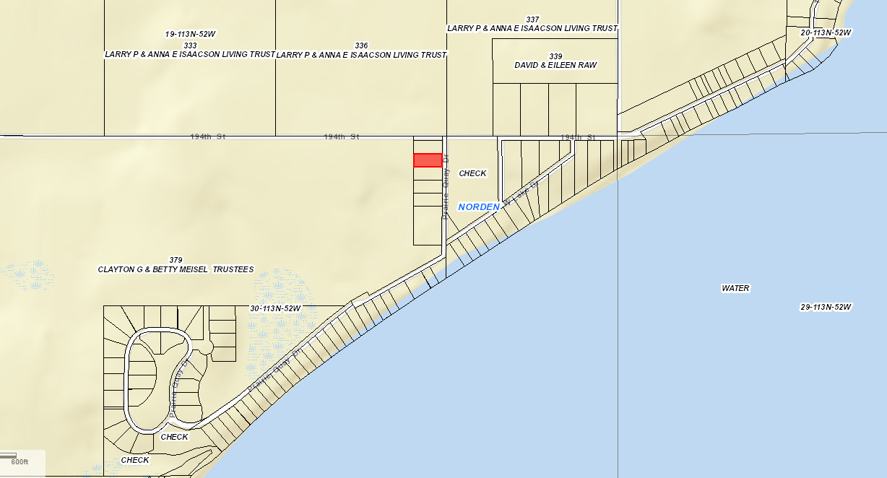

Issues:
- Applicants wish to construct a 50’ x 18’ with 14’ sidewalls addition in between two existing garages.
  - Closest to the road the building is 50’ x 72’ with 14’ sidewalls at 31.5’ from the road
  - Nearest the back property line the building is 50’ x 72’ with 16’ sidewalls at 9’ from the back property line.
- Zoning Ordinance requires a conditional use for unattached garages with dimensions greater than 36’ x 42’ with sidewalls greater than 10 ½’.
- Site location of the new addition onto the existing garages meets all necessary setbacks from front yard, side yard and rear yard.
- This proposed structure sits alongside other large oversized garages along Prairie Quay Drive and would fit in with the overall design of the existing buildings on site.

Staff recommendation – Staff recommends approval based upon the following:
  - The garage meets all necessary setback regulations
  - Approve If there are no objections from adjoining property owners

Board Action: Conditional Use: Attached Garage with dimensions greater than 36 feet x 42 feet with sidewalls greater than 10 ½’: The Board may: 1) Postpone the decision 2) Deny the Request 3) Approve the request with or without conditions.

ITEM #3 Conditional Use

Applicant/Owner: Schubloom Construction/Doug & Marilyn Amen
Property Description: Nitteberg Beach: E 25’ of Lot 35 & All of Lot 36 & 37 Less E 25’ of Lot 37 in Section 20, Township 113N, Range 52W of the 5th P.M., Hamlin County, South Dakota.
Action Items: Conditional Use – attached garage with dimensions greater than 36’ x 42’ with sidewalls greater than 10 ½’ (Section 3.07.05.7)
Zoning Designation: LP1 – Lake Park District 1
Request: Applicant is seeking to construct an unattached garage on their lakefront property.

Location:
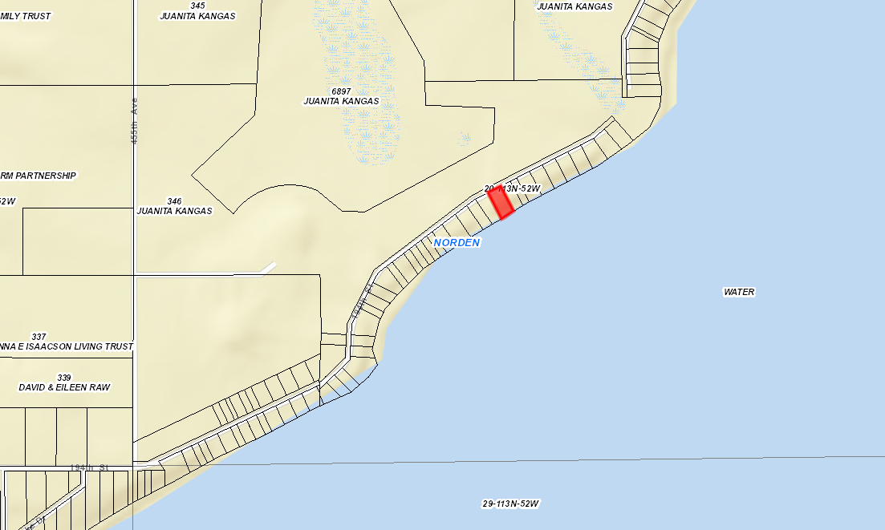

Issues:
- Applicant is seeking to construct a 26’ x 48’ garage with 14’ sidewalls on their lakefront property.
  - Currently there is a 8’ x 16’ lawn shed and existing house on the property with no garage on the lakefront or backlot property. Lawn shed will be moved to NW portion of the property and continue to be used.
- Zoning Ordinance requires a conditional use for unattached garages with dimensions greater than 36’ x 42’ with sidewalls greater than 10 ½’.
- Site location of the new addition onto the existing garages meets all necessary setbacks from front yard, side yard and rear yard.
  - Existing house sits 50’ from the shoreline and the garage will be setback from the house ensuring it meets the rear yard lake front setback.
- While most unattached garages larger than allowed by a building permit sit on the backlot property, the design allows for it to meet all the setbacks and sit on the lake front property.
- The property owner to the east of the current site has provided a letter which is included in your packet explaining their opposition to the proposed plans.
  - There is no requirement that larger garages be placed on the backlot property in the zoning Ordinance. With no backlot property available across the road for the applicant, they believe this is the best location for their garage which they intend to use for personal storage of vehicles and materials.
- The proposed structure, compared to its immediate neighbors, would be a larger garage than on these properties. As seen across the lake, large size garages are commonplace and have been approved by the Board on numerous occasions. Neighbor objections are not a valid finding of fact for denial in this conditional use application.

Staff recommendation – Staff recommends approval based upon the following:
- The garage meets all necessary setback regulations.
- The garage fits in with similar sized buildings across Lake Poinsett that are used for personal storage.

Board Action: Conditional Use: Attached Garage with dimensions greater than 36 feet x 42 feet with sidewalls greater than 10 ½’: The Board may: 1) Postpone the decision 2) Deny the Request 3) Approve the request with or without conditions.

ITEM # 4 Conditional Use

Applicant/Owner: Glen Waldner/Claremont Colony Hutterian Brethren Inc.
Property Description: E ½ of Section 4, Township 114N, Range 51W of the 5th P.M., Hamlin County, South Dakota.
Action Items: Conditional Use - Class A CAFO (Section 3.04.04.9)
Zoning Designation: Agricultural
Request: The applicant seeks to develop a new 3,000 finishing swine barn and an expansion of existing swine population within existing confinement barns.

Staff Review of Application:
Location

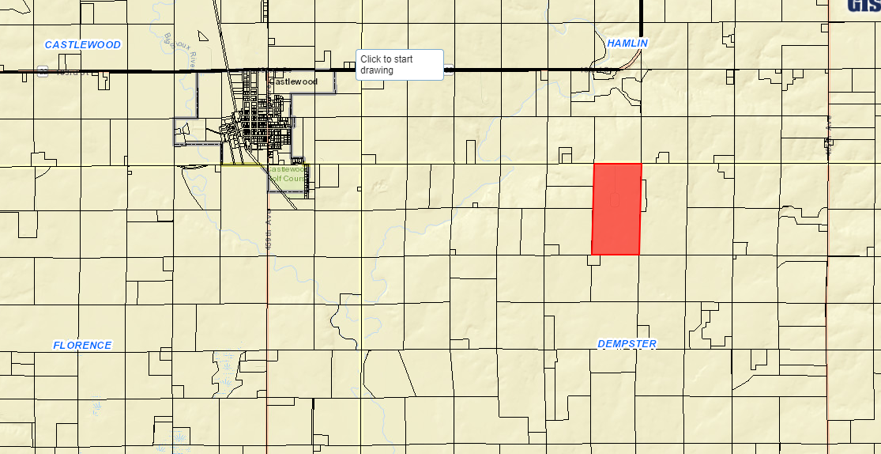

Overview of Application Materials (Section 5.25.05.11)
- Claremont Colony seeks to establish a new finishing swine barn operation with 3,000 head (1,200 AU’s) as well as an expansion of existing swine operations on site. They have enlisted the help of Dakota Environmental to proper the application materials and engineering services in the construction of the proposed site.
  - In addition to the new nursery swine barn (3,000 head) the total nursery swine population will increase from 1,953 to 4,200. Finishing swine will increase from currently 5,100 head to 6,080 head. And sows would increase from 825 to 1,150 head.
    - 420 AU’s Nursery Swine, 2,432 AU’s Finishing Swine, 4,255 AU’s Sows and 3 Boars.
  - Claremont has an existing State General Permit from DENR for existing hog operations and has been approved for the expansion (9/24/2015) but construction of the expansion did not occur and thus necessitates a reapplication at the County and State level.
- Proposed new operation will have one self-contained barn with eight-foot-deep concrete pits beneath for manure storage and house the new 3,000 head (1,200 AU’s) and modifications (listed in the NMP and MMP) will be made to the existing barns to account for the increase in population.
- The initial Nutrient Management Plan has been developed using DENR General Permit requirements. They have included information concerning proposed population, storage, application methods, land available for application, crop yield projections, and soils test data. The land where manure will be applied has been approved by DENR as a part of the Main Claremont Colony CAFO for the existing operations and the NMP accounts for the increase in population in terms of land available for applications.
- The Manure Management and Operation Plan is included as well, meeting DENR General Permit standards. Site has been engineered for manure containment for over 365 days, which is more than the required minimum storage size.
  - Applicant’s operation is designed to be a zero-discharge operation.
- A Management plan for fly and odor control is also included in the application materials
- The proposed site meets all required setbacks for a Class A CAFO which include
  - ½ mile from established residences and private wells (2 waivers required and signed)
    - Well on Uthe property – recommended condition to add monitoring devices on site and on Uthe property for water quality management.
  - 150’ off Township ROW (185th Street) and 300’ off County ROW (463th Avenue)
- SD DENR will provide additional oversight and review of all submitted application materials such as engineering plans, nutrient management plan, manure management and operation plan, and the fly and odor control management plan.
  - Operation of the Class A CAFO required a certificate of compliance before stocking of the barns can occur. Approval from DENR of engineered design plans are required before Zoning Office can approve a building permit.
- All information on soils, shallow aquifers, designated wellhead protection areas, and 100-year floodplain designations have been included. The proposed site does not site above Zone B of the Aquifer Protection District or any areas designated as being a part of the FEMA Mapped floodplain.
  - Portions of the property are classified as potential floodplain in the FEMA Discovery Map.
- Dempster Township Officials and Sioux Rural Water were sent letters concerned the proposed use as they the application Road and Water Authorities. Property owners within one mile were notified of the proposed use and given the opportunity to provide their comments before the public hearing.
  - As of the time writing this report, Staff has received three comments from the public stating their opposition to the proposed expansion.

Staff Recommendation: Staff recommends approval with conditions placed in a letter of assurance as follows below:
Conditional Use Permit – Class A CAFO: The Board may postpone the decision, deny the request or approve the request. If approved, the staff recommends, at a minimum, the following conditions:

- The applicant agrees to comply with the submitted nutrient management plan, fly and odor management plan, and manure management plan.
- Applicant shall provide updated information regarding fields included in the nutrient management plans upon request by the Zoning Officer.
- This Conditional Use Permit authorizes the use of this property for a Concentrated Animal Feeding Operation consisting of 7,110 animal units. In no case shall it be implied that this permit authorizes greater than 7,110 animal units.
- Haul road agreements with Dempster Township shall be provided for the use of 185th Street as the primary haul route. Unless otherwise agreed to between the township and the applicant, Hamlin County requires the Grantor (applicant) to abide by the following terms to be included in the Agreements:
  - The Grantor shall be responsible for any costs associated with extraordinary maintenance and graveling on the portions of 185th Street designated as the primary haul road, and
  - All road work whether customary or extraordinary shall be done under the authority and supervision of the Township and meet its specifications. The work shall be done through the applicable contractor unless the Grantor receives prior authorization from the applicable road authority to conduct its own repairs or maintenance.
  - Dempster Township shall be responsible for all ordinary snow removal on its portion of 188th Street on the same basis as provided to the remainder of the Township. Any additional snow removal deemed necessary for the Grantor to continue its operations is hereby authorized to be done at Grantor’s expense.
  - The Grantor acknowledges that, to the extent already provided for by the law, and further acknowledges that it shall be responsible for any and all damages to applicable road authority roads or road right-of-ways due to the result of the Grantor’s operations (i.e. Delivery of feed, Hogs, manure disposal). Work will be done on the same basis as specified hereinabove. However, no unique standard or obligation not otherwise provided for by law is created by this acknowledgment.
  - The Grantor may have an Agreement with a contractor for hauling manure and shall notify the Township in advance of manure hauling by listing the roads that will be traveled.
  - The Township and Grantor may review and assign new haul routes on an annual basis.
  - In the event the haul road agreements hereinbefore described are not executed, the grantor, his heirs, assigns or successors in interest of the Grantor agree that all of the terms and conditions of Item “4” above are to be deemed a covenant running with the above-described property. Furthermore, it is agreed that, in accepting title to the above-described property any grantee, heir, assign, or successor in interest to the undersigned expressly agrees to be bound by the terms of Item “4”.
- The Grantor shall comply with established minimum manure application setbacks when spreading manure generated from the CAFO.
- The conditional use shall be in effect only as long as sufficient land specified for spreading purposes is available for such purposes and other provisions of the permit are adhered to.
- The Grantor, his heirs and assigns agree that the permitted number of animal units on site will be no greater than seven thousand one hundred and ten (7,110). Expansion over seven thousand one hundred and ten (7,110) animal units will require a new conditional use permit action.
- The Conditional Use Permit is transferable. Subsequent owners/operators will be required to agree to the terms of this permit.
- If there are 1) Violations of the Conditional Use Permit or other Hamlin County Zoning regulations or 2) Failure of the manure containment system, the applicant may be required to forfeit the Conditional Use Permit.
- Violation of the terms of this conditional use permit will be determined by the Hamlin County Zoning Officer.
  - The first violation substantiated by the Zoning Officer of this conditional use permit may result in a notification letter stating the violation and a prescribed period of time to remove the violation. A second violation occurring within one calendar year of the previous violation may result in a review of the validity of the conditional use permit and potential revocation of said permit. A third violation within one calendar year of the initial violation may result in revocation of the conditional use permit and cessation of all feeder operations within forty-five days (45) of notice of revocation.
  - The applicant may make appeal from the decision of the Zoning Officer or other agent of the Hamlin County Board of Adjustment to the Hamlin County Board of Adjustment. The applicant shall file with the Zoning Officer a notice of appeal specifying the grounds thereof. The Zoning Officer shall forthwith transmit to the Board of Adjustment all papers constituting the record upon which the action appealed from was taken. Such appeal shall be taken within thirty (30) days. Appeals from the Board of Adjustment shall be taken to Circuit Court.
  - Failure to comply with the decision of the Zoning Officer or other agent of the Hamlin County Board of Adjustment may be deemed a separate violation.
- All of the terms and conditions herein shall extend to and be binding upon the heirs, assigns, or successors in interest of the Grantor, and are to be deemed a covenant running with the above-described property. Furthermore, it is agreed that, in accepting title to the above-described property any grantee, heir, assign, or successor in interest to the undersigned expressly agrees to be bound by the terms of this agreement which shall, upon its execution, be recorded with the Hamlin County Register of Deeds Office.
Board Action:
The Board may: 1) Postpone the decision 2) Deny the Request 3) Approve the request with or without conditions.

