Hamlin County Planning Commission & Board of Adjustment
Staff Report
Monday – March 25th, 2019 – 1:00PM

Planning Commission

Old Business

Item #1: Plat Review

Applicant/Owner: Jon Hall
Property Description(s): Lots 1-11, 112-117, & 120 of Harvest Moon Bay Addition in Govt Lot 9 in SE ¼ of Section 26-113N-R53W and in Govt Lot 1 in SW ¼ of Section 25-113N-R53W (Norden Township)
Action Item: Plat Review
Zoning Designation: Lake Park 1
Request: Mr. Hall seeks to present a preliminary plan for development of residential lots in the North Bay area.

- Staff Review
  - All lots meet the minimum lot area and access requirements
  - Recommended approval of this plat would confer approval for subsequent platting of lots and could go to the County Commission. Mr. Hall intends on platting lots as they are sold.

Planning Commission Action: The Commission may: 1) Postpone the decision or 2) Recommend Approval to County Commission or 3) Recommend Denial to County Commission.

New Business

Item #2: Plat Review

Applicant/Owner: Ken Hansen
Property Description: Sunset Parks Estates Addition in Section 26, Township 113N, Range 52W of the 5th P.M., Hamlin County, South Dakota (Estelline Township)
Action Item: Plat Review
Zoning Designation: Lake Park 1
Request: Mr. Hansen seeks to present a preliminary plan for development of residential lots on the East side of Lake Poinsett.

- Staff Review
  - All lots meet the minimum lot area and access requirements
  - Staff and Zoning Board has spoken with the applicant previously on the development of these lots. Previously in 2018, we conferred that presenting a master plan for the development area would quicken the platting process for individual lots as they are sold.
  - In review of the plans, the lots to the east of Sunset Park Drive fall outside of the Lake Park 1 Zoning District. Subsequently, before these lots become platted they will need to be rezoned to Lake Park 1 in order for higher density housing to be placed there.

Planning Commission Action: The Commission may: 1) Postpone the decision or 2) Recommend Approval to County Commission or 3) Recommend Denial to County Commission.

Item #3: Plat

Applicant/Owner: Riverview LLC/Jon Anderson
Property Description: Lots 1, 2, and 3 of Riverview Addition in the SE ¼ of Section 15, Township 113N, Range 55W of the 5th P.M., Hamlin County, South Dakota (Garfield Township)
Action Item: Plat Approval
Zoning Designation: Agricultural
Request: Riverview is seeking to plat out the Garfield Dairy property for construction and separation from the Anderson’s remaining property.

- Staff Review
  - All lots meet the minimum lot area and access requirements
    - Riverview has obtained approval from SD DOT for a secondary access on SD HWY 28
    - Plat matches the plans submitted with the Garfield Dairy in terms of access and lot layout.
  - Lot 1 is the main Riverview dairy site, with Lots 2 & 3 being the remaining portions of the Anderson’s property. Lot 2 has grain bins on site and Lot 3 is the Anderson’s residence.

Planning Commission Action: The Commission may: 1) Postpone the decision or 2) Recommend Approval to County Commission or 3) Recommend Denial to County Commission.

Item #4: Rezoning

Applicant: Josh Spilde
Property Description: Block 1, Spilde Second Addition in the E ½ of SE ¼ of Section 36, Township 113N, Range 53W of the 5th P.M., Hamlin County, South Dakota (Norden Township)
Action Item: Rezoning
Zoning Designation: AG to LP1
Request: Mr. Spilde seeks to rezone a portion of his property from Ag to Lake Park 1 in order to allow future expansion of his campground in the future.

- General Location
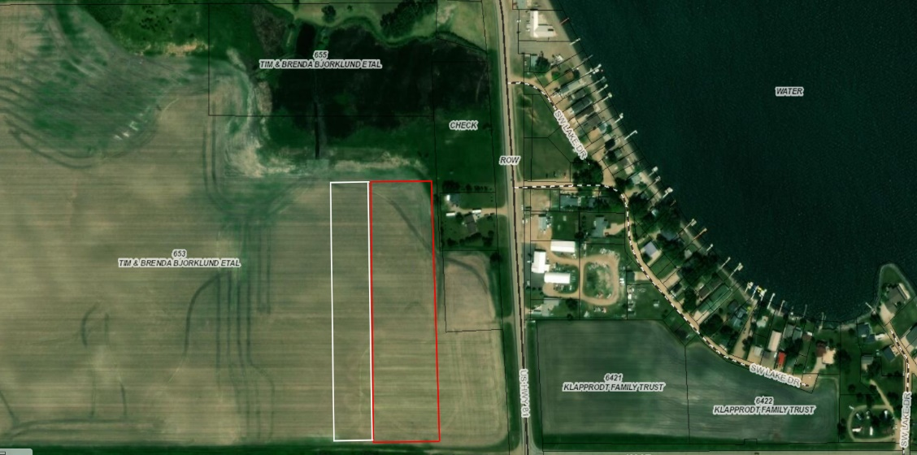

- Staff Review
  - Area in white represents the Spilde Second Addition. Property is the same length as the campground at around 1,044’ and 75’ wide. Access will be provided off 196th street similar to Spilde First Addition.
  - A small portion of the NE corner of the property lies within the Lake Park 1 District, but the rest is zoned as Agricultural.
  - Mr. Spilde does intend to expand the campground, to include 20 additional camping spots which would require approval of plans from the Board of Adjustment on the existing conditional use. Plans and specifications have not been submitted to staff as of this report. Staff will determine the proper procedure for how to integrate this request with the current conditional use. Whether that means an additional conditional use application is needed or another procedure is the correct course of action.
- Staff recommends approval based upon:
  - The comprehensive land use plan identifies this area as an area of development transition.
  - Policies or issues to consider in the development of lake property include
    - In areas of development transition adjacent to lakes, the subdivision and development of land will not be permitted without approved water and sanitary sewer services.

Planning Commission Action: The Commission may: 1) Postpone the decision or 2) Recommend Approval to County Commission or 3) Recommend Denial to County Commission.

BOARD OF ADJUSTMENT

Old Business

Item #1: Variance Request

Owner/Applicant: Clint Kooima
Property Description: Lake Albert 1st Auxiliary Addition, Lots 1 & 2 in the E ½ of the SW ¼ of Section 25, Township 113N, Range 53W of the 5th P.M., Hamlin County, South Dakota (Norden Township).

Action Item –Variance: Lake Area Regulations: Rear Yard Road Front Setback (3.7.10)
Zoning Designation: LP1 – Lake Park District
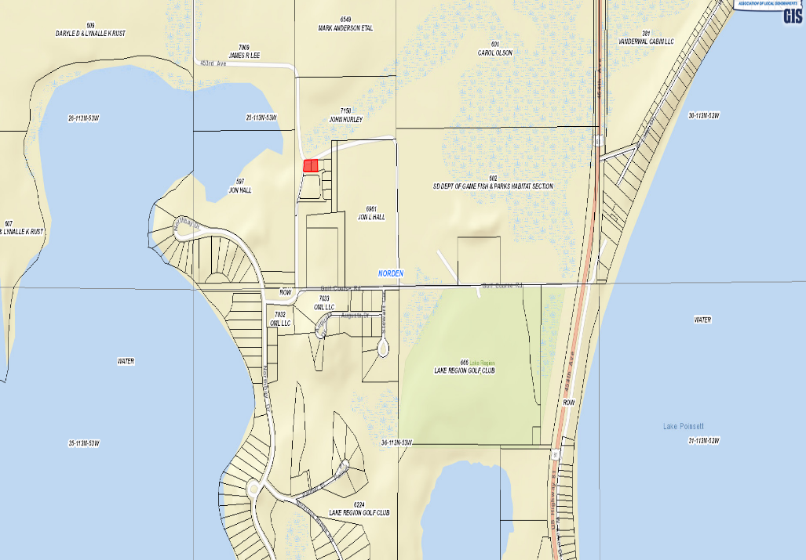
Request: The applicant is requesting a variance to construct a commercial storage garage closer to the ROW (20’)

            - Staff Review of Application
              - General Location

      - Previously in 2013, variance was granted to allow for construction of structure to the east with a reduced setback from the road ROW to the North.
      - In the Lake Park 1 zoning district, the setback from the road front is 30’ from the road right of way.
        - With this property being in-between two right of ways, the road front setback will be used for both north and south sides of the property.
        - The new proposed setback would be 10’ from the ROW on the North side. The structure would meet all other setbacks (10’ on side yard setback and 30’ on road front setback)
      - Applicant has received approval from Norden Township officials on the placement of the structure within the required setback.
        - They state this portion of road has not been maintained, basically unused since the development of North Bay.
      - Staff Recommends approval:
        - Based upon the special conditions and circumstances that exist which are peculiar to the land: size of property and ROW that sits unused and abandoned.
        - Received sign off from Norden Township Officials
        - No objections from adjoining landowners

Board Action: Rear Yard Road Front Setback: The Board may: 1) Postpone the decision 2) Deny the Request 3) Approve the request with or without conditions.

Item #2: Conditional Use

Applicant/Owner: Midwest Ag Services/Drumgoon Real Estate
Property Description: E 1090.6’ of W 2296.9’ of N 675’ EXC Arneson Addition in the NW ¼ of Section 24, Township 113N, Range 53W of the 5th P.M., Hamlin County, South Dakota (Norden Township)
Action Item – Conditional Use: Conditional Uses in the Ag District (3.04.04.36)
Zoning Designation: Ag – Agricultural
Request: Midwest Ag Services seeks a conditional use permit to operate an agribusiness in the Ag District

- Staff Review of Application
  - General Location
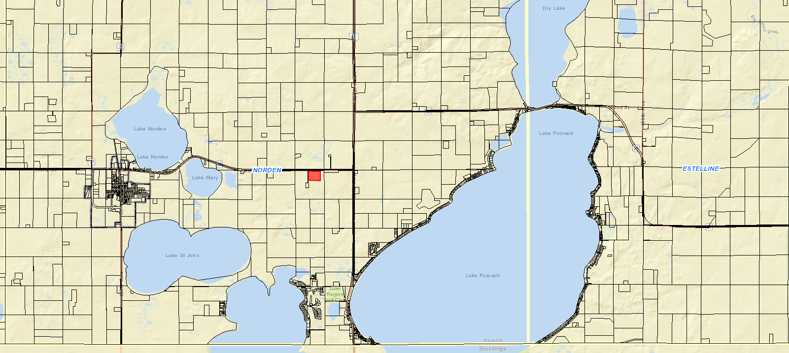

- Chapter 5.35: Agribusiness Activities: 5.35.02: Requirements
  - Agribusiness activities must have access to a concrete or bituminous asphalt, or gravel street.
    - Access to the proposed site is located along SD Highway 28.
  - Operators of agribusiness activities shall enter into and comply with a haul road agreement for the applicable streets if deemed necessary by the applicable road authority for the maintenance of identified haul routes attendant to the operation of the proposed business.
    - A haul road agreement will be included within Letter of Assurance and future discussion with Norden Township.
  - Lighting on the site shall be limited to downward directed lights or other lighting customarily used for agricultural operations.
    - All planned lighting is downward facing.
  - The number, size, and illumination standards for signs shall be determined by the Board of Adjustment.
    - Current sign plans are for placement on building, no designs or plans have been submitted.
  - No equipment or process shall be used in such extended home occupation which creates noise, vibration, glare, fumes, odors, or electrical interference detectable to the normal senses off the lot. In the case of electrical interference, no equipment or process shall be used which creates visual or audible interference in any radio or television receivers off the premises, or causes fluctuations in line voltage off the premises.
  - All vehicles and equipment stored outside shall be operable.

- Additional required information:
  - Physical dimensions and locations of the property, existing structures, and proposed structures
    - 120’ x 60’ Main Building with two additions (42’ x 40’ on North side and 24’ x 24’ on East side)
  - A detailed description of what activities will occur on the entire property
    - Midwest Ag Services will provide seed and chemical distribution to local farm customers, machinery for other agricultural applications on site such as striptilling, side dressing, and spraying uses.
  - Distance from all building lines to the property lines at the closest points
    - 250’ from North Property Line and ROW of HWY 28. All other distances meet required setbacks.
  - Maximum number of employees expected to be employed at the site.
    - Maximum number of employees on site will be 7
  - Hours of operation. (If it is expected that hours of operation will vary depending upon the season, the applicant should state minimum and maximum hours of operation and when those minimum and maximum hours are expected.)
    - Winter/Normal Hours: 8 a.m. to 5 p.m.
    - Spring/Summer: 6 a.m. to 10 p.m. (16 Hours)
  - Number and type of vehicles expected to use the site each day.
    - 4 pick-up trucks and seasonally semi-trucks.
  - Parking lots or spaces; designate each space, give dimensions of the lot, stalls and aisles (if applicable).
    - No specific parking lot plans were submitted. Parking will be available immediately adjacent to the building.
  - Names and locations of proposed haul roads.
    - SD Highway 28
  - Proposed grading and drainage pattern.
    - Drainage will slope away from building. Proposed drain field is north of shop in the proposed lawn (between building and ROW)
  - Phasing plan for development (if more than one phase is planned).
    - No other structures than described in plans. Possible building behind the main building to be built in future to store machinery.

Staff Recommendation: Staff recommends approval of the request subject to the applicant signing a letter of assurance agreeing to maintain in accordance with information provided to the Board at this meeting and any conditions applied by the Board.

Board Action:
The Board may after consideration of testimony and staff report: 1) Postpone the decision 2) Deny the Request 3) Approve the request with or without conditions.

ITEM # 3 Conditional Use

Applicant/Owner: Herb Wollman/Poinsett Hutterian Brethren Inc.
Property Description: NE ¼ of Section 26, Township 114N, Range 51W of the 5th P.M., Hamlin County, South Dakota. (Dempster Township)
Action Items: Conditional Use - Class A CAFO (Section 3.04.04.9)
Zoning Designation: Agricultural
Request: The applicant seeks to develop a 4,800 Head Nursery Swine and 7,200 Head Finishing swine Barn (Class A – 3,360 Animal Units)

Staff Review of Application:
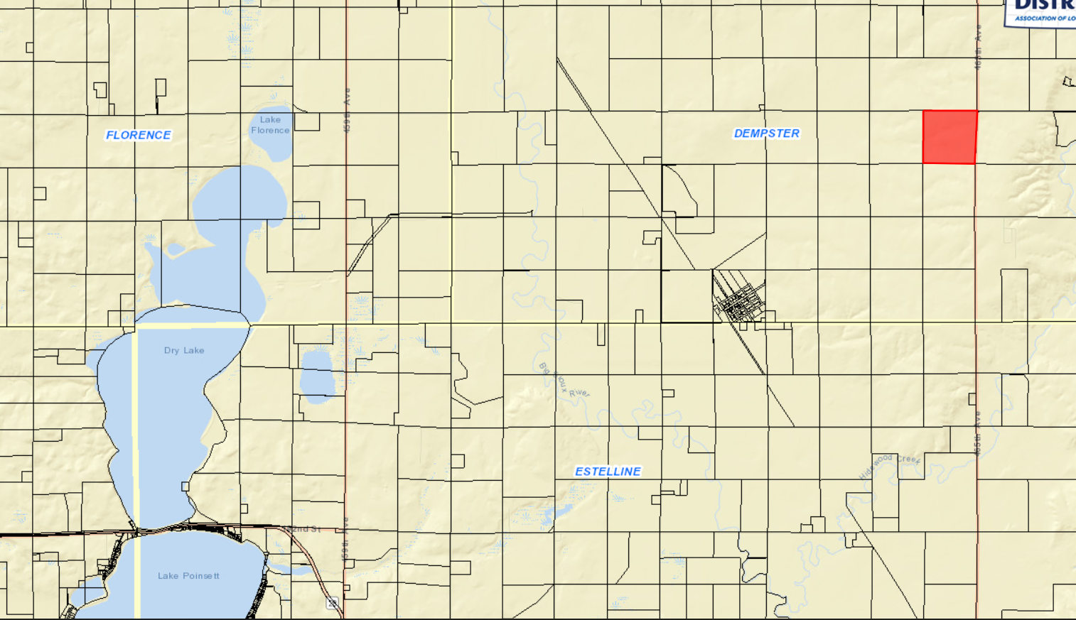
General Location

Overview of Application Materials (Section 5.25.05.11)
- Poinsett Colony seeks to establish a Hog Barn operation with 4,800 head of Nursery Swine and 7,200 Head of Finishing Swine (3,360 AUs) They have enlisted the help of Dakota Environmental to proper the application materials and engineering services in the construction of the proposed site.
  - Poinsett Colony will not be exercising the conditional use permit granted to them in August 2018 for a Class C CAFO which would consist of the Nursery Swine portion of this operation. They determined it was best to have both nursery and finishers at the same location.
- Proposed operation will have two self-contained barns with eight-foot-deep concrete pits beneath for manure storage. A loadout building will be attached to the finisher barn, which will include a holding pen with shallow concrete pits which will drain to the main pits. A utility building will be located nearby the nursery building. An office will be attached to the nursery barn.
- The initial Nutrient Management Plan has been developed using DENR General Permit requirements. They have included information concerning proposed population, storage, application methods, land available for application, crop yield projections, and soils test data. The land where manure will be applied has been approved by DENR as a part of the Main Poinsett Colony CAFO, but the land listed in their application materials will be reserved solely for this proposed CAFO.
- The Manure Management and Operation Plan is included as well, meeting DENR General Permit standards. Site has been engineered for manure containment for over 365 days, which is more than the required minimum storage size.
  - Applicant’s operation is designed to be a zero-discharge operation.
- A Management plan for fly and odor control is also included in the application materials
- The proposed site meets all required setbacks for a Class A CAFO which include
  - ½ mile from established residences and private wells
  - 11,000 feet from Town Districts (Dempster)
  - 150’ off Township ROW (186th Street) and 300’ off County ROW (465th Avenue)
- SD DENR will provide additional oversight and review of all submitted application materials such as engineering plans, nutrient management plan, manure management and operation plan, and the fly and odor control management plan.
  - Operation of the Class A CAFO required a certificate of compliance before stocking of the barns can occur. Approval from DENR of engineered design plans are required before Zoning Office can approve a building permit.
- All information on soils, shallow aquifers, designated wellhead protection areas, and 100-year floodplain designations have been included. The proposed site does not site above Zone B of the Aquifer Protection District or any areas designated as being a part of the FEMA Mapped floodplain.
  - Portions of the property are classified as potential floodplain in the FEMA Discovery Map, but no portion of the proposed site on the property are included.
- Dempster Township Officials and Sioux Rural Water were sent letters concerned the proposed use as they the application Road and Water Authorities. Property owners within one mile were notified of the proposed use and given the opportunity to provide their comments before the public hearing.

Staff Recommendation: Staff recommends approval with conditions placed in a letter of assurance as follows below:
Conditional Use Permit – Class A CAFO: The Board may postpone the decision, deny the request or approve the request. If approved, the staff recommends, at a minimum, the following conditions:

- The applicant agrees to comply with the submitted nutrient management plan, fly and odor management plan, and manure management plan.
- Applicant shall provide updated information regarding fields included in the nutrient management plans upon request by the Zoning Officer.
- This Conditional Use Permit authorizes the use of this property for a Concentrated Animal Feeding Operation consisting of 3,360 animal units. In no case shall it be implied that this permit authorizes greater than 3,360 animal units.
- Haul road agreements with Dempster Township shall be provided for the use of 188th Street as the primary haul route. Unless otherwise agreed to between the township and the applicant, Hamlin County requires the Grantor (applicant) to abide by the following terms to be included in the Agreements:
  - The Grantor shall be responsible for any costs associated with extraordinary maintenance and graveling on the portions of 188th Street designated as the primary haul road, and
  - All road work whether customary or extraordinary shall be done under the authority and supervision of the Township and meet its specifications. The work shall be done through the applicable contractor unless the Grantor receives prior authorization from the applicable road authority to conduct its own repairs or maintenance.
  - Dempster Township shall be responsible for all ordinary snow removal on its portion of 188th Street on the same basis as provided to the remainder of the Township. Any additional snow removal deemed necessary for the Grantor to continue its operations is hereby authorized to be done at Grantor’s expense.
  - The Grantor acknowledges that, to the extent already provided for by the law, and further acknowledges that it shall be responsible for any and all damages to applicable road authority roads or road right-of-ways due to the result of the Grantor’s operations (i.e. Delivery of feed, Hogs, manure disposal). Work will be done on the same basis as specified hereinabove. However, no unique standard or obligation not otherwise provided for by law is created by this acknowledgment.
  - The Grantor may have an Agreement with a contractor for hauling manure and shall notify the Township in advance of manure hauling by listing the roads that will be traveled.
  - The Township and Grantor may review and assign new haul routes on an annual basis.
  - In the event the haul road agreements hereinbefore described are not executed, the grantor, his heirs, assigns or successors in interest of the Grantor agree that all of the terms and conditions of Item “4” above are to be deemed a covenant running with the above-described property. Furthermore, it is agreed that, in accepting title to the above-described property any grantee, heir, assign, or successor in interest to the undersigned expressly agrees to be bound by the terms of Item “4”.
- The Grantor shall comply with established minimum manure application setbacks when spreading manure generated from the CAFO.
- The conditional use shall be in effect only as long as sufficient land specified for spreading purposes is available for such purposes and other provisions of the permit are adhered to.
- The Grantor, his heirs and assigns agree that the permitted number of animal units on site will be no greater than three thousand three hundred and sixty (3,360). Expansion over three thousand three hundred and sixty (3,360) animal units will require a new conditional use permit action.
- The Conditional Use Permit is transferable. Subsequent owners/operators will be required to agree to the terms of this permit.
- If there are 1) Violations of the Conditional Use Permit or other Hamlin County Zoning regulations or 2) Failure of the manure containment system, the applicant may be required to forfeit the Conditional Use Permit.
- Violation of the terms of this conditional use permit will be determined by the Hamlin County Zoning Officer.
  - The first violation substantiated by the Zoning Officer of this conditional use permit may result in a notification letter stating the violation and a prescribed period of time to remove the violation. A second violation occurring within one calendar year of the previous violation may result in a review of the validity of the conditional use permit and potential revocation of said permit. A third violation within one calendar year of the initial violation may result in revocation of the conditional use permit and cessation of all feeder operations within forty-five days (45) of notice of revocation.
  - The applicant may make appeal from the decision of the Zoning Officer or other agent of the Hamlin County Board of Adjustment to the Hamlin County Board of Adjustment. The applicant shall file with the Zoning Officer a notice of appeal specifying the grounds thereof. The Zoning Officer shall forthwith transmit to the Board of Adjustment all papers constituting the record upon which the action appealed from was taken. Such appeal shall be taken within thirty (30) days. Appeals from the Board of Adjustment shall be taken to Circuit Court.
  - Failure to comply with the decision of the Zoning Officer or other agent of the Hamlin County Board of Adjustment may be deemed a separate violation.
- All of the terms and conditions herein shall extend to and be binding upon the heirs, assigns, or successors in interest of the Grantor, and are to be deemed a covenant running with the above-described property. Furthermore, it is agreed that, in accepting title to the above-described property any grantee, heir, assign, or successor in interest to the undersigned expressly agrees to be bound by the terms of this agreement which shall, upon its execution, be recorded with the Hamlin County Register of Deeds Office.
Board Action:
The Board may: 1) Postpone the decision 2) Deny the Request 3) Approve the request with or without conditions.

