Hamlin County Planning Commission & Board of Adjustment
Staff Report
Tuesday January 8th, 2019 – 1:00PM
Planning Commission
Item #1 Plat
Applicant/Owner(s): Josh Spilde
Property Description: Block 1, Spilde Second Addition in the E ½ of SE ¼ of Section 36, Township 113N, Range 53W of the 5th P.M., Hamlin County, South Dakota (Norden Township)
Action Item: Plat Approval
Zoning Designation: Agricultural
Request: Mr. Spilde seeks to add a strip of property recently purchased to the existing plat.
Staff Review
- Plat meets the minimum lot area requirements and access requirements.
  - Access provided off of 196th Street.
- Staff recommends approval
Planning Commission Action: The Commission may: 1) Postpone the decision or 2) Recommend Approval to County Commission or 3) Recommend Denial to County Commission.
Board of Adjustment
Item #1: Conditional Use
Applicant/Owner: Kevin Grunewaldt
Property Description: Portion of Hudy Addition in SE ¼ of Section 36, Township 113N, Range 53W of the 5th P.M., Hamlin County, South Dakota (Norden Township). AND Government Lot 7 EXCEPT Lots 1, 2, 3 and Block 1, Peterson Addition in Section 36, Township 113N, Range 53W of the 5th P.M., Hamlin County, South Dakota (Norden Township). AND Portion of S ½ & SE ¼ and NE ¼ & SE ¼ EXCEPT Lot 1 Dollar General, Block 1 Spilde Addition, and Block 1 Bjorklund Addition of the 5th P.M., Hamlin County, South Dakota (Norden Township).

Action Item: Conditional Use - Section 3.07.05.2 – Private Park/Campground

Zoning Designation: LP1 – Lake Park

Request: Kevin Grunewaldt seeks a conditional use permit to construct and operate a private campground with 200 spots in between Lake Poinsett and Lake Albert

- General Location:
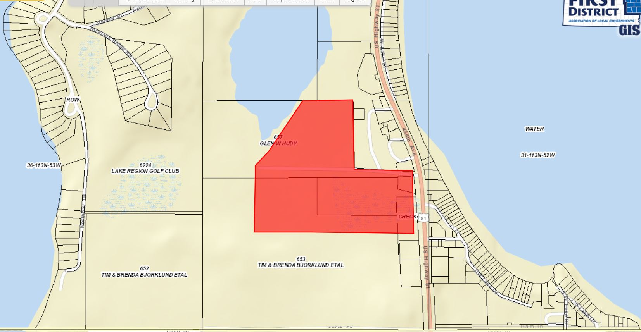

- Requirements:
  - Detailed drawings of campground layout have been provided. Engineering work done by Civil Design Inc. The campground is divided into three phases of construction.
    - 70 L x13.5 W for each camping pad with individual sewer/electrical/water hookups. Each site will have a fire pit spaced 14.5’ from edge of pad.
    - All access roads within the campground are 20’ wide
    - The only identified access is on US Hwy 81
Phase 1: | 23 camping pads, | 5 tent pads
Phase 2: | 63 camping pads |  | 10 cabins
Phase 3: | 113 camping pads |  | 6 cabins
Total | 199 camping pads | 5 tent pads | 16 Cabins
    - Cabins have been described as two-story cabins similar to existing cabins at SD State Parks. They will provide parking space on-site and within the cabin with living quarters on the second story. No detailed plans have been submitted to the Zoning Office. SD Department of Health has additional regulations concerning the construction, operation, and use of the cabins.
    - Timeline:
      - Phase 1: Begin utility installation in March, ready for customers on June 1st.
      - Phase 2: Begin grading, drainage and construction August 1st.
      - Phase 3: Construction start March 1st, 2020
        - This proposed timeline and construction plans will extend in 2020, staff recommends applicant come before the Board in 2020 to provide an update on construction timeline and ordinance compliance.
  - Utility information:
    - Water will be supplied by Kingbrook Rural Water
    - Electricity provided by HD Electric
    - Garbage/Rubbish services provided by Brookings Dumpster Service
    - Wastewater System: plans being reviewed by SD DENR (Scott Hipple) for compliance with the proposed campground capacity. Applicant has spoken with LP Sanitary District to connect proposed bathroom/shower facility to existing line.
  - Detailed drawings of the proposed campground show placement of bathroom/showers, shelters light poles, and garbage/rubbish bins.
    - One main bathroom/shower facility located within Phase 2 section on the SE corner.
      - A completed building permit will be required before construction of the bathroom/shower facility can occur.
    - Five shelters are proposed, evenly spaced throughout the campground. Four of the shelters are described as standard size shipping containers (8’ W x 8.5’ H x 20’ or 40 L). They are designed to be placed in the ground and shall be compliant with necessary access points for entry and exit. No engineering information has been provided for how they will be secured into the ground and/or provide a safe and secure option for campground residents to use in the event of severe weather.
    - Light poles are located at each garbage bin and shelter and will face downward. Staff recommends the addition of light poles to cover more of the campground for added safety and security, either at each intersection or every 300’ within the campground.
    - Garbage bins are located throughout campground, trash compactor may be utilized. Screening information has not been detailed.
  - Campground dimensions have been designed by Civil Design in congruence with recommended standards as set by the Board (spacing between campers, setback from US HWY 81)
  - Parking Spaces: each camping pad will have one additional vehicle (car, truck, boat, etc) There are parking areas evenly spaced throughout the three phases according to number of camping pads per phase. Each spot is listed at 10’x20’. The Board may recommend additional space reserved for parking.
    - Phase 1: 6
    - Phase 2: 15
    - Phase 3: 26
  - Proposed open spaces are located within each phased area. Large swimming areas/ponds are proposed. A walking path/trail is outlined within the campground layout to allow for pedestrian walkways. Trees will line the proposed swimming areas/ponds as well as shoreline improvements.
  - Maintenance and record keeping of the campground will be the responsibility of the Applicant in compliance with SD Department of Health standards. Storage of maintenance items is not specified within the submitted plans.
Other Permit Granting Authorities:
- SD Department of Energy & Natural Resources: Storm Water and Sanitary Sewer System Permits: Sanitary Sewer plans must be submitted and approved before operation of campground can occur. Storm water plans are also reviewed and approved by SD DENR. Receipt of approval from DENR will be sent to the Zoning Office.
  - Applicant has contacted LP Sanitary District to connect proposed Bathroom/Shower Facilities to existing nearby line.
- Kingbrook Rural Water Systems: Designing water supply plan
- SD Department of Health: An annual permit needed for operation and continuing compliance and initial plans are reviewed under SDCL Chapter 44:02:14 Campground Regulation.
- Army Corp of Engineers: Grading and Drainage plans reviewed, no additional permit required.
- SDDOT: Access permit because change in use of property
Staff Recommendation – Conditional Use Permit – Private Park & Campground
- Staff recommends approval of the request subject to the applicant signing a letter of assurance agreeing to maintain in accordance with information provided to the Board at this meeting and any conditions applied by the Board. Specifically, the following:
  - Applicant will make road improvements to Access with US Hwy 81 per recommendations from SDDOT or ASHTO guidelines to accommodate increased traffic (widen access point and surface upgrading in conjunction with Phase 3.)
  - Sanitary Sewer: When the Lake Poinsett Sanitary Sewer District (District) extends sanitary sewer collection in a manner which can serve this property, the District may require connection. If determined necessary by the District, the applicant will then be required to connect. Until such time, the applicant will be allowed to utilize sealed holding tanks in compliance and built to SD DENR requirements after consultation with the District.
  - Applicant needs to construct at least 2 storm shelters which would accommodate 50 persons each. Said storm shelters to be constructed to FEMA design standards – First storm shelter may be incorporated with proposed bathing/shower facilities. Second shelter to be built prior to or in conjunction with Phase 3. Proposed storm shelter
  - Applicant agrees to come before the Board before August 2020 to provide update on construction timeline.
  - Building permits are required for all permanent structures
  - Require Lighting at all intersections or every 300 feet or as approved by zoning officer
  - Fencing to be approved by the Zoning Officer to be constructed next to Hurley Campground at time of Phase 2.

Board Action: Private Park & Campground: The Board may: 1) Postpone the decision 2) Deny the Request 3) Approve the request with or without conditions.

Item #2: Variance Request:
Applicant/Owner: Daniel Drew/John Hurley
Property Description: Lake Poinsett Estates Block 1 in Section 36, Township 113N, Range 53W of the 5th P.M., Hamlin County, South Dakota (Norden Township)
Action Item: Variance Request – Manufactured Home and Modular Home Provisions – Section 5.10.01.7
Zoning Designation: LP1 – Lake Park
Request: Daniel Drew seeks a variance to the maximum age requirement to place a Type B Manufactured Home on Mr. Hurley’s property.
- General Location:
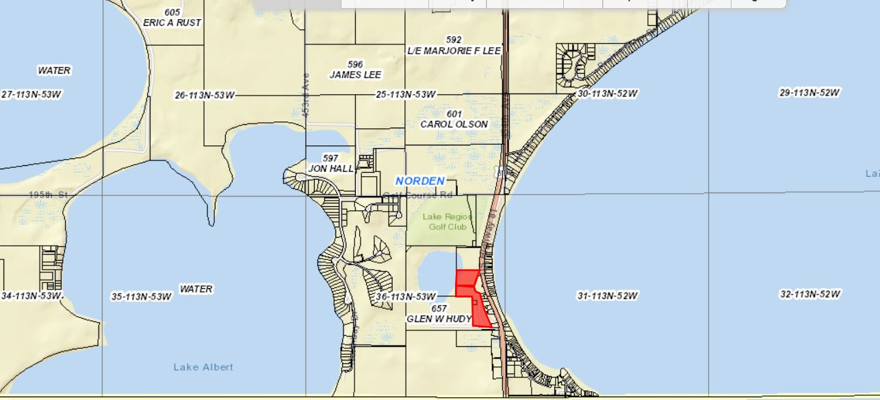

- Mr. Drew is seeking to place a type B Manufactured Home on property owner by John Hurley.
- Section 5.10.01 Type A and B Manufactured Homes: “Be structurally sound, well-maintained, have been constructed within the last ten (10) years.”
  - The applicant’s proposed home meets this definition and thus to be placed upon a building site, it must meet three additional provisions later in the section.
- The applicant has met all three provisions the Board of Adjustment can grant the variance
  - Photographs of the manufactured home
  - Code Compliance (gas, plumbing, electrical, and construction)
  - Signatures from Adjacent Landowners (4 property owners)
Staff recommendations – Staff recommends approval based upon the following:
        - The applicant met the requirements of Section 5.10.01.7 which specify the conditions needed to receive approval from the Board of Adjustment on this variance request.

Board Action: Manufactured Home and Modular Home Provisions: The Board may: 1) Postpone the decision 2) Deny the Request 3) Approve the request with or without conditions.

Item # 3: Conditional Use
Applicant/Owner: Jonathon Wollman/ Claremont Hutterian Bretheren Inc.
Property Description: E ½ of Section 4, Township 114N, Range 51W of the 5th P.M., Hamlin County, South Dakota (Dempster Township).
Action Item: Conditional Use – Section 3.04.04.34 – Religious Farming Community
Zoning Designation: AG – Agricultural
Request: Claremont Hutterian Colony seeks a conditional use permit to be listed as a Religious Farming Community to be in compliance with the Zoning Ordinance.
Staff Review of Application:
- General Location
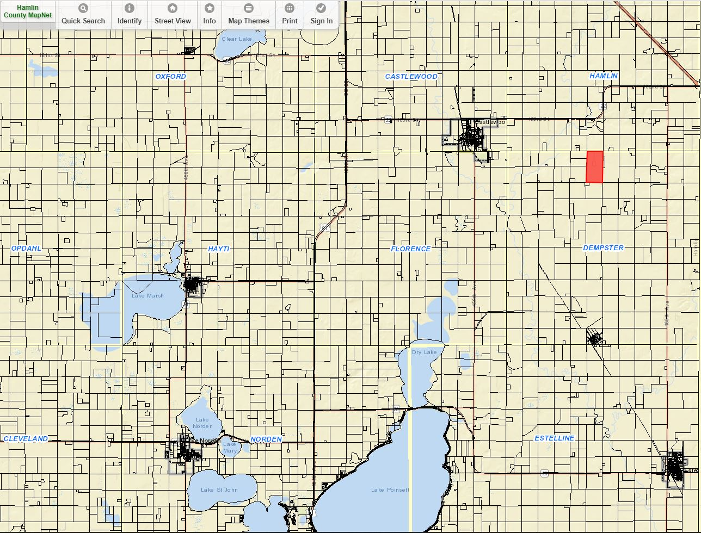

- Jonathon Wollman of Claremont Hutterian Colony approached Staff in November seeking to reconstruct barns that were burned down earlier in November.
- Upon further review of Zoning Office records on Claremont Colony is was discovered they had never obtained a conditional use permit to operate as a “Religious Farming Community”.
- The Zoning Officer is not allowed to issue building permits on property that requires a conditional use permit but has not yet received said permit.
- Claremont Hutterian Colony meets the zoning ordinance definition of a Religious Farming Community (Section 369)
- Claremont Wollman has provided a detailed map of the current structures on site with the application.
- The issuance of this permit would not impact taxation but would only authorize the issuance of future building permits in accordance with the conditional use permit. Denial of the permit would allow the colony to continue but the issuance of future building permits would not be allowed
Staff recommendation – Staff recommends approval
Board Action:
The Board may after consideration of testimony and staff report: 1) Postpone the decision 2) Deny the Request 3) Approve the request with or without conditions.

Staff Report
No permitted special uses permitted in December.
End of Year Report

