Hamlin County Planning Commission & Board of Adjustment
Staff Report
Monday – February 25th, 2019 – 1:00PM

Planning Commission

Item #1: Plat review
Applicant/Owner: Jon Hall
Property Description(s): Lots 1-11, 112-117, & 120 of Harvest Moon Bay Addition in Govt Lot 9 in SE ¼ of Section 26-113N-R53W and in Govt Lot 1 in SW ¼ of Section 25-113N-R53W (Norden Township)
Action Item: Plat Review
Zoning Designation: Lake Park 1
Request: Mr. Hall seeks to present a preliminary plan for development of residential lots in the North Bay area.

- Staff Review
  - All lots meet the minimum lot area and access requirements
  - Recommended approval of this plat would confer approval for subsequent platting of lots and could go to the County Commission. Mr. Hall intends on platting lots as they are sold.

Board of Adjustment

Item #1: Variance Request

Owner/Applicant: Clint Kooima
Property Description: Lake Albert 1st Auxiliary Addition, Lots 1 & 2 in the E ½ of the SW ¼ of Section 25, Township 113N, Range 53W of the 5th P.M., Hamlin County, South Dakota (Norden Township).

Action Item –Variance: Lake Area Regulations: Rear Yard Road Front Setback (3.7.10)
Zoning Designation: LP1 – Lake Park District
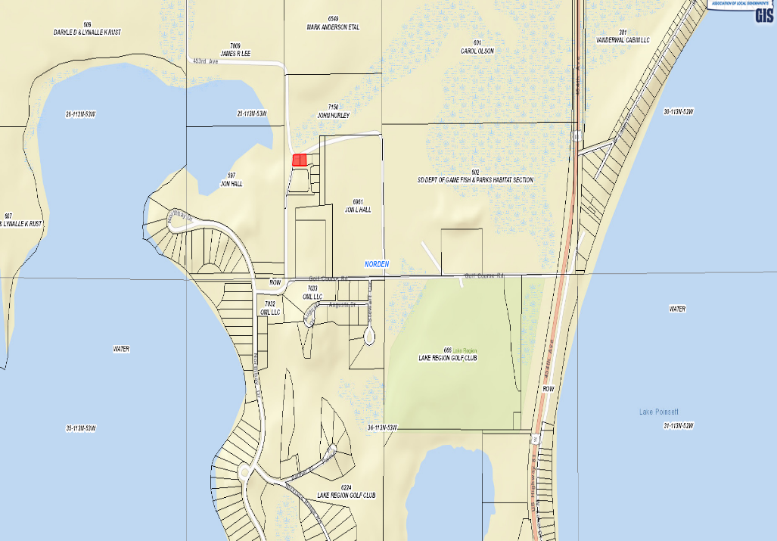
Request: The applicant is requesting a variance to construct a commercial storage garage closer to the ROW (20’)

            - Staff Review of Application
              - General Location

      - Previously in 2013, variance was granted to allow for construction of structure to the east with a reduced setback from the road ROW to the North.
      - In the Lake Park 1 zoning district, the setback from the road front is 30’ from the road right of way.
        - With this property being in-between two right of ways, the road front setback will be used for both north and south sides of the property.
        - The new proposed setback would be 10’ from the ROW on the North side. The structure would meet all other setbacks (10’ on side yard setback and 30’ on road front setback)
      - Applicant has received approval from Norden Township officials on the placement of the structure within the required setback.
        - They state this portion of road has not been maintained, basically unused since the development of North Bay.
      - Staff Recommends approval:
        - Based upon the special conditions and circumstances that exist which are peculiar to the land: size of property and ROW that sits unused and abandoned.
        - Received sign off from Norden Township Officials
        - No objections from adjoining landowners

Board Action: Rear Yard Road Front Setback: The Board may: 1) Postpone the decision 2) Deny the Request 3) Approve the request with or without conditions.

Item #2: Conditional Use

Applicant/Owner: Midwest Ag Services/Drumgoon Real Estate
Property Description: E 1090.6’ of W 2296.9’ of N 675’ EXC Arneson Addition in the NW ¼ of Section 24, Township 113N, Range 53W of the 5th P.M., Hamlin County, South Dakota (Norden Township)
Action Item – Conditional Use: Conditional Uses in the Ag District (3.04.04.36)
Zoning Designation: Ag – Agricultural
Request: Midwest Ag Services seeks a conditional use permit to operate an agribusiness in the Ag District

- Staff Review of Application
  - General Location
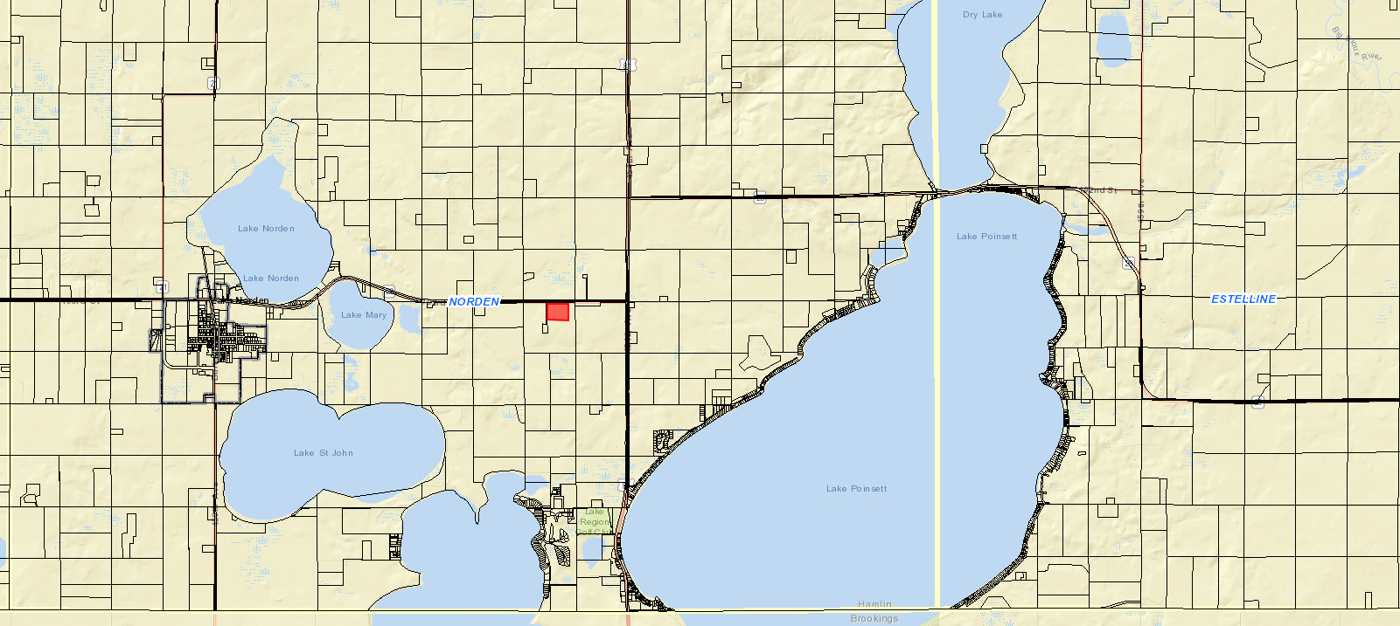

- Chapter 5.35: Agribusiness Activities: 5.35.02: Requirements
  - Agribusiness activities must have access to a concrete or bituminous asphalt, or gravel street.
    - Access to the proposed site is located along SD Highway 28.
  - Operators of agribusiness activities shall enter into and comply with a haul road agreement for the applicable streets if deemed necessary by the applicable road authority for the maintenance of identified haul routes attendant to the operation of the proposed business.
    - A haul road agreement will be included within Letter of Assurance and future discussion with Norden Township.
  - Lighting on the site shall be limited to downward directed lights or other lighting customarily used for agricultural operations.
    - All planned lighting is downward facing.
  - The number, size, and illumination standards for signs shall be determined by the Board of Adjustment.
    - Current sign plans are for placement on building, no designs or plans have been submitted.
  - No equipment or process shall be used in such extended home occupation which creates noise, vibration, glare, fumes, odors, or electrical interference detectable to the normal senses off the lot. In the case of electrical interference, no equipment or process shall be used which creates visual or audible interference in any radio or television receivers off the premises, or causes fluctuations in line voltage off the premises.
  - All vehicles and equipment stored outside shall be operable.

- Additional required information:
  - Physical dimensions and locations of the property, existing structures, and proposed structures
    - 120’ x 60’ Main Building with two additions (42’ x 40’ on North side and 24’ x 24’ on East side)
  - A detailed description of what activities will occur on the entire property
    - Midwest Ag Services will provide seed and chemical distribution to local farm customers, machinery for other agricultural applications on site such as striptilling, side dressing, and spraying uses.
  - Distance from all building lines to the property lines at the closest points
    - 250’ from North Property Line and ROW of HWY 28. All other distances meet required setbacks.
  - Maximum number of employees expected to be employed at the site.
    - Maximum number of employees on site will be 7
  - Hours of operation. (If it is expected that hours of operation will vary depending upon the season, the applicant should state minimum and maximum hours of operation and when those minimum and maximum hours are expected.)
    - Winter/Normal Hours: 8 a.m. to 5 p.m.
    - Spring/Summer: 6 a.m. to 10 p.m. (16 Hours)
  - Number and type of vehicles expected to use the site each day.
    - 4 pick-up trucks and seasonally semi-trucks.
  - Parking lots or spaces; designate each space, give dimensions of the lot, stalls and aisles (if applicable).
    - No specific parking lot plans were submitted. Parking will be available immediately adjacent to the building.
  - Names and locations of proposed haul roads.
    - SD Highway 28
  - Proposed grading and drainage pattern.
    - Drainage will slope away from building. Proposed drain field is north of shop in the proposed lawn (between building and ROW)
  - Phasing plan for development (if more than one phase is planned).
    - No other structures than described in plans. Possible building behind the main building to be built in future to store machinery.

Staff Recommendation: Staff recommends approval of the request subject to the applicant signing a letter of assurance agreeing to maintain in accordance with information provided to the Board at this meeting and any conditions applied by the Board.

Board Action:
The Board may after consideration of testimony and staff report: 1) Postpone the decision 2) Deny the Request 3) Approve the request with or without conditions.

Staff Report/BP Update/Permitted Special Use

