Hamlin County Planning Commission & Board of Adjustment
Staff Report
Wednesday – May 22nd, 2019 – 7:00PM
Planning Commission

Item #1 Plat

Applicant/Owner: Gordon Kangas
Property Description: Lot 1 of Kangas Addition in the SW ¼ of Section 8, Township 113N, Range 53W of the 5th P.M., Hamlin County, South Dakota (Norden Township)
Action Item: Plat Approval
Zoning Designation: Agricultural
Request: Applicant is seeking to plat property for residential development

- Staff Review
  - Lot meets the minimum lot area, density and access requirements in the Agricultural District.
- Staff recommends approval

Planning Commission Action: The Commission may: 1) Postpone the decision or 2) Recommend Approval to County Commission or 3) Recommend Denial to County Commission.

Board of Adjustment:

Item A Board Discussion: Alsville Crossing Gas Station
- Continuation of Board Discussion from last month with Engineer who designed drainage plan present.
- See Additional Letter provided by Mr. Halme regarding these issues in your packet.

Issue #1: Conditional Use

Applicant: Arlington Rental Property LLC (Robert Jenkins)

Owner: John Hurley

Property Description: Block 1, Petersen Second Edition in the E ½ of the SE ¼ of Section 36, Township 113N, Range 53W of the 5th P.M., Hamlin County, South Dakota (Norden Township).

Action Item: Conditional Use – Commercial Storage Garages (3.07.05.10)

Zoning Designation: LP1 – Lake Park District

Request: Applicant requests to construct commercial storage garages for private use on property adjacent to US HWY 81.

Location:

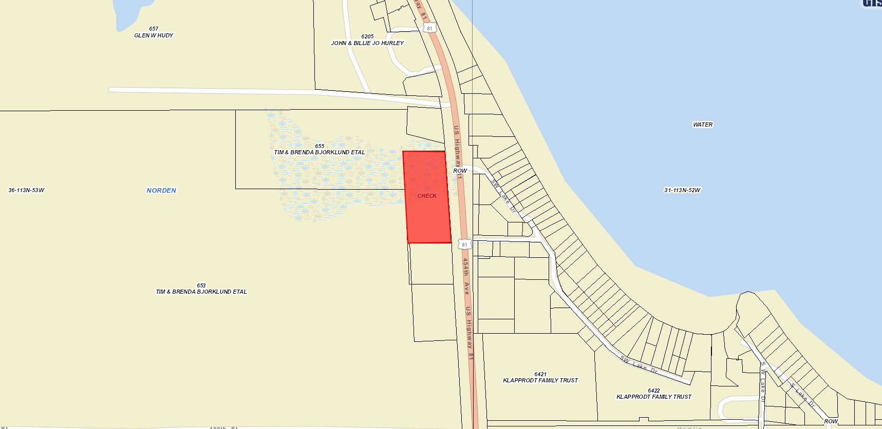

History/Issues:

- Applicant is requesting to construct 4 storage unit buildings for private personal use on property owned by Mr. Hurley.
  - If proposal is approved, Mr. Jenkins will purchase the land and oversee management of the facility.
- Proposal is for four storage buildings on the property
  - Building #1: 25’ x 180’ with 33 units
  - Building #2: 30’ x 120’ with 16 units
  - Building #3: 25’ x 180’ with 18 units
  - Building # 4: 40’ x 120’ with 30 units
- Entrance and Exit access will be directly onto US Highway 81. They have received a Highway Access Permit to construct a new approach for this property from SD DOT. Building #4 is offset from the center of the 3 buildings to accommodate for incoming vehicles to the property.
- No designated off-street parking is defined on the site plans, there is adequate space for movement of vehicles between buildings when loading and unloading into a unit.
- Utilities and Security room will be located on the east side of Building #1
- No screening or buffering were proposed in the submitted plans.
- No signs were proposed in the submitted plans.
- Lighting and security cameras will be located throughout the property. No specification on the type of lighting was listed.
- Layout of buildings meets the required setbacks from ROW (30 feet) and side yards (10 feet for commercially used properties)
- General Compatibility: There are no other storage units within the immediate area where this is proposed (Excluding Spilde Proposal) so one may see this as filling a need for personal storage of boats, campers or similar items in the most “commercially” developed area of Lake Poinsett. The proposal will also be adjacent to two campgrounds (Grunewaldt and Spilde).

- Staff Recommendation: If approved – Staff recommends the following conditions:
  - The commercial storage garages will only be used for personal storage and no other commercial activities will operate on the property.
  - Proposed commercial storage buildings are required to be built to IBC 2015. Documentation verifying compliance with 2015 Code is required.
  - Applicant sign a letter of assurance agreeing to the submitted plans and conditions to be recorded with the Register of Deeds.

Board Action: Commercial Storage Garages: The Board may: 1) Postpone the decision 2) Deny the Request 3) Approve the request with or without conditions.

Item #2: Conditional Use

Applicant/Owner: Josh Spilde

Property Description: Block 1 Spilde First Addition in the SE ¼ of Section 36, Township 113N, Range 53W of the 5th P.M., Hamlin County, South Dakota (Norden Township)

Action Item: Conditional Use Permit – (3.07.05.2) Expansion of Existing Conditional Use Permit

Zoning Designation: LP1 – Lake Park District

Request: Mr. Spilde is requesting a change to his conditional use permit to expand his existing campground to allow for a cumulative 130 camping pads.

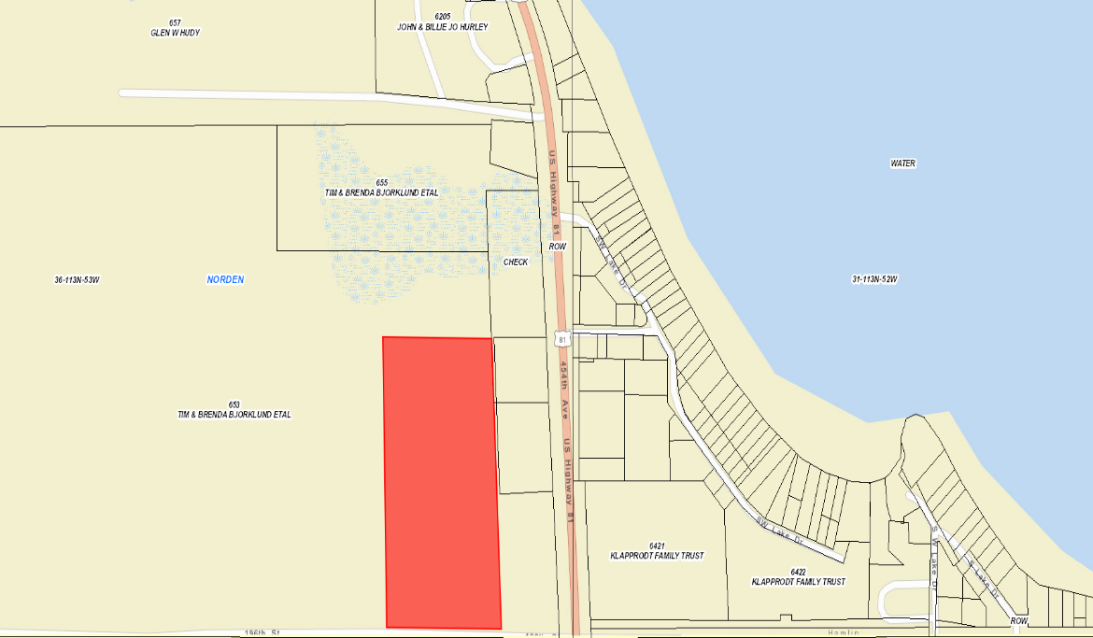
Location:

History/Issues:

- Mr. Spilde was granted a conditional use permit back in January 2018 for a private park/campground with up to 118 camping pads. This request is to add additional rows of camping pads on the western portion of the newly platted property. This expansion will be on the property rezoned in March and subsequently added to the main campground property through a new plat. A row will also be placed on the eastern portion of the campground where the commercial storage garages were originally planned.
- Expansion of campground will allow for 130 camping pads, dimensions of pads will match the existing pads on site. Camping pads proposed on plans at the very northern edge of property are not included in the expansion. Concerns of topography and dirt fill needed to build pads has
- Each new camping pad will have the same individual water and electrical hookups with services from Kingbrook RWS and HD Electric.
- Sanitary Sewer requirements have been met with the installation of additional holding tanks and a letter from SD DENR dated April 4th ensuring that the increased holding capacity will accommodate the increase in the number of camping pads.
- The Letter of Assurance regarding this permit stated that once development was to occur on the eastern tier of the campground screening (fences/trees) would be installed to block campground from adjacent property owners. The letter of assurance will need to be updated to reflect the expansion as well.
- Staff recommends approval.

Board Action: Private Park/Campground: The Board may: 1) Postpone the decision 2) Deny the Request 3) Approve the request with or without conditions.

Item #3: Conditional Use

Applicant/Owner: Josh Spilde

Property Description: Block 1, Bjorklund Addition in the E ½ of the SE ¼ of Section 36, Township 113N, Range 53W of the 5th P.M., Hamlin County, South Dakota (Norden Township)

Action Item: Conditional Use Permit – Commercial Storage Garages (3.07.05.10)

Zoning Designation: LP1 – Lake Park District

Request: Mr. Spilde is requesting to construct commercial storage garages for private use on property adjacent to US HWY 81.

Location:
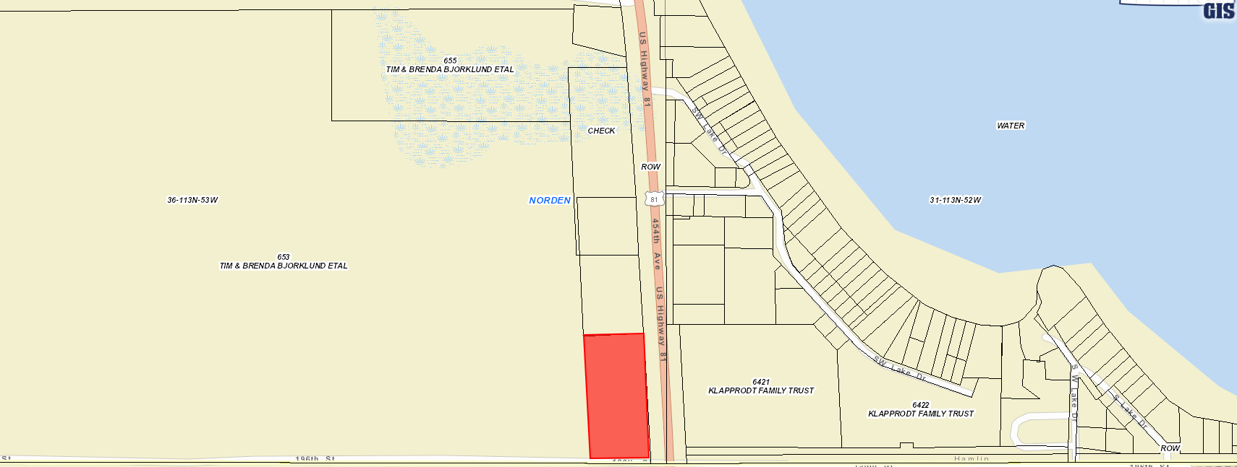

History/Issues:

- Previously these storage garages were planned to be apart of the campground adjacent to this property, but since then Mr. Spilde purchased this property for future development.
- The proposal is for 4 buildings (each 60’ x 160’). Number and size of units was not specified in submitted plans.
- Entrance and Exit will be off of 196th Street.
- No designated off-street parking is defined on the site plans, there is adequate space for movement of vehicles between buildings when loading and unloading into a unit.
- Tree Plantings or Shrubbery is planned for screening between the storage units and the campground. Plans also show trees providing screening between buildings and Highway 81.
- No signs were proposed in the submitted plans. Applicant has stated the placement of banner signs on buildings. The maximum amount of on-site signage is not allowed to exceed 80 square feet per Section 5.04.01.4 of the Zoning Ordinance.
- No lighting plans were submitted with the plans. Previously when the storage units were apart of the campground plans, Board placed a condition that adequate lighting be installed for the structures.
- Layout of buildings meets the required setbacks from ROW (30 feet) and side yards (10 feet for commercially used properties)
- General Compatibility: In addition to the proposal by Arlington Rental Properties, there will be a substantive increase in the number of storage units for personal storage along Highway 81. Dollar General is located to the north of this property and Spilde’s Campground is located to the west.
- Staff Recommendation: If approved - Staff recommends the following conditions:
- The commercial storage garages will only be used for personal storage and no other commercial activities will operate on the property.
- Lighting to be installed for the general safety and security of the property.
- Proposed commercial storage buildings are required to be built to IBC 2015. Documentation verifying compliance with 2015 Code is required.
- Applicant sign a letter of assurance agreeing to the submitted plans and conditions to be recorded with the Register of Deeds.
Board Action: Commercial Storage Garages: The Board may: 1) Postpone the decision 2) Deny the Request 3) Approve the request with or without conditions.

ISSUE #4 CONDITIONAL USE

Applicant: Riverview LLP

Owner: Roger and Barb Fritz

Property Description: SE1/4 of Section 23, Township 115N, Range 54W of the 5th P.M., Hamlin County, South Dakota (Oxford Township)

Action Items: Conditional Use - Class A CAFO (3.04.04.9)

Zoning Designation: A - Agricultural

Request: Riverview requests to operate a Class A CAFO - 10,00 head Jersey Cow Dairy

Location: site outlined in blue, properties outlined in red are within 1 mile of the site

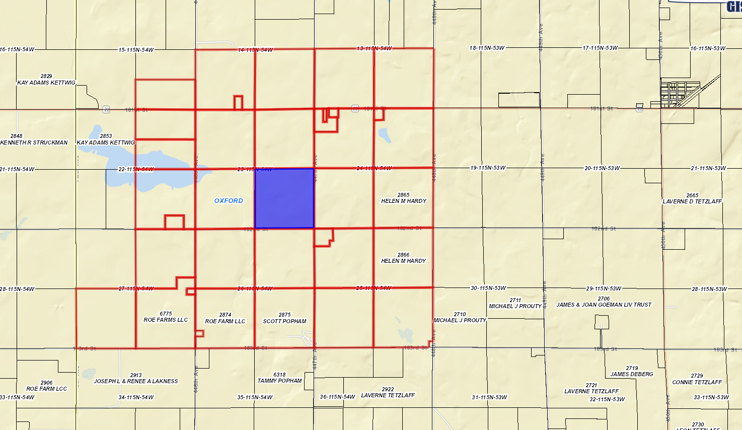

History/Issue(s):

Specifics of Request:
- Riverview requests to operate a 10,00 head Jersey Cow Dairy (14,300 Animal Units) on the above described property owned by Roger and Barb Fritz (Fritz signed application).
- General site information:
  - 160-acre parcel
  - Site plan covers the SE ¼ of Section 23-T115N-R54W with a private drive on the half section line running along the west edge of the proposed site. This provides direct access to SD HWY 22.
  - Currently, drainage from this property generally follows east to west, exiting SW draining onto the adjoining property 600’ W of the proposed site.
  - Information from FEMA indicates that in a 25-year rain event (~2.5 inches) results in some water pooling on the northwestern portion of the lot but substantial drainage (up to 2.3 feet of water) into a drainageway running southwest along the property and exits to the southwest part of the lot.
- The applicant operates a Dairy near Veblen, SD and others in Minnesota. Riverview was permitted last year for a similar sized Dairy Operation near Bryant, SD.
- This proposal preliminarily includes the following site improvements:
  - 1,530’ x 610’ Freestall Barn, 210’ x 124’ Milking Parlor and 265’ x 72’ Holding Barn
  - Concrete pad for feed storage (covered)
  - 3 outbuildings
  - 2 apartment buildings for on-site employee housing
  - 5 Manure Storage Ponds
    - 3 ponds are 7.6 acres and covered with synthetic liners
    - 1 pond is 4 acres and covered with synthetic liners
    - 1 pond is 1.89 acres and straw covered
    - Designed to provide for greater than 365 days of storage
  - 3 Stormwater lagoons/basins (3.7, 3.9 and .27 acres)
    - Required by DENR to contain 25-year stormwater.
  - 2 Feedpad run-off ponds (covered and 1.57 & 1.10 acres, respectively)

- Access is proposed on SD HWY 22 with 2 driveway access points to 182nd Street on the south side of the site.
  - Riverview has obtained a Highway Access Permit off SD HWY 22 to the private drive running on the west side of the site.
  - Daily Traffic (feed and milk trucks) will use the private access onto the property. Silage and similar trucks will travel in from all directions and thus use township roads upon entrance to the dairy. Based upon this we will ask for haul road agreements with the township for the use of surrounding roads (446th & 447th Avenue and 182nd Street) adjacent to Section 23.
- On-site employee housing is proposed with two multi-unit dwellings with “four-plex” layouts similar to Garfield Dairy proposal.
  - The main layout will differ with each unit having individual bedrooms for the employees – the overall number of shared dwellings as defined in Ordinance #03-18 will stay the same at 4 Multi-unit dwellings per apartment building.
  - Proposed plan meets the matrix in the Ordinance listing the number of Animal Units, Maximum number of dwellings, and Maximum number of persons living in the structures.
  - Per Ordinance #03-18, they will need to construct the dwelling to meet the requirements of SDCL 10-11-6 which requires compliance with the most recently adopted version of the International Building Code.
  - Sanitary sewer is required to be installed in accordance with SDDENR standards.

Ordinance and Comprehensive Land Use Plan regarding this request:
- The Comprehensive land use plan supports the development of special agricultural uses such as CAFO’s subject to rules for the protection of environmentally sensitive areas (Aquifer Protection and Floodplain Regulations); protection of water features (supported by requirements for CAFO’s to be reviewed by DENR); to avoid conflict with urban areas (ability for communities to waive setback requirements.)
- The request is to create a new 10,000 head dairy cattle operation (14,300 animal units) where one does not currently exist.
- The very southwest corner of the legal description sits over Zone B of the Aquifer Protection District. However, no part of the feeding operation is situated over the Aquifer Protection District.
- The Board shall consider the following in determining whether the proposed CAFO will create a significant contribution of pollution:
  - Size of feeding operation and amount of manure reaching waters of the state
    - Historically the Board has relied in determination of SDDENR in reference to this question since waters of the state are under their jurisdiction.
    - The project engineer certifies that zero manure from the operation will leave the operation. Feed pads and barns are designed to drain to water any of 5 holding areas (approximately 10.5 acres). Stormwater originating off-site is intended to pass around the feedlot, mostly southwest of the feedlot on the applicant’s property.
  - Location of feeding operation in relation to waters of the state
    - No waters of the state run through the proposed site.
  - Means of conveyance of manure and process wastewater into waters of the state
    - See items a. and b.
    - Typically the Boards rely on determination of SDDENR in reference to this question since waters of the state are under their jurisdiction and this is a component of the State General Permit review.
  - The slope, vegetation, rainfall and other factors affecting the likelihood or frequency of discharge of animal wastes and process wastewater into waters of the state. Stormwater, not processed wastewater, will be draining off the property to the west. Processed waste
    - Property north, south, and east of the site is used for crops. Property west of the site is used primarily as pasture.
    - Finished grading is intended to contain process water in lagoons and allow stormwater to pass by the property in similar volumes to pre-development conditions.
    - Rainfall for this area is similar to the rest of the county
    - Historically the Board has relied in determination of SDDENR in reference to this question since waters of the state are under their jurisdiction and this is a component of the State General Permit review. DENR approval would satisfy this project as not being a potential pollution hazard.
- The applicant has indicated his intent to apply for a State General Permit. The county has historically approved conditional use permits conditioned on receiving a State General Permit.
- A nutrient management plan is required.
  - Nutrient management plan (NMP) has been prepared and submitted. The NMP will be submitted to SD DENR for review. It describes practices and management activities on how best to utilize manure as a fertilizer resource while protecting surface and ground water.
  - Fields in the nutrient management plan are expected to change (per the applicant and based upon the zoning ordinance.) Currently, most of the fields are located five or less miles from the site.
  - The SDDENR will determine whether the NMP meets regulatory standards in review of the State General Permit.
  - Historically, the Board of Adjustment has recognized SD DENR approval of the NMP as part of the State General Permit to be sufficient for the Board’s purpose. DENR approval would satisfy this requirement.
- A manure management plan is required
  - Manure management plan was prepared by an engineer. It included:
    - An engineered site plan detailing manure management facilities
    - Operation procedures and maintenance of manure facilities (which were supplemented upon request of the zoning office.)
    - Not intended to store waste for more than two years.
    - Plans and engineering were specific to 365 days of manure storage for 14,300 animal units.
    - Applicant will not be authorized to store manure for more than 2 years.
    - Plans specify records on manure application will be kept and document that acceptable manure and nutrient management practices have been followed.
    - SDDENR has more technical expertise to specifically address manure management facilities and operations and will review these as a part of the State general permit.
  - SD DENR has more technical expertise to specifically address manure management facilities and operations and will review these as a part of the State General Permit. Historically, the Board has recognized SD DENR approval of the manure management plan as part of the State General Permit to be sufficient for the Board’s purpose. DENR approval would satisfy this requirement.

- A Management plan for fly and odor control.
  - Completed – (Found under “O&M Plans” tab under “Management Plan for Fly and Odor Control.”
    - Operational plans for manure collection storage, treatment is expected to be updated and implemented
    - Applicant has location on site for death loss and rendering service takes them away.
    - No new trees are proposed with the project (existing tree belt to North of manure ponds)
    - Cross ventilated barns will be used.
    - Grading/pumping/cleaning of stalls is intended to remove surface water from pens.
    - Manure stacking is expected to have drainage to minimize odor generation
    - Outlines plans for removing manure from pens.
    - Synthetic covers are proposed for four of the manure storage basins
    - Manure will be injected when possible to reduce odor.
    - It is the intent to avoid spreading manure on weekends, holidays, and evenings on warm days.
    - It is the intent to avoid spreading on calm and humid days.
- Based upon submitted information (application and electronic information for staff review) the site is greater than required separation distances for churches, businesses, commercially zoned areas, Town Districts, private wells other than the operator’s, lakes and streams classified as fisheries.
  - Since no variances are requested, if it is determined that manure containment facilities or barns are located less than required separation distances are required (inconsistent with the plans provided); operation and/or construction of the facilities would be required to cease until variance is granted or the facilities are moved in conformance with the separation requirements.
- The site is less than one-half mile from one established residence.
  - Troy & Heather Opdahl: residence – Waiver of separation distance submitted.
- Any setback not specifically listed is implied to be that of the zoning district itself (front yard, rear and side yard.) These setbacks are met.
- The ordinance does allow the Board to expand setbacks for an operation this size. However, with waivers provided, a lack of history for expansion of setbacks, and based upon odor information provided by the applicant there seems to be little justification to do so.
- Review of Specifications and nutrient management plan by DENR.
  - Applicant is required to keep and maintain records of fields to receive manure, utilize adequate acres for the spreading of manure in accordance with state general permit standards, and adhere to minimum manure application setbacks.
- The zoning office does not have a record of any complaints against the Riverview’s other Operations. The State of South Dakota as part of their review for a State general permit will review history of the applicant.
- All information required of the applicant in Section 5.25.05.10 were provided.
- Information on soils, shallow aquifers, wellhead protection areas and floodplain (provided)
  - Part of this information is done by performing soil boring tests in different locations on site. Riverview conducted 11 test borings on the proposed site. After initial review, Staff asked for an opinion from East Dakota Water Development District concerning their results and proximity to the identified shallow aquifer. Jay Gilbertson stated:
    - “the geotechnical test boring logs conducted during the site assessment referenced above did not encounter any materials that would have qualified as what would have been mapped as surficial aquifer on these maps” “Near surface aquifer as identified in Section 3.10.03 does appear to be present in far southwestern portion of the site.”
- The applicant notified the road authorities and water providers prior to making application.
- The zoning office notified owners of property within one-mile of the site.

Staff Recommendation

Conditional Use Permit – Class A CAFO: The Board may table the request, deny the request or approve the request. If approved, the staff recommends, at a minimum, the following conditions to be included in a letter of assurance.

- This Conditional Use Permit authorizes the use of this property for a Concentrated Animal Feeding Operation (Dairy Cattle) consisting of fourteen thousand three hundred (14,300) animal units. Expansion over fourteen thousand three hundred (14,300) animal units will require a new conditional use permit action.
- The proposed holding ponds and lagoons shall be designed to provide primary containment for greater than ten thousand (10,00) dairy cattle (14,300 animal units). Prior to stocking documentation of approval of minimum design requirements shall be submitted to the Zoning Officer.
  - Applicant may stock with the maximum number of animals for which the holding pond and manure stacking pad is designed provided documentation is provided by SDDENR that such designs are approved for said animals.
  - In no case shall it be implied that this permit authorizes greater than 14,300 animal units.
- The applicant agrees to comply with the submitted nutrient management plan, fly and odor management plan, and manure management plan.
- The conditional use shall be in effect only as long as sufficient land specified for spreading purposes is available for such purposes and other provisions of the permit are adhered to.
- Applicant shall provide updated information regarding fields included in the nutrient management plans upon request by the Zoning Officer.
- Haul road agreements with Oxford Township & Hamlin County shall be provided for the use of 447th Avenue from Highway 22 to 182nd Street, 182st Street from 446th Avenue to 447th Ave and 446th Ave from Highway 22 to 182nd Street (County Road) for a primary haul route(s). Unless otherwise agreed to between the applicable road authorities and the applicant, Hamlin County requires the Grantor to abide by the following terms to be included in the Agreements:

- The Grantor shall be responsible for any costs associated with the upgrading roads listed in #6 to standard agreed upon by the Oxford Township and the applicant.
- The Grantor shall be responsible for any costs associated with the extraordinary maintenance, graveling, and snow removal on the portion of 447th Avenue from Highway 22 to 182nd Street and 446th Ave from Highway 22 to 182nd Street, which are hereby designated as the primary haul roads. 182st Street from 446th Avenue to 447th Ave is also a primary haul road. Since this road is a minimum maintenance road all minimum maintenance and snow removal is the responsibility of the Grantor.
- All road work whether customary or extraordinary shall be done under the authority and supervision of the applicable road authority and meet its specifications. The work shall be done through the applicable contractor unless the Grantor receives prior authorization from the applicable road authority to conduct its own repairs or maintenance.
- Unless otherwise agreed upon by the applicable road authority prior to hauling manure upon any streets or the laying of any pipes intended to transport liquid manure within any right-of-way. This approval is not to be construed as authorization or licensure to occupy any right-of-way without obtaining proper permits, licenses, or other authorization for such use of right-of-way.
- The Grantor acknowledges that, to the extent already provided for by the law, and further acknowledges that it shall be responsible for any and all damages to applicable road authority roads or road right-of-ways due to the result of the Grantor’s operations (i.e. Delivery of feed, silage chopping or manure disposal). Work will be done on the same basis as specified hereinabove. However, no unique standard or obligation not otherwise provided for by law is created by this acknowledgment.
- The township and applicant may review and assign new haul routes on an annual basis.

- In the event the haul road agreements hereinbefore described are not executed, the grantor, his heirs, assigns or successors in interest of the Grantor agree that all of the terms and conditions of Item “6” are to be deemed a covenant running with the above-described property. Furthermore, it is agreed that, in accepting title to the above-described property any grantee, heir, assign, or successor in interest to the undersigned expressly agrees to be bound by the terms of Item “6”.
- The Grantor shall comply with established minimum manure application setbacks when spreading manure generated from the CAFO.
- The Conditional Use Permit is transferable. Subsequent owners/operators will be required to agree to the terms of this permit.
- Violation of the terms of this conditional use permit will be determined by the Hamlin County Zoning Officer.
- The first violation substantiated by the Zoning Officer of this conditional use permit may result in a notification letter stating the violation and a prescribed period-of-time to remove the violation. A second violation occurring within one calendar year of the previous violation may result in a review of the validity of the conditional use permit and potential revocation of said permit. A third violation within one calendar year of the initial violation may result in revocation of the conditional use permit and cessation of all feeder operations within forty-five days (45) of notice of revocation.
- The applicant may make appeal from the decision of the Zoning Officer or other agent of the Hamlin County Board of Adjustment to the Hamlin County Board of Adjustment. The applicant shall file with the Zoning Officer a notice of appeal specifying the grounds thereof. The Zoning Officer shall forthwith transmit to the Board of Adjustment all papers constituting the record upon which the action appealed from was taken. Such appeal shall be taken within thirty (30) days. Appeals from the Board of Adjustment shall be taken to Circuit Court.
- Failure to comply with the decision of the Zoning Officer or other agent of the Hamlin County Board of Adjustment may be deemed a separate violation.

- All of the terms and conditions herein shall extend to and be binding upon the heirs, assigns, or successors in interest of the Grantor, and are to be deemed a covenant running with the above-described property. Furthermore, it is agreed that, in accepting title to the above-described property any grantee, heir, assign, or successor in interest to the undersigned expressly agrees to be bound by the terms of this agreement which shall, upon its execution, be recorded with the Hamlin County Register of Deeds Office.

