Hamlin County Planning Commission & Board of Adjustment
Staff Report
Monday August 26th, 2019 – 7:00PM

Planning Commission

Item 1: Public Hearing - Ordinance Amendment 02-19 – Commercial Storage Garages

Background: Last month, the Planning Commission was presented with proposed changes to the Ordinance regarding commercial storage garages brought forward by Board Member Kemnitz. After discussion and a couple changes, the Board asked the proposal be brought to this month’s Planning Commission meeting for a public hearing and recommendation to the County Commission for approval of the Ordinance changes.

Section 3.07.09 Supplementary “LP” Lake Park District Regulations

9. Commercial Storage Garages
- Access. For all proposed structure adjacent to the State highway, an access permit from the State of South Dakota Department of Transportation shall be required prior to the filing of a plat or the issuance of a building permit.

- Lot Area. Lot area shall be determined by need, side yards, rear yards, parking requirements, building site and future expansion; however in no case shall the lot have less than three (3) acres. Lot elevation must be three (3) feet above the most recent high-water level.

- Storage. All outdoor storage within five hundred (500) feet of a residential dwelling, commercial business or structure, public park, public roadway, or approved camp site, must be completely enclosed in a building or by a solid walled fence at least two (2) feet above the highest point of the storage material. The fence shall be maintained in safe and good repair. The County may require asphalt or concrete surface of parking area.

- Parking. Each Commercial Storage lot shall have off-street parking. Number of parking spaces shall be determined by the Board of Adjustment. Trees used for landscaping within a Commercial Storage lot are exempt from the minimum front, rear, and side yard requirements.

- Sewage and Liquid Wastes. No operation shall be carried on which involves the discharge into the sewer, watercourse, river or ground that may contain any radioactive nature, or liquid wastes of chemical nature, which are detrimental to normal sewage plant operations or contaminate to the natural resources.

- Fire Hazard. No flammable substance may be stored unless handling of said materials is in conformance with the standard of the National Board of Fire Underwriters and any additional regulations that may be adopted by the County Commissioners.

- Physical Appearance. All structures must obtain an appearance that is in concert with the surrounding structures. Physical appearance must be approved by the Hamlin County Planning and Zoning prior to construction.
  - Ex: stucco, brick, horizontal lap siding (steel)

- Design Plans. Design plans including floor plans and elevation maps need to be submitted to the Zoning Officer as a part of the Conditional Use application.

Item 2: Plat
Applicant/Owner: Ronna Tekrony
Property Description: Nelson Addition in the NE ¼ of Section 17, Township 115N, Range 52W of the 5th P.M., Hamlin County, South Dakota.
Action Item: Plat Approval
Zoning Designation: AG
Request: Applicant is seeking to plat a small piece of property for future residential construction.

- Staff Review
  - Lot meets the minimum lot area, density and access requirements in the Agricultural District.
- Staff recommends approval.

Planning Commission Action: The Commission may: 1) Postpone the decision or 2) Recommend Approval to County Commission or 3) Recommend Denial to County Commission.

Item 3: Plat

Applicant/Owner: Jack & Linda Tolk
Property Description: Tolk-Ode Addition in the N ½ of Government Lot 2 in Section 16, Township 113N, Range 53W of the 5th P.M., Hamlin County, South Dakota.
Action Item: Plat Approval
Zoning Designation: AG
Request: Applicant is seeking to plat a small piece of property for future residential construction.

- Staff Review
  - Lot meets the minimum lot area, density and access requirements in the Agricultural District.
- Staff recommends approval.

Planning Commission Action: The Commission may: 1) Postpone the decision or 2) Recommend Approval to County Commission or 3) Recommend Denial to County Commission.

Item 4: Plat

Applicant/Owner: David & Colleen Juntunen
Property Description: Dixon 15 Southeast Addition in the SE ¼ of Section 15, Township 114N, Range 55W of the 5th P.M., Hamlin County, South Dakota.
Action Item: Plat Approval
Zoning Designation: AG
Request: Applicant is seeking to plat a small piece of property for future residential construction.

- Staff Review
  - Lot meets the minimum lot area, density and access requirements in the Agricultural District.
- Staff recommends approval.

Planning Commission Action: The Commission may: 1) Postpone the decision or 2) Recommend Approval to County Commission or 3) Recommend Denial to County Commission.

Item 5: Plat
Applicant/Owner: Hamlin County Farmers Co-Op
Property Description: Hamlin County Farmers Coop Addition in the SW ¼ of SW ¼ of Section 21, Township 114N, Range 53W of the 5th P.M., Hamlin County, South Dakota.
Action Item: Plat Approval
Zoning Designation: AG
Request: Applicant is seeking to plat property

- Staff Review
  - Lot meets the minimum lot area, density and access requirements in the Agricultural District.
- Staff recommends approval.

Planning Commission Action: The Commission may: 1) Postpone the decision or 2) Recommend Approval to County Commission or 3) Recommend Denial to County Commission.

Item 6: Plat
Applicant/Owner: Paul & Laurie Konrad/Marcia Chicoine
Property Description: Lot 100 and Lot 101 of Miller Place, in Government Lot 4 in the NW ¼ of Section 26, Township 113, Range 53W of the 5th P.M., Hamlin County, South Dakota.
Action Item: Plat Approval
Zoning Designation: LP1
Request: Applicants are seeking to replat lots on East side of Lake Poinsett.

- Staff Review
  - Lots meets the minimum lot area and access requirements in the Lake Park District
- Staff recommends approval.

Planning Commission Action: The Commission may: 1) Postpone the decision or 2) Recommend Approval to County Commission or 3) Recommend Denial to County Commission.

Board of Adjustment

Item 1: Conditional Use

Applicant/Owner: Orvin Gedstad

Property Description: Lot 4 in Block 1 of Wade Second Addition in Government Lot 7 in Section 30, Township 113N, Range 52W of the 5th P.M., Hamlin County, South Dakota.

Action Item: Conditional Use Permit – Unattached Garage with dimensions greater than 36’ x 42’ - Section 3.07.05.7

Zoning Designation: LP 1 – Lake Park District

Request: Mr. Gedstad is seeking to construct an unattached garage on a backlot with dimensions greater than 36’ x 42’.

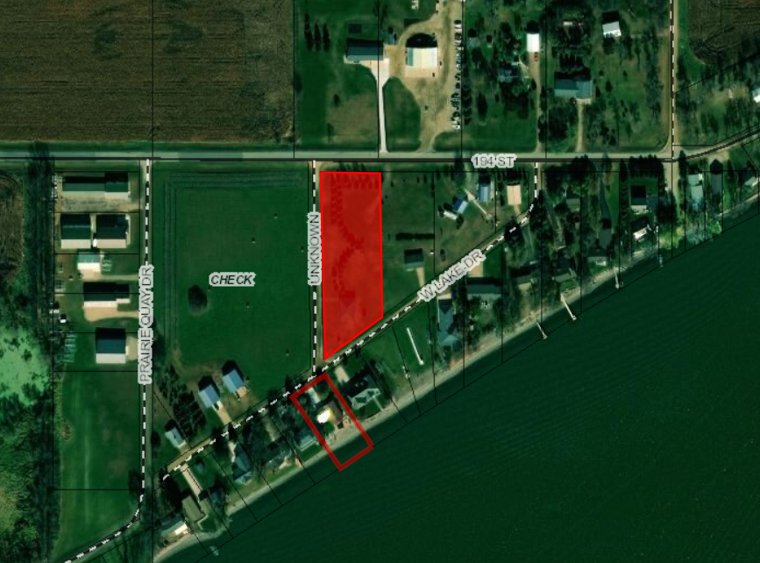
Location:

Issues:
- Mr. Gedstad wishes to construct a 36’ x 72’ unattached garage on his backlot property.
- Zoning Ordinance requires a conditional use for unattached garages with dimensions greater than 36’ x 42’.
- The site location of the garage meets all setbacks from the side yard and front yard to the road ROW.
- This proposed structure does fit into (dimensions and design), in the opinion of staff, with similar buildings on backlots along West Lake Drive and Prairie Quay Drive.

Staff recommendation – Staff recommends approval based upon the following:
1. The garage meets all necessary setback regulations
2. Approve If there are no objections from adjoining property owners

Board Action: Conditional Use: Unattached Garage with dimensions greater than 36 feet x 42 feet: The Board may: 1) Postpone the decision 2) Deny the Request 3) Approve the request with or without conditions.

Item 2: Conditional Use

Applicant/Owner: Witt Construction/Mark Stevenson

Property Description: Grape 1st Addition: Lot 10A in Section 16, Township 113N, Range 52W of the 5th P.M., Hamlin County, South Dakota.

Action Item: Conditional Use Permit – Unattached Garage with dimensions greater than 36’ x 42’ and sidewalls greater than 10 ½’ - Section 3.07.05.7

Zoning Designation: LP 1 – Lake Park District

Request: Mr. Stevenson is seeking to construct an unattached garage on a backlot with dimensions greater than 36’ x 42’ and sidewalls greater than 10 ½’.

Location:
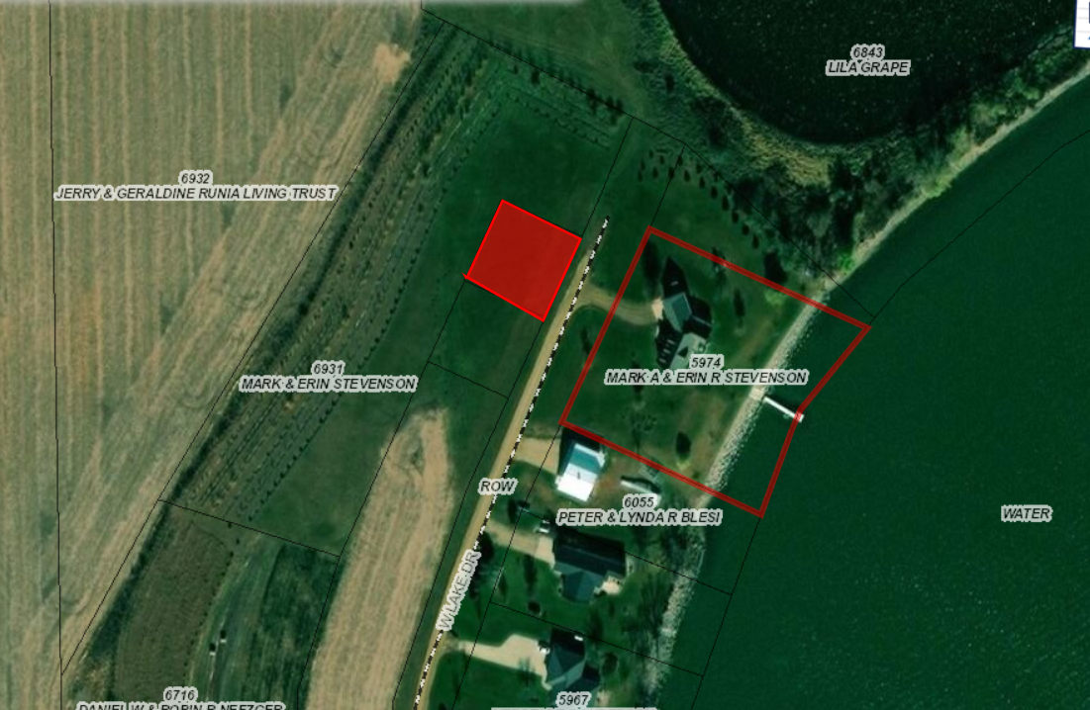

Issues:
- Mr. Stevenson wishes to construct a 40’ x 68’ unattached garage on his backlot property with 14’ sidewalls.
- Zoning Ordinance requires a conditional use for unattached garages with dimensions greater than 36’ x 42’ and sidewalls greater than 10 ½’.
- The site location of the garage meets all setbacks from the side yard and front yard to the road ROW.
- This proposed structure does fit into (dimensions and design), in the opinion of staff, with similar buildings on backlots along West Lake Drive.

Staff recommendation – Staff recommends approval based upon the following:
1. The garage meets all necessary setback regulations
2. Approve If there are no objections from adjoining property owners

Board Action: Conditional Use: Unattached Garage with dimensions greater than 36 feet x 42 feet: The Board may: 1) Postpone the decision 2) Deny the Request 3) Approve the request with or without conditions.

Item 3: Conditional Use and Variance Request

Applicant/Owner: Dolph Creek Development

Property Description: W 300’ of the 1915’ of the N 435’ of the NE ¼ of Section 24, Township 113N, Range 54W of the 5th P.M., Hamlin County, South Dakota.

Action Item: Conditional Use Permit – Extended Home Occupation (5.19) & Variance Request – Minimum Front Yard Setback (3.04.06)

Zoning Designation: Ag - Agricultural

Request: Mr. Halme is seeking to construct the use specified in the Conditional use application granted March 2018 (Extended Home Occupation – Welding Shop) closer to the ROW than allowed.

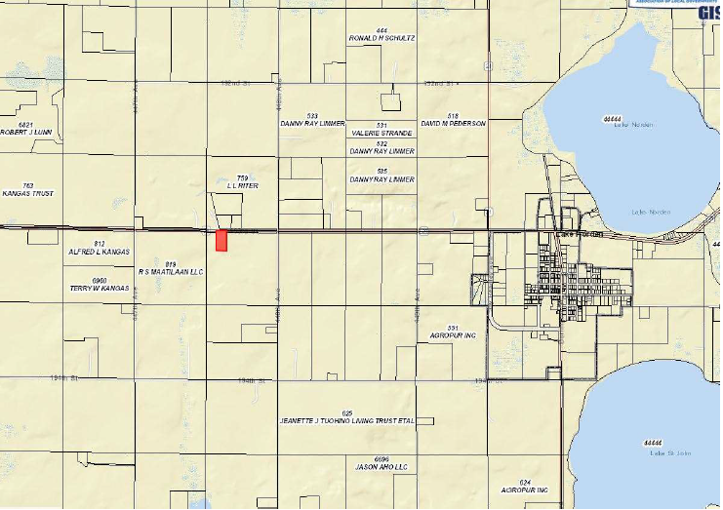
Location:

Issues:
- The Conditional Use permit granted in March 2018 for an extended home occupation has expired after one year and no execution of the permit, thus before considering the variance request the Board must again approve the conditional use for an extended home occupation on this property.
- The Variance request is to place the main building at 40’ from the ROW rather than the required 100’ from the ROW. The stated reasoning for this reduced setback is to accommodate use of the whole property and provide screening from the Highway of activity and items associated with the operation of the business.
  - Based in the Letter of Assurance for the conditional use permit it stated that if complaints arose from the storage of materials on site, the Zoning Board would meet with the applicant to address fencing and screening solutions. In this case, the applicant is seeking to better screen the materials and other items in moving the building closer to the front of the property and use the rear yard as space for storing the materials.
  - While the new placement of the building may provide for better screening, in Staff’s view there still may be the need for additional fencing on the property to obstruct view from the Highway.
- Based upon the standard findings of fact for all variances, Staff does not have an applicable finding to attach to this variance for hardship or reasoning stated in the Ordinance to have grounds to issue the variance. Staff will allow the Board and the Applicant to make a determination for the variance request.

Staff recommendation –
- If approved, the Board may grant based upon:
    - The Board finds that the proposed construction does not further encroach upon any other required setback.
    - At the time of this report, staff has received no complaints from adjoining landowners.
    - Standard findings of fact being met:
      - That special conditions and circumstances exist which are peculiar to the land, structure or building involved, and which are not applicable to other land, structures, or buildings in the same district.
- If denied
          - No standard finding of fact listed in the Ordinance has been met.

Board Action: Minimum Front Yard Setback: The Board may: 1) Postpone the decision 2) Deny the Request 3) Approve the request with or without conditions.

