Hamlin County Planning Commission & Board of Adjustment
Staff Report
Tuesday July 30th, 2019 – 7:00PM

Planning Commission

Item 1: Plat
Applicant/Owner: Lila Grape
Property Description: Lots 3, 4, and 5 of Grape Second Addition in Gov’t Lots 4 & 5 of Section 16, Township 113N, Range 52W of the 5th P.M., Hamlin County, South Dakota
Action Item: Plat Approval
Zoning Designation: Lake Park 1
Request: Applicant is seeking to plat back lot properties on Lake Poinsett for future development.

- Staff Review
  - All Lots meet minimum lot area and access requirements for new properties in the Lake Park District.
- Staff recommends approval

Planning Commission Action: The Commission may: 1) Postpone the decision or 2) Recommend Approval to County Commission or 3) Recommend Denial to County Commission. ‘

Item 2: Bryant TIF Approval
- Toby Morris will present the Bryant TIF Plan as was sent you to a few weeks back and outline the project and answer any questions you may have.

Item 3: Update on Revision to CAFO Regulations
- Based upon a 4-1 vote by the County Commission, 1st District will begin a review and analysis of the existing CAFO regulations beginning later this year to understand how existing regulations affect new and existing operators and provide recommendations based upon public meetings and discussion.

Item 4: Board Discussion on Kenmitz Proposed Ordinance Amendment
- Len provided me with a draft Ordinance Amendment concerning commercial storage garages and additional regulations to add to the ordinance regarding their construction and development. I have included the proposal within your packets.

Board of Adjustment

Item #1: Variance Request

Applicant/Owner: David & Sharon Clay

Property Description: Hendrickson’s Beach: Lots 23 & 24 in Section 34-T113N-R52W of the 5th P.M., Hamlin County, South Dakota.

Action Item: Variance Request – Lake Area Regulations (3.07.10)

Zoning Designation: LP 1 – Lake Park District

Request: The applicants are seeking a reduced front yard setback from the ROW to construct a new house.

Location:
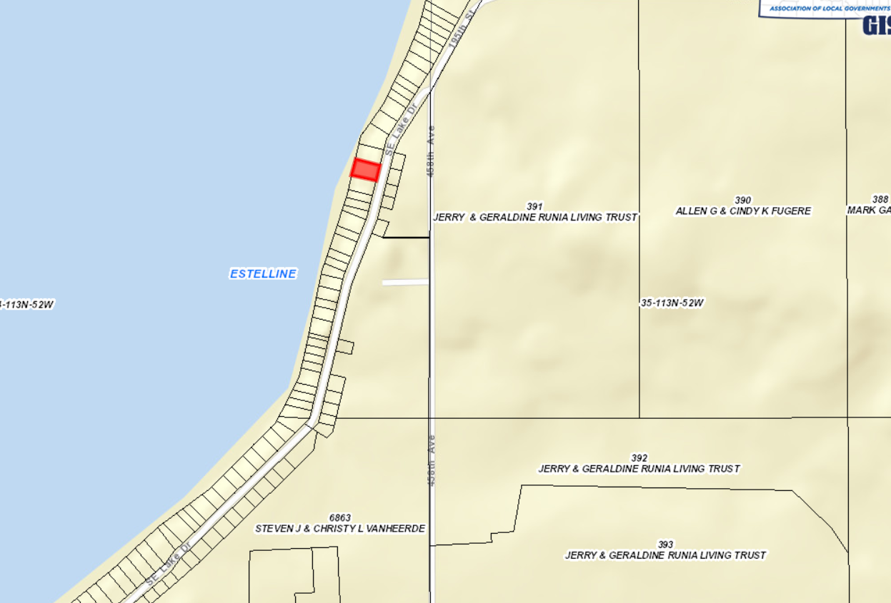

Issues:
- The Clay’s are seeking to demolish the existing house on the property and construct a new house & garage.
- The existing house and garage are set back 53 feet from the edge of the road and the new proposed house & garage would sit 20’ from the edge of the road. The garage (24’ L x 28’ W) will sit 20 from the edge of the road, where the house will be 44’ from the edge of the road.
- Proposed site design meets all other setbacks from side yards (8’) and rear yard lake front (50’).
- Initial design plans for the house & garage met all the existing setbacks, but the request to be closer than allowed is due to the destabilizing wood wall that sits along the shoreline. Over the next few years they will be replacing this wall and request the extra 10’ to assist in this process.
  - Under the findings of fact required for the approval of a variance, one finding as stated “That the special conditions and circumstance do not result from the actions of the applicant;” Staff is unsure if the stated request for the variance falls under this category, this is a determination for the Board to make after hearing testimony from the applicant/contractor.
Staff recommendations – If approved, the Board may grant the variance based upon the following findings:
        - At the time of this report, staff has received no complaints from adjoining landowners.
        - The proposal meets all other required setbacks.
        - The request for the variance is not a result of the special conditions and circumstance from the actions of the applicant.

Board Action: Front Yard Road Setback Variance: The Board may: 1) Postpone the decision 2) Deny the Request 3) Approve the request with or without conditions.

