Hamlin County Planning Commission & Board of Adjustment
Staff Report
Monday – October 29th, 2018 – 7:00PM

Planning Commission

Item #1: Board Discussion: Agri-Business Ordinance

Background: The Board had discussion on this topic last month concerning the addition of an Agri-Business ordinance to allow certain agriculturally related commercial operations to be in the Ag District. Staff presented the Board with options for an Agri-Business ordinance ranging from simple definitions to add or a broader ordinance with performance standards and supplemental information to be qualified to construct and operate such business. The Board instructed Staff to come back the following month with sample language with a wider scope of regulation and as such below is the recommended route for the Ordinance Amendment.

Ordinance Amendment: 2018-05
Chapter ____ Agribusiness Activities
Section _____. Intent
Agribusiness activities include identified commercial activities involving the handling, storage, processing and shipping of farm products. Agribusiness activities are operated as a principle use on a property, and are not operated accessory to residential uses. Agribusiness Activities may be operated as extended home occupations, when such activities are accessory to the residential use of the lot. The following commercial activities may be considered agribusiness activities if operated in accordance with the requirements contained in Section _____:
- Custom fertilizer/herbicide application;

- Custom planting;

- Custom harvesting;

- Grain storage;

- Processing of products raised or grown by the landowner or operator.

- As determined by the discretion of the Board, any additional uses

Supplemental Regulations/Requirements
Section _____Requirements
- Agribusiness activities must have access to a concrete or bituminous asphalt, or county gravel street.

- Operators of agribusiness activities shall enter into and comply with a haul road agreement for the applicable streets if deemed necessary by the applicable road authority for the maintenance of identified haul routes attendant to the operation of the proposed business.

- Lighting on the site shall be limited to downward directed lights or other lighting customarily used for agricultural operations.

- The number, size, and illumination standards for signs shall be determined by the Board of Adjustment.

- No equipment or process shall be used in such extended home occupation which creates noise, vibration, glare, fumes, odors, or electrical interference detectable to the normal senses off the lot. In the case of electrical interference, no equipment or process shall be used which creates visual or audible interference in any radio or television receivers off the premises, or causes fluctuations in line voltage off the premises.

- All vehicles and equipment stored outside shall be operable.

- Permits for Agribusiness activities are specific to a single use listed in Section. An agribusiness activity may only be changed to another agribusiness activity if specifically authorized by the Board of Adjustment.

- Permits for Agribusiness activities may be transferred, unless otherwise stated by the Board of Adjustment.

Section____: Applications.
- In addition to the following information, plans shall be drawn to scale and shall be of sufficient clarity to indicate the location, nature, and extent of the work proposed and show in detail that it will conform to the provisions of this chapter and all other relevant laws, ordinances, rules and regulations. The Zoning Officer may waive the submission of plans if the nature of the work applied for is such that reviewing of plans is not necessary to obtain compliance with this chapter. The site plan shall contain the following:
- The address of the property and the legal description.
- The name of the project and/or business.
- The scale and north arrow.
- All existing and proposed buildings or additions.
- Dimensions of all buildings.
- Distance from all building lines to the property lines at the closest points.
- Dimensions of all property lines.
- Maximum number of employees expected to be employed at the site.
- Hours of operation. (If it is expected that hours of operation will vary depending upon the season, the applicant should state minimum and maximum hours of operation and when those minimum and maximum hours are expected.)
- Number and type of vehicles expected to use the site each day. (If it is expected that traffic will vary depending upon the season, the applicant should state minimum and maximum number of vehicles expected and when those minimum and maximum numbers are expected.)
- Parking lots or spaces; designate each space, give dimensions of the lot, stalls and aisles (if applicable).
- The landscaped setback and trees; indicate species of trees and material to be used for landscaping.
- Name and location of all adjacent streets, alleys, waterways and other public places.
- Names and locations of proposed haul roads.
- Proposed grading and drainage pattern.
- Proposed interior circulation pattern indicating the status of street ownership.
- Phasing plan for development (if more than one phase is planned).

- Approved plans shall not be changed, modified, or altered without authorization from the Board of Adjustment giving final approval, and all work shall be done in accordance with the approved plans.

Board of Adjustment

Item #1: Public Hearing

Owner/Applicant: Josh Spilde
Property Description: Block 1 Spilde Addition in SE ¼ of Section 36 Township 113N Range 53W of the 5th P.M., Hamlin County, South Dakota (Norden Township)

Action Item – Amendment to Condition #5 of Letter of Assurance granted on January 30, 2018
Zoning Designation: LP1 – Lake Park District
Request: Mr. Spilde requests an amendment to the Letter of Assurance requiring connection to Lake Poinsett Sanitary Sewer District.

Overview/History:
- On January 30, 2018 The Hamlin County BOA granted a conditional use permit to Josh Spilde to develop an RV Park with approximately 96 pads at full build out. Also to construct 4 – 48’x150’ storage buildings on the eastern side of the property. At the time of application, Hamlin County did not have any specific regulations concerning campgrounds. All conditions added were based upon recommendations from Staff.
  - Specifically: Spilde was to assure that each camping pad will have access to water, electricity and will further be connected to the Lake Poinsett Sanitary Sewer District.
- Prior to the Board’s decision, Staff received a letter from the Sanitary District stating: language from letter.
- From this letter, Staff recommended Spilde connect to the Lake Poinsett Sanitary District.
- Without the letter and no specific requirements, Staff would have recommended the use of sealed holding tanks or connection to the Sanitary District. Consistent with current practices in the Lake Park and Aquifer Protection District.
- Spilde began construction and operation of a portion of the RV park during the summer of 2018. Staff was not aware of how sanitary sewer was being accommodated and presumed tanks had been buried and connection was in the process of being completed.
- With direction from Board Member John Pantkze, Staff investigated compliance with the Letter of Assurance.
- Staff discovered Spilde had installed sealed holding tank(s) to accommodate the campground residents and said tank(s) were being pumped and waste removed by a registered pumper.
- At the September Zoning Board meeting, the Board became aware of:
      - Lake Poinsett Sanitary Sewer District does not presently have the funds to construct a sewer line to Mr. Spilde’s property
      - Lake Poinsett Sanitary Sewer District does not have an agreed to easement to cross Mr. Hurley’s property.
      - Spilde had installed 2 sealed holding tanks.
      - Dollar General, who had the same condition to connect to the Lake Poinsett Sanitary Sewer, had also installed sealed holding tank in lieu of connection.
      - Spilde plans on building out the rest of the RV Park to full capacity in 2019.
      - Staff was instructed to work with the applicant and Lake Poinsett Sanitary Sewer District to resolve the issue.

- On October 15, Staff met with: Josh Spilde John Delzer, Deputy State’s Attorney Gary Schumacher, and Chairman Richard Wiarda to discuss the matter at hand.
  - After discussion, it was generally agreed Mr. Spilde will be allowed to utilize sealed holding tanks until the Lake Poinsett Sanitary Sewer District extends services to his property.
  - The Agreement was to do the following:
    - Connection to Sanitary Sewer when services have been extended to his legal description (Block 1 Spilde Addition in SE ¼ of Section 36 Township 113N Range 53W of the 5th P.M., Hamlin County, South Dakota (Norden Township) (This is the standard procedure for how new connections are brought into the Sanitary District.
    - Until such time as Lake Poinsett Sanitary Sewer extends a sewer line to Spilde’s property, Spilde will be allowed to utilize the sealed holding tanks to be pumped by licensed pumper with records available at the request of the County Zoning Officer.
    - Sealed holding tanks shall be operated in accordance with SD DENR standards.
Staff recommendation: The Board approves this amendment by adding the above conditions to the Letter of Assurance based upon the following.
  - The intent of the original condition was that septic tanks/drain-fields would not be placed over the shallow aquifer.
  - Connection was required to occur and is still anticipated to occur. There was not specific timeline required.
  - The intent of original condition is currently being met and will continue to be met by the installation and operation of sealed holding tank(s) in accordance with SD DENR standards.
  - Had Staff been aware that connection to the Sanitary Sewer District was not imminent the above conditions would have been recommended at the January hearing.
  - The decision of the Board in this matter will need to be repeated for Dollar General.
  - Staff recommends the following language to replace Condition #5:
5. Grantor shall assure that each camping pad will have access to water, electricity; and will further be connected to the Lake Poinsett Sanitary Sewer District. Will connect to the Lake Poinsett Sanitary Sewer District when said services have been extended to (Block 1 Spilde Addition in SE ¼ of Section 36 Township 113N Range 53W of the 5th P.M., Hamlin County, South Dakota (Norden Township)) and until such time as Lake Poinsett Sanitary Sewer extends a sewer line to Spilde’s property, Spilde will be allowed to utilize the sealed holding tanks with pumping records available at the request of the County Zoning Officer; Sealed holding tanks shall be installed and operated in accordance with SD DENR requirements.

Board Action: Amendment to Condition #5: The Board may: 1) Postpone the decision 2) Deny the Amendment 3) Approve the Amendment with or without additional conditions.

Item #2: Variance Request

Owner/Applicant: Thomas & Megan Kreutner
Property Description: S ½ of Lot 5 Saaranen’s Beach in Govt Lot 1 in NE ¼ of Section 16, Township 113N, Range 52W of the 5th P.M., Hamlin County, South Dakota (Norden Township)

Action Item –Variance: Lake Area Regulations: Front Yard Setback (3.7.10)
Zoning Designation: LP1 – Lake Park District
Request: The applicant is requesting a variance to construct the attached garage closer to the road ROW from 30’ to 12’.

            - Staff Review of Application
              - General Location
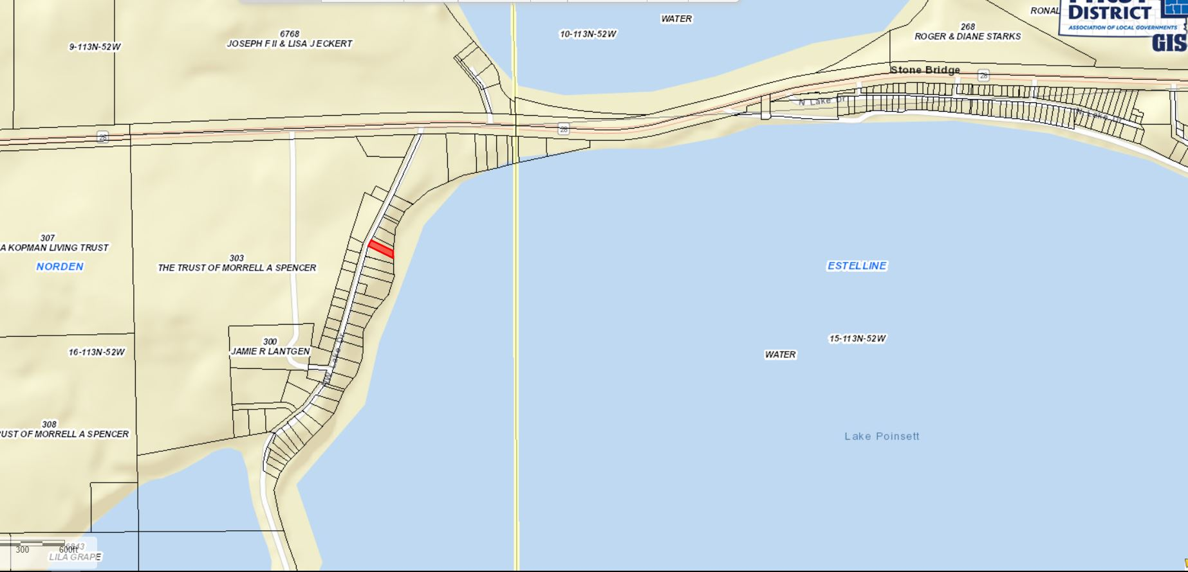

  - The required front yard setback along the ROW is 30’. The applicant is seeking to a 18’ variance in the construction of a new garage and house addition.
    - The existing garage placement is closer than proposed new setback. The new setback would accommodate parking easier with the use of the garage.
    - The proposed construction does not further encroach into the existing rear yard (lake front) setback or side yard setbacks. The addition would be a second level to the dwelling and a new garage.
    - Though it may be the intent of Section 3.02.06 (Continuation of Nonstandard Uses) to allow for in line additions to nonconforming structures. The language does not specifically allow for the zoning officer to issue this permit without a variance issued by the Board. An ordinance amendment to allow for the Zoning Officer to issue these without Board approval would reduce the number of variance requests to the Board and ensure the intentions of the Comprehensive Plan and Zoning Ordinance are met.
2. Staff recommendations – Staff recommends approval based upon the following:
        - The board finds that it is the intent of Section 3.02.06 to allow for a nonconforming addition to be made on a nonconforming structure provided the addition is no closer to the property line (lake) than the current structure.
        - The Board finds that the proposed construction does not further encroach upon the rear yard lake front setback.
        - At the time of this report, staff has received no complaints from adjoining landowners.
        - Standard findings of fact being met:
i. That special conditions and circumstances exist which are peculiar to the land, structure or building involved, and which are not applicable to other land, structures, or buildings in the same district;
a. Shape of the lot, proposed plan fixes a safety issue to the best possible layout while meeting all 3 other setbacks.
Board Action: Front Yard Setback Variance: The Board may: 1) Postpone the decision 2) Deny the Request 3) Approve the request with or without conditions.

Item #3: Staff Report
Update on Building Permits and Permitted Special Use

