Hamlin County Planning Commission & Board of Adjustment
Staff Report
Tuesday – July 31, 2018 – 7:00PM

Planning Commission

Item #1: Plat

Applicant/Owner(s): Larry and Mike Steffensen

Property Description: Lots 109-111, 132, 133, and 137-142, North Bay Twelfth Addition in the West ½ of Section 36, Township 113N, Range 53W of the 5th P.M., Hamlin County, South Dakota. (Norden Township)

Action Item: Plat Approval

Zoning Designation: Lake Park 1

Request: Mike and Larry Steffensen seek to place out a total of 11 lots for residential development in the North Bay development.

Staff Review
- The property owned by the Steffensen’s is listed under Northbay 6th Addition Lots 1, 2, 3 and 5, which was included in last month’s property rezone of North Bay Addition.
- The new lots included on the plat do conform to the “unofficial” master plan of North Bay done by Sayre Associates.
- All lots meet minimum lot area and lot widths.
  - Lot 137 has a frontage of 50’ at Augusta Drive, but lot width is measured 50’ back from the road line.
- Staff recommends approval

Planning Commission Action: The Commission may: 1) Postpone the decision or 2) Recommend Approval to County Commission or 3) Recommend Denial to County Commission.

Board of Adjustment

Issue #1: Variance

Applicant/Owner: Erik & Barbara Jensen

Property Description: Paulson’s Subdivision Block 1 Lot 19 in Section 31, Township 113N, Range 52W of the 5th P.M., Hamlin County, South Dakota. (Norden Township)

Action Item: Side Yard Lake Front Setback (3.07.09)

Zoning Designation: Lake Park 1

Request: The applicant is requesting a reduced setback to construct an addition to the house.

Staff Review of the Application
- General Location
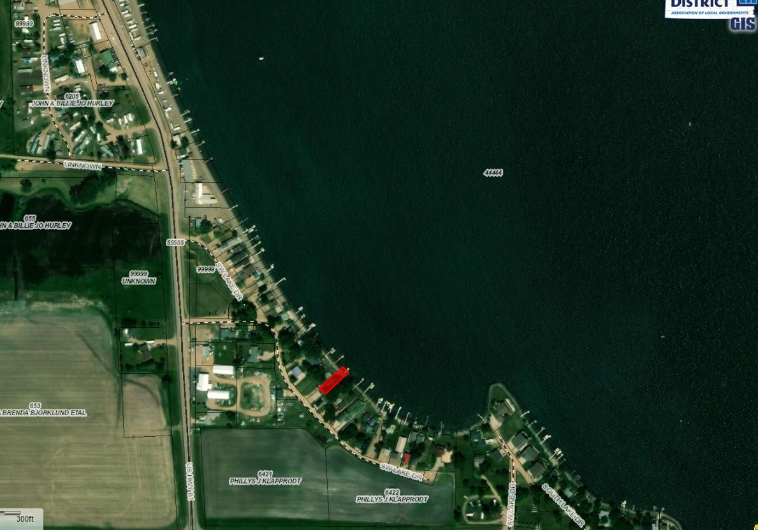

- The required setback for the side yard is 8’ from the adjoining property line. The applicant is seeking to construct an addition along the existing setback line (4’)
- The proposed construction does not further encroach into the existing side yard setback. The proposed addition does not encroach on any other setback.
- Though it may be the intent of Section 3.02.06 (Continuation of Nonstandard Uses) to allow for in line additions to nonconforming structures. The language does not specifically allow for the zoning officer to issue this permit without a variance issued by the Board. (Similar variance was granted in March 2018 to Corey Bawdon at Clear Lake)

Staff recommendations – Staff recommends approval based upon the following:
a. The board finds that it is the intent of Section 3.02.06 to allow for a nonconforming addition to be made on a nonconforming structure provided the addition is no closer to the property line (lake) than the current structure.
b. The Board finds that the proposed construction does not further encroach upon the side yard setback.
c. At the time of this report, staff has received no complaints from adjoining landowners.

Board Action: Side Yard Variance: The Board may: 1) Postpone the decision 2) Deny the Request 3) Approve the request with or without conditions.

Item # 2 Conditional Use
Applicant/Owner(s): Otter Tail Power Company
Property Description: Lot 7 of Railroad Addition, a part of Lot 5 of the Plat of Lots 5 and 6 of Railroad Addition in S ½ of Section 33, Township 114N, Range 51W of the 5th P.M., Dempster, Hamlin County, South Dakota.
Action Item: Conditional Uses in the Town District (Essential Public Services) (3.09.03.7)
Zoning Designation: TD – Town District
Request: Otter Tail Power Company is seeking to construct a pole platform substation.

Staff Review of Application:
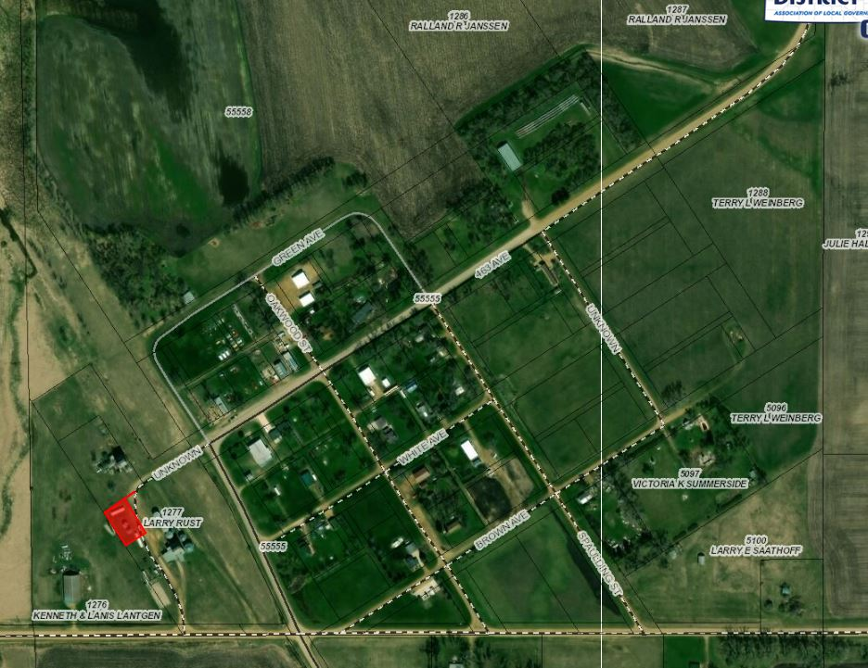
- General Location:

- Background/History
  - Otter Tail Power Company contacted the Zoning Officer in April with a Plat of Lot 7 Railroad addition and started discussion on the proposed project. With further research, it was discovered there was not a listed permitted or conditional use which would allow their project to move forward. After discussion with representatives of Otter Tail, it was determined an Ordinance Amendment was necessary to allow their use. Staff initiated the Ordinance Amendment which was heard before the Board of Adjustment at the May 2018 Meeting and subsequently recommended approval to the County Commission. The Ordinance Amendment came into effect on July 9th allowing for essential public services as a listed conditional use in the Town District.
  - With concern to the Plat of Lot 7 Railroad Addition, Staff brought this to the April Planning Commission meeting and described the lack of proper access to the property and the proposed use issues. Otter Tail has gained access through an easement with the property owner adjacent (Larry Rust). Thus, the Plat was brought to the June 2018 Planning Commission meeting and was recommended approval to the County Commission who subsequently approved the Plat.
- Otter Tail Power Company seeks to place a 3-phase pole platform substation on Lot 7 to better serve the unincorporated town of Dempster and the surrounding area.
- Since this property only has access through an easement The Board of Adjustment should only approve this permit if it determines the access easement already recorded is sufficient for the use.
- Lot 7 is an 80’x30’ lot. The structure with consist of 2 power poles placed 15’ apart with a platform mounted between them with to hold the substation equipment. The structure will be a total 50’ long (including 40’ guy wire and 8’ lead)
- No specific requirements for essential public services are listed in ordinance.
- The substation’s proposed lot does fall into the adopted Flood Zone. Otter Tail’s plans comply with section 3.11.04 Methods of Reducing Flood Losses in the Flood Plain Overlay District.
- The substation’s proposed lot does lie over Zone B of the Aquifer Protection District.
  - No contaminants or hazardous materials are proposed to be stored on-site.
- The request appears to comply with Section 4.04.01 Powers and Jurisdiction Relating to Conditional Uses.
- Staff is unaware of any permitting requirements with PUC or other applicable departments of the state.
- Otter Tail Power Company must comply to the National Electric Safety Code during the construction of the substation as with similar substations in the County.

Staff recommendation – Staff recommends approval based upon the following:
- Applicant meeting conditions for conditional uses established in section 4.04.01.
- Applicant agrees to submit documentation that the proposed services will be built in accordance with applicable state and federal requirements.

Board Action: Conditional Use: Conditional Uses in the Town District: The Board may: 1) Postpone the decision 2) Deny the Request 3) Approve the request with or without conditions.
Item #3: Conditional Use

Applicant/Owner(s): Otter Tail Power Company

Property Description: A 50’ wide strip of private property adjacent to (west of) 449th Avenue from 196th Street to the North side of 194th Street; and A 50’ wide strip of private property on the North side of 194th Street from 449th Avenue to the Western boundary of Lake Norden City limits.

Action Item: Conditional Use – Conditional Uses in the Agricultural District (Essential Public Services) (3.04.04.13)

Zoning Designation: AG – Agricultural District

Request: Otter Tail Power Company is seeking to construct a 115 kV electrical transmission line.
Staff Review of the Application:

- General Location:
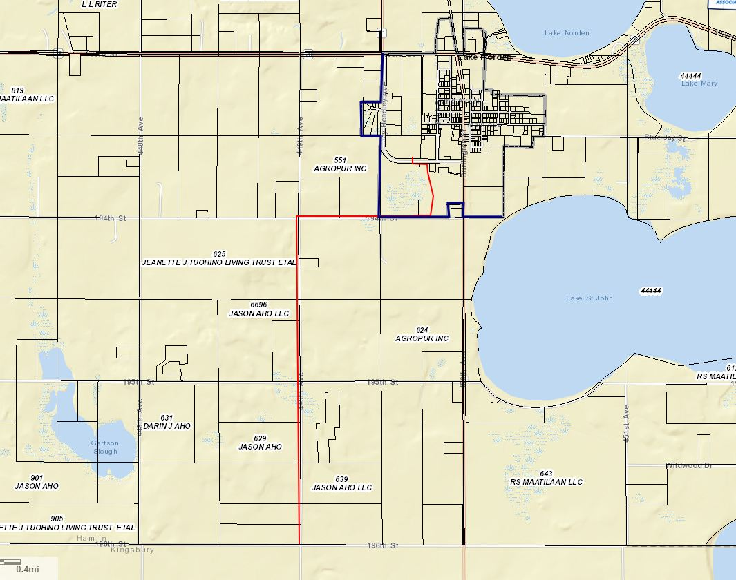

- Transmission line is represented by the Red line. The Blue line represents Lake Norden City Limits. The line, for the County, begins in the SE ¼ of Section 20 owned by Agropur Inc and runs west to 449th Ave and runs south on the West side of the Right of Way to the County border with Kingsbury County where the line will run to Hetland SD.
- The proposed route runs through a 50’ easement (on private property) adjacent to the township road Right of Way. Both 194th Street West of Lake Norden City Limits and 449th Ave are Norden Township Roads.
  - The transmission line will be placed 5’ from the East edge of the Easement.
- The Transmission line is a listed conditional use under section 3.04.04.13 as an essential public service.
- No specific requirements for essential public services are listed in ordinance.
- The request appears to comply with Section 4.04.01 Powers and Jurisdiction Relating to Conditional Uses.
- The line will cross an area identified as potential 100-year floodplain, in the SW1/4 of Section 32-113-53. It should be noted that this floodmap provided by FEMA HAS NOT YET BEEN ADOPTED, so it serves only as a guidance document, but not regulatory.
- The portion of this line that runs adjacent to 194th Street is primarily located over Zone B of the Aquifer Protection District. The project complies with the Aquifer Protection District requirements.
- Staff is unaware of any permitting requirements with PUC or other applicable departments of the state.
- Otter Tail Power Company must comply to the National Electric Safety Code during the construction of the transmission line as with similar electrical lines in the County.

Staff recommendation – Staff recommends approval based upon the following:
1. Applicant meeting conditions for conditional uses established in section 4.04.01.
2. Applicant agrees to submit documentation that the proposed services will be built in accordance with applicable state and federal requirements.

Board Action: Conditional Use: Conditional Uses in the Agricultural District: The Board may: 1) Postpone the decision 2) Deny the Request 3) Approve the request with or without conditions.

