Hamlin County Planning Commission & Board of Adjustment
Staff Report
Monday – August 27th, 2018 – 7:00PM

Planning Commission

Item #1 Plat
Applicant/Owner(s): Lyle Gehrke
Property Description: S. Gehrke Addition in the SW ¼ of Section 8, Township 114N, Range 52W of the 5th P.M., Hamlin County, South Dakota.

Action Item: Plat Approval

Zoning Designation: Agricultural

Request: Lyle Gehrke seeks to plat out a small acreage for residential development

Staff Review
- Plat meets the minimum lot area requirements and access requirements.
- Establishment of a dwelling in this location adheres to density requirements of one house per ¼ ¼.
- Staff recommends approval

Planning Commission Action: The Commission may: 1) Postpone the decision or 2) Recommend Approval to County Commission or 3) Recommend Denial to County Commission.

Item #2 Plat
Applicant/Owner(s): Gregory Wellhouse
Property Description: Block 1, Wellhouse Addition in the S ¼ and NW ¼ of Section 26, Township 115N, Range 51W of the 5th P.M., Hamlin County, South Dakota.

Action Item: Plat Approval

Zoning Designation: Agricultural

Request: Mr. Wellhouse seeks to plat out his property for future sale.

Staff Review
- Plat meets all lot area requirements and access requirements.
- The unusual shape of the plat is to include multiple buildings and shelterbelts which the applicant seeks to include in the future sale of his property.
- Staff recommends approval

Planning Commission Action: The Commission may: 1) Postpone the decision or 2) Recommend Approval to County Commission or 3) Recommend Denial to County Commission.

ITEM #3: Board Discussion: Spilde RV Campground

Review: Over the past couple weeks, I have heard from multiple accounts and Mr. Spilde himself they have not completed the connection of the RV campground and the waste management facilities to the Lake Poinsett Sanitary Sewer District. When the Board approved the RV campground in January 2018, a condition placed upon the approval of the conditional use permit was to require Mr. Spilde to hookup to the Sanitary District. I am asking the Board for any additional information on the status of the project (John Pantzke) and for any recommendation on how to proceed.

Board of Adjustment

ITEM #1: Variance

Applicant/Owner: Gordon and Delores Kangas

Property Description: E 573’ of N 551’ of NW ¼ of Section 20, Township 113N, Range 53W of the 5th P.M., Hamlin County, South Dakota. (Norden Township)

Action Item: Intensity of Use in the Agricultural District (Section 3.04.06.2)

Zoning Designation: Agricultural

Request: The applicant is requesting a variance to place a single-family dwelling on a quarter quarter section where there is no development right.

Staff Review of the Application
- General Location
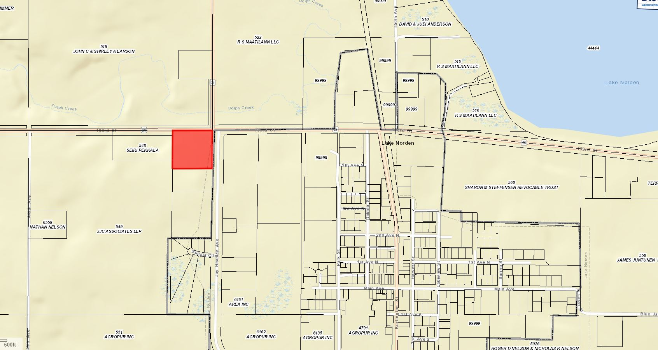

- The applicant(s) are seeking to construct a single-family dwelling on the property legally described above.
- Per Section 3.04.06.2 Intensity of Use, buildable lots are required to have a minimum of 2 acres (Property is 7.5 acres) and there are to be no more than 1 dwelling per ¼ ¼. Currently there are three houses in the ¼ section (2 Houses in the NE ¼ ¼) with a portion of the section already within Lake Norden City Limits.
- With 3 dwellings in the ¼ section, there is a development right available in the Northwest or Southeast ¼ ¼, all owned by JJC Associates LLP. As it stands, they would be the only landowner with the right to construct a home.
- The Kangas’ did possess a development right for the Northeast ¼ ¼, unfortunately this was used (knowingly or unknowingly) when they subdivided their property and Eric and Janelle Kangas constructed a home in 2014.
- Hamlin County Comprehensive Plan: The area encompassing the house is defined in the Future Land use Map as an area of Development Advantage. As defined in the Comprehensive Plan, these areas are placed here because they are immediately adjacent to municipalities and lakes that can provide adequate infrastructure for development. Under policies of the Development Advantage area, the County is to encourage annexation of potential development sites within fringe municipal areas. Another policy is to discourage premature development which is defined as development that could limit future land use options and opportunities to locate and finance public infrastructure improvements.
  - The Kangas’ property falls under the development advantage with its proximity to The City of Lake Norden.

Staff recommendations – Staff recommends denial based upon the following:
  - The board has not, based upon Zoning Office records, granted a variance to allow for more than 1 house per ¼ ¼ section where there was no other avenue to constructing a second home.
    - As of the date of this application, the Board in January 2018 turned down Mr. Schooley to transfer a development right where there was none available and the Board stated they would not change the ordinance(Density Standards of 1 house per ¼ ¼) to accommodate this request.
  - Staff finds that there is no hardship applicable to the granting of this variance based upon the conditions stipulated in the Zoning Ordinance to provide justification for the application.
  - The Kangas’ do not have a development right on their property as it is currently zoned Agricultural under the Counties jurisdiction.
  - The Comprehensive Plan: Development Advantage as classified by the Comprehensive Plan and thus it is encouraged to annex into the City of Lake Norden.
  - Staff recommended the Kangas’ begin the process to formally annex into the City of Lake Norden as they are adjacent to city limits and the City’s Comprehensive Plan and Zoning Ordinance is better suited to construct residential development.
    - They could petition to have their property zoned under the City of Lake Norden’s Zoning Ordinance as an “agricultural” zoned property and abide by those regulations to construct a single family home. The regulations are similar to the County’s, yet they do not abide by the same density requirements as the County.

Board Action: Intensity of Use in the Agricultural District: The Board may: 1) Postpone the decision 2) Deny the Request 3) Approve the request with or without conditions.

ITEM #2 CONDITIONAL USE

Applicant/Owner: Drumgoon Dairy

Property Description: NW1/4, Section 6-T113N-R52W, Hamlin County, South Dakota. (Norden Township)

Action Items: Conditional Use – Accessory Agricultural Housing (5.25.06)

Zoning Designation: A - Agricultural

Request: Drumgoon requests to build a second dwelling to house an additional 8 employees for a total of 24 employees housed on site.

History/Issue(s):

- General Location

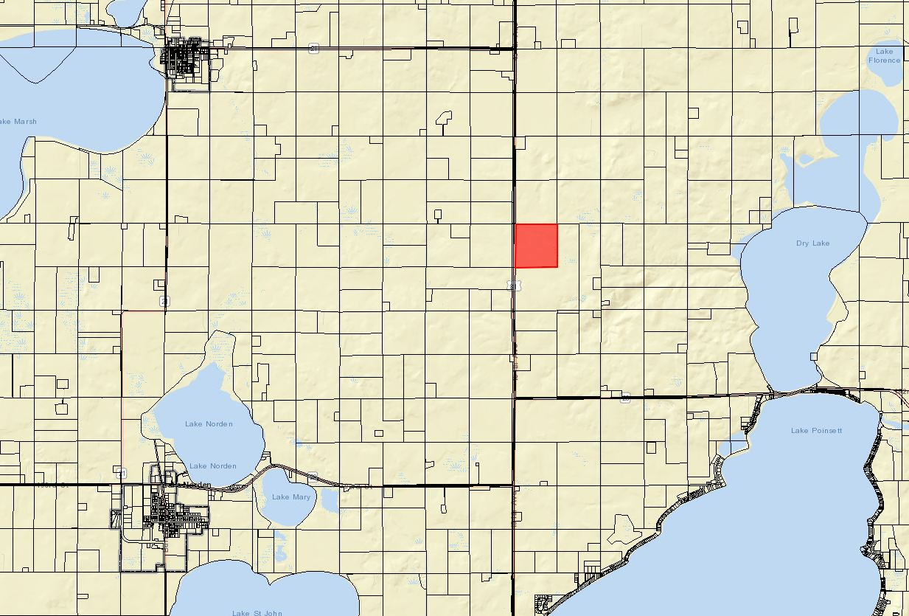
Specifics of Request

- Drumgoon constructed a dormitory-style “farm dwelling” for up to 16 employees in 2017. Staff is unable to find a conditional use permit which may have authorized the use of the structure.
- The applicant requests to build a second dwelling for up to 8 additional employees. The structure will have steel siding and be constructed more like a 4-plex with 2-bedroom units and central corridor with a washroom and utility room.

Ordinance and Comprehensive Land Use Plan regarding this request:
- In 2017 the Zoning Ordinance was amended to allow for “Accessory Agricultural Housing” as a conditional Use. In 2018, after the initial application Drumgoon Dairy submitted it was determined they could not proceed with the proposed use and the Accessory Agricultural Housing Section of the Zoning Ordinance needed to be amended. The newly updated section was adopted on July 21st, 2018 and came into force 20 days later. The requirements for Acccessory Agricultural Housing are listed under Section 5.25.06
- Drumgoon operates a Class A CAFO on the above described property. They were permitted for 4,900 head of mature dairy cattle and 200 heifers in May of 2017.
- Site location of the accessory housing will be on the same section of land as the permitted CAFO
- The farm owner does not live on the same lot (not required by ordinance)
- The lot contains 160 acres (minimum 2 acres required.)
- This request will allow for a total of two dwellings one accommodating 16 individuals and the other (new structure) accommodating 8 individuals.
  - The Board will have to determine whether vertical steel siding is appropriate for the siding of the structure.
- Proposed plan meets the matrix in the Ordinance listing the number of Animal Units, Maximum number of dwellings, and Maximum number of persons living in the structures.
- The proposed structure will be required to meet building code in accordance with state law.
- Sanitary sewer is required to be installed in accordance with SDDENR standards.

Staff Summary and Recommendation

Since no record of a Conditional Use permit is available for the existing 16-person structure the Board’s motion will be to approve staff housing in two structures for up to 24-individuals (combined) Staff’s recommendation is to approve the request

Conditional Use Permit – Accessory Agricultural Housing: The Board may postpone the request if it is generally felt more information or time to deliberate is needed; deny the request; or approve the request. If approved, the staff recommends, at a minimum, the following conditions:

- This Conditional Use Permit authorizes the use of this property for accessory agricultural housing providing residence for up to twenty-four (24) farm employees with:
  - One structure accommodating up to sixteen (16) farm employees; and
  - One structure accommodating up to eight (8) farm employees.
- As a condition of obtaining a conditional use permit to establish accessory agricultural housing on the above property the Grantors, their heirs, successors, and assigns agree that no further residential development shall be allowed on the above described property unless in accordance with the terms of this permit or the Hamlin County Zoning Ordinance at the time of development. Residential development to be defined as a “dwelling” per the Hamlin County Zoning Ordinance.
- Prior to occupying the accessory agricultural structure, the grantor shall provide documentation of compliance with the most recently adopted version of the International Building Code in accordance with SDCL 11-10-6 for any dwelling structure with two or more dwelling units or housing more than three unrelated individuals.
- Prior to occupying the accessory agricultural housing dwelling/shared dwelling, the applicant shall provide documentation of compliance with any South Dakota Administrative Rules 74:53.
- The dwelling(s) shall be occupied by the agricultural labor force, or a family member of the agricultural employer.
- The dwelling/shared dwelling shall be removed or renovated into a single-family dwelling in the event the permit for the concentrated animal feeding operation becomes void.
- The grantor agrees to notify the zoning officer if either structure becomes unoccupied. In the event the accessory agricultural housing dwelling/shared dwelling remains unoccupied for a period of one (1) year; or is not used in conformance with this Chapter, the accessory agricultural housing dwelling/shared dwelling shall be removed or with permission of the Board of Adjustment may be used for any use accessory to the Concentrated Animal Feeding Operation.
- Violation of the terms of this conditional use permit will be determined by the Hamlin County Zoning Officer.
- The first violation substantiated by the Zoning Officer of this conditional use permit may result in a notification letter stating the violation and a prescribed period of time to remove the violation. A second violation will result in a hearing to review the validity of the conditional use permit and may result in revocation of the conditional use permit.
- The applicant may make appeal from the decision of the Zoning Officer or other agent of the Hamlin County Board of Adjustment to the Hamlin County Board of Adjustment. The applicant shall file with the Zoning Officer a notice of appeal specifying the grounds thereof. The Zoning Officer shall forthwith transmit to the Board of Adjustment all papers constituting the record upon which the action appealed from was taken. Such appeal shall be taken within thirty (30) days. Appeals from the Board of Adjustment shall be taken to Circuit Court.
- Failure to comply with the decision of the Zoning Officer or other agent of the Hamlin County Board of Adjustment may be deemed a separate violation.

- All of the terms and conditions herein shall extend to and be binding upon the heirs, assigns, or successors in interest of the Grantor, and are to be deemed a covenant running with the above-described property. Furthermore, it is agreed that, in accepting title to the above-described property any grantee, heir, assign, or successor in interest to the undersigned expressly agrees to be bound by the terms of this agreement which shall, upon its execution, be recorded with the Hamlin County Register of Deeds Office.

ITEM # 3 Conditional Use

Applicant/Owner: Herb Wollman/Poinsett Hutterian Bretheren Inc.

Property Description: SE ¼ of Section 27, Township 114N, Range 51W of the 5th P.M., Hamlin County, South Dakota. (Dempster Township)

Action Items: Conditional Use - Class C CAFO (Section 3.04.04.9)

Zoning Designation: Agricultural

Request: The applicant seeks to develop a 4,800 Head Nursery Swine Barn (Class C – 480 Animal Units)

Staff Review of Application:

General Location:

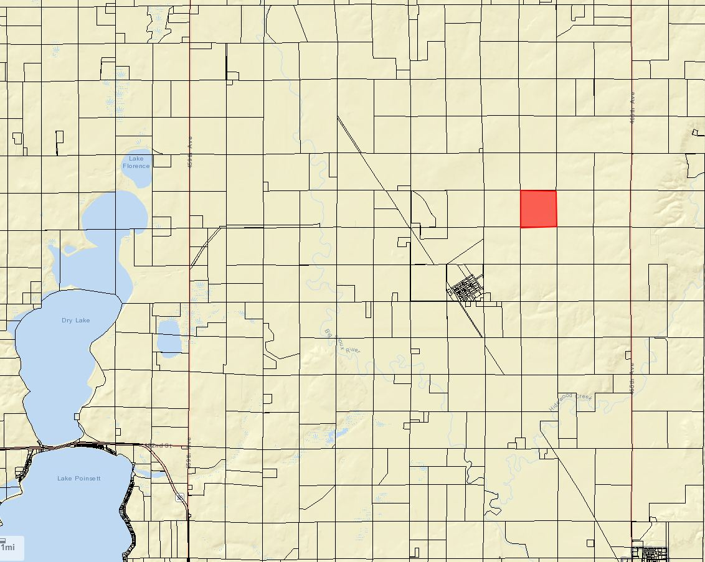

Overview of Application Materials (Section 5.25.05.11)
- Poinsett Colony seeks to establish a 4,800 head nursery swine (480 Animal Units) concentrated animal feeding operation. Poinsett Colony has enlisted the help of Dakota Environmental to assist in planning and engineering of the site.
- The initial Nutrient Management Plan has been developed using DENR General Permit requirements. They have included information concerning proposed population, storage, application methods, land available for application, crop yield projections, and soils test data. The land where manure will be applied has been approved by DENR as a part of the Main Poinsett Colony CAFO, but the land listed in their application materials will be reserved solely for this proposed CAFO.
- They do have a Manure Management and operation plan, this also is done to DENR general permit standards.
- They have a Management plan for fly and odor control.
- The proposed meets all required setbacks for a Class C CAFO, which include:
  - 1.320 feet from Established Residences, Churches, Commercial, and Planned Residential District.
  - 1,320 feet from Incorporated Municipality Limits, Schools, Town Districts (Dempster 4,600 feet.
  - 1,320 feet from Private Wells other than operator.
  - 200 feet from Lakes and Streams
  - 150’ from Township ROW
- No DENR review will be necessary as it is a Class C CAFO (No State General Permit) and the facility is not to use a lagoon or earthen storage basin. The swine will be housed in a self-contained barn provided with an eight foot deep concrete pit for manure storage.
- All information on soils, shallow aquifers, designated wellhead protection areas, and 100- year floodplain designations have been included. The proposed site does not site above Zone B of the Aquifer Protection District or the Floodplain District.
    - Portions of the property are classified as potential floodplain in the FEMA Discovery Map, but no portion of the proposed site on the property are included.
- Dempster Township officials and Sioux Rural Water were sent letters concerning the proposed use as they are the applicable Road and Water Authorities for the property. Adjoining landowners were notified as well.
Staff Recommendation: Staff recommends approval with conditions placed in a letter of assurance as follows below:
Conditional Use Permit – Class B CAFO: The Board may postpone the decision, deny the request or approve the request. If approved, the staff recommends, at a minimum, the following conditions:

- The applicant agrees to comply with the submitted nutrient management plan, fly and odor management plan, and manure management plan.
- Applicant shall provide updated information regarding fields included in the nutrient management plans upon request by the Zoning Officer.
- This Conditional Use Permit authorizes the use of this property for a Concentrated Animal Feeding Operation consisting of 480 animal units. In no case shall it be implied that this permit authorizes greater than 480 animal units.
- Haul road agreements with Dempster Township shall be provided for the use of 189th Street and 464th Avenue for primary haul routes. Unless otherwise agreed to between the township and the applicant, Hamlin County requires the Grantor (applicant) to abide by the following terms to be included in the Agreements:
  - The Grantor shall be responsible for any costs associated with extraordinary maintenance and graveling on the portions of 189th Street and 464th Avenue designated as the primary haul roads, and
  - All road work whether customary or extraordinary shall be done under the authority and supervision of the Township and meet its specifications. The work shall be done through the applicable contractor unless the Grantor receives prior authorization from the applicable road authority to conduct its own repairs or maintenance.
  - Dempster Township shall be responsible for all ordinary snow removal on its portion of 189th Street and 464th Avenue on the same basis as provided to the remainder of the Township. Any additional snow removal deemed necessary for the Grantor to continue its operations is hereby authorized to be done at Grantor’s expense.
  - The Grantor acknowledges that, to the extent already provided for by the law, and further acknowledges that it shall be responsible for any and all damages to applicable road authority roads or road right-of-ways due to the result of the Grantor’s operations (i.e. Delivery of feed, Hogs, manure disposal). Work will be done on the same basis as specified hereinabove. However, no unique standard or obligation not otherwise provided for by law is created by this acknowledgment.
  - The Grantor may have an Agreement with a contractor for hauling manure and shall notify the Township in advance of manure hauling by listing the roads that will be traveled.
  - The Township and Grantor may review and assign new haul routes on an annual basis.
  - In the event the haul road agreements hereinbefore described are not executed, the grantor, his heirs, assigns or successors in interest of the Grantor agree that all of the terms and conditions of Item “4” above are to be deemed a covenant running with the above-described property. Furthermore, it is agreed that, in accepting title to the above-described property any grantee, heir, assign, or successor in interest to the undersigned expressly agrees to be bound by the terms of Item “4”.
- The Grantor shall comply with established minimum manure application setbacks when spreading manure generated from the CAFO.
- The conditional use shall be in effect only as long as sufficient land specified for spreading purposes is available for such purposes and other provisions of the permit are adhered to.
- The Grantor, his heirs and assigns agree that the permitted number of animal units on site will be no greater than four hundred and eighty (480). Expansion over four hundred and eighty (480) animal units will require a new conditional use permit action.
- The Conditional Use Permit is transferable. Subsequent owners/operators will be required to agree to the terms of this permit.
- If there are 1) Violations of the Conditional Use Permit or other Hamlin County Zoning regulations or 2) Failure of the manure containment system, the applicant may be required to forfeit the Conditional Use Permit.
- Violation of the terms of this conditional use permit will be determined by the Hamlin County Zoning Officer.
  - The first violation substantiated by the Zoning Officer of this conditional use permit may result in a notification letter stating the violation and a prescribed period of time to remove the violation. A second violation occurring within one calendar year of the previous violation may result in a review of the validity of the conditional use permit and potential revocation of said permit. A third violation within one calendar year of the initial violation may result in revocation of the conditional use permit and cessation of all feeder operations within forty-five days (45) of notice of revocation.
  - The applicant may make appeal from the decision of the Zoning Officer or other agent of the Hamlin County Board of Adjustment to the Hamlin County Board of Adjustment. The applicant shall file with the Zoning Officer a notice of appeal specifying the grounds thereof. The Zoning Officer shall forthwith transmit to the Board of Adjustment all papers constituting the record upon which the action appealed from was taken. Such appeal shall be taken within thirty (30) days. Appeals from the Board of Adjustment shall be taken to Circuit Court.
  - Failure to comply with the decision of the Zoning Officer or other agent of the Hamlin County Board of Adjustment may be deemed a separate violation.
- All of the terms and conditions herein shall extend to and be binding upon the heirs, assigns, or successors in interest of the Grantor, and are to be deemed a covenant running with the above-described property. Furthermore, it is agreed that, in accepting title to the above-described property any grantee, heir, assign, or successor in interest to the undersigned expressly agrees to be bound by the terms of this agreement which shall, upon its execution, be recorded with the Hamlin County Register of Deeds Office.
Board Action:
The Board may: 1) Postpone the decision 2) Deny the Request 3) Approve the request with or without conditions.

