Hamlin County
Pre-Disaster Mitigation Plan
2019-2024

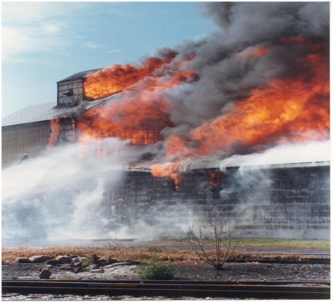
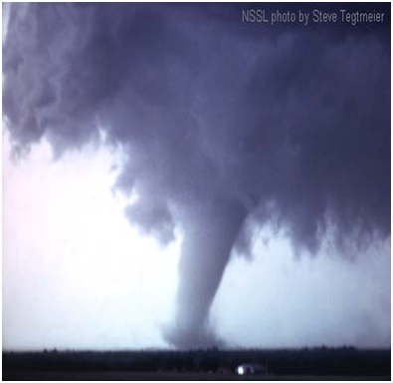
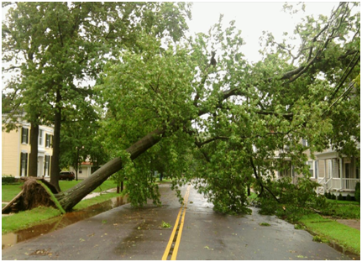
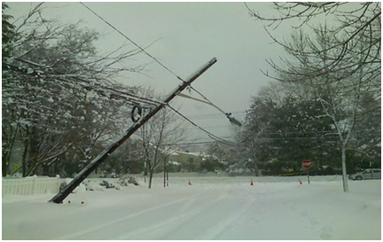
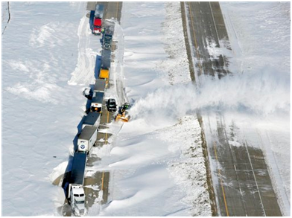
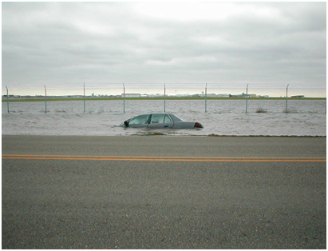

Prepared by: First District Association of Local Governments

418 18th Avenue NE
Watertown, SD 57201
Phone: 605-882-5115
Fax: 605-882-5049
www.1stdistrict.org

For: Federal Emergency Management Administration

TABLE OF CONTENTS
CHAPTER 1 – INTRODUCTION 1
- Introduction 1
- Authority for Pre-disaster Mitigation Plan 1
- Purpose 2
- Use of Plan 2
- Scope of Plan 2
- What is Hazard Mitigation 3
- Hamlin County Profile 4
  - Population 4
  - Social and Economic Description 7
  - Physical Description and Hydrology 7
  - Climate ………………………………………………………………………………………………... 7
  - Transportation and Commuting Patterns 8
  - Utility Infrastructure …………………………………………………………………………………...8
  - Medical and Emergency Services 9

CHAPTER 2 – PREREQUISITES 10
- Adoption by Local Governing Body 10
- Multi-jurisdictional Plan Participation 10

CHAPTER 3 – PLANNING PROCESS 13
- Background 13
- Documentation of Planning Process 14
  - Methodology 14
  - Planning Framework 14
  - Risk Identification & Assessment/Mitigation Strategy/Review of Plan 18

CHAPTER 4 – RISK ASSESSMENT 21
- Identification of Hazards 21
- Types of Natural Hazards in the PDM Jurisdiction Area 23
- Hazard Profile 27
  - Drought 27
  - Wildfire ……………………………………………………………………………………………… 28
  - Flood 30
  - Hail 31
  - Lightning 34
  - Tornado 34
  - Extreme Temperatures 36
  - Thunderstorm and High Wind 37
  - Winter Storms 39
- Assessing Vulnerability: Overview 44
- Assessing Vulnerability: National Flood Insurance Program Compliance 49
- Assessing Vulnerability: Repetitive Loss Properties 50
- Assessing Vulnerability: Severe Repetitive Loss Properties 50
- Assessing Vulnerability: Identifying Structures 51
- Assessing Vulnerability: Community Capabilities 63
- Assessing Vulnerability: Estimating Potential Losses 63
  - Flooding 66
  - Tornado 68
- Assessing Vulnerability: Analyzing Development Trends 69
- Unique or Varied Risk Assessment 72

CHAPTER 5 – MITIGATION STRATEGY 80
- Mitigation Overview 80
- Implementation of Mitigation Actions 110

CHAPTER 6 – PLAN MAINTENANCE 111
- Monitoring, Evaluating, and Updating the Plan 111
- Continued Public Participation/Involvement 111
- Annual Reporting Procedures 112
- Five-Year PDM Review 112
- Plan Amendments 112
- Incorporation into Existing Planning Mechanisms 113
- Potential Funding Sources 113
- Federal 114
- Local 117
- Non-Governmental 117

LIST OF TABLES
- 1.1: Hamlin County Municipalities 4
- 1.2: Hamlin County Townships 5
- 2.1: Plan Participants 10
- 2.2: Dates of Plan Adoption by Jurisdiction 11
- 2.3: Record of Participation 12
- 3.1: Participation in Plan Development 15
- 3.2: Opportunities for Public Comment 17
- 3.3: Record of Review (Summary) 20
- 4.1: Significant Hazard Occurrences 2007-2018 21
- 4.2: Hazards Categorized by Likelihood of Occurrence 22
- 4.3: Presidential Disaster Declarations in Hamlin County 27
- 4.4: Hamlin County Ten Year Drought History 28
- 4.5: Hamlin County Structural, Vehicle and Outside (Wildfire) Department Responses 29
- 4.6: Hamlin County 10-year Flood History 30
- 4.7: Hamlin County 10-year Hail History 32
- 4.8: Hamlin County 22-year Tornado History 35
- 4.9: Hamlin County 10-year History of Extreme Temperatures 36
- 4.10: Hamlin County 15-year History for Thunderstorms 37
- 4.11: Hamlin County 14-year History of Snow and Ice Storms 40
- 4.12: Overall Summary of Vulnerability by Jurisdiction 44
- 4.13: Communities Participating in the National Flood Program, Hamlin County, SD 49
- 4.14: Hamlin County National Flood Insurance Program Statistics 50
- 4.15: Critical Structures in Brookings County 51
- 4.16: Administrative and Technical Capabilities 60
- 4.17: Capabilities of Growth Guidance Instruments 61
- 4.18: Hamlin County (Rural Area) Estimated Potential Dollar Losses
to Vulnerable Structures 64
- 4.19: Bryant Estimated Potential Dollar Losses to Vulnerable Structures 64
- 4.20: Castlewood Estimated Potential Dollar Losses to Vulnerable Structures 64
- 4.21: Estelline Estimated Potential Dollar Losses to Vulnerable Structures 65
- 4.22: Hayti Estimated Potential Dollar Losses to Vulnerable Structures 65
- 4.23: Hazel Estimated Potential Dollar Losses to Vulnerable Structures 65
- 4.24: Lake Norden Estimated Potential Dollar Losses to Vulnerable Structures 65
- 4.25: Hamlin County (Total) Estimated Potential Dollar Losses to Vulnerable Structures 66
- 4.26: HAZUS-MH Base Flood (1 Percent Chance) Loss Estimation Results (2011) 68
- 4.27: Hamlin County Annualized Losses from Tornadoes 68
- 4.28: Sioux Valley Energy Vulnerable Structures. 68
- 4.29: Hamlin County (Unincorporated Area) Potential Floodplain
Development – By Land Use Type 70
- 4.30: City of Bryant Potential Floodplain Development – By Land Use Type 70
- 4.31: City of Castlewood Potential Floodplain Development – By Land Use Type 70
- 4.32: City of Estelline Potential Floodplain Development – By Land Use Type 71
- 4.33: Town of Hayti Potential Floodplain Development – By Land Use Type 71
- 4.34: City of Lake Norden Potential Floodplain Development – By Land Use Type 71
- 5.1: Actions/Projects to Reduce Flood Risk through Policy Implementation 82
- 5.2: Actions/Projects to Change the Characteristics or Impacts of Flood Hazards 83
- 5.3: Actions/Projects to Reduce Loss Potential of Infrastructure to Flood Hazards 84
- 5.4: Actions/Projects to Reduce Severe Weather Risk through Policy Implementation 84
- 5.5: Actions/Projects to Change the Characteristics or Impacts of Severe Weather Hazards 85
- 5.6: Actions/Projects to Reduce Loss Potential of Infrastructure to Severe Weather Hazards 85
- 5.7: Actions/Projects to Reduce Fire and Drought Risk Through Policy Implementation 87
- 5.8: Actions/Projects to Reduce Loss Potential of Infrastructure to Fire and Drought Hazards 87
- 5.9: Actions/Projects to Change the Characteristics or Impacts of Fire and Drought Hazards 88
- 5.10: Technological Activities 88
- 5.11: Planning Activities 89
- 5.12: Administration/Coordination Activities 90
- 5.13: Proposed Mitigation Activities 93

LIST OF FIGURES
- 1.1: Political Map 6
- 4.1: HAZUS-MH Base Flood (1 Percent Chance) Loss Estimation Results (2010) ……………. 67
- 4.2: Hamlin County Hazard Vulnerability Map 73
- 4.3: City of Bryant Hazard Vulnerability Map 74
- 4.4: City of Castlewood Hazard Vulnerability Map 75
- 4.5: City of Estelline Hazard Vulnerability Map 76
- 4.6: Town of Hayti Hazard Vulnerability Map 77
- 4.7: Town of Hazel Hazard Vulnerability Map 78
- 4.8: City of Lake Norden Hazard Vulnerability Map 79
- 5.1: Hamlin County Potential Mitigation Project Map 103
- 5.2: City of Bryant Potential Mitigation Project Map 104
- 5.3: City of Castlewood Potential Mitigation Project Map 105
- 5.4: City of Estelline Potential Mitigation Project Map 106
- 5.5: Town of Hayti Potential Mitigation Project Map 107
- 5.6: Town of Hazel Potential Mitigation Project Map 108
- 5.7: City of Lake Norden Potential Mitigation Project Map 109

APPENDIX 118
- Appendix A: Resolution of Adoption by Jurisdiction 119
- Appendix B: PDM Planning Team Agendas, Sign-in Sheets, Minutes, Adjoining County Info 128
- Appendix C: Community Meeting Agendas and Sign in Sheets 138
- Appendix D: Hazard Identification/Vulnerability Worksheets by Jurisdiction 151
- Appendix E: Township Vulnerable and Potential Mitigation Project Site Maps 168
- Appendix F: Comprehensive Land Use Maps ……………………………………………………….175
- Appendix G: Review of 2014 PDM Mitigation Project Implementation 182
- Appendix H: References 186

CHAPTER 1

INTRODUCTION

INTRODUCTION

Hamlin County (County) is vulnerable to natural hazards that have the possibility of causing serious threat to the health, welfare, and security of our citizens. The cost of response and recovery, in terms of potential loss of life or loss of property, from potential disasters can be lessened when attention is turned to mitigating their impacts and effects before they occur or re-occur.

This plan is an update of the Pre-Disaster Mitigation Plan (PDM) that was developed by the County in 2014. The document will serve as a strategic planning tool for use by the county and its communities in its efforts to mitigate against future disaster events. The plan identifies and analyzes the natural disasters that may occur in the County in order to understand the county’s vulnerabilities and propose mitigation strategies that minimize future damage caused by those hazards. This knowledge will help identify solutions that can significantly reduce threat to life and property. The plan is based on the premise that hazard mitigation works. With increased attention to mitigating natural hazards, communities can do much to reduce threats to existing citizens and avoid creating new problems in the future. In addition, many mitigation actions can be implemented at minimal cost.

In the past ten years there have been twenty-five Presidential Disaster Declarations which have occurred fully or partially within the state of South Dakota. With seven of those declarations including Hamlin County, the County is not a stranger to natural and man-made disasters. In order to prevent and reduce the cost that is incurred by businesses, citizens, and property owners from these disasters, the Hamlin County Pre-Disaster Mitigation Plan was developed. This plan identifies hazards that occur throughout Hamlin County and mitigation projects that will aid in preventing and reducing the effects of those disasters on the property and lives within.

This is not an emergency response or emergency management plan. Certainly, the plan can be used to identify weaknesses and refocus emergency response planning. Enhanced emergency response planning is an important mitigation strategy. However, the focus of this plan is to support better decision making directed toward avoidance of future risks and the implementation of activities or projects that will eliminate or reduce the risk for those that may already have exposure to a natural hazard threat.

AUTHORITY FOR PRE-DISASTER MITIGATION PLAN

In October of 2000, the Disaster Mitigation Act (DMA2K) was signed to amend the 1988 Robert T. Stafford Disaster Relief and Emergency Assistance Act. Section 322 (a-d) requires that local governments, as a condition of receiving federal disaster mitigation funds, have a pre-disaster mitigation (PDM) plan in place that:

- Identifies hazards and their associated risks and vulnerabilities;
- Develops and prioritizes mitigation projects; and
- Encourages cooperation and communication between all levels of government and the public.

The objective of this plan is to meet the hazard mitigation planning needs for the County and participating entities. Consistent with the Federal Emergency Management Agency’s guidelines, this plan will review all possible activities related to disasters to reach efficient solutions, link hazard management policies to specific activities, educate and facilitate communication with the public, build public and political support for mitigation activities, and develop implementation and planning requirements for future hazard mitigation projects.

PURPOSE

The County PDM is a planning tool to be used by the County, as well as other local, state and federal units of government, in their efforts to fulfill federal, state, and local hazard mitigation planning responsibilities; to promote pre and post disaster mitigation measures, short/long range strategies that minimize suffering, loss of life, and damage to property resulting from hazardous or potentially hazardous conditions to which citizens and institutions within the county are exposed; and to eliminate or minimize conditions which would have an undesirable impact on our citizens, economy, environment, or the well-being of the County. This plan will aid city, township, and county agencies and officials in enhancing public awareness to the threat hazards have on property and life, and what can be done to help prevent or reduce the vulnerability and risk of each County jurisdiction.

USE OF PLAN

The plan will be used to help the county and communities and their elected and appointed officials:

- Plan, design and implement programs and projects that will help reduce their community’s vulnerability to natural hazards
- Facilitate inter-jurisdictional coordination and collaboration related to natural hazard mitigation planning and implementation.
- Develop or provide guidance for local emergency response planning.
- Be compliant with the Disaster Mitigation Act of 2000.

SCOPE OF PLAN

- Provide opportunities for public input and encourage participation and involvement regarding the mitigation plan.
- Identify hazards and vulnerabilities within the county and local jurisdictions.
- Combine risk assessments with public and emergency management ideas.
- Develop goals based on the identified hazards and risks.
- Review existing mitigation measures for gaps and establish projects to sufficiently fulfill the goals.
- Prioritize and evaluate each strategy/objective.
- Review other plans for cohesion and incorporation with the PDM.
- Establish guidelines for updating and monitoring the plan.
- Present the plan to the Hamlin County Commissioners and the participating communities within the county for adoption.

WHAT IS HAZARD MITIGATION?

Hazard mitigation is defined as any cost-effective action(s) that has the effect of reducing, limiting, or preventing vulnerability of people, property, and the environment to potentially damaging, harmful, or costly hazards. Hazard mitigation measures, which can be used to eliminate or minimize the risk to life and property, fall into three categories. First are those that keep the hazard away from people, property, and structures. Second are those that keep people, property, and structures away from the hazard. Third are those that do not address the hazard at all but rather reduce the impact of the hazard on the victims such as insurance. This mitigation plan has strategies that fall into all three categories.

Hazard mitigation measures must be practical, cost effective, and environmentally and politically acceptable. Actions taken to limit the vulnerability of society to hazards must not in themselves be more costly than the value of anticipated damages.

The primary focus of hazard mitigation actions must be at the point at which capital investment decisions are made and based on vulnerability. Capital investments, whether for homes, roads, public utilities, pipelines, power plants, or public works, determine to a large extent the nature and degree of hazard vulnerability of a community. Once a capital facility is in place, very few opportunities will present themselves over the useful life of the facility to correct any errors in location or construction with respect to hazard vulnerability. It is for these reasons that zoning and other ordinances, which manage development in high vulnerability areas, and building codes, which ensure that new buildings are built to withstand the damaging forces of hazards, are often the most useful mitigation approaches a jurisdiction can implement.

Previously, mitigation measures have been the most neglected programs within emergency management. Since the priority to implement mitigation activities is generally low in comparison to the perceived threat, some important mitigation measures take time to implement. Mitigation success can be achieved, however, if accurate information is portrayed through complete hazard identification and impact studies, followed by effective mitigation management. Hazard mitigation is the key to eliminating long-term risk to people and property in South Dakota from hazards and their effects. Preparedness for all hazards includes: response and recovery plans, training, development, management of resources, and mitigation of each jurisdictional hazard.

This plan evaluates the impacts, risks and vulnerabilities of natural hazards within the jurisdictional area of the entire county. The plan supports, provides assistance, identifies and describes mitigation projects for each of the local jurisdictions who participated in the plan update. The suggested actions and plan implementation for local governments could reduce the impact of future natural hazard occurrences. Lessening the impact of natural hazards can prevent such occurrences from becoming disastrous, but will only be accomplished through coordinated partnership with emergency managers, political entities, public works officials, community planners and other dedicated individuals working to implement this program.

HAMLIN COUNTY PROFILE

Population

Hamlin County is in eastern South Dakota. The county has a geographic area of 538 square miles and its Census 2010 population was 5,903, which averages to 11 persons per square mile. Approximately seventeen percent of the population is older than age 65. Education levels of persons age twenty-five and older include eighty-nine percent high school graduates and seventeen percent with a bachelor’s degree or higher.

The county seat is Hayti, which is situated four miles west of the intersection of South Dakota Highway 21 and US Highway 81. Table 1.1 shows the population and number of housing units of the County’s municipalities. Table 1.2 lists the thirteen County Townships by population. The County has continued to experience population growth since 1960. This is due primarily to the county’s proximity to Brookings and Watertown which serve as the governmental, employment and trade centers for the region along with growing apostolic faith community within Hamlin County.

Table 1.1: Hamlin County Municipalities

Name | Population | Location | Elevation | Housing Units
Bryant | 456 | 44 35' 24'' N  97 28' 04'' W | 1,850 feet | 196
Castlewood | 627 | 44 43' 28'' N  97 01' 52'' W | 1,686 feet | 292
Estelline | 768 | 44 34' 34'' N  96 54' 01'' W | 1,657 feet | 297
Hayti | 381 | 44 39' 24'' N  97 12' 16'' W | 1,693 feet | 173
Hazel | 91 | 44 45' 29'' N  97 22' 50'' W | 1,765 feet | 36
Lake Norden | 467 | 44 34' 45'' N  97 12' 30'' W | 1,683 feet | 198
Unincorporated Areas | 3,113 |  |  | 1,434
Hamlin County | 5,903 | 44 40' 00'' N  97 10' 31'' W | 1,752 feet | 2,626
Source: 2010 Census, https://www.latlong.net/

Table 1.2: Hamlin County Townships

Township | Population
Brantford | 123
Castlewood | 226
Cleveland | 251
Dempster | 257
Dixon | 116
Estelline | 324
Florence | 146
Garfield | 118
Hamlin | 233
Hayti | 279
Norden | 511
Opdahl | 197
Oxford | 332
Source: 2010 Census

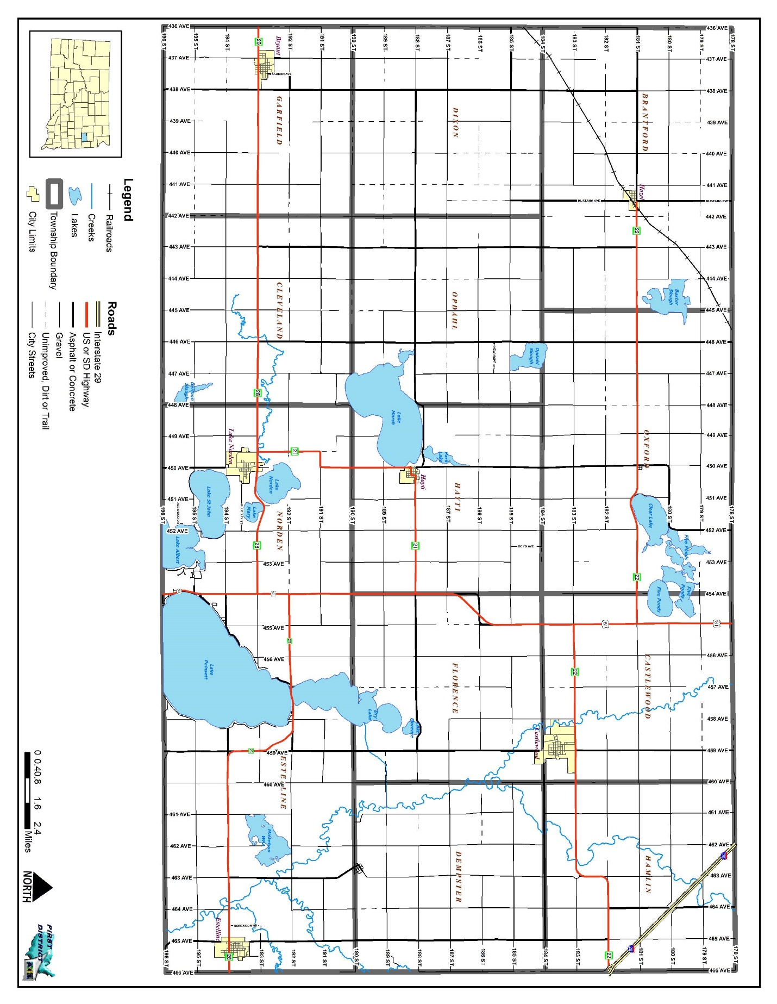
Figure 1.1 Political Map

Social and Economic Description

The County’s economy is dependent upon its agricultural and manufacturing sectors. Most non-agricultural employment is in manufacturing, education, health care, or service industries. The Town of Hayti is the governmental center for the County. The rural communities in the County serve as bedroom communities to Brookings and Watertown and provide “small town” atmosphere to those residents. A large majority of the residents within these communities commute to Brookings, Watertown or other employment centers. Most of the communities have limited retail and service sectors which provide basic needs to its residents. Lake Poinsett, South Dakota’s largest natural lake, is located within the county providing camping facilities, swimming beaches, biking trails, boat docks and excellent fishing opportunities. Economic development is concentrated most in the area surrounding Lake Poinsett as housing density increases and an increase in residents around the lake has brought businesses and services to the area.

Physical Description and Hydrology

The topography within the County varies, to some degree, dependent upon the type of glacial deposits present. Generally, the area west of the Big Sioux River is described as a knob and kettle geography with many natural lakes. The drainage is very poorly developed with few streams in this area. East of the Big Sioux River, gently rolling, well drained topography is characterized by the creeks and streams that are tributaries to the river. The principal surface water resources in Hamlin County are the Big Sioux River and the many wetlands and natural lakes in the County. The Big Sioux River runs south of Watertown in Codington County through Castlewood and continues traveling south near Estelline. As mentioned before, Lake Poinsett is located in southeastern Hamlin County and is an 8,000 acre lake providing recreation and connected to the following lakes in Hamlin County: Park, Marsh, Norden, Mary, John and Albert.

Climate

The County’s climate is considered Mid-Continental with hot summers and cold winters. The weather can be quite changeable with large day to day temperature variations, particularly from the fall to the spring. Days with severe winter cold and summer heat are typical.

Normally the temperature is moderate until the beginning of July, after which short, hot periods are experienced until the end of August. The freeze-free period is the number of days between the average last occurrence of freezing temperatures in the spring and the average first occurrence of 32 degrees Fahrenheit or lower in the fall. The length of the freeze-free period approximates the length of the growing season which ranges from 130 days or more between May 21st and September 21st. Topography and local weather conditions can produce subfreezing temperatures at the ground surface while the air temperature a few feet above the ground remains above 32 degrees F.

Annual average precipitation is 22.11 inches, with over 75% of the precipitation falling from May through September. Precipitation can vary significantly from year to year, and location to location within a given year. The heaviest most intense precipitation often occurs with localized downpours associated with thunderstorms in June through August. Significant flash flooding can result from these downpours with over 3 inches of precipitation reported in a few events. Widespread heavy precipitation events of 1 to 2 inches can occur every few years and is most common from April through June and September through early November.

Average winter snowfall ranges up to 30 inches. The heaviest snowstorms often occur from late March through May or mid October to mid November. These storms can produce more than 12 inches of snow and are often made more severe as temperatures are warmer, and therefore the snow is heavier and more difficult to travel in and remove. These storms are often accompanied by high winds resulting in blizzard conditions. In spring these storms can coincide with the calving season resulting in livestock loss. Mid-winter snowstorms in general produce less than 6 inches of snow, but heavier amounts up to 19 inches or more have occurred. Despite the generally lighter amounts and drier snow, high winds can result in blizzard conditions. Even without falling snow, in the colder conditions of mid-winter, high winds can pick up loose snow, resulting in local ground blizzards. With ever changing weather patterns and associated climate change related severe storms, it is important to understand a new normal higher level of precipitation is expected across the county and state.

Severe thunderstorms are common from June into early September. Typically the greatest hazards associated with these thunderstorms are very highs winds and large hail. Damage to structures and crops occurs every summer from these storms. Tornadoes have been reported, but are relatively rare.

An important element of the climate in Hamlin County is the often windy conditions. Average wind speeds range from 10 to 15 mph depending on the exposure of the location. The average and peak sustained winds tend to be stronger over higher more exposed terrain. The highest wind gusts often occur with thunderstorms during the summer, with gusts over 60 mph occurring every year. The highest sustained winds tend to occur in the spring and fall, with sustained winds over 40 mph occurring every year.

Transportation and Commuting Patterns

Transportation systems in Hamlin County have expanded and evolved in recent years. Hamlin County’s road network is composed of a total of 880 miles including federal and state highways, county roads, township roads, city streets, and private roads. South Dakota Highways 22 and 28 are the main east-west routes through the county with Highway 81 being the main north-south route. Interstate 29 passes through the very northeast corner of the county. The County’s road system includes 263 miles of roads. More specifically those roads are composed of 129 gravel road miles, 134 hard surface rural road miles, and 59 bridges (according to South Dakota Department of Transportation). In Hamlin County, the transportation choices are limited to mostly private automobiles traveling over state highways and county roads. The rural road system performs two basic functions: (1) providing general mobility for the residents in rural areas, and (2) accommodating the movements of agricultural products to market. The rural transportation system was not designed to accommodate large volumes of traffic on a daily basis.

The Burlington Northern Sante Fe Railroad line is located in the northwest part of the county and runs through Hazel. There are no major airports in the county.

Utility Infrastructure
Two rural water systems in the county, Kingbrook Rural Water and Sioux Rural Water serve most of the rural residences in the County and the communities of Bryant, Hayti, and Hazel. The communities of Castlewood, Estelline and Lake Norden operate municipal water systems.
Regarding wastewater disposal, all municipalities within the County have municipal wastewater collection and treatment systems. Rural residences rely on individual septic tanks and drainfields.
Electric power is provided to rural county residents and people in the communities by Codington-Clark Electric Cooperative, H-D Electric Cooperative, Northwestern Energy, and Ottertail Power, and East River Electric Cooperative Bryant and Estelline operate their own municipal power system.

The primary telephone company serving the County’s rural population is Interstate Telephone Company (ITC). Cellular phone service is available in most parts of the county, but there are still places in the county where signals are weak.

Northern Border Pipeline also runs south of Watertown into Hamlin County and continues to the southeast towards Castlewood.

Medical and Emergency Services

There are four medical clinics that serve the needs of Bryant, Estelline, Lake Norden, Hayti, and the surrounding area. There are two long term care facilities in the County: Estelline Nursing Care Center in Estelline and Avantara in Lake Norden.

The County is governed by five-member board of commissioners. The Sheriff’s Department including a Sheriff, five deputies and two city police officers (Hayti and Lake Norden) provide law enforcement throughout the county.

The Emergency 9-1-1 Center in Watertown, South Dakota provides 911 services to the Hamlin County Sheriff’s Department and other area agencies as well. Those agencies include:
- Castlewood Ambulance Service
- Estelline Ambulance Service
- Lake Norden Ambulance Service
- Hamlin County Emergency Management
- Hamlin County Sheriff’s Office
- Six volunteer fire departments
- South Dakota Highway Patrol
CHAPTER 2
PREREQUISITES

ADOPTION BY LOCAL GOVERNING BODY

The local governing body that oversees the update of the Hamlin County Pre-Disaster Mitigation Plan is the Hamlin County Board of Commissioners. The Commission has tasked the Hamlin County Emergency Management Office with the responsibility of ensuring that the PDM is compliant with Federal Emergency Management Agency (FEMA) Guidelines and corresponding regulations.

MULTI-JURISDICTIONAL PLAN PARTICIPATION
Requirement 201.6(c)(1). Local Mitigation Plan Review Tool – A1.
Requirement 201.6(c)(5). Local Mitigation Plan Review Tool – E1.
Requirement 201.6(c)(5). Local Mitigation Plan Review Tool – E2.

This plan is a multi-jurisdictional plan which serves the entire geographical area located within the boundaries of Hamlin County, South Dakota. The County has six incorporated municipalities. All of the incorporated municipalities located entirely within the County elected to participate in the planning process and the update of the existing PDM. In September 2018, an email was sent to Emergency Management Directors in the adjoining counties inviting them to participate in the Hamlin County PDM update. The participating local jurisdictions include:

Table 2.1: Plan Participants

Participating Jurisdictions | Do Not Participate*
Bryant | All 13 Townships
Castlewood
Estelline
Hayti
Hazel
Lake Norden
Hamlin County
Sioux Rural Water Systems**
*All townships reviewed hazard history and identified vulnerable infrastructure. Therefore they are eligible to benefit from future mitigation projects identified by the County.
** Stakeholder

Non-participating communities are still eligible for hazard mitigation funding, however may not directly apply for assistance. Instead any assistance would need to be applied for on behalf of the non-participating communities by Hamlin County. Non-participants include the unincorporated communities with very small populations: Thomas is located approximately eight miles east of Hazel; and Dempster which is located approximately six miles northwest of Estelline. The unincorporated villages and townships are not direct participating entities in the plan because these entities are too small, both in population and in resources, to be capable of handling disaster needs on their own. The villages are governed by the township boards and are served by the County whenever necessary.
The townships are not direct participating entities in the plan because these entities are too small, both in population and in resources, to be capable of handling disaster needs on their own. The townships were invited to participate in the PDM update by the PDM Planning Team. Township supervisors were asked to review and identify hazard risks, vulnerability and critical infrastructure to provide the above described information at their annual, county-wide meeting on January16 2019. Six of the thirteen townships responded to the request.

The Hamlin County Commission and each of the listed participating municipalities will pass resolutions to adopt the updated PDM. The dates of adoption by resolution for each of the jurisdictions are summarized in Table 2.2.

Table 2.2: Dates of Plan Adoption by Jurisdiction

Jurisdiction | Date of Adoption
Hamlin County Commission
Bryant
Castlewood
Estelline
Hayti
Hazel
Lake Norden
Sioux Rural Water Systems

All of the participating jurisdictions were involved in the plan update. Representatives from each municipality, the County, and electric providers were invited to planning meetings. Those in attendance provided valuable perspective on the changes required for the plan. All representatives took part in the risk assessment exercise at the October 23rd, 2018 meeting.

Representatives in attendance took information from the PDM planning meetings back to their respective councils/organizations and presented the progress of the plan update. First District staff travelled to each community and met with their local governing board to present community specific information regarding critical infrastructure, hazard vulnerability and identification information and potential mitigation projects for the updated plan. Representatives of the PDM Team met with First District staff to provide feedback and oversight into the draft plan. Those participants identified in Table 2.1 that did not attend a PDM Planning Team meetings participating in the planning process by reviewing information relevant to their communities and feedback by email or telephone conversations. A final meeting was held to make final comments and corrections and provide a motion to submit the plan to the State Office of Emergency Management. The local jurisdictions/organizations have also presented the Resolution of Adoption to their councils/boards and will pass the resolutions upon FEMA approval of the PDM update. The Resolutions are included in the Appendix.

Table 2.3 was derived to help define “participation” for the local jurisdictions who intend on adopting the plan. To be considered “participating”, each jurisdiction must have at least seven of the ten participation requirements fulfilled.
Table 2.3: Record of Participation

Nature of Participation | Bryant | Castlewood | Estelline | Hayti | Hazel | Lake Norden | Hamlin County | SRWS
Attended Meetings or work sessions (a minimum of 1 meeting will be considered satisfactory).
Submitted inventory and summary of reports and plans relevant
to hazard mitigation.
Submitted the Risk Assessment
Worksheet.
Submitted description of what is at risk (including local critical facilities
and infrastructure at risk from specific Hazards worksheet)
Submitted a description or map of local land-use patterns (current and proposed/ expected).
Developed goals for the community.
Developed mitigation actions with an analysis/ explanation of why those actions were selected.
Prioritized actions emphasizing relative cost-effectiveness.
Reviewed and commented on draft Plan.
Hosted opportunities for public involvement (allowed time for public
comment at a minimum of 1 city council meeting after giving a status report on the progress of the PDM update)

CHAPTER 3
PLANNING PROCESS

BACKGROUND

The effort that led to the development of this plan is part of the larger, integrated approach to hazard mitigation planning in South Dakota that is led by the South Dakota Office of Emergency Management. Production of the plan was the ultimate responsibility of the Hamlin County Emergency Management Director, who served as the county’s point of contact for all activities associated with this plan. Input was received from the PDM Planning Team that was put together by the Emergency Management Director and whose members are listed below in Table 3.1.

The plan itself was written by an outside contractor, First District Association of Local Governments (First District) of Watertown, South Dakota, one of the state’s six regional planning entities. The office has an extensive amount of experience in producing various kinds of planning documents, including municipal ordinances, land use plans, and zoning ordinances, and it is an acknowledged leader in geographic information systems (GIS) technology in South Dakota. following staff members of the First District Association of Local Governments were involved in the production of the plan. Thomas Nealon, Planner, was the project manager of the plan. Nealon attended the PDM Planning Team meetings as the plan was being developed. Assisting Mr. Nealon was Amy Arnold, Geographic Information Systems Planner, who produced all the maps for the plan, Luke Muller, Senior Planner, directed the floodplain risk analysis, and completed the county land cover analysis discussed in the previous chapter. Meeting coordination performed by Project Intern Mark McLaughlin. Several other individuals at the state level provided additional support and information that was quite useful. They include:

- Marc Macy, South Dakota National Flood Insurance Program Coordinator – provided classification and information regarding value and number of flood insurance policies and claims, as well as guidance and direction as the plan was being developed.

- SD State Fire Marshall Office – provided information on fire calls in the county.

- Tim Schaal, South Dakota State Dam Inspector – provided information on dams located in the county.
- Greg Pollreisz, SD Department of Transportation – provided bridges and road mileage information for county.
DOCUMENTATION OF THE PLANNING PROCESS
Requirement 201.6(c)(1). Local Mitigation Plan Review Tool – A1.
Requirement 201.6(c)(2). Local Mitigation Plan Review Tool – A2.
Requirement 201.6(b)(1). Local Mitigation Plan Review Tool – A3.

Methodology

Mitigation planning is a process that communities use to identify policies, activities, and tools to implement mitigation actions. The process that was used to develop this plan consisted of the following steps:

- Planning Framework
- Risk Identification and Assessment
- Mitigation Strategy
- Review of Plan
- Plan Adoption and Maintenance

Planning Framework

The planning framework component identified five objectives:

- Develop Plan to Plan;
- Establish Initial Planning Team
- Define Scope of the Plan;
- Identify Governmental Entities/Stakeholders;
- Establish PDM Planning Team

Prior to receiving funding public meetings were held at the Hamlin County Courthouse to inform the public about the required PDM update. Funding from FEMA and the South Dakota Office of Emergency Management to prepare the mitigation plan was awarded to the county in September 2018. Once funding was secured, the Hamlin County Emergency Management Director and the First District acted as the initial PDM Planning Team in order to discuss the strategy to be used to develop the plan. The first task was to identify those entities/stakeholders that would have direct and indirect interests in the update of the PDM.

Prior to the first public informational meeting, the Chairman of the Hamlin County Commissioners and Hamlin County Emergency Management Director wrote letters to all the stakeholders, community organizations, municipalities, townships, utility providers and emergency responders and concerned residents who might wish to volunteer their time and serve on a committee, and to those who would act as a resource for the PDM Planning Team. The letters included a brief description of the PDM. Emails were sent to adjoining emergency management directors inviting them to participate in the Hamlin County PDM Process. However, no adjoining emergency management director participated in the process through meeting attendance or written/verbal comment. Public input was solicited via notices regarding the PDM planning process in local media outlets and via the Internet.

Each individual who was contacted for the PDM Planning Team had at least one of the following attributes to contribute to the planning process:

- Significant understanding of how hazards affect the county and participating jurisdictions.
- Substantial knowledge of the county’s infrastructure system.
- Resources at their disposal to assist in the planning effort, such as maps or data on past hazard events.

Table 3.1 lists the PDM Planning Team members including those who were sent invitations and listing their attendance at the planning meetings, all of which were open to the public, that were held as the plan was being developed. An agenda was sent out to the PDM Planning Team prior to each meeting, and the meeting minutes were sent to them afterward to keep everybody informed of what was discussed and any decisions that were made.

Table 3.1: Participation in Plan Development
Last Name | First Name | Entity Represented | Job Title | Invitation Sent | Meeting Attendance
 |  |  |  |  | Meeting 1 | Meeting 2 | Meeting 3
Aho | Jason | City of Lake Norden | Mayor | X
Anderson | Doug | Sioux Rural Water Systems | Manager | X
Beld | Orlando | Lake Norden Fire Department | Firefighter | X | X
Clark | Brent | Castlewood Fire/Ambulance | Employee | X | X
Dewitt | Dan | City of Estelline | Mayor | X
Fodness | Keith | Castlewood School | Superintendent | X
Goebel | Debra | Town of Hayti | City Councilor | X |  | X | X
Joregenson | Joel | Hamlin Education Center | Superintendent | X
Kwasniewski | Troy | HD Electric Cooperative | Manager | X
Lemme | Dorene | City of Lake Norden | City Councilor | X
Nystrom | Jeff | Estelline Fire Department/Ambulance | Firefighter | X | X
Olsen | David | LEPC Chairman | Member | X
Olsen | Kelly | Hayti Fire Department | Firefighter | X | X
Ries | Brian | City of Castlewood | Mayor | X
Saathoff | Larry | Hamlin County Commission | Commissioner | X
Sauder | Spencer | Bryant Fire Department | Firefighter | X
Schaefer | David | Hamlin County | Emergency Manager | X | X | X | X
Schlenker | Ron | Town of Hayti | Mayor | X
Schlotterbeck | Chad | Hamlin County Sheriff’s Office | Sheriff | X |  | X | X
Singrey | Marvin | Hazel Fire Department | Firefighter | X
Thompson | Heath | Sioux Rural Water System | Manager | X
Trautner | Joe | Town of Hazel | City Councilor | X
Denison | Wendy | Lake Norden Ambulance | Employee | X |  | X
Leiseth | Dustin | Brantford Township | Clerk | X
Jankord | Carmen | Castlewood Township | Clerk | X
Noem | Wayne | Cleveland Township | Clerk | X
Jongeling | Shelley | Dempster Township | Clerk | X
Buck | Bret | Dixon Township | Clerk | X
Bakke | Evelyn | Estelline Township | Clerk | X
Olson | Wanda | Florence Township | Clerk | X
Wastweet | Joan | Garfield Township | Clerk | X
Schmit | Dan | Hamlin Township | Clerk | X
Henley | Troy | Hayti Township | Clerk | X
Skroch | Betty | Norden Township | Clerk | X
Anderson | Diane | Opdahl Township | Clerk | X
Schultz | Robert | Oxford Township | Clerk | X
Sutton | Jim | Codington County Emergency Management | Director | X
Monnier | Sheila | Deuel County Emergency Management | Director | X
Gravning | Michael | Clark County Emergency Management | Director | X
Hill | Robert | Brookings County Community Development | Emergency Management Director | X
Bau | Cindy | Kingsbury County Emergency Management | Director | X

Leadership and guidance in the planning effort and at the planning meetings was provided by the First District staff and the Hamlin County Emergency Management Director. An agenda was distributed to each PDM Planning Team member prior to each meeting, but free-flowing discussion was always encouraged. When PDM Planning Team members had questions about a topic of discussion, either First District staff or the Emergency Management Director provided supporting information.

Generally speaking, the planning process associated with the plan’s development was relaxed and informal. No subcommittees were formed, and all decisions were made by mutual consensus of the PDM Planning Team members - no votes were taken or motions made. Everyone’s opinion was respected, nobody was discouraged from voicing their opinion, and no one was made to feel any less important than anyone else.

As the PDM Planning Team was being assembled, arrangements were made for the first PDM Planning Team meeting, which took place at the Hamlin County 4-H Building in Hayti on October 23rd, 2018. An agenda was distributed to prospective PDM Planning Team members. The Appendix includes a copy of each meeting agenda, the signup sheet from each meeting, and the minutes from each meeting.

Those who attended the October meeting for the PDM update were asked to volunteer to serve on the PDM Planning Team. The PDM Planning Team was tasked with fostering coordination between the various entities involved; reviewing the drafts and providing comments after First District Association of Local Governments staff-initiated changes to the existing plan. Each of the local jurisdictions had a member of their respective councils represent the municipalities in the plan.

The representatives from the municipalities were asked to share the progress of the plan at their council meetings and to ensure that those attending the council meetings were aware that they are invited to make comments on and participate in the process of updating the new plan. Comments provided by local residents at the city council and PDM Planning Team meetings were collected and incorporated into the plan.

The public was provided several opportunities to comment on the plan during the drafting stages at the PDM Planning Team Meetings and City Council Meetings. There were several work sessions and public hearings held to keep the public updated and involved in the plan. Primarily, public input included the involvement in hazard assessment and mitigation projects. Those who were most involved were the representatives PDM Planning Team and representatives from the municipalities. The municipalities put the PDM update on the agenda at their council meetings and allowed people to comment at the meetings. Table 3.2 identifies the location and date of each opportunity that was provided for the public to comment and how it was advertised.

The first meeting of the PDM Planning Team served to introduce the participants to the concept of mitigation planning; why the plan was being updated and how the process would proceed in the months to come (scheduling, assigning responsibilities, etc.). The meeting also included a review of the existing plan, which led to two important decisions. First, it was the consensus opinion of the PDM Planning Team that a comprehensive rewrite of the plan would be needed. The PDM Planning Team decided that:

- The 2014 PDM did not include all of the necessary requirements found in the Local Hazard Plan Review Tool (2011). Thus, to ensure that the updated plan included everything required by the plan review tool, the PDM Planning Team and community meetings used the plan review tool to guide the discussions. The 2006 PDM was then compared to the new plan review tool and any portion of the 2006 PDM that was not needed to fulfill the new crosswalk requirements was eliminated and deficiencies were noted as areas of focus.

- More information and data regarding the risk assessment was needed, more informative tables and maps would be helpful, and the mitigation strategy needed to be rethought.

- The risk identification and assessment as well as the identification of critical infrastructure and local municipal goals and objectives should be completed by the First District prior to the next meeting of the PDM Planning Team.

Table 3.2: Opportunities for Public Comment

Location of Opportunity | Date | Type of Participation |  |  | How Was Meeting Advertised
 |  | City Council or County Commission  Meeting | PDM  Meeting | City Staff/Township Annual Mtg/Survey | Public  Notice | Website
Bryant | 02/04/2019 | X |  |  | X
 | Adoption Date
Castlewood | 05/06/2019 | X |  |  | X
 | Adoption Date
Estelline | 03/06/2019 | X |  |  | X
 | Adoption Date
Hayti | 03/13/2019 | X |  |  | X
 | Adoption Date
Hazel | 02/11/2019 | X |  |  | X
 | Adoption Date
Lake Norden | 05/07/2019 | X |  |  | X
 | Adoption Date
Hamlin County | PDM Grant Application 09/01/2018
 | 10/23/2018 |  | X |  | X
 | 11/12/2019 |  | X |  | X
 | 11/18/2019 |  | X |  | X

Risk Identification & Assessment/Mitigation Strategy/Review of Plan
Requirement 201.6(c)(1). Local Mitigation Plan Review Tool – A1.
Requirement 201.6(b)(1). Local Mitigation Plan Review Tool – A3.
Requirement 201.6(b)(3). Local Mitigation Plan Review Tool – A4.
Requirement 201.6(d)(3). Local Mitigation Plan Review Tool – D3.

The Risk Identification and Assessment component identified three objectives: Collect and Organize Data, Develop GIS Data, and Analyze Data. The Mitigation Strategy component identified five objectives: Review Existing PDM and other plans Formation of Goals/Objectives, Compile existing resources to accomplish goals/objectives, Public review of Goals/Objectives, and PDM Planning Team Review of goals/objectives. The Review of PDM component identified three objectives: Writing of PDM; Public Review of PDM; PDM Planning Team Review of PDM.

Prior to the second PDM Planning Team meeting, First District Staff met with the participating municipalities and the Hamlin County Townships at public noticed meetings to identify hazards and critical facilities, assess vulnerability, discuss development trends, and develop mitigation goals. Meeting dates are referenced in Table 3.2. Staff members from City of Estelline, Hamlin County, and Hamlin County Townships were asked to identify hazards and critical facilities, assess vulnerability, discuss development trends, and develop mitigation goals and review these items with each respective governing body (if applicable). First District staff also conducted research regarding the history of disaster events in the county, including events that had occurred since the original plan was developed.

First District also conducted a technical review of existing documents. This review incorporated existing plans, studies, reports, technical information, zoning and flood damage prevention ordinances into the PDM Update. It should be noted that most of the planning documents of each of the communities had been previously developed by the First District. However, the Town of Hazel did not have such planning documents. Additionally, the 2014 PDM was used as a resource for the new plan because most of the natural hazard profile research had already been completed when it was drafted. In addition to the 2014 PDM, the First District reviewed several other existing documents including but not limited to the State of South Dakota Hazard Mitigation Plan, Hamlin County Hazardous Materials Plan, and Flood Insurance Rate Maps for the local jurisdictions. A summary of the technical review and incorporation of existing plans is included in Table 3.3.

Risk Identification/Assessment was discussed at the PDM Planning Team meeting on October 23rd, 2018. First District staff reviewed the hazards identified in the State of South Dakota Hazard Mitigation Plan and that risk assessment portion of the existing PDM. First District staff also provided an overview of the information regarding Critical Facilities, Risk Identification, Hazard Vulnerability and mitigation goals identified by the County’s municipalities. Also at that meeting, the PDM Planning Team identified goals for the PDM Update and compared those goals to those identified in the 2014 PDM.

The list of hazards that the PDM Planning Team decided to focus on is presented in Chapter 4. A profile of each of the hazards was begun at this meeting. The profile included information from each of the participating jurisdictions about how the hazard affected their community. Discussion also occurred regarding the existing strategies being used to mitigate each hazard, with a particular emphasis on the critical and essential facilities in each community.

The PDM Planning Team also dealt with the Mitigation Strategy at the October 2018 meeting. Formation of the strategy began with a review of the results of the risk assessment, which led to discussion about the goals to be achieved with the mitigation plan. The list of goals is included in Chapter 5.

The draft plan was posted on the First District Association of Local Governments and Hamlin County websites. Participants were notified they had forty-five days to review and make comments which were to be addressed at the upcoming PDM Team meetings.

At the second meeting, on November 12th, the PDM Planning Team reviewed the updates prepared by the First District and discussed specific mitigation actions. The PDM Planning Team began by reviewing the proposed actions included in the previous mitigation plan and discussion followed about the progress that had been made on implementing the actions. Specific mitigation actions recently identified by the participating jurisdictions were also discussed.

The rest of the meeting was spent discussing the mitigation actions and discussing how the plan would be implemented. It was emphasized that cooperation between the county and the participating jurisdictions was especially important, and discussion occurred about how this could best be achieved. Representatives from the jurisdictions were made aware of the critical role they needed to play to ensure the success of the mitigation strategy, such as implementing specific mitigation actions. The Emergency Management Director emphasized the importance of ensuring that no local decisions be made or actions taken contrary to the goals of this plan. Also, responsible parties were identified for reporting on progress being made to implement the proposed mitigation actions, for evaluating the plan’s overall effectiveness, and for getting the public more involved in the planning process. The PDM Planning Team decided to rely on the prioritization of projects by jurisdiction rather than on a county-wide basis since each jurisdiction is responsible for the implementation of respective mitigation actions.

At the end of the meeting the First District was instructed to conduct an internal review of the document and forward the document to the South Dakota Office of Emergency Management for their review and comment. The draft plan was posted on the First District Association of Local Governments and Brookings County websites and emailed to all of the participants and to the emergency managers in the neighboring counties of: Clark, Codington, Deuel, Brookings, and Kingsbury in South Dakota. Everyone who received an email copy of the plan draft was allowed forty-five days to comment on the draft.

A third and final meeting of the PDM Planning Team was subsequently held on November 18th, 2019 to review and discuss final draft as amended based upon comments from participating jurisdictions and adjoining counties, PDM Planning Team members and the public. Only comments received were from the PDM Planning Team. At the meeting the PDM Planning Team recommended that the plan be submitted to FEMA. The final draft of the plan was again posted on the First District Association of Local Governments and Hamlin County websites a link for which was emailed to all of the participants.

Table 3.3: Record of Review (Summary)

Existing Program/Policy/Technical Documents | Local Jurisdiction
 | Bryant | Castlewood | Estelline | Hayti | Hazel | Lake Norden | Hamlin  County | Referenced in Plan
Comprehensive Plan | ✓ | ✓ | ✓ | ✓ | NA | ✓ | ✓ | Appendix F
Flood Damage Prevention Ordinance | NA | ✓ | ✓ | NA | NA | ✓ | ✓ | Pg. 50-51
Local Emergency Operations Plan | C | C | C | C | C | C | ✓ | Appendix G
Flood Insurance Studies or Engineering studies for streams | ✓ | ✓ | ✓ | ✓ | NA | ✓ | ✓ | Pg. 49-50
Hazard Vulnerability Analysis (by the local Emergency Management Agency) | ✓ | ✓ | ✓ | ✓ | ✓ | ✓ | ✓ | Pg. 73 & Pg 103
Emergency Operations Plan | C | C | C | C | C | C | ✓ | Pg. 18 & Pg. 44
Zoning Ordinance | ✓ | ✓ | ✓ | ✓ | NA | ✓ | ✓ | Pg. 18 & 20
Subdivision Ordinance | ✓ | ✓ | ✓ | ✓ | NA | ✓ | ✓ | Appendix H
Floodplain Ordinance | NA | ✓ | ✓ | NA | NA | ✓ | ✓ | Pg. 51-72
Existing Land Use maps | ✓ | ✓ | ✓ | ✓ | NA | ✓ | ✓ | Appendix F
Aquifer Protection Ordinance | NA | NA | ✓ | NA | NA | NA | ✓ | Pg. 18
State Hazard Mitigation Plan | ✓ | ✓ | ✓ | ✓ | ✓ | ✓ | ✓ | All Chapters

NA The jurisdiction does not have this program/policy/technical document
O The jurisdiction has the program/policy/technical document, but did not review/incorporate it in the mitigation plan
C The jurisdiction is regulated under the County’s policy/program/technical document/
- The jurisdiction reviewed the program/policy/technical document
CHAPTER 4
RISK ASSESSMENT

IDENTIFICATION OF HAZARDS
Requirement 201.6(c)(2)(i). Local Mitigation Plan Review Tool – B1.
Requirement 201.6(c)(2)(i). Local Mitigation Plan Review Tool – B2.

In this chapter, the hazards that were identified by the PDM Planning Team as having the most significance for the County are analyzed. As part of the analysis, various maps and tables were produced and are included within this chapter. The planning participants began the risk assessment process by reviewing the State of South Dakota Hazard Mitigation Plan. The PDM Planning Team also reviewed records of hazard events that have occurred in the county since the 2007, relying primarily on the Spatial Hazard Events and Losses Database for the United States (SHELDUS), compiled by the University of South Carolina’s Hazards and Vulnerability Research Institute and data from the National Climatic Data Center’s Storm Events Database. A summary of the findings for significant hazard occurrences from the past ten years is provided below in Table 4.1: The PDM Planning Team also identified potential hazards by observing development patterns, interviews from towns and townships, public meetings, PDM work sessions, previous disaster declarations and research of the history of hazard occurrences located within the County.

Table 4.1: Significant Hazard Occurrences 2007-2018

Type of Hazard | # of Occurrences  2007-2018 | Source
Drought | 15 | NOAA
Wildfire/Forest Fire | 68 | NOAA & State Fire Marshall's Office
Flood | 11 | NOAA & SHELDUS
Hail | 27 | NOAA & SHELDUS
Lightning | 0 | NOAA & SHELDUS
Tornado | 3 | NOAA & SHELDUS
Temperature Extremes | 16 | NOAA & SHELDUS
Snow, Blizzard, and Ice | 37 | NOAA & SHELDUS
Thunderstorm and High Wind | 22 | NOAA & SHELDUS

Hazards were analyzed in terms of the hazard’s probability of occurrence in the county. Representatives from each participating jurisdiction and the PDM Planning Team were asked to complete worksheets that categorized hazards by the likelihood of occurrence for either their specific geographical location, or for county-wide risks.

Every possible hazard or disaster was evaluated and placed into one of three separate columns depending on the likelihood of the disaster occurring in the PDM jurisdiction. Hazards that occur at least once a year or more were placed in the High Probability column; hazards that may have occurred in the past or could occur in the future but do not occur on a yearly basis were placed in the low probability column; and hazards or disasters that have never occurred in the area before and are unlikely to occur in the PDM jurisdiction any time in the future were placed in the Unlikely to Occur column. While man-made hazards were discussed briefly during the completion of the worksheet, the PDM Planning Team decided to eliminate man-made hazards from the PDM because those types of hazards are difficult to predict and assess due to wide variations in the types, frequencies, and locations. Types and scopes of manmade hazards are unlimited.

Due to the topographical features of the County and the nature of the natural hazards that affect the geographical area covered by this PDM, most areas of the county have similar likelihood of being affected by the natural hazards identified. Only the natural hazards from the High Probability and Low Probability Columns will be further evaluated throughout this plan, with an emphasis on the High Probability hazards. All hazards in the Unlikely to Occur column will not be further evaluated in the plan. Table 4.2 is an adjusted list of hazards produced from the FEMA worksheets completed by each participating jurisdiction and the PDM Planning Team.

Table 4.2: Hazards Categorized by Likelihood of Occurrence
High Probability | Low Probability | Unlikely to Occur
Extreme Cold | Drought | Earthquake*
Extreme Heat | Flood | Ice Jam
Hail | Tornado | Subsidence
Lightning | Urban Fire
Strong Winds | Wild Fire
Thunderstorm
 | *Earthquakes are marked with an asterisk because they occur but are so small that the effects are minimal. Thus, mitigation measures specifically for earthquakes are not a priority.

TYPES OF NATURAL HAZARDS IN THE PDM JURISDICTION AREA
Requirement 201.6(c)(2)(i). Local Mitigation Plan Review Tool – B1.

Some descriptions of the natural hazards likely to occur in the County were taken directly from the 2006 Hamlin County PDM. Most of the descriptions were revised for better clarity. For the purpose of consistency throughout the plan, additional definitions were included to reflect all of the hazards that have a chance of occurring in the area and all of the hazards are alphabetized. For all of the hazards identified the probability of future occurrence is expected to be the same for all of the jurisdictions covered in the PDM.

Blizzards are a snow storm that lasts at least three hours with sustained wind speeds of thirty-five miles per hour (mph) or greater, visibility of less than one-quarter mile, temperatures lower than 20°F and white out conditions. Snow accumulations vary, but another contributing factor is loose snow existing on the ground which can get whipped up and aggravate the white out conditions. When such conditions arise, blizzard warnings or severe blizzard warnings are issued. Severe blizzard conditions exist when winds obtain speeds of at least forty-five mph plus a great density of falling or blowing snow and a temperature of 10°F or lower. At least one blizzard should occur each year in Hamlin County.

Drought is an extended period of months or years when a region notes a deficiency in its water supply. Generally, this occurs when a region receives consistently below average precipitation. It can have a substantial impact on the ecosystem and agriculture of the affected region. Although droughts can persist for several years, even a short, intense drought can cause significant damage and harm the local economy. This global phenomenon has a widespread impact on agriculture. The Keetch-Byron Drought Index measures drought impact. There is an 8% chance of drought occurring annually.

Dam Failure Dams function to serve the needs of flood control, recreation, and water management. During a flood, a dam’s ability to serve as a control agent may be challenged. An excessive amount of water may result in a dam breach, simply an overflowing. Dams that are old or unstable, dams that receive extreme amounts of water, or dams that get debris pile-up behind their face may result in dam failure, a cracking and/or breaking. All dams are considered by the South Dakota Dam Inspector as “low risk” for failure. Dam Failure was considered unlikely to occur by the PDM Planning Team and Communities, however is detailed here because it was determined to be the most likely of the “Unlikely to Occur” hazards. Hamlin County has zero dams.

Earthquakes are a sudden rapid shaking of the earth caused by the shifting of rock beneath the earth's surface. Earthquakes can cause buildings and bridges to collapse, disrupt gas, electric and phone lines, and often cause landslides, flash floods, fires, avalanches, and tsunamis. Larger earthquakes usually begin with slight tremors but rapidly take the form of one or more violent shocks, and are followed by vibrations of gradually diminishing force called aftershocks. The underground point of origin of an earthquake is called its focus; the point on the surface directly above the focus is the epicenter. The Richter Scale measures earthquake intensity. The potential for an earthquake to occur in the County is .68% annually.

Extreme Cold What constitutes extreme cold and its effects can vary across different areas of the country. In regions relatively unaccustomed to winter weather, near freezing temperatures are considered “extreme cold,” however, Eastern South Dakota is prone to much more extreme temperatures than other areas in the country. Temperatures typically range between zero degrees Fahrenheit and 100 degrees Fahrenheit, so extreme cold could be defined in the Hamlin County PDM jurisdiction area as temperatures below zero. The Wind Chill Chart is used to measure extreme cold. At least one extreme cold event should occur each year

Extreme Heat, also known as a Heat Wave, is a prolonged period of excessively hot weather, which may be accompanied by high humidity. There is no universal definition of a heat wave; the term is relative to the usual weather in the area. Temperatures in the County have a very wide range typically between 0 to 100 degrees Fahrenheit, therefore anything outside those ranges could be considered extreme. The term is applied both to routine weather variations and to extraordinary spells of heat which may occur only once a century. The Heat Index measures the impact of extreme heat on people and livestock.

Flooding is an overflow of water that submerges land, producing measurable property damage or forcing evacuation of people and vital resources. Floods can develop slowly as rivers swell during an extended period of rain, or during a warming trend following a heavy snow. Even a very small stream or dry creek bed can overflow and create flooding. Two different types of flooding hazards are present within the County.

- Inundation flooding occurs most often in the spring. The greatest risks are realized typically during a rapid snowmelt, before ice is completely off all of the rivers.

- Flash flooding is more typically realized during the summer months. This flooding is primarily localized, though enough rain can be produced to cause inundation flooding in areas along the Big Sioux River and its tributaries. Heavy, slow moving thunderstorms often produce large amounts of rain. The threat of flooding would be increased during times of high soil moisture.

National Flood Insurance Rate maps designate 100 year and 500 year floodplain zones. Areas subject to inundation by the 1-percent-annual-chance flood event are designated 100 year floodplain. Moderate risk areas within the 0.2-percent-annual-chance floodplain are designated 500 year floodplain. Brookings County should anticipate having one flood event each year.

Freezing Rain/Ice occurs when temperatures drop below thirty degrees Fahrenheit and rain starts to fall. Freezing rain coats objects with ice, creating dangerous conditions due to slippery surfaces, platforms, sidewalks, roads, and highways. Sometimes ice is unnoticeable, and is then referred to as black ice. Black ice creates dangerous conditions, especially for traffic. Additionally, a quarter inch of frozen rain can significantly damage trees, electrical wires, weaken structures, and other objects due to the additional weight bearing down on them.

Hail is formed through rising currents of air in a storm. These currents carry water droplets to a height at which they freeze and subsequently fall to earth as round ice particles. Hailstones usually consist mostly of water ice and measure between 5 and 150 millimeters in diameter, with the larger stones coming from severe and dangerous thunderstorms. The County has a 100% potential for hail occurring each year

Heavy Rain is defined as precipitation falling with intensity in excess of 0.30 inches (0.762 cm) per hour. Short periods of intense rainfall can cause flash flooding while longer periods of widespread heavy rain can cause rivers to overflow. At least one heavy rain event will occur in the County annually.

Ice Jams occur when warm temperatures and heavy rain cause snow to melt rapidly. Snow melt combined with heavy rains can cause frozen rivers to swell, which breaks the ice layer on top of the river. The ice layer often breaks into large chunks, which float downstream and often pile up near narrow passages and other obstructions, such as bridges and dams.

Landslide is a geological phenomenon which includes a wide range of ground movement, such as rock falls, deep failure of slopes and shallow debris flows, which can occur in offshore, coastal and onshore environments. Although the action of gravity is the primary driving force for a landslide to occur, there are other contributing factors build up specific sub-surface conditions that make the area/slope prone to failure, whereas the actual landslide often requires a trigger before being released.

Lightning results from a buildup of electrical charges that happens during the formation of a thunderstorm. The rapidly rising air within the cloud, combined with precipitation movement within the cloud, results in these charges. Giant sparks of electricity occur between the positive and negative charges both within the atmosphere and between the cloud and the ground. When the potential between the positive and negative charges becomes too great, there is a discharge of electricity, known as lightning. Lightning bolts reach temperatures near 50,000˚ F in a split second. The rapid heating and expansion, and cooling of air near the lightning bolt causes thunder. There is a 100% chance of lightning occurring in Hamlin County each year.

Severe Winter Storms deposit four or more inches of snow in a twelve-hour period or six inches of snow during a twenty-four hour period. Such storms are generally classified into four categories with some taking the characteristics of several categories during distinct phases of the storm. These categories include: freezing rain, sleet, snow, and blizzard. Generally winter storms can range from moderate snow to blizzard conditions and can occur between October and April. The months of May, June, July, August, and September could possibly see snow, though the chances of a storm are very minimal. Like summer storms, winter storms are considered a weather event not a natural hazard, and thus will not be evaluated as a natural hazard throughout this PDM.

Sleet does not generally cling to objects like freezing rain, but it does make the ground very slippery. This also increases the number of traffic accidents and personal injuries due to falls. Sleet can severely slow down operations within a community. Not only is there a danger of slipping, but with wind, sleet pellets become powerful projectiles that may damage structures, vehicles, or other objects.

Snow is a common occurrence throughout the County during the months from October to April. Average annual snowfall for the county is about twenty-two inches. Accumulations in dry years can be as little as five to ten inches, while wet years can see yearly totals up to eighty inches. Snow is a major contributing factor to flooding, primarily during the spring months of melting.

Strong winds are usually defined as winds over forty miles per hour, are not uncommon in the area. Winds over fifty miles per hour can be expected twice each summer. Strong winds can cause destruction of property and create safety hazards resulting from flying debris. Strong winds also include severe localized wind blasting down from thunderstorms. These downward blasts of air are categorized as either microbursts or macrobursts depending on the amount geographical area they cover. Microbursts cover an area less than 2.5 miles in diameter and macrobursts cover an area greater than 2.5 miles in diameter. Multiple strong wind events will occur in the County annually.

Subsidence is defined as the motion of a surface as it shifts downward relative to a datum. The opposite of subsidence is uplift, which results in an increase in elevation. There are several types of subsidence such as dissolution of limestone, mining-induced, faulting induced, isostatic rebound, extraction of natural gas, ground-water related, and seasonal effects.

Summer Storms are generally defined as atmospheric hazards resulting from changes in temperature and air pressure which cause thunderstorms that may cause hail, lightning, strong winds, and tornados. Summer storms are considered a weather event rather than a natural hazard; therefore summer storms are not evaluated as a natural hazard throughout this PDM.

Thunderstorms are formed when moisture, rapidly rising warm air, and a lifting mechanism such as clashing warm and cold air masses combine. The three most dangerous items associated with thunderstorms are hail, lightning, and strong winds.

Tornados are violent windstorms that may occur singularly or in multiples as a result of severe thunderstorms. They develop when cool air overrides warm air, causing the warm air to rapidly rise. Many of these resulting vortices stay in the atmosphere, though touchdown can occur. The Fujita Tornado Damage Scale categorizes tornadoes based on their wind speed:

F0=winds less than 73 m/h
F1=winds 73-112 m/h
F2=winds 113-157 m/h
F3=winds 158-206 m/h
F4=winds 207-260 m/h
F5=winds 261-318 m/h
F6=winds greater than 318 m/h

Wildfires are uncontrolled conflagrations that spread freely through the environment. Other names such as brush fire, bushfire, forest fire, grass fire, hill fire, peat fire, vegetation fire, and wild fire may be used to describe the same phenomenon. A wildfire differs from the other fires by its extensive size; the speed at which it can spread out from its original source; its ability to change direction unexpectedly; and to jump gaps, such as roads, rivers and fire breaks.

Fires start when an ignition source is brought into contact with a combustible material that is subjected to sufficient heat and has an adequate supply of oxygen from the ambient air. Ignition may be triggered by natural sources such as a lightning strike,or may be attributed to a human source such as “discarded cigarettes, sparks from equipment, and arched power lines”. The Keetch-Byram Drought Index assesses the risk of fire due to drought. Multiple wildfires will occur in the County annually.

Climate Change is a long term change in the earth’s climate, especially a change due to an increase in the average atmospheric temperature. In particular, a change apparent from the mid to late 20th century onwards and attributed largely to the increased levels of atmospheric carbon dioxide produced by the use of fossil fuels. Rising temperatures will lead to more climate and weather hazards of greater intensity such as flooding, droughts, severe storms and winter storms. Many scientists consider climate change a global phenomenon.

HAZARD PROFILE
Requirement 201.6(c)(2)(i). Local Mitigation Plan Review Tool – B1.
Requirement 201.6(c)(2)(i). Local Mitigation Plan Review Tool – B2.
Requirement 201.6(c)(2)(ii). Local Mitigation Plan Review Tool – B3.

It should be stated that most of the hazards identified in the previous section have the potential of occurring anywhere in the County. A brief section about the history of each hazard’s occurrence in the county is provided. Table 4.3 below shows all of the Presidential Disaster Declarations that have involved the county. Information on previous occurrences – the location, the extent (i.e., magnitude or severity) of each hazard, and probability of future events (i.e., chance or occurrence) are listed individually by the type of hazard in the following tables. Occurrences are listed from 2007 – 2017 Partial data for 2018 became available during the drafting of this plan and is referenced where applicable..

Table 4.3: Presidential Disaster Declarations in South Dakota
Including Hamlin County

Date | Disaster Dec # | Type | Total Damage | FEMA Disaster Relief Costs
4/18/1969 | 257 | Flooding | $4,599,306
5/3/1986 | 764 | Severe Storms and Flooding | $5,158,130
7/2/1992 | 948 | Flooding, Severe Storms, and Tornadoes
7/19/1993 | 999 | Severe Storms, Tornadoes and Flooding | $53,068,748
6/21/1994 | 1031 | Severe Storms and Flooding | $8,187,938
5/26/1995 | 1052 | Flooding | $35,649,349
1/5/1996 | 1075 | Severe Winter Storm | $13,085,649
1/10/1997 | 1156 | Severe Winter Storm and Blizzard | $19,455,263
4/7/1997 | 1173 | Severe Winter Storm and Severe Flooding | $87,069,429
5/17/2001 | 1375 | Severe Winter Storm and Flooding |  | $9,919,599
12/20/2005 | 1620 | Severe Winter Storm |  | $28,000.000
5/13/2010 | 1915 | Flooding |  | $21,818,449
5/13/2011 | 1984 | Flooding |  | $53,064,506
8/2/2013 | 4137 | Severe Storms, Tornadoes and Flooding |  | $1,129,907
02/01/2017 | 4298 | Severe Winter Storm |  | $9,807,576
06/07/2019 | 4440 | Severe Winter Storm, Snowstorm and Flooding |  | $2,111,673.18
09/23/2019 | 4463 | Severe Storms and Flooding
SOURCE: http://www.fema.gov/news/disasters.fema
State of South Dakota Multi-Hazard Mitigation Plan – Basic Plan

While the PDM Planning Team reviewed all hazard occurrences that have been reported in the last 100 years, the list for some of the hazards was extremely long. The information provided in the tables is not a complete history report, but rather an overview of the hazard events which have occurred over the last ten years. The PDM Planning Team felt the hazard trend for the last ten years could be summarized in this section and decided to include any new occurrence that have taken place since the previous PDM was drafted.

DROUGHT

South Dakota's climate is characterized by cold winters and warm to hot summers. There is usually light moisture in the winter and marginal to adequate moisture for the growing season for crops in the eastern portion of the state. Semi-arid conditions prevail in the western portion. This combination of hot summers and limited precipitation in a semi-arid climatic region places South Dakota present a potential position of suffering a drought in any given year. The climatic conditions are such that a small departure in the normal precipitation during the hot peak growing period of July and August could produce a partial or total crop failure.

The fact South Dakota's economy is closely tied to agriculture only magnifies the potential loss which could be suffered by the state's economy during drought conditions. Roughly every fifty years a significant drought is experienced within the county, while many less severe droughts can occur at times every three years. Table 4.4 identifies the ten-year drought history for the County. The Drought monitor has not recorded a period of drought in Hamlin County since 2013.

Table 4.4: Hamlin County Ten Year Drought History

Location | Date Start | Date End | Type
Hamlin County | 01/01/04 | 05/11/04 | Moderate Drought
Hamlin County | 07/25/06 | 08/08/06 | Moderate Drought
Hamlin County | 08/08/06 | 08/15/06 | Severe Drought
Hamlin County | 08/15/06 | 08/22/06 | Moderate Drought
Hamlin County | 07/24/07 | 08/28/07 | Moderate to Severe Drought
Hamlin County | 09/06/11 | 11/08/11 | Moderate Drought
Hamlin County | 11/08/11 | 04/10/12 | Moderate to Severe Drought
Hamlin County | 04/17/12 | 04/24/12 | Moderate Drought
Hamlin County | 07/17/12 | 09/25/12 | Moderate Drought
Hamlin County | 09/25/12 | 10/09/12 | Severe Drought
Hamlin County | 10/09/12 | 02/05/13 | Extreme Drought
Hamlin County | 02/05/13 | 05/14/13 | Moderate Drought
Hamlin County | 08/27/13 | 10/15/13 | Moderate to Severe Drought

SOURCE: http://droughtmonitor.unl.edu/MapsAndData/WeeklyComparison.aspx

Major Drought Occurrences:

- 1987-1990: An abnormally low amount of precipitation in the summer of 1987 combined with a hot and dry summer during 1988, left South Dakota in dire straits. Agricultural income was down 0.8% and wheat price per bushel decreased significantly.

- 1930s: During the infamous dust bowl years, Hamlin County was not spared a fair share of problems. Particularly dry summers were in 1934 and 1936.

- 1880s-1890s: The years 1887, 1894-1896, 1898-1901 were very dry years. The National Weather Service has several fire danger informational items located on their website.

WILDFIRE

A strong possibility exists for simultaneous emergencies during droughts. Wildfires are the most common. While researching the hazard occurrences that have taken place in the County, it became evident that the information found on the NOAA and SHELDUS websites was incomplete. Therefore, other sources were contacted whenever possible. Specifically, NOAA had zero occurrences listed for wildfires in the County, but the State Fire Marshal’s Office was contacted to verify that information. That office’s information is derived from the reports submitted by the local fire departments who respond to the fires. It was explained that since many of the fire departments in the County are Volunteer Fire Departments many times wildfires are extinguished and reports are never filed with the State. Thus, the information provided by the State Fire Marshall’s office is not entirely complete either. For the purpose of this PDM we have used the numbers provided by the State Fire Marshal’s Office as a point of reference in determining the likelihood of a wildfire hazard occurrence within the jurisdiction. The information provided identifies 60 structure fire responses, 34 vehicle fire responses, and 68 other fire responses reported from 2008-2018. The cause of the outside fires is not listed, so it is not known for certain whether all or some of these fires resulted due to a natural hazard occurrence or as a result of human behavior. The Fire Marshal’s Office also provided information about the number of injuries and fatalities reported as a result of these fires. According to the records, from 2008 to 2018 two fire service responder injuries and one civilian death were attributed to fires in Hamlin County.

Table 4.5 identifies the number of fire department responses to structural, vehicle and other fires that have been experienced within the county. It should be noted that the number of responses does not necessarily mean that there were 68 other (wildfire) fires as some fires required multiple departments to respond. The data complied by the SMFO is not discriminate enough to determine whether a fire can be classified as an urban or wild-fire. The picture displayed on the following page is Hamlin County as described in the South Dakota Wildland Urban Interface from the South Dakota State Hazard Mitigation Plan. This shows very little chance of a wildfire occurrence broadly over the entire county jurisdiction.

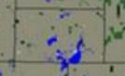

Table 4.5:
Hamlin County Structural, Vehicle and Outside (Wildfire) Department Responses

Year | Structural Fires | Vehicle Fires | Other Fires
2008 | 5 | 3 | 4
2009 | 3 | 4 | 13
2010 | 6 | 5 | 6
2011 | 3 | 2 | 0
2012 | 8 | 2 | 10
2013 | 1 | 1 | 6
2014 | 6 | 1 | 2
2015 | 13 | 6 | 15
2016 | 8 | 3 | 7
2017 | 3 | 3 | 3
2018 | 4 | 4 | 2
Total | 62 | 35 | 68
SOURCE: South Dakota State Fire Marshall Office

FLOOD

Flooding is a temporary overflow of water onto lands not normally covered by water producing measurable property damage or forcing evacuation of people and resources. Floods can result in injuries and even loss of life when quickly moving water is involved. Six inches of moving water is enough to sweep a vehicle off a road. Disruption of communication, transportation, electric service, and community services, along with contamination of water supplies and transportation accidents are very possible. Table 4.6 is a flood history in the County from 1997 to 2014.

Table 4.6: Hamlin County Flood History (1997-2014)

Location or County | Date | Time | Property Damage
Hamlin County | 3/21/1997 | 2:00 | 0.00K
Hamlin County | 4/1/1997 | 0:00 | 0.00K
Hamlin County | 4/1/1997 | 15:00 | 0.00K
Hamlin County | 4/5/1997 | 10:00 | 0.00K
Hamlin County | 5/1/1997 | 0:00 | 0.00K
Hamlin County | 4/7/2001 | 1:00 | 260.00K
Castlewood | 3/14/2007 | 11:00 | 0.00K
Castlewood | 3/19/2009 | 8:00 | 0.00K
Thomas | 3/14/2010 | 8:00 | 0.00K
Hazel | 3/15/2010 | 8:00 | 0.00K
Hamlin County | 6/26/2010 | NA | 50.00K
Hazel | 3/15/2011 | 8:00 | 0.00K
Thomas | 3/21/2011 | 8:00 | 0.00K
Hazel | 4/1/2011 | 0:00 | 800.00K
Thomas | 4/2/2011 | 7:00 | 0.00K
Thomas | 03/28/2018 | 12:30 | 0.00K
Thomas | 04/19/2018 | 22:00 | 0.00K
Thomas | 05/01/2018 | 00:00 | 0.00K
Thomas | 03/22/2019 | 09:00 | 0.00K
Hazel | 03/24/2019 | 07:00 | 0.00K
Hazel | 04/01/2019 | 00:00 | 0.00K
Thomas | 04/01/2019 | 00:00 | 0.00K
Stone Bridge | 04/01/2019 | 00:00 | 0.00K
Stone Bridge | 05/01/2019 | 00:00 | 0.00K
Thomas | 05/01/2019 | 00:00 | 0.00K
Stone Bridge | 06/01/2019 | 00:00 | 0.00K
Lake Norden | 07/01/2019 | 00:00 | 0.00K
SOURCE: ncdc.noaa.gov/stormevents/

Major Flood Occurrences:

- General History: Typically, the most significant damage comes from poor runoff and saturated ground. However ground saturation, rising water in potholes, ditches, and sloughs represent a higher historic problem. Flooding occurs primarily in the Sioux River Basin. Flooding, as a natural hazard, has been a part of the county’s conflict with nature throughout history. Hamlin County has this river traversing near the communities of Castlewood and Estelline. Several creeks feed into the river that can cause municipal flooding and township and county roads can be washed out. The spring flood danger period generally occurs during March and April. A wet fall, early freeze with saturated ground at the time of freezing, heavy winter precipitation, and warm rains during and after spring thaw add to the seriousness of the spring flooding situation. Spring flooding along the Sioux River in Hamlin County is a yearly event in that the normal winter snow melt is likely to push the river beyond flood stage.

- March to April 2011 - Major flooding of the Big Sioux River, other streams, lakes, and general flooding, which began with a rapid March snowmelt, continued through April. Snowmelt flooding damaged many roads and highways, including U.S. Highway 81, throughout Hamlin County. Many roads were closed throughout the county. High water and groundwater levels resulting from record precipitation in the previous year was the main reason that improvement was so slow. Some roads were heavily damaged. Some homes and businesses were still flooded and damages were estimated at $800,000.

- March to August 2019 – Major flooding of the Big Sioux River, other streams, lakes, and general flooding, which began with rapid snow melt in March and addition of severe winter storm in April. Flooded roadways, such as Us Highway 81 and 450th Avenue around Hayti. Many roads were closed for months around Hamlin County. High water and groundwater levels resulting from record precipitation in the previous year was the main reason that improvement was so slow. Some roads were heavily damaged. Some homes and businesses were still flooded and damages were estimated at well over $1,000,000.

- April 2001 - Heavy rain of 1 to 3 inches combined with snowmelt runoff brought flooding to parts of northeast South Dakota. Many roads across Hamlin County were flooded and damaged. The Big Sioux River and Lake Poinsett also rose and resulted in some agricultural land and road flooding.

- April 1997 - Near record to record snowmelt runoff and heavy rains of 1 to 2 inches on April 5th combined to bring Lake Poinsett to a record 6 feet overfull on April 18th. Over 100 cabins, homes, and businesses around the lake became inundated with extensive damage done to most. Extensive sandbagging was done to save property. Periods of strong winds through the end of April combined with debris in the Lake, railroad ties, propane takes, etc, resulted in broken windows and doors on some of the cabins on the Lake.

HAIL

Table 4.7 indicates one hundred seven (107) hail occurrences by location throughout the county since 1997. However, the information provided by the NOAA and SHELDUS websites was incomplete due to inconsistent reporting of damage after such hazards occurred. Obviously, with such a high number of occurrences it is reasonable to expect that at least some property or crop damage was sustained in the communities during some of the occurrences, even though the damage may not have been reported or recorded. It is possible that such damage was not reported because it was believed to be insignificant at the time, or because those responsible for reporting such information did not report to the proper agencies. In 2012 and 2013, four incidents of hail were logged. The largest being two and one-half inches in diameter, collected in Lake Norden on June 21, 2013.

Table 4.7: Hamlin County 10-year Hail History

Location or County | Date | Time | Type | Magnitude
Hayti | 4/21/2007 | 19:32 | Hail | 0.88 In.
Hayti | 4/21/2007 | 19:41 | Hail | 1.00 In.
Thomas | 4/21/2007 | 19:53 | Hail | 1.00 In.
Castlewood | 4/21/2007 | 21:24 | Hail | 0.75 In.
Castlewood | 9/20/2007 | 5:50 | Hail | 0.88 In.
Hazel | 6/12/2008 | 15:37 | Hail | 1.25 In.
Lake Norden | 6/26/2010 | 14:49 | Hail | 1.00 In.
Lake Norden | 6/26/2010 | 14:50 | Hail | 1.75 In.
Stone Bridge | 6/26/2010 | 14:55 | Hail | 1.00 In.
Lake Norden | 6/26/2010 | 15:00 | Hail | 1.50 In.
Dempster | 6/26/2010 | 15:02 | Hail | 0.88 In.
Lake Norden | 6/26/2010 | 15:02 | Hail | 1.25 In.
Hazel | 7/17/2010 | 16:58 | Hail | 2.75 In.
Hazel | 7/17/2010 | 17:05 | Hail | 1.75 In.
Stone Bridge | 7/17/2010 | 17:30 | Hail | 1.00 In.
Lake Norden | 7/17/2010 | 17:34 | Hail | 1.00 In.
Stone Bridge | 7/17/2010 | 17:38 | Hail | 1.50 In.
Dempster | 7/17/2010 | 17:57 | Hail | 1.00 In.
Estelline Muni Arpt | 7/17/2010 | 18:04 | Hail | 1.00 In.
Hayti | 9/1/2010 | 22:07 | Hail | 1.00 In.
Lake Norden | 5/30/2011 | 2:00 | Hail | 0.88 In.
Castlewood | 7/7/2011 | 18:15 | Hail | 0.88 In.
Castlewood | 7/7/2011 | 18:20 | Hail | 1.25 In.
Castlewood | 7/7/2011 | 18:30 | Hail | 0.75 In.
Castlewood | 7/7/2011 | 18:51 | Hail | 0.88 In.
Castlewood | 7/7/2011 | 19:04 | Hail | 0.75 In.
Hayti | 5/5/2012 | 19:47 | Hail | 1.00 In.
Hazel | 6/17/2012 | 18:44 | Hail | 1.00 In.
Lake Norden | 6/21/2013 | 14:30 | Hail | 2.50 In.
Hazel | 9/18/2013 | 21:55 | Hail | 1.00 In.
Estelline Muni Arpt | 7/17/2010 | 18:04 | Hail | 1.00 In.
Hayti | 9/1/2010 | 22:07 | Hail | 1.00 In.
Lake Norden | 5/30/2011 | 2:00 | Hail | 0.88 In.
Castlewood | 7/7/2011 | 18:15 | Hail | 0.88 In.
Castlewood | 7/7/2011 | 18:20 | Hail | 1.25 In.
Castlewood | 7/7/2011 | 18:30 | Hail | 0.75 In.
Castlewood | 7/7/2011 | 18:51 | Hail | 0.88 In.
Castlewood | 7/7/2011 | 19:04 | Hail | 0.75 In.
Hayti | 5/5/2012 | 19:47 | Hail | 1.00 In.
Hazel | 6/17/2012 | 18:44 | Hail | 1.00 In.
Lake Norden | 6/21/2013 | 14:30 | Hail | 2.50 In.
Hazel | 9/18/2013 | 21:55 | Hail | 1.00 In.

Location or County | Date | Time | Type | Magnitude
Hayti | 7/24/2014 | CST -6 | Hail | 1.75 In.
Stone Bridge | 7/24/2014 | CST -6 | Hail | 1.75 In.
Hazel | 5/10/2015 | CST -6 | Hail | 1.5 In.
Hazel | 5/10/2015 | CST -6 | Hail | 1.25 In.
Castlewood | 7/17/2015 | CST -6 | Hail | 1 In.
Grover | 8/6/2015 | CST -6 | Hail | 0.88 In.
Thomas | 8/6/2015 | CST -6 | Hail | 1 In.
Hazel | 8/6/2015 | CST -6 | Hail | 1 In.
Thomas | 8/6/2015 | CST -6 | Hail | 0.88 In.
Grover | 8/6/2015 | CST -6 | Hail | 0.88 In.
Grover | 8/6/2015 | CST -6 | Hail | 0.75 In.
Grover | 8/6/2015 | CST -6 | Hail | 0.88 In.
Thomas | 8/6/2015 | CST -6 | Hail | 0.88 In.
Castlewood | 8/6/2015 | CST -6 | Hail | 0.75 In.
Hayti | 5/25/2016 | CST -6 | Hail | 1 In.
Lake Norden | 7/5/2016 | CST -6 | Hail | 1 In.
Hazel | 7/16/2016 | CST -6 | Hail | 1.75 In.
Lake Norden | 7/16/2016 | CST -6 | Hail | 1 In.
Lake Norden | 7/16/2016 | CST -6 | Hail | 1 In.
Lake Norden | 7/16/2016 | CST -6 | Hail | 1 In.
Lake Norden | 7/16/2016 | CST -6 | Hail | 1 In.
Stone Bridge | 7/16/2016 | CST -6 | Hail | 1 In.
Hayti | 8/18/2016 | CST -6 | Hail | 1 In.
Stone Bridge | 5/16/2017 | CST -6 | Hail | 1 In.
Stone Bridge | 6/11/2017 | CST -6 | Hail | 1 In.
Lake Norden | 6/13/2017 | CST -6 | Hail | 0.88 In.
Lake Norden | 6/13/2017 | CST -6 | Hail | 0.88 In.
Thomas | 6/13/2017 | CST -6 | Hail | 0.75 In.
Castlewood | 6/22/2017 | CST -6 | Hail | 1 In.
Hazel | 7/11/2017 | CST -6 | Hail | 1 In.
Hayti | 7/11/2017 | CST -6 | Hail | 1 In.
Hayti | 7/11/2017 | CST -6 | Hail | 1.75 In.
Hayti | 7/11/2017 | CST -6 | Hail | 0.88 In.
Lake Norden | 7/11/2017 | CST -6 | Hail | 1 In.
Lake Norden | 7/11/2017 | CST -6 | Hail | 1 In.
Lake Norden | 7/25/2017 | CST -6 | Hail | 0.88 In.
Estelline Muni Airport | 7/25/2017 | CST -6 | Hail | 0.88 In.
Hayti | 8/13/2017 | CST -6 | Hail | 0.88 In.
Hazel | 7/2/2018 | CST -6 | Hail | 0.88 In.
Lake Norden | 8/26/2018 | CST -6 | Hail | 0.88 In.
Estelline Muni Airport | 8/26/2018 | CST -6 | Hail | 1.5 In.
Estelline Muni Airport | 9/18/2018 | CST -6 | Hail | 1.75 In.
Dempster | 5/31/2019 | CST -6 | Hail | 1 In.
Dempster | 6/27/2019 | CST -6 | Hail | 0.88 In.
SOURCE: http://www.ncdc.noaa.gov

Major Hail Occurrences:
- June, 2013 - Thunderstorms produced a variety of severe weather on June 21st and 22nd. These storms produced wind and hail that resulted in severe damage to crops and forage and loss of all electrical power in Hamlin County. On June 25, 2013 the Hamlin County Commissioners adopted a resolution declaring Hamlin County a disaster area.
- June, 2010 - Thunderstorms produced a variety of severe weather and flash flooding in much of northeast South Dakota from late morning through the afternoon and into the early evening of June 26th. Widespread large hail, with numerous stones to baseball size, fell along a narrow path several miles long which included the City of Lake Norden. The hail heavily damaged numerous vehicles, denting vehicle bodies and smashing or cracking windows, and also heavily damaged roofs on homes and other buildings. Crop damage was suspected in the area, but the amount of crop damage was not known.
- May 2005 - Large hail from Hayti to Estelline to Castlewood caused extensive crop damage. The hail also broke some windows and otherwise damaged cars.

- June 1997 - Several supercell thunderstorms produced large hail and damaging winds. The most extensive crop, building, and tree damage was around the areas of Hazel, Lake Norden, Castlewood, and Estelline. The hail swaths of destruction were as much as 10 miles wide in places. Some farmers said you could not even tell what was planted because the crops were completely destroyed. Hail piled up to two feet in places.

LIGHTNING

The extent or severity of lightning can range from significant to insignificant depending on where it strikes and what structures are hit. Water towers, cell phone towers, power lines, trees, and common buildings and structures all have the possibility of being struck by lightning. People who leave shelter during thunderstorms to watch or follow lightning also have the possibility of being struck by lightning. According to Sheldus and NOAA the lightning history for the past eighteen years denotes zero (0) occurrences where damage was reported; however, possibility exists that the information reported is incomplete. It is also important to note that while no damage was reported, lightning strikes are very common in all South Dakota counties.

TORNADO

The annual risk for intense summer storms is very high. The entire County is susceptible to summer storms. Warning time for summer storms is normally several hours, sufficient for relocation and evacuation if necessary. However, tornadoes may occur with little or no warning. The State of South Dakota Mitigation Plan, 2019 identified 17 tornado events in Hamlin County between 1950 and 2009. The most detailed empirical data regarding tornadoes can be found at http://www.ncdc.noaa.gov. That data identified an additional tornado event in 2013. Table 4.8 includes the tornado history in the County since 1996.

Table 4.8: Hamlin County Tornado History (1996-2018)

Location | Date | Time | Type | Magnitude | Injuries | Property Damage
Hazel | 5/18/1996 | 20:50 | Tornado | F0 | 0 | 0.00K
Hazel | 5/18/1996 | 20:50 | Tornado | F0 | 0 | 0.00K
Castlewood | 10/26/1996 | 12:30 | Tornado | F1 | 0 | 50.00K
Hayti | 6/22/1997 | 15:26 | Tornado | F0 | 0 | 0.00K
Lake Norden | 6/22/1997 | 15:28 | Tornado | F1 | 0 | 0.00K
Bryant | 6/22/1997 | 15:45 | Tornado | F1 | 0 | 0.00K
Hazel | 6/13/2001 | 16:11 | Tornado | F0 | 0 | 0.00K
Bryant | 6/24/2003 | 19:35 | Tornado | F0 | 0 | 0.00K
Lake Norden | 6/21/2013 | 14:34 | Tornado | EF0 | 0 | 0.00K
SOURCE: http://www.ncdc.noaa.gov

Major Tornado Occurrences:
- June 2013 - Multiple tornadoes and a line of severe thunderstorms ripped through eastern South Dakota on June 21, destroying several homes and knocking out power in several counties. Some of the worst damage was reported in Hamlin counties which lost all power and reported several destroyed homes from the tornadoes, according to The Associated Press.
- June 1997 – Several supercell thunderstorms moved southeast along a strong warm front from eastern Corson County to southwest Deuel County from the morning through the late afternoon producing several tornados, large hail, very heavy rains, and damaging winds. The most extensive crop, building, and tree damage was around the areas of Redfield, Vienna, Naples, Hazel, Bryant, Henry, Lake Norden, Castlewood, Estelline, and Toronto all south of Highway 212. A tornado touched down near Bryant and moved some grain bins and uprooted several trees in a shelter belt.

- October 1996- A tornado touched down at a farm east of Castlewood and took most of a 40 by 60 foot cattle shed and deposited in a cornfield across the road to the north. Several doors of buildings were torn off their hinges with one door thrown into some trees. A 2 X 6 was driven into the gravel road. Power lines were also downed leaving the farm without power until late in the day. The tornado proceeded north across Highway 22 where it ripped apart a new calf shed at another farm, tipped an elevator over, and pushed a three stall garage off of its foundation. A lot of tree damage occurred at both farms.

Each year, many storms and a few tornadoes affect the county. Summer storms in the County usually produce a wide range of damage making damage estimates very difficult. A complete listing of all summer storms having occurred within the county is not possible due to inaccurate reporting. The National Weather Service reports online were the primary source for this information.

EXTREME TEMPERATURES

Extreme temperatures in the County are common occurrences. It is expected that at least two times each year there will be extreme heat or extreme cold in the area. The following information was found on the SHELDUS and NOAA websites. It is possible that people in the area have adapted to this type of extreme temperatures and thus such weather events are not reported as often as they occur. It is also possible that the information has only in recent years been tracked or reported. Table 4.9 identifies dates and times of the temperature extremes.

The location in table 4.9 is not specifically identified in the table by jurisdiction due to the vast area across the State of South Dakota affected by extreme temperatures. On January 13, 2009, after a clipper system dropped from one to four inches of snow, Arctic air and blustery north winds pushed into the area. The coldest air and the lowest wind chills of the season spread across much of central and northeast South Dakota. Wind chills fell to thirty-five to fifty degrees below zero late in the evening of the thirteenth and remained through the fourteenth. By the morning of January 15, 2009 the Arctic high pressure area settled in across northeast South Dakota, bringing wind chills as low as sixty degrees below zero. Many vehicles did not start because of the extreme cold and several schools had delayed starts. Daytime highs remained well below zero across the area. This was one of the coldest days that most areas experienced since the early 1970s. The records were broken by 1 to as much as 7 degrees. Some of the record lows included, -31 degrees at Sisseton; -32 degrees at Milbank; -35 degrees near Summit; and -39 degrees at Castlewood. Some near record low temperatures included -29 degrees at Redfield and Victor; and -34 degrees at Watertown. With these types of temperature extremes the biggest concern for people is exposure because prolonged exposure means almost certain death.

The counterpart to extreme cold is extreme heat which also has dangerous implications to humans, livestock, and critical structures and facilities if certain conditions are present. A temperature extreme occurrence took place between July 28 and July 30, 2006 when record heat and high humidity affected central, north central, and northeast South Dakota. Heat indices rose to 105 to 115 degrees across the area. Also in 2011 extreme heat and high humidity caused the deaths of many head of livestock in the County. Table 4.9 includes the history of extreme temperatures in the County since 2006.

Table 4.9: Hamlin County History of Extreme Temperatures (2006-2019)

Location | Date | Time | Type
Hamlin | 7/28/2006 | 11:00 | Heat
Hamlin | 1/29/2008 | 10:00 | Extreme Cold/Wind Chill
Hamlin | 2/10/2008 | 7:00 | Extreme Cold/Wind Chill
Hamlin | 2/19/2008 | 20:00 | Extreme Cold/Wind Chill
Hamlin | 12/15/2008 | 2:00 | Extreme Cold/Wind Chill
Hamlin | 12/20/2008 | 22:00 | Extreme Cold/Wind Chill
Hamlin | 1/13/2009 | 21:00 | Extreme Cold/Wind Chill
Hamlin | 1/7/2010 | 16:00 | Extreme Cold/Wind Chill
Hamlin | 2/2/2011 | 0:00 | Extreme Cold/Wind Chill
Hamlin | 2/8/2011 | 5:00 | Extreme Cold/Wind Chill
Hamlin | 7/16/2011 | 12:00 | Excessive Heat
Location | Date | Time | Type
Hamlin | 1/21/2013 | 1:00 | Extreme Cold/Wind Chill
Hamlin | 1/31/2013 | 3:00 | Extreme Cold/Wind Chill
Hamlin | 12/7/2013 | 2:00 | Extreme Cold/Wind Chill
Hamlin | 12/23/2013 | 3:00 | Extreme Cold/Wind Chill
Hamlin | 12/29/2013 | 5:00 | Extreme Cold/Wind Chill
Hamlin | 07/20/2016 | 6:00 | Excessive Heat
Hamlin | 12/7/2013 | 6:00 | Extreme Cold/Wind Chill
Hamlin | 12/23/2013 | 6:00 | Extreme Cold/Wind Chill
Hamlin | 12/29/2013 | 6:00 | Extreme Cold/Wind Chill
Hamlin | 1/5/2014 | 6:00 | Extreme Cold/Wind Chill
Hamlin | 1/23/2014 | 6:00 | Extreme Cold/Wind Chill
Hamlin | 3/2/2014 | 6:00 | Extreme Cold/Wind Chill
Hamlin | 1/17/2016 | 6:00 | Extreme Cold/Wind Chill
Hamlin | 12/18/2016 | 6:00 | Extreme Cold/Wind Chill
Hamlin | 12/30/2017 | 6:00 | Extreme Cold/Wind Chill
Hamlin | 1/1/2018 | 6:00 | Extreme Cold/Wind Chill
Hamlin | 1/15/2018 | 6:00 | Extreme Cold/Wind Chill
Hamlin | 1/29/2019 | 6:00 | Extreme Cold/Wind Chill
Hamlin | 2/8/2019 | 6:00 | Extreme Cold/Wind Chill
Hamlin | 3/3/2019 | 6:00 | Extreme Cold/Wind Chill
SOURCE: http://www.ncdc.noaa.gov

THUNDERSTORMS/HIGH WIND

Thunderstorms and high wind occurrences in the County are also very common. According to the National Climatic Data Center Storm Events database, the County experienced seventy-six (76) wind events from 1970-2013. Table 4.10 denotes the extent and severity of such hazards occurring since 2004. In addition, one occurrence of thunderstorm wind peak at 89.9 mph was recorded near Lake Poinsett on June 21, 2013. The County continues to educate residents of the dangers of such storms through public service announcements and other printed media.

Table 4.10: Hamlin County History for Thunderstorms (2004-2019)

Location | Date | Time | Type | Mag  (mph) | Death | Injury | Property Damage
Hamlin County | 12/12/2004 | 8:00 | High Wind | 35 kts. ES | 0 | 0 | 0.00K
Hamlin County | 3/10/2005 | 10:30 | High Wind | 55 kts. MG | 0 | 0 | 0.00K
Hazel | 5/7/2005 | 19:35 | Thunderstorm Wind | 56 kts. EG | 0 | 0 | 0.00K
Hayti | 6/7/2005 | 22:53 | Thunderstorm Wind | 73 kts. MG | 0 | 0 | 0.00K
Hayti | 6/7/2005 | 23:06 | Thunderstorm Wind | 63 kts. MG | 0 | 0 | 0.00K
Location | Date | Time | Type | Mag  (mph) | Death | Injury | Property Damage
Estelline | 6/7/2005 | 23:25 | Thunderstorm Wind | 52 kts. EG | 0 | 0 | 0.00K
Castlewood | 7/3/2005 | 1:15 | Thunderstorm Wind | 52 kts. EG | 0 | 0 | 0.00K
Hamlin | 6/7/2007 | 0:33 | High Wind | 51 kts. MG | 0 | 0 | 0.00K
Hayti | 6/12/2008 | 18:44 | Thunderstorm Wind | 53 kts. MG | 0 | 0 | 0.00K
Lake Norden | 6/12/2008 | 18:49 | Thunderstorm Wind | 61 kts. EG | 0 | 0 | 0.00K
Castlewood | 6/12/2008 | 18:55 | Thunderstorm Wind | 56 kts. MG | 0 | 0 | 0.00K
Estelline Muni Arpt | 6/12/2008 | 19:00 | Thunderstorm Wind | 52 kts. EG | 0 | 0 | 0.00K
Dempster | 6/12/2008 | 19:09 | Thunderstorm Wind | 61 kts. EG | 0 | 0 | 0.00K
Hamlin County | 10/26/2008 | 9:43 | High Wind | 60 kts. MG | 0 | 0 | 0.00K
Lake Norden | 7/7/2009 | 15:00 | Thunderstorm Wind | 52 kts. EG | 0 | 0 | 0.00K
Thomas | 7/31/2009 | 16:40 | Thunderstorm Wind | 52 kts. EG | 0 | 0 | 0.00K
Hayti | 7/17/2010 | 17:24 | Thunderstorm Wind | 81 kts. MG | 0 | 0 | 0.00K
Hayti | 7/17/2010 | 17:25 | Thunderstorm Wind | 70 kts. EG | 0 | 0 | 0.00K
Bryant | 7/23/2010 | 19:58 | Thunderstorm Wind | 52 kts. EG | 0 | 0 | 0.00K
Estelline Muni Arpt | 8/30/2010 | 19:15 | Thunderstorm Wind | 61 kts. EG | 0 | 0 | 0.00K
Hamlin County | 10/26/2010 | 13:55 | High Wind | 55 kts. MG | 0 | 0 | 0.00K
Castlewood | 8/2/2011 | 4:00 | Thunderstorm Wind | 52 kts. EG | 0 | 0 | 0.00K
Hamlin County | 9/20/2011 | 12:00 | High Wind | 50 kts. MG | 0 | 0 | 0.00K
Castlewood | 8/3/2012 | 18:20 | Thunderstorm Wind | 70 kts. EG | 0 | 0 | 0.00K
Lake Norden | 6/21/2013 | 14:37 | Thunderstorm Wind | 56 kts. EG | 0 | 0 | 0.00K
Hazel | 6/21/2013 | 14:43 | Thunderstorm Wind | 70 kts. EG | 0 | 0 | 0.00K
Stone Bridge | 6/21/2013 | 14:43 | Thunderstorm Wind | 78 kts. EG | 0 | 0 | 0.00K
Stone Bridge | 6/21/2013 | 14:45 | Thunderstorm Wind | 78 kts. EG | 1 | 1 | 215.00K
Lake Norden | 6/21/2013 | 14:51 | Thunderstorm Wind | 70 kts. EG | 0 | 0 | 0.00K
Hamlin | 10/12/2015 | 6:00 | High Wind | 52 kts. EG | 0 | 0 | 0.00K
Hamlin | 11/18/2015 | 6:00 | High Wind | 52 kts. EG | 0 | 0 | 0.00K
Hamlin | 03/07/2017 | 6:00 | High Wind | 35 kts. ES | 0 | 0 | 0.00K
Location | Date | Time | Type | Mag  (mph) | Death | Injury | Property Damage
Hayti | 6/22/2015 | 6:00 | Thunderstorm Wind | 61 | 0 | 0 | 0
Lake Norden | 7/16/2016 | 6:00 | Thunderstorm Wind | 52 | 0 | 0 | 0
Lake Norden | 7/16/2016 | 6:00 | Thunderstorm Wind | 70 | 0 | 0 | 0
Thomas | 6/22/2017 | 6:00 | Thunderstorm Wind | 70 | 0 | 0 | 0
Castlewood | 6/22/2017 | 6:00 | Thunderstorm Wind | 70 | 0 | 0 | 0
Thomas | 6/15/2019 | 6:00 | Thunderstorm Wind | 52 | 0 | 0 | 0
Bryant | 7/20/2019 | 6:00 | Thunderstorm Wind | 70 | 0 | 0 | 0
SOURCE: http://www.ncdc.noaa.gov

Major Wind Occurrences:
- June 2013 - A strong warm front along with very unstable air and strong deep layer winds brought several supercell thunderstorms along with a damaging line of thunderstorms/bow echo to parts of central and northeast South Dakota during the afternoon hours. Damaging winds up to 90 mph uprooted large trees and caused considerable structural and crop damage and loss of power to those in its path. The worst wind damage was located at Lake Poinsett. A woman was killed and her husband was seriously injured on Lake Poinsett when their lake house was destroyed. Numerous trees were downed along with many structures damaged or destroyed. Many trees had fallen onto homes, cabins, and trailers. Thousands of people were also left without power. Hamlin County was declared in a Federal Disaster Declaration. Total damage estimates were around 215,000 dollars.
- August 2012 - Eighty mph winds downed between thirty and forty trees in Castlewood and Hayti. Many power outages were also reported.
- July 2010 - Winds measured over 90 mph in Hayti along with some large hail broke numerous windows out of several homes and vehicles, damaged several roofs, and downed many trees. A concrete silo was also destroyed. The highway shop lost half of its roof along with severe damage to the roof of a trucking business in Hayti.
- June 2008 - Seventy mph winds downed several trees in Lake Norden. The lumber yard also received some damage to its buildings.

WINTER STORMS

Table 4.11 shows just how common snow and ice storms are in the County. While such storms would be considered extreme in many parts of the State, the consistent nature of such weather hazards are expected in this area. Thus, planning and response mechanisms for snow and ice storms are vital to the County and are routine procedures in the County due to the common nature of such storms. Winter storms in South Dakota are known to cover large geographical areas, often an entire county or multiple counties can be affected by a single storm. All of the storms identified in Table 4.11 were considered to have occurred countywide. Due to the multiple occurrences of winter storms each year, an exhaustive compilation is not possible.

Table 4.11 Hamlin County History of Blizzard, Winter Storm, Heavy Snow and Ice Storms
(2005-2019)

Location | Date | Time | Type
Hamlin County | 1/21/2005 | 19:00 | Blizzard
Hamlin County | 11/27/2005 | 12:00 | Ice Storm
Hamlin County | 12/29/2005 | 18:00 | Winter Storm
Hamlin County | 12/30/2006 | 4:00 | Winter Storm
Hamlin County | 2/23/2007 | 22:00 | Winter Storm
Hamlin County | 2/28/2007 | 10:00 | Heavy Snow
Hamlin County | 3/2/2007 | 9:42 | Blizzard
Hamlin County | 4/10/2007 | 8:00 | Heavy Snow
Hamlin County | 12/1/2007 | 7:00 | Heavy Snow
Hamlin County | 3/26/2008 | 21:00 | Heavy Snow
Hamlin County | 3/31/2008 | 1:00 | Heavy Snow
Hamlin County | 4/10/2008 | 12:00 | Blizzard
Hamlin County | 4/25/2008 | 6:00 | Winter Storm
Hamlin County | 11/6/2008 | 15:30 | Winter Storm
Hamlin County | 12/13/2008 | 18:00 | Blizzard
Hamlin County | 12/19/2008 | 23:00 | Blizzard
Hamlin County | 1/12/2009 | 4:00 | Blizzard
Hamlin County | 2/26/2009 | 3:00 | Winter Storm
Hamlin County | 3/30/2009 | 21:00 | Blizzard
Hamlin County | 12/23/2009 | 19:00 | Blizzard
Hamlin County | 1/6/2010 | 2:00 | Winter Storm
Hamlin County | 1/22/2010 | 13:00 | Winter Storm
Hamlin County | 1/25/2010 | 10:00 | Blizzard
Hamlin County | 12/11/2010 | 10:00 | Blizzard
Hamlin County | 12/20/2010 | 7:00 | Heavy Snow
Hamlin County | 12/30/2010 | 12:30 | Blizzard
Hamlin County | 12/31/2010 | 12:00 | Blizzard
Hamlin County | 1/1/2011 | 0:00 | Blizzard
Hamlin County | 1/30/2011 | 15:00 | Heavy Snow
Hamlin County | 2/20/2011 | 8:00 | Blizzard
Hamlin County | 3/11/2011 | 18:00 | Blizzard
Hamlin County | 2/28/2012 | 16:00 | Winter Storm
Hamlin County | 12/8/2012 | 16:00 | Winter Storm
Hamlin County | 12/9/2012 | 9:00 | Blizzard
Hamlin County | 2/10/2013 | 17:00 | Blizzard
Hamlin County | 2/18/2013 | 13:00 | Blizzard
Location | Date | Time | Type
Hamlin County | 3/8/2013 | 19:00 | Ice Storm
Hamlin County | 3/18/2013 | 8:00 | Blizzard
Hamlin County | 4/10/2013 | 19:00 | Winter Storm
Hamlin County | 4/14/2013 | 3:00 | Ice Storm
Hamlin County | 1/3/2014 | 9:00 | Blizzard
Hamlin County | 1/16/2014 | 7:00 | Blizzard
Hamlin County | 1/18/2014 | 2:00 | Blizzard
Hamlin County | 1/22/2014 | 5:00 | Blizzard
Hamlin County | 1/25/2014 | 18:00 | Blizzard
Hamlin County | 2/13/2014 | 8:55 | Blizzard
Hamlin County | 3/31/2014 | 18:00 | Blizzard
Hamlin County | 3/18/2014 | 1:00 | Heavy Snow
Hamlin County | 11/9/2014 | 22:00 | Heavy Snow
Hamlin County | 12/15/2014 | 17:00 | Blizzard
Hamlin County | 1/8/2015 | 12:30 | Blizzard
Hamlin County | 3/3/2015 | 6:00 | Blizzard
Hamlin County | 11/30/2015 | 8:00 | Heavy Snow
Hamlin County | 12/1/2015 | 0:00 | Heavy Snow
Hamlin County | 11/18/2016 | 7:00 | Blizzard
Hamlin County | 12/10/2016 | 11:00 | Ice Storm
Hamlin County | 12/16/2016 | 11:00 | Heavy Snow
Hamlin County | 12/26/2016 | 6:30 | Blizzard
Hamlin County | 3/12/2017 | 9:00 | Heavy Snow
Hamlin County | 12/4/2017 | 15:45 | Blizzard
Hamlin County | 3/5/2018 | 600 | Heavy Snow
Hamlin County | 4/8/2018 | 10:00 | Heavy Snow
Hamlin County | 4/13/2018 | 13:00 | Blizzard
Hamlin County | 12/27/2018 | 15:00 | Blizzard
Hamlin County | 12/31/2018 | 6:45 | Blizzard
Hamlin County | 1/18/2019 | 4:00 | Heavy Snow
Hamlin County | 1/27/2019 | 23:00 | Blizzard
Hamlin County | 2/7/2019 | 11:00 | Blizzard
Hamlin County | 2/19/2019 | 19:00 | Heavy Snow
Hamlin County | 2/24/2019 | 4:25 | Blizzard
Hamlin County | 3/9/2019 | 7:00 | Heavy Snow
Hamlin County | 4/11/2019 | 6:00 | Blizzard
SOURCE: http://www.ncdc.noaa.gov

Major Winter Storm Occurrences:

- April 2019: Strong winds combined with several inches and up to feet of snow caused whiteout conditions and stranded several motorists on area highways and especially I-29. . Local and State government were shut down for three days and the event was declare a disaster by the President.

- April 2008 - A strong low pressure area brought widespread heavy snow of 6 to 20 inches to most of northeast South Dakota. Many stranded motorists had to abandon their vehicles in the hardest hit areas. Travel was not advised across the entire area. A school bus slid into a ditch east of Castlewood with no injuries occurring. Interstate-29 was closed from 3 pm the 25th until 3 pm on the 26th from Brookings north to the North Dakota border. In addition, South Dakota State Highway 12 was closed from Webster to the Minnesota line from the afternoon of the 25th until the late morning of the 26th. Most counties affected by the storm opened emergency shelters when Interstate 29 was closed to house stranded motorists. Also, many schools were closed across the area. The very heavy snow set several records across the area. The 19 inches at Watertown broke its all time 24 hour snowfall record of 16 inches. Both Victor and Clear Lake had their second highest snowfall ever recorded in a 24 hour period. Watertown, along with several other locations in northeast South Dakota, received near record or record snowfall for the month of April. In fact, Watertown's 29.5 inches of snow for the month of April was almost their seasonal normal snowfall. This event was also declared a disaster by the President.

- November 2005 - Snowfall varying from 4 to 15 inches combined with winds gusting over 50 mph to produce blizzard conditions. The heaviest snowfalls were mostly near and west of the James River, in the area where a severe ice storm immediately preceded the blizzard. Several reports of 6 to 8 foot drifts were received from this area. Visibilities were lowered frequently to zero and travel was made impossible in many areas. Roads, including Interstate Highways 90 and 29 were closed for extended periods of time. Most schools and businesses that were not already closed because of the ice storm were forced to close. The winds during the blizzard continued to bring down power lines and poles, most of which had been coated and weighted down by ice in the area hit by the ice storm. In addition, minor damage was caused to homes and vehicles by the strong winds and by windblown debris, mainly from trees.

- November 1996 through April 1997 - There were numerous reports of people stranded in their vehicles after going into the ditch or getting stuck in snowdrifts. Many school districts cancelled school. With the closed roads, mail was delayed up to 3 days in many communities. Strong winds made the drifted snow so hard that many plows just rode up and over the drift instead of knocking it down. There were also reports of snowplow blades being broken off by the hard compacted snow. Hamlin County Highway Department had to abandon some roads because they no longer had money or equipment to reopen them. Power lines were also knocked down in many parts of South Dakota, leaving people without electricity for hours. Many ranchers faced the possibility of losing part of their cattle herd due to the cold and being unable to get food to them. Many buildings were beginning to fail from the weight of the snow of this storm and the previous one. There were reports of people getting stranded in vehicles for up to 40 hours. Governor Janklow declared the state a disaster area. This was followed with President Clinton approving the first ever request for a major statewide snow emergency disaster in South Dakota. The National Guard, State DOT, and Private Contractors along with out of state resources were called in to help with snow removal as many communities had already spent their snow removal money before the storm.

- October 1995 - a severe autumn snow and ice storm caused widespread damage in South Dakota. Winds associated with the storm caused lines to slap together and poles to fail, producing widespread power outages to large portions of rural South Dakota. Tree damage also led to significant damage to electrical utilities. Thirteen rural electric cooperatives reported damage from this storm. The cooperatives lost nearly 9,500 poles and 170 transmission lines. Damage was estimated at $10 to $10.3 million to rural electric infrastructure only. Approximately 30,290 households were affected by the power outages. The power outages also caused several rural water system pumping stations to go off line, causing a loss of water utilities to members of rural water systems. The National Guard provided generators to power these pumping stations to restore water service. This storm also forced major transportation delays as portions of Interstates 90 and 29 had to be closed because of the snow accumulation on the roadway and poor visibility. Twenty-eight counties including Hamlin County were included in the disaster declaration:

- December 1968 through February, 1969 – Winter snow accumulations of over 100” occurred throughout eastern and central South Dakota including Hamlin County. Livestock losses were heavy and state assisted several counties with Plan Bulldozer to provide access to feed supplies and emergency snow routes.

- December 1966 - Winds gusting 60/60 mph combined with several inches of snow caused whiteout conditions and stranded several motorists on area highways and especially I-29. Many injuries due to frostbite occurred. It took several days to rescue some of the motorists.
ASSESSING VULNERABILITY: OVERVIEW
Requirement 201.6(c)(2)(i). Local Mitigation Plan Review Tool – B1.
Requirement 201.6(c)(2)(i). Local Mitigation Plan Review Tool – B2.
Requirement 201.6(c)(2)(ii). Local Mitigation Plan Review Tool – B3.

Hazards were also analyzed in terms of the level of the community or county’s vulnerability to the hazard. Vulnerability to the hazard is the susceptibility of life, property, and the environment to injury or damage if a hazard occurs. Representatives from each participating jurisdiction and the PDM Planning Team were asked to complete worksheets that rated their perception to vulnerability of hazards for either their specific geographical location, or for county-wide risks. A low vulnerability hazard is one that has very low damage potential to either life or property (minor damage to less than 5% of the jurisdiction). A “medium” vulnerability hazard is unlikely to threaten human life, although some people may be at risk, but may pose moderate damage potential (causing partial damage to 5% to 10% of the jurisdiction, on an irregular occurrence). A “high” vulnerability hazard may threaten human life, and more than ten percent of the jurisdiction may be at risk on a regular occurrence. Table 4.12a below is an overall summary of vulnerability by jurisdiction produced from the FEMA worksheets completed by each participating jurisdiction and PDM Planning Team. Also See Tables 5.1-5.12 for additional strategies and solutions that jurisdictions are taking to mitigate high-priority hazards.

Table 4.12: Overall Summary of Vulnerability by Jurisdiction
Type of Disaster | Hamlin County | Bryant | Castlewood | Estelline | Hayti | Hazel | Lake Norden | SRWS
Dam Failure | N | N | N | N | N | N | N | N
Drought | H | L | L | L | M | L | M | M
Earthquake | L | N | N | N | N | N | N | N
Extreme Cold | H | L | L | L | H | M | H | M
Extreme Heat | H | L | L | L | H | M | H | M
Flood | H | L | M | M | H | L | L | H
Freezing Rain/Sleet/Ice | M | L | L | M | H | M | H | M
Hail | M | L | L | M | H | L | M | L
Heavy Rain | M | L | M | L | H | L | M | M
Heavy Snow | M | L | L | L | H | M | M | M
Ice Jam | L | N | L | N | N | N | L | N
Landslide | L | N | N | N | N | N | N | N
Lightning | M | L | L | M | H | L | L | L
Rapid Snow Melt | M | L | M | L | H | L | M | M
Strong Winds | H | L | M | L | H | M | M | L
Subsidence | N | N | N | N | N | N | N | N
Thunderstorm | H | L | L | L | H | M | L | L
Tornado | M | H | H | H | H | M | L | M
Urban Fire | M | M | M | L | M | L | L | N
Wild Fire | M | L | N | L | M | L | L | N

N | : Not applicable; not a hazard to the jurisdiction
L | : Low risk/vulnerability; little damage potential (minor damage to less than 5% of the jurisdiction)
M | : Medium risk/vulnerability; moderate damage potential (causing partial damage to 5-10% of the jurisdiction, and irregular occurrence)
H | : High risk/vulnerability; significant risk/major damage potential (for example, destructive, damage  to more than 10% of the jurisdiction and/or regular occurrence)

The following paragraphs summarize the description of the jurisdiction’s vulnerability to each hazard and the impact of each hazard on the jurisdiction.

Blizzards are characterized by high winds, blowing snow, cold temperatures, and low visibility. Blizzards create conditions such as icy roads, closed roads, downed power lines and trees. The County’s population is especially vulnerable to these conditions because people tend to leave their homes to get to places such as work, school, and stores rather than staying inside. Traffic is one of the biggest hazards in the County during a blizzard because people often get stuck, stranded, and lost when driving their vehicles which usually prompts others such as family and or emergency responders to go out in the conditions to rescue them.

Drought can be defined as a period of prolonged lack of moisture. High temperatures, high winds, and low relative humidity all result from droughts and are caused by droughts. A decrease in the amount of precipitation can adversely affect stream flows and reservoirs, lakes, and groundwater levels. Crops and other vegetation are harmed when moisture is not present within the soil.

South Dakota's climate is characterized by cold winters and warm to hot summers. There is usually light moisture in the winter and marginal to adequate moisture for the growing season for crops in the eastern portion of the state. Semi-arid conditions prevail in the western portion. This combination of hot summers and limited precipitation in a semi-arid climatic region present a potential position of suffering a drought in any given year. The climatic conditions are such that a small departure in the normal precipitation during the hot peak growing period of July and August could produce a partial or total crop failure. South Dakota's economy is closely tied to agriculture only magnifies the potential loss which could be suffered by the state's economy during drought conditions. Roughly every fifty years a significant drought is experienced within the county, while less severe droughts have occurred as often as every three years.

Earthquakes occur in the area, but have not had a great enough magnitude or intensity in the past ten years to be reported. The magnitude and intensity of an earthquake is measured by the Richter scale and the Mercalli scale. An earthquake of noteworthy magnitude has not occurred in the county for decades, but it would be reasonable to expect that a large earthquake would have comparative impact on the County as it would anywhere else. The County does not have skyscrapers or very many tall buildings, but it also does not have codes in place that require homes or buildings to be retrofitted.

Extreme Cold temperatures often accompany a winter storm, so you may have to cope with power failures and icy roads. Whenever temperatures drop decidedly below normal and as wind speed increases, heat can leave your body more rapidly. These weather-related conditions may lead to serious health problems. Extreme cold is a dangerous situation that can bring on health emergencies in susceptible people, such as those without shelter or who are stranded, or who live in a home that is poorly insulated or without heat. Exposure is the biggest threat/vulnerability to human life; however, incidences of exposure are isolated and thus unlikely to happen in masses.

Extreme Heat Severe heat waves have caused catastrophic crop damage, thousands of deaths from hyperthermia, and widespread power failures due to increased use of air conditioning. Loss of power and crop damage are the largest vulnerability to the county during extreme heat. Both have an effect on quality of life, however, neither are detrimental to the existence of the population of the County.

Flooding can result in injuries and even loss of life when quickly moving water is involved. Six inches of moving water is enough to sweep a vehicle off a road. Disruption of communication, transportation, electric service, and community services, along with contamination of water supplies and transportation accidents are very possible.

The County is networked with a series of creeks and tributaries, which are part of the Big Sioux River watershed. This area receives several large thunderstorms per year that can cause intense rainfall for short periods of time, resulting in water feeding the Big Sioux River through its respective tributaries. In addition to flooding caused by rainfall, the area surrounding the Big Sioux River is subject to flood damage because of the possibility of extensive snowpack and subsequent spring snowmelt flooding.

There have also been past issues dealing with the maintenance and clearing of drainage channels in the area that have resulted in obstructions restricting the flow of water during a storm. Some residents live in the 100-year flood plain located in the Big Sioux River watershed. Conditions, at times, make response and evacuation operations, very difficult, adversely affecting the safety of residents.

The flooding of township roads is a concern for the entire county. Township officials have identified areas that are either vulnerable or have experienced recurring damages. These areas are identified in maps contained in the Appendix.

Freezing Rain causes adverse conditions such as slippery surfaces and extra weight buildup on power lines, poles, trees, and structures. The additional weight can often cause weak structures to cave in and cause tree branches and power lines to break and fall. The County and the local jurisdictions within are susceptible to these conditions due to the types of structures and surfaces that exist in the county that cannot be protected from freezing rain. Traffic on the roads and highways tend to be the biggest hazard during freezing rain conditions because vehicles often slide off the road which prompts emergency responders and others to have to go out on rescue missions in the adverse conditions.

Hail causes damage to property such as crops, vehicles, windows, roofs, and structures. The County and its local jurisdictions are vulnerable to hail, like most other areas in the State due to the nature of the hazard. Mitigating for hail is difficult and is usually found in the form of insurance policies for structures, vehicles, and crops.

Heavy Rain causes damage to property such as homes and roads. Often when heavy rains occur in the County it may cause sewers to backup in homes due to excess water entering the wastewater collection lines. The excess water sometimes has no place to go and thus basements fill up with water which results in damage to water heaters, furnaces, and damage to living quarters for people who live in basement apartments. Roads and bridges can be washed out, thus causing traffic hazards for travelers and commuters. Many times the roads have to be closed causing rural traffic to have to take alternate routes which can sometimes be an additional five to ten miles out of the way. All areas of the County are vulnerable when heavy rains occur. Storm sewers are built for the typical storm and therefore do not accommodate for excessive or heavy rains.

Ice Jams cause damage to bridges, roads, and culverts due to water currents pushing large chunks of ice under or through small openings. There are 181 bridges and many more culverts throughout Brookings County which are at risk for ice jams.

Landslides have a low chance of occurring in the County due to the relatively flat topography.

Lightning often strikes the tallest objects within the area. In towns trees and poles often receive the most strikes. In rural areas, shorter objects are more vulnerable to being struck. Electrical lines and poles are also vulnerable because of their height and charge. In addition, many streetlights function with sensors. Since thunderstorms occur primarily during hours of darkness, lightning strikes close to censored lights cause the lights to go out, causing a potential hazard for drivers. Flickering lights and short blackouts are not at all uncommon in the county.

One of lightning’s dangerous attributes includes the ability to cause fires. Since the entire county is vulnerable to lightning strikes and subsequent fires, these fires will be treated under the fire section of this PDM.

Most injuries from lightning occur near the end of thunderstorms. Individuals who sought shelter leave those areas prior to the entire completion of the thunderstorm. Believing it is safe to freely move around, concluding lightning strikes catch them off guard.

Severe Winter Storms have a high risk of occurrence. Approximately five snowstorms each resulting in five to ten inches of snow occur in the County area annually. Heavy snow can immobilize transportation, down power lines and trees and cause the collapsing of weaker structures. Livestock and wildlife are also very vulnerable during periods of heavy snow. Most storms can be considered to have occurred countywide. Due to the multiple occurrences of winter storms each year, an exhaustive compilation is not possible.

Additionally, winter storms often result in some forms of utility interruptions. High voltage electric transmission/distribution lines run the length of the County. These lines are susceptible to breaking under freezing rain and icy conditions and severing during high blizzard winds. Within the county, particularly within Brookings, there are fiber optics associated with phone transmissions that are the lifeline to communications. Any electrical complications bring associated risk of food spoilage, appliance burnout, loss of water, and potential harm for in-house life support users. Limited loss of power is not uncommon on an annual basis. A typical power interruption lasts from one to three hours. Most residents are prepared to deal with this type of inconvenience.

The greatest danger during winter weather is traveling. Many individuals venture out in inclement weather. Reasons include the necessity of getting to work, going to school, going out just to see how the weather is, and to rescue stranded persons.

Snow Drifts are caused by wind blowing snow and cold temperatures. These drifts can be small finger drifts on roadways causing cautionary driving, or twenty to forty foot high drifts that block entire highways, roads, and farmyards for several days.

Populations at highest vulnerability for this type of hazard are rural homeowners, which account for approximately seventeen percent of the county, and the elderly. As with any weather event, those dependent upon healthcare supplies and other essentials will also bear the brunt of highway closures and slowed transportation due to snow and ice. Emergency services will also be delayed during winter storms.

Snow removal policies and emergency response is at excellent performance and no projects will be considered in this area. Generators provide back-up power to many critical facilities within the municipalities and in rural areas. However, some of the critical facilities that could be utilized in disaster situations do not have backup generators. Also, some facilities have generators that only power a portion of operations.

Strong Winds can be detrimental to the area. Trees, poles, power lines, and weak structures are all susceptible and vulnerable to strong winds. When strong winds knock down trees, poles, power lines, and structures it creates additional traffic hazards for travelers and commuters. Strong winds are a common occurrence in all parts of the County. The farming community tends to be vulnerable because many old farm sites have weak, dilapidated, or crumbling structures or structures such as grain bins which can easily be blown over. Another area of particular vulnerability would be those areas with dense tree growth where dead or decaying trees lose their stability and can be blown over or knocked down easily.

Thunderstorms cause lightening and sometimes large amounts of rain in a small timeframe. The entire county experiences thunderstorms on a regular basis and is only vulnerable when weather events outside the norm occur. Specific vulnerabilities are further identified in the paragraphs for “Lightening” and “Heavy Rains”.

Tornadoes present significant danger and occur most often in South Dakota during the months of May, June, and July. The greatest period of tornado activity (about 82 percent of occurrence) is from eleven a.m. to midnight. Within this time frame, most tornadoes occur between four p.m. and six p.m. The annual risk for intense summer storms is very high. Often associated with summer storms are utility problems. High voltage electrical transmission lines run the length of the County. These lines are susceptible to breaking during high winds and hail. Tall trees located near electrical lines can be broken in wind or by lightning strikes and land on electrical lines, severing connections. Any electrical complications bring associated risk of food spoilage, appliance burnout, loss of water, and potential harm to in-house life support dependents. Limited loss of power is common on an annual basis. Typical power interruptions last around one to three hours. Most residents are prepared to deal with this.

Wildfires occur primarily during drought conditions. Wildfires can cause extensive damage, both to property and human life, and can occur anywhere in the county. Even though wildfires can have various beneficial effects on wilderness areas for plant species that are dependent on the effects of fire for growth and reproduction, large wildfires often have detrimental atmospheric consequences, and too frequent wildfires may cause other negative ecological effects. Current techniques may permit and even encourage fires in some regions as a means of minimizing or removing sources of fuel from any wildfire that might develop.

Since there are no remote forested regions in the County, wildfires can be easily spotted and are capable of being maintained. The County does not have any areas that are considered wildland-urban interface because property outside city limits is primarily agricultural land, thus, there are no urban interface areas of risk in the County. In addition, fire interference with traffic on highways is not a major concern. The most important factor in mitigating against wildfires continues to be common sense and adherence to burning regulations and suggestions disseminated by the County.

Moisture amounts have the biggest impact on fire situations. During wet years, fire danger is low. More controlled burns are conducted and fewer mishaps occur. During dry years, severe restrictions are placed on any types of burns. For information on dealing with open/controlled burning within the county, see SDCL 34-29B and SDCL 34-35.

Climate Change is a global issue. Climate change exacerbates many of the identified weather hazards such as drought, extreme temperatures, severe storms, flooding, tornadoes and wildfires. Current climate conditions in the northern Great Plains already put a strain on communities and cause millions of dollars in damages. Climate change will only add to these problems.

ASSESSING VULNERABILITY: NATIONAL FLOOD INSURANCE PROGRAM COMPLIANCE
Requirement 201.6(c)(3)(ii). Local Mitigation Plan Review Tool – C2.

The County participates in the National Flood Insurance Program (NFIP). Castlewood, Estelline, and Lake Norden participate in the NFIP, while Bryant, Hayti, and Hazel do not. The Cities of Hayti and Bryant adopted Flood Hazard Boundary Maps from 1975 and 1976 respectively; however are not listed as communities participating in the National Flood Program. No special flood hazard area has been identified for the community of Lake Norden. Therefore, all the City of Lake Norden is considered Zone C. A flood hazard boundary map was created for the portions of the Big Sioux River (which included the City of Castlewood) and Lake Poinsett in Hamlin County in 1986. The Cities of Castlewood, Estelline, and Lake Norden; as well as Hamlin County will continue to participate and ensure compliance of the participating local jurisdictions located within the flood plain. FEMA is in the process of updating the county’s flood hazard boundary map for areas near the Big Sioux River and Lake Poinsett.

Table 4.13:
Communities Participating in the National Flood Program, Hamlin County, SD

Community  Name | Community  ID | Current Map Effective Date
Hamlin County | 460034# | 5/15/86
Bryant | Not Participating
Castlewood | 460035 | 4/15/86
Estelline | 460036# | 1/22/80
Hayti | Not Participating
Hazel | Not Participating
Lake Norden | 460124 | (NSFHA)

Castlewood, Estelline and Hamlin County use paper copies of their flood hazard boundary maps to enforce the floodplain protection measures of their respective zoning ordinances. In addition to the communities of Hazel and Lake Norden either not being mapped or having no flood hazard areas identified; large portions of the rural areas of Hamlin County including numerous lakes have no flood hazard areas. However, should these areas be mapped or updated the communities would work to establish/update and enforce such regulations. Regarding the communities of Bryant and Hayti, proper steps will be considered to ensure compliance with the National Flood Insurance Program.

ADDRESSING VULNERABILTY: REPETITIVE LOSS PROPERTIES
Requirement §201.6(c) (2) (ii): [The risk assessment] must also address National Flood Insurance Program (NFIP) insured structures that have been repetitively damaged by floods.

Due to various geomorphologic and topographical conditions, periodic flooding affects numerous areas in both incorporated and unincorporated areas of the County. Property adjacent to Lake Poinsett and areas near the City of Castlewood are most prone to flooding in Hamlin County. Residential development occurred adjacent to numerous lakes in Hamlin County, particularly Lake Poinsett, long before the initial flood hazard boundaries being identified in 1986. Very few structures are identified as being located within a Flood Hazard Area on the rate map despite numerous flood events in the past three decades which have resulted in floods that inundated areas beyond those currently identified as Zone A Flood Hazard Areas. As a result many structures located within the County have experienced flooding or although the property owner may not be required to carry flood insurance on the property. The County has a total of one hundred three (103) flood insurance policy holders. The vast majority of those policies insure residents adjacent to the numerous lakes in Hamlin County.

Table 4.14: Hamlin County National Flood Insurance Program Statistics

Community  Name | Current NFIP Policies | Number of Claims Paid Since 1978 | Total Value of Claims Paid | Policies for Structures in A-Zones | Repetitive Loss Properties
City of Castlewood | 10 | 5 | $39,257 | 5 | 0
City of Estelline | 3 | 8 | $33,199 | 1 | 0
Unincorporated areas of Hamlin County | 183 | 327 | $4,876,955 | 13 | 49
Totals | 196 | 340 | $4,949,411 | 19 | 49
SOURCE: South Dakota State NFIP Coordinator (11/22/2019)

The PDM Planning Team focused attention particularly on flood related issues. An issue of primary concern the number of times specific properties and structures on those properties flood. The forty-one repetitive loss properties in Hamlin County are the most of any County in South Dakota. Repetitive loss properties are those for which two or more losses of at least $1,000 each have been paid under the National Flood Insurance Program (NFIP) within any ten-year period. A goal of the County is to protect specific areas in the county from flooding. This goal aims to protect properties prone to flood losses, but does not discount the possibility that in some cases structures located in the floodplain may need to be removed.

ADDRESSING VULNERABILTY: SEVERE REPETITIVE LOSS PROPERTIES

The Flood Insurance Reform Act of 2004 identified another category of repetitive loss, severe repetitive loss, and defined it as “a single family property (consisting of one-to-four residences) that is covered under flood insurance by the NFIP and has incurred flood-related damage for which four or more separate claims payments have been paid under flood insurance coverage with the amount of each claim payment exceeding $5,000 and with cumulative amount of such claims payments exceeding $20,000; or for which at least two separate claims payments have been made with the cumulative amount of such claims exceeding the reported value of the property. Hamlin County does not have any properties classified as “severe repetitive loss.”
ASSESSING VULNERABILITY: IDENTIFYING STRUCTURES
Requirement 201.6(c)(2)(ii). Local Mitigation Plan Review Tool – B3.

One of the primary purposes of this PDM is identifying critical facilities, emergency shelters, and summer storm shelters and equipping those facilities with the means to provide the necessary energy for access to sanitation and maintain important functions during a natural hazard occurrence.

Each jurisdiction was responsible for listing critical infrastructure within their communities. Table 4.15 is a list of critical facilities that would cause the greatest distress in the county if destruction occurred. The information provided in Table 4.15 was compiled via survey of the participating communities. It should be noted that electrical transmission lines, transformers, and substations are generally not listed in Table 4.15 despite information being provided for them. They are displayed in Figure 4.2 and Tables 4.26, 4.27, and 4.28.

Table 4.15: Critical Infrastructure in Hamlin County

Jurisdiction/ Entity | Location | Address | Sector | Sub sector | Name | Owner Type
Bryant | City of Bryant | 201 E. Main St | Government Facility | Building | Bryant City Hall | Public
Bryant | City of Bryant | 104 S. Underwood St. | Non Emergency Response Facility | Building | Bryant City Shop | Public
Bryant | City of Bryant | 115 E Main St. | Non Emergency Response Facility | Building | Auditorium | Public
Bryant | City of Bryant | 105 S. William St | Emergency Services | Building | Bryant Fire Hall | Public
Bryant | City of Bryant | 103 S. William St. | Non Emergency Response Facility | Building | Bryant City Storage Building | Public
Bryant | City of Bryant | 103 S. Underwood St. | Non Emergency Response Facility | Electrical Supply | Power Plant | Public
Bryant | City of Bryant | 113 Main St | Population to Protect | Building | Senior Citizen Center | Public
Bryant | City of Bryant | 303 W. 6th Ave | Population to Protect | Building | Parkview Care Center | Private
Bryant | City of Bryant | 412 S Broadway St | Population to Protect | Building | Parkview Apartments | Private
Bryant | City of Bryant | 410 S Broadway St | Population to Protect | Building | South Park Assisted Living Center | Private
Bryant | City of Bryant | 202 S. Broadway St. | Population to Protect | Building | 8-Plex Apartments | Private
Bryant | City of Bryant | 305 W. Main St. | Population to Protect | Building | 5-Plex Apartments | Private
Bryant | City of Bryant | 304 S. Hill St. | Population to Protect | Building | United Congregational Church | Private
Jurisdiction/ Entity | Location | Address | Sector | Sub sector | Name | Owner Type
Bryant | City of Bryant | 204 S. Lebanon St | Population to Protect | Building | St. Mary’s Catholic Church | Private
Bryant | City of Bryant | 212 S. William St. | Population to Protect | Building | Our Redeemer Lutheran Church | Private
Bryant | City of Bryant | 105 Main St. | Communications | Communications | ITC | Private
Castlewood | City of Castlewood | 204 E main St | Government Facility | Building | Castlewood City Hall | Public
Castlewood | City of Castlewood | 204 E main St | Emergency Services | Building | Castlewood Fire Department | Public
Castlewood | City of Castlewood | 107 2nd Ave N | Non Emergency Response Facility | Water Supply – Water Tower | Castlewood Water Tower | Public
Castlewood | City of Castlewood | 107 2nd Ave N | Non Emergency Response Facility | Building | Castlewood  City Shop | Public
Castlewood | City of Castlewood | 109 2nd Ave N | Non Emergency Response Facility | Building | Castlewood City Maintenance | Public
Castlewood | City of Castlewood | West of City | Non Emergency Response Facility | Sanitary Sewer | Wastewater Lagoons | Public
Castlewood | City of Castlewood | Corner of Oak & Main | Non Emergency Response Facility | Sanitary Sewer | Lift Station | Public
Castlewood | City of Castlewood | 319 Cemetery Rd | Non Emergency Response Facility | Sanitary Sewer | South Lift Station | Public
Castlewood | City of Castlewood | 101 1st Ave N | Non Emergency Response Facility | Water Supply-Pumphouse | Pumphouse | Public
Castlewood | City of Castlewood | 101 N Oak Ave | Non Emergency Response Facility | Water Supply-Pumphouse | Pumphouse | Public
Castlewood | City of Castlewood | 108 W Main St | Population to Protect | Assisted Living |  | Private
Castlewood | City of Castlewood | 310 E Harry St | Population to Protect | Elementary and High School | Castlewood Elementary and High School | Public
Castlewood | City of Castlewood | 3503 S 4th Ave | Non Emergency Response Facility | Substation | Ottertail Substation | Private
Castlewood | City of Castlewood | 105 S 2nd Ave | Communications | Building | ITC | Private
Castlewood | City of Castlewood | 205 E Main | Non Emergency Response Facility | Storm Siren | Storm Siren | Public
Castlewood | City of Castlewood | 503 S 4th Ave | Non Emergency Response Facility | Storm Siren | Storm Siren | Public
Castlewood | City of Castlewood | South of Main Str and East of Elm Ave and West of Oak Ave | Population to Protect | Public Park | Memorial Park | Public
Jurisdiction/ Entity | Location | Address | Sector | Sub sector | Name | Owner Type
Estelline | City of Estelline | 117 Main St N | Non Emergency Response Facility | Building | Estelline City Hall/Police Dept | Public
Estelline | City of Estelline | 305 Main St N | Non Emergency Response Facility | Building | Estelline Fire Hall/Ambulance | Public
Estelline | City of Estelline | 304 State Ave E | Non Emergency Response Facility | Building | City Maintenance Shop | Public
Estelline | City of Estelline | 305 Hospital Dr | Population to Protect | Building | Medical Clinic | Private
Estelline | City of Estelline | 219 Main St N | Population to Protect | Building | Community Center | Public
Estelline | City of Estelline | 201 Eva Ave N | Population to Protect | Building | Catholic Church | Private
Estelline | City of Estelline | 117 Main St N | Non Emergency Response Facility | Water Supply | Well House 1 | Public
Estelline | City of Estelline | 302 1st St S | Non Emergency Response Facility | Water Supply | Well House 2 | Public
Estelline | City of Estelline | West on Hwy 28 | Non Emergency Response Facility | Sanitary Sewer | Wastewater Lagoon | Public
Estelline | City of Estelline | One block East of Bell Avenue/7th Street intersection | Non Emergency Response Facility | Water Supply | Watertower | Public
Estelline | City of Estelline | State and 1st St | Non Emergency Response Facility | Sanitary Sewer | Sewer Lift Station | Public
Estelline | City of Estelline | Ash and 5th St | Non Emergency Response Facility | Sanitary Sewer | Sewer Lift Station | Public
Estelline | City of Estelline | 6th and Davis Ave | Non Emergency Response Facility | Sanitary Sewer | Sewer Lift Station | Public
Estelline | City of Estelline | 205 Fjerstad Ave E | Population to Protect | Building | Nursing Home | Private
Estelline | City of Estelline | 215 Main St | Population to Protect | Building | Little Hearts Daycare | Private
Estelline | City of Estelline | 708 Davis Ave E | Population to Protect | Education | High School | Public
Estelline | City of Estelline | 406 6th St N | Population to Protect | Education | Elementary School | Public
Estelline | City of Estelline | 306 6th St N | Population to Protect | Education | School Arena | Public
Estelline | City of Estelline | 301 Railroad St | Non Emergency Response Facility | Building | County Hwy Shop | Public
Estelline | City of Estelline | 202 Bell Ave E | Non Emergency Response Facility | Building | City Power Plant-Substation | Public
Jurisdiction/ Entity | Location | Address | Sector | Sub sector | Name | Owner Type
Estelline | City of Estelline | 305 Bell Ave E | Non Emergency Response Facility | Communications | ITC Telecom | Private
Estelline | City of Estelline | One block North of intersection of Fjerstad Ave and Main St | Non Emergency Response Facility | Communications | Media Comm | Private
Hayti | Town of Hayti | 214 Main St | Non Emergency Response Facility | Building | Hayti City Hall | Public
Hayti | Town of Hayti | 214 Main St | Non Emergency Response Facility | Building | Hayti Fire Hall | Public
Hayti | Town of Hayti | 201 Charger | Non Emergency Response Facility | Building | City Garage | Public
Hayti | Town of Hayti | 300 4th St | Non Emergency Response Facility | Building | Courthouse Sheriff's Department  Emergency Management | Public
Hayti | Town of Hayti | 212 Main St | Non Emergency Response Facility | Water Supply | Water Tower/2 pump houses | Public
Hayti | Town of Hayti | 304 1st St | Non Emergency Response Facility | Sanitary Sewer | Lift Station | Public
Hayti | Town of Hayti | 512 Dakota St | Non Emergency Response Facility | Sanitary Sewer | Lift Station | Public
Hayti | Town of Hayti | 305 Marsh | Non Emergency Response Facility | Substation | Ottertail Power Substation | Private
Hayti | Town of Hayti | 108 Main St | Non Emergency Response Facility | Communications | ITC | Private
Hayti | Town of Hayti | 192nd Street | Non Emergency Response Facility | Water Supply | Sioux Rural Water | Private
Hayti | Town of Hayti | South 7th Street | Non Emergency Response Facility | Sanitary Sewer | Sanitary Sewer Lagoon | Public
Hazel | Town of Hazel | 19 W William Ave | Non Emergency Response Facility | Building | Hazel Community Center/Fire Hall | Public
Hazel | Town of Hazel | 15 W William Ave | Non Emergency Response Facility | Building | Hazel Maintenance Building | Public
Hazel | Town of Hazel | 11 Highway 22 | Non Emergency Response Facility | Building | County Highway Shop | Public
Hazel | Town of Hazel | 15 W LaFayette | Non Emergency Response Facility | Communications | ITC | Private
Hazel | Town of Hazel | 16 W William Ave | Non Emergency Response Facility | Building | City Cafe | Public
Jurisdiction/ Entity | Location | Address | Sector | Sub sector | Name | Owner Type
Hazel | Town of Hazel | 10 W William Ave | Non Emergency Response Facility | Sanitary Sewer | Lift Station | Public
Hazel | Town of Hazel | ½ mile Northeast of town off of 442nd Ave | Non Emergency Response Facility | Sanitary Sewer | Lagoon | Public
Hazel | Town of Hazel | Throughout Community | Non Emergency Response Facility | Electricity | Overhead Power Lines | Private
Hazel | Town of Hazel | Burlington Drive | Non Emergency Response Facility | Transportation | Rail Road | Private
Lake Norden | City of Lake Norden | 508 Main Ave | Non Emergency Response Facility | Building | Lake Norden  City Office | Public
Lake Norden | City of Lake Norden | 600 Main Avenue | Non Emergency Response Facility | Building | Lake Norden Ambulance, Fire Hall, City Maintenance Building | Public
Lake Norden | City of Lake Norden | 19349 SD Hwy 21 | Non Emergency Response Facility | Water Supply – Wells | Lake Norden City Water Wells | Public
Lake Norden | City of Lake Norden | 905 Park St | Non Emergency Response Facility | Water Supply – Treatment Plant | Lake Norden City Water Treatment Plant | Public
Lake Norden | City of Lake Norden | 905 Park St | Non Emergency Response Facility | Water Supply – Water Storage Tank | Lake Norden City Water Storage Tank | Public
Lake Norden | City of Lake Norden | 309 J Headley Ave | Non Emergency Response Facility | Water Supply – Water Storage Tank | Lake Norden City Water Tower | Public
Lake Norden | City of Lake Norden | 1st Ave & 15th Ave | Population to Protect | Public Park | Memorial Park | Public
Lake Norden | City of Lake Norden | Park Street | Population to Protect | Public Park | Ray Antonen Field | Public
Lake Norden | City of Lake Norden | SD Hwy 28 | Non Emergency Response Facility | Building | City Lake Park | Public
Lake Norden | City of Lake Norden | 600 Main Ave | Non Emergency Response Facility | Building | Hamlin County Maintenance Building | Public
Lake Norden | City of Lake Norden | 512 Main Ave | Population to Protect | Building | Sioux Valley Medical Clinic | Private
Lake Norden | City of Lake Norden | 511 1st Ave n | Non Emergency Response Facility | Communications | ITC Telecom | Private
Lake Norden | City of Lake Norden | 298 1st Ave S | Non Emergency Response Facility | Electrical Supply | Ottertail  Substation | Private
Lake Norden | City of Lake Norden | 301 1st Ave S | Non Emergency Response Facility | Electrical Supply | Ottertail  Substation | Private
Lake Norden | City of Lake Norden | 44998 SD Hwy 28 | Non Emergency Response Facility | Natural Gas Supply | Northwestern Public Service – Natural Gas | Private
Jurisdiction/ Entity | Location | Address | Sector | Sub sector | Name | Owner Type
Lake Norden | City of Lake Norden | 1000 1st Ave North | Non Emergency Response Facility | Sanitary Sewer | Lift Station | Public
Lake Norden | City of Lake Norden | 44983 SD Hwy 28 | Non Emergency Response Facility | Sanitary Sewer | Lift Station | Public
Lake Norden | City of Lake Norden | 401 Laker Street | Non Emergency Response Facility | Sanitary Sewer | Lift Station | Public
Lake Norden | City of Lake Norden | 1900 450th Ave | Non Emergency Response Facility | Sanitary Sewer | Wastewater Treatment Plant/Ponds/Lift Station | Public
Lake Norden | City of Lake Norden | 201 Burlington St | Non Emergency Response Facility | Sanitary Sewer | Davisco Wastewater Treatment Plant | Private
Lake Norden | City of Lake Norden | 708 Lakeview St | Population to Protect | Building | Lake Norden Housing | Private
Lake Norden | City of Lake Norden | 803 Park Street | Population to Protect | Building | Golden Living Center | Private
Lake Norden | City of Lake Norden | Homestead Assisted Living | Population to Protect | Building | Homestead Assisted Living Center | Private
Lake Norden | City of Lake Norden | 510 Main Ave | Population to Protect | Building | Senior Citizens Center | Private
Hamlin County | Hamlin County | 44577 188th St | Population to Protect | Building | Hamlin Education Center | Public
Hamlin County | Hamlin County | 45347 183rd St | Non Emergency Response Facility | 911 Tower | Hamlin County 911 | Public
Hamlin County | Hamlin County | 19222 465th Ave | Non Emergency Response Facility | Communications | Hamlin County 911 Tower | Public
Hamlin County | Hamlin County | 18592 454th Ave | Non Emergency Response Facility | Communications | Verizon  Cell Tower | Private
Hamlin County | Hamlin County | 18594 455th Ave | Non Emergency Response Facility | Communications | Amateur Radio Tower | Public
Hamlin County | Hamlin County | 46280 SD Hwy 22 | Non Emergency Response Facility | Communications | AT&T  Cell Tower | Private
Hamlin County | Hamlin County | 45169 SD Hwy 21 | Non Emergency Response Facility | Communications | AT&T  Cell Tower | Private
Hamlin County | Hamlin County | 45300 183rd St | Non Emergency Response Facility | Electric Supply | WAPA Substation | Public
Hamlin County | Hamlin County | 44298 188th St | Non Emergency Response Facility | Electric Supply | East River Power Substation | Public
Jurisdiction/ Entity | Location | Address | Sector | Sub sector | Name | Owner Type
Hamlin County | Hamlin County | 45382 SD Hwy 21 | Non Emergency Response Facility | Electric Supply | East River Power Substation | Public
Hamlin County | Hamlin County | 46298 188th St | Non Emergency Response Facility | Electric Supply | East River Power Substation | Public
Hamlin County | Hamlin County | 18450 459th Ave | Non Emergency Response Facility | Natural Gas | NWPS Border Station | Private
Hamlin County | Hamlin County | 44996 SD Hwy 28 | Non Emergency Response Facility | Natural Gas | NWPS Border Station | Private
Hamlin County | Hamlin County | 19324 465th Ave | Non Emergency Response Facility | Natural Gas | NWPS Border Station | Private
Hamlin County | Hamlin County | 19247 Sauder Ave | Non Emergency Response Facility | Natural Gas | Northern Natural Gas Valve Station | Private
Hamlin County | Hamlin County | 44197 181st St | Non Emergency Response Facility | Natural Gas | Northern Natural Gas Valve Station | Private
Hamlin County | Hamlin County | 45371 178th St | Non Emergency Response Facility | Natural Gas | Northern Natural Gas Pumping Station | Private
Hamlin County | Hamlin County | 409 4th Ave S | Non Emergency Response Facility | Electric Supply | Ottertail Power Co. Sub Station | Private
Hamlin County | Hamlin County | 303 SD Hwy 21 | Non Emergency Response Facility | Electric Supply | Ottertail Power Co. Sub Station | Private
Hamlin County | Hamlin County | 298 1st Ave S | Non Emergency Response Facility | Electric Supply | Ottertail Power Co. Sub Station | Private
Hamlin County | Hamlin County | 45748 184th St | Non Emergency Response Facility | Water Supply | Sioux Rural Water Pump House/Treatment Plant | Public
Hamlin County | Hamlin County | 45053 SD Hwy 21 | Non Emergency Response Facility | Building | Hamlin County Highway Dept. | Public
Hamlin County | Hamlin County | 44575 188th St | Population to Protect | Building | Hamlin Daycare | Private
Hamlin County | Hamlin County | 45054 SD Hwy 21 | Non Emergency Response Facility | Transportation | SDDOT Yard | Public
Hamlin County | Hamlin County | 45289 178th St | Non Emergency Response Facility | Transportation | FAA Air Traffic Control Beacon Air Traffic Control | Public
Hamlin County | Hamlin County | 46271 184th St | Population to Protect | Hutterite Colony | Claremont Colony | Private
Hamlin County | Hamlin County | 46527 189th St | Population to Protect | Hutterite Colony | Poinsett Colony | Private
Hamlin County | Hamlin County | 450 Ave/199th St | Population to Protect | Unincorporated Town | Thomas | Private
Jurisdiction/ Entity | Location | Address | Sector | Sub sector | Name | Owner Type
Hamlin County | Hamlin County | 463 Ave/190th St | Population to Protect | Unincorporated Town | Dempster | Private
Hamlin County | Hamlin County | 197th Street between 455th and 456th Avenues | Non Emergency Response Facility | Sanitary Sewer | Lake Poinsett Sanitary Sewer District Lift Station/Lagoon | Private
Hamlin County | Hamlin County | Intersection of Golf Course Road and 453rd Avenue | Non Emergency Response Facility | Sanitary Sewer | Lake Poinsett Sanitary Sewer District Lift Station/Lagoon | Private
Hamlin County | Hamlin County | Dixon Township Section 35 | Non Emergency Response | Water Supply | Sioux Rural Water System Elevated Tower | Private
Hamlin County | Hamlin County | Brantford  Township Section 23 | Non Emergency Response | Water Supply | Sioux Rural Water System Elevated Tower | Private
Hamlin County | Hamlin County | Opdahl  Township Section 10 | Non Emergency Response | Water Supply | Sioux Rural Water System Booster Station | Private
Hamlin County | Hamlin County | Hayti  Township Section 21 | Non Emergency Response | Water Supply | Sioux Rural Water System Reservoir | Private
Hamlin County | Hamlin County | Oxford  Township Section 8 | Non Emergency Response | Water Supply | Sioux Rural Water System Elevated Tower | Private
Hamlin County | Hamlin County | Castlewood Township Section 34 | Non Emergency Response | Water Supply | Sioux Rural Water System Water Treatment Plant/Reservoir | Private
Hamlin County | Hamlin County | Hamlin  Township Section 35 | Non Emergency Response | Water Supply | Sioux Rural Water System Reservoir  Booster Station | Private
Hamlin County | Hamlin County | Oxford Township Section 36 | Non Emergency Response | Water Supply | Sioux Rural Water System Reservoir | Private
Hamlin County | Hamlin County | ½ mile east of 456th Avenue and 157th Street | Non Emergency Response Facility | Sanitary Sewer | Lake Poinsett Sanitary Sewer District Lift Station/Lagoon | Private
Sioux Rural Water System | Hamlin County | Located in portions of rural county | Water Utility | Non Emergency Response Facility | Drinking water distribution piping | Member Owned
Sioux Rural Water System | Deuel County | Located in portions of rural county | Water Utility | Non Emergency Response Facility | Drinking water distribution piping | Member Owned
Sioux Rural Water System | Hamlin County | 45748 184th ST Castlewood, SD 57223 | Water Utility | Non Emergency Response Facility | Water Treatment Plant | Member Owned
Sioux Rural Water System | Hamlin County | 45748 184th ST Castlewood, SD 57223 | Water Utility | Non Emergency Response Facility | Castlewood Well Field, 8 –Wells | Member Owned
Sioux Rural Water System | Hamlin County | 45748 184th ST Castlewood, SD 57223 | Water Utility | Non Emergency Response Facility | 2- Aquastores | Member Owned
Jurisdiction/Entity | Location | Address | Sector | Sub sector | Name | Owner Type
Sioux Rural Water System | Hamlin County | 44598 186th ST Hayti, SD 57241 | Non Emergency Response Facility | Water Utility | Hayti Booster (c) | Member Owned
Sioux Rural Water System | Hamlin County | 44005 189th ST Bryant, SD 57221 | Non Emergency Response Facility | Water Utility | Bryant Water Tower (A) | Member Owned
Sioux Rural Water System | Hamlin County | 18193 441st AVE  Hazel SD 57242 | Non Emergency Response Facility | Water Utility | Hazel Water Tower (B) | Member Owned
Sioux Rural Water System | Hamlin County | 44986 180th ST Hayti, SD 57241 | Non Emergency Response Facility | Water Utility | Thomas Water Tower (E) | Member Owned
Sioux Rural Water System | Hamlin County | 45349 183rd ST Castlewood SD | Non Emergency Response Facility | Water Utility | Aquastore | Member Owned
Sioux Rural Water System | Hamlin County | 45349 183rd ST Castlewood SD | Non Emergency Response Facility | Water Utility | Kones Booster Station | Member Owned
Sioux Rural Water System | Hamlin County | 18303 465th Ave Castlewood, SD 57223 | Non Emergency Response Facility | Water Utility | Krause Booster Station | Member Owned
Sioux Rural Water System | Hamlin County | 18303 465th Ave Castlewood, SD 57223 | Non Emergency Response Facility | Water Utility | 2- Aquastores | Member Owned

Table 4.16: Administrative and Technical Capabilities

Administrative/ Staff  Composition | Bryant | Castlewood | Estelline | Hayti | Hazel | Lake Norden | Hamlin County
Board of Adjustment | Elected Officials | Elected Officials | Elected Officials | Elected Officials | NA | Elected Officials | Planning Commission
Building Official | NA | NA | NA | NA | NA | NA | Appointed
Community Planner | NA | NA | NA | NA | NA | NA | Appointed
Elected Officials | Aldermanic | Aldermanic | Aldermanic | Aldermanic | Trustee | Aldermanic | Commission
Emergency Manager | NA | NA | NA | NA | NA | NA | Appointed
Engineer/Highway Superintendent | NA | NA | NA | NA | NA | NA | Appointed
Floodplain Administrator | Finance Officer | Zoning Officer | Finance Officer | Finance Officer | NA | Finance Officer | Zoning Officer
GIS Coordinator | NA | NA | NA | NA | NA | NA | NA
Planning Commission | Elected Officials | Elected Officials | Elected Officials | Elected Officials | NA | Elected Officials | Appointed
Zoning Officer | Finance Officer | Appointed | Finance Officer | Finance Officer | NA | NA | Appointed
Grant Writing Capability (Yes/No) | Yes* | Yes* | Yes* | Yes* | Yes* | Yes* | Yes*
Non-profit organizations focused on environmental protection. | Yes** | Yes** | Yes** | Yes** | Yes** | Yes** | Yes**
Public-Private partnership initiatives addressing disaster-related issues | No | No | No | No | No | No | No
NA: This Jurisdiction has nobody serving in this role
* First District Association of Local Governments provides these services without cost
** East Dakota Watershed Development District
Table 4.17: Capabilities of Growth Guidance Instruments

Capabilities of Community Planning Mechanisms | Bryant | Castlewood | Estelline | Hayti | Hazel | Lake Norden | Hamlin County
Does the Future Land-Use Map identify natural hazard areas? | Y | Y | Y | Y | NA | Y | Y
Do the land-use policies discourage development or redevelopment within natural hazard areas? | Y | Y | Y | Y | NA | Y | Y
Does the plan provide adequate space for expected future growth in areas located outside natural hazard areas? | Y | Y | Y | Y | NA | Y | Y
Does the transportation plan limit access to hazard areas? | N | N | N | N | NA | N | N
Is transportation policy used to guide growth in safe locations? | Y | Y | Y | Y | NA | Y | Y
Are movement systems designed to function under disaster conditions (e.g. evacuation)? | Y | Y | Y | Y | NA | Y | Y
Are environmental systems that protect development from hazards identified and mapped? | N | N | N | N | NA | N | N
Do environmental policies provide incentives to development that is located outside protective ecosystems? | N | N | N | N | NA | N | N
Do environmental policies maintain and restore protective ecosystems? | N | N | N | N | NA | N | Y
Are the goals and policies of the comprehensive plan related to those of the FEMA Local Hazard Mitigation Plan? | N | N | N | N | NA | N | N
Is safety explicitly included in the plan's growth and development policies? | Y | Y | Y | Y | NA | Y | Y
Does the monitoring and implementation section of the plan cover safe growth objectives? | N | N | N | N | NA | N | N
Capabilities of Community Planning Mechanisms | Bryant | Castlewood | Estelline | Hayti | Hazel | Lake Norden | Hamlin County
Does the Zoning Ordinance conform to the comprehensive plan in terms of discouraging development or redevelopment within natural hazard areas? | Y | Y | Y | Y | NA | Y | Y
Does the zoning ordinance contain natural hazard overlay zones that set conditions for land use within such zones? | Y | Y | Y | Y | NA | Y | Y
Do rezoning procedures recognize natural hazard areas as limits on zoning changes that allow greater intensity or density of use? | N | N | N | N | NA | N | Y
Does the zoning ordinance restrict development within, or filling of, wetlands, floodways, and floodplains? | Y | Y | Y | Y | NA | Y | Y
Do the subdivision regulations restrict the subdivision of land within or adjacent to natural hazard areas? | Y | Y | Y | Y | NA | Y | Y
Do the subdivision regulations provide for conservation subdivisions or cluster subdivisions in order to conserve environmental resources? | N | N | N | N | NA | N | Y
Do the subdivision regulations allow density transfers where Hazard areas exist? | N | N | N | N | NA | N | N

NA: This jurisdiction does not have the specified document.

ASSESSING VULNERABILITY: COMMUNITY CAPABILITIES
Requirement 201.6(c)(2)(i). Local Mitigation Plan Review Tool – B1.
Requirement 201.6(c)(3). Local Mitigation Plan Review Tool – C1.

Each community has a unique set of capabilities, including authorities, policies, programs, staff, funding, and other resources for accomplishing mitigation. One important step in assessing the vulnerability of a given community is to objectively review the capabilities to implement mitigation strategies and to identify limiting factors. Each community reviewed existing administrative documents, procedures, and policies. This helped the communities and planning team to evaluate how existing capabilities contribute to the vulnerability by reducing or exacerbating disaster impacts. Table 4.16 (above) identifies whether each community has the specified administrative and technical capabilities, and who serves in such capacity. It should be noted that First District Association of Local Governments provides grant writing services without cost for all communities listed. In addition, East Dakota Watershed Development District is a non-profit organization focused on environmental, particularly watershed, protection. Table 4.17(above) encapsulates the efficacy of the specified planning mechanisms with regard to disaster mitigation and to identify potential deficiencies in the specified plans.

ASSESSING VULNERABILITY: ESTIMATING POTENTIAL LOSSES
Requirement 201.6(c)(2)(ii). Local Mitigation Plan Review Tool – B3.

The information provided in the following tables was collected from the Hamlin County Director of Equalization. Inconsistencies and missing information result from lack of existing mechanisms, plans, and technical documents available.

The assessor’s office provided the assessed valuation of total structures on each property within the incorporated and rural areas of the county. The data provides a total value for structures of a certain use on each property. It was not possible to discern the value of each structure on a lot so the actual number of structures is based on the number of parcels with the specified use type. For example, the number in the reported for “Agricultural Structures in the Hazard Area” is 33, despite a total count of 161 agricultural structures actually located within the floodplain on those 33 properties. For the purposes of this plan only Residential, Commercial/Industrial, Agricultural, and Manufactured Homes were included. Structures in Castlewood and the unincorporated areas of Hamlin County were reviewed based upon the paper flood hazard boundary maps established in 1986. Structures in Estelline were reviewed based upon the paper flood hazard boundary map for that community from 1980. Average value for structures of a given use type was calculated and applied to the total number of properties identified within the floodplain to establish the value of structures within the floodplain. The information does not account for letters of map amendment or letters of map revision which may have been approved.

All properties with structures, whether owner occupied or not were included in the valuations provided in Tables 4.18 through 4.25. The reports provided by the assessor’s office did not include the number of people in each structure; thus, many of the tables are missing this information. The following tables also do not address information regarding religious, governmental, or utility structures. Although not included in Tables 4.18 through 4.25, the State of South Dakota Hazard Mitigation Plan incorporated HAZUS analysis accounting for potential losses to those structures within Hamlin County.

Table 4.18: Hamlin County (Rural Area)
Estimated Potential Dollar Losses to Vulnerable Structures

Type of Structure | Number of Structures |  |  | Value of Structures |  |  | Number of People
 | # in County | # in HA | % in HA | $ in County | $ in HA | % in HA | # in Rural  Areas | # in HA | % in HA
Residential | 1,847 | 180 | 9.75 | $144,986,149 | $14,129,672 | 9.75 | 3,113 | 482 | 15.58
Commercial/Industrial | 54 | 9 | 16.67 | $2,372,895 | $395,562 | 16.67
Agricultural | 677 | 33 | 4.88 | $14,676,619 | $716,219 | 4.88
Mobile Homes | 103 | 9 | 8.74 | $1,652,089 | $144,393 | 8.74 |  | 24 | 0.77
Total | 2,681 | 231 | 8.62 | $163,687,752 | $15,385,846 | 9.40 | 3,113 | 506 | 16.25

Table 4.19: Bryant Estimated Potential Dollar Losses to Vulnerable Structures

Type of Structure | Number of Structures |  |  | Value of Structures |  |  | Number of People
 | # in City | # in HA | % in HA | $ in City | $ in HA | % in HA | # in City | # in HA | % in HA
Residential | 224 | 1 | 0.45 | $4,317,400 | 19,274 | 0.45 | 456 | 3 | 0.66
Commercial/Industrial | 42 | 0 | 0 | $2,304,601 | 0 | 0
Agricultural | 1 | 0 | 0 | $14,916 | 0 | 0
Manufactured Home | 10 | 0 | 0 | $95,807 | 0 | 0
Total | 277 | 0 | 0.36 | $6,732,724 | 19,274 | 0.29 | 456 | 3 | 0.66

Table 4.20: Castlewood Estimated Potential Dollar Losses to Vulnerable Structures

Type of Structure | Number of Structures |  |  | Value of Structures |  |  | Number of People
 | # in City | # in HA | % in HA | $ in City | $ in HA | % in HA | # in City | # in HA | % in HA
Residential | 334 | 14 | 4.19 | $19,840,754 | $831,328 | 4.19 | 627 | 33 | 5.26
Commercial/Industrial | 59 | 2 | 3.39 | $3,328,209 | $112,826 | 3.39
Agricultural | 3 | 1 | 33.3 | $25,458 | $8,485 | 33.3
Manufactured Home | 18 | 1 | 5.56 | $204,462 | $11,368 | 5.56 |  | 3 | 0.48
Total | 414 | 18 | 4.35 | $23,398,883 | $964,007 | 4.12 | 627 | 36 | 5.74

Table 4.21: Estelline Estimated Potential Dollar Losses to Vulnerable Structures

Type of Structure | Number of Structures |  |  | Value of Structures |  |  | Number of People
 | # in City | # in HA | % in HA | $ in City | $ in HA | % in HA | # in City | # in HA | % in HA
Residential | 389 | 8 | 2.06 | $12,655,083 | $260,695 | 2.06 | 768 | 26 | 3.39
Commercial/Industrial | 51 | 1 | 1.96 | $2,014,237 | $39,479 | 1.96
Agricultural | 2 | 0 | 0 | $22,158 | 0 | 0
Manufactured Home | 18 | 3 | 16.7 | $189,824 | $31,644 | 16.7 |  | 7 | 0.91
Total | 460 | 12 | 2.61 | $14,881,302 | $331,818 | 2.23 | 768 | 33 | 4.30

Table 4.22: Hayti Estimated Potential Dollar Losses to Vulnerable Structures

Type of Structure | Number of Structures |  |  | Value of Structures |  |  | Number of People
 | # in City | # in HA | % in HA | $ in City | $ in HA | % in HA | # in City | # in HA | % in HA
Residential | 199 | 0 | 0 | $7,563,940 | 0 | 0 | 381 | 0 | 0
Commercial/Industrial | 35 | 0 | 0 | $1,994,516 | 0 | 0
Agricultural | 0 | 0 | 0 | $0 | 0 | 0
Manufactured Home | 13 | 0 | 0 | $139,086 | 0 | 0
Total | 247 | 0 | 0 | $9,697,542 | 0 | 0 | 381 | 0 | 0

Table 4.23: Hazel Estimated Potential Dollar Losses to Vulnerable Structures

Type of Structure | Number of Structures |  |  | Value of Structures |  |  | Number of People
 | # in City | # in HA | % in HA | $ in City | $ in HA | % in HA | # in City | # in HA | % in HA
Residential | 63 | 0 | 0 | $1,808,690 | 0 | 0 | 91 | 0 | 0
Commercial/Industrial | 12 | 0 | 0 | $925,076 | 0 | 0
Agricultural | 4 | 0 | 0 | $48,021 | 0 | 0
Manufactured Home | 4 | 0 | 0 | $78,454 | 0 | 0
Total | 83 | 0 | 0 | $2,860,241 | 0 | 0 | 91 | 0 | 0

Table 4.24: Lake Norden Estimated Potential Dollar Losses to Vulnerable Structures

Type of Structure | Number of Structures |  |  | Value of Structures |  |  | Number of People
 | # in City | # in HA | % in HA | $ in City | $ in HA | % in HA | # in City | # in HA | % in HA
Residential | 213 | 0 | 0 | $6,587,069 | 0 | 0 | 467 | 0 | 0
Commercial/Industrial | 40 | 0 | 0 | $10,547,256 | 0 | 0
Agricultural | 1 | 0 | 0 | $938 | 0 | 0
Manufactured Home | 18 | 0 | 0 | $255,144 | 0 | 0
Total | 272 | 0 | 0 | $17,390,407 | 0 | 0 | 467 | 0 | 0

Table 4.25: Hamlin County Estimated Potential Dollar Losses to Vulnerable Structures

Type of Structure | Number of Structures |  |  | Value of Structures |  |  | Number of People
 | # in County | # in HA | % in HA | $ in County | $ in HA | % in HA | # in County | # in HA | % in HA
Residential | 3,269 | 203 | 6.21% | $197,759,085 | $15,240,969 | 7.71% | 5,903 | 544 | 9.22%
Commercial/Industrial | 293 | 12 | 4.10% | $23,486,790 | $547,867 | 2.33%
Agricultural | 688 | 34 | 4.94% | $14,788,110 | $724,704 | 4.90%
Manufactured Home | 184 | 13 | 7.07% | $2,614,866 | $187,405 | 7.17% |  | 34 | 0.58%
Total | 4,434 | 262 | 5.91% | $238,648,851 | $16,700,945 | 7.00% | 5,903 | 578 | 9.79%
Notes:
# in HA: Number of structures in hazard area was determined using aerial photography and DFIRM boundaries provided by the FHBM established in 1985 for Howard. Some structures included may have received LOMA’s, removing them from the flood plain, since the effective date of the maps.
$ in HA: Value of structures in hazard area was estimated by determining the average value per structure and multiplying that value by the number of properties or structures used with a corresponding land use.
# in [Jurisdiction]: The number of people was based on the 2010 Census.
# in Hazard Area: The number of people in a hazard area was determined by multiplying the average household size of a given community as identified by the number of structures in the identified hazard area, and multiplying that number by the rate of occupancy for the community (All statistics from the US Census 2010).

As part of the State of South Dakota Hazard Mitigation Plan, data were prepared for specific hazard types. Although the data is not current, the modeling used in the plan would be difficult to replicate or improve upon. The following sections describing vulnerability to flooding and tornadoes is based largely on the corresponding sections in the State of South Dakota Hazard Mitigation Plan.

Flooding

All of Hamlin County is in the Big Sioux River Watershed, therefore Hamlin County was included within the Big Sioux Region in the State of South Dakota Hazard Mitigation Plan. Based on its history of flood problems, the County was deemed a high priority jurisdiction in South Dakota’s Plan. For that reason HAZUS-MH analysis was performed in conjunction with the completion of the State’s Plan. The results were based on flooding with a one percent chance of occurrence or commonly referred to as a “100-year flood” and display the potential base flood losses to the County. The full results of HAZUS-MH analysis for the County are displayed in Table 4.29.

FEMA updated the HAZUS modeling based on 2010 Census information as part of a nationwide study. Data from Hamlin County was extracted to produce a specified report for the purposes of this plan. It should be noted that the data represented in Figure 4.1 is intended to identify those areas most prone to flooding in Hamlin County, rather than to provide a precise prediction of losses in a base flood (1 percent chance). Since no flood elevations have been established for any portion of Hamlin County, the HAZUS data, though not precise is the best available data for projecting flood losses in Hamlin County at the present time.

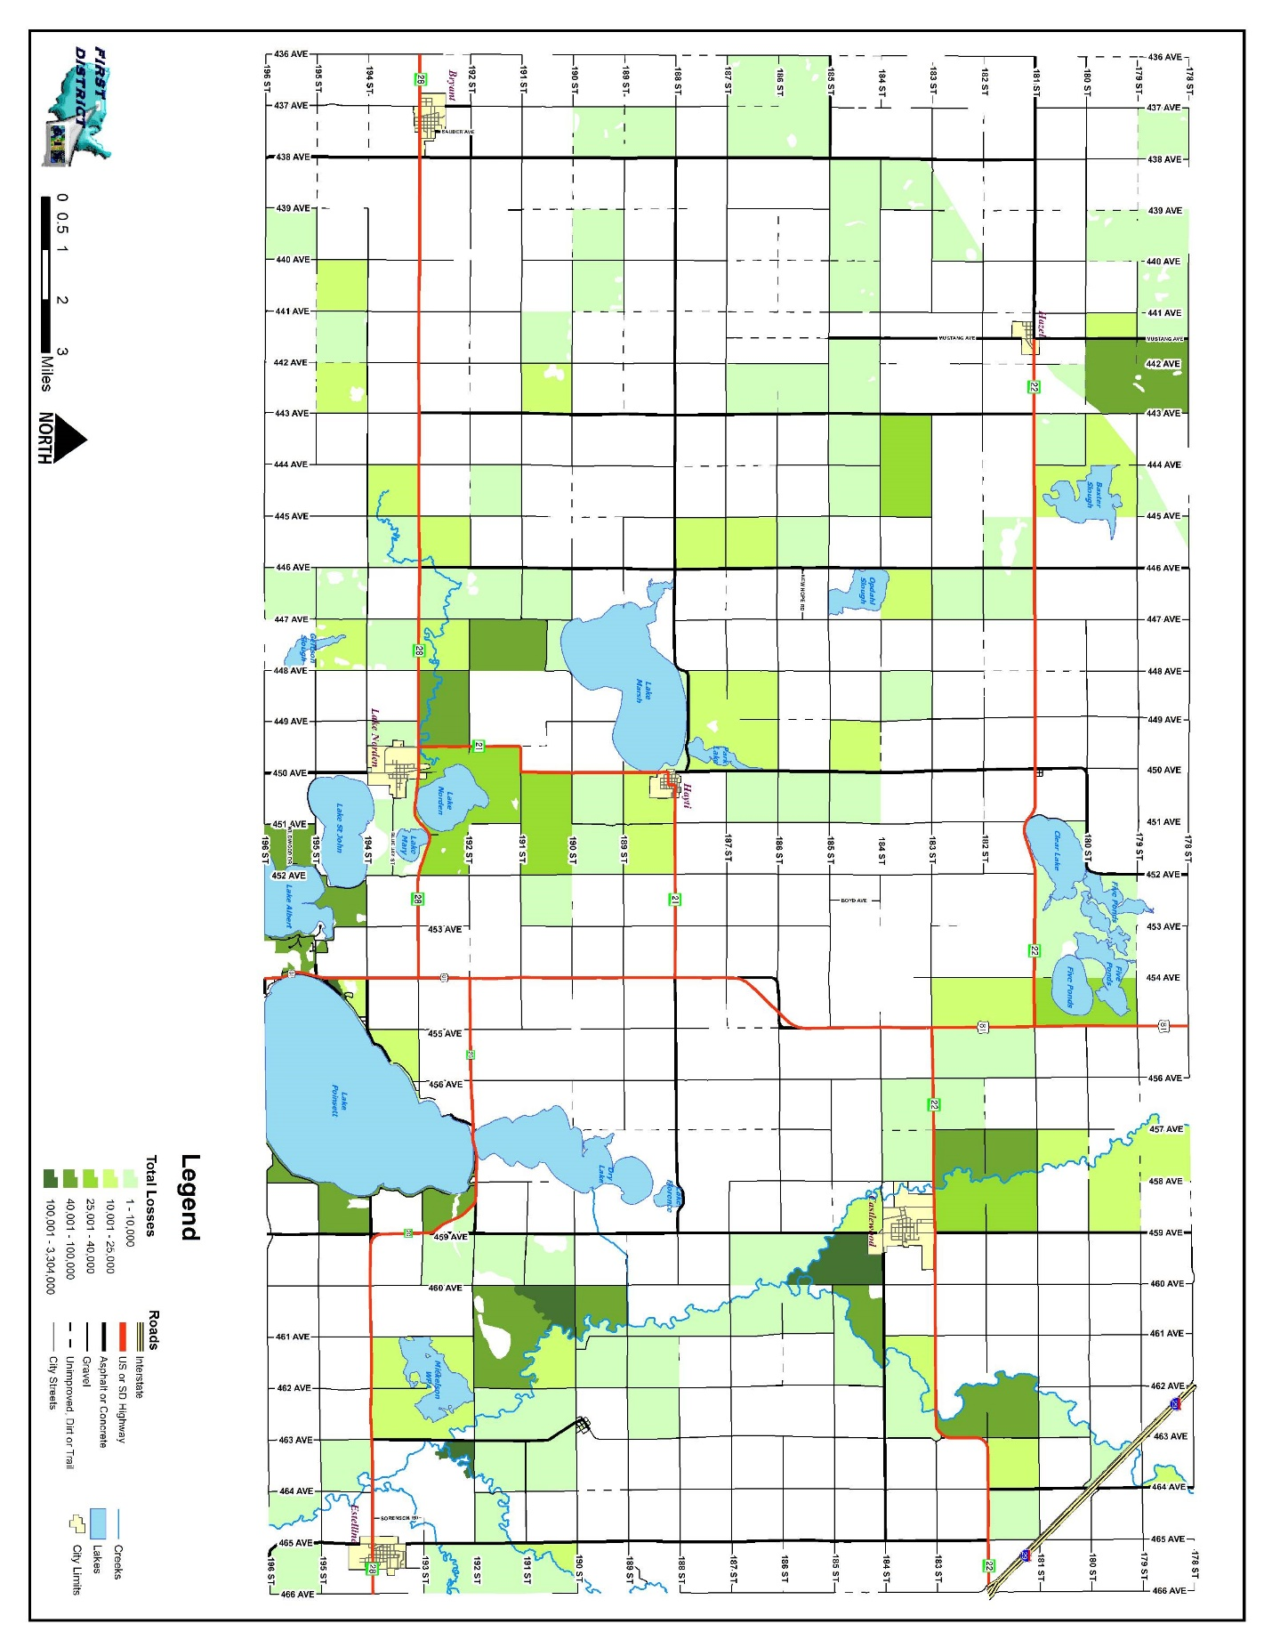
Figure 4.1: HAZUS-MH Base Flood (1 Percent Chance) Loss Estimation Results (2010)

Table 4.26: HAZUS-MH Base Flood (1 Percent Chance) Loss Estimation Results (2011)

Building  Damage | Loss Ratio* | Contents  Damage and  Inventory Loss | Total Economic  Building  Loss | Number of  Displaced  People | People  Needing  Shelter
5,398,000 | 1.4% | $9,963,000 | 16,441,000 | 387 | 31
SOURCE: State of South Dakota Hazard Mitigation Plan. p 3-147; Table 3-41. South Dakota Office of Emergency Management. 2011.
*Loss ratio is the percent of the total building inventory value that could be damaged from flooding in any given year.

Tornado

As part of the State of South Dakota Hazard Mitigation Plan HAZUS-MH analysis was performed calculating potential building exposure to tornadoes in the state. Total value of structures lost due to tornadoes from 1950 – 2009 was calculated, inflated to current (2009) dollars. A loss ratio was then calculated by dividing the total damage by the total building exposure. Table 4.27 identifies data specific to the annualized losses from tornadoes for the County as identified in the State of South Dakota Hazard Mitigation Plan.

Table 4.27: Hamlin County Annualized Losses from Tornadoes

Total Events  1950-2009 | Total Property  Damage (inflated) 1950-2009 | Annualized Losses | Total Building  Exposure | Loss Ratio
17 | $738,730 | $12,312 | $385,529,000 | 0.00003
SOURCE: State of South Dakota Hazard Mitigation Plan. p. 3-174; Table 3-67. South Dakota Office of Emergency Management. 2011.

Sioux Rural Water Systems, as a participating entity has also included a list of vulnerable structures and their value to the operation of the utility. Specific location of critical infrastructure can be found on Table 4.15.
Table 4.28: Sioux Rural Water Systems
Vulnerable Structures
Type of Structure | Total # of Structures | Total  $ of Structures
 |  |  | Hazards
 |  |  | Flood | Strong Winds | Tornado | Winter Storms | Drought | Extreme Cold | Extreme Heat | Lightning
Distribution Piping | 1100 miles | 12,607.811.00 | x |  |  |  |  | x
SCADA system | 13 | 1,100,000.00 |  | x | x | x |  |  | x | x
Castlewood Treatment Plant | 1 | 2,000,000.00 | x |  | x |  |  |  | x
Sioux Treatment Plant | 1 | 1,450,000.00 |  |  | x
Booster Stations | 5 | 1,000,000.00 | x |  | x | x |  |  | x | x
Castlewood  Well Field | 8 | 1,250,000.00 | x |  | x |  | x |  | x
Sioux Well Field | 4 | 250,000.00 | x |  | x |  | x
Type of Structure | Total # of Structures | Total  $ of Structures | Hazards
 |  |  | Flood | Strong Winds | Tornado | Winter Storms | Drought | Extreme Cold | Extreme Heat | Lightning
Aqua Store Water Ground Storage Facilities | 6 | 1,800,000.00 | x |  | x |  |  | x
Water Towers | 5 | 2,000,000.00 |  | x | x | x

ASSESSING VULNERABILITY: ANALYZING DEVELOPMENT TRENDS
Requirement 201.6(c)(3). Local Mitigation Plan Review Tool – C1.
Requirement 201.6(d)(3). Local Mitigation Plan Review Tool – D1.
Requirement 201.6(d)(3). Local Mitigation Plan Review Tool – D2.

The land use and development trends for each jurisdiction were identified by the representatives from each of the jurisdictions. Five of the county’s six communities as well as the county itself have comprehensive land use plans which identified future areas for development. In addition to Hamlin County, the cities of Bryant, Castlewood, Estelline, Hayti, and Lake Norden all have adopted Comprehensive Land Use Plans with Future Land Use Maps. The Comprehensive Land Use Plans for each community were reviewed by each community utilizing one. Specifically, available undeveloped areas projected for residential, commercial, and industrial uses were reviewed. Based upon their own projected density of development for each land use, the communities then identified the potential number of lots which could be created within flood hazard areas given current land use regulations and controls. Each of the communities have Flood Hazard Areas identified in maps which were drawn between 1975 and 1986. Those paper maps were used to determine the amount of available, undeveloped land by use type in identified hazard areas. Although no base flood elevation(s) have been established within the rural portions of Hamlin County, the county continues to enforce a Natural Resources Zoning District which restricts land use within a specified distance of some water bodies in the county. Tables 4.29 – 4.34 identify the projected vulnerability for communities which have adopted land use plans. Future Land Use Maps for each jurisdiction which have adopted Comprehensive Land Use Plans are included in Appendix F.

Table 4.29: Hamlin County (Unincorporated Area)
Potential Floodplain Development – By Land Use Type

 | Community Totals |  | Flood Hazard Area
Land Use Category | Projected Development Density (Acres/Unit) | Acres of projected future development | Acres of future development in Hazard Area | % Area for future development | Potential # of Lots for future development | # of Undeveloped Lots Already Appropriately Zoned
Ag – Residential* | 2 | N/A | 29,974 | N/A | 646 | N/A
Lake - Residential | 2 | 404 | 0 | 0 | 0 | 0
Commercial | .25 | N/A | N/A | N/A | 0 | 0
Industrial | .5 | N/A | N/A | N/A | 0 | 0
* Minimum lot area is 2 acres in the Agricultural District, however not more than one residence is allowed per quarter-quarter section based upon the United States Public Land Survey.
N/A: Most of the rural area is planned to remain agricultural in use with varying degree of land use restrictions.

Table 4.30: City of Bryant
Potential Floodplain Development – By Land Use Type

 | Community Totals |  | Flood Hazard Area
Land Use Category | Projected Development Density (Units/Acre) | Acres of projected future development | Acres of future development in Hazard Area | % Area for future development | Potential # of Lots for future development | # of Undeveloped Lots Already Appropriately Zoned
Residential | 2.5 | 38 | 0.0 | 0.0 | 0 | 0
Commercial | 1 | 12 | 0.0 | 0 | 0 | 0
Industrial | 0.25 | 12 | 0.0 | 0 | 0 | 0

Table 4.31: City of Castlewood
Potential Floodplain Development – By Land Use Type

 | Community Totals |  | Flood Hazard Area
Land Use Category | Projected Development Density (Units/Acre) | Acres of projected future development | Acres of future development in Hazard Area | % Area for future development | Potential # of Lots for future development | # of Undeveloped Lots Already Appropriately Zoned
Residential | 2.5 | 34 | 0.0 | 0 | 0 | 0
Commercial | 1 | 10 | 0.0 | 0 | 0 | 0
Industrial | 0.25 | 2 | 0.0 | 0 | 0 | 0

Table 4.32: City of Estelline
Potential Floodplain Development – By Land Use Type

 | Community Totals |  | Flood Hazard Area
Land Use Category | Projected Development Density (Units/Acre) | Acres of projected future development | Acres of future development in Hazard Area | % Area for future development | Potential # of Lots for future development | # of Undeveloped Lots Already Appropriately Zoned
Residential | 2.5 | 34 | 9.7 | 28.7 | 24 | 4
Commercial | 1 | 10.5 | 9.9 | 94.3 | 10 | 0
Industrial | 0.25 | 10.5 | 0.0 | 0.0 | 0 | 0
.

Table 4.33: Town of Hayti
Potential Floodplain Development – By Land Use Type

 | Community Totals |  | Flood Hazard Area
Land Use Category | Projected Development Density (Units/Acre) | Acres of projected future development | Acres of future development in Hazard Area | % Area for future development | Potential # of Lots for future development | # of Undeveloped Lots Already Appropriately Zoned
Residential | 2.5 | 21 | 0.0 | 0 | 0 | 0
Commercial | 1 | 6 | 0.0 | 0 | 0 | 22
Industrial | 0.25 | 5 | 0.0 | 0 | 0 | 6

Table 4.34: City of Lake Norden
Potential Floodplain Development – By Land Use Type

 | Community Totals |  | Flood Hazard Area
Land Use Category | Projected Development Density (Units/Acre) | Acres of projected future development | Acres of future development in Hazard Area | % Area for future development | Potential # of Lots for future development | # of Undeveloped Lots Already Appropriately Zoned
Residential | 2.5 | 85 | 0.0 | 0 | 0 | 0
Commercial | 1 | 70 | 0.0 | 0 | 0 | 22
Industrial | 0.25 | 105 | 0.0 | 0 | 0 | 6

UNIQUE OR VARIED RISK ASSESSMENT
Requirement 201.6(c)(2)(i). Local Mitigation Plan Review Tool – B1.
Requirement 201.6(c)(2)(ii). Local Mitigation Plan Review Tool – B3.
Requirement 201.6(d)(3). Local Mitigation Plan Review Tool – D1.

After conducting the risk assessment for each jurisdiction, the PDM Planning Team decided that all areas of the county have an equal chance of a natural hazard occurrence in their area. While the extent to which each jurisdiction is affected by such hazards varies slightly between the local jurisdictions, the implications are the same. Thus, the PDM Planning Team decided that all jurisdictions in the County are equally affected by the types of hazards/risks that affect the PDM jurisdiction. Thus, the unique or varied risk requirement is not applicable to the Hamlin County PDM.

On the following pages, a hazard vulnerability map is shown for each of the jurisdictions participating in this PDM. (See Figures 4.1 – 4.7.) The maps identify critical infrastructure and one-hundred-year flood plain. Since the other major hazards facing the county are not geographically based. Winter storms and severe summer storms are about as likely to occur in one part of the county as another. Similarly, wildfires can occur almost anywhere in the county, although they are more likely to occur in areas with extensive grassland cover or shrubs. Certain facilities provide for utility services within Hamlin County in addition to transmitting energy and resources through the jurisdiction, into other portions of the state and nation. While specific locations for above ground electrical distribution lines are not identified on the map(s) Figure 4.1 identifies electrical energy generators (power plants, wind turbines), enforced consultation zones for pipelines in Hamlin County, bridges, culverts and evacuation routes.

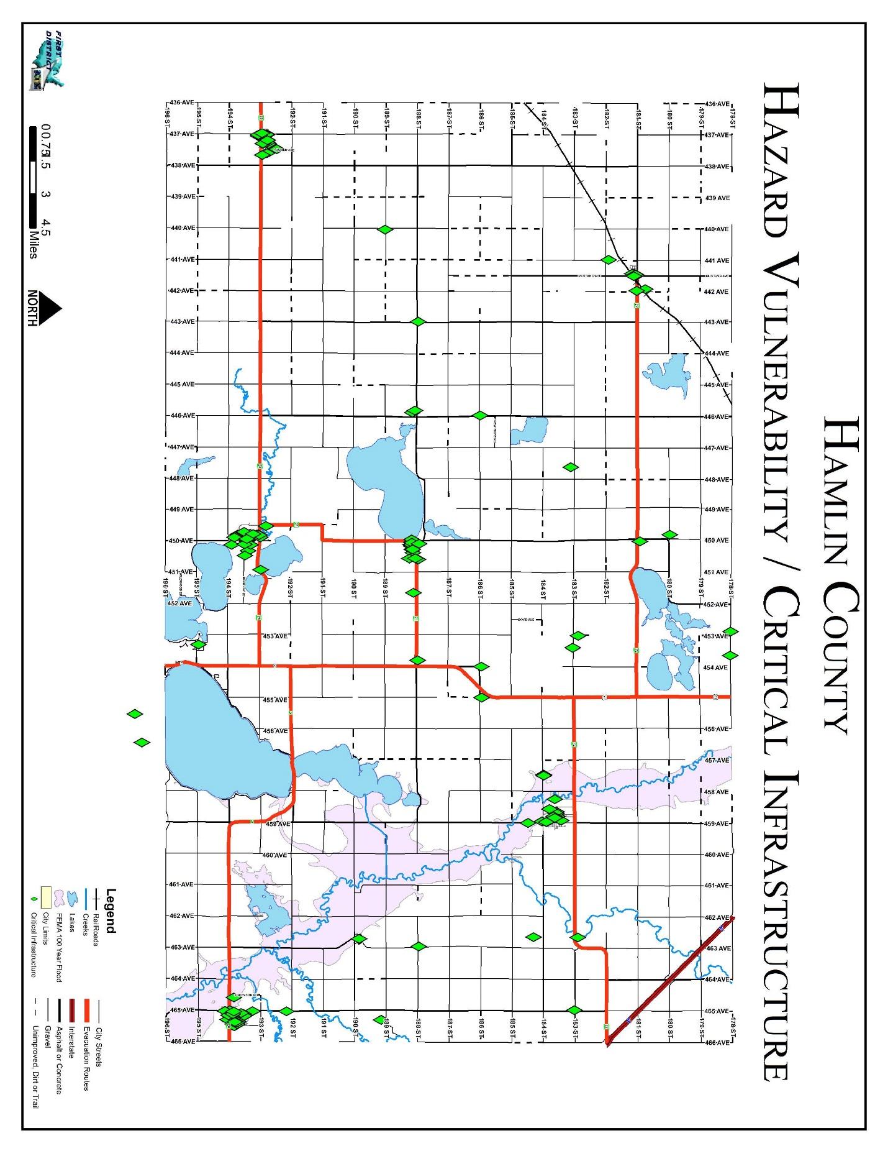
Figure 4.2: Hamlin County Hazard Vulnerability Map
Figure 4.3 City of Bryant Hazard Vulnerability Map

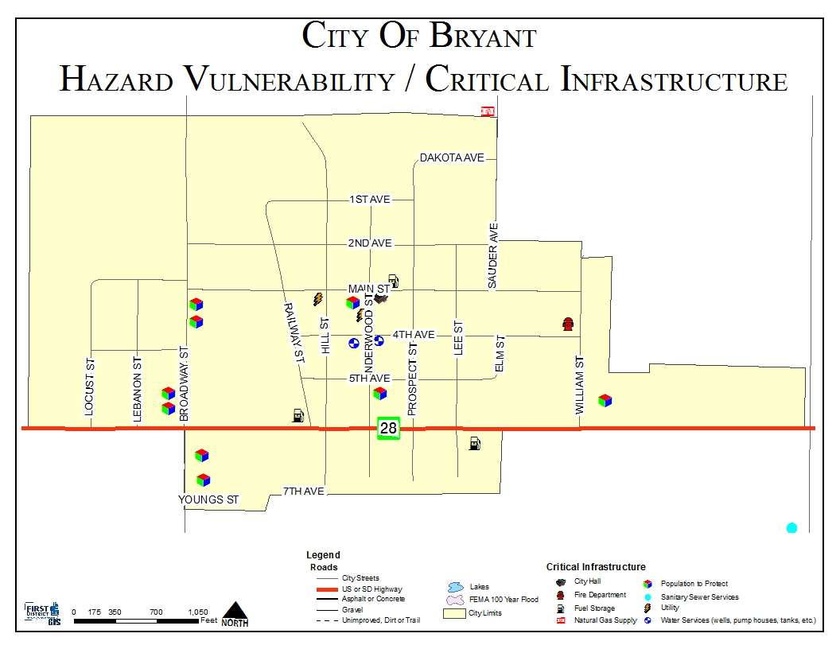
Figure 4.4: City of Castlewood Hazard Vulnerability Map
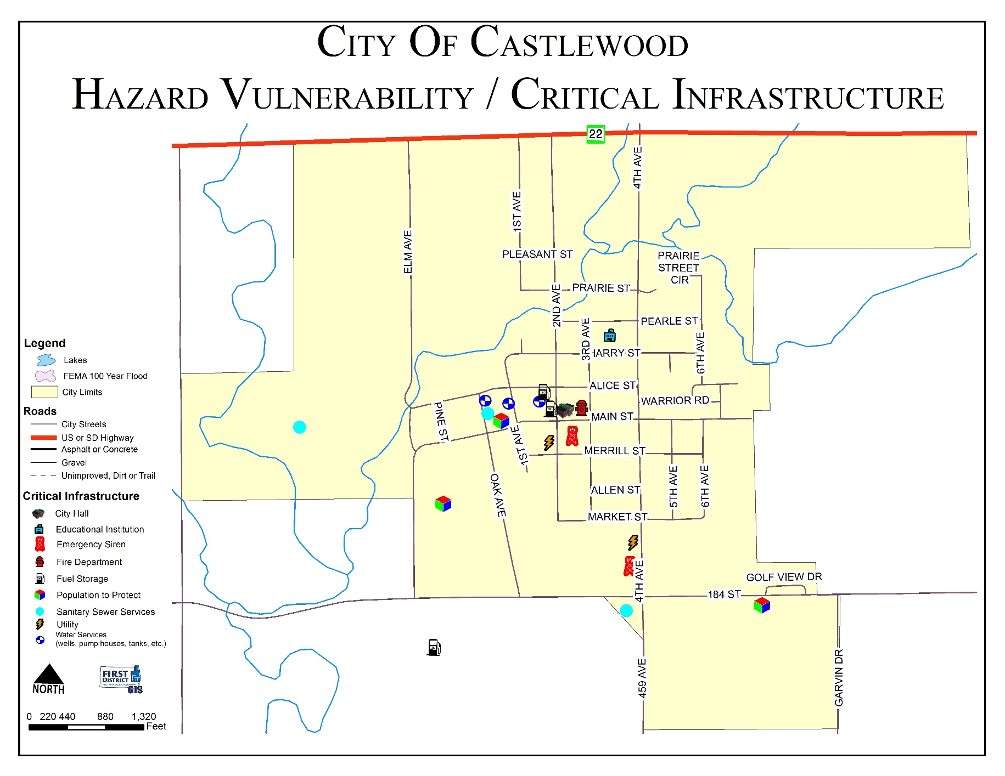
Figure 4.5: City of Estelline Hazard Vulnerability Map
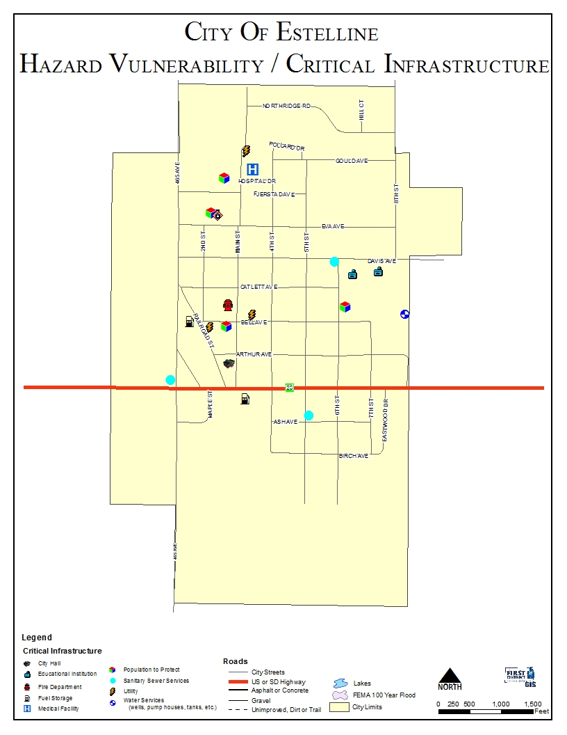
Figure 4.6: Town of Hayti Hazard Vulnerability Map
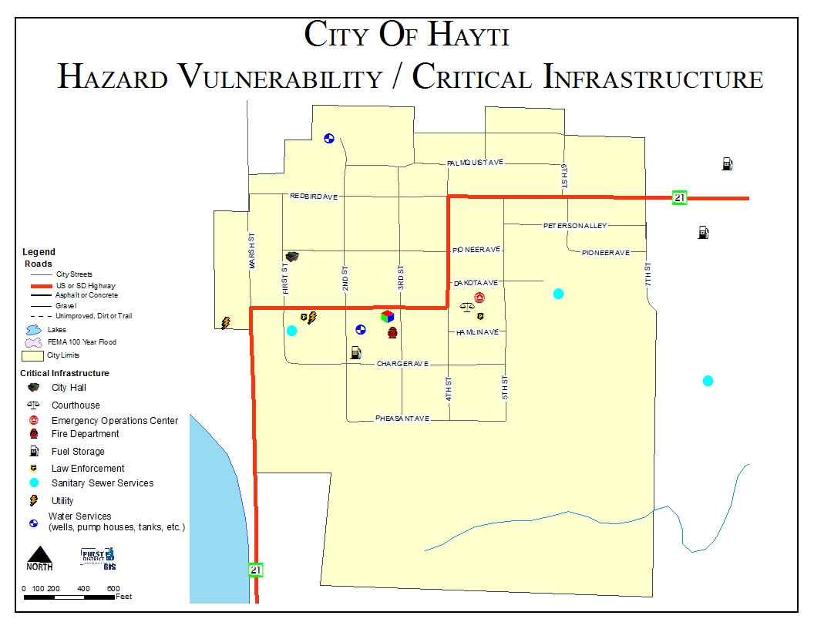
Figure 4.7: Town of Hazel Hazard Vulnerability Map
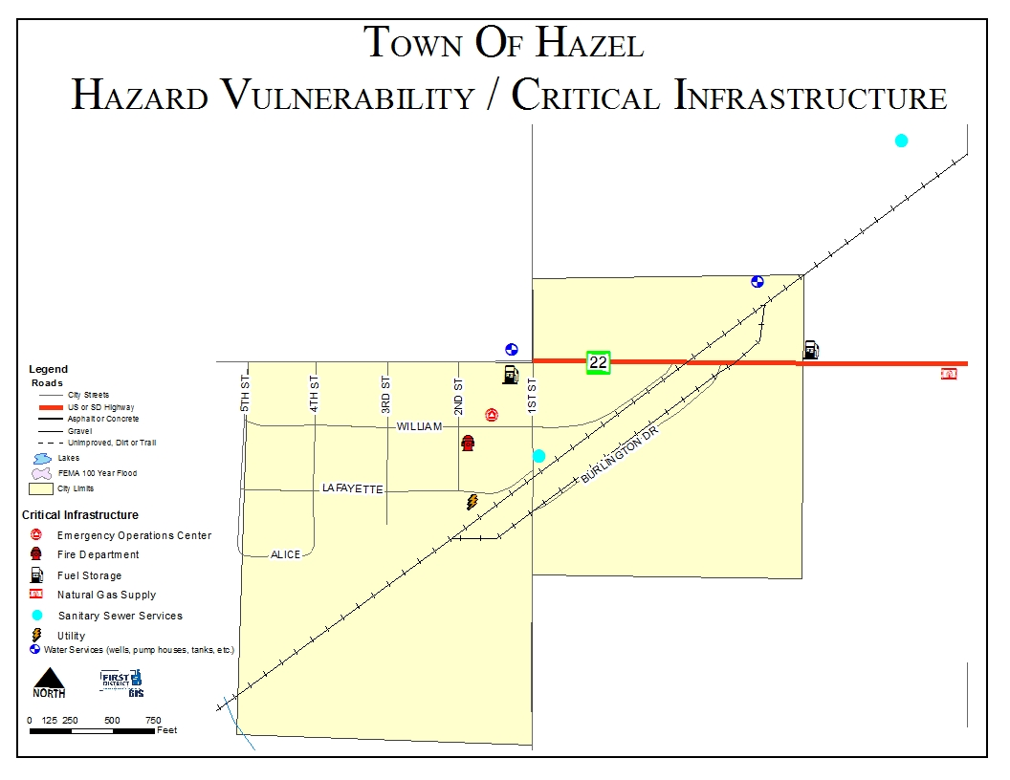

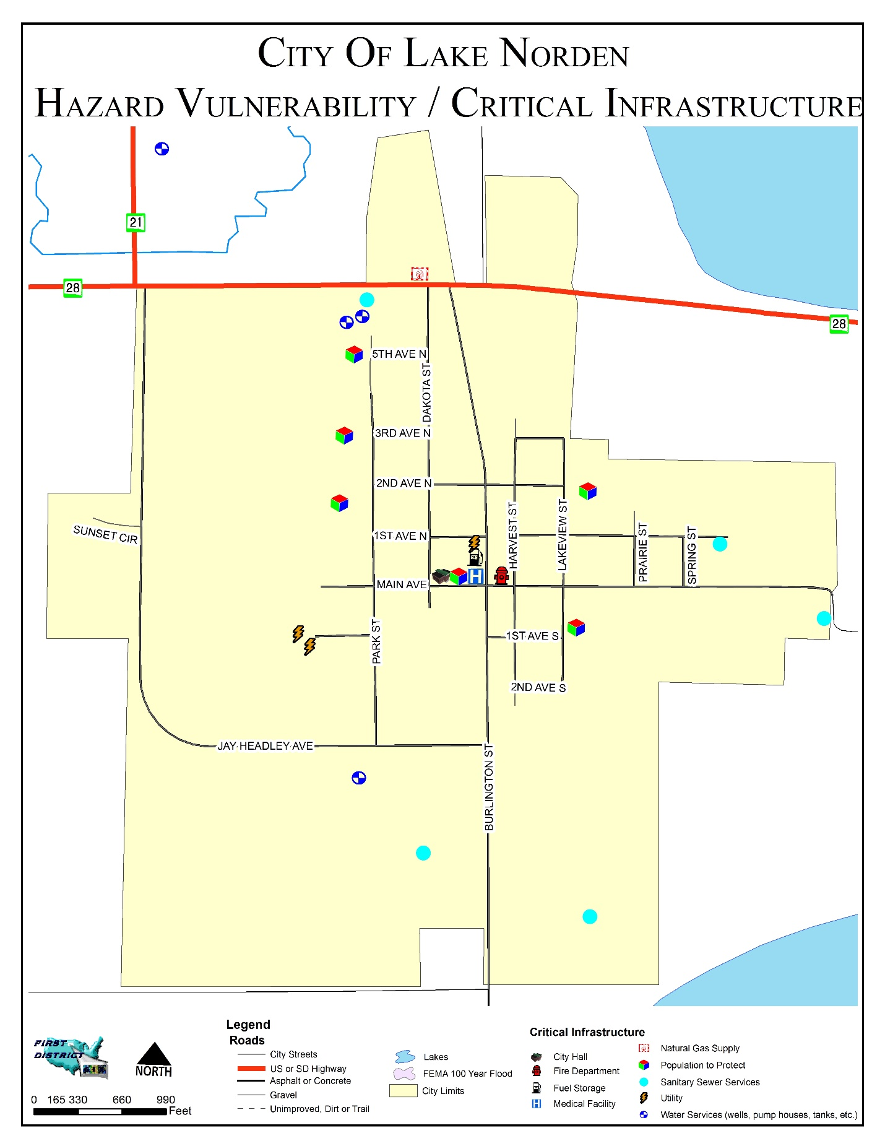
Figure 4.8: City of Lake Norden Hazard Vulnerability Map
CHAPTER 5
MITIGATION STRATEGY

MITIGATION OVERVIEW
Requirement 201.6(c)(3)(i). Local Mitigation Plan Review Tool – C3.
Requirement 201.6(c)(3)(ii). Local Mitigation Plan Review Tool – C4.
Requirement 201.6(c)(3)(iii) & (iv). Local Mitigation Plan Review Tool – C5.
Requirement 201.6(d)(3). Local Mitigation Plan Review Tool – D2.
Requirement 201.6(d)(3). Local Mitigation Plan Review Tool – D3.

The State Hazard Mitigation Plan addresses several mitigation categories including warning and forecasting, community planning, and infrastructure reinforcement. The County and participating entities’ greatest needs are mitigating high wind and flood hazards, backup generators for critical infrastructure, construction of storm shelters, and public awareness.

After the completion of the risk assessment (identification of hazards, probability of hazards and vulnerability to hazards), it was the mutual consensus of the PDM Planning Team that mitigation strategies of the PDM should focus on the following hazards: winter storms, severe summer storms, flooding, wildfires (urban/rural).

The PDM Planning Team first reviewed the goals, objectives and priorities of the previous Plan. The goals and objectives of the previous plan were incorporated into the goals of this plan. The PDM Planning Team completed the goal identification process by considering the county’s and participating jurisdictions’ vulnerability to each identified hazard, and the severity of the threat posed by each hazard. Much of the discussion focused on damage caused by past events, and what could be done to ensure that future damage will be lessened or eliminated. By reviewing each jurisdiction’s Comprehensive Land Use Plan (if available), the participants also considered how future development might affect the county’s and participating jurisdictions’ vulnerability to the hazards they face. When identifying goals, numerous activities or projects were identified with broadly defined benefits to numerous jurisdictions within the County. Numerous actions were agreed by the PDM Planning Team to have broad reaching benefits but due to scope or varying levels of importance to individual jurisdictions no specific cost, timeframe, or priority was assigned. Likewise many infrastructure projects and policies throughout all communities would mitigate hazards but were not located in the most vulnerable areas. All communities reviewed the activities/policies and corresponding problem statements to identify whether they applied to their respective jurisdiction. The results of the community review of those general activities/policies are displayed in Tables 5.1 – 5.12. Specific projects for each community are listed in Table 5.13 Those projects intended to mitigate problems at a specific location are represented in Figures 5.1 to 5.9.

Principal Goals

- Reduce the loss of life, property, infrastructure, critical facilities, cultural resources and impacts from severe weather, flooding and other natural disasters.

- Improve public safety during severe weather, flooding and other natural disasters.

- Improve the County’s Emergency Preparedness and Disaster Response and Recovery capabilities.

Mitigation Activities for Flooding Hazards

Goal #1: Protect specific areas of Hamlin County from flooding.
Goal #2: Educate and inform Hamlin County residents regarding flooding safety.
Goal #3: Reduce the extent to which utility interruptions affect areas during flooding events.

- Actions/Projects to reduce flood risk through policy implementation (See Table 5.1)

  - Actions/Projects to change the characteristics or impacts of flood hazards (See Table 5.2)

  - Actions to reduce loss potential of infrastructure to flood hazards (See Table 5.3)

Mitigation Activities for Severe Weather Hazards (summer and winter)

Goal #1: Increase public awareness and education on severe weather issues.
Goal #2: Improve public safety during severe weather.
Goal #3: Reduce the extent to which utility interruptions affect areas during severe weather situations.
Goal #4: Reduce crippling effects of winter storms, especially regarding smaller communities.

- Actions/Projects to reduce severe weather risk through policy implementation (See Table 5.4)

  - Actions/Projects to change the characteristics or impacts of severe weather hazards (See Table 5.5)

  - Actions/Projects to reduce loss potential of infrastructure to sever weather hazards (See Table 5.6)

Table 5.1: Actions/Projects to Reduce Flood Risk through Policy Implementation

Problem Statements | Actions | Bryant | Castlewood | Estelline | Hayti | Hazel | Lake Norden | Hamlin County
Public is unaware of scope of flood risk and existing emergency plans | Public education. Disseminate information regarding how to deal with flooding. This would include transportation issues, home protection strategies, safety issues, and how to move forward after a flooding situation. | ✓ | ✓ | ✓ | ✓ | ✓ | ✓ | ✓
 | Encouraging homeowners in flood-prone areas to purchase flood insurance. |  | ✓ | ✓ |  |  | ✓ | ✓
Jurisdiction is unaware potential hydrologic impacts of drainage/ development projects | Conduct necessary studies addressing drainage (storm water flow/runoff, etc). | ✓ | ✓ | ✓ | ✓ | ✓ | ✓ | ✓
Residents are not eligible for flood insurance | Begin participation in the National Flood Insurance Program. | ✓ |  |  | ✓ | ✓
Failure to comply with NFIP programs makes the community ineligible for flood insurance and certain funding | Ensure continued National Flood Insurance Program compliance by enforcing flood plain management ordinance. |  | ✓ | ✓ |  |  | ✓ | ✓
Jurisdiction is unaware of opportunities to participate programs to assist in achieving mitigation goals | Work to improve the level of communication and coordination with the State NFIP coordinator. | ✓ | ✓ | ✓ | ✓ | ✓ | ✓ | ✓
Jurisdiction has no legal mechanism to regulate land use | Adoption and enforcement of land use regulation. |  |  |  |  | ✓
Need to continue to regulate minimum land use and development standards | Continue enforcement of zoning and subdivision ordinances. | ✓ | ✓ | ✓ | ✓ |  | ✓ | ✓
Jurisdiction has little legal mechanism to regulate drainage | Developing a county/city drainage ordinance.
Problem Statements | Actions | Bryant | Castlewood | Estelline | Hayti | Hazel | Lake Norden | Hamlin County
No technical analysis or identification of specific mitigation projects | Identify and prioritize capital/structural mitigation projects that are cost effective and technically feasible. | ✓ | ✓ | ✓ | ✓ | ✓ | ✓ | ✓

Table 5.2: Actions/Projects to Change the Characteristics or Impacts of Flood Hazards

Problem Statements | Actions | Bryant | Castlewood | Estelline | Hayti | Hazel | Lake Norden | Hamlin County
Portions of storm sewer system is not designed to 100 year flood event | Installing or upgrading storm sewer piping. | ✓ | ✓ | ✓ | ✓ | ✓ | ✓
Inadequate warning for flooding on Big Sioux River | Add additional stream gauges along river within the county |  | ✓ | ✓ |  |  |  | ✓
Drainage patterns have changed, culverts are inadequate for conveyance of water | Installing or enlarging drainage culverts. | ✓ | ✓ | ✓ | ✓ | ✓ | ✓ | ✓
Certain streets have substandard or no curb and gutter | Curbing and guttering of city streets to improve storm water flow. | ✓ | ✓ | ✓ | ✓ | ✓ | ✓
Capacity of rivers, streams, and retention areas is decreased due to accumulation of debris | Clean out debris in drainage areas, tributaries, etc to improve water flow | ✓ | ✓ | ✓ | ✓ | ✓ | ✓ | ✓
Sanitary and/or storm sewer are vulnerable to back-up in flood event | Install valves, plugs in sanitary and storm sewer system. | ✓ | ✓ | ✓ | ✓ | ✓ | ✓
Potential for development in flood prone areas. | Preservation and expansion of open space along the river and enhancement of existing berm areas. |  | ✓ | ✓ |  |  |  | ✓
 | Work with property owners to implement deed restrictions for open lots/vacant properties in the flood hazard areas to prevent development. | ✓ | ✓ | ✓ | ✓ | ✓ | ✓ | ✓

Table 5.3: Actions/Projects to Reduce Loss Potential of Infrastructure to Flood Hazards

Problem Statements | Actions | Bryant | Castlewood | Estelline |  | Hayti | Hazel | Lake Norden | Hamlin County
Many roads and bridges were built prior to identification of flood hazard areas | Replace and raise bridges |  | ✓ | ✓ |  |  |  | ✓ | ✓
 | Elevating roads in flood-prone areas | ✓ | ✓ | ✓ | ✓ |  | ✓ | ✓ | ✓
Some utility poles are located in areas vulnerable to flooding | Flood-proof or replace utility structures in flood-prone areas | ✓ | ✓ | ✓ | ✓ |  | ✓ | ✓ | ✓
Structures constructed in the floodplain prior to identification of flood hazard areas | Making structural retrofits to infrastructure | ✓ | ✓ | ✓ | ✓ |  | ✓ | ✓ | ✓

Table 5.4: Actions/Projects to Reduce Severe Weather Risk through Policy Implementation

Problem Statements | Actions | Bryant | Castlewood | Estelline | Hayti | Hazel | Lake Norden | Hamlin County
Public is unfamiliar with certain disaster preparation measures | Public education. Disseminate information regarding how to deal with severe weather (summer/winter). Some of the issues that may be addressed within the information would include: safety issues on downed power lines, electrical and fire dangers, the necessity for generators and advice on using them, protecting property, survival strategies during storms, and purchasing of back-up power for various household and farming operations. | ✓ | ✓ | ✓ | ✓ | ✓ | ✓ | ✓
Lack of data regarding vulnerability to winter storms | Gather data to create a more precise loss estimate for winter storms. | ✓ | ✓ | ✓ | ✓ | ✓ | ✓ | ✓
Lack of data regarding vulnerability to summer storms | Gather data to create a more precise loss estimate for summer storms. | ✓ | ✓ | ✓ | ✓ | ✓ | ✓ | ✓
Table 5.5: Actions/Projects to Change the Characteristics or Impacts of Severe Weather Hazards

Problem Statements | Actions | Bryant | Castlewood | Estelline | Hayti | Hazel | Lake Norden | Hamlin County
Certain areas and populations are not served by storm shelters | Construct tornado safe rooms or community shelters. | ✓ | ✓ | ✓ | ✓ | ✓ | ✓ | ✓
 | Construct storm shelters at manufactured home parks | ✓ | ✓ | ✓ | ✓ | ✓ | ✓ | ✓
 | Construct storm shelters at RV parks. | ✓ | ✓ | ✓ | ✓ | ✓ | ✓ | ✓
Critical facilities are vulnerable to power failure | Install backup generators | ✓ | ✓ | ✓ | ✓ | ✓ | ✓ | ✓
Sirens are out of date | Ensure storm sirens meet federal standards | ✓ | ✓ | ✓ | ✓ | ✓ | ✓ | ✓
Certain areas are susceptible to snow drifting | Survey areas in need of snow shelterbelts and plant trees accordingly. | ✓ | ✓ | ✓ | ✓ | ✓ | ✓ | ✓
 | Install or plant living snow fences | ✓ | ✓ | ✓ | ✓ | ✓ | ✓ | ✓
Certain areas of town cannot hear storm sirens and other emergency warning systems | Construct new or improve existing warning systems | ✓ | ✓ | ✓ | ✓ | ✓ | ✓ | ✓

Table 5.6: Actions/Projects to Reduce Loss Potential of Infrastructure to Severe Weather Hazards
Problem Statements | Actions | Bryant | Castlewood | Estelline | Hayti | Hazel | Lake Norden | Hamlin County
Utility lines and structures are subject to failure in high wind, heavy rain, ice events | Upgrading of utility lines. | ✓ | ✓ | ✓ | ✓ | ✓ | ✓ | ✓
 | Burial of utility lines when needed. | ✓ | ✓ | ✓ | ✓ | ✓ | ✓ | ✓
 | Require upgrading of overhead lines when age or disasters provide an opportunity. | ✓ | ✓ | ✓ | ✓ | ✓ | ✓ | ✓
 | Removal of trees near power lines. | ✓ | ✓ | ✓ | ✓ | ✓ | ✓ | ✓
 | Attachment of guy wires to dead-end poles. | ✓ | ✓ | ✓ | ✓ | ✓ | ✓ | ✓
 | Testing integrity of poles | ✓ | ✓ | ✓ | ✓ | ✓ | ✓ | ✓
 | Usage of anti galloping devices | ✓ | ✓ | ✓ | ✓ | ✓ | ✓ | ✓
 | Making structural retrofits to facilities. | ✓ | ✓ | ✓ | ✓ | ✓ | ✓ | ✓

Mitigation Activities for Fire and Drought Hazards

Goal #1: Increase fire fighting capabilities.
Goal #2: Reduce the negative effects droughts have on Hamlin County.
Goal #3: Reduce the negative effects wildfires have on Hamlin County.

- Actions/Projects to reduce fire and drought risk through policy implementation (See Table 5.7)

  - Actions/Projects to reduce loss potential of infrastructure to fire and drought hazards (See Table 5.8)

  - Actions/Projects to change the characteristics or impacts of fire and drought hazards (See Table 5.9)

General Mitigation Activities

Technological (See Table 5.10):

Planning (See Table 5.11):

Administration/Coordination (See Table 5.12)
Table 5.7: Actions/Projects to Reduce Fire and Drought Risk through Policy Implementation

Problem Statements | Actions | Bryant | Castlewood | Estelline | Hayti | Hazel | Lake Norden | Hamlin County
Community becomes vulnerable to fire hazard while staff is being trained. | Find funding sources to pay for persons to fill positions while individuals are at training courses. | ✓ | ✓ | ✓ | ✓ | ✓ | ✓ | ✓
Potential for development in areas vulnerable to wildfire or urban fire | Adoption and enforcement of property regulations in areas vulnerable to wildfire. | ✓ | ✓ | ✓ | ✓ | ✓ | ✓ | ✓
 | Establish/require minimum fire suppression standards for subdivisions | ✓ | ✓ | ✓ | ✓ | ✓ | ✓ | ✓
Community has no plan/policy for water rationing in emergency | Develop water rationing measures that will be implemented during a drought situation. | ✓ | ✓ | ✓ | ✓ | ✓ | ✓ | ✓
Public is unaware of benefits of conserving water | Educate residents on the benefits of conserving water at all times, not just during a drought. | ✓ | ✓ | ✓ | ✓ | ✓ | ✓ | ✓

Table 5.8: Actions/Projects to Reduce Loss Potential of Infrastructure to Fire and Drought Hazards

Problem Statements | Actions | Bryant | Castlewood | Estelline | Hayti | Hazel | Lake Norden | Hamlin County
Fire fighting equipment becomes out of date quickly | Ensure that fire departments are adequately equipped to respond to wildfires | ✓ | ✓ | ✓ | ✓ | ✓ | ✓ | ✓
Fire hydrants become unusable | Have rural fire departments locate dry fire hydrants. | ✓ | ✓ | ✓ | ✓ |  | ✓
Table 5.9: Actions/Projects to Change the Characteristics or Impacts of Fire and Drought Hazards

Problem Statements | Actions | Bryant | Castlewood | Estelline | Hayti | Hazel | Lake Norden | Hamlin County
Reservoirs are vulnerable to silting and decrease in efficient provision of water services in emergency situations | Dredge reservoirs to improve water quality. Reservoirs silt in and dredging, water can flow to more places, more quickly, and more easily. | ✓ | ✓ | ✓ | ✓ | ✓ | ✓ | ✓
Dead or dry plant material creates fire hazard/ location changes seasonally and annually | Burn areas to ensure a fire break rather than ignition fuel. | ✓ | ✓ | ✓ | ✓ | ✓ | ✓ | ✓
Local economy is very dependent on corn/soybean production | Educate farmers on the benefits of a diversified crop protection plan in the event of a drought | ✓ | ✓ | ✓ | ✓ | ✓ | ✓ | ✓
 | Work with local farmers to investigate the use of more drought resistant crops. | ✓ | ✓ | ✓ | ✓ | ✓ | ✓ | ✓

Table 5.10: Technological Activities

Problem Statements | Actions | Bryant | Castlewood | Estelline | Hayti | Hazel | Lake Norden | Hamlin County
Current data and software can become obsolete or out of date | Continue utilizing a working computer aided mapping project for the County. This includes using overlays of GIS data, HazMat, and Roads. |  |  |  |  |  |  | ✓
 | Enhance existing computer aided dispatch. | ✓ | ✓ | ✓ | ✓ | ✓ | ✓ | ✓
 | Use HAZUS software to estimate losses in flooding situations. Information may also be able to be used for other hazard areas. | ✓ | ✓ | ✓ | ✓ | ✓ | ✓ | ✓
 | Work with South Dakota State University to explore additional methods of estimating losses in natural hazards | ✓ | ✓ | ✓ | ✓ | ✓ | ✓ | ✓

Table 5.11: Planning Activities

Problem Statements | Actions | Bryant | Castlewood | Estelline | Hayti | Hazel | Lake Norden | Hamlin County
Maintenance of a mitigation plan is beyond the economic capability of this community | Find funding to review and update the regional and local disaster mitigation plans on a five-year cycle. | ✓ | ✓ | ✓ | ✓ | ✓ | ✓ | ✓
Disaster mitigation projects have not always been incorporated into other plans | Incorporate disaster mitigation actions into appropriate local and regional plans – Master Plans, land use, transportation, open space, and capital programming. | ✓ | ✓ | ✓ | ✓ | ✓ | ✓ | ✓
 | Integrate disaster mitigation concerns into subdivision, site plan review, and other zoning reviews. In particular require the consideration of downstream flooding impacts caused by new projects. | ✓ | ✓ | ✓ | ✓ | ✓ | ✓ | ✓
 | Integrate disaster mitigation concerns into transportation projects (e.g. drainage improvements, underground utilities, etc.). | ✓ | ✓ | ✓ | ✓ | ✓ | ✓ | ✓
This community's mitigation projects are not coordinated with other communities' projects | Develop a means for sharing information on a regional basis about successful disaster mitigation planning and programs. | ✓ | ✓ | ✓ | ✓ | ✓ | ✓ | ✓

Table 5.12: Administration/Coordination Activities

Problem Statements | Actions | Bryant | Castlewood | Estelline | Hayti | Hazel | Lake Norden | Hamlin County
This community is not staffed nor does it have funding mechanisms to apply for and administer funding sources for mitigation projects | Identify and pursue funding that builds local capacity and supports grant-writing for mitigation actions identified in the PDM. | ✓ | ✓ | ✓ | ✓ | ✓ | ✓ | ✓
Need to improve coordination of activities with other governmental jurisdictions and utility providers | Increase communication /coordination between federal, state, regional, county, municipal, private, and non-profit agencies in the area of pre-disaster mitigation. | ✓ | ✓ | ✓ | ✓ | ✓ | ✓ | ✓
 | Maintain and enhance working relationships with the utility providers. | ✓ | ✓ | ✓ | ✓ | ✓ | ✓ | ✓

After meetings with the local jurisdictions and opportunities for public input, a series of mitigation goals were devised to best aid the County in reducing and lessening the effects of hazards. Projects previously identified in the 2006 PDM were carefully analyzed and discussed to determine which of the projects had enough merit to be included in the updated PDM and to determine if the projects meet the hazard mitigation needs of the county. These projects were evaluated based on a cost/benefit ratio and priority. Although this PDM focuses on disaster mitigation rather than disaster preparedness, some communities discussed disaster preparedness projects as well. It was difficult for individual communities to recognize the difference between providing storm shelters and making sure the storm shelters function properly (for example). Actions considered in this category included the acquisition of emergency generators and erecting or replacing warning sirens in areas that currently are not well served

Most of the mitigation actions proposed by the jurisdictions were identified by city council members, public works personnel, or PDM Planning Team members from the jurisdiction. Some actions were also proposed by townships due to the direct impact of disasters on infrastructure and services they provide. Once each jurisdiction had its list of proposed actions complete, it was submitted to the Emergency Management Director. At the second PDM Planning Team meeting, the actions were reviewed. At the third PDM Planning Team meeting a final opportunity was given for the jurisdictions to add any additional actions or refine information relating to previously identified projects.

Although in some cases additional data will be necessary, a timeframe for completion, oversight, funding sources, and any other relevant issues were addressed. These implementation strategies are geared toward the specific goal and area. Often, these projects will not encounter any resistance from environmental agencies, legal authorities, and political entities. Table 5.13 is a presentation of the mitigation actions proposed by the PDM Planning Team. In addition to identifying the proposed actions, the table includes additional information about each action. Elected officials and staff of each municipality and the county were responsible for providing most of this information for actions in their community, but the other planning participants helped in this process. The following information is provided for each action:

- A statement regarding the specific problem the proposed action will mitigate.
- The local priority rating (discussed in the next section).
- The time frame to accomplish the action – “Short” means actions that are intended to be initiated within two years, “Medium” is for actions that should be started within five years, and “Long” is for actions that are not anticipated to be started for at least five years.
- The party(s) primarily responsible for implementing the action.
- The estimated cost - estimates for many of the actions were obtained from knowledgeable sources based on current information. Estimates are subject to change due to specific details of specific projects.
- Potential sources of funding (discussed below).
- The primary hazard being addressed.
- The goal corresponding to the action.

As mentioned above, jurisdictions and entities integrally involved in the planning for disasters due to wide ranging implications to them include townships and most utility providers. Utility providers were represented on the PDM Planning Team. Each utility provider was asked individually to submit their own mitigation actions. The main mitigation activity proposed by utility providers was the burying of overhead lines in rural areas of the county.

In addition, a meeting in which all township supervisors was held on February 19, 2019. At that meeting the Township supervisors were asked to identify potential mitigation projects. Each individual township was provided maps upon which they were asked to identify potential mitigation activities and vulnerable roads or infrastructure. Primarily these activities included replacing culverts with larger culverts, elevating or rip-rapping roads, and reconstructing roads. Not all townships submitted the maps with potential activities; however the appendix includes maps of vulnerable sites and potential mitigation actions proposed by the townships in the County.

A High Priority Rating can be defined as a potential project that had received widespread support amongst the local governing body when asked during the planning process and would be first priority when planning future mitigation projects. A Medium Priority Rating also would receive general support amongst the governing body, but was not a first priority project compared to those deemed a High Priority. Low Priority received the least amount of support, but still were believed to be a necessary action to take for hazard mitigation. Where estimated project costs were available, they were considered in establishing priorities. However, no formal cost benefit analysis was performed on any specific project. Ultimately the prioritization of these projects were based upon the perceived needs of the local jurisdiction.

Particular attention needs to be paid to sources of funding for the actions. Given the existing financial reality of very tight county and municipal budgets, some of the proposed actions realistically cannot be implemented without substantial grant assistance. With such assistance, it is likely that many of the high priority projects can be undertaken without placing an onerous burden on local budgets. Resources for some of the actions available from FEMA through the South Dakota Office of Emergency Management include the Hazard Mitigation Grant Program, Pre-Disaster Mitigation grant program, and Flood Mitigation Assistance grant programs. Other possible sources of funding include:

Grant and loan programs/sources

- Community Development Block Grant program
- Economic Development Administration
- FEMA Assistance to Firefighters Grant program
- South Dakota Dept of Environment and Natural Resources
- South Dakota Dept of Transportation
- US Department of Agriculture Rural Development Office

Local resources

- General obligation bonds
- Revenue bonds
- Tax Increment Financing (TIF) districts

Table 5.13: Proposed Mitigation Activities

HAMLIN COUNTY PROBLEM STATEMENTS | HAMLIN COUNTY ACTIONS | PRIORITY RATING | TIMEFRAME | CONTACT | COST | FUNDING SOURCE | HAZARD | GOAL
Base flood elevation for residentially developed lakes is unknown | Establishment of base flood elevation for Lake Albert | High | Short | Hamlin County Floodplain Administrator | $75,000 | County, HMGP | Flooding | Protect Specific Areas of Hamlin county from Floods
 | Continue requiring structures to be constructed 7’ above ordinary high-water mark adjacent to Lake Poinsett and Lake Albert | High | Ongoing | Hamlin County Zoning Officer | Unknown | County | Flooding | Protect Specific Areas of Hamlin County from Floods
Lake Poinsett needs outdoor warning system | Install Storm Sirens | High | Short | Hamlin County Emergency Management | $72,000 | HMGP, County, GFP | Severe Weather Hazards (Summer and Winter | Improve public safety during severe weather situations
Many structures were constructed in the floodplain prior to its identification | Educate property owners in flood prone areas of programs available to buy-out properties / pursue removal of structures in flood hazard areas | Medium | Short | Hamlin County Floodplain Administrator / Hamlin County Director of Equalization | Unknown | HMGP, County | Flooding | Protect Specific Areas of Hamlin County from Floods
Many structures were constructed in the floodplain prior to its identification | Encourage retrofitting/replacement of existing private structures within the floodplain | Medium | Medium | Hamlin County Floodplain Administrator / Hamlin County Director of Equalization | Unknown | Private, HMGP, NFIP | Flooding | Protect Specific Areas of Hamlin County from Floods
HAMLIN COUNTY PROBLEM STATEMENTS | HAMLIN COUNTY ACTIONS | PRIORITY RATING | TIMEFRAME | CONTACT | COST | FUNDING SOURCE | HAZARD | GOAL
Certain roadways regularly flood in high water events | Conduct engineering / hydrologic study on waterways which regularly flood County and Township Roads | Medium | Long | Hamlin County | Unknown | HMGP, County, Townships | Flooding | Protect Specific Areas of Hamlin County from Floods
 | Increase culvert size, raise roads, implement other recommendations of engineering / hydrologic study | Medium | Long | Hamlin County | Unknown | HMGP, County, Townships | Flooding | Protect Specific Areas of Hamlin County from Floods
CITY OF BRYANT  PROBLEM STATEMENTS | CITY OF BRYANT ACTIONS | PRIORITY RATING | TIMEFRAME | CONTACT | COST | FUNDING SOURCE | HAZARD | GOAL
The City needs to enhance emergency notification procedures and education | Provide storm family plans/Emergency Kits/NOAA radios | Medium | Short | Office of Emergency Management, LEPC | UNKNOWN | City, USDA, FEMA | Severe Weather Hazards (Summer and Winter) | Improve public safety during severe weather.
Old trees are vulnerable to high wind. They fall on power lines. | Bury overhead powerlines | High | Short | (Bryant) Finance Officer | $1,000,000 | HMGP  REA | Severe Weather Hazards (summer and winter) | Reduce the extent to which utility interruptions affect areas during severe weather situations.
The City needs back- up generators for City Auditorium | Purchase of Portable Back-up Generator for Critical Infrastructure | High | Short | Bryant City Council | $6,000 | City,  HMGP | Severe Weather Hazards (Summer and Winter) | Reduce the extent to which utility interruptions affect areas during severe weather situations.
CITY OF CASTLEWOOD  PROBLEM STATEMENTS | CITY OF CASTLEWOOD ACTIONS | RATING | TIMEFRAME | CONTACT | COST | FUNDING SOURCE | HAZARD | GOAL
The City needs a Tornado Safe Emergency Shelter. | Construction of Tornado Shelter. | Low | Low | (Castlewood) Finance Officer | $50,000.00 | HMGP | Tornado | Improve public safety during severe weather.
The City needs a Storm siren near Hwy 22 and 2nd Avenue. | Install Storm Siren | High | Medium | (Castlewood) Finance Officer | $17,000 | HMGP | Severe Weather Hazards (Summer and Winter) | Improve public safety during severe weather situations
The City needs back- up generators for storm sirens. | Purchase of Portable Back-up Generator for Critical Infrastructure | High | Medium | (Castlewood) Finance Officer | $20,000 | HMGP | Severe Weather Hazards (Summer and Winter) | Reduce the extent to which utility interruptions affect areas during severe weather situations.
The southwestern portion of City is located within the 100 year floodplain (Big Sioux River) | Implement Drainage Improvements Including Storm Sewer in SW portion of City | High | Medium | (Castlewood) Finance Officer | UNKNOWN | HMGP | Flooding | Protect Specific Areas of Hamlin County from floods.
CITY OF ESTELLINE  PROBLEM STATEMENTS | CITY OF ESTELLINE ACTIONS | RATING | TIMEFRAME | CONTACT | COST | FUNDING SOURCE | HAZARD | GOAL
The City does not have a back-up generator for the current Watertower and lift station. | Purchase of Back-up Generators for Watertower and Lift Station | High | Short | (Estelline) Finance Officer | $50,000 | HMGP/OEM | Severe Weather Hazards (summer and winter) | Reduce the extent to which utility interruptions affect areas during severe weather situations.
The City does not have a Tornado Safe Emergency Shelter. | Construction of Tornado Shelter. | Medium | Medium | (Estelline) Finance Officer | $50,000 | HMGP | Tornado | Improve public safety during severe weather.
Portions of community is subject to flooding in heavy rain or rapid snow melt. | Study and implement stormwater drainage improvements in targeting these areas. | Medium | Medium | (Estelline) Finance Officer | Unknown | HMGP | Flooding | Protect Specific Areas of Hamlin County from floods.
TOWN OF HAYTI  PROBLEM STATEMENTS | TOWN OF HAYTI ACTIONS | RATING | TIMEFRAME | CONTACT | COST | FUNDING SOURCE | HAZARD | GOAL
The City does not have a back-up generator | Purchase of Back-up Generator | Medium | Medium | City Council | $20,000 | HMGP/OEM/ CITY | Severe Weather Hazards (summer and winter) | Reduce the extent to which utility interruptions affect areas during severe weather situations.
TOWN OF HAYTI  PROBLEM STATEMENTS | TOWN OF HAYTI ACTIONS | RATING | TIMEFRAME | CONTACT | COST | FUNDING SOURCE | HAZARD | GOAL
Policies need to comply with this and other plans. | Update Comprehensive Land Use Plan and Zoning Regulations | Low | Long | City Council | $5,000 | City | Flooding | Improve public safety during severe weather.
Firefighting equipment and firefighter training is insufficient to adequately provide fire protection. | Training of firefighters and Purchase of Firefighting Equipment (ie pump trucks and personnel gear) | High | Short | (Hayti) Fire Chief | Unknown | HMGP/ Homeland Security | Fire | Increase fire fighting capabilities.
Overhead lines are vulnerable to freezing rain/sleet/ice melt. | Bury 3 Phase power lines in community | High | Short | City Council/ Ottertail | $200,000 | HMGP/CDBG  RD/CITY | Severe Weather Hazards (summer and winter) | Reduce the extent to which utility interruptions affect areas during severe weather situations.
Flow of water at the outlet of Lake marsh becomes obstructed during heavy rain or rapid snow melt, thereby causing flooding. | Purchase land and remove old Railroad bed and culverts | High | Medium | City Council | $100,000 | HMGP/CDBG  CITY | Flooding | Protect Specific Areas of Hamlin County from floods.
TOWN OF HAYTI  PROBLEM STATEMENTS | TOWN OF HAYTI ACTIONS | RATING | TIMEFRAME | CONTACT | COST | FUNDING SOURCE | HAZARD | GOAL
During high water levels in Lake Marsh, water flows into sewer system overflowing sewer lagoons | Reline problem sewer lines | High | Medium | City Council | $100,000 | HMGP/CDBG  RD/CITY | Flooding) | Improve public safety during severe weather.
TOWN OF HAZEL  PROBLEM STATEMENTS | TOWN OF  HAZEL ACTIONS | RATING | TIMEFRAME | CONTACT | COST | FUNDING SOURCE | HAZARD | GOAL
Policies need to comply with this and other plans. | Develop Comprehensive Land Use Plan and Zoning Regulations | Medium | Medium | (Hazel)  Town Board | $5,000 | Town | Flooding | Improve public safety during severe weather.
The town has no functioning fire hydrants. | Install water tank for emergency purposes | Medium | Long | (Hazel)  Town Board | $25,000 | HMGP | Fire | Increase fire fighting capabilities.
Firefighting equipment and firefighter training is insufficient to adequately provide fire protection. | Training of firefighters and Purchase of Firefighting Equipment (ie pump trucks and personnel gear) | High | High | Hazel  Fire Chief | Unknown | HMGP/ Homeland Security/Bank/ Town | Fire | Increase fire fighting capabilities.
The town’s sanitary sewer lift station is inadequate and vulnerable to electrical failure. | Update lift station and purchase generator for lift station. | High | Medium | (Hazel)  Town Board | $40,000 | DENR/HMGP/  REED/TOWN | Severe Weather Hazards (summer and winter) | Improve public safety during severe weather.
TOWN OF HAZEL  PROBLEM STATEMENTS | TOWN OF  HAZEL ACTIONS | RATING | TIMEFRAME | CONTACT | COST | FUNDING SOURCE | HAZARD | GOAL
The town’s sanitary sewer lagoon is inadequate and prone to inundation in flood events. | Make improvements to Sanitary Sewer Lagoon. | Low | Low | (Hazel)  Town Board | $100,000 | DENR/HMGP/  REED/TOWN/  CDBG/BANK | Severe Weather Hazards (summer and winter) | Improve public safety during severe weather.
The town’s sanitary sewer force main is located on Railroad Property. | Move Sanitary Sewer Force Main. | Medium | Medium | (Hazel)  Town Board | $100,000 | DENR/HMGP/  REED/TOWN/  CDBG/BANK | Severe Weather Hazards (summer and winter) | Improve public safety during severe weather.
CITY OF LAKE NORDEN  PROBLEM STATEMENTS | CITY OF LAKE NORDEN  ACTIONS | RATING | TIMEFRAME | CONTACT | COST | FUNDING SOURCE | HAZARD | GOAL
The city’s sanitary sewer system is vulnerable to electrical failure. | Upgrade lift stations for generators | High | Medium | (Lake Norden) City Council | $30,000 | City/HMGP | Severe Weather Hazards (summer and winter) | Reduce the extent to which utility interruptions affect areas during severe weather situations.
Difficult/impossible to hear siren in portions of the City. | Upgrade Storm Siren System | High | Medium | (Lake Norden) City Council | $30,000 | City/HMGP/OEM | Severe Weather Hazards (Summer and Winter) | Improve public safety during severe weather.
CITY OF LAKE NORDEN  PROBLEM STATEMENTS | CITY OF LAKE NORDEN  ACTIONS | RATING | TIMEFRAME | CONTACT | COST | FUNDING SOURCE | HAZARD | GOAL
The town’s sanitary sewer lagoon is vulnerable to inundation in flood events. | Make improvements to Sanitary Sewer Lagoon (Riprapping). | Medium | Long | (Lake Norden) City Council | $30,000 | DENR/HMGP/  City/CDBG | Severe Weather Hazards (summer and winter) | Improve public safety during severe weather.
The City needs a Tornado Safe Emergency Shelter. | Construction of Tornado Shelter. | Low | Low | (Lake Norden) Finance Officer | $100,000.00 | HMGP | Tornado | Improve public safety during severe weather.
Urban development has exceeded capacity/capability of stormwater mgt system. Areas of city are prone to flooding in heavy rain or rapid snow melt. | Study and implement stormwater drainage improvements in | Medium | Long | (Lake Norden) City Council | $2,000,000 | DENR/HMGP/  City/CDBG | Flooding | Protect Specific Areas of Hamlin County from floods.

SIOUX RURAL WATER SYSTEMS  PROBLEM STATEMENTS | SIOUX RURAL WATER SYSTEMS  ACTIONS | RATING | TIMEFRAME | CONTACT | COST | FUNDING SOURCE | HAZARD | GOAL
Distribution Piping vulnerable to flooding. River Crossing washed out or exposed. Pipeline becoming permanently submerged. | Re-route or replace distribution piping. | High | Medium | Sioux Rural Water System | Dependent on type of line and construction method | FEMA-HMGP / Utility Funds | Flooding | Improve public safety and access to drinking water.
Distribution Piping vulnerable to freezing in extreme cold. | Lower or insulate Piping | High | High | Sioux Rural Water System | Dependent on type of line and construction method | FEMA-HMGP / Utility Funds | Extreme Cold | Reduce the extent to which utility interruptions affect areas during extreme cold weather.
SCADA | Control Climate inside buildings | High | High | Sioux Rural Water System | Dependent on Building and Climate Control Options | FEMA-HMGP/ Utility Funds | Extreme Heat | Reduce the extent to which utility interruption affect areas during extreme hot weather

SIOUX RURAL WATER SYSTEMS  PROBLEM STATEMENTS | SIOUX RURAL WATER SYSTEMS ACTIONS | RATING | TIMEFRAME | CONTACT | COST | FUNDING SOURCE | HAZARD | GOAL
Aquastore Water Storage Facilities | Install water circulation equipment. | Medium | Medium | Sioux Rural Water System | Dependent on equipment needs and installation costs. | FEMA-HMGP / Utility Funds | Extreme Cold | Reduce the extent to which utility interruptions affect areas during extreme cold weather.
Sioux Well Field | Move wells potentially affected by flooding | Medium | Medium | Sioux Rural Water System | Dependent on availability of location and construction costs. | FEMA-HMGP / Utility Funds | Flooding | Improve public safety and access to drinking water.
Booster Stations | Install standby electrical generation at each booster site. | Medium | Medium | Sioux Rural Water System | Dependent on generator size and construction cost. | FEMA-HMGP / Utility Funds | Tornado  Winter/Summer Storms | Reduce the extent to which utility interruptions affect areas during severe weather situations.
Castlewood Well Field | Relocate Well Field | High | High | Sioux Rural Water System | Dependent on availability of location and construction costs. | FEMA-HMGP/Utility Funds | Flooding | Improve public safety and access to drinking water.
Aquastore Water Storage Facilities | Dependent on Location berm Aquastore Water Tanks to guard against flooding. | Medium | Medium | Sioux Rural Water System | Dependent on Construction needed. | FEMA-HMGP/Utility Funds | Flooding | Improve public safety and access to drinking water.

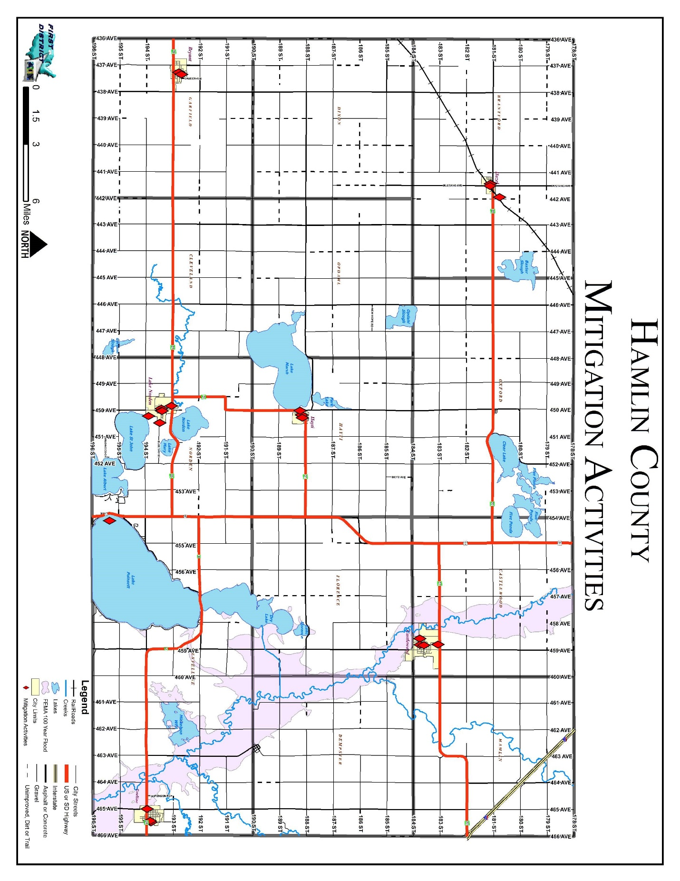
Figure 5.1: Hamlin County Potential Mitigation Project Map

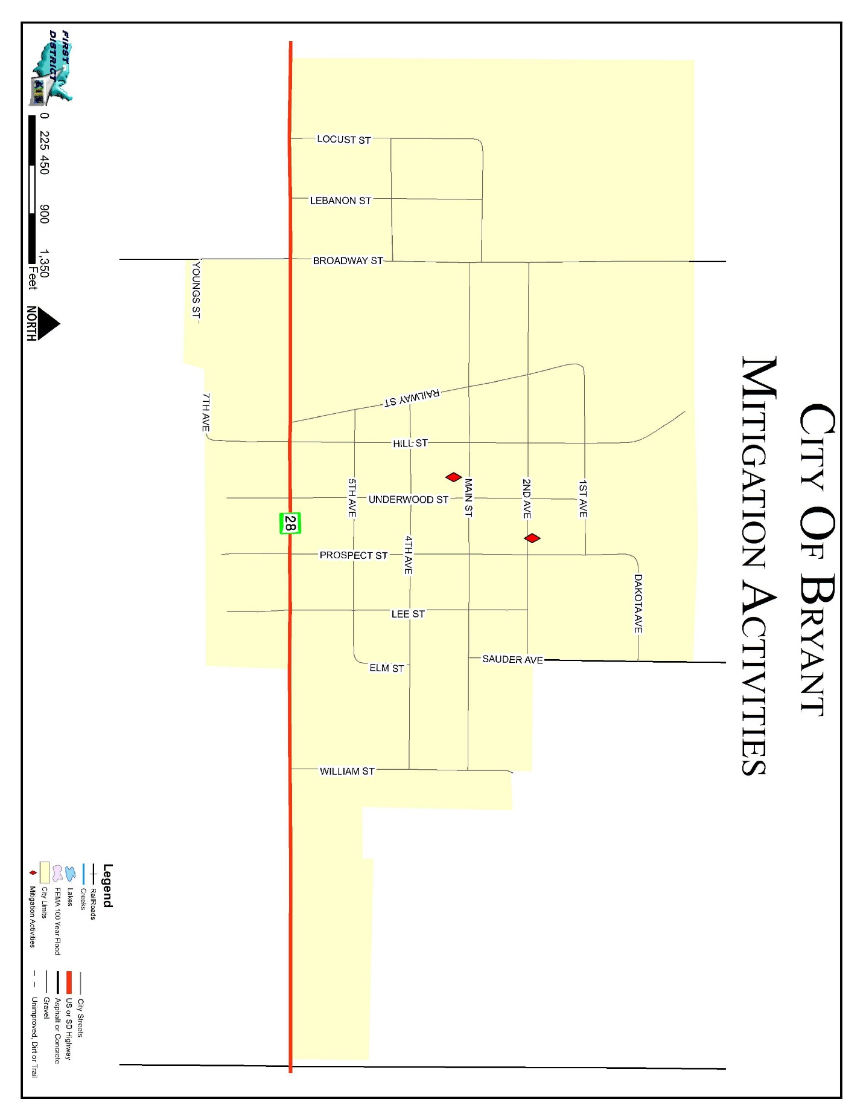
Figure 5.2: City of Bryant Potential Mitigation Project Map

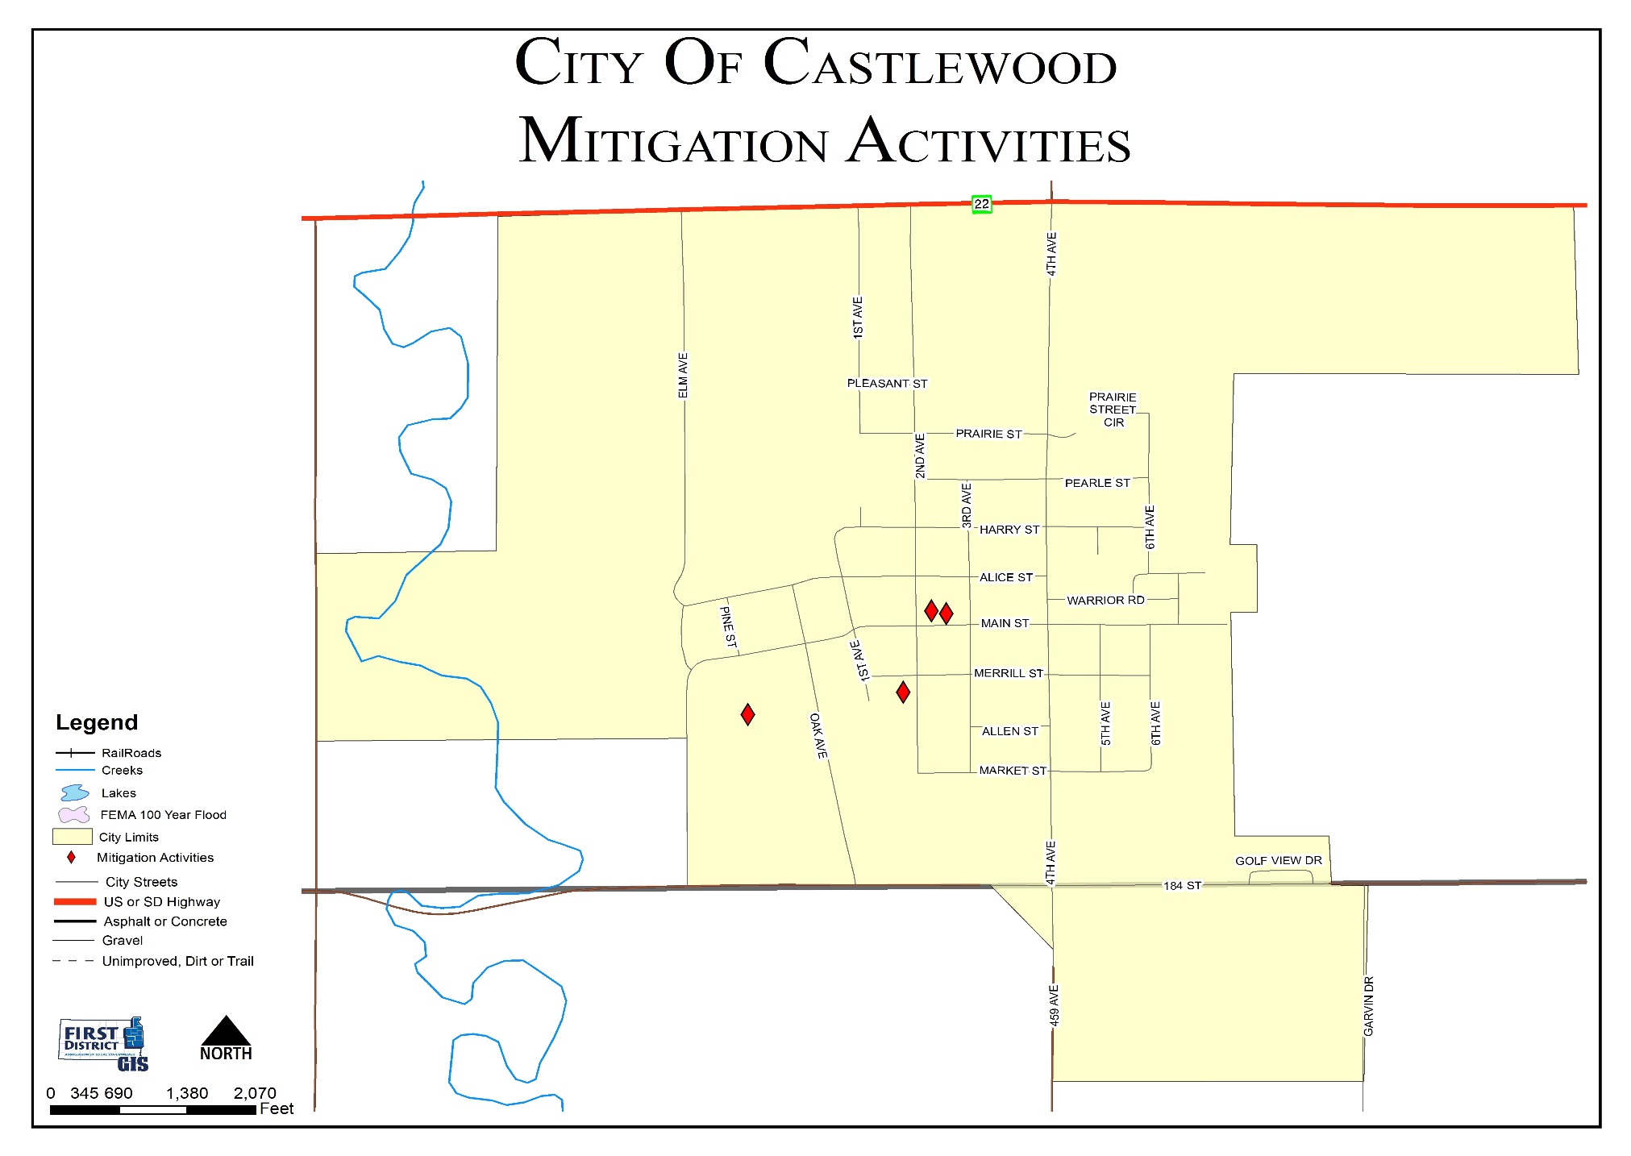
Figure 5.3: City of Castlewood Potential Mitigation Project Map

Figure 5.4: City of Estelline Potential Mitigation Project Map
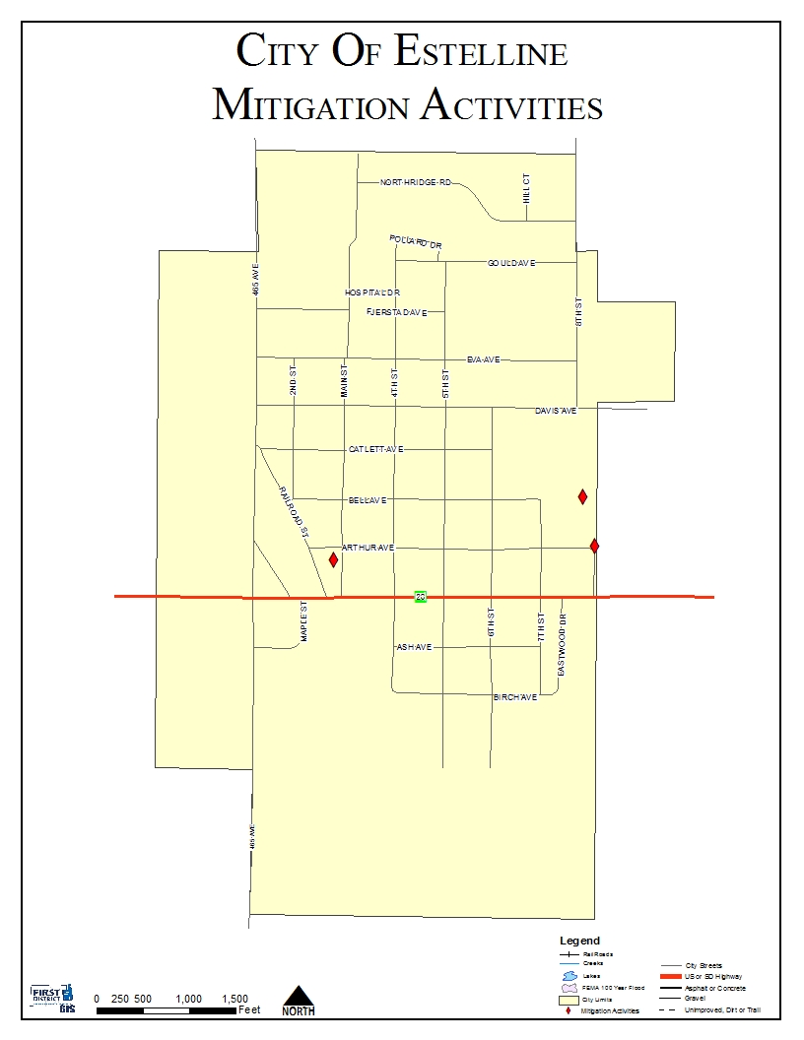

Figure 5.5: Town of Hayti Potential Mitigation Project Map
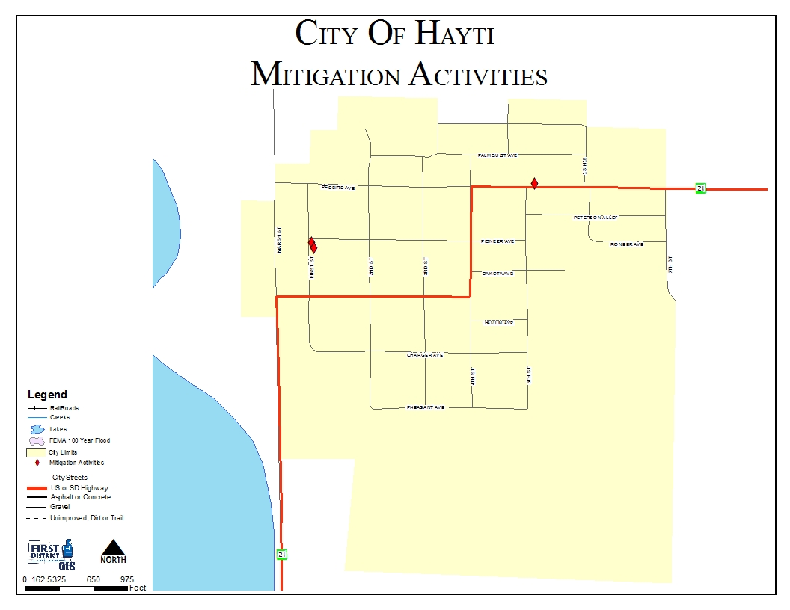
Figure 5.6: Town of Hazel Potential Mitigation Project Map
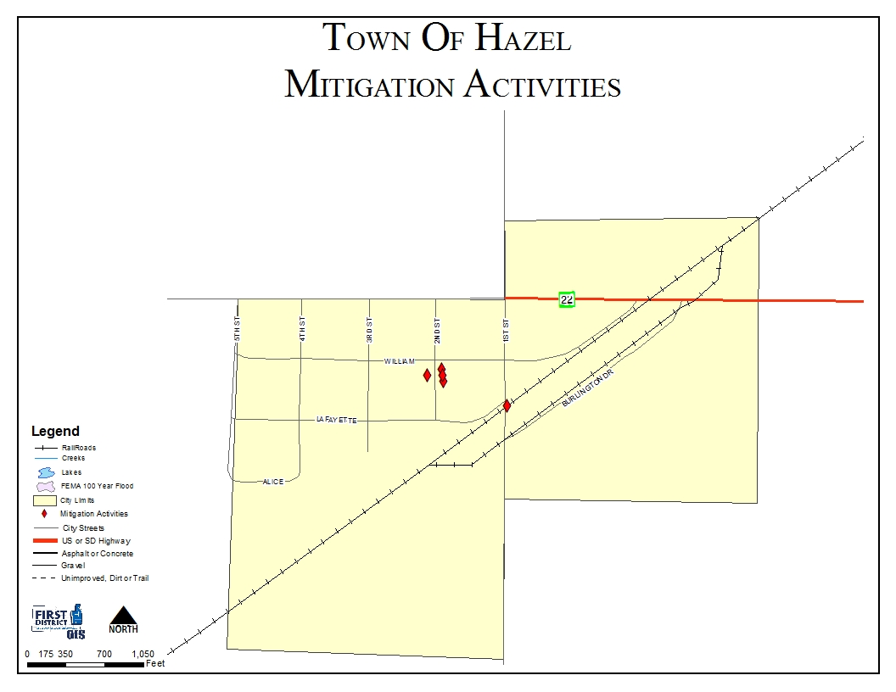

Figure 5.7: City of Lake Norden Potential Mitigation Project Map
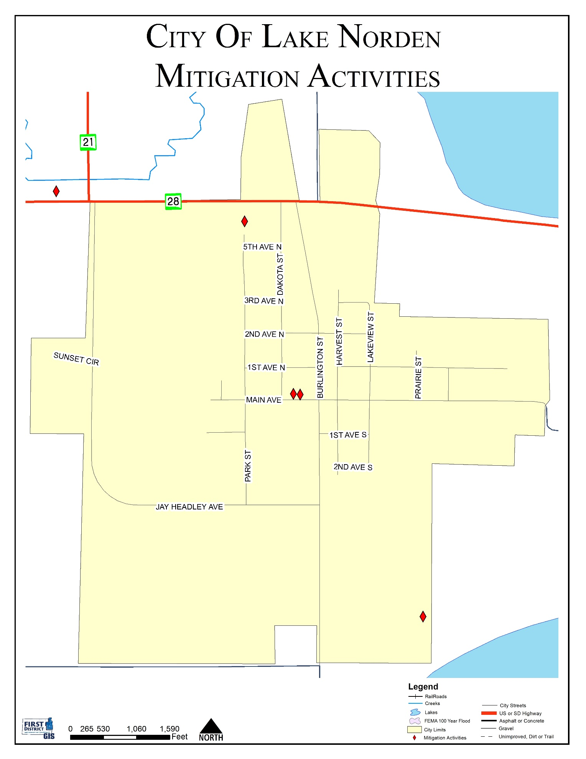
IMPLEMENTATION OF MITIGATION ACTIONS
Requirement 201.6(c)(4)(ii). Local Mitigation Plan Review Tool – C6.
Requirement 201.6(d)(3). Local Mitigation Plan Review Tool – D3.

Upon adoption of the updated Hamlin County PDM, each jurisdiction will become responsible for implementing its own mitigation actions. The planning required for implementation is the sole responsibility of the local jurisdictions and private businesses that have participated in the PDM update. All of the municipalities have indicated that they do not have the financial capability to move forward with projects identified in the PDM at this time, however, all will consider applying for funds through the State and Federal Agencies once such funds become available. If and when the municipalities are able to secure funding for the mitigation projects, they will move forward with the projects identified. A cost-benefit analysis will be conducted on an individual basis after the decision is made to move forward with a project.

CHAPTER 6
PLAN MAINTENANCE

MONITORING, EVALUATING, AND UPDATING THE PLAN
Requirement 201.6(c)(4)(i). Local Mitigation Plan Review Tool – A6.
Requirement 201.6(c)(4)(ii). Local Mitigation Plan Review Tool – C6.

The County and all of the participating local jurisdictions thereof will incorporate the findings and projects of the PDM in all planning areas as appropriate. Periodic monitoring and reporting of the PDM is required to ensure that the goals and objectives for the County PDM are kept current and that local mitigation efforts are being carried out. Communities will establish an annual review of projects and infrastructure listed in the plan. As funding becomes available, projects are completed, or the inevitable new project needs to be added, communities will report to the Hamlin County Emergency Management Director. Communities should adopt a schedule which corresponds with the annual report of the Emergency Management Director to the County Commissioners in November of each year.

During the process of implementing mitigation strategies, the county or communities within the county may experience lack of funding, budget cuts, staff turnover, and/or a general failure of projects. These scenarios are not in themselves a reason to discontinue and fail to update the PDM. A good plan needs to provide for periodic monitoring and evaluation of its successes and failures and allow for appropriate changes to be made.

CONTINUED PUBLIC PARTICIPATION/INVOLVEMENT
Requirement 201.6(c)(4)(iii). Local Mitigation Plan Review Tool – A5.
Requirement 201.6(c)(4)(ii). Local Mitigation Plan Review Tool – C6.

During interim periods between the five year re-write, efforts will be continued to encourage and facilitate public involvement and input. The PDM will be available for public view and comment at the Hamlin County Emergency Management Office located in the Hamlin County Courthouse in Hayti and the First District Association of Local Governments office. The PDM will also be available for review on the web at the Hamlin County website www.hamlincountysd.org and at the First District Association of Local Governments homepage www.1stdistrict.org. Comments will always be received whether orally, written or by e-mail.

All ongoing workshops and trainings will be open to the public and appropriately advertised. Ongoing press releases and interviews will help disseminate information to the general public and encourage participation.

As implementation of the mitigation strategies continues in each local jurisdiction, the primary means of public involvement will be the jurisdiction’s own public comment and hearing process. State law as it applies to municipalities and counties requires this as a minimum for many of the proposed implementation measures. Effort will be made to encourage cities, towns and counties to go beyond the minimum required to receive public input and engage stakeholders.

ANNUAL REPORTING PROCEDURES
Requirement 201.6(c)(4)(ii). Local Mitigation Plan Review Tool – C6.

The PDM shall be reviewed annually, as required by the County Emergency Management Director, or as the situation dictates such as following a disaster declaration. The Hamlin County Emergency Management Director will review the PDM annually in November and ensure the following:

- The County Elected body will receive an annual report and/or presentation on the implementation status of the PDM;
- The report will include an evaluation of the effectiveness and appropriateness of the mitigation actions proposed in the PDM; and
- The report will recommend, as appropriate, any required changes or amendments to the PDM.

FIVE-YEAR PDM REVIEW
Requirement 201.6(c)(4)(i). Local Mitigation Plan Review Tool – A6.
Requirement 201.6(c)(4)(ii). Local Mitigation Plan Review Tool – C6.

Every five years the PDM will be reviewed and a complete update will be initiated. All information in the PDM will be evaluated for completeness and accuracy based on new information or data sources. New property development activities will be added to the PDM and evaluated for impacts. New or improved sources of hazard related data will also be included.

In future years, if the County relies on grant dollars to hire a contractor to write the PDM update, the County will initiate the process of applying for and securing such funding in the third year of the PDM to ensure the funding is in place by the fourth year of the PDM. The fifth year will then be used to write the PDM update, which in turn will prevent any lapse in time where the county does not have a current approved PDM on file.

The goals, objectives, and mitigation strategies will be readdressed and amended as necessary based on new information, additional experience and the implementation progress of the PDM. The approach to this PDM update effort will be essentially the same as the one used for the original PDM development.

The Emergency Management Director will meet with the PDM Planning Team for review and approval prior to final submission of the updated PDM.

PLAN AMENDMENTS
Requirement 201.6(c)(4)(ii). Local Mitigation Plan Review Tool – C6.

PDM amendments will be considered by the Hamlin County Emergency Management Director, during the PDM’s annual review to take place the end of each county fiscal year. All affected local jurisdictions (cities, towns, and counties) will be required to hold a public hearing and adopt the recommended amendment by resolution prior to considerations by the PDM Planning Team.

INCORPORATION INTO EXISTING PLANNING MECHANISMS
Requirement 201.6(B)(3). Local Mitigation Plan Review Tool – A4.
Requirement 201.6(c)(4)(ii). Local Mitigation Plan Review Tool – C6.

All municipalities in the County, with the exceptions of the Town of Hazel have a comprehensive and/or capital improvements plan. All communities with existing comprehensive land use plans will review mitigation projects annually when reviewing their comprehensive land use plan, as is recommended in each of their plans. In addition all municipalities, including the towns without comprehensive land use plans, will consider the mitigation requirements, goals, actions, and projects when it considers and reviews the budget and other existing planning documents. Preparation of the budget is an opportune time to review the plan since municipalities are required by state law to prepare budgets for the upcoming year and typically consider any expenditure for the upcoming year at that time.

The local jurisdictions will post a permanent memo to their files as a reminder for them to incorporate their annual review of the mitigation actions identified into the budget preparation process. This does not require the projects be included in the budget, it merely serves as a reminder to the City officials that they have identified mitigation projects in the PDM that should be considered if the budget allows for it.

POTENTIAL FUNDING SOURCES

Although all mitigation techniques will likely save money by avoiding losses, many projects are costly to implement. None of the local jurisdictions have the funds available to more forward with mitigation projects at this time; thus, the Potential Funding Sources section was included so that the local jurisdictions can work towards securing funding for the projects. Inevitably, due to the small tax base and small population most of the local jurisdictions do not have the ability to generate enough revenue to support anything beyond the basic needs of the community. Thus mitigation projects will not be completed without a large amount of funding support from State or Federal programs.

The County jurisdictions will continue to seek outside funding assistance for mitigation projects in both the pre- and post-disaster environment. Primary Federal and State grant programs have been identified and briefly discussed, along with local and non-governmental funding sources, as a resource for the local jurisdictions

Federal
The following federal grant programs have been identified as funding sources which specifically target hazard mitigation projects:

Title: Pre-Disaster Mitigation Program
Agency: Federal Emergency Management Agency
Through the Disaster Mitigation Act of 2000, Congress approved the creation of a national program to provide a funding mechanism that is not dependent on a Presidential Disaster Declaration. The Pre-Disaster Mitigation (PDM) program provides funding to states and communities for cost-effective hazard mitigation activities that complement a comprehensive mitigation program and reduce injuries, loss of life, and damage and destruction of property.

The funding is based upon a 75% Federal share and 25% non-Federal share. The non-Federal match can be fully in-kind or cash, or a combination. Special accommodations will be made for “small and impoverished communities”, who will be eligible for 90% Federal share/10% non-Federal.

FEMA provides PDM grants to states that, in turn, can provide sub-grants to local governments for accomplishing the following eligible mitigation activities: State and local hazard mitigation planning,
Technical assistance (e.g. risk assessments, project development), Mitigation Projects, Acquisition or relocation of vulnerable properties, Hazard retrofits, Minor structural hazard control or protection projects
Community outreach and education (up to 10% of State allocation)

Title: Flood Mitigation Assistance Program
Agency: Federal Emergency Management Agency
FEMA’s Flood Mitigation Assistance program (FMA) provides funding to assist states and communities in implementing measures to reduce or eliminate the long-term risk of flood damage to buildings, manufactured homes and other structures insurable under the National Flood Insurance Program (NFIP). FMA was created as part of the National Flood Insurance Reform Act of 1994 (42 USC 4101) with the goal of reducing or eliminating claims under the NFIP.

FMA is a pre-disaster grant program, and is available to states on an annual basis. This funding is available for mitigation planning and implementation of mitigation measures only, and is based upon a 75% Federal share/25% non-Federal share. States administer the FMA program and are responsible for selecting projects for funding from the applications submitted by all communities within the state. The state then forwards selected applications to FEMA for an eligibility determination. Although individuals cannot apply directly for FMA funds, their local government may submit an application on their behalf.

Title: Repetitive Flood Claims Program
Agency: Federal Emergency Management Agency
FEMA’s Repetitive Flood Claims (RFC) grant program was authorized by the Bunning-Bereuter-Blumenauer Flood Insurance Reform Act of 2004 (P.L. 108–264), which amended the National Flood Insurance Act (NFIA) of 1968 (42 U.S.C. 4001, et al).
Up to $10 million is available annually for FEMA to provide RFC funds to assist States and communities reduce flood damages to insured properties that have had one or more claims to the National Flood Insurance Program (NFIP).
FEMA may contribute up to 100 percent of the total amount approved under the RFC grant award to implement approved activities, if the Applicant has demonstrated that the proposed activities cannot be funded under the Flood Mitigation Assistance (FMA) program.

Title: Hazard Mitigation Grant Program
Agency: Federal Emergency Management Agency
The Hazard Mitigation Grant Program (HMGP) was created in November 1988 through Section 404 of the Robert T. Stafford Disaster Relief and Emergency Assistant Act. The HMGP assists states and local communities in implementing long-term mitigation measures following a Presidential disaster declaration.

To meet these objectives, FEMA can fund up to 75% of the eligible costs of each project. The state or local cost-share match does not need to be cash; in-kind services or materials may also be used. With the passage of the Hazard Mitigation and Relocation Assistance Act of 1993, federal funding under the HMGP is now based on 15% of the federal funds spent on the Public and Individual Assistance programs (minus administrative expenses) for each disaster.

The HMGP can be used to fund projects to protect either public or private property, so long as the projects in question fit within the state and local governments overall mitigation strategy for the disaster area, and comply with program guidelines. Examples of projects that may be funded include the acquisition or relocation of structures from hazard-prone areas, the retrofitting of existing structures to protect them from future damages; and the development of state or local standards designed to protect buildings from future damages.

Eligibility for funding under the HMGP is limited to state and local governments, certain private nonprofit organizations or institutions that serve a public function, Indian tribes and authorized tribal organizations. These organizations must apply for HMPG project funding on behalf of their citizens. In turn, applicants must work through their state, since the state is responsible for setting priorities for funding and administering the program.

Title: Public Assistance (Infrastructure) Program, Section 406
Agency: Federal Emergency Management Agency
FEMA’s Public Assistance Program, through Section 406 of the Robert T. Stafford Disaster Relief and Emergency Assistance Act, provides funding to local governments following a Presidential Disaster Declaration for mitigation measures in conjunction with the repair of damaged public facilities and infrastructure. The mitigation measures must be related to eligible disaster related damages and must directly reduce the potential for future, similar disaster damages to the eligible facility. These opportunities usually present themselves during the repair/replacement efforts.

Proposed projects must be approved by FEMA prior to funding. They will be evaluated for cost effectiveness, technical feasibility and compliance with statutory, regulatory and executive order requirements. In addition, the evaluation must ensure that the mitigation measures do not negatively impact a facility’s operation or risk from another hazard.

Public facilities are operated by state and local governments, Indian tribes or authorized tribal organizations and include:

*Roads, bridges & culverts *Water, power & sanitary systems
*Draining & irrigation channels *Airports & parks
*Schools, city halls & other buildings

Private nonprofit organizations are groups that own or operate facilities that provide services otherwise performed by a government agency and include, but are not limited to the following:

*Universities and other schools *Power cooperatives & other utilities
*Hospitals & clinics *Custodial care & retirement facilities
*Volunteer fire & ambulance *Museums & community centers

Title: SBA Disaster Assistance Program
Agency: US Small Business Administration
The SBA Disaster Assistance Program provides low-interest loans to businesses following a Presidential disaster declaration. The loans target businesses to repair or replace uninsured disaster damages to property owned by the business, including real estate, machinery and equipment, inventory and supplies. Businesses of any size are eligible; along with non-profit organizations.SBA loans can be utilized by their recipients to incorporate mitigation techniques into the repair and restoration of their business.
Title: Community Development Block Grants
Agency: US Department of Housing and Urban Development
The community Development Block Grant (CDBG) program provides grants to local governments for community and economic development projects that primarily benefit low- and moderate-income people. The CDBG program also provides grants for post-disaster hazard mitigation and recovery following a Presidential disaster declaration. Funds can be used for activities such as acquisition, rehabilitation or reconstruction of damaged properties and facilities and for the redevelopment of disaster areas.

Local

Local governments depend upon local property taxes as their primary source of revenue. These taxes are typically used to finance services that must be available and delivered on a routine and regular basis to the general public. If local budgets allow, these funds are used to match Federal or State grant programs when required for large-scale projects.

Non-Governmental

Another potential source of revenue for implementing local mitigation projects are monetary contributions from non-governmental organizations, such as private sector companies, churches, charities, community relief funds, the Red Cross, hospitals, Land Trusts and other non-profit organizations.

APPENDIX

Appendix A - Resolution of Adoption by Jurisdiction

Appendix B - PDM Planning Team Agendas, Sign-in Sheets, and Minutes

Appendix C –Community Meeting Agendas and Sign-in Sheets

Appendix D - Hazard Identification/Vulnerability Worksheets

Appendix E - Township Vulnerable and Potential Mitigation Project Site Maps

Appendix F – Comprehensive Land Use Maps

Appendix G – Review of 2014 PDM Mitigation Project Implementation

Appendix H - References
Appendix A
Resolution of Adoption by Jurisdiction

Hamlin County Resolution
Reserved
City of Bryant Resolution
Reserved
City of Castlewood Resolution
Reserved
City of Estelline Resolution
Reserved
Town of Hayti Resolution
Reserved
Town of Hazel Resolution
Reserved

City of Lake Norden Resolution
Reserved

Sioux Rural Water Systems Resolution
Reserved

Appendix B
PDM Planning Team Agendas, Sign-in Sheets, Minutes, and Adjoining County invitation

Hamlin County
Pre-disaster Mitigation Plan Kickoff Meeting
7:00 p.m. October 23rd, 2019
Hamlin County 4-H Building

Agenda

- Introduction of team members
- What is mitigation planning
- Why is Hamlin County updating the Pre-Disaster Mitigation Plan
- Review plan components
- Review timeline/scope

Sign in Sheet
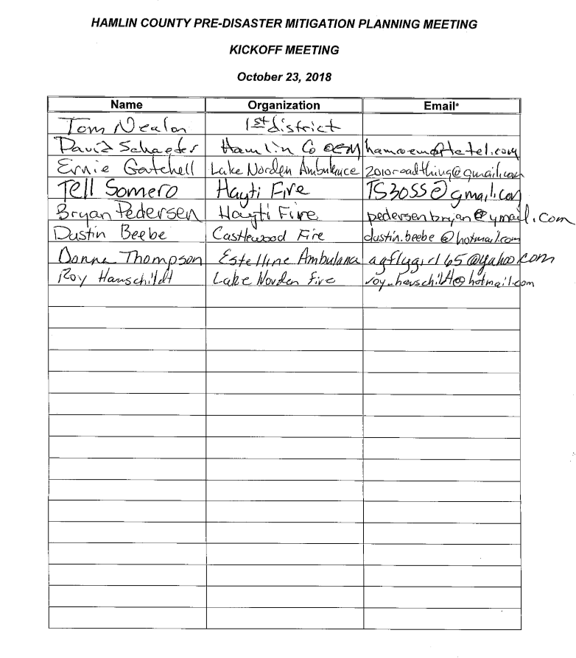

Minutes
Hamlin County Pre-Disaster Mitigation Plan Team Kick-Off Meeting
October 23rd, 2018
Hamlin County 4-H Building
7:00 p.m.

8 individuals were in attendance:

Nealon | Tom | First District
Schaefer | David | Hamlin County Emergency Management
Gatchell | Ernie | Lake Norden Ambulance
Somero | Tell | Hayti Fire Department
Pedersen | Bryan | Hayti Fire Department
Beebe | Dustin | Castlewood Fire Department
Thompson | Donna | Estelline Ambulance
Hauschildt | Roy | Lake Norden Fire Department

Hamlin County Emergency Management Director David Schaefer welcomed those in attendance and had Team members introduce themselves and what entity they represented. Schaefer then introduced Tom Nealon of the First District Association of Local Governments.

Nealon provided an overview of what is mitigation planning and why the county is required to update their Pre-Disaster Mitigation (PDM) Plan. Nealon also provided a review of the components to be included within the plan (risk assessment, vulnerability, proposed mitigation actions).

Planning Team representatives provided information regarding mitigation activities within their own respective entities. A general review of the existing Pre-Disaster Mitigation Plan started by defining work responsibilities, having the First District doing background and research, and the PDM Team providing oversight and guidelines throughout the process. The timeline and scope of project were reviewed.

Meeting adjourned at 8:00 p.m. Date and time for the next meeting to be scheduled for mid-fall 2019

Minutes recorded by Tom Nealon.

Hamlin County
Pre-disaster Mitigation Planning Team Meeting #2
7:00 p.m. Wednesday, November 13th, 2019
Hamlin County 4-H Building

Agenda

- PDM Jurisdiction Risk Assessment Review
  - Hazard Identification
  - Hazard Profile
  - Vulnerability Assessment
- Mitigation Activities and Strategies
  - Review of Goals and Objectives
    - Previous Plan
    - Proposed Plan
  - Review Activities and Strategies of each community
- Review of PDM Preliminary Draft
  - Risk Assessment/critical infrastructure
  - Mitigation Strategies/projects
- Set date of final review

Sign in Sheet
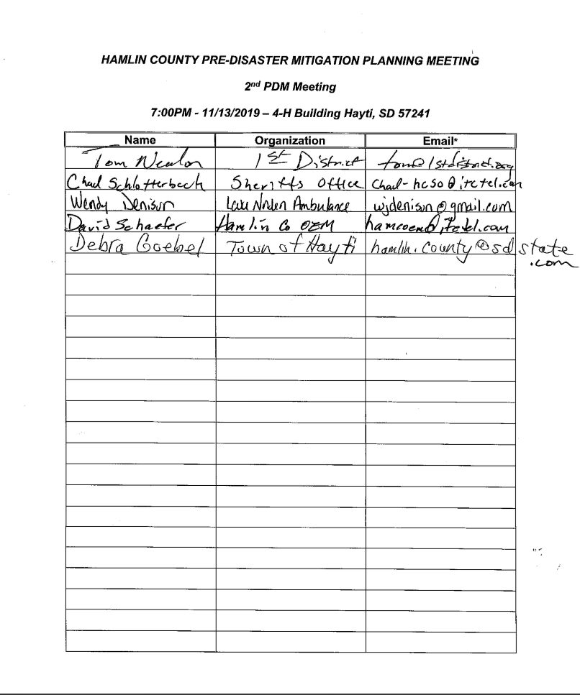
Minutes
Hamlin County Pre-disaster Mitigation Planning Team Meeting #2
7:00 p.m. Wednesday, November 13th, 2019 - Hamlin County 4-H Building

5 people were in attendance:

Last Name | First Name | Organization
Nealon | Tom | First District
Schaefer | Dave | Hamlin County Emergency Management
Schlotterbeck | Chad | Hamlin County Sheriff's Office
Goebel | Deb | Town of Hayti
Denison | Wendy | Lake Norden Ambulance

Nealon of First District provided an overview of the preliminary draft of the Pre-Disaster Mitigation Plan, a link for which was sent out to the Team members two weeks prior to the PDM meeting. Comments were received from those in attendance. Each section of the plan was reviewed, including introduction, purpose, process involved, risk assessment, mitigation strategy, and plan maintenance.

Hazard Identification: Nealon provided an overview of historical hazard events in Hamlin County since 2013.

Mitigation Strategy: Nealon reviewed mitigation projects developed from meetings with participating entities since the October 2018 meeting of the PDM Team and reviewed goals and objectives of those projects.

The Team also reviewed and revised goals and objectives of the previous PDM Plan and discussed potential mitigation projects throughout the county.

Risk Assessment: Nealon provided information regarding hazard vulnerability and critical infrastructure identified by the participating entities.

Consensus of the Team was to spend more time on individual review of the document and to provide First District staff with any corrections. Team members and respective communities are to review the plan and contact First District Staff with questions or corrections. Meeting adjourned at 8:00 p.m.
Hamlin County
Pre-disaster Mitigation Planning Team Meeting
November 18th, 2019 – 7:00PM
Hamlin County 4-H Building

Agenda

- Final Review of PDM Plan
- Recommendation of Approval and Submission to FEMA

Minutes
Hamlin County
Pre-disaster Mitigation Planning Team Meeting
November 18th, 2019
Hamlin County 4-H Building

4 people were in attendance:

Last Name | First Name | Organization
Nealon | Tom | First District
Schafer | Dave | Hamlin County Emergency Management
Schlotterbeck | Chad | Hamlin County Sheriff’s Office
Goebel | Deb | Town of Hayti

Nealon of First District provided an overview of the changes to the Pre-Disaster Mitigation Plan since the last meeting. Comments were received from those in attendance.

Motion by Schaefer, second by Schlotterbeck to recommend the Plan to be submitted to FEMA, pending the completion of the notification period(s) and completion of the above described changes, for their review. Motion passed unanimously.

Muller reviewed the community and county adoption process after approval by FEMA.

Meeting adjourned at 7:15 p.m.

September 13, 2018 Email to Adjoining Counties

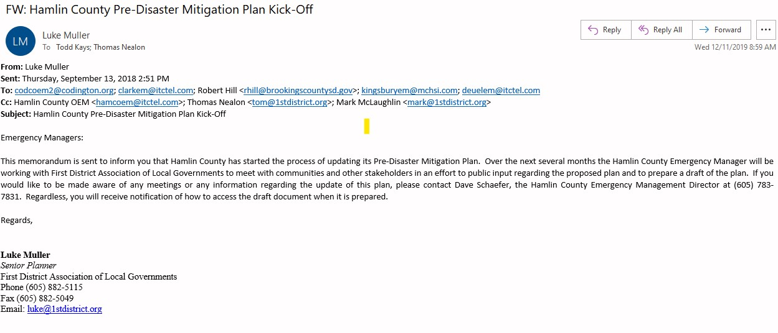
Appendix C
First Community Meeting Agendas and Sign-in Sheets

Appendix C includes Agendas and “Sign-in Sheets” from Meetings held at the community level for the Hamlin County Pre-Disaster Mitigation Plan. Meetings were held at the regular monthly meetings for the following communities:

Town Date
Bryant February 4th, 2019
Castlewood May 6th, 2019
Estelline March 6th, 2019
Hayti March 13th, 2019
Hazel February 11th, 2019
Lake Norden May 7th, 2019

At all of the previously described meetings each individual in attendance was asked to identify the probability of each specific hazard’s occurrence. Following discussion on each individual hazard, Board members categorized these hazards as high probability to occur, low probability to occur, or unlikely to occur. The result was recorded on a master sheet for each town. Next, each individual in attendance was asked to identify the town’s vulnerability to each specific hazard. Following discussion on each individual hazard, Board members classified the town’s vulnerability to each hazard as high vulnerability, low vulnerability, or noted that the hazard was not a hazard in the jurisdiction. The result was recorded on a master sheet for each town. Finally, the Town Board was asked to identify critical infrastructure within the community. All master sheets compiled at those meetings can be found in Appendix E. A master infrastructure list was compiled for each town (Table 4.16).

First District Association of Local Governments contacted each township requesting the identification of areas most vulnerable to natural hazards (on a map) and return them to the Emergency Management Director or First District. Those maps are included in Appendix F. For townships that did not return the maps it is assumed that they do not perceive any areas to be more vulnerable than others to natural hazards.

Attendance sign-in sheets and for each of the above described meetings are included below.

Bryant Agenda
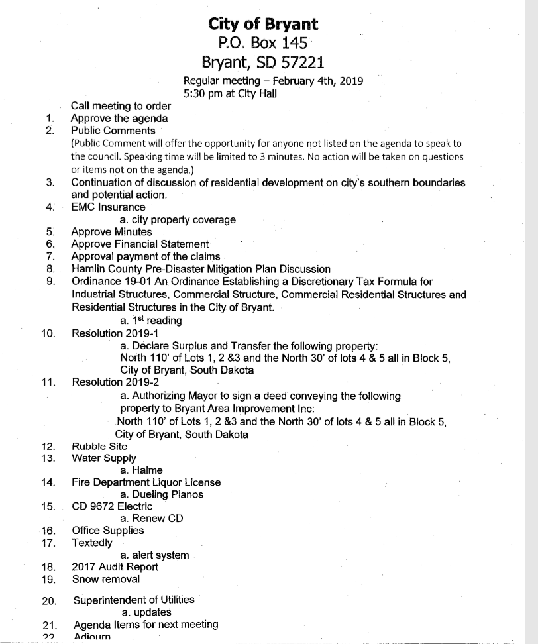
Bryant Sign in Sheet
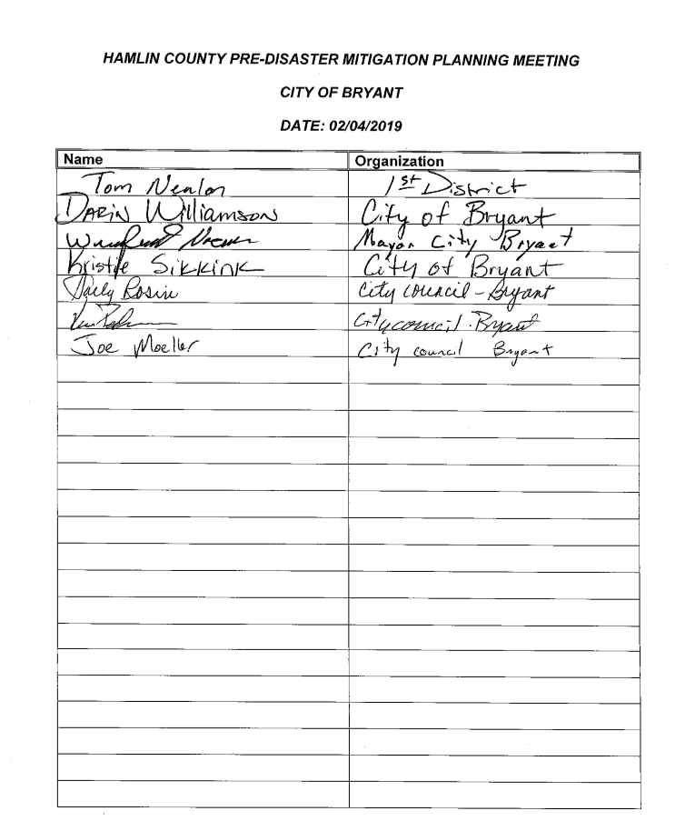
CASTLEWOOD CITY COUNCIL MEETING AGENDA
Monday, May 6, 2019 • 7:30 p.m.

- Call the meeting to order
- Approval of agenda
- Pledge of Allegiance
- Approval of minutes
- Approval of bills
- Public Comments (Public comments will offer the opportunity for anyone not listed on the agenda to speak to the council. Speaking time will be limited to 5 minutes. No action will be taken on questions or items not on the agenda)
- Mayor’s report
- Building permits for April – none issued
- Appoint Economic Development board member
- Siren
- Emergency Spending Policy
- Executive Session Personnel 1-25-2(1) & Contractual Agreement 1-25-2(3)
- Adjourn old council
- New Business – Call the meeting to order
- Oaths of Office – Heather Schmit, Jenny Olson and Jeanette Bohls
- Nominate President and Vice President
- Appointments
- Hamlin County Predisaster Mitigation – Tom Nealon
- Malt Beverage License – Cat’s Corner
- Economic Development
- Recreation
- Moving Permit – Stef Goldhorn 10’x16’ shed (new)
- Clean Up Days
- Sidewalks
- Chip sealing and crack sealing
- Mobile Home Ordinance
- Budget training
- Elected Officials workshop
- Golf course employees
- General Journal entries
- Adjournment

Castlewood Sign in Sheet
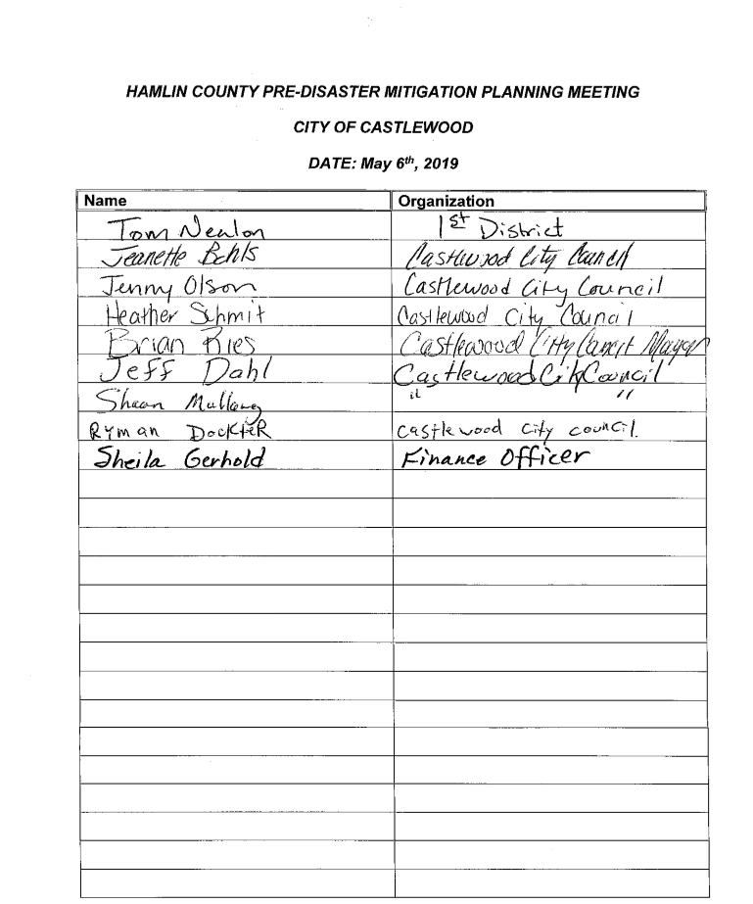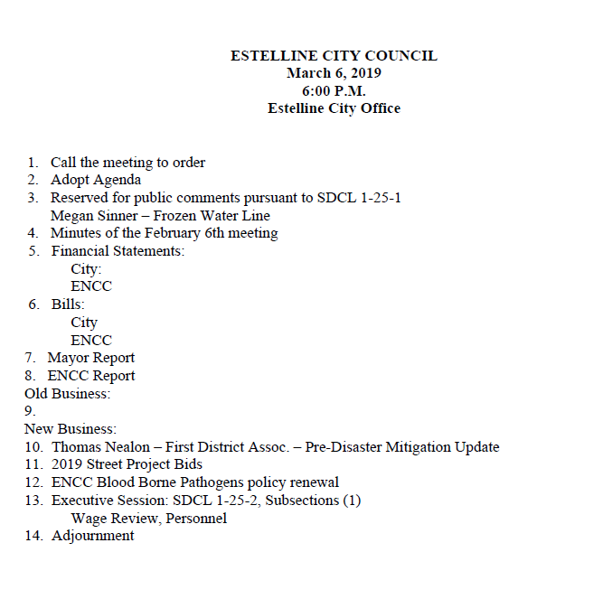

tw

Estelline Sign in Sheet
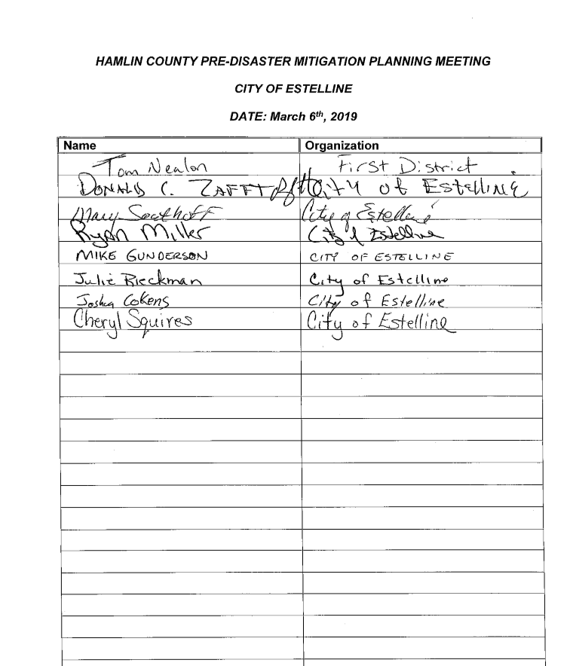
Town of Hayti Agenda
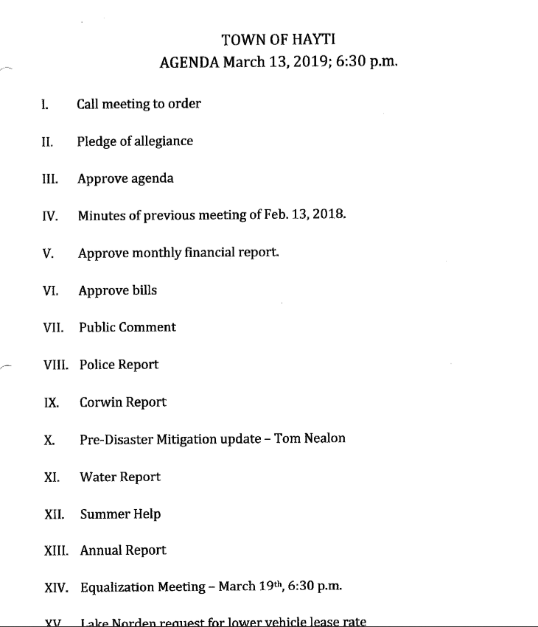

Town of Hayti Sign in Sheet
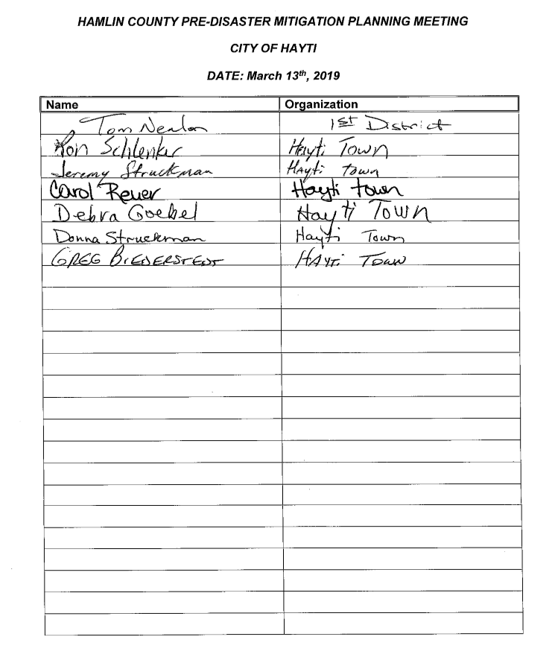

Town of Hazel Agenda
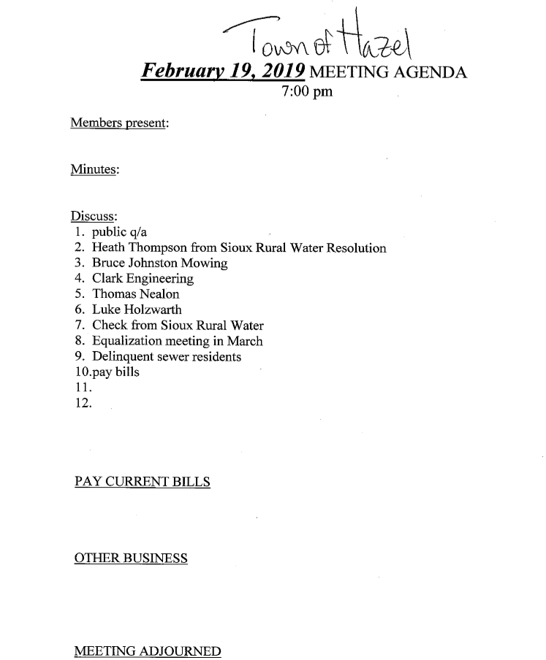
Town of Hazel Sign in Sheet
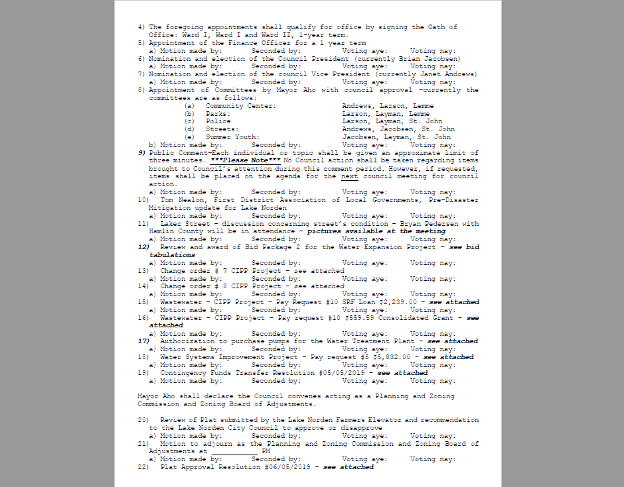
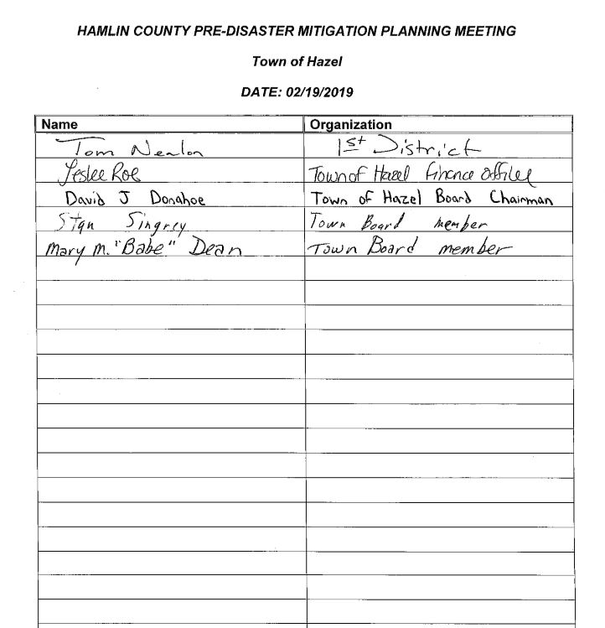
City of Lake Norden Agenda

City of Lake Norden Sign in Sheet
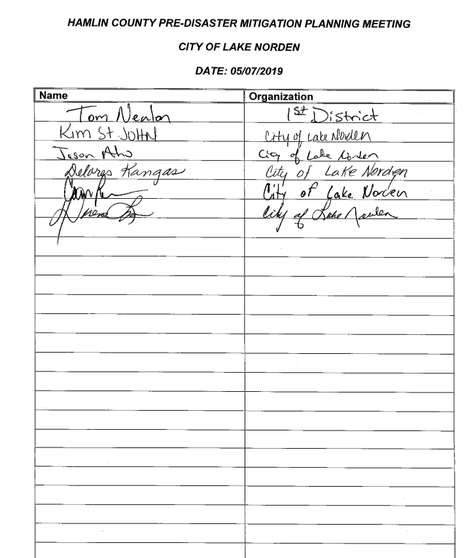

Appendix D - Hazard Identification/Vulnerability Worksheets

Appendix D includes master worksheets for Hazard Identification and Vulnerability for jurisdictions compiled as described in Appendix C. List were gathered by Sioux Rural Water System their respective entities and at meetings for the other communities as described below:

Entity Date
Bryant February 4, 2019
Castlewood May 5th, 2019
Estelline March 6th, 2019
Hayti March 13th, 2019
Hazel February 11, 2019
Lake Norden May 5th, 2019

Master worksheets for Hazard Identification and Vulnerability for jurisdictions below. The probability of each hazard event differs from each community and overall county area based upon the local governing body opinions of the probability of an event occurring. Appendix D represents a subjective analysis of opinions regarding hazard identification and vulnerabilities by residents of the communities. The empirical data regarding probability of hazards is discussed in the hazard profile in Chapter 4. Overall, based upon the topography and similar weather patterns in the county the probability of future occurrences is expected to be the same across Hamlin County.

Hamlin County PDM
Worksheet #1 (Hamlin County)
Risk Assessment Worksheet – Hazard Identification

What is the probability of occurrence of the following hazards?

Hazard | High Probability  to Occur  (At least once in a year) | Low Probability  to Occur  (Hazards that may have occurred in the past or could occur in the future but do not occur on a yearly basis) | Unlikely  to Occur  (Hazards or disasters that have never occurred in the area before and are unlikely to occur)
Avalanche |  |  | X
Coastal Storm |  |  | X
Communication Disruption | X
Dam Failure |  | X
Drought |  | X
Earthquake |  | X
Extreme Cold | X
Extreme Heat | X
Flood | X
Freezing Rain/Sleet/Ice | X
Hail | X
Heavy Rain | X
Heavy Snow |  | X
Hurricane |  |  | X
Ice Jam |  | X
Landslide |  | X
Lightning | X
Rapid Snow Melt | X
Strong Winds | X
Subsidence |  |  | X
Thunderstorm | X
Tornado |  | X
Urban Fire |  | X
Utility Interruption | X
Volcanic Activity |  |  | X
Wild Fire | X

Hamlin County PDM
Worksheet #2 (Hamlin County)
Risk Assessment Worksheet – Hazard Vulnerability

How vulnerable is the community from the following hazard? In other words if the hazard occurs is there a potential to impact the community? If so, what would be impacted?

Hazard | High Vulnerability Significant risk/major damage potential (for example, destructive, damage to more than 10% of the jurisdiction and/or regular occurrence) | Medium Vulnerability Moderate damage potential (causing partial damage to 5-10% of the jurisdiction, and irregular occurrence) | Low Vulnerability  Little damage potential (minor damage to less than 5% of the jurisdiction) | NA  Not a hazard to the jurisdiction
Communication Disruption |  | X
Dam Failure |  |  | X
Drought | X
Earthquake |  |  | X
Extreme Cold | X
Extreme Heat | X
Flood | X
Freezing Rain/Sleet/Ice |  | X
Hail |  | X
Heavy Rain |  | X
Heavy Snow |  | X
Hurricane |  |  |  | X
Ice Jam |  |  | X
Landslide |  |  | X
Lightning |  | X
Rapid Snow Melt |  | X
Strong Winds | X
Thunderstorm | X
Tornado |  | X
Urban Fire |  | X
Utility Interruption | X
Wild Fire |  | X

Hamlin County PDM
Worksheet #1 (Bryant)
Risk Assessment Worksheet – Hazard Identification

What is the probability of occurrence of the following hazards?

Hazard | High Probability  to Occur  (At least once in a year) | Low Probability  to Occur  (Hazards that may have occurred in the past or could occur in the future but do not occur on a yearly basis) | Unlikely  to Occur  (Hazards or disasters that have never occurred in the area before and are unlikely to occur)
Avalanche |  |  | X
Coastal Storm |  |  | X
Communication Disruption |  | X
Dam Failure |  |  | X
Drought |  | X
Earthquake |  |  | X
Extreme Cold | X
Extreme Heat | X
Flood |  | X
Freezing Rain/Sleet/Ice | X
Hail | X
Heavy Rain | X
Heavy Snow | X
Hurricane |  |  | X
Ice Jam |  |  | X
Landslide |  |  | X
Lightning | X
Rapid Snow Melt |  | X
Strong Winds | X
Subsidence |  |  | X
Thunderstorm | X
Tornado |  | X
Urban Fire |  | X
Utility Interruption | X
Volcanic Activity |  |  | X
Wild Fire |  | X

Hamlin County PDM
Worksheet #2 (Bryant)
Risk Assessment Worksheet – Hazard Vulnerability

How vulnerable is the community from the following hazard? In other words if the hazard occurs is there a potential to impact the community? If so, what would be impacted?

Hazard | High Vulnerability Significant risk/major damage potential (for example, destructive, damage to more than 10% of the jurisdiction and/or regular occurrence) | Medium Vulnerability Moderate damage potential (causing partial damage to 5-10% of the jurisdiction, and irregular occurrence) | Low Vulnerability  Little damage potential (minor damage to less than 5% of the jurisdiction) | NA  Not a hazard to the jurisdiction
Communication Disruption |  | X
Dam Failure |  |  |  | X
Drought |  |  | X
Earthquake |  |  |  | X
Extreme Cold |  |  | X
Extreme Heat |  |  | X
Flood |  |  | X
Freezing Rain/Sleet/Ice |  |  | X
Hail |  |  | X
Heavy Rain |  |  | X
Heavy Snow |  |  | X
Hurricane |  |  |  | X
Ice Jam |  |  |  | X
Landslide |  |  |  | X
Lightning |  |  | X
Rapid Snow Melt |  |  | X
Strong Winds |  |  | X
Thunderstorm |  |  | X
Tornado | X
Urban Fire |  | X
Utility Interruption | X
Wild Fire |  |  | X

Hamlin County PDM
Worksheet #1 (Castlewood)
Risk Assessment Worksheet – Hazard Identification

What is the probability of occurrence of the following hazards?

Hazard | High Probability  to Occur  (At least once in a year) | Low Probability  to Occur  (Hazards that may have occurred in the past or could occur in the future but do not occur on a yearly basis) | Unlikely  to Occur  (Hazards or disasters that have never occurred in the area before and are unlikely to occur)
Avalanche |  |  | X
Coastal Storm |  |  | X
Communication Disruption |  | X
Dam Failure |  |  | X
Drought | X
Earthquake |  |  | X
Extreme Cold | X
Extreme Heat | X
Flood | X
Freezing Rain/Sleet/Ice | X
Hail | X
Heavy Rain | X
Heavy Snow | X
Hurricane |  |  | X
Ice Jam |  | X
Landslide |  |  | X
Lightning | X
Rapid Snow Melt | X
Strong Winds | X
Subsidence |  |  | X
Thunderstorm | X
Tornado |  | X
Urban Fire |  | X
Utility Interruption | X
Volcanic Activity |  |  | X
Wild Fire |  |  | X

Hamlin County PDM
Worksheet #2 (Castlewood)
Risk Assessment Worksheet – Hazard Vulnerability

How vulnerable is the community from the following hazard? In other words if the hazard occurs is there a potential to impact the community? If so, what would be impacted?

Hazard | High Vulnerability Significant risk/major damage potential (for example, destructive, damage to more than 10% of the jurisdiction and/or regular occurrence) | Medium Vulnerability Moderate damage potential (causing partial damage to 5-10% of the jurisdiction, and irregular occurrence) | Low Vulnerability  Little damage potential (minor damage to less than 5% of the jurisdiction) | NA  Not a hazard to the jurisdiction
Communication Disruption |  | X
Dam Failure |  |  |  | X
Drought |  |  | X
Earthquake |  |  |  | X
Extreme Cold |  |  | X
Extreme Heat |  |  | X
Flood |  | X
Freezing Rain/Sleet/Ice |  |  | X
Hail |  |  | X
Heavy Rain |  | X
Heavy Snow |  |  | X
Hurricane |  |  |  | X
Ice Jam |  |  | X
Landslide |  |  |  | X
Lightning |  |  | X
Rapid Snow Melt |  | X
Strong Winds |  | X
Thunderstorm |  |  | X
Tornado | X
Urban Fire |  | X
Utility Interruption |  | X
Wild Fire |  |  | X

Hamlin County PDM
Worksheet #1 (Estelline)
Risk Assessment Worksheet – Hazard Identification

What is the probability of occurrence of the following hazards?

Hazard | High Probability  to Occur  (At least once in a year) | Low Probability  to Occur  (Hazards that may have occurred in the past or could occur in the future but do not occur on a yearly basis) | Unlikely  to Occur  (Hazards or disasters that have never occurred in the area before and are unlikely to occur)
Avalanche |  |  | X
Coastal Storm |  |  | X
Communication Disruption |  | X
Dam Failure |  |  | X
Drought |  | X
Earthquake |  |  | X
Extreme Cold | X
Extreme Heat | X
Flood |  | X
Freezing Rain/Sleet/Ice | X
Hail | X
Heavy Rain | X
Heavy Snow | X
Hurricane |  |  | X
Ice Jam |  |  | X
Landslide |  |  | X
Lightning | X
Rapid Snow Melt |  | X
Strong Winds | X
Subsidence |  |  | X
Thunderstorm | X
Tornado |  | X
Urban Fire |  | X
Utility Interruption |  | X
Volcanic Activity |  |  | X
Wild Fire |  |  | X

Hamlin County PDM
Worksheet #2 City of Estelline
Risk Assessment Worksheet – Hazard Vulnerability

How vulnerable is the community from the following hazard? In other words if the hazard occurs is there a potential to impact the community? If so, what would be impacted?

Hazard | High Vulnerability Significant risk/major damage potential (for example, destructive, damage to more than 10% of the jurisdiction and/or regular occurrence) | Medium Vulnerability Moderate damage potential (causing partial damage to 5-10% of the jurisdiction, and irregular occurrence) | Low Vulnerability  Little damage potential (minor damage to less than 5% of the jurisdiction) | NA  Not a hazard to the jurisdiction
Communication Disruption |  |  | X
Dam Failure |  |  |  | X
Drought |  |  | X
Earthquake |  |  |  | X
Extreme Cold |  |  | X
Extreme Heat |  |  | X
Flood |  | X
Freezing Rain/Sleet/Ice |  | X
Hail |  | X
Heavy Rain |  |  | X
Heavy Snow |  |  | X
Hurricane |  |  |  | X
Ice Jam |  |  |  | X
Landslide |  |  |  | X
Lightning |  | X
Rapid Snow Melt |  |  | X
Strong Winds |  |  | X
Thunderstorm |  |  | X
Tornado | X
Urban Fire |  |  | X
Utility Interruption |  | X
Wild Fire |  |  | X

Hamlin County PDM
Worksheet #1 (Hayti)
Risk Assessment Worksheet – Hazard Identification

What is the probability of occurrence of the following hazards?

Hazard | High Probability  to Occur  (At least once in a year) | Low Probability  to Occur  (Hazards that may have occurred in the past or could occur in the future but do not occur on a yearly basis) | Unlikely  to Occur  (Hazards or disasters that have never occurred in the area before and are unlikely to occur)
Avalanche |  |  | X
Coastal Storm |  |  | X
Communication Disruption |  | X
Dam Failure |  |  | X
Drought |  | X
Earthquake |  |  | X
Extreme Cold | X
Extreme Heat | X
Flood | X
Freezing Rain/Sleet/Ice | X
Hail | X
Heavy Rain | X
Heavy Snow | X
Hurricane |  |  | X
Ice Jam |  |  | X
Landslide |  |  | X
Lightning | X
Rapid Snow Melt | X
Strong Winds | X
Subsidence |  |  | X
Thunderstorm | X
Tornado | X
Urban Fire |  | X
Utility Interruption | X
Volcanic Activity |  |  | X
Wild Fire |  | X

Hamlin County PDM
Worksheet #2 (Hayti)
Risk Assessment Worksheet – Hazard Vulnerability

How vulnerable is the community from the following hazard? In other words if the hazard occurs is there a potential to impact the community? If so, what would be impacted?

Hazard | High Vulnerability Significant risk/major damage potential (for example, destructive, damage to more than 10% of the jurisdiction and/or regular occurrence) | Medium Vulnerability Moderate damage potential (causing partial damage to 5-10% of the jurisdiction, and irregular occurrence) | Low Vulnerability  Little damage potential (minor damage to less than 5% of the jurisdiction) | NA  Not a hazard to the jurisdiction
Communication Disruption |  | X
Dam Failure |  |  |  | X
Drought |  | X
Earthquake |  |  |  | X
Extreme Cold | X
Extreme Heat | X
Flood | X
Freezing Rain/Sleet/Ice | X
Hail | X
Heavy Rain | X
Heavy Snow | X
Hurricane |  |  |  | X
Ice Jam |  |  |  | X
Landslide |  |  |  | X
Lightning | X
Rapid Snow Melt | X
Strong Winds | X
Thunderstorm | X
Tornado | X
Urban Fire |  | X
Utility Interruption | X
Wild Fire |  | X

Hamlin County PDM
Worksheet #1 (Hazel)
Risk Assessment Worksheet – Hazard Identification

What is the probability of occurrence of the following hazards?

Hazard | High Probability  to Occur  (At least once in a year) | Low Probability  to Occur  (Hazards that may have occurred in the past or could occur in the future but do not occur on a yearly basis) | Unlikely  to Occur  (Hazards or disasters that have never occurred in the area before and are unlikely to occur)
Avalanche |  |  | X
Coastal Storm |  |  | X
Communication Disruption |  | X
Dam Failure |  |  | X
Drought |  | X
Earthquake |  | X
Extreme Cold | X
Extreme Heat | X
Flood |  | X
Freezing Rain/Sleet/Ice | X
Hail | X
Heavy Rain | X
Heavy Snow | X
Hurricane |  |  | X
Ice Jam |  |  | X
Landslide |  |  | X
Lightning | X
Rapid Snow Melt |  | X
Strong Winds | X
Subsidence |  |  | X
Thunderstorm | X
Tornado |  | X
Urban Fire |  | X
Utility Interruption | X
Volcanic Activity |  |  | X
Wild Fire |  | X

Hamlin County PDM
Worksheet #2 (Hazel)
Risk Assessment Worksheet – Hazard Vulnerability

How vulnerable is the community from the following hazard? In other words if the hazard occurs is there a potential to impact the community? If so, what would be impacted?

Hazard | High Vulnerability Significant risk/major damage potential (for example, destructive, damage to more than 10% of the jurisdiction and/or regular occurrence) | Medium Vulnerability Moderate damage potential (causing partial damage to 5-10% of the jurisdiction, and irregular occurrence) | Low Vulnerability  Little damage potential (minor damage to less than 5% of the jurisdiction) | NA  Not a hazard to the jurisdiction
Communication Disruption |  | X
Dam Failure |  |  |  | X
Drought |  |  | X
Earthquake |  |  |  | X
Extreme Cold |  | X
Extreme Heat |  | X
Flood |  |  | X
Freezing Rain/Sleet/Ice |  | X
Hail |  |  | X
Heavy Rain |  |  | X
Heavy Snow |  | X
Hurricane |  |  |  | X
Ice Jam |  |  |  | X
Landslide |  |  |  | X
Lightning |  |  | X
Rapid Snow Melt |  |  | X
Strong Winds |  | X
Thunderstorm |  | X
Tornado |  | X
Urban Fire |  |  | X
Utility Interruption | X
Wild Fire |  |  | X

Hamlin County PDM
Worksheet #1 (Lake Norden)
Risk Assessment Worksheet – Hazard Identification

What is the probability of occurrence of the following hazards?

Hazard | High Probability  to Occur  (At least once in a year) | Low Probability  to Occur  (Hazards that may have occurred in the past or could occur in the future but do not occur on a yearly basis) | Unlikely  to Occur  (Hazards or disasters that have never occurred in the area before and are unlikely to occur)
Avalanche |  |  | X
Coastal Storm |  |  | X
Communication Disruption |  | X
Dam Failure |  |  | X
Drought |  | X
Earthquake |  |  | X
Extreme Cold | X
Extreme Heat | X
Flood |  | X
Freezing Rain/Sleet/Ice | X
Hail | X
Heavy Rain | X
Heavy Snow | X
Hurricane |  |  | X
Ice Jam | X
Landslide |  |  | X
Lightning | X
Rapid Snow Melt | X
Strong Winds | X
Subsidence |  |  | X
Thunderstorm | X
Tornado | X
Urban Fire |  | X
Utility Interruption |  | X
Volcanic Activity |  |  | X
Wild Fire |  | X

Hamlin County PDM
Worksheet #2 (Lake Norden)
Risk Assessment Worksheet – Hazard Vulnerability

How vulnerable is the community from the following hazard? In other words if the hazard occurs is there a potential to impact the community? If so, what would be impacted?

Hazard | High Vulnerability Significant risk/major damage potential (for example, destructive, damage to more than 10% of the jurisdiction and/or regular occurrence) | Medium Vulnerability Moderate damage potential (causing partial damage to 5-10% of the jurisdiction, and irregular occurrence) | Low Vulnerability  Little damage potential (minor damage to less than 5% of the jurisdiction) | NA  Not a hazard to the jurisdiction
Communication Disruption |  | X
Dam Failure |  |  |  | X
Drought |  | X
Earthquake |  |  |  | X
Extreme Cold | X
Extreme Heat | X
Flood |  |  | X
Freezing Rain/Sleet/Ice | X
Hail |  | X
Heavy Rain |  | X
Heavy Snow |  | X
Hurricane |  |  |  | X
Ice Jam |  |  | X
Landslide |  |  |  | X
Lightning |  |  | X
Rapid Snow Melt |  | X
Strong Winds |  | X
Thunderstorm |  |  | X
Tornado |  |  | X
Urban Fire |  |  | X
Utility Interruption |  |  | X
Wild Fire |  |  | X

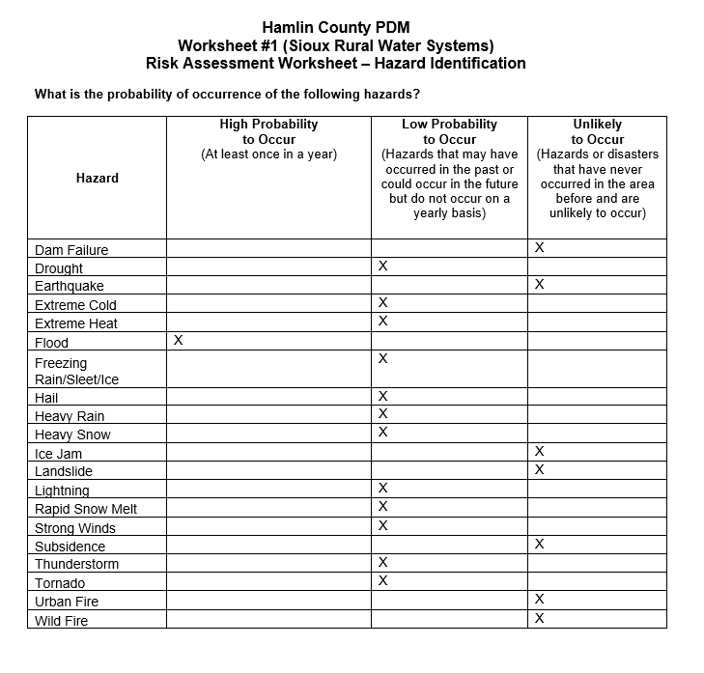

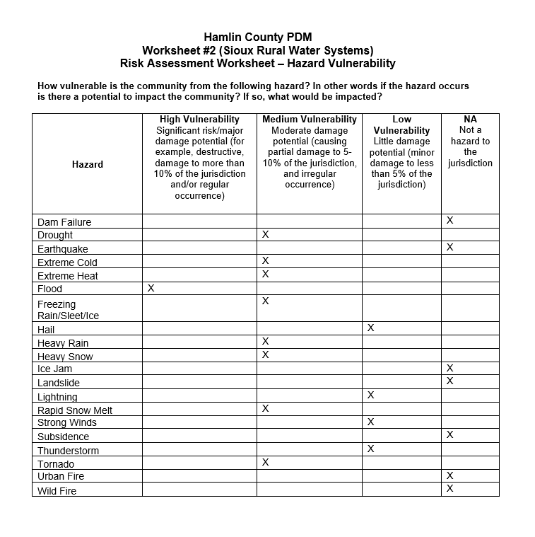

Appendix E
Township Vulnerable and Potential Mitigation Project Site Maps

In January 2019, First District met with the Hamlin County Townships at their annual County meeting. Maps were provided to the Townships and they were requested to list any critical infrastructure and identify (on a map) any areas which are most vulnerable to natural hazards, specifically flooding. It was assumed that any townships which did not respond to the information request had no critical infrastructure or vulnerable areas which may require mitigation activities. Of the 13 Townships contacted, 6 responded with vulnerable areas identified.

Township Name | Response
Brantford | Identified vulnerabilities
Castlewood | Not returned/ No vulnerabilities
Cleveland | Identified vulnerabilities
Dempster | Not returned/ No vulnerabilities
Dixon | Identified vulnerabilities
Estelline | Identified vulnerabilities
Florence | Not returned/ No vulnerabilities
Garfield | Not returned/ No vulnerabilities
Hamlin | Identified vulnerabilities
Hayti | Not returned/ No vulnerabilities
Norden | Not returned/ No vulnerabilities
Opdahl | Identified vulnerabilities
Oxford | Not returned/ No vulnerabilities

Maps identifying vulnerable areas for those townships which identified such areas are shown below.

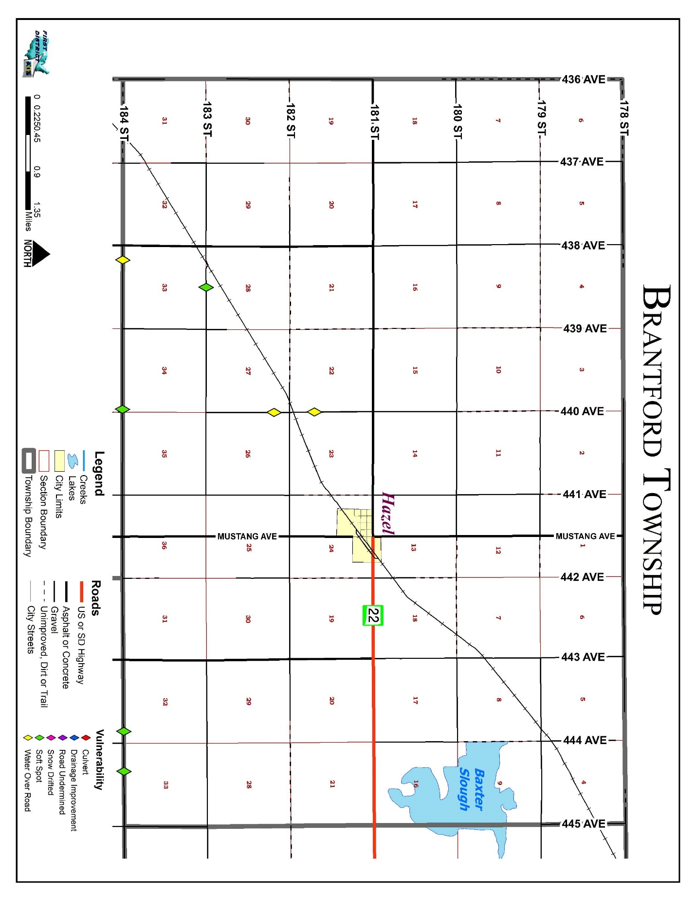
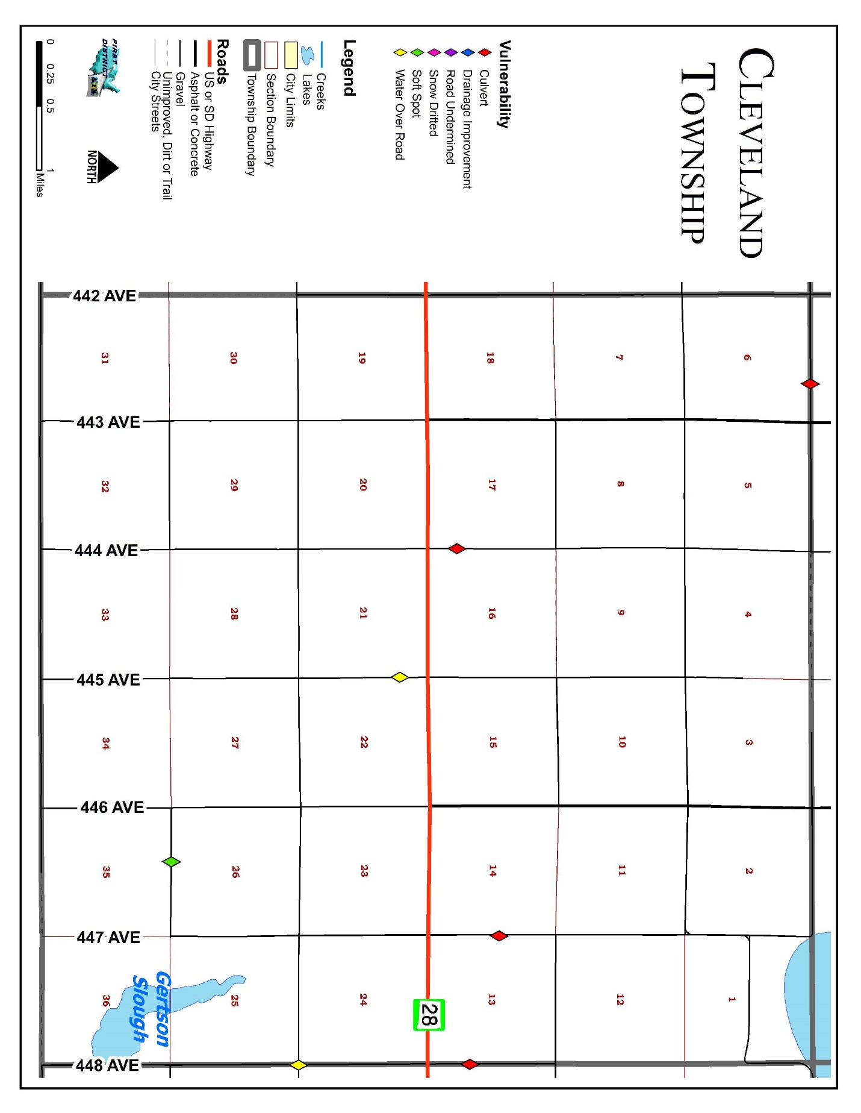
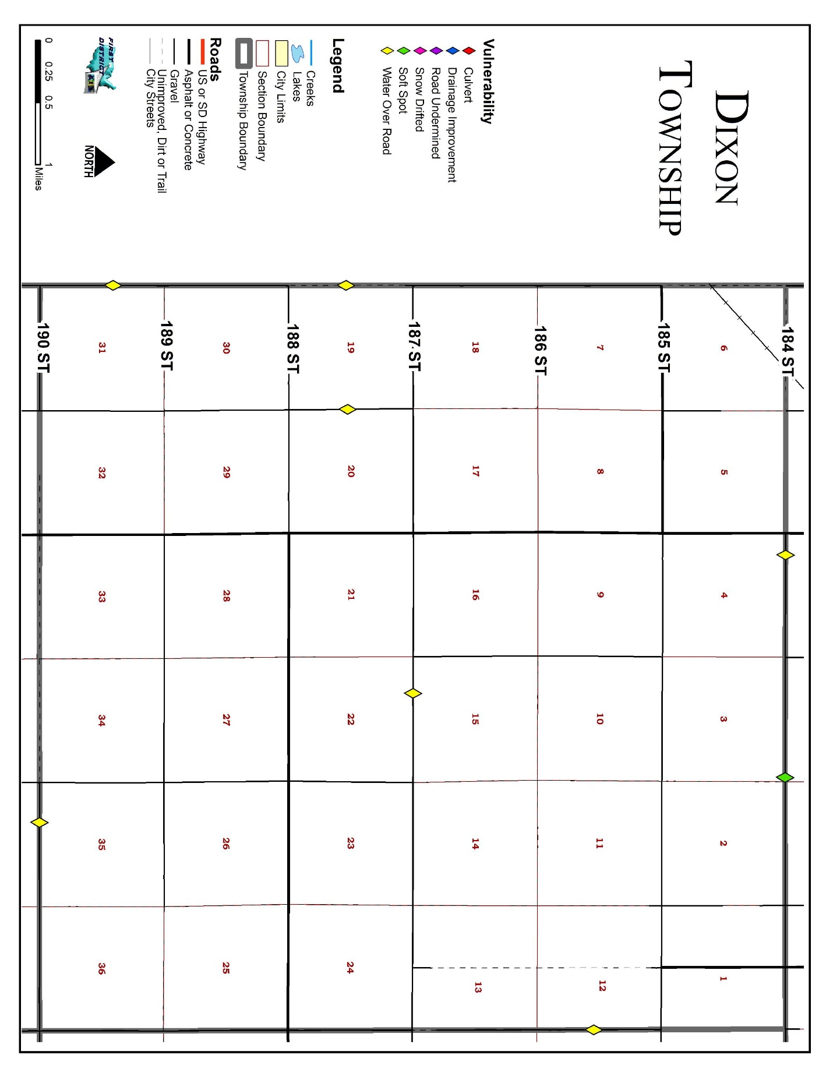

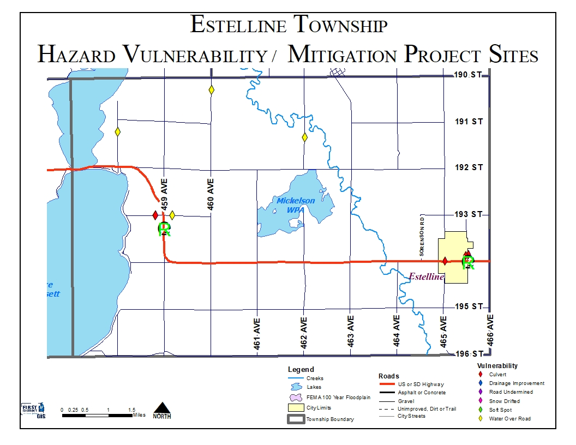

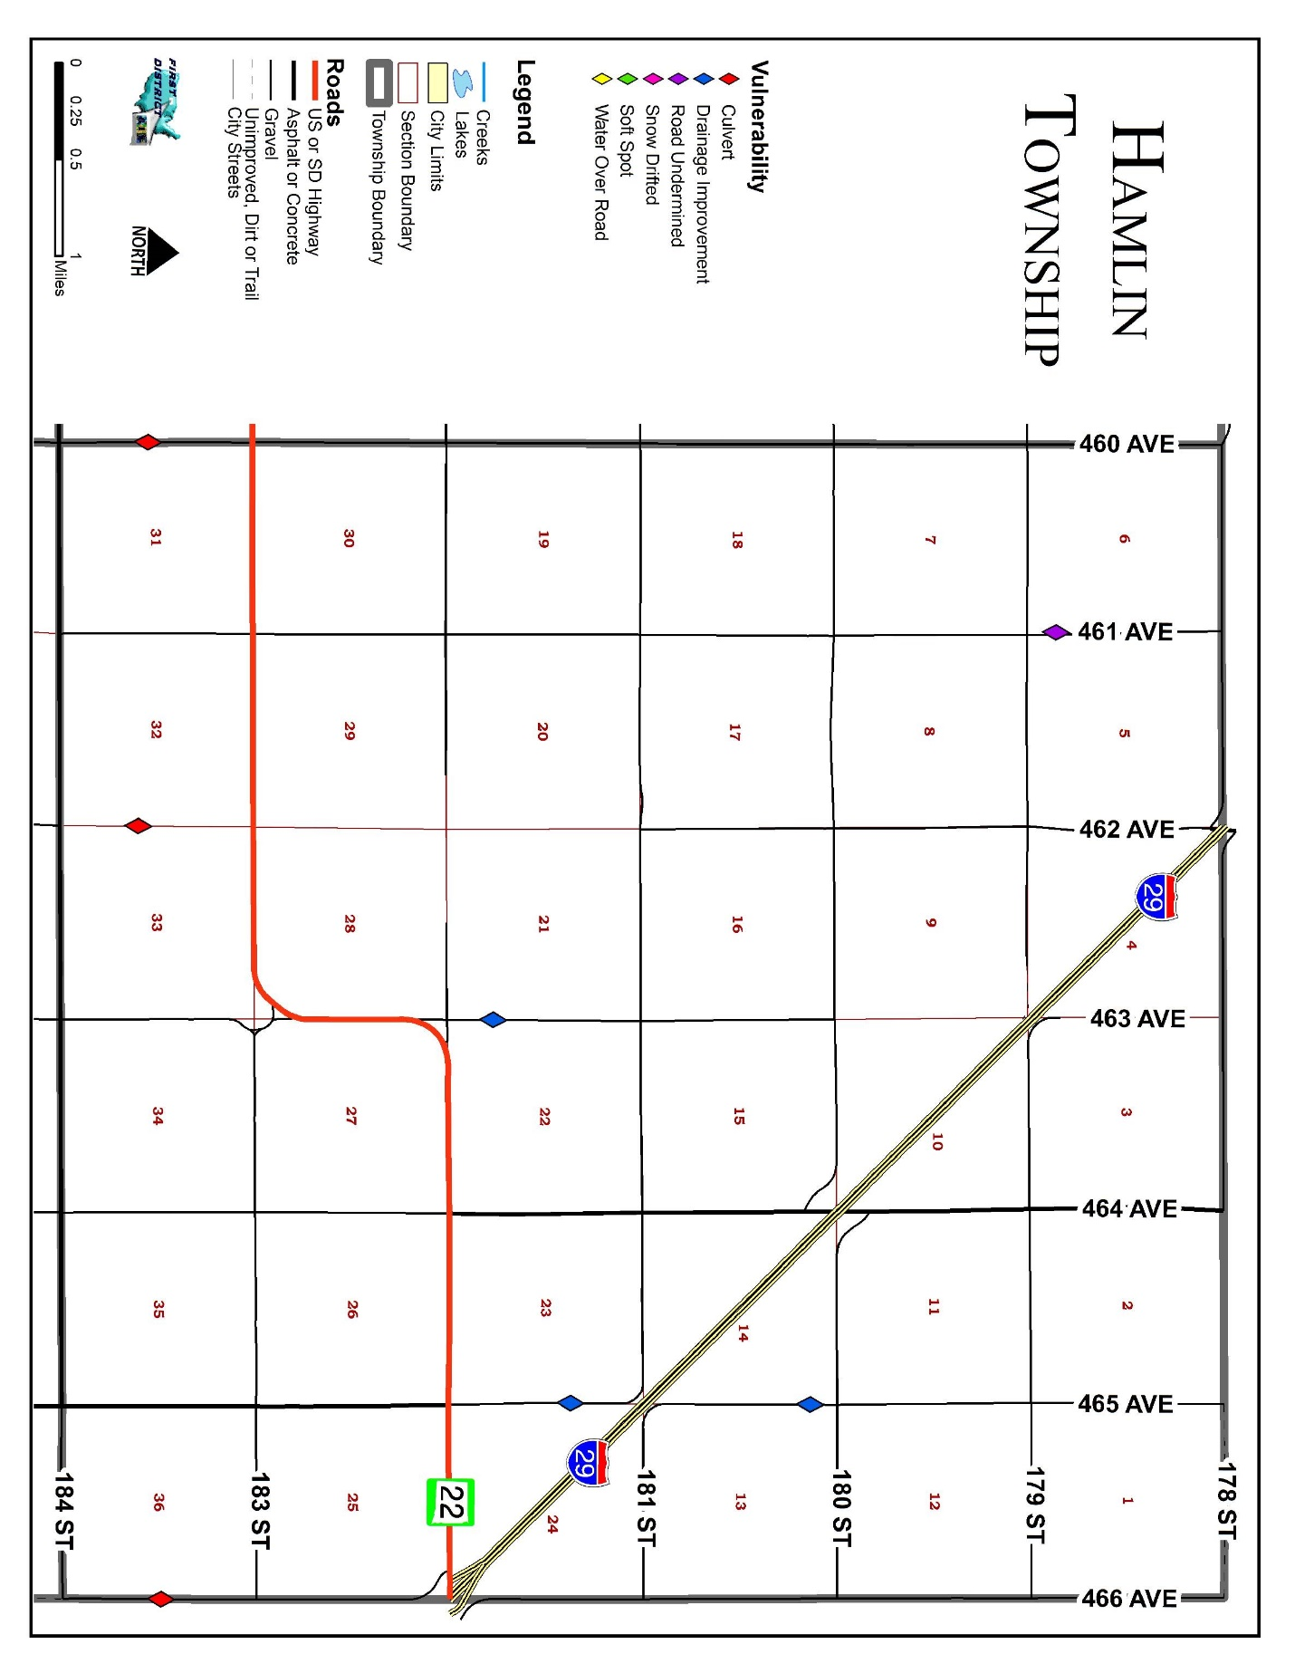

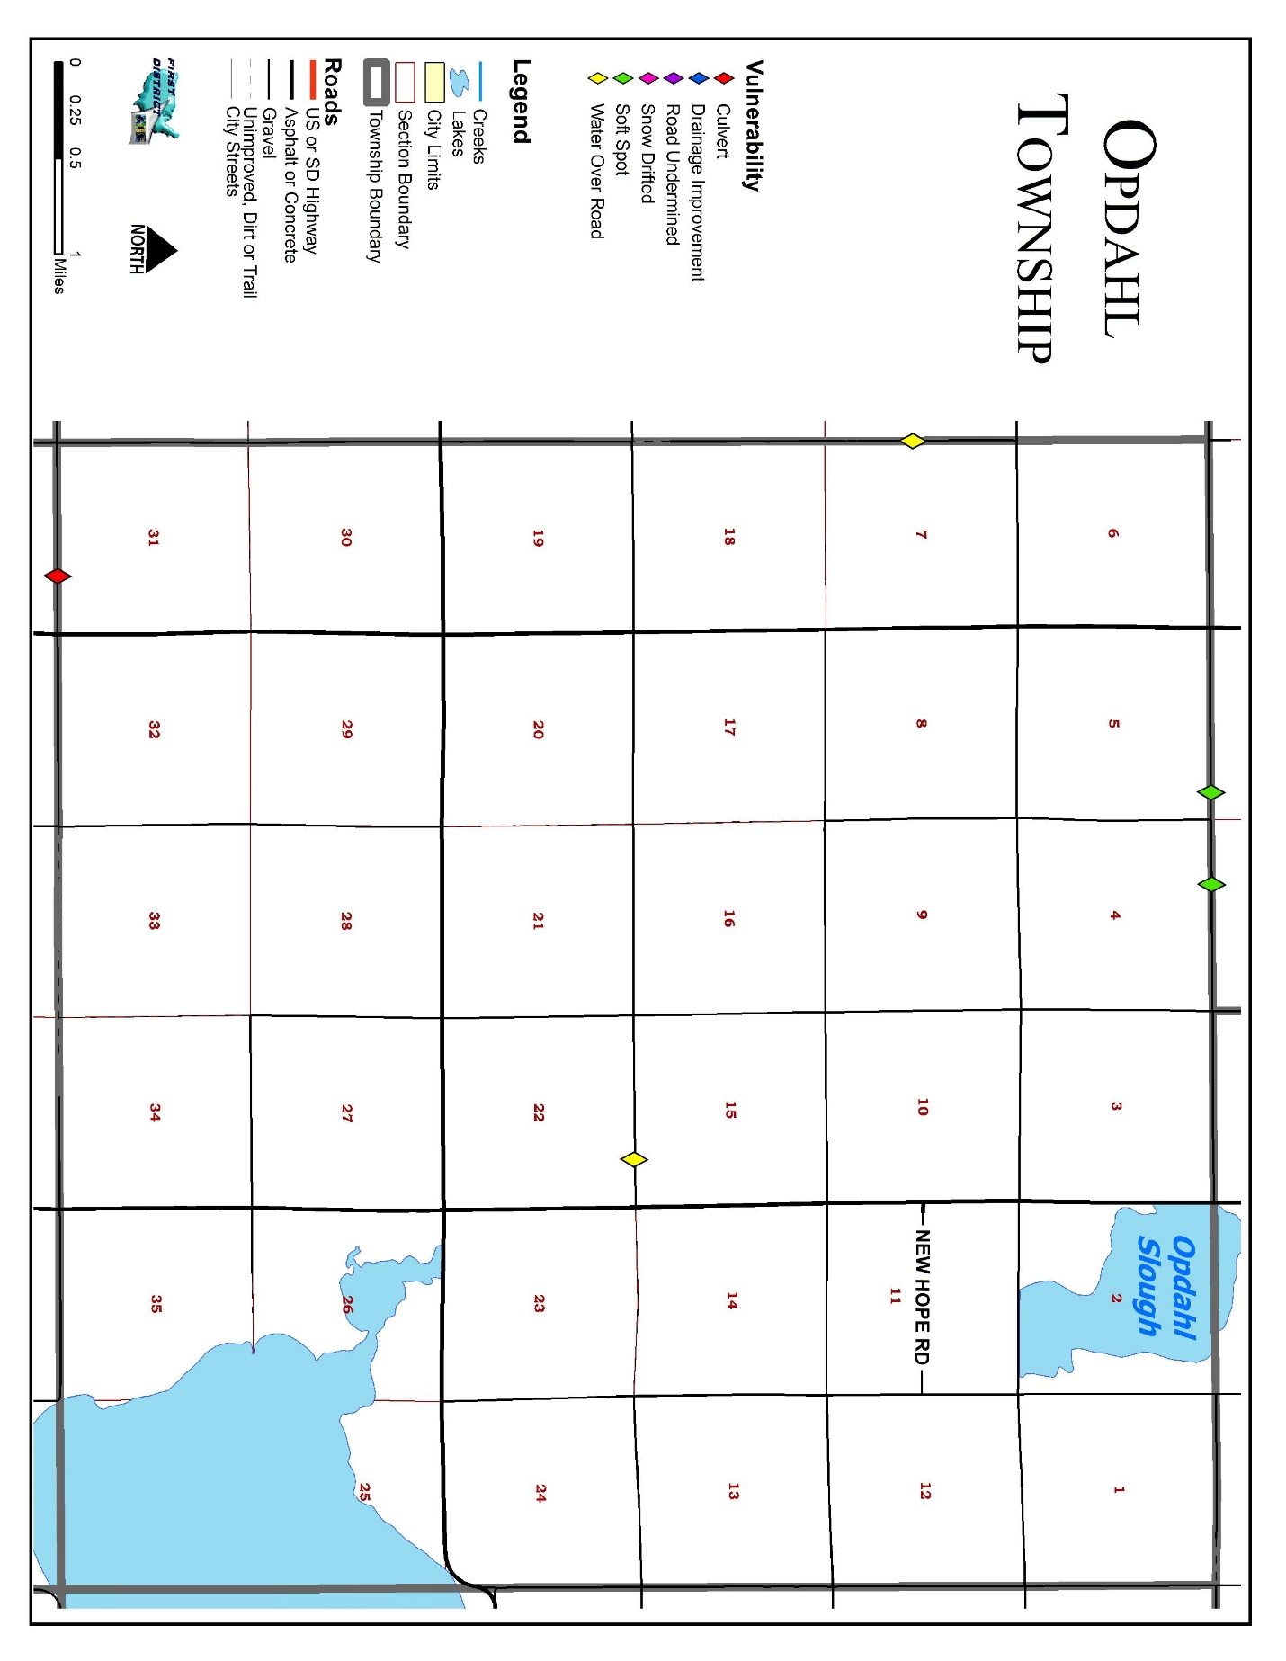

Appendix F – Comprehensive Land Use Maps

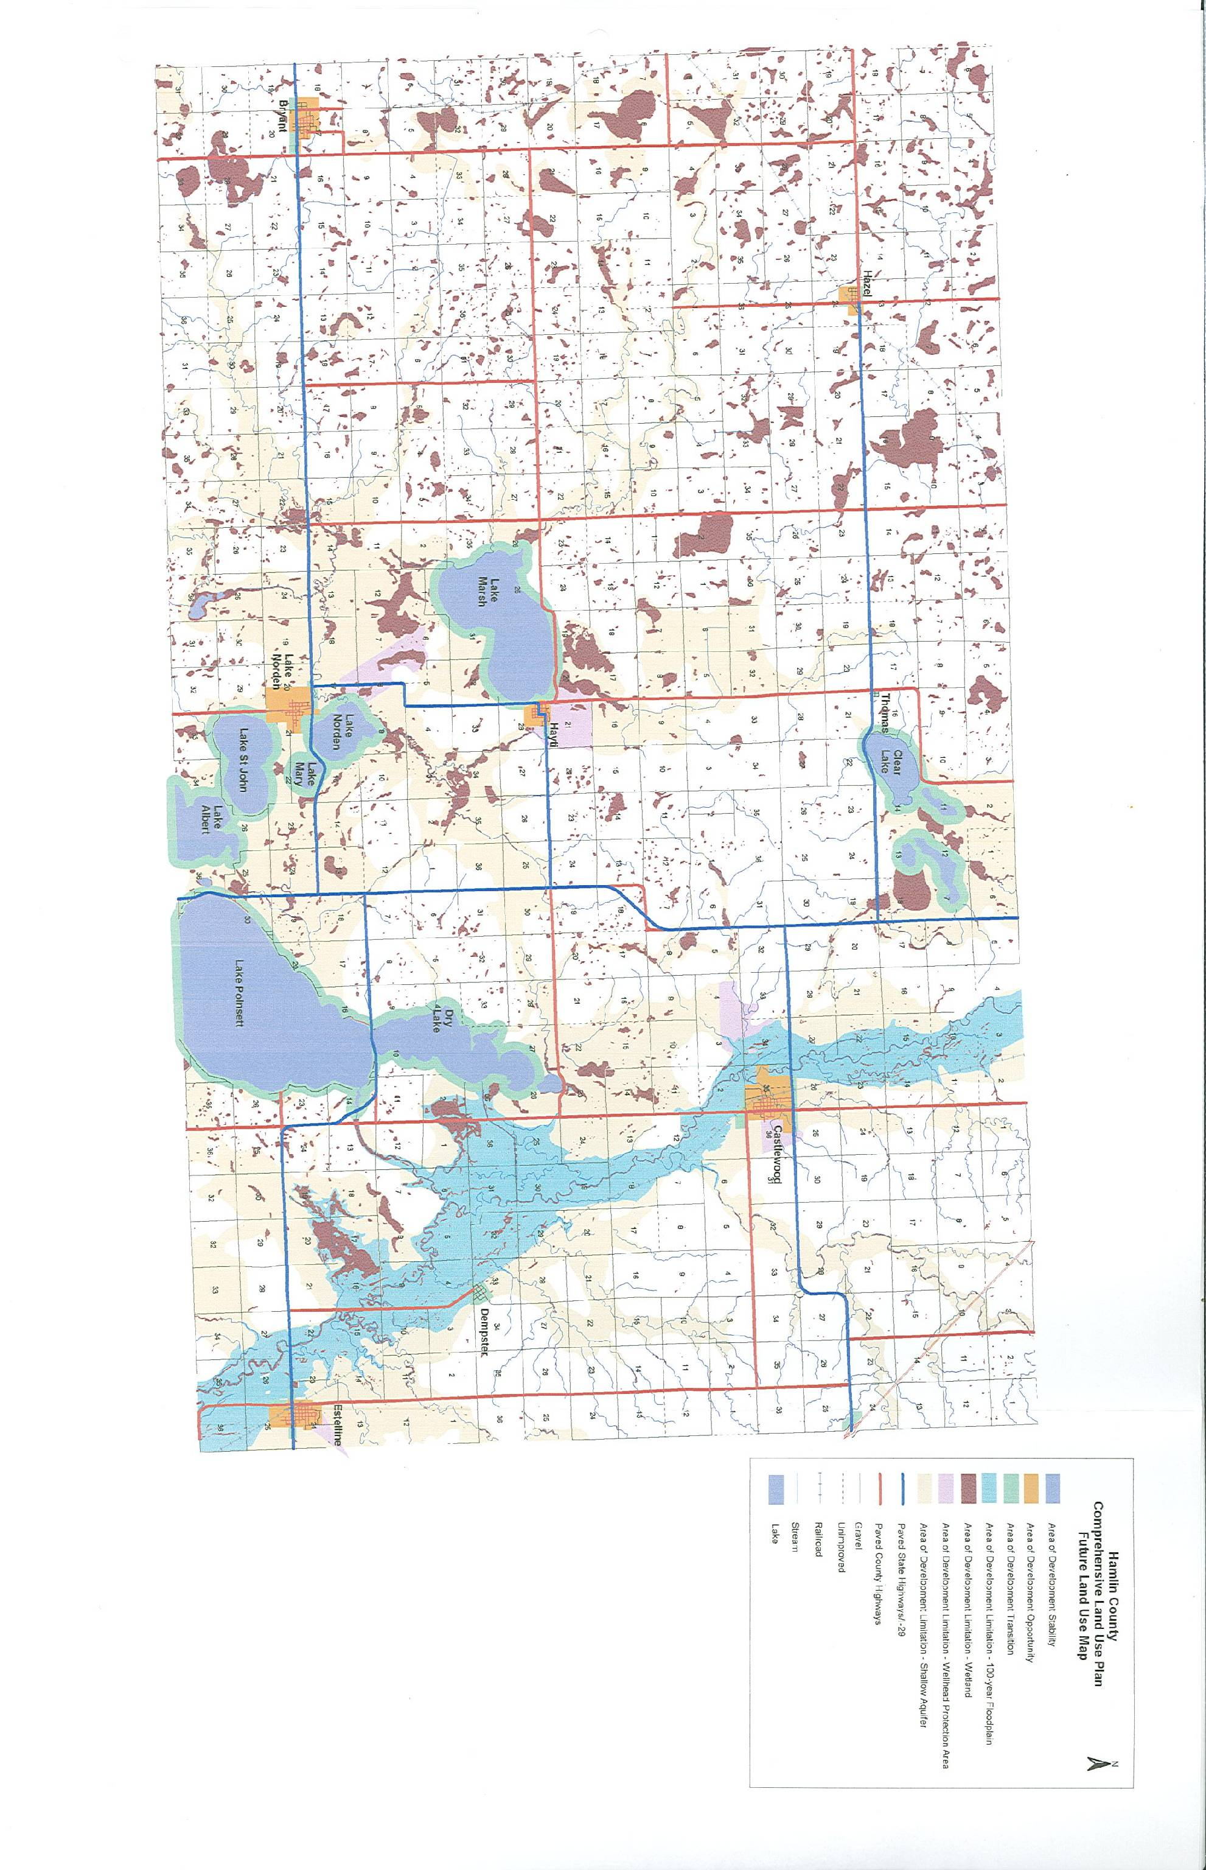
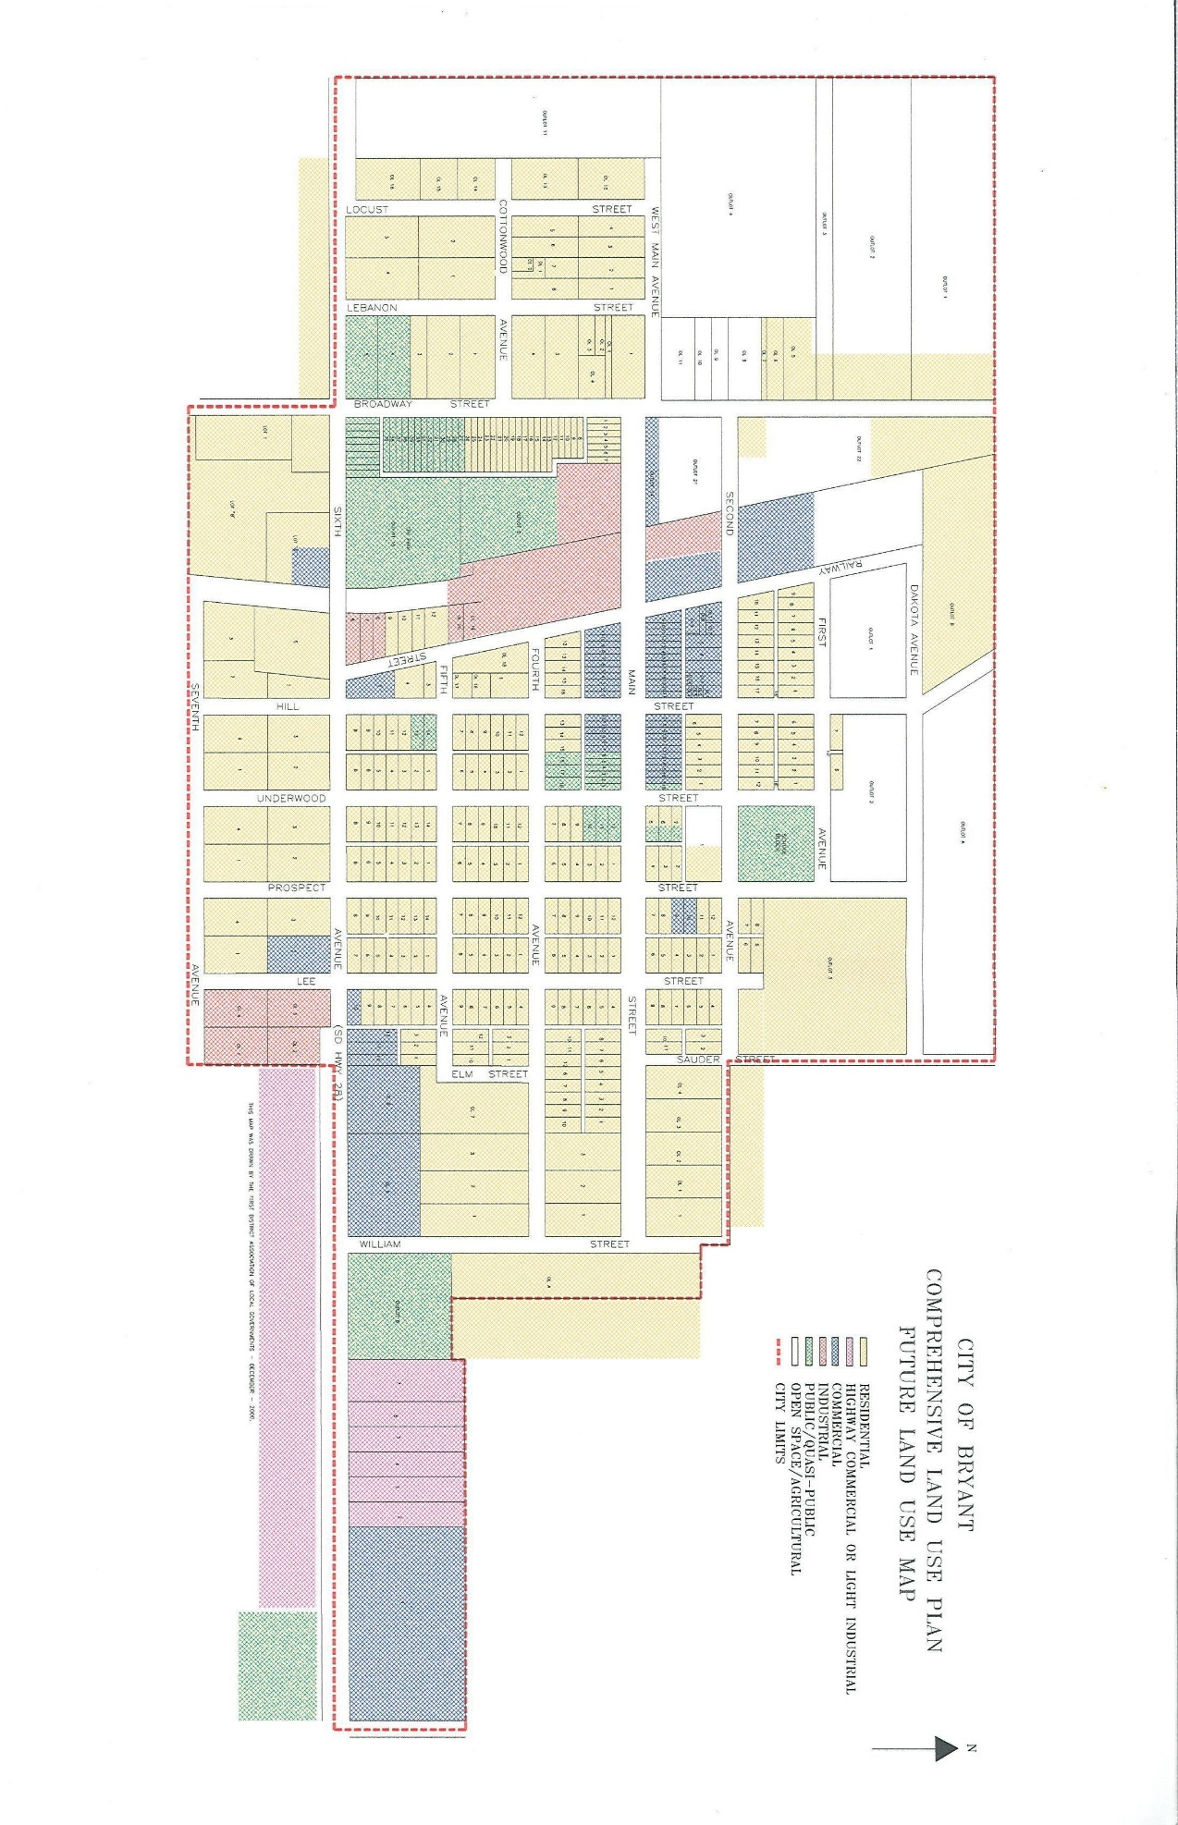
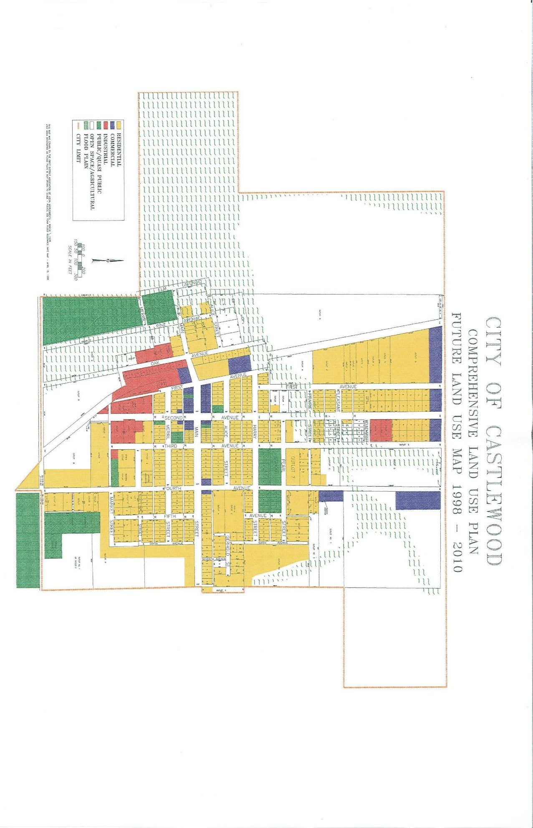

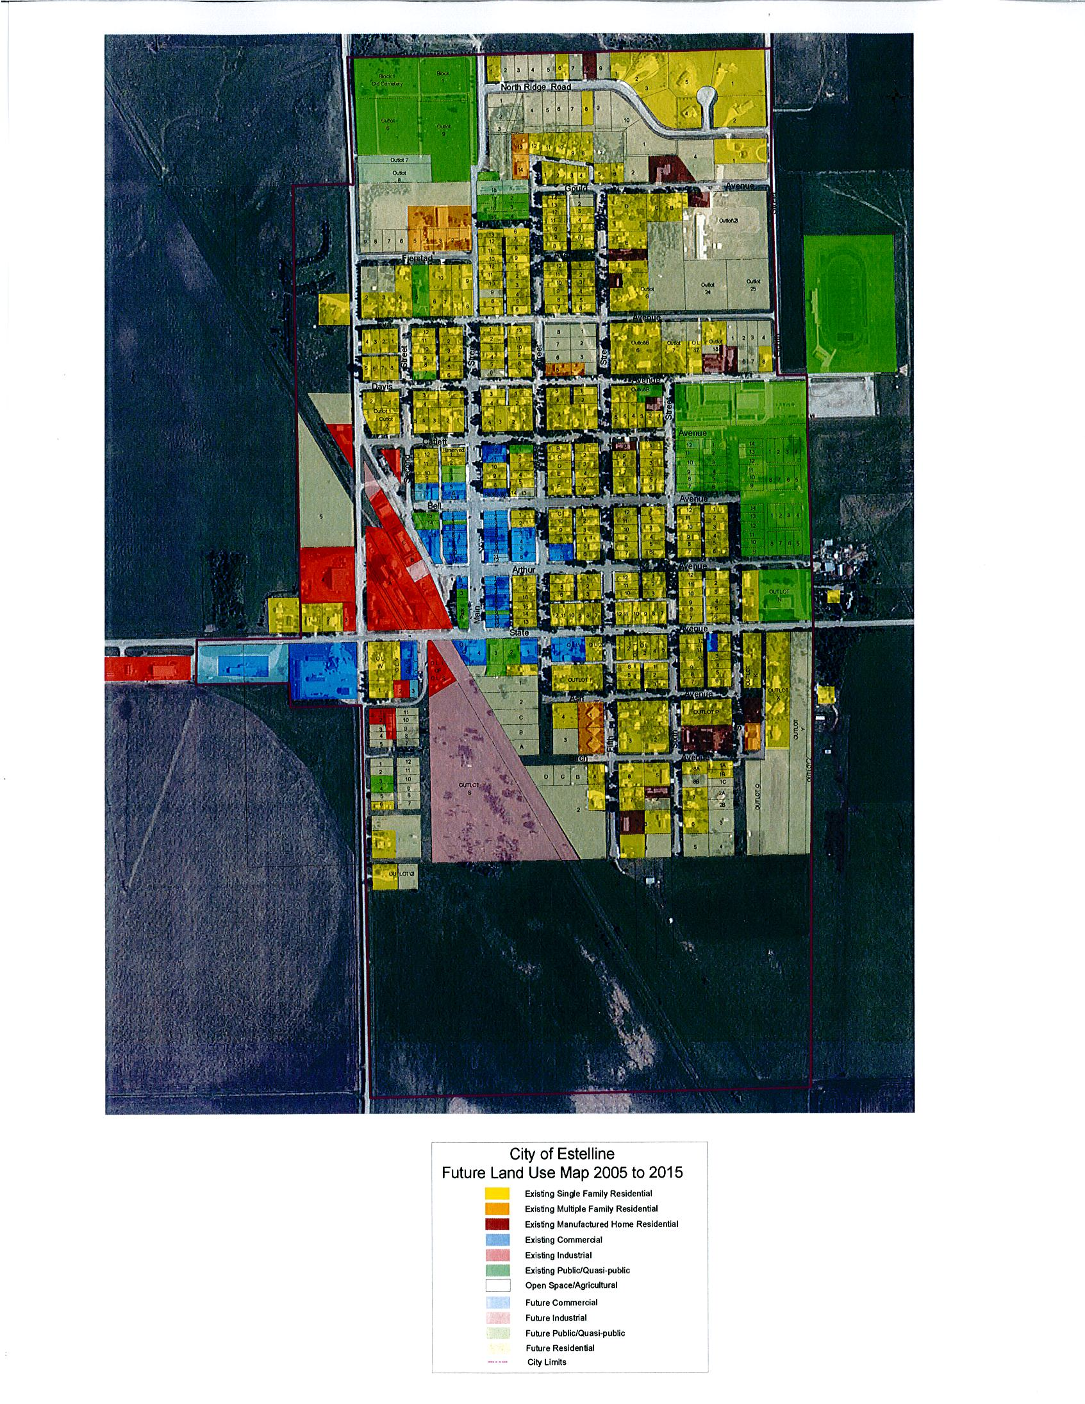
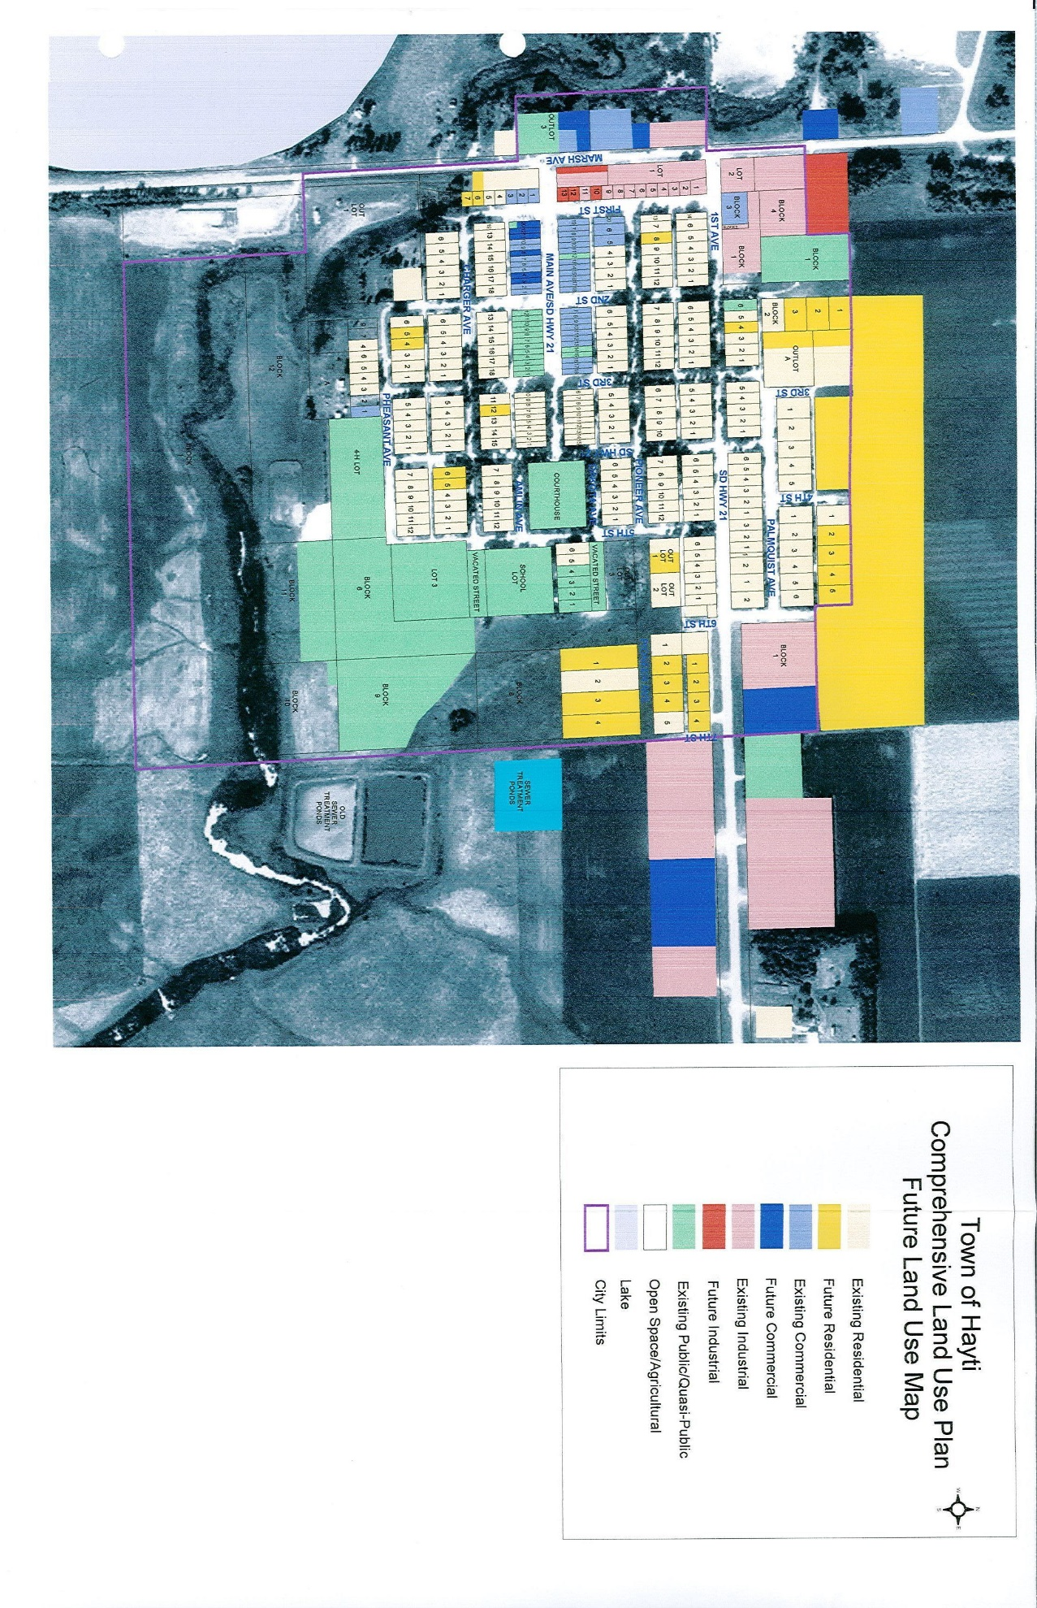

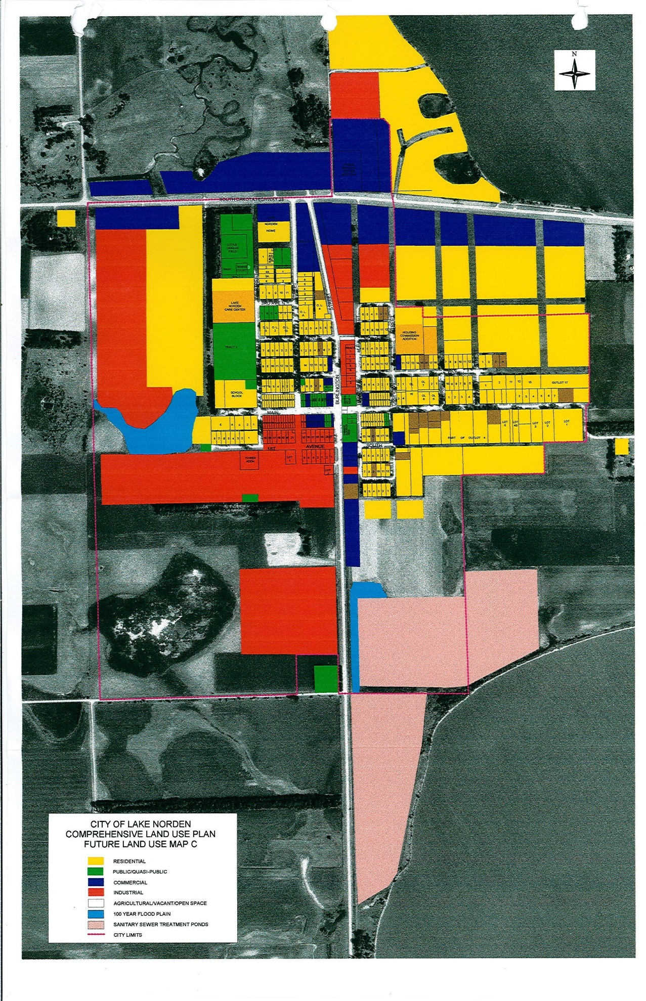
Appendix G
Review of 2014 PDM Mitigation Project Implementation
COMMUNITY | POTENTIAL MITIGATION PROJECTS | HAZARD | PRIORITY RANK | INCLUDED IN 2019 PLAN? | STATUS
Hamlin County | Establish Base flood elevation for Lake Albert & Lake Poinsett | Flooding | High | Yes | Ongoing
Hamlin County | Install 4 Storm Sirens @ Lake Poinsett | Severe Weather | High | Yes | Ongoing
Hamlin County | GIS Software purchase | Flooding | High | No | Completed
Hamlin County | Educate Property owners about flood prone areas and available buy-out programs | Flooding | High | Yes | Ongoing
Hamlin County | Encourage replacement of existing private structures in floodplain | Flooding | High | Yes | Ongoing
Hamlin County | Conduct Hydrological study on waterways | Flooding | High | Yes | Ongoing
Hamlin County | Repair and replace deteriorating road infrastructure due to flooding damage | Flooding | High | Yes | Ongoing
City of Bryant | Update Comp Plan and Zoning Ordinance | Flooding | High | Yes | In the process
City of Bryant | Provide storm family family/emergency kits/NOAA radios | Severe Weather | High | Yes | Ongoing
COMMUNITY | POTENTIAL MITIGATION PROJECTS | HAZARD | PRIORITY RANK | INCLUDED IN 2019 PLAN? | STATUS
City of Bryant | Bury overhead powerlines | Severe Weather | Medium | Yes | Ongoing
City of Bryant | Purchase Back up generator for critical infrastructure | Severe Weather | Medium | Yes | Ongoing
City of Castlewood | Construct Tornado Shelter | Tornado | Low | Yes | Ongoing
City of Castlewood | Install storm siren | Severe Weather | High | Yes | Ongoing
City of Castlewood | Purchase Back up generator for critical infrastructure | Severe Weather | High | Yes | Ongoing
City of Castlewood | Implement Drainage improvement | Flooding | High | Yes | Ongoing
City of Estelline | Purchase Back up generator for critical infrastructure | Severe Weather | High | Yes | Ongoing
City of Estelline | Construct Tornado Shelter | Tornado | Medium | Yes | Ongoing
City of Estelline | Conduct study to improve stormwater drainage within the city | Flooding | High | Yes | Ongoing
Town of Hayti | Purchase Back up generator | Severe Weather | High | Yes | Ongoing
COMMUNITY | POTENTIAL MITIGATION PROJECTS | HAZARD | PRIORITY RANK | INCLUDED IN 2019 PLAN? | STATUS
Town of Hayti | Update Comp Plan and Zoning Ordinance | Flooding | Medium | Yes | Ongoing
Town of Hayti | Train Firefighters and purchase necessary equipment | Fire | High | Yes | Ongoing
Town of Hayti | Bury 3 Phase power line | Severe Weather | High | Yes | Ongoing
Town of Hayti | Purchase land and remove railroad bed and culverts | Flooding | Medium | Yes | Ongoing
Town of Hayti | Reline sewer pipes | Flooding | Medium | Yes | Ongoing
Town of Hazel | Update Comp Plan and Zoning Ordinance | Flooding | Medium | Yes | Ongoing
Town of Hazel | Install Water tank for emergency use | Fire | Medium | Yes | Ongoing
Town of Hazel | Train Firefighters and purchase necessary equipment | Fire | Medium | Yes | Ongoing
Town of Hazel | Upgrade lift station and purchase generator | Severe Weather | High | Yes | Ongoing
COMMUNITY | POTENTIAL MITIGATION PROJECTS | HAZARD | PRIORITY RANK | INCLUDED IN 2019 PLAN? | STATUS
Town of Hazel | Make improvements to lagoon | Flooding | High | Yes | Ongoing
Town of Hazel | Move Sanitary sewer main line | Severe Weather | High | Yes | Ongoing
City of Lake Norden | Upgrade lift stations for generators | Severe Weather | High | Yes | Ongoing
City of Lake Norden | Upgrade storm siren system | Severe Weather | High | Yes | Ongoing
City of Lake Norden | Improve lagoons | Severe Weather | High | Yes | Ongoing
City of Lake Norden | Construct Tornado Shelter | Tornado | High | Yes | Ongoing
City of Lake Norden | Implement stormwater drainage improvements | Flooding | High | Yes | Ongoing
Appendix H - References

Hamlin County Comprehensive Land Use Plan – First District Association of Local Governments,
2005

Hamlin County Zoning Ordinance – First District Association of Local Governments, 2011

Hamlin County Multi-Hazard Mitigation Plan, 2019

City of Bryant Comprehensive Land Use Plan and Zoning Ordinance - First District Association of Local Governments, 2001

City of Castlewood Comprehensive Land Use Plan and Zoning Ordinance - First District Association of Local Governments, 1998

City of Estelline Comprehensive Land Use Plan and Zoning Ordinance - First District Association of Local Governments, 2005

Town of Hayti Comprehensive Land Use Plan and Zoning Ordinance - First District Association of Local Governments, 2003

City of Lake Norden Comprehensive Land Use Plan and Zoning Ordinance - First District Association of Local Governments, 2002

Federal Emergency Management Agency. 2011. Local Hazard Mitigation Planning Tool.

NFIP Flood Insurance Rate Maps

State of South Dakota Hazard Mitigation Plan. South Dakota Office of Emergency Management. 2019.

