Hamlin County Board of Adjustment
Staff Report
Monday – January 28th, 2019 – 1:00PM

Board of Adjustment

Item #1: Variance Request

Owner/Applicant: Royce Quamen/Vertex Construction
Property Description: Mykelmyre’s 3rd Addition Lot 34 and 34A in Section 30, Township 113N, Range 52W of the 5th P.M., Hamlin County, South Dakota (Norden Township)

Action Item –Variance: Lake Area Regulations: Rear Yard Lake Front Setback (3.7.10)
Zoning Designation: LP1 – Lake Park District
Request: The applicant is requesting a variance to construct an enclosed porch within the 50’ setback from the OHM.

            - Staff Review of Application
              - General Location

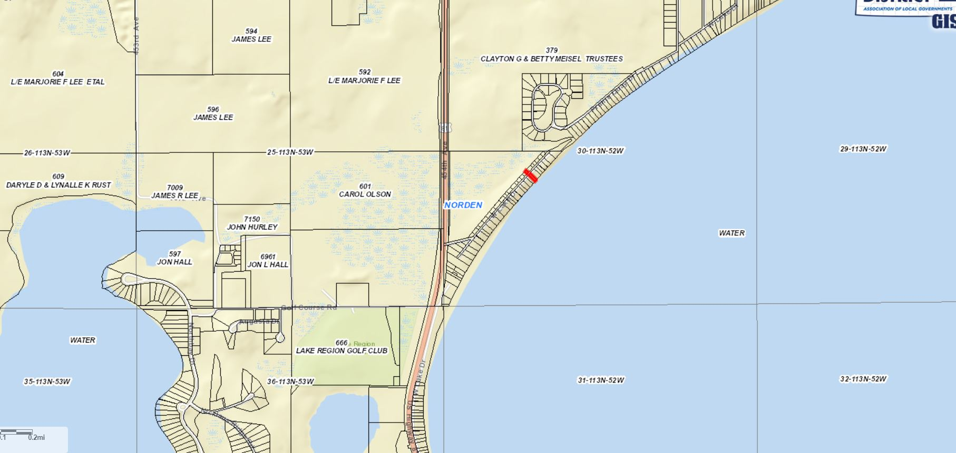

- The required setback for the rear yard (lake front) is 50’ from the ordinary high-water mark (1651.5’)
  - The applicant’s existing structure is within 50’ of the rear yard setback. The structure would be constructed at 38’ from the shoreline (12’ variance)
  - The proposed construction does not further encroach into the existing rear yard
  - Structure sits 10’ off the ground
- Though it may be the intent of Section 3.02.06 (Continuation of Nonstandard Uses) to allow for in line additions to nonconforming structures. The language does not specifically allow for the zoning officer to issue this permit without a variance issued by the Board.
2. Staff recommendations – Staff recommends approval based upon the following:
        - The board finds that it is the intent of Section 3.02.06 to allow for a nonconforming addition to be made on a nonconforming structure provided the addition is no closer to the property line (lake) than the current structure.
        - The Board finds that the proposed construction does not further encroach upon the rear yard lake front setback.
        - At the time of this report, staff has received no complaints from adjoining landowners.
Board Action: Rear Yard Lake Front Setback Variance: The Board may: 1) Postpone the decision 2) Deny the Request 3) Approve the request with or without conditions.

Item #2: Conditional Use

Owner/Applicant: Sioux Rural Water System Inc.
Property Description: The S 238’ of N 750’ of the E 410’ of the NW ¼ in Section 36, Township 115N, Range 53W of the 5th P.M., Hamlin County, South Dakota (Oxford Township)
Action Item – Conditional Use: Conditional Uses in the Ag District (3.04.04.13)
Zoning Designation: Ag – Agricultural
Request: Sioux Rural Water System seeks a conditional use permit to construct a booster station.

- Staff Review of Application
  - General Location
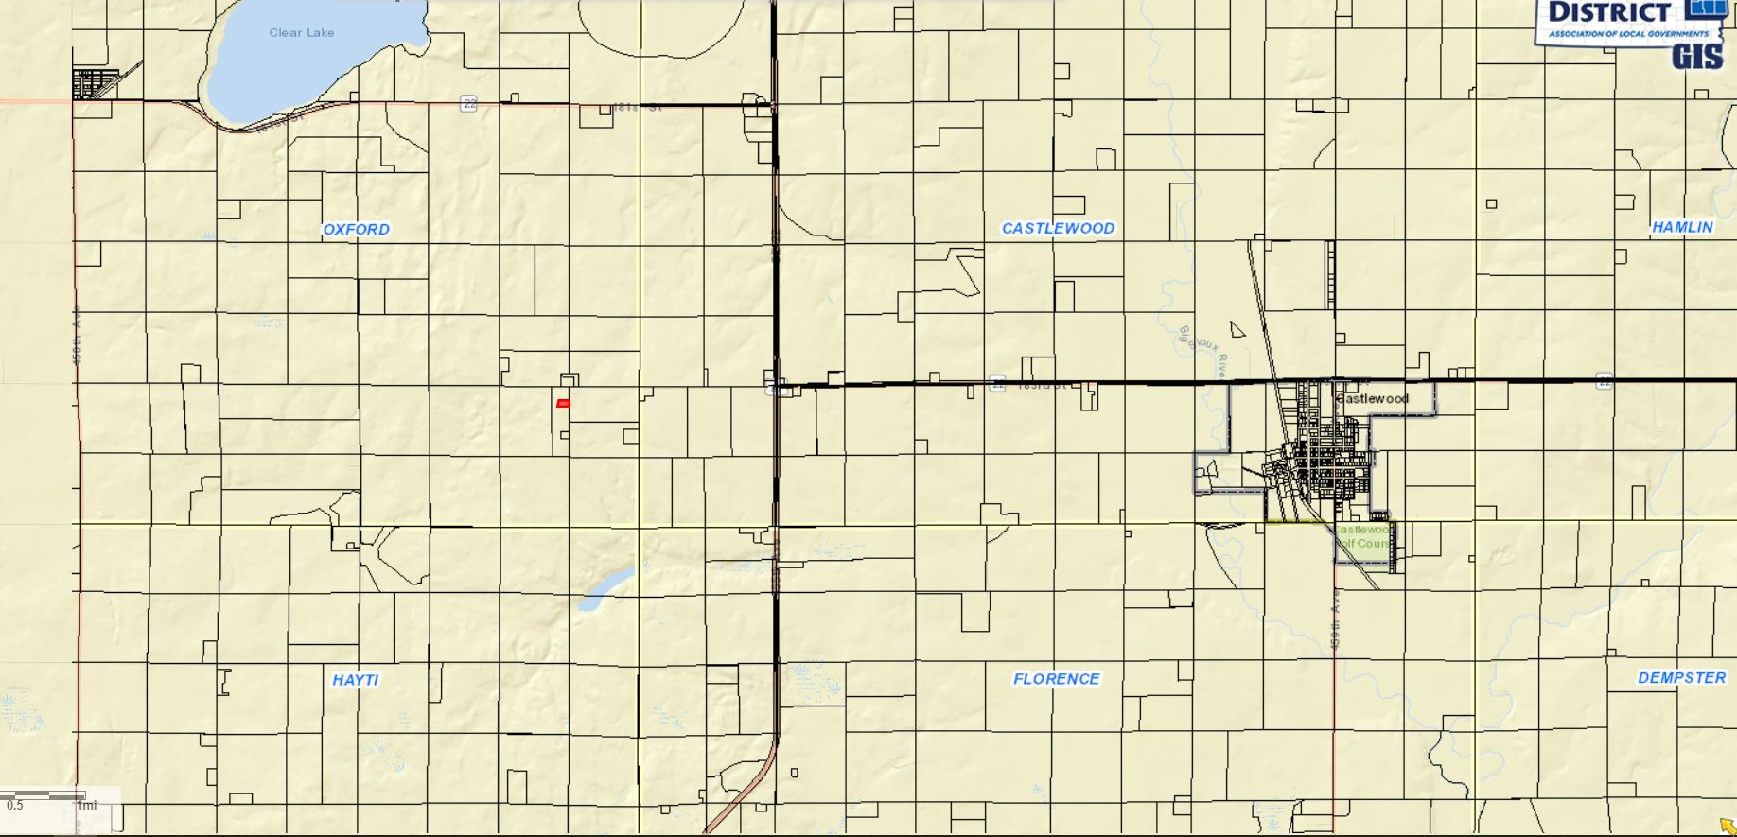

  - Sioux Rural Water System seeks to construct a booster station to provide better distribution and pumping to this service area.
  - Under the Hamlin County Zoning Ordinance, this classifies as construction under the Essential Public Service’s definition:
    - “Overhead or underground electrical, gas, steam or water transmission or distribution systems and structures, or collection, communication, supply or disposal systems and structures used by public for protection of the public health, safety or general welfare, including towers, poles, wires, mains drains, sewers, pipes, conduits, cables satellite dishes, and accessories in connection therewith.” (Section 269)
  - Proposed structure is 28’ wide and 14’ long and situated southwest of an existing ground storage reservoir on site
  - Structure meets all required setbacks from lot lines. Sioux Rural Water has an existing access easement with the adjacent landowners to provide access onto the property.
- Staff Recommendation: Staff recommends approval

Board Action:
The Board may after consideration of testimony and staff report: 1) Postpone the decision 2) Deny the Request 3) Approve the request with or without conditions.

Staff Report/BP Update/Permitted Special Use

