Hamlin County Planning Commission & Board of Adjustment
Staff Report
Monday – April 29th, 2019 – 7:00PM

Planning Commission

Item #1: Plat

Applicant/Owner: Sherri Kemink
Property Description: Lots 26B, 27B and 28B Saaranen’s Beach in the NE ¼ of Section 16, Township 113N, Range 52W of the 5th P.M., Hamlin County, South Dakota (Norden Township).
Action Item: Plat Approval
Zoning Designation: Lake Park 1
Request: Applicant is seeking to replat properties alongside Lake Poinsett for future development.

- Staff Review
  - All Lots meet minimum lot area and access requirements
  - Replat would consolidate four lots into three, allowing for more buildable space for future residential construction.
- Staff recommends approval

Planning Commission Action: The Commission may: 1) Postpone the decision or 2) Recommend Approval to County Commission or 3) Recommend Denial to County Commission.

Item #2: Plat

Applicant/Owner: Roger Smith
Property Description: Koenig Addition in the N ½ of the SE ¼ of Section 26, Township 115N, Range 55W of the 5th P.M., Hamlin County, South Dakota (Brantford Township)
Action Item: Plat Approval
Zoning Designation: Agricultural
Request: Applicant is seeking to replat property to separate residence from farming operations.

- Staff Review
  - Lot meets minimum lot area, density and access requirements in the Agricultural District
- Staff recommends approval

Planning Commission Action: The Commission may: 1) Postpone the decision or 2) Recommend Approval to County Commission or 3) Recommend Denial to County Commission.

Item #3: Plat

Applicant/Owner: Michael Smith
Property Description: Lot 1 of Smith Addition in the N ½ of the SE ¼ of Section 24, Township 113N, Range 54W of the 5th P.M., Hamlin County, South Dakota (Cleveland Township)
Action Item: Plat Approval
Zoning Designation: Agricultural
Request: Applicant is seeking to plat property for establishment of residential structure

- Staff Review
  - Lot meets minimum lot area, density and access requirements in the Agricultural District
- Staff recommends approval

Planning Commission Action: The Commission may: 1) Postpone the decision or 2) Recommend Approval to County Commission or 3) Recommend Denial to County Commission.

Item #4: Board Discussion - Alsville Crossing Gas Station

- Staff was notified by adjoining property owners to the Alsville Gas Station of their failure to meet the conditions placed upon their conditional use permit for the construction and operation of a gas station at the intersection of HWY 81 and HWY 28.
  - A fence had not been constructed along the eastern and southern portions of the property to shield headlights from the adjoining property.
  - Detailed drainage plans had not been submitted or plans for how to reduce and mitigate drainage of materials off site of the gas station through use of a detention pond or vegetated strip as means of filtration.
- After public comment from one of the adjoining land owners on these issues as well as dumping of snow and materials onto their property, the Board instructed Staff to send a letter to the owners of the Gas Station to appear at the next Board meeting to discuss these issues and potential solutions to the issues raised.

Board of Adjustment

Item #1: Variance Request

Owner/Applicant: Richard Carlson
Property Description: Saaranen’s Beach: Lot 17 & 16A Less the Northerly 60’ in Section 16, Township 113N, Range 52W of the 5th P.M., Hamlin County, South Dakota (Norden Township)
Action Item –Variance: Lake Area Regulations: Front Yard Road Front Setback (3.7.10)
Zoning Designation: LP1 – Lake Park District
Request: The applicant is requesting a variance to construct a new home closer to the road than required front yard road setback.

            - Staff Review of Application
              - General Location
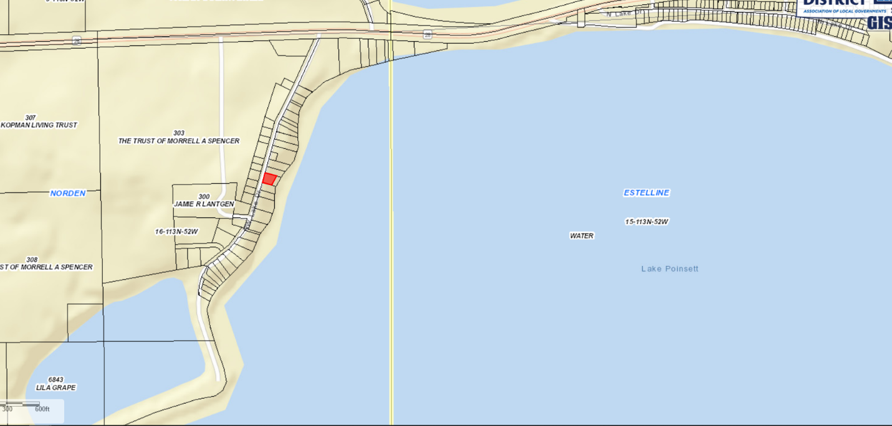

      - The applicant is requesting a reduced front yard setback to construct a new home. The required front yard road front setback is 30’, the applicant is requesting a 12’ variance.
      - Proposed construction meets all other required setbacks of the side yards and rear yard lake front (8’ and 50’ respectively)
      - The property slopes dramatically downward towards the lake, limiting the amount of usable space to construct the house within the required setbacks.
      - Staff Recommends approval:
        - Based upon the special conditions and circumstances that exist which are peculiar to the land: Size of property and topographic limitations.
        - No objections from adjoining landowners

Board Action: Front Yard Road Front Setback: The Board may: 1) Postpone the decision 2) Deny the Request 3) Approve the request with or without conditions.

Item #2: Conditional Use

Applicant/Owner: John Pantzke
Property Description: Lots 17, 17A, 18, & 18A of Prestrudes Subdivision in Lots 1 & 2 in the SE ¼ of the SW ¼ of Section 23, Township 113N, Range 52W of the 5th P.M., Hamlin County, South Dakota (Estelline Township)
Action Item – Conditional Use: Conditional Uses in the Lake Park District (3.07.05.05)
Zoning Designation: LP1 – Lake Park 1
Request: Mr. Pantzke is requesting to construct a boathouse within 50’ of the high-water mark on Lake Poinsett.

- Staff Review of Application
  - General Location
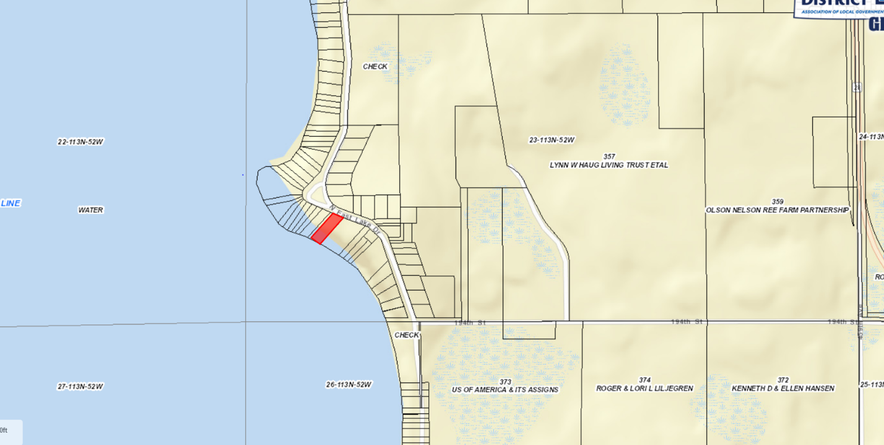

- Constructing a boat house within 50’ of the high-water mark is a conditional use listed in the Lake Park District.
- The proposed boathouse would be located 25’ from the measured OHM. Due to the topographic nature of the property, the structure will sit above the required 7’ about the OHM at around 1667’. The structure will be substantially buried into ground on account of the topography.
- Structure is proposed at 14’ wide by 30’ long with 10’ concrete sidewalls.

Staff Recommends approval with no additional conditions

Board Action:
The Board may after consideration of testimony and staff report: 1) Postpone the decision 2) Deny the Request 3) Approve the request with or without conditions.

Staff Report/Building Permit Update/Permitted Special Use Update

