Miner County
Pre-Disaster Mitigation Plan
2019 - 2024
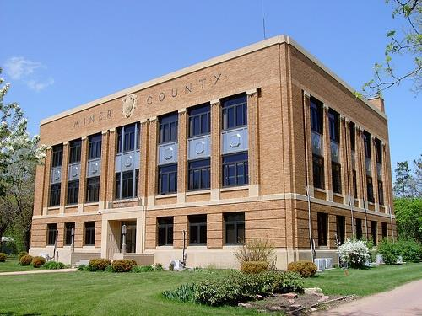

Prepared by: First District Association of Local Governments

- 1st Avenue NW Watertown, SD 57201 Phone: 605-882-5115

Fax: 605-882-5049 www.1stdistrict.org

For: Federal Emergency Management Administration

Miner County Pre-Disaster Mitigation Plan Page 1

TABLE OF CONTENTS

CHAPTER 1 – INTRODUCTION 5
• Introduction 5

• Authority for Pre-disaster Mitigation Plan 5

• Purpose 6

• Use of Plan 6

• Scope of Plan 6

• What is Hazard Mitigation 7

• Miner County Profile 8
o Population 8
o Social and Economic Description 11
o Physical Description and Climate 11
o Transportation and Commuting Patterns 11
o Utility Infrastructure 11
o Medical and Emergency Services 12

CHAPTER 2 – PREREQUISITES 13
• Adoption by Local Governing Body 13

• Multi-jurisdictional Plan Participation 13

CHAPTER 3 – PLANNING PROCESS 16
• Background 16

• Documentation of Planning Process 17
o Methodology 17
o Planning Framework 17
o Risk Identification & Assessment/Mitigation Strategy/Review of Plan 21

CHAPTER 4 – RISK ASSESSMENT 24
• Identification of Hazards 24

• Types of Natural Hazards in the PDM Jurisdiction Area 25

• Hazard Profile 29
o Dam Failure 30
o Drought and Fire 30
o Flood 32
o Hail 33
o Lightning 34
o Tornado 34
o Extreme Temperatures 35
o Thunderstorm and High Wind 36
o Winter Storms 37
• Assessing Vulnerability: Overview 39

• Assessing Vulnerability: National Flood Insurance Program Compliance 46

• Assessing Vulnerability: Repetitive Loss Properties 46

• Assessing Vulnerability: Severe Repetitive Loss Properties 47

• Assessing Vulnerability: Identifying Structures 48

• Assessing Vulnerability: Estimating Potential Losses 53
o Flooding 56
o Tornado 56
• Assessing Vulnerability: Analyzing Development Trends 56

• Unique or Varied Risk Assessment 58

Miner County Pre-Disaster Mitigation Plan Page 2

CHAPTER 5 – MITIGATION STRATEGY.................................................................................................. |  | 63
• | Mitigation Overview ........................................................................................................................ | 63
• Implementation of Mitigation Actions ............................................................................................. |  | 87
CHAPTER 6 – PLAN MAINTENANCE ...................................................................................................... |  | 88
• Monitoring, Evaluating, and Updating The Plan ............................................................................ |  | 88
• | Continued Public Participation/Involvement................................................................................... | 88
• | Annual Reporting Procedures ........................................................................................................ | 89
• | Five-Year PDM Review .................................................................................................................. | 89
• | Plan Amendments .......................................................................................................................... | 89
• Incorporation into Existing Planning Mechanisms ......................................................................... |  | 90
• | Potential Funding Sources ............................................................................................................. | 90
• | Federal ........................................................................................................................................... | 91
• | Local ............................................................................................................................................... | 94
• | Non-Governmental ......................................................................................................................... | 94

LIST OF TABLES

• | 1.1: | Miner County Municipalities ................................................................................................... | 8
• | 1.2: | Miner County Townships ........................................................................................................ | 9
• | 2.1: | Plan Participants ................................................................................................................... | 13
• | 2.2: | Dates of Plan Adoption by Jurisdiction ................................................................................. | 14
• | 2.3: | Record of Participation ......................................................................................................... | 15
• | 3.1: | Participation in Plan Development ....................................................................................... | 18
• | 3.2: | Opportunities for Public Comment ....................................................................................... | 20
• | 3.3: | Record of Review (Summary) ............................................................................................... | 23
• | 4.1: | Significant Hazard Occurrences 2000-2010 ......................................................................... | 24
• | 4.2: | Hazards Categorized by Likelihood of Occurrence ............................................................. | 25
• | 4.3: | Presidential Disaster Declarations in Miner County ............................................................. | 30
• | 4.4: | Dam Locations in Miner County ........................................................................................... | .30
• | 4.5: | Miner County Ten Year Drought History ............................................................................... | 31
• | 4.6: | Miner County Structural, Vehicle and Outside (Wildfire) Department Responses ............... | 32
• | 4.7: | Miner County 10-year Flood History ..................................................................................... | 32
• | 4.8: | Miner County 10-year Hail History ....................................................................................... | 33
• | 4.9: | Miner County Lightning History ............................................................................................. | 34
• | 4.10: | Miner County 10-year Tornado History ................................................................................ | 34
• | 4.11: | Miner County 10-year History of Extreme Temperatures .................................................... | 36
• | 4.12: | Miner County 10-year History for Thunderstorms ................................................................ | 37
• | 4.13 | Miner County 10-year History of Snow and Ice Storms ........................................................ | 38
• 4.14: Overall Summary of Vulnerability by Jurisdiction .................................................................. |  |  | 40
• 4.15: Communities Participating in the National Flood Program, Miner County, SD..................... |  |  | 46
• 4.16: Miner County National Flood Insurance Program Statistics ................................................. |  |  | 46
• 4.17: Critical Structures in Miner County ....................................................................................... |  |  | 48
• 4.18: Administrative and Technical Capabilities ............................................................................ |  |  | 51
• 4.19: Capabilities of Growth Guidance Instruments ...................................................................... |  |  | 52
• 4.20: Miner County (Rural Area) Estimated Potential Losses to Vulnerable Structures ............... |  |  | 54
• 4.21: Canova Estimated Potential Dollar Losses to Vulnerable Structures ................................... |  |  | 54
• 4.22: Carthage Estimated Potential Dollar Losses to Vulnerable Structures ................................ |  |  | 54
• 4.23: Howard Estimated Potential Dollar Losses to Vulnerable Structures ................................... |  |  | 55
• 4.24: Vilas Estimated Potential Dollar Losses to Vulnerable Structures ....................................... |  |  | 55
• 4.25: Miner County Estimated Potential Dollar Losses to Vulnerable Structures .......................... |  |  | 55
• | 4.26: HAZUS-MH Base Flood (1 Percent Chance) Loss Estimation Results (2007) ................... |  | 56
• 4.27: Miner County Annualized Losses from Tornadoes ............................................................... |  |  | 56
Miner County Pre-Disaster Mitigation Plan |  |  | Page 3

• 4.28: Miner County Potential Floodplain Development – By Land Use Type 57

• 4.29: Town of Canova Potential Floodplain Development – By Land Use Type 57

• 4.30: Town of Carthage Potential Floodplain Development – By Land Use Type 57

• 4.31: City of Howard Potential Floodplain Development – By Land Use Type 58

- 5.1: Actions/Projects to Reduce Risk Through Policy Implementation ………………………………65

- 5.2: Actions/Projects to Change the Characteristics or Impacts Hazards ………………………….67

- 5.3: Actions/Projects to Reduce Loss Potential of Infrastructure to Hazards ………………………68

- 5.4: Actions/Projects to Reduce Severe Weather Risk through Policy Implementation …………...69

- 5.5: Actions/Projects to Change the Characteristics or Impacts of Severe Weather Hazards ……70

- 5.6: Actions/Projects to Reduce Loss Potential of Infrastructure to Severe Weather Hazards …...71

- 5.7: Actions/Projects to Reduce Fire and Drought Risk through Policy Implementation ………….73

- 5.8: Actions/Projects to Reduce Loss Potential of Infrastructure to Fire and Drought Hazards ….73

- 5.9: Actions/Projects to Change the Characteristics or Impacts of Fire and Drought Hazards …. 74

- 5.10 Technological Activities …………………………………………………………………………….74

- 5.11: Planning Activities ………………………………………………………………………………….75

- 5.12: Administration/Coordination Activities ……………………………………………………………76
• 5.13: Proposed Mitigation Activities 79

LIST OF FIGURES

• 1.1: Political Map 10

• 4.1: Town of Canova Hazard Vulnerability/Critical Infrastructure Map 59

• 4.3: City of Carthage Hazard Vulnerability/Critical Infrastructure Map 60

• 4.4: City of Howard Hazard Vulnerability/Critical Infrastructure Map 61

• 4.5: Miner County Hazard Vulnerability/Critical Infrastructure Map 62

• 5.1: Miner County Mitigation Activity Sites Map 83

• 5.2: Town of Canova Mitigation Activity Sites Map 84

• 5.3: City of Carthage Mitigation Activity Sites Map 85

• 5.4: City of Howard Mitigation Activity Sites Map 86

APPENDIX 95

• Appendix A: Resolution of Adoption by Jurisdiction 96

• Appendix B: PDM Planning Team Agendas, Sign-in Sheets 101

• Appendix C: Community Meeting and Sign in Sheets Jurisdiction 111

- Appendix D: Hazard Identification/Vulnerability Worksheets ……………………………………… 121
• Appendix E: Township Vulnerable and Potential Mitigation Project Site Maps 130

- Appendix F: Comprehensive Land Use Maps ……………………………………………………….147
• Appendix G: Review of 2013 PDM Mitigation Project Implementation 152

• Appendix H: References 154

Miner County Pre-Disaster Mitigation Plan Page 4

CHAPTER 1
INTRODUCTION

INTRODUCTION

Miner County (County) is vulnerable to natural hazards that have the possibility of causing serious threat to the health, welfare, and security of our citizens. The cost of response and recovery, in terms of potential loss of life or loss of property, from potential disasters can be lessened when attention is turned to mitigating their impacts and effects before they occur or re-occur.

This plan is an update of the Pre-Disaster Mitigation Plan (PDM) that was developed by the County in 2014. The document will serve as a strategic planning tool for use by the county and its communities in its efforts to mitigate against future disaster events. The plan identifies and analyzes the natural disasters that may occur in the County in order to understand the county’s vulnerabilities and propose mitigation strategies that minimize future damage caused by those hazards. This knowledge will help identify solutions that can significantly reduce threat to life and property. The plan is based on the premise that hazard mitigation works. With increased attention to mitigating natural hazards, communities can do much to reduce threats to existing citizens and avoid creating new problems in the future. In addition, many mitigation actions can be implemented at minimal cost.

In the past 10 years there have been 20 major Disaster Declarations which have occurred fully or partially within the state of South Dakota, including 6 which occurred in 2010. Miner County is not a stranger to natural and man-made disasters. In order to prevent and reduce the cost that is incurred by businesses, citizens, and property owners from these disasters, the Miner County Pre-Disaster Mitigation Plan developed. This plan identifies hazards that occur throughout Miner County and mitigation projects that will aid in preventing and reducing the effects of those disasters on the property and lives within. Special consideration has been given to critical infrastructure throughout the country.

This is not an emergency response or emergency management plan. Certainly, the plan can be used to identify weaknesses and refocus emergency response planning. Enhanced emergency response planning is an important mitigation strategy. However, the focus of this plan is to support better decision making directed toward avoidance of future risks and the implementation of activities or projects that will eliminate or reduce the risk for those that may already have exposure to a natural hazard threat.

AUTHORITY FOR PRE-DISASTER MITIGATION PLAN

In October of 2000, the Disaster Mitigation Act (DMA2K) was signed to amend the 1988 Robert T. Stafford Disaster Relief and Emergency Assistance Act. Section 322 (a-d) requires that local governments, as a condition of receiving federal disaster mitigation funds, have a pre-disaster mitigation (PDM) plan in place that:

- Identifies hazards and their associated risks and vulnerabilities;

- Develops and prioritizes mitigation projects; and

- Encourages cooperation and communication between all levels of government and the public.

The objective of this plan is to meet the hazard mitigation planning needs for the County and participating entities. Consistent with the Federal Emergency Management Agency’s guidelines,

Miner County Pre-Disaster Mitigation Plan Page 5

this plan will review all possible activities related to disasters to reach efficient solutions, link hazard management policies to specific activities, educate and facilitate communication with the public, build public and political support for mitigation activities, and develop implementation and planning requirements for future hazard mitigation projects.

PURPOSE

The County PDM is a planning tool to be used by the County, as well as other local, state and federal units of government, in their efforts to fulfill federal, state, and local hazard mitigation planning responsibilities; to promote pre and post disaster mitigation measures, short/long range strategies that minimize suffering, loss of life, and damage to property resulting from hazardous or potentially hazardous conditions to which citizens and institutions within the county are exposed; and to eliminate or minimize conditions which would have an undesirable impact on our citizens, economy, environment, or the well-being of the County. This plan will aid city, township, and county agencies and officials in enhancing public awareness to the threat hazards have on property and life, and what can be done to help prevent or reduce the vulnerability and risk of each County jurisdiction.

USE OF PLAN

The plan will be used to help the county and communities and their elected and appointed officials:

- Plan, design and implement programs and projects that will help reduce their community’s vulnerability to natural hazards

- Facilitate inter-jurisdictional coordination and collaboration related to natural hazard mitigation planning and implementation.

- Develop or provide guidance for local emergency response planning.

- Be compliant with the Disaster Mitigation Act of 2000.

SCOPE OF PLAN

- Provide opportunities for public input and encourage participation and involvement regarding the mitigation plan.

- Identify hazards and vulnerabilities within the county and local jurisdictions.

- Combine risk assessments with public and emergency management ideas.

- Develop goals based on the identified hazards and risks.

- Review existing mitigation measures for gaps and establish projects to sufficiently fulfill the goals.

- Prioritize and evaluate each strategy/objective.

- Review other plans for cohesion and incorporation with the PDM.

- Establish guidelines for updating and monitoring the plan.

- Present the plan to the Miner County Commissioners and the participating communities within the county for adoption.

Miner County Pre-Disaster Mitigation Plan Page 6

WHAT IS HAZARD MITIGATION?

Hazard mitigation is defined as any cost-effective action(s) that has the effect of reducing, limiting, or preventing vulnerability of people, property, and the environment to potentially damaging, harmful, or costly hazards. Hazard mitigation measures, which can be used to eliminate or minimize the risk to life and property, fall into three categories. First are those that keep the hazard away from people, property, and structures. Second are those that keep people, property, and structures away from the hazard. Third are those that do not address the hazard at all but rather reduce the impact of the hazard on the victims such as insurance. This mitigation plan has strategies that fall into all three categories.

Hazard mitigation measures must be practical, cost effective, and environmentally and politically acceptable. Actions taken to limit the vulnerability of society to hazards must not in themselves be more costly than the value of anticipated damages.

The primary focus of hazard mitigation actions must be at the point at which capital investment decisions are made and based on vulnerability. Capital investments, whether for homes, roads, public utilities, pipelines, power plants, or public works, determine to a large extent the nature and degree of hazard vulnerability of a community. Once a capital facility is in place, very few opportunities will present themselves over the useful life of the facility to correct any errors in location or construction with respect to hazard vulnerability. It is for these reasons that zoning and other ordinances, which manage development in high vulnerability areas, and building codes, which ensure that new buildings are built to withstand the damaging forces of hazards, are often the most useful mitigation approaches a jurisdiction can implement.

Previously, mitigation measures have been the most neglected programs within emergency management. Since the priority to implement mitigation activities is generally low in comparison to the perceived threat, some important mitigation measures take time to implement. Mitigation success can be achieved, however, if accurate information is portrayed through complete hazard identification and impact studies, followed by effective mitigation management. Hazard mitigation is the key to eliminating long-term risk to people and property in South Dakota from hazards and their effects. Preparedness for all hazards includes: response and recovery plans, training, development, management of resources, and mitigation of each jurisdictional hazard.

This plan evaluates the impacts, risks and vulnerabilities of natural hazards within the jurisdictional area of the entire county. The plan supports, provides assistance, identifies and describes mitigation projects for each of the local jurisdictions who participated in the plan update. The suggested actions and plan implementation for local governments could reduce the impact of future natural hazard occurrences. Lessening the impact of natural hazards can prevent such occurrences from becoming disastrous, but will only be accomplished through coordinated partnership with emergency managers, political entities, public works officials, community planners and other dedicated individuals working to implement this program.

Miner County Pre-Disaster Mitigation Plan Page 7

MINER COUNTY PROFILE

Population

Miner County is located in southeast South Dakota. It borders Kingsbury County to the north, Lake County to the east, Hanson and McCook Counties to the south, and Sanborn County to the west. The county has a geographic area of 576 square miles and it’s population according to the 2010 US Census was 2,389, which averages to 4.2 people per square mile. Just over 22 percent of the population is older than age 65. Education levels of persons include eighty-five percent high school graduate and seventeen percent college level.

The county has experienced a significant reduction in population during the past 10 years and is expected to decrease slightly during the next 10 years. See table in the appendix (Estimated population losses 2000-2008) Miner had an estimated 15.5% population decrease from 2000 to 2008. Population decreases are expected in both the rural and municipal populations. Miner County had the largest percentage decrease in population since the last census of any county within the state. The 1990 population was 3,272, while the 2010 population was 2,389. This is mainly due to the location and close proximity to much larger communities. Madison, Sioux Falls, and Mitchell tend to attract residents due to employment opportunities. The City of Howard has a revitalization committee and is working to attract industry to the area. They have had success, attracting some small industry to provide local employment. Table 1.1 shows the population and number of housing units of the county’s municipalities. Table 1.2 lists the sixteen County Townships by population.

Table 1.1: Miner County Municipalities

Name | Population | Location |  |  | Elevation | Housing Units
Canova | 105 | 43 | 52’ 52” N |  | 1,522 feet | 59
 |  | 97 | 30’ 16” W
Carthage | 144 | 44 | 10’ 16” N |  | 1,434 feet | 136
 |  | 97 | 42’ 59” W
Howard | 858 | 44 | 00’ 39” N |  | 1,575 feet | 509
 |  | 97 | 31’ 36” W
Roswell* | 15 | 44 | 00'26'' N |  | 1,401 feet | 11
 |  | 97 | 41'45'' W
Vilas** | 20 | 44 | 00'38'' | N | 1,480 feet | 13
 |  | 97 | 35'50'' W
Fedora* | *Township | 44 | 00'32'' | N | 1,375 feet | 16
 |  | 97 | 47'27'' W
Epiphany* | *Township | 43 | 50'57'' | N | 1,362 feet | 10
 |  | 97 | 39'42'' W
Miner County | 1,232 | 44 | 02'40'' | N | 1,463 feet | 1,308
(rural area only) |  | 97 37'29'' W
*Unincorporated
**Non-participating entity

Source: 2010 Census, www.Lat-Long.com, www.usbeacon.com

Miner County Pre-Disaster Mitigation Plan Page 8

Table 1.2: Miner County Townships

Township | Population | Township | Population
Adams | 120 | Henden | 111
Beaver | 40 | Howard | 140
Belleview | 70 | Miner | 35
Canova | 82 | Redstone | 19
Carthage | 38 | Rock Creek | 78
Clearwater | 162 | Roswell | 58
Clinton | 82 | Vermillion | 90
Grafton | 71
Green Valley | 51 | Township Total Pop. | 1,247

Source: 2010 Census – note: municipal populations not included

Miner County Pre-Disaster Mitigation Plan Page 9

Figure 1.1 Political Map
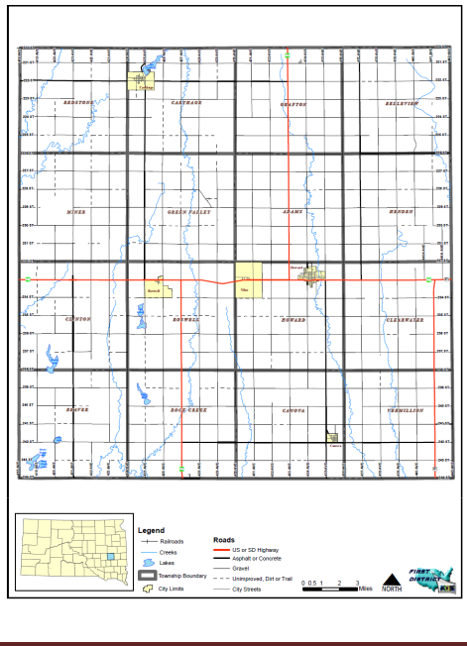

Miner County Pre-Disaster Mitigation Plan Page 10

Social and Economic Description

Miner County is governed by a five member board of commissioners and the County’s economy is primarily dependent upon the agricultural sector. Most non-agricultural employment is concentrated in the City of Howard and consists of a mixture of manufacturing, education, health care, and service sector employment. The City of Howard is also the county seat and the retail hub for the area.

The remaining communities serve as bedroom communities for Howard and other surrounding communities while providing a small town atmosphere for those residents. Most of the communities have limited retail and service sectors which provide basic needs to the residents.

Physical Description and Climate

Miner County is located in southeast South Dakota. It borders Kingsbury County to the north, Lake County to the east, Hanson and McCook Counties to the south, and Sanborn County to the west. A majority of the land area within the County is undeveloped with most of the land consisting of grassland, pasture and cropland. The topography of the County is mostly flat to undulating. The County’s elevation has a range of approximately 1,400 feet above sea level to approximately 1,575 feet above sea level.

Miner County has a limited amount of large lakes in the county with Lake Carthage being the largest in the community of Carthage. Rock Creek runs southeast from Lake Carthage. Red Stone Creek is about five miles west of Howard and runs south through the county. The West Vermillion Creek runs through the municipal golf course and does cause flooding during high water events. Miner County participates in the National Flood Insurance Program, but the only mapping available is for the City of Howard.

The County’s climate is considered Mid-Continental with hot summers and cold winters. Normal summer temperatures are eighty degrees Fahrenheit and winter temperature twenty-one degrees (about twelve degrees in January). Average annual precipitation is twenty inches (approximately eighty percent of the precipitation falls between the months of April and September), and the average annual snowfall is twenty-four inches, although as much as eighty inches and as little as five inches have fallen annually. Due to the strong winds that usually accompany the snowfall, it is common to find open fields bare while snow piles up in the sheltered areas.

Transportation and Utility Infrastructure

US Highway 34 is the main east/west route and US Highway 25 is the major north/south route in Miner County. US Highway 81 also provides interstate access in the eastern portion of the County. Transportation systems, other than the highway system are very limited. The railroad was abandoned several years ago and the tracks removed. The Howard Airport has grass runways and only private aircraft utilize the facility. The airport does not have any nav-aid, communications or flight service capabilities.

The remainder of the county meets its current transportation needs through a mixture of county, township and municipal road systems. The rural road system performs two basic functions: (1) providing general mobility for the residents in rural areas, and (2) accommodating the movements of agricultural products to market. The rural transportation system was not designed to accommodate large volumes of traffic on a daily basis.

Miner County Pre-Disaster Mitigation Plan Page 11

Water is provided to Miner County residents through private wells, the Hanson Rural Water System or the Kingbrook Rural Water System. Carthage, Howard, Fedora and Vilas receive water from Kingbrook Rural Water System as well as many rural residents within the County. Epiphany receives water from the Hanson Rural Water System. Private wells serve the remainder of the County’s residents.

Electricity within the County is provided Central Electric Cooperative and Excel Energy. The City of Howard operates a municipal power system. The primary providers of phone, cable and internet services are Alliance Communications, Santel Communications, and, Triotel Communications. AT&T and Verizon provide cellular towers and service is available in most parts of the county, but there are still places in the county where cellular coverage does not reach.

Medical and Emergency Services

The primary medical facility in the County is the Howard Community Health Center, which can provide emergency services and is open 44 hours a week. The Howard Community Health Center is part of the Horizon Health Care, Inc. and has a community-based network of 17 community health centers throughout South Dakota. Miner County operates a volunteer ambulance service with the addition of two full-time "on-call" EMTs. Cora Schwader serves as ambulance manager under the direction of the Miner County Ambulance Board. Board members include Kari Jo Carlson, Barb Esser, Lanny Klinkhammer, Jerome Johnson, Denise Gassman, Valera Anderson, and Michael Connor.

The Miner Country Sheriff’s Department provides law enforcement for the entire county.

There are fire departments in Canova, Carthage, and Howard.

Miner County Pre-Disaster Mitigation Plan Page 12

CHAPTER 2
PREREQUISITES

ADOPTION BY LOCAL GOVERNING BODY

The local governing body, that oversees the update of the Miner County Pre-Disaster Mitigation Plan, is the Miner County Board of Commissioners. The Commission has tasked the Miner County Emergency Management Office with the responsibility of ensuring that the PDM is compliant with Federal Emergency Management Agency (FEMA) Guidelines and corresponding regulations.

MULTI-JURISDICTIONAL PLAN PARTICIPATION

Requirement 201.6(c)(1) Local Mitigation Plan Review Tool – A1.

Requirement 201.6(c)(5). Local Mitigation Plan Review Tool – E2.

Requirement 201.6(c)(5). Local Mitigation Plan Review Tool – E1.

This plan is a multi-jurisdictional plan which serves the entire geographical area located within the boundaries of Miner County, South Dakota. The County has four incorporated municipalities. All of the incorporated municipalities located within the County elected to participate in the planning process and the update of the existing PDM. Table 2.1 shows the participating local jurisdictions include the following municipalities:

Table 2.1: Plan Participants

Continuing Participants | Do Not Participate
Canova | Fedora
Carthage | Epiphany
Howard | Roswell
Miner County | Vilas

Non-participating communities are still eligible for hazard mitigation funding, however may not directly apply for assistance. Instead any assistance would need to be applied for on behalf of the non-participating communities by Miner County. All of the non-participants are unincorporated communities with very small populations (50 people or less) Fedora is located approximately 5 miles west of Roswell. Epiphany is located approximately 13 miles south of Roswell. Roswell is located approximately 8 miles west of Howard.

The unincorporated villages and townships are not direct participating entities in the plan because these entities are too small, both in population and in resources, to be capable of handling disaster needs on their own. The villages are governed by the township boards and are served by the County whenever necessary. The townships were invited to participate in the PDM update and asked to identify hazard risks, vulnerability and critical infrastructure.

Miner County Pre-Disaster Mitigation Plan Page 13

The Miner County Commission and each of the listed participating municipalities will pass resolutions to adopt the updated PDM. The dates of adoption by resolution for each of the jurisdictions are summarized in Table 2.2.

Table 2.2: Dates of Plan Adoption by Jurisdiction

Jurisdiction | Date of Adoption
Miner County Commission | August 6th, 2019
Canova | July 10th, 2019
Carthage | July 8th, 2019
Howard | August 12th, 2019

All of the participating jurisdictions were involved in the plan update. Representatives from each municipality and the County attended the planning meetings and provided valuable perspective on the changes required for the plan.

Representatives also took information from the PDM planning meetings back to their respective councils and presented the progress of the plan update. The local jurisdictions have also presented the Resolution of Adoption to their councils and will pass the resolutions upon FEMA approval of the PDM update. The Resolutions are included in the Appendix.

Table 2.3 was derived to help define “participation” for the local jurisdictions who intend on adopting the plan. To be considered “participating”, each jurisdiction must have at least seven of the ten participation requirements fulfilled.

Miner County Pre-Disaster Mitigation Plan Page 14

Table 2.3: Record of Participation

Nature |  |  |  |  | of | Canova | Carthage | Howard | Vilas | Miner
Participation |  |  |  |  |  |  |  |  |  | County
Attended Meetings or
work |  | sessions |  |  | (a
minimum |  |  |  | of | 1
meetings |  |  | will |  | be
considered
satisfactory).
Submitted |  |  | inventory
and | summary |  |  |  | of
reports |  | and |  | plans
relevant
to hazard mitigation.
Submitted |  |  | the |  | Risk
Assessment
Worksheet.
Submitted
description of what is
at risk (including local
critical facilities
and | infrastructure at
risk | from |  |  | specific
Hazards worksheet)
Submitted |  |  |  |  | a
description or map of
local |  |  | land-use
patterns (current and
proposed/expected).
Developed |  |  | goals for
the community.
Developed mitigation
actions |  |  | with |  | an
analysis/explanation
of why those actions
were selected.
Prioritized |  |  |  | actions
emphasizing |  |  |  | relative
cost-effectiveness.
Reviewed |  |  |  |  | and
commented on |  |  |  |  | draft
Plan.
Hosted |  | opportunities
for |  |  |  | public
involvement (allowed
time for public
comment |  |  | of | at | a
minimum |  |  |  | 1 | city
council meeting after
giving a status report
on the progress of the
PDM update)

Requirement Met

Requirement Not Met

Miner County Pre-Disaster Mitigation Plan Page 15

CHAPTER 3
PLANNING PROCESS

BACKGROUND

The effort that led to the development of this plan is part of the larger, integrated approach to hazard mitigation planning in South Dakota that is led by the South Dakota Office of Emergency Management. Production of the plan was the ultimate responsibility of the Miner County Emergency Management Director, who served as the county’s point of contact for all activities associated with this plan. Input was received from the PDM Planning Team that was put together by the Emergency Management Director and whose members are listed below in Table 3.1.

The plan itself was written by a contractor, First District Association of Local Governments (First District) of Watertown, South Dakota, one of the state’s six regional planning entities. The office has an extensive amount of experience in producing various kinds of planning documents, including municipal ordinances, land use plans, and zoning ordinances, and it is an acknowledged leader in geographic information systems (GIS) technology in South Dakota. First District assisted the County in the development of the county’s original PDM in 2006. The following staff members of the First District Association of Local Governments were involved in the production of the plan. Thomas Nealon, Planner, serves as the project managers of the plan. Nealon attended the PDM Planning Team meetings as the plan was being developed while Luke Muller, Senior Planner, prepared valuation data and floodplain analysis for the plan. Amy Arnold, Geographic Information Systems Coordinator, produced all the maps for the plan and completed the county land cover analysis discussed in the previous chapter.

Additional research and information gathering was provided by Mark McLaughlin, a planning intern with the First District. Several other individuals at the state level provided additional support and information that was quite useful. They include:

- Marc Macy, South Dakota National Flood Insurance Program Coordinator – provided classification and information regarding value and number of flood insurance policies and claims, as well as guidance and direction as the plan was being developed.

- SD State Fire Marshall Office – provided information on fire calls in the county.

- Tim Schaal, South Dakota State Dam Inspector – provided information on dams located in the county.

- Greg Pollreisz, SD Department of Transportation – provided bridges and road mileage information for county.

Miner County Pre-Disaster Mitigation Plan Page 16

DOCUMENTATION OF THE PLANNING PROCESS

Methodology

Mitigation planning is a process that communities use to identify policies, activities, and tools to implement mitigation actions. The process that was used to develop this plan consisted of the following steps:

- Planning Framework

- Risk Identification and Assessment

- Mitigation Strategy

- Review of Plan

- Plan Adoption and Maintenance

Planning Framework

The planning framework component identified five objectives:

- Develop Plan to Plan;

- Establish PDM Planning Team;

- Define Scope of the Plan;

- Identify Governmental Entities/Stakeholders; and

- Establish PDM Planning Team

Prior to receiving funding public meetings were held at the Miner County Courthouse to inform the public about the required PDM update. Funding from FEMA and the South Dakota Office of Emergency Management to prepare the mitigation plan was received by the county in July 2018. Once funding was secured, the Miner County Emergency Management Director and the First District acted as the PDM Planning Team began to discuss the strategy to be used to develop the plan. The first task was to identify those entities/stakeholders that would have direct and indirect interests in the update of the PDM.

Prior to the first public informational meeting, the Chairperson of the Miner County Commissioners and Miner County Emergency Management Director wrote letters to all the stakeholders, community organizations, municipalities, townships, utility providers and emergency responders and concerned residents who might wish to volunteer their time and serve on a committee, and to those who would act as a resource for the PDM Planning Team. The letters included a brief description of the PDM. Public input was solicited via notices regarding the PDM planning process in local media outlets and via the Internet.

Participation by the public and local business community is vital to the value, effectiveness, and usefulness of any plan. To produce an effective plan that fits Miner County and its residents, there will be given to all of those affected ample opportunity on an annual basis – minimum of five year basis – an opportunity to review and comment on the Miner County Multi-Hazard Mitigation Plan and any of the proposed mitigation projects it contains, through the means of either public hearings, newspaper correspondence, or other means set by the Emergency Manager.

Miner County Pre-Disaster Mitigation Plan Page 17

Each individual who was contacted for the PDM Planning Team had at least one of the following attributes to contribute to the planning process:

- Significant understanding of how hazards affect the county and participating jurisdictions.

- Substantial knowledge of the county’s infrastructure system.

- Resources at their disposal to assist in the planning effort, such as maps or data on past hazard events.

Table 3.1 lists the PDM Planning Team members, and it includes their attendance at the planning meetings, all of which were open to the public, that were held as the plan was being developed. An agenda was sent out to the PDM Planning Team prior to each meeting, and the meeting minutes were sent to them afterward to keep everybody informed of what was discussed and any decisions that were made.

Table 3.1: Participation in Plan Development

Last Name | First | Entity Represented
 | Name
 |  |  |  |  |  | Meeting | Meeting | Meeting
 |  |  |  |  |  | 1 | 2 | 3
Nealon | Tom | First | District Association |  | of | X | X | X
 |  | Local Governments
Calmus | Bob | Miner | County | Emergency |  | X | X | X
 |  | Management
Arens | Don | City of Howard |  |  |  | X | X | X
Glanzer | Todd | Town of Canova |  |  |  | X
Hattervig | Dave | City of Carthage |  |  |  | X
Hanson | Craig | Village of Vilas |  |  |  | X |  | X
Klinkhammer | Lanny | Miner | County | Sheriff’s
 |  | Department |  |  |  |  |  | X
Neises | Tim | Central Electric
Moses | Steve | Heartland Power
Heumiller | Tom | Xcel Energy
Curd | Kevin | Kingbrook Rural Water
Gulbranson | Sid | Northern Natural Gas
Ruml | Nate | Howard Fire Department
Tobin | Josh | Canova Fire Department
Stevens | Grant | Carthage Fire Department
Page | Dan | Fedora Fire Department
Rentschler | Henry | LEPC |  |  |  | X
Lee | Todd | Howard School District
Loundenburg | Troy | City of Howard Public Works |  |  |  |  | X
Connor | Susan | Miner County Auditor |  |  |  | X
Wentland | Roger | Miner | County | Commission |  | X
 |  | Chairman

Miner County Pre-Disaster Mitigation Plan Page 18

Leadership and guidance in the planning effort and at the planning meetings was provided by the First District staff and the Miner County Emergency Management Director. An agenda was distributed to each PDM Planning Team member prior to each meeting, but free-flowing discussion was always encouraged. When PDM Planning Team members had questions about a topic of discussion, either First District staff or the Emergency Management Director would step in.

Generally speaking, the planning process associated with the plan’s development was relaxed and informal. No subcommittees were formed, and all decisions were made by mutual consensus of the PDM Planning Team members - no votes were taken or motions made. Everyone’s opinion was respected, nobody was discouraged from voicing their opinion, and no one was made to feel any less important than anyone else.

As the PDM Planning Team was being assembled, arrangements were made for the first PDM Planning Team meeting, which took place at the Miner County Courthouse building in Howard in September 2018. An agenda was distributed to prospective PDM Planning Team members. The Appendix includes a copy of each meeting agenda, the signup sheet from each meeting, and the minutes from each meeting.

Those who attended the September meeting for the PDM update were asked to volunteer to serve on the PDM Planning Team. The PDM Planning Team was tasked with fostering coordination between the various entities involved; reviewing the drafts and providing comments after First District Association of Local Governments staff-initiated changes to the existing plan. Each of the local jurisdictions had a member of their respective councils represent the municipalities in the plan.

The representatives from the municipalities were asked to share the progress of the plan at their council meetings and to ensure that those attending the council meetings were aware that they are invited to make comments on and participate in the process of updating the new plan. Comments provided by local residents at the city council and PDM Planning Team meetings were collected and incorporated into the plan.

The public was provided several opportunities to comment on the plan during the drafting stages at the PDM Planning Team Meetings, Miner County Townships’ Annual Meeting and City Council Meetings. There were several work sessions and public hearings held to keep the public updated and involved in the plan, however, there was no public comment on the plan from the public that attended the meetings.

Those who were most involved were the representatives PDM Planning Team and representatives from the municipalities. The municipalities put the PDM update on the agenda at their council meetings and allowed people to comment at the meetings. Table 3.2 identifies the location and date of each opportunity that was provided for the public to comment and how it was advertised.

The first meeting of the PDM Planning Team served to introduce the participants to the concept of mitigation planning; why the plan was being updated and how the process would proceed in the months to come (scheduling, assigning responsibilities, etc.). The meeting also included a review of the existing plan, which led to two decisions. First, it was the consensus opinion of the PDM Planning Team that an updated rewrite of the plan would be needed. The PDM Planning Team decided that:

Miner County Pre-Disaster Mitigation Plan Page 19

- More information and data regarding the risk assessment was needed, more informative tables and maps would be helpful, and the mitigation strategy needed to be rethought.

- The risk identification and assessment as well as the identification of critical infrastructure and local municipal goals and objectives should be completed by the First District prior to the next meeting of the PDM Planning Team.

- An updated rewrite of the plan was needed to include all participants of the PDM Planning Team.

Table 3.2: Opportunities for Public Comment

 |  |  |  |  | How |  | the
 |  |  |  |  | Meeting |  | was
Location of | Date | Type of Participation |  |  | Advertised
 |  | City Council or |  | City
Opportunity
 |  | County |  | Staff/Township | Public | Website
 |  | Commission | PDM | Annual | Notice
 |  | Meeting | Meeting | Mtg/Survey
Canova | 10/15/2018 | X |  |  | X
Carthage | 12/10/2018 | X |  |  | X
Howard | 12/10/2018 | X |  |  | X
Vilas | 12/12/2018 | X
Miner | 09/25/2018 |  | X |  | X
 | 02/13/2019 |  | X |  | X
County
 | 02/26/2019 |  | X |  | X

Miner County Pre-Disaster Mitigation Plan Page 20

Risk Identification & Assessment/Mitigation Strategy/Review of Plan

Requirement 201.6(c)(1). Local Mitigation Plan Review Tool – A1.

Requirement 201.6(b)(1). Local Mitigation Plan Review Tool – A3.

Requirement 201.6(b)(3). Local Mitigation Plan Review Tool – A4.

The Risk Identification and Assessment component identified three objectives: Collect and Organize Data, Develop GIS Data, and Analyze Data. The Mitigation Strategy component identified five objectives: Review Existing PDM and other plans Formation of Goals/Objectives, Compile existing resources to accomplish goals/objectives, Public review of Goals/Objectives, and PDM Planning Team Review of goals/objectives. The Review of PDM component identified three objectives: Writing of PDM, Public Review of PDM, and PDM Planning Team Review of PDM.

Prior to the second PDM Planning Team meeting, First District Staff met with the participating municipalities and City and County representatives to identify hazards and critical facilities, assess vulnerability, discuss development trends, and develop mitigation goals. Meeting dates are referenced in Table 3.2. First District staff also conducted research regarding the history of disaster events in the county, including events that had occurred since the original plan was developed.

First District also conducted a technical review of existing documents. This review incorporated existing plans, studies, reports, technical information, zoning and flood damage prevention ordinances into the PDM Update. It should be noted that most of the planning documents of each of the communities had been previously developed by the First District. However, some of the smaller communities did not have such planning documents. Additionally, the 2013 PDM was used as a resource for the new plan because most of the natural hazard profile research had already been completed when it was drafted. In addition to the PDM, the First District reviewed several other existing documents including but not limited to the State of South Dakota Hazard Mitigation Plan, Miner County Hazardous Materials Plan, and Flood Insurance Rate Maps for the local jurisdictions. A summary of the technical review and incorporation of existing plans is included in Table 3.3.

Risk Identification/Assessment was discussed at the PDM Planning Team meeting in September 2018. First District staff reviewed the hazards identified in the State of South Dakota Hazard Mitigation Plan and that risk assessment portion of the existing PDM. First District staff also provided an overview of the information regarding Critical Facilities, Risk Identification, Hazard Vulnerability and mitigation goals identified by the County’s municipalities.

The list of hazards that the PDM Planning Team decided to focus on is presented in Chapter 4. A profile of each of the hazards was begun at this meeting. The profile included information from each of the participating jurisdictions about how the hazard affected their community. Discussion also occurred regarding the existing strategies being used to mitigate each hazard, with a particular emphasis on the critical and essential facilities in each community.

The PDM Planning Team also dealt with the Mitigation Strategy at the September 2018 meeting. Formation of the strategy began with a review of the results of the risk assessment, which led to discussion about the goals to be achieved with the mitigation plan. The list of goals is included in Chapter 5.

Miner County Pre-Disaster Mitigation Plan Page 21

Based upon the discussions and information provided at the second meeting, it was determined that the existing PDM Risk Assessment and Mitigation Strategies were insufficient and that a comprehensive rewrite of the entire sections were needed. Before the third meeting, First District Staff revised or created the Introduction, Pre-requisites, Risk Assessment, Mitigation Strategy, and Plan Implementation components of the PDM. First District also met with each participating jurisdiction to review proposed mitigation actions, including estimated costs, responsibility and priority.

At the second meeting in January 2019 the PDM Planning Team reviewed the updates prepared by the First District and discussed specific mitigation actions. The PDM Planning Team began by reviewing the list of proposed actions included in the previous mitigation plan and discussion followed about the progress that had been made on implementing the actions. Specific mitigation actions recently identified by the participating jurisdictions were also discussed.

The rest of the meeting was spent prioritizing the mitigation actions and discussing how the plan would be implemented. It was emphasized that cooperation between the county and the participating jurisdictions was especially important, and discussion occurred about how this could best be achieved. Representatives from the jurisdictions were made aware of the critical role they needed to play to ensure the success of the mitigation strategy, such as implementing specific mitigation actions. The Emergency Management Director emphasized the importance of ensuring that no local decisions be made, or actions taken contrary to the goals of this plan. Also, responsible parties were identified for reporting on progress being made to implement the proposed mitigation actions, for evaluating the plan’s overall effectiveness, and for getting the public more involved in the planning process. The PDM Planning Team decided to rely on the prioritization of projects by jurisdiction rather than on a county-wide basis since each jurisdiction is responsible for implementing respective mitigation actions.

At the end of the meeting the First District was instructed to conduct an internal review of the document and forward the document to the South Dakota Office of Emergency Management for their review and comment. The draft plan was also to be posted on the First District Association of Local Governments and Miner County websites and emailed to all of the participants and to the emergency managers in the neighboring counties of: Beadle, Kingsbury, Lake, McCook, Hanson, and Sanborn. Everyone who received an email copy of the plan draft was allowed forty-five days to comment on the draft.

A third and final meeting of the PDM Planning Team was subsequently held in February 2019 to review and discuss final draft as amended based upon comments from the State. At the meeting the PDM Planning Team recommended that the plan be submitted to FEMA. The final draft of the plan was again posted on the First District Association of Local Governments and Miner County websites and emailed to all of the participants.

Miner County Pre-Disaster Mitigation Plan Page 22

Table 3.3: Record of Review (Summary)

Existing |  |  |  |  | Local Jurisdiction
 |  |  |  |  |  |  |  |  | Miner
Program/Policy/Technical
Documents |  |  |  | Canova |  | Carthage | Howard | Vilas | County
Comprehensive Plan |  |  |  | ✓ |  | ✓ | ✓ | NA | ✓
Capital Improvement Plan |  |  |  | NA |  | NA | ✓ | NA | NA
Flood Damage |  | Prevention |  | ✓ |  | NA | ✓ | NA | NA
Ordinance
Economic | Development |  |  | NA |  | NA | ✓ | NA | ✓
Plan
Local |  | Emergency |  | ✓ |  | ✓ | ✓ | NA | ✓
Operations Plan
Transportation Plan |  |  |  | NA |  | NA | NA | NA | NA
Stormwater Management/ |  |  |  | NA |  | NA | NA | NA | NA
Drainage Plan
Land Use Regulation Near |  |  |  | NA |  | NA | NA | NA | NA
Pipelines
Flood Insurance Studies or |  |  |  | NA |  | NA | ✓ | NA | NA
Engineering | studies |  | for
streams
Hazard | Vulnerability |  |  | C |  | C | C | C | ✓
Analysis (by |  | the | local
Emergency | Management
Agency)
Emergency |  | Operations |  | NA |  | NA | NA | NA | ✓
Plan
Zoning Ordinance |  |  |  | ✓ |  | ✓ | ✓ | NA | ✓
Building Code |  |  |  | NA |  | NA | NA | NA | NA
Site Plan Review |  |  |  | ✓ |  | ✓ | ✓ | NA | NA
Subdivision Ordinance |  |  |  | NA |  | ✓ | ✓ | NA | NA
Drainage Ordinance |  |  |  | NA |  | NA | NA | NA | O
Existing Land Use maps |  |  |  | ✓ |  | ✓ | ✓ | NA | ✓
Aquifer |  | Protection |  | NA |  | NA | NA | NA | ✓
Ordinance
State Hazard |  | Mitigation |  | ✓ |  | ✓ | ✓ | ✓ | ✓
Plan

NA The jurisdiction does not have this program/policy/technical document

- The jurisdiction has the program/policy/technical document, but did not review/incorporate it in the mitigation plan

CThe jurisdiction is regulated under the County’s policy/program/technical document\

- The jurisdiction reviewed the program/policy/technical document

Miner County Pre-Disaster Mitigation Plan Page 23

CHAPTER 4
RISK ASSESSMENT

IDENTIFICATION OF HAZARDS

Requirement 201.6(c)(2)(i). Local Mitigation Plan Review Tool – B1.

In this chapter, the hazards that were identified by the PDM Planning Team as having the most significance for the County are analyzed. As part of the analysis, various maps and tables were produced and are included within this chapter. The planning participants began the risk assessment process by reviewing the State of South Dakota Hazard Mitigation Plan. The PDM Planning Team also reviewed records of hazard events that have occurred in the county since 2007, relying primarily on the Spatial Hazard Events and Losses Database for the United States (SHELDUS), compiled by the University of South Carolina’s Hazards and Vulnerability Research Institute and data from the National Oceanic and Atmospheric Administration’s (NOAA) National Climatic Data Center’s (NCDC) Storm Events Database. A summary of the findings for significant hazard occurrences from the past ten years is provided below in Table 4.1: The PDM Planning Team also identified potential hazards by observing development patterns, interviews from towns and townships, public meetings, PDM work sessions, previous disaster declarations and research of the history of hazard occurrences located within the County.

Table 4.1: Significant Hazard Occurrences 2008-2018

Type of Hazard | # of Occurrences | Source
 | Since 2008
Drought | 8 | NOAA
Wildfire/Forest Fire | 104 | NOAA
Flood | 4 | NOAA
Hail | 24 | NOAA
Lightning | 0 | NOAA
Tornado | 7 | NOAA
Temperature Extremes | 13 | NOAA
Winter Storm | 35 | NOAA
Thunderstorm and High Wind | 17 | NOAA

Hazards were analyzed in terms of the hazard’s probability of occurrence in the county. Representatives from each participating jurisdiction and the PDM Planning Team were asked to complete worksheets that categorized hazards by the likelihood of occurrence for either their specific geographical location, or for county-wide risks.

Every possible hazard or disaster was evaluated and placed into one of three separate columns depending on the likelihood of the disaster occurring in the PDM jurisdiction. Hazards that occur at least once a year or more were placed in the High Probability column; hazards that may have occurred in the past or could occur in the future but do not occur on a yearly basis were placed in

Miner County Pre-Disaster Mitigation Plan Page 24

the low probability column; and hazards or disasters that have never occurred in the area before and are unlikely to occur in the PDM jurisdiction any time in the future were placed in the Unlikely to Occur column. While man-made hazards were listed on the worksheets and discussed briefly during the completion of the worksheets, the PDM Planning Team decided to eliminate man-made hazards from the PDM because those types of hazards are difficult to predict and assess due to wide variations in the types, frequencies, and locations. Types and scopes of manmade hazards are unlimited.

Due to the topographical features of the County and the nature of the natural hazards that affect the geographical area covered by this PDM, most areas of the county have similar likelihood of being affected by the natural hazards identified. Only the natural hazards from the High Probability and Low Probability Columns will be further evaluated throughout this plan, with an emphasis on the High Probability hazards. All hazards in the Unlikely to Occur column will not be further evaluated in the plan. Table 4.2 is an adjusted list of hazards produced from the FEMA worksheets completed by each participating jurisdiction and the PDM Planning Team.

Table 4.2: Hazards Categorized by Likelihood of Occurrence

High Probability | Low Probability | Unlikely to Occur
Extreme Cold | Drought | Dam Failure
Extreme Heat | Ice Jam | Earthquake*
Flood | Tornado | Landslide
Freezing Rain/Sleet/Ice | Urban Fire | Subsidence
Hail | Wild Fire
Heavy Rain
Heavy Snow
Lightning
Rapid Snow Melt
Strong Winds
Thunderstorm

*Earthquakes are marked with an asterisk because they occur but are so small that the effects are minimal. Thus, mitigation measures specifically for earthquakes are not a priority.

TYPES OF NATURAL HAZARDS IN THE PDM JURISDICTION AREA

Requirement 201.6(c)(2)(i). Local Mitigation Plan Review Tool – B1.

Some descriptions of the natural hazards likely to occur in the County were taken directly from the 2013 Miner County PDM. Most of the descriptions were revised for better clarity. For the purpose of consistency throughout the plan, additional definitions were included to reflect all of the hazards that have a chance of occurring in the area and all of the hazards are alphabetized. For all of the hazards identified the probability of future occurrence is expected to be the same for all of the jurisdictions covered in the PDM.

Blizzards are a snow storm that lasts at least three hours with sustained wind speeds of thirty-five miles per hour (mph) or greater, visibility of less than one-quarter mile, temperatures lower

Miner County Pre-Disaster Mitigation Plan Page 25

than 20°F and white out conditions. Snow accumulations vary, but another contributing factor is loose snow existing on the ground which can get whipped up and aggravate the white out conditions. When such conditions arise, blizzard warnings or severe blizzard warnings are issued. Severe blizzard conditions exist when winds obtain speeds of at least forty-five mph plus a great density of falling or blowing snow and a temperature of 10°F or lower.

Drought is an extended period of months or years when a region notes a deficiency in its water supply. Generally, this occurs when a region receives consistently below average precipitation. It can have a substantial impact on the ecosystem and agriculture of the affected region. Although droughts can persist for several years, even a short, intense drought can cause significant damage and harm the local economy. This global phenomenon has a widespread impact on agriculture.

Dam Failure Dams function to serve the needs of flood control, recreation, and water management. During a flood, a dam’s ability to serve as a control agent may be challenged. An excessive amount of water may result in a dam breach, simply an overflowing. Dams that are old or unstable, dams that receive extreme amounts of water, or dams that get debris pile-up behind their face may result in dam failure, a cracking and/or breaking. The County has two dams, with neither of the dams having the potential to endanger lives or damage property.

Earthquakes are a sudden rapid shaking of the earth caused by the shifting of rock beneath the earth's surface. Earthquakes can cause buildings and bridges to collapse, disrupt gas, electric and phone lines, and often cause landslides, flash floods, fires, avalanches, and tsunamis. Larger earthquakes usually begin with slight tremors but rapidly take the form of one or more violent shocks and are followed by vibrations of gradually diminishing force called aftershocks. The underground point of origin of an earthquake is called its focus; the point on the surface directly above the focus is the epicenter.

Extreme Cold What constitutes extreme cold and its effects can vary across different areas of the country. In regions relatively unaccustomed to winter weather, near freezing temperatures are considered “extreme cold,” however, Eastern South Dakota is prone to much more extreme temperatures than other areas in the country. Temperatures typically range between zero degrees Fahrenheit and 100 degrees Fahrenheit, so extreme cold could be defined in the Miner County PDM jurisdiction area as temperatures below zero.

Extreme Heat, also known as a Heat Wave, is a prolonged period of excessively hot weather, which may be accompanied by high humidity. There is no universal definition of a heat wave; the term is relative to the usual weather in the area. Temperatures in the County have a very wide range typically between 0 to 100 degrees Fahrenheit, therefore anything outside those ranges could be considered extreme. The term is applied both to routine weather variations and to extraordinary spells of heat which may occur only once a century.

Flooding is an overflow of water that submerges land, producing measurable property damage or forcing evacuation of people and vital resources. Floods can develop slowly as rivers swell during an extended period of rain, or during a warming trend following a heavy snow. Even a very small stream or dry creek bed can overflow and create flooding. Two different types of flooding hazards are present within the County.

- Inundation flooding occurs most often in the spring. The greatest risks are realized typically during a rapid snowmelt, before ice is completely off all of the rivers.

Miner County Pre-Disaster Mitigation Plan Page 26

- Flash flooding is more typically realized during the summer months. This flooding is primarily localized, though enough rain can be produced to cause inundation flooding in areas along the Big Sioux River and its tributaries. Heavy, slow moving thunderstorms often produce large amounts of rain. The threat of flooding would be increased during times of high soil moisture.

Miner County is located in the Big Sioux Region which is a major recurring flood area. The Big Sioux River Basin is the eastern most major river pattern in South Dakota. It is formed within a topographic feature known as the Coteau de Prairie Highlands. This glacial formed feature rises about 800 feet above the bordering Red River lowlands of Minnesota. It is also bordered on the west by the James River lowland. The Coteau has what is known as a flatiron shape lying in a general northwest to southeast direction. It is about 200 miles long and 80 miles wide at the widest point. It has a variation in elevation from 2,050 feet at the highest point to 1,090 feet at the lowest point.

The Vermillion River Basin is the smallest of the East River systems. It has its headwaters in the lake country of Kingsbury County. The river flows through Miner, Lake, McCook, Turner, and Clay counties to join with the Missouri River near Burbank, South Dakota. The west branch originates in Miner County and connects with the main stem near Parker in Turner County.

Freezing Rain/Ice occurs when temperatures drop below thirty degrees Fahrenheit and rain starts to fall. Freezing rain coats objects with ice, creating dangerous conditions due to slippery surfaces, platforms, sidewalks, roads, and highways. Sometimes ice is unnoticeable, and is then referred to as black ice. Black ice creates dangerous conditions, especially for traffic. Additionally, a quarter inch of frozen rain can significantly damage trees, electrical wires, weak structures, and other objects due to the additional weight bearing down on them.

Hail is formed through rising currents of air in a storm. These currents carry water droplets to a height at which they freeze and subsequently fall to earth as round ice particles. Hailstones usually consist mostly of water ice and measure between 5 and 150 millimeters in diameter, with the larger stones coming from severe and dangerous thunderstorms.

Heavy Rain is defined as precipitation falling with intensity in excess of 0.30 inches (0.762 cm) per hour. Short periods of intense rainfall can cause flash flooding while longer periods of widespread heavy rain can cause rivers to overflow.

Ice Jams occur when warm temperatures and heavy rain cause snow to melt rapidly. Snow melt combined with heavy rains can cause frozen rivers to swell, which breaks the ice layer on top of the river. The ice layer often breaks into large chunks, which float downstream and often pile up near narrow passages and other obstructions, such as bridges and dams.

Landslide is a geological phenomenon which includes a wide range of ground movement, such as rock falls, deep failure of slopes and shallow debris flows, which can occur in offshore, coastal and onshore environments. Although the action of gravity is the primary driving force for a landslide to occur, there are other contributing factors build up specific sub-surface conditions that make the area/slope prone to failure, whereas the actual landslide often requires a trigger before being released.

Lightning results from a buildup of electrical charges that happens during the formation of a thunderstorm. The rapidly rising air within the cloud, combined with precipitation movement within the cloud, results in these charges. Giant sparks of electricity occur between the positive and negative charges both within the atmosphere and between the cloud and the ground. When the

Miner County Pre-Disaster Mitigation Plan Page 27

potential between the positive and negative charges becomes too great, there is a discharge of electricity, known as lightning. Lightning bolts reach temperatures near 50,000˚ F in a split second. The rapid heating and expansion, and cooling of air near the lightning bolt causes thunder.

Severe Winter Storms deposit four or more inches of snow in a twelve-hour period or six inches of snow during a twenty-four hour period. Such storms are generally classified into four categories with some taking the characteristics of several categories during distinct phases of the storm. These categories include: freezing rain, sleet, snow, and blizzard. Generally winter storms can range from moderate snow to blizzard conditions and can occur between October and April. The months of May, June, July, August, and September could possibly see snow, though the chances of a storm is very minimal. Like summer storms, winter storms are considered a weather event not a natural hazard, and thus will not be evaluated as a natural hazard throughout this PDM.

Sleet does not generally cling to objects like freezing rain, but it does make the ground very slippery. This also increases the number of traffic accidents and personal injuries due to falls. Sleet can severely slow down operations within a community. Not only is there a danger of slipping, but with wind, sleet pellets become powerful projectiles that may damage structures, vehicles, or other objects.

Snow is a common occurrence throughout the County during the months from October to April. Average annual snowfall for the county is twenty-two point seven inches. Accumulations in dry years can be as little as five to ten inches, while wet years can see yearly totals up to eighty inches. Snow is a major contributing factor to flooding, primarily during the spring months of melting.

Strong winds are usually defined as winds over forty miles per hour, are not uncommon in the area. Winds over fifty miles per hour can be expected twice each summer. Strong winds can cause destruction of property and create safety hazards resulting from flying debris. Strong winds also include severe localized wind blasting down from thunderstorms. These downward blasts of air are categorized as either microbursts or macrobursts depending on the amount geographical area they cover. Microbursts cover an area less than 2.5 miles in diameter and macrobursts cover an area greater than 2.5 miles in diameter.

Subsidence is defined as the motion of a surface as it shifts downward relative to a datum. The opposite of subsidence is uplift, which results in an increase in elevation. There are several types of subsidence such as dissolution of limestone, mining-induced, faulting induced, isostatic rebound, extraction of natural gas, ground-water related, and seasonal effects.

Summer Storms are generally defined as atmospheric hazards resulting from changes in temperature and air pressure which cause thunderstorms that may cause hail, lightning, strong winds, and tornados. Summer storms are considered a weather event rather than a natural hazard; therefore summer storms are not evaluated as a natural hazard throughout this PDM.

Thunderstorms are formed when moisture, rapidly rising warm air, and a lifting mechanism such as clashing warm and cold air masses combine. The three most dangerous items associated with thunderstorms are hail, lightning, and strong winds.

Tornados are violent windstorms that may occur singularly or in multiples as a result of severe thunderstorms. They develop when cool air overrides warm air, causing the warm air to rapidly rise. Many of these resulting vortices stay in the atmosphere, though touchdown can occur. The Fujita Tornado Damage Scale categorizes tornadoes based on their wind speed:

Miner County Pre-Disaster Mitigation Plan Page 28

F0=winds less than 73 m/h=winds 261-318 m/h

F1=winds 73-112 m/h=winds greater than 318 m/h

F2=winds 113-157 m/h

F3=winds 158-206 m/h

F4=winds 207-260 m/h

F5=winds 261-318 m/h

Wildfires are uncontrolled conflagrations that spread freely through the environment. Other names such as brush fire, bushfire, forest fire, grass fire, hill fire, peat fire, vegetation fire, and wild fire may be used to describe the same phenomenon. A wildfire differs from the other fires by its extensive size; the speed at which it can spread out from its original source; its ability to change direction unexpectedly; and to jump gaps, such as roads, rivers and fire breaks.

Fires start when an ignition source is brought into contact with a combustible material that is subjected to sufficient heat and has an adequate supply of oxygen from the ambient air. Ignition may be triggered by natural sources such as a lightning strike, or may be attributed to a human source such as “discarded cigarettes, sparks from equipment, and arched power lines”.

Climate Change is a long term change in the earth’s climate, especially a change due to an increase in the average atmospheric temperature. In particular, a change apparent from the mid to late 20th century onwards and attributed largely to the increased levels of atmospheric carbon dioxide produced by the use of fossil fuels. Rising temperatures will lead to more climate and weather hazards of greater intensity such as flooding, droughts, severe storms and winter storms. Many scientists consider climate change a global phenomenon.

HAZARD PROFILE

Requirement 201.6(c)(2)(i). Local Mitigation Plan Review Tool – B1.

Requirement 201.6(c)(2)(i). Local Mitigation Plan Review Tool – B2.

Requirement 201.6(c)(2)(ii). Local Mitigation Plan Review Tool – B3.

It should be stated that most of the hazards identified in the previous section have the potential of occurring anywhere in the County. A brief section about the history of each hazard’s occurrence in the county is provided. Table 4.3 below shows all of the Presidential Disaster Declarations that have involved the county. Information on previous occurrences – the location, the extent (i.e., magnitude or severity) of each hazard and probability of future events (i.e., chance or occurrence) are listed individually by the type of hazard in the following tables.

Miner County Pre-Disaster Mitigation Plan Page 29

Table 4.3: Presidential Disaster Declarations South Dakota Including Miner County

 | Disaster |  | Total | Public
Date |  | Type |  | Assistance
 | Dec # |  | Damage
 |  |  |  | Cost
4/18/1969 | 257 | Flooding | $4,599,306
5/3/1996 | 764 | Severe Storms and Flooding | $5,158,130
7/19/1993 | 999 | Severe Storms, Tornadoes and Flooding | $53,068,748
6/21/1994 | 1031 | Severe Storms and Flooding | $8,187,938
5/26/1995 | 1052 | Flooding | $35,649,349
1/5/1996 | 1075 | Severe Winter Storm | $13,085,649
1/10/1997 | 1156 | Severe Winter Storm and Blizzard | $19,455,263
4/7/1997 | 1173 | Severe Winter Storm and Severe Flooding | $87,069,429
6/1/1998 | 1218 | Flooding, Severe Storms and Tornadoes | $16,853,902
5/17/2001 | 1375 | Severe Winter Storm and Flooding | $10,441,684 | $5,097,818.74
12/20/2005 | 1620 | Severe Winter Storm | $28,071,441 | $24,647,039.99
5/13/2010 | 1915 | Flooding |  | $21,498,619.82
05/13/2011 | 1984 | Flooding |  | $52,090,678.47
 |  | Source: https://www.fema.gov/disasters

While the PDM Planning Team reviewed all hazard occurrences that have been reported in the last 100 years, the list for some of the hazards was extremely long. The information provided in the tables is not a complete history report, but rather an overview of the hazard events which have occurred over the last ten years. The PDM Planning Team felt the hazard trend for the last ten years could be summarized in this section and decided to include any new occurrence that have taken place since the 2013 PDM was drafted.

DAM FAILURE

Dam breach or failure is of lesser concern for the citizens of the County than flooding. Miner County has a number of structures which control or regulate flow from one water body to another. Such as the earthen dam which is not considered a risk to residents. South Dakota Department of Environment and Natural Resources identifies one dam in the county (listed below). The dam is not listed as vulnerable to failure. (cannot tell if this is still true)

Table 4.4 Dam Locations in Miner County

Ownership Type | Location | Water Body
 | NW1/4 SW1/4
State | 8-T108N-R57W | Redstone Creek

DROUGHT AND WILDFIRE

South Dakota's climate is characterized by cold winters and warm to hot summers. There is usually light moisture in the winter and marginal to adequate moisture for the growing season for crops in the eastern portion of the state. Semi-arid conditions prevail in the western portion. This combination of hot summers and limited precipitation in a semi-arid climatic region places South Dakota present a potential position of suffering a drought in any given year. The climatic

Miner County Pre-Disaster Mitigation Plan Page 30

conditions are such that a small departure in the normal precipitation during the hot peak growing period of July and August could produce a partial or total crop failure.

The fact South Dakota's economy is closely tied to agriculture only magnifies the potential loss which could be suffered by the state's economy during drought conditions. Roughly every fifty years a significant drought is experienced within the county, while many less severe droughts can occur at times every three years. Table 4.5 identifies the ten-year drought history for the County.

Table 4.5: Miner County Ten Year Drought History

Location | Date Start | Date End | Type
Miner County | 07/31/2007 | 08/14/2007 | Severe Drought
Miner County | 01/10/2012 | 03/06/2012 | Moderate Drought
Miner County | 07/03/2012 | 05/21/2013 | Moderate to Extreme Drought
Miner County | 09/24/2013 | 10/15/2013 | Moderate Drought
Miner County | 05/06/2014 | 06/03/2014 | Moderate Drought
Miner County | 03/31/2015 | 07/07/2015 | Moderate to Severe Drought
Miner County | 07/11/2017 | 08/29/2017 | Moderate Drought
Miner County | 06/19/2018 | 08/07/2018 | Moderate Drought
SOURCE: https://droughtmonitor.unl.edu/Data/DataTables.aspx

Major Drought Occurrences:

- 1987-1990: An abnormally low amount of precipitation in the summer of 1987 combined with a hot and dry summer during 1988, left South Dakota in dire straits. Agricultural income was down 0.8% and wheat price per bushel decreased significantly.

- 1930s: During the infamous dust bowl years, Miner County was not spared a fair share of problems. Particularly dry summers were in 1934 and 1936.

- 1880s-1890s: The years 1887, 1894-1896, 1898-1901 were very dry years. The National Weather Service has several fire danger informational items located on their website.

A strong possibility exists for simultaneous emergencies during droughts. Wildfires are the most common. While researching the hazard occurrences that have taken place in the County, it became evident that the information found on the NOAA and SHELDUS websites was incomplete. Therefore, other sources were contacted whenever possible. Specifically, NOAA had zero occurrences listed for wildfires in the County, but the State Fire Marshal’s Office (SMFO) was contacted to verify that information. That SMFO information is derived from the reports submitted by the local fire departments who respond to the fires. It was explained that since many of the fire departments in the County are Volunteer Fire Departments many times wildfires are extinguished and reports are never filed with the State. Thus, the information provided by the State Fire Marshall’s office is not entirely complete either. For the purpose of this PDM we have used the numbers provided by the State Fire Marshal’s Office as a point of reference in determining the likelihood of a wildfire hazard occurrence within the jurisdiction. The information provided identifies 18 structure fire responses, 16 vehicle fire responses, and 60 outside fire responses reported from 2008-2017. The cause of the outside fires is not listed, so it is not known for certain whether all or some of these fires resulted due to a natural hazard occurrence or as a result of human behavior. The Fire Marshal’s Office also provided information about the number of injuries and fatalities reported as a result of these fires. According to the records, from 2008 to 2017 five civilian injuries and two civilian deaths were attributed to fires in Miner County.

Miner County Pre-Disaster Mitigation Plan Page 31

Table 4.6 identifies the number of fire department responses to structural, vehicle and outside fires that have been experienced within the county. It should be noted that the number of responses does not necessarily mean that there were 60 outside (wildfire) fires as some fires required multiple departments to respond. The 2006 PDM did not list or identify the history of wildfire occurrences.

Table 4.6: Miner County Structural, Vehicle and Outside (Wildfire) Department Responses

 |  | Structural | Vehicle | Outside
Year |  | Fires | Fires | Fires
2008 |  | 1 | 3 | 9
2009 |  | 2 | 1 | 5
2010 |  | 2 | 1 | 5
2011 |  | 3 | 2 | 6
2012 |  | 1 | 1 | 9
2013 |  | 5 | 1 | 2
2014 |  | 3 | 4 | 7
2015 |  | 4 | 2 | 5
2016 |  | 4 | 1 | 2
2017 |  | 0 | 3 | 10
Total |  | 25 | 19 | 60
 | SOURCE: South Dakota State Fire Marshall Office

FLOOD

Flooding is a temporary overflow of water onto lands not normally covered by water producing measurable property damage or forcing evacuation of people and resources. Floods can result in injuries and even loss of life when quickly moving water is involved. Six inches of moving water is enough to sweep a vehicle off a road. Disruption of communication, transportation, electric service, and community services, along with contamination of water supplies and transportation accidents are very possible. Table 4.7 is a ten-year flood history in the County from 2007 to 2018.

Table 4.7: Miner County 10-year Flood History

Location or County |  | Type | Date | Time |  | Property Damage
Epiphany |  | Flash Flood | 05/05/2007 | 2:45 p.m. |  | 0
Howard |  | Flash Flood | 07/30/2010 | 12:00 p.m. |  | 50K
Carthage |  | Flood | 03/16/2011 | 06:00 a.m. |  | 0
Carthage |  | Flood | 04/01/2011 | 12:00 a.m. |  | 100K
 | SOURCE: https://www.ncdc.noaa.gov/stormevents/

Major Flood Occurrences:

- 1997 - Miner County was affected by flooding from the huge amounts of snow that melted from the winter of 1996/97. The county was part of FEMA SD-DR-1173 for flooding in 1997. Roads, culverts, streets and sewer systems in the county, townships and cities were damaged. Estimated reimbursements were $445,000.

Miner County Pre-Disaster Mitigation Plan Page 32

- 1995 - Miner County was also involved in FEMA SD-DR-1052 for flooding. Roads, culverts, street and sewer system damage occurred in the county, townships and cities. Estimated reimbursements were $110,000. Central Electric had pole damages due to flooding. Cost estimate was $20,000.

- July 1993 - Miner County experienced heavy rains as did eastern SD. The county was part of FEMA Presidential Declaration SD-DR-999. Road, bridge and culvert damage in the county, townships and the towns of Canova, Carthage and Howard were reimbursed approximately $200,000.

- 1984 and 1986 - Miner County was involved in Presidential Flood Declarations that caused heavy damage to roads and culverts on the county and township road systems. Thousands of dollars were reimbursed for damages to infrastructure throughout the county.

HAIL

Table 4.8 indicates hail occurrences by location throughout the county. However, the information provided by the NOAA and SHELDUS websites was incomplete due to inconsistent reporting after such hazards occur. Obviously, with such a high number of occurrences it is reasonable to expect that at least some property or crop damage was sustained in the communities during some of the occurrences, even though the damage may not have been reported or recorded. It is possible that such damage was not reported because it was believed to be insignificant at the time, or because those responsible for reporting such information did not report to the proper agencies.

Table 4.8: Miner County 10-year Hail History

 | Location or County |  | Date | Time | Type | Magnitude
 | Carthage |  | 06/27/2008 | 4:00 p.m. | Hail | 0.75 In.
 | Fedora |  | 06/27/2008 | 4:17 p.m. | Hail | 0.75 In.
 | Carthage |  | 05/25/2009 | 4:05 p.m. | Hail | 0.75 In.
 | Carthage |  | 05/31/2009 | 6:51 p.m. | Hail | 0.88 In.
 | Carthage |  | 06/18/2009 | 7:23 p.m. | Hail | 0.88 In.
 | Carthage |  | 06/18/2009 | 7:27 p.m. | Hail | 1.00 In.
 | Fedora |  | 06/26/2010 | 4:30 p.m. | Hail | 2.50 In.
 | Carthage |  | 06/26/2010 | 4:48 p.m. | Hail | 1.75 In.
 | Roswell |  | 07/27/2010 | 5:10 p.m. | Hail | 1.75 In.
 | Howard |  | 09/14/2010 | 11:45 p.m. | Hail | 0.75 In.
 | Howard Airport |  | 09/15/2010 | 2:47 p.m. | Hail | 1.00 In.
 | Canova |  | 07/01/2011 | 1:15 p.m. | Hail | 3.00 In.
 | Vilas |  | 08/22/2011 | 8:49 p.m. | Hail | 1.00 In.
 | Roswell |  | 08/22/2011 | 8:48 p.m. | Hail | 1.00 In.
 | Epiphany |  | 05/05/2012 | 06:52 p.m. | Hail | 1.00 In.
 | Howard |  | 05/26/2012 | 05:08 a.m. | Hail | 1.00 In.
 | Fedora |  | 07/23/2015 | 09:15 a.m. | Hail | 0.88 In.
 | Fedora |  | 05/30/2016 | 09:31 p.m. | Hail | 0.75 In.
 | Howard |  | 08/18/2016 | 06:50 p.m. | Hail | 1.75 In.
 | Argonne |  | 08/18/2016 | 06:57 p.m. | Hail | 1.00 In.
Miner County Pre-Disaster Mitigation Plan |  |  |  |  |  |  | Page 33

Fedora | 06/22/2017 | 04:48 p.m. | Hail | 1.50 In.
Fedora | 07/25/2017 | 04:00 p.m. | Hail | 1.00 In.
Carthage | 07/25/2017 | 04:42 p.m. | Hail | 1.00 In.
Argonne | 05/08/2018 | 06:50 p.m. | Hail | 1.00 In.

Source: https://www.ncdc.noaa.gov/stormevents/

Major Hail Occurrences:

- The damage path of the hail was estimated to be about 12 miles long and 3 to 5 miles wide south of Howard. The hail caused widespread crop damage, many windows were broken, and some sheds and vehicles were damaged.

- Large hail damaged crops and homes, breaking some windows and causing roof damage in the Canova area.

- Large hail dented several vehicles in and around Fedora.

- Golfball size hail combined with strong winds of over 50 miles an hour that lasted nearly

  - hour. One hundred per cent of crops in the area were destroyed. Some paint was stripped off and other housing damage. Main damage area was in the Howard area.

LIGHTNING

The extent or severity of lightning can range from significant to insignificant depending on where it strikes and what structures are hit. Water towers, cell phone towers, power lines, trees, and common buildings and structures all have the possibility of being struck by lightning. People who leave shelter during thunderstorms to watch or follow lightning also have the possibility of being struck by lightning. The lightning history for the past ten years only denotes one occurrence where damage was reported; however, possibility exists that the information reported is incomplete.

The lightning history for the past ten years denotes no occurrences where damage was reported; however, possibility exists that the information reported is incomplete. It is also important to note that while no damage was reported, lightning strikes are very common in all South Dakota counties.

TORNADO

The annual risk for intense summer storms is very high. The entire County is susceptible to summer storms. Warning time for summer storms is normally several hours, sufficient for relocation and evacuation if necessary. However, tornadoes may occur with little or no warning. Between the years of 1950 and 2018, the County confirmed thirty-four tornadoes. Table 4.10 includes the tornado history in the County over the course of the past ten years.

Table 4.10: Miner County 10-year Tornado History

 |  |  |  |  |  |  | Property
 | Location | Date | Time | Type | Magnitude | Injuries | Damage
 | Carthage | 06/26/2010 | 5:02 p.m. | Tornado | F0 | 0 | 0
 | Epiphany | 08/03/2010 | 5:58 p.m. | Tornado | F0 | 0 | 0
Miner County Pre-Disaster Mitigation Plan |  |  |  |  |  |  | Page 34

Canova | 05/10/2015 | 04:16 p.m. | Tornado | F0 |  | 0 | 0
Fedora | 07/23/2015 | 09:07 p.m. | Tornado | F0 |  | 0 | 0
Roswell | 07/23/2015 | 09:25 p.m. | Tornado | F0 |  | 0 | 0
Argonne | 07/23/2015 | 09:49 p.m. | Tornado | F0 |  | 0 | 0
Vilas | 05/08/2018 | 07:00 p.m. | Tornado | F0 |  | 0 | 0
 | SOURCE: https://www.ncdc.noaa.gov/stormevents/

Major Tornado Occurrences:

- An F2 tornado with accompanying straight line winds caused crop, tree, roof and siding damage on farms near Canova.

- A small F1 tornado spotted north of Howard, caused damage to crops and some trees.

- (9) An F2 tornado caused extensive damage to crops, power lines and trees. Some roof damage due to high winds occurred in and around Carthage.

- Small tornado spotted north and west of Howard, crop damage, trees and power lines were affected.

- An F2 tornado caused tree damage, crop and power line damage in rural area east of Howard. Some farm homes experienced roof and siding damage. Two barns damaged.

- A large F3 tornado damaged some roofs in and around Canova, downed several trees, power lines and caused extensive crop damage.

- A small tornado overturned cars and downed trees 3 miles south of Howard.

Each year, many storms and a few tornadoes affect the county. Summer storms in the County usually produce a wide range of damage making damage estimates very difficult. A complete listing of all summer storms having occurred within the county is not possible due to inaccurate reporting. The National Weather Service reports online were the primary source for this information.

EXTREME TEMPERATURES

Extreme temperatures in the County are common occurrences. It is expected that at least two times each year there will be extreme heat or extreme cold in the area. The following information was found on the SHELDUS and NOAA websites. It is possible that people in the area have adapted to this type of extreme temperatures and thus such weather events are not reported as often as they occur. It is also possible that the information has only in recent years been tracked or reported. Table 4.11 identifies dates and times of the temperature extremes.

The location in table 4.11 is not specifically identified in the table by jurisdiction due to the vast area across the State of South Dakota affected by extreme temperatures. On January 13, 2009, after a clipper system dropped from one to four inches of snow, Arctic air and blustery north winds pushed into the area. The coldest air and the lowest wind chills of the season spread across much of central and northeast South Dakota. Wind chills fell to thirty-five to fifty degrees below zero late in the evening of the thirteenth and remained through the fourteenth. By the morning of January

Miner County Pre-Disaster Mitigation Plan Page 35

15, 2009 the Arctic high pressure area settled in across northeast South Dakota, bringing wind chills as low as sixty degrees below zero. Many vehicles did not start because of the extreme cold and several schools had delayed starts. Daytime highs remained well below zero across the area. This was one of the coldest days that most areas experienced since the early 1970s. The records were broken by 1 to as much as 7 degrees. Some of the record lows included, -31 degrees at Sisseton; -32 degrees at Milbank; -35 degrees near Summit; and -39 degrees at Castlewood. Some near record low temperatures included -29 degrees at Redfield and Victor; and -34 degrees at Watertown. With these types of temperature extremes the biggest concern for people is exposure because prolonged exposure means almost certain death.

The counterpart to extreme cold is extreme heat which also has dangerous implications to humans, livestock, and critical structures and facilities if certain conditions are present. A temperature extreme occurrence took place between July 28 and July 30, 2006 when record heat and high humidity affected central, north central, and northeast South Dakota. Heat indices rose to 105 to 115 degrees across the area. Also in 2011 extreme heat and high humidity caused the deaths of many head of livestock in the County.

Table 4.11: Miner County 10-year History of Extreme Temperatures

Location |  | Date | Time | Type
Miner County |  | 01/07/2010 | 12:00 a.m. | Extreme Cold/Wind Chill
Miner County |  | 02/01/2011 | 00:00 a.m. | Extreme Cold/Wind Chill
Miner County |  | 07/15/2011 | 12:00 p.m. | Excessive Heat
Miner County |  | 07/02/2012 | 11:00 a.m. | Excessive Heat
Miner County |  | 07/15/2012 | 11:00 a.m. | Excessive Heat
Miner County |  | 07/19/2012 | 11:00 a.m. | Excessive Heat
Miner County |  | 08/01/2012 | 11:00 a.m. | Excessive Heat
Miner County |  | 12/23/2013 | 01:00 a.m. | Extreme Cold/Wind Chill
Miner County |  | 01/16/2016 | 09:00 p.m. | Extreme Cold/Wind Chill
Miner County |  | 06/10/2016 | 11:00 a.m. | Excessive Heat
Miner County |  | 07/20/2016 | 12:00 p.m. | Excessive Heat
Miner County |  | 12/30/2017 | 08:00 a.m. | Extreme Cold/Wind Chill
Miner County |  | 01/01/2018 | 00:00 a.m. | Extreme Cold/Wind Chill
 | SOURCE: https://www.ncdc.noaa.gov/stormevents/

THUNDERSTORMS/HIGH WIND

Thunderstorms and high wind occurrences in the County are also very common. According to the National Climatic Data Center Storm Events database, the County experienced fifty-six wind events from 1955-2017. Table 4.12 denotes the extent and severity of such hazards occurring in the last ten years. The County continues to educate residents of the dangers of such storms through public service announcements and other printed media.

Miner County Pre-Disaster Mitigation Plan Page 36

Table 4.12: Miner County 10-year History for Thunderstorms

Location |  | Date | Time | Type | Mag
Canova |  | 05/05/2007 | 2:55 p.m. | Thunderstorm Wind | 52 kts.
Fedora |  | 09/29/2007 | 10:28 p.m. | Thunderstorm Wind | 52 kts.
Canova |  | 06/05/2008 | 6:10 p.m. | Thunderstorm Wind | 52 kts.
Fedora |  | 07/27/2008 | 1:13 a.m. | Thunderstorm Wind | 52 kts.
Miner County |  | 10/26/2008 | 11:00 a.m. | High Wind | 39 kts.
Carthage |  | 07/31/2009 | 5:05 p.m. | Thunderstorm Wind | 52 kts.
Howard Airport |  | 07/23/2010 | 8:07 p.m. | Thunderstorm Wind | 61 kts.
Howard |  | 09/14/2010 | 11:41 p.m. | Thunderstorm Wind | 52 kts.
Miner County |  | 10/26/2010 | 7:00 a.m. | High Wind | 52 kts.
Canova |  | 07/09/2011 | 11:15 p.m. | Thunderstorm Wind | 56 kts.
Carthage |  | 07/26/2011 | 10:05 p.m. | Thunderstorm Wind | 52 kts.
Argonne |  | 06/21/2013 | 02:12 p.m. | Thunderstorm Wind | 52 kts.
Carthage |  | 06/09/2015 | 05:30 p.m. | Thunderstorm Wind | 56 kts.
Fedora |  | 06/11/2017 | 03:50 a.m. | Thunderstorm Wind | 61 kts
Fedora |  | 07/25/2017 | 04:00 p.m. | Thunderstorm Wind | 52 kts
Howard |  | 08/25/2017 | 06:00 p.m. | Thunderstorm Wind | 56 kts
Carthage |  | 09/19/2017 | 09:20 p.m. | Thunderstorm Wind | 61 kts
 | SOURCE: https://www.ncdc.noaa.gov/stormevents/

WINTER STORMS

Table 4.13 shows just how common snow and ice storms are in the County. While such storms would be considered extreme in many parts of the State, the consistent nature of such weather hazards are expected in this area. Thus, planning and response mechanisms for snow and ice storms are vital to the County and are routine procedures in the County due to the common nature of such storms. Winter storms in South Dakota are known to cover large geographical areas, often an entire county or multiple counties can be affected by a single storm. All of the storms identified in Table 4.13 were considered to have occurred countywide. Due to the multiple occurrences of winter storms each year, an exhaustive compilation is not possible.

Major Winter Storm Occurrences:

- In 1969 most of South Dakota experienced over 100 inches of snow. The State of South Dakota implemented Plan Bulldozer to assist Miner County and other counties to plow snow. Livestock losses were very heavy.

Miner County Pre-Disaster Mitigation Plan Page 37

- In 1966 winds gusting to 40/60mph combined with snow cover and new snow caused whiteout/blizzard conditions and made travel extremely hazardous. Several vehicles were stranded or slid into ditches.

- Widespread heavy snow fell in the Howard area measuring 9 inches. Many minor traffic accidents occurred.

- In October, 1995, a widespread ice storm caused severe pole damages to Rural Electric Coops throughout south central and south eastern South Dakota. Central Electric Rural Coop serving Miner County was part of FEMA-SD-DR-1075 and had damages exceeding $1,000,000.

- In 1996, heavy snowfall with blizzard conditions already added to several inches on the ground in Miner County. Wind conditions causing travel and access problems. The Governor and FEMA declared SD-DR-1156 Presidential for snow removal. This was unprecedented in the state. Miner County was one of the worst hit. National Guard, private contractors, State DOT and County forces had to continually provide emergency access only in rural areas and in communities. The county, towns and townships received FEMA funds estimated at $175,000 for snow removal not including State and National Guard costs.

- In November, 2005, a devastating ice storm caused severe pole and power line damage to both private and Rural Electric Cooperatives. Miner County luckily was on the northern end of the ice storm and did not suffer heavy pole damage. Central Rural Electric has millions of dollars in damage that will be estimated under a granted FEMA Disaster Declaration throughout their coverage area.

Table 4.13 Miner County 10-year History of Snow and Ice Storms

 | Location | Date | Time | Type
 | Miner County | 03/26/2008 | 9:00 p.m. | Heavy Snow
 | Location | Date | Time | Type
 | Miner County | 03/31/2008 | 3:00 a.m. | Heavy Snow
 | Miner County | 04/10/2008 | 1:00 p.m. | Blizzard
 | Miner County | 04/25/2008 | 5:00 a.m. | Heavy Snow
 | Miner County | 11/06/2008 | 9:00 p.m. | Blizzard
 | Miner County | 11/06/2008 | 11:00 p.m. | Blizzard
 | Miner County | 12/14/2008 | 6:00 a.m. | Blizzard
 | Miner County | 12/20/2008 | 9:00 a.m. | Blizzard
 | Miner County | 01/12/2009 | 10:00 a.m. | Blizzard
 | Miner County | 03/31/2009 | 4:00 a.m. | Blizzard
 | Miner County | 04/04/2009 | 10:00 a.m. | Blizzard
 | Miner County | 12/23/2009 | 4:00 p.m. | Blizzard
 | Miner County | 01/06/2010 | 10:00 a.m. | Winter Storm
 | Miner County | 01/25/2010 | 8:00 a.m. | Blizzard
 | Miner County | 12/10/2010 | 11:00 p.m. | Blizzard
Miner County Pre-Disaster Mitigation Plan |  |  |  |  | Page 38

Miner County | 12/31/2010 | 6:00 a.m. | Blizzard
Miner County | 12/31/2010 | 6:00 a.m. | Winter Storm
Miner County | 01/01/2011 | 12:00 a.m. | Blizzard
Miner County | 01/01/2011 | 12:00 a.m. | Winter Storm
Miner County | 01/09/2011 | 6:00 p.m. | Heavy Snow
Miner County | 02/13/2012 | 04:30 a.m. | Heavy Snow
Miner County | 12/09/2012 | 07:00 a.m. | Blizzard
Miner County | 02/10/2013 | 12:00 p.m. | Blizzard
Miner County | 04/09/2013 | 03:00 a.m. | Winter Storm
Miner County | 12/03/2013 | 05:00 p.m. | Winter Storm
Miner County | 01/16/2014 | 10:00 a.m. | Blizzard
Miner County | 03/18/2014 | 09:00 a.m. | Heavy Snow
Miner County | 01/05/2015 | 11:00 a.m. | Winter Storm
Miner County | 11/30/2015 | 03:00 a.m. | Winter Storm
Miner County | 12/01/2015 | 00:00 a.m. | Winter Storm
Miner County | 12/25/2015 | 08:00 p.m. | Winter Storm
Miner County | 11/18/2016 | 03:00 a.m. | Winter Storm
Miner County | 12/16/2016 | 10:00 a.m. | Winter Storm
Miner County | 03/05/2018 | 09:00 a.m. | Winter Storm
Miner County | 04/13/2018 | 03;00 p.m. | Blizzard
SOURCE: https://www.ncdc.noaa.gov/stormevents/

Climate Change

Climate change is a global phenomenon. Human related activities are releasing increasing quantities of carbon dioxide and other heat trapping gases into the Earth’s atmosphere causing increases in temperatures worldwide. Dennis Todey, Extension State Climatologist, predicts increased precipitation in the northern Great Plains with more heavy precipitation events and flooding. Warmer temperatures will lengthen the growing season and increase the number of frost free days. Total snow fall accumulations will decrease. Overall, climate change will increase the number and intensity of weather hazards in the region.

ASSESSING VULNERABILITY: OVERVIEW

Requirement 201.6(c)(2)(i). Local Mitigation Plan Review Tool – B1.

Requirement 201.6(c)(2)(i). Local Mitigation Plan Review Tool – B2.
Requirement 201.6(c)(2)(ii). Local Mitigation Plan Review Tool – B3.

Hazards were also analyzed in terms of the level of the community or county’s vulnerability to the hazard. Vulnerability to the hazard is the susceptibility of life, property, and the environment to injury or damage if a hazard occurs. Representatives from each participating jurisdiction and the PDM Planning Team were asked to complete worksheets that rated their perception to vulnerability of hazards for either their specific geographical location, or for county-wide risks. A low vulnerability hazard is one that has very low damage potential to either life or property (minor damage to less than 5% of the jurisdiction). A “medium” vulnerability hazard is unlikely to threaten

Miner County Pre-Disaster Mitigation Plan Page 39

human life, although some people may be at risk, but may pose moderate damage potential (causing partial damage to 5% to 10% of the jurisdiction, on an irregular occurrence). A “high” vulnerability hazard may threaten human life, and more than ten percent of the jurisdiction may be at risk on a regular occurrence. Table 4.14 above is an overall summary of vulnerability by jurisdiction produced from the FEMA worksheets completed by each participating jurisdiction and PDM Planning Team.

Table 4.14: Overall Summary of Vulnerability by Jurisdiction

Type of | Miner | Canova | Carthage | Howard | Vilas
Disaster | County
Dam Failure | L | M | L | L | N
Drought | M | L | L | L | L
Earthquake | L | N | N | N | L
Extreme Cold | H | L | L | L | L
Extreme Heat | H | L | L | L | L
Flood | M | L | M | L | L
Freezing | H | M | H | H | L
Rain/Sleet/Ice
Hail | M | M | H | H | L
Heavy Rain | H | L | H | L | L
Heavy Snow | H | M | H | H | L
Ice Jam | L | N | L | N | L
Landslide | N | N | N | N | N
Lightning | H | L | M | H | L
Rapid Snow Melt | H | L | M | L | L
Strong Winds | M | M | M | H | L
Subsidence | L | N | N | N | N
Thunderstorm | M | L | M | H | L
Tornado | M | H | H | H | L
Urban Fire | M | M | L | H | L
Wild Fire | M | M | H | M | L
N: Not applicable; not a hazard to the jurisdiction

L: Low risk/vulnerability; little damage potential (minor damage to less than 5% of the jurisdiction)

M: Medium risk/vulnerability; moderate damage potential (causing partial damage to 5-10% of the jurisdiction, and irregular ccurrence)

H: High risk/vulnerability; significant risk/major damage potential (for example, destructive, damage to more than 10% of the jurisdiction and/or regular occurrence)

The following paragraphs summarize the description of the jurisdiction’s vulnerability to each hazard and the impact of each hazard on the jurisdiction.

Blizzards are characterized by high winds, blowing snow, cold temperatures, and low visibility. Blizzards create conditions such as icy roads, closed roads, downed power lines and trees. The County’s population is especially vulnerable to these conditions because people tend to leave their homes to get to places such as work, school, and stores rather than staying inside. Traffic is one of the biggest hazards in the County during a blizzard because people often get stuck, stranded, and lost when driving their vehicles which usually prompts others such as family and or emergency responders to go out in the conditions to rescue them.

Drought can be defined as a period of prolonged lack of moisture. High temperatures, high winds, and low relative humidity all result from droughts and are caused by droughts. A decrease in the

Miner County Pre-Disaster Mitigation Plan Page 40

amount of precipitation can adversely affect stream flows and reservoirs, lakes, and groundwater levels. Crops and other vegetation are harmed when moisture is not present within the soil.

South Dakota's climate is characterized by cold winters and warm to hot summers. There is usually light moisture in the winter and marginal to adequate moisture for the growing season for crops in the eastern portion of the state. Semi-arid conditions prevail in the western portion. This combination of hot summers and limited precipitation in a semi-arid climatic region present a potential position of suffering a drought in any given year. The climatic conditions are such that a small departure in the normal precipitation during the hot peak growing period of July and August could produce a partial or total crop failure. South Dakota's economy is closely tied to agriculture only magnifies the potential loss which could be suffered by the state's economy during drought conditions. Roughly every fifty years a significant drought is experienced within the county, while less severe droughts have occurred as often as every three years.

Earthquakes occur in the area, but have not had a great enough magnitude or intensity in the past ten years to be reported. The magnitude and intensity of an earthquake is measured by the Richter scale and the Mercalli scale. An earthquake of noteworthy magnitude has not occurred in the county for decades, but it would be reasonable to expect that a large earthquake would have comparative impact on the County as it would anywhere else. The County does not have skyscrapers or very many tall buildings, but it also does not have codes in place that require homes or buildings to be retrofitted.

Extreme Cold temperatures often accompany a winter storm, so you may have to cope with power failures and icy roads. Whenever temperatures drop decidedly below normal and as wind speed increases, heat can leave your body more rapidly. These weather-related conditions may lead to serious health problems. Extreme cold is a dangerous situation that can bring on health emergencies in susceptible people, such as those without shelter or who are stranded, or who live in a home that is poorly insulated or without heat. Exposure is the biggest threat/vulnerability to human life, however, incidences of exposure are isolated and thus unlikely to happen in masses.

Extreme Heat Severe heat waves have caused catastrophic crop damage, thousands of deaths from hyperthermia, and widespread power failures due to increased use of air conditioning. Loss of power and crop damage are the largest vulnerability to the county during extreme heat. Both have an effect on quality of life, however, neither are detrimental to the existence of the population of the County.

Flooding can result in injuries and even loss of life when quickly moving water is involved. Six inches of moving water is enough to sweep a vehicle off a road. Disruption of communication, transportation, electric service, and community services, along with contamination of water supplies and transportation accidents are very possible. Spring flooding from rapid snow and ice melt as well as flash flooding from heavy rains can both occur within the county. Due to rolling and hilly type topography in Miner County, especially the western portion of the county, flash floods occur regularly causing damage to roads, bridges and culverts. One of the worst events was the flooding of 1997 due to 90 to 100 inches of snow melt and a late April snowstorm. Many roads were damaged along with infrastructure such as rural and municipal power lines.

According to the National Climatic Data Center Storm Events database, there were 735 floods in South Dakota between 1993 and April 2010. Total property and crop damage for these events is estimated at $275 million in 2009 dollars. This suggests that South Dakota experiences 43.2 floods and $16.2 million in flood losses (property and crop) annually. There were two deaths and

Miner County Pre-Disaster Mitigation Plan Page 41

three injuries during this time period. South Dakota is remarkable in that as early as the late 1800s; flood mitigation efforts were pursued and implemented. The first effort was after the 1881 flood of the Vermillion and Missouri rivers that wiped out the town of Vermillion. The town was relocated on the bluffs behind the former town to prevent another recurrence. This was the first recorded hazard mitigation effort by a government entity in South Dakota and possibly the nation. The second effort followed the 1972 Black Hills/Rapid City flood. This flood stands out in South Dakota history as the deadliest and most expensive in terms of damage. Following the flood, Rapid City refused to allow rebuilding in the floodway, effectively launching federal government efforts to create a hazard mitigation program. While there have been failures of low hazard dams in recent years, no deaths or injuries were reported, and property damage was minimal. The only significant failures of high hazard dams are the breach of Canyon Lake Dam in 1972

The county is networked with a series of creeks and tributaries, which are part of the Big Sioux River watershed. This area receives several large thunderstorms per year that can cause intense rainfall for short periods of time, resulting in water feeding the Big Sioux River through its respective tributaries. In addition to flooding caused by rainfall, the area surrounding the Big Sioux River is subject to flood damage because of the possibility of extensive snowpack and subsequent spring snowmelt flooding.

There have also been past issues dealing with the maintenance and clearing of drainage channels in the area that have resulted in obstructions restricting the flow of water during a storm. Many residents live in the 100-year flood plain located in the Big Sioux River watershed. Conditions, at times, make response and evacuation operations, very difficult, adversely affecting the safety of residents.

The flooding of township roads is a concern for the entire county. Township officials have identified areas that are either vulnerable or have experienced recurring damages. These areas are identified in maps contained in the Appendix.

Freezing Rain causes adverse conditions such as slippery surfaces and extra weight buildup on power lines, poles, trees, and structures. The additional weight can often cause weak structures to cave in and cause tree branches and power lines to break and fall. The County and the local jurisdictions within are susceptible to these conditions due to the types of structures and surfaces that exist in the county that cannot be protected from freezing rain. Traffic on the roads and highways tend to be the biggest hazard during freezing rain conditions because vehicles often slide off the road which prompts emergency responders and others to have to go out on rescue missions in the adverse conditions.

Hail causes damage to property such as crops, vehicles, windows, roofs, and structures. The County and its local jurisdictions are vulnerable to hail, like most other areas in the State due to the nature of the hazard. Mitigating for hail is difficult and is usually found in the form of insurance policies for structures, vehicles, and crops.

Heavy Rain causes damage to property such as homes and roads. Often when heavy rains occur in the County it may cause sewers to backup in homes due to excess water entering the wastewater collection lines. The excess water sometimes has no place to go and thus basements fill up with water which results in damage to water heaters, furnaces, and damage to living quarters for people who live in basement apartments. Roads and bridges can be washed out, thus causing traffic hazards for travelers and commuters. Many times the roads have to be closed causing rural traffic to have to take alternate routes which can sometimes be an additional five to ten miles out of the way. All areas of the County are vulnerable when heavy rains occur. Storm

Miner County Pre-Disaster Mitigation Plan Page 42

sewers are built for the typical storm and therefore do not accommodate for excessive or heavy rains.

Ice Jams cause damage to bridges, roads, and culverts due to water currents pushing large chunks of ice under or through small openings. There are many unspecified areas throughout the county that are vulnerable to ice jams.

Landslides have a low chance of occurring in the County due to the relatively flat topography.

Lightning often strikes the tallest objects within the area. In towns trees and poles often receive the most strikes. In rural areas, shorter objects are more vulnerable to being struck. Electrical lines and poles are also vulnerable because of their height and charge. In addition, many streetlights function with sensors. Since thunderstorms occur primarily during hours of darkness, lightning strikes close to censored lights cause the lights to go out, causing a potential hazard for drivers. Flickering lights and short blackouts are not at all uncommon in the county.

One of lightning’s dangerous attributes includes the ability to cause fires. Since the entire county is vulnerable to lightning strikes and subsequent fires, these fires will be treated under the fire section of this PDM.

Most injuries from lightning occur near the end of thunderstorms. Individuals who sought shelter leave those areas prior to the entire completion of the thunderstorm. Believing it is safe to freely move around, concluding lightning strikes catch them off guard.

Severe Winter Storms have a high risk of occurrence. Approximately five snowstorms each resulting in five to ten inches of snow occur in the County area annually. Heavy snow can immobilize transportation, down power lines and trees and cause the collapsing of weaker structures. Livestock and wildlife are also very vulnerable during periods of heavy snow. Most storms can be considered to have occurred countywide. Due to the multiple occurrences of winter storms each year, an exhaustive compilation is not possible.

Additionally, winter storms often result in some forms of utility mishaps. High voltage electric transmission/distribution lines run the length of the County. These lines are susceptible to breaking under freezing rain and icy conditions and severing during high blizzard winds. Within the county there are fiber optics associated with phone transmissions that are the lifeline to communications. Any electrical complications bring associated risk of food spoilage, appliance burnout, loss of water, and potential harm for in-house life support users. Limited loss of power is not uncommon on an annual basis. A typical power interruption lasts from one to three hours. Most residents are prepared to deal with this type of inconvenience.

Blizzards, ice storms, and extreme cold occur throughout the county on an annual basis, these storms can impact the entire county during any one event. Damages that can occur from winter storms are difficult to predict and can be extremely damaging in terms of economic loss, property damages, livestock loss, and transportation accidents. Snowstorms can collapse buildings, ice storms can disrupt power and communication services, and the extreme cold affects the human and livestock population throughout the county. Also affected by winter storms are transportation routes. Countless traffic accidents can be attributed to winter weather, from zero visibility to icy roads. This can be the most dangerous part of a winter storm. It is difficult to determine repair and replacement costs to damages resulting from a winter storm because of the numerous variables that occur within each type of storm. Past events have occurred numerous times throughout the county.

Miner County Pre-Disaster Mitigation Plan Page 43

The greatest danger during winter weather is traveling. Many individuals venture out in inclement weather. Reasons include the necessity of getting to work, going to school, going out just to see how the weather is, and to rescue stranded persons.

Snow Drifts are caused by wind blowing snow and cold temperatures. These drifts can be small finger drifts on roadways causing cautionary driving, or twenty to forty foot high drifts that block entire highways, roads, and farmyards for several days.

Populations at highest vulnerability for this type of hazard are rural homeowners, which account for approximately seventeen percent of the county, and the elderly. As with any weather event, those dependent upon healthcare supplies and other essentials will also bear the brunt of highway closures and slowed transportation due to snow and ice. Emergency services will also be delayed during winter storms.

Snow removal policies and emergency response is at excellent performance and no projects will be considered in this area. Generators provide back-up power to many critical facilities within the municipalities and in rural areas. However, some of the critical facilities that could be utilized in disaster situations do not have backup generators. Also, some facilities have generators that only power a portion of operations.

Strong Winds can be detrimental to the area. Trees, poles, power lines, and weak structures are all susceptible and vulnerable to strong winds. When strong winds knock down trees, poles, power lines, and structures it creates additional traffic hazards for travelers and commuters. Strong winds are a common occurrence in all parts of the County. The farming community tends to be vulnerable because many old farm sites have weak, dilapidated, or crumbling structures or structures such as grain bins which can easily be blown over. Another area of particular vulnerability would be those areas with dense tree growth where dead or decaying trees lose their stability and can be blown over or knocked down easily.

Thunderstorms cause lightening and sometimes large amounts of rain in a small timeframe. The entire county experiences thunderstorms on a regular basis and is only vulnerable when weather events outside the norm occur. Specific vulnerabilities are further identified in the paragraphs for “Lightning” and “Heavy Rains”.

Tornadoes present significant danger and occur most often in South Dakota during the months of May, June, and July. The greatest period of tornado activity (about 82 percent of occurrence) is from eleven a.m. to midnight. Within this time frame, most tornadoes occur between four p.m. and six p.m. The annual risk for intense summer storms is very high. Often associated with summer storms are utility problems. High voltage electrical transmission lines run the length of the County. These lines are susceptible to breaking during high winds and hail. Tall trees located near electrical lines can be broken in wind or by lightning strikes and land on electrical lines, severing connections. Any electrical complications bring associated risk of food spoilage, appliance burnout, loss of water, and potential harm to in-house life support dependents. Limited loss of power is common on an annual basis. Typical power interruptions last around one to three hours. Most residents are prepared to deal with this.

Wildfires occur primarily during drought conditions. Wildfires can cause extensive damage, both to property and human life, and can occur anywhere in the county. Even though wildfires can have various beneficial effects on wilderness areas for plant species that are dependent on the effects of fire for growth and reproduction, large wildfires often have detrimental atmospheric

Miner County Pre-Disaster Mitigation Plan Page 44

consequences, and too frequent wildfires may cause other negative ecological effects. Current techniques may permit and even encourage fires in some regions as a means of minimizing or removing sources of fuel from any wildfire that might develop.

Since there are no remote forested regions in the County, wildfires can be easily spotted and are capable of being maintained. The County does not have any areas that are considered wildland-urban interface because property outside city limits is primarily agricultural land, thus, there are no urban interface areas of risk in the County. In addition, fire interference with traffic on highways is not a major concern. The most important factor in mitigating against wildfires continues to be common sense and adherence to burning regulations and suggestions disseminated by the County.

Moisture amounts have the biggest impact on fire situations. During wet years, fire danger is low. More controlled burns are conducted and fewer mishaps occur. During dry years, severe restrictions are placed on any types of burns. For information on dealing with open/controlled burning within the county, see SDCL 34-29B and SDCL 34-35.

Climate Change is a global issue. Climate change exacerbates many of the identified weather hazards such as drought, extreme temperatures, severe storms, flooding, tornadoes and wildfires. Current climate conditions in the northern Great Plains already put a strain on communities and cause millions of dollars in damages. Climate change will only add to these problems.

Miner County Pre-Disaster Mitigation Plan Page 45

ASSESSING VULNERABILITY: NATIONAL FLOOD INSURANCE PROGRAM COMPLIANCE

Requirement 201.6(c)(3)(ii). Local Mitigation Plan Review Tool – C2.

Miner County participates in the National Flood Insurance Program (NFIP). Carthage and Vilas do not participate in the NFIP. No special flood hazard area has been identified for the rural portions of Miner County. Similarly, no hazard areas have been identified for Canova. Therefore all rural areas of the county and the Town of Canova are considered Zone C. A flood hazard boundary map was created for the City of Howard in 1985. The City of Howard, Town of Canova, and Miner County will continue to participate and ensure compliance of the participating local jurisdictions located within the flood plain.

Table 4.15: Communities Participating in the National Flood Program, Miner County, SD

 |  | Current Map
Community | Community | Effective
Name | ID | Date
Miner County | 460283 | (NSFHA)
Canova | 460102 | (NSFHA)
Howard | 460183 | 08/19/85

The City of Howard uses paper copies of the 1985 flood hazard boundary maps to enforce the floodplain protection measures of the zoning ordinance. Since no other portions of the county (or municipalities) have identified flood hazard areas, no other jurisdictions have mechanisms in place to enforce floodplain ordinances. However, should these areas be mapped the communities would work to establish and enforce such regulations.

ADDRESSING VULNERABILTY: REPETITIVE LOSS PROPERTIES

Requirement 201.6(c)(2)(ii). Local Mitigation Plan Review Tool – B4.

Due to the relatively flat topography of Miner County very little property is identified within flood hazard areas. Since only the municipality of Howard, and no rural areas have identified flood hazard areas in the county there are very few structures required to carry flood insurance. The County has a total of one (1) flood insurance policy holder.

Table 4.16: Miner County National Flood Insurance Program Statistics

 |  |  | Current |  | Number of |  |  |  | Policies |  | Repetitive
 | Community |  |  |  | Claims |  | Total Value of Claims |  | for
 |  |  | NFIP |  |  |  |  |  |  |  | Loss
 | Name |  |  |  | Paid Since |  | Paid |  | Structures
 |  |  | Policies |  |  |  |  |  |  |  | Properties
 |  |  |  | 1978 |  |  |  |  | in A-Zones
 | City of Howard | 1 |  | 0 |  | $0.00 |  | 0 |  | 0
 | Unincorporated
 | areas of Miner
 | County | 0 |  | 0 |  | $0.00 |  | 0 |  | 0
 | Totals |  | 1 |  | 0 |  | $0.00 |  | 0 |  | 0
 |  |  | SOURCE: South Dakota State NFIP Coordinator
 | Miner County Pre-Disaster Mitigation Plan |  |  |  |  |  |  |  | Page 46

The PDM Planning Team reviewed flood related issues. An issue of primary concern the number of times specific properties and structures on those properties flood. Fortunately for Miner County there has been no incidence of repetitive loss claims throughout the county. Repetitive loss properties are those for which two or more losses of at least $1,000 each have been paid under the National Flood Insurance Program (NFIP) within any ten-year period. A goal of the County is to protect specific areas in the county from flooding. This goal aims to protect properties prone to flood losses, but does not discount the possibility that in some cases structures located in the floodplain may need to be removed.

ADDRESSING VULNERABILTY: SEVERE REPETITIVE LOSS PROPERTIES

Requirement 201.6(c)(2)(ii). Local Mitigation Plan Review Tool – B4.

The Flood Insurance Reform Act of 2004 identified another category of repetitive loss, severe repetitive loss, and defined it as “a single family property (consisting of one-to-four residences) that is covered under flood insurance by the NFIP and has incurred flood-related damage for which four or more separate claims payments have been paid under flood insurance coverage with the amount of each claim payment exceeding $5,000 and with cumulative amount of such claims payments exceeding $20,000; or for which at least two separate claims payments have been made with the cumulative amount of such claims exceeding the reported value of the property. Again, since Miner County does not have any properties classified as “repetitive loss” there are none classified as “severe repetitive loss” either.

Miner County Pre-Disaster Mitigation Plan Page 47

ASSESSING VULNERABILITY: IDENTIFYING STRUCTURES

Requirement 201.6(c)(2)(ii). Local Mitigation Plan Review Tool – B3.

One of the primary purposes of this PDM is identifying critical facilities, emergency shelters, and summer storm shelters and equipping those facilities with the means to provide the necessary energy for access to sanitation and maintain important functions during a natural hazard occurrence. In the event of a disaster as a result of severe summer or winter storms, a terrorist attack, or a hazardous materials incident, the County and participating entities will have the ability to prevent further loss of life by generator powered critical facility shelters. Each jurisdiction was responsible for listing critical infrastructure within their communities. Table 4.17 is a list of critical facilities that would cause the greatest distress in the county if destruction occurred. The information provided in Table 4.17 was compiled via survey of the participating communities.

Table 4.17: Critical Structures in Miner County

 | Jurisdiction/ |  |  | Location |  |  | Address |  |  |  | Sector |  |  | Sub sector |  |  | Name |  |  | Owner
 | Entity |  |  |  |  |  |  |  |  |  |  |  |  |  |  |  |  |  |  | Type
 | Town of Canova |  | Canova |  |  |  | 140 Railroad St |  |  |  | Non-emergency |  |  | Water supply |  |  | Water |  |  | Public
 |  |  |  |  |  |  |  |  |  |  | response facility |  |  |  |  |  | tower/Pumphouse
 | Town of Canova |  | Canova |  |  |  | East of water tower |  |  |  | Non-emergency |  |  | Sanitary sewer |  |  | Lift station |  |  | Public
 |  |  |  |  |  |  |  |  |  |  | response facility
 | Town of Canova |  | Canova |  |  |  | W Main St & 435th Ave |  |  |  | Non-emergency |  |  | Sanitary sewer |  |  | Lagoons |  |  | Public
 |  |  |  |  |  |  |  |  |  |  | response facility
 | Town of Canova |  | Canova |  |  |  | South alley of W Pine |  |  |  | Communications |  |  | Telephone center |  |  | Triotel |  |  | Private
 |  |  |  |  |  |  | Street (100 block) |  |  |  |  |  |  |  |  |  | Communications
 |  |  |  |  |  |  |  |  |  |  | Emergency |  |  |  |  |  | Canova | Fire
 | Town of Canova |  | Canova |  |  |  | 131 W. Main |  |  |  |  |  |  | Building |  |  | Department/Com |  |  | Public
 |  |  |  |  |  |  |  |  |  |  | services/shelter
 |  |  |  |  |  |  |  |  |  |  |  |  |  |  |  |  | munity Room
 | Town of Canova |  | Canova |  |  |  | 340 Kate St |  |  |  | Non-emergency |  |  | Building |  |  | Canova | Care |  | Public
 |  |  |  |  |  |  |  |  |  |  | response facility |  |  |  |  |  | Center
 | Town of Canova |  | Canova |  |  |  | N Short St |  | and W |  | Population to Protect |  |  | Recreation |  |  | Campground/Park |  |  | Public
 |  |  |  |  |  |  | Plum St
 | Town of Canova |  | Canova |  |  |  | W Main St & S |  |  |  | Non-emergency |  |  | Building |  |  | City Hall |  |  | Public
 |  |  |  |  |  |  | Railroad St |  |  |  | response facility
 | Town of Canova |  | Canova |  |  |  | W Main St and 435th |  |  |  | Non-emergency |  |  | Tower |  |  | Wind Turbine |  |  | Private
 |  |  |  |  |  |  | Ave |  |  |  | response facility
 | City of Carthage |  | Carthage |  |  |  | Main | and | Station |  | Non-emergency |  |  | Water Supply |  |  | Water tower |  |  | Public
 |  |  |  |  |  |  | Street |  |  |  | response facility
 | City of Carhage |  | Carthage |  |  |  | W Main and S Buell |  |  |  | Non-emergency |  |  | Building |  |  | City Auditorium |  |  | Public
 |  |  |  |  |  |  | Street |  |  |  | response facility
 | City of Carthage |  | Carthage |  |  |  | 831 W. Main Street |  |  |  | Non-emergency |  |  | Sanitary sewer |  |  | Lagoons |  |  | Public
 |  |  |  |  |  |  |  |  |  |  | response facility
 | City of Carthage |  | Carthage |  |  |  | 121 W Main St |  |  |  | Government Facility |  |  | Building |  |  | US Post Office |  |  | Public
 | City of Carthage |  | Carthage |  |  |  | Main | and | Fredrick |  | Communications |  |  | Tower |  |  | Repeater |  |  | Public
 |  |  |  |  |  |  | Street

Miner County Pre-Disaster Mitigation Plan Page 48

 | Jurisdiction/ |  |  |  | Location |  |  | Address |  |  |  |  |  | Sector |  |  | Sub sector |  |  | Name |  |  |  |  | Owner
 | Entity |  |  |  |  |  |  |  |  |  |  |  |  |  |  |  |  |  |  |  |  |  |  |  | Type
 | City of Carthage |  |  | Carthage |  |  | 110 |  | W. Main |  |  |  |  | Emergency |  |  | Building |  |  | Carthage |  | Fire |  |  | Public
 |  |  |  |  |  |  |  |  |  |  |  |  |  | services/shelter |  |  |  |  |  | Department
 | City of Carthage |  |  | Carthage |  |  |  | Main |  | and | Frederic |  |  | Non-emergency |  |  | Building |  |  | Carthage |  | City |  |  | Public
 |  |  |  |  |  |  |  | Street |  |  |  |  |  | response facility |  |  |  |  |  | Shop
 | City of Carthage |  |  | Carthage |  |  |  | Main |  | and | S Drake |  |  | Emergency |  |  | Building |  |  | Storm Shelter(s) |  |  |  |  | Public
 |  |  |  |  |  |  |  | Street |  |  |  |  |  | Services/shelter
 | City of Howard |  |  | Howard |  |  | 205 |  | E. Market |  |  |  |  | Non-emergency |  |  | Building |  |  | Howard |  | Street |  |  | Public
 |  |  |  |  |  |  |  |  |  |  |  |  |  | response facility |  |  |  |  |  | Shop
 | City of Howard |  |  | Howard |  |  | 200 |  | E. Market |  |  |  |  | Non-emergency |  |  | Building |  |  | Howard City Light |  |  |  |  | Public
 |  |  |  |  |  |  |  |  |  |  |  |  |  | response facility |  |  |  |  |  | Plant
 | City of Howard |  |  | Howard |  |  | 500 |  | N. Section Line |  |  |  |  | Public institution |  |  | School |  |  | Howard |  | High |  |  | Public
 |  |  |  |  |  |  |  |  |  |  |  |  |  |  |  |  |  |  |  | School
 |  |  |  |  |  |  |  |  |  |  |  |  |  |  |  |  |  |  |  | Howard
 | City of Howard |  |  | Howard |  |  | 201 |  | N. Minnie St |  |  |  |  | Public institution |  |  | School |  |  | Elementary |  |  |  |  | Public
 |  |  |  |  |  |  |  |  |  |  |  |  |  |  |  |  |  |  |  | School
 | City of Howard |  |  | Howard |  |  | 300 |  | W. Hazel |  |  |  |  | Population to protect |  |  | Nursing home |  |  | Good | Samaritan |  |  |  | Private
 |  |  |  |  |  |  |  |  |  |  |  |  |  |  |  |  |  |  |  | Center of Howard
 | City of Howard |  |  | Howard |  |  | 700 |  | S. Main St. |  |  |  |  | Population to protect |  |  | Assisted | living |  | Whispering Winds |  |  |  |  | Private
 |  |  |  |  |  |  |  |  |  |  |  |  |  |  |  |  | center |  |  | Assisted Living
 | City of Howard |  |  | Howard |  |  | 206 |  | N. Main St. |  |  |  |  | Population to protect |  |  | Day care |  |  | Children’s |  | Care |  |  | Private
 |  |  |  |  |  |  |  |  |  |  |  |  |  |  |  |  |  |  |  | Corner
 | City of Howard |  |  | Howard |  |  | 107 |  | S. Dakota St. |  |  |  |  | Communications |  |  | Telephone center |  |  | Alliance |  |  |  |  | Private
 |  |  |  |  |  |  |  |  |  |  |  |  |  |  |  |  |  |  |  | Communications
 | City of Howard |  |  | Howard |  |  | 401 |  | N. Main St. |  |  |  |  | Government facility/ |  |  | Building/Dispatch |  |  | Miner | County |  |  |  | Public
 |  |  |  |  |  |  |  |  |  |  |  |  |  | communications |  |  | Center |  |  | Courthouse
 | City of Howard |  |  | Howard |  |  | 100 |  | S. Main St. |  |  |  |  | Government facility/ |  |  | Building/Tower |  |  | Howard Municipal |  |  |  |  | Public
 |  |  |  |  |  |  |  |  |  |  |  |  |  | communications |  |  | Repeater |  |  | Building
 |  |  |  |  |  |  |  |  |  |  |  |  |  |  |  |  |  |  |  | Howard |  | Fire
 | City of Howard |  |  | Howard |  |  | 201 |  | W. Highway 34 |  |  |  |  | Emergency services |  |  | Building |  |  | Department/Ambu |  |  |  |  | Public
 |  |  |  |  |  |  |  |  |  |  |  |  |  |  |  |  |  |  |  | lance Dept
 | City of Howard |  |  | Howard |  |  |  | 109 Main St. |  |  |  |  |  | Emergency services |  |  | Health Clinic |  |  | Horizon |  | Health |  |  | Private
 |  |  |  |  |  |  |  |  |  |  |  |  |  |  |  |  |  |  |  | Care
 |  |  |  |  |  |  |  |  |  |  |  |  |  |  |  |  |  |  |  | Howard | Hotel &
 | City of Howard |  |  | Howard |  |  | 103 |  | S Main St |  |  |  |  | Population to Protect |  |  | Building |  |  | Conference |  |  |  |  | Private
 |  |  |  |  |  |  |  |  |  |  |  |  |  |  |  |  |  |  |  | Center
 | City of Howard |  |  | Howard |  |  |  | S. Arthur St. |  |  |  |  |  | Non-Emergency |  |  | Sanitary sewer |  |  | Lagoons |  |  |  |  | Public
 |  |  |  |  |  |  |  |  |  |  |  |  |  | response facility
 | City of Howard |  |  | Howard |  |  |  | E Market Ave |  |  |  | & S |  | Population to Protect |  |  | Recreation |  |  | City Campground |  |  |  |  | Public
 |  |  |  |  |  |  |  | Vermillion St
 | City of Howard |  |  | Howard |  |  | 103 |  | E. Highway 34 |  |  |  |  | Non-Emergency |  |  | Water supply |  |  | Water Tower |  |  |  |  | Public
 |  |  |  |  |  |  |  |  |  |  |  |  |  | response facility
 | City of Howard |  |  | Howard |  |  |  | Dakota St. & Park Ave |  |  |  |  |  | Population to Protect |  |  | Recreation |  |  | Courthouse Park |  |  |  |  | Public
 | City of Howard |  |  | Howard |  |  |  | Chet |  | Corey | Dr | and |  | Population to Protect |  |  | Recreation |  |  | Loe Park |  |  |  |  | Public
 |  |  |  |  |  |  |  | Elm St
 | City of Howard |  |  | Howard |  |  |  | HWY |  | 34 | between |  |  | Population to Protect |  |  | Recreation |  |  | Taschner Park |  |  |  |  | Public
 |  |  |  |  |  |  |  | Main and Miner St
 | City of Howard |  |  | Howard |  |  | 117 |  | N Arthur St |  |  |  |  | Population to Protect |  |  | Building(s) |  |  | Sunrise | Terrace |  |  |  | Private
 |  |  |  |  |  |  |  |  |  |  |  |  |  |  |  |  |  |  |  | Apartments
 | City of Howard |  |  | Howard |  |  | 201 |  |  | and | 203 | N |  | Population to Protect |  |  | Building(s) |  |  | Apartments |  |  |  |  | Private
 |  |  |  |  |  |  |  | Douglas St
 | City of Howard |  |  | Howard |  |  | 305-309 |  |  |  |  | W |  | Population to Protect |  |  | Building(s) |  |  | Apartments |  |  |  |  | Private
 |  |  |  |  |  |  |  | Washington Ave
 | City of Howard |  |  | Howard |  |  | 201 |  | SD HWY 34 |  |  |  |  | Non-Emergency |  |  | Building |  |  | County | Highway |  |  |  | Public
 |  |  |  |  |  |  |  |  |  |  |  |  |  | response facility |  |  |  |  |  | Shop
 | City of Howard |  |  | Howard |  |  | 307 |  | SD HWY 34 |  |  |  |  | Non-Emergency |  |  | Emergency | Fuel |  | Howard | Farmer’s |  |  |  | Public
 |  |  |  |  |  |  |  |  |  |  |  |  |  | response facility |  |  | Storage |  |  | Co-Op

Miner County Pre-Disaster Mitigation Plan Page 49

 | Jurisdiction/ |  |  | Location |  |  | Address |  |  |  |  | Sector |  |  | Sub sector |  |  | Name |  |  |  | Owner
 | Entity |  |  |  |  |  |  |  |  |  |  |  |  |  |  |  |  |  |  |  |  | Type
 |  |  |  |  |  |  | Farmers |  | Ave and |  |  | Non-Emergency
 | City of Howard |  | Howard |  |  |  | Arthur St & Fairway St |  |  |  |  |  |  |  | Sanitary Sewer |  |  | Lift Station(s) |  |  |  | Public
 |  |  |  |  |  |  |  |  |  |  |  | response facility
 |  |  |  |  |  |  | and Tall Grass Circle
 | City of Howard |  | Howard |  |  |  | 610 N Section Line St |  |  |  |  | Non-Emergency |  |  | Water |  |  | Kingbrook Rural |  |  |  | Public
 |  |  |  |  |  |  |  |  |  |  |  | response facility |  |  | Supply/Building |  |  | Water Systems
 | Miner County |  | Rural |  |  |  |  |  |  |  |  | Non-Emergency |  |  | Natural gas supply |  |  | Northwestern |  |  |  | Private
 |  |  |  |  |  |  |  |  |  |  |  | response facility |  |  |  |  |  | Energy
 | Miner County |  | Rural |  |  |  | 23596 421st Ave. |  |  |  |  | Non-Emergency |  |  | Electric supply |  |  | East River Electric |  |  |  | Private
 |  |  |  |  |  |  |  |  |  |  |  | response facility |  |  |  |  |  | Substation
 | Miner County |  | Rural |  |  |  | 23203 434th Ave. |  |  |  |  | Non-Emergency |  |  | Electric supply |  |  | East River Electric |  |  |  | Private
 |  |  |  |  |  |  |  |  |  |  |  | response facility |  |  |  |  |  | Substation
 | Miner County |  | Rural |  |  | 1 |  | mile | south | of |  | Communications |  |  | Repeater |  |  | Repeater |  |  |  | Public
 |  |  |  |  |  |  | Howard on Hwy 25
 | Miner County |  | Rural |  |  | 2 |  | miles | west | of |  | Telecommunications |  |  | Cell Tower |  |  | AT&T |  |  |  | Private
 |  |  |  |  |  |  | Howard on Hwy 34
 | Miner County |  | Rural |  |  |  | 1 mile east of Howard |  |  |  |  | Telecommunications |  |  | Cell Tower |  |  | Verizon |  |  |  | Private
 |  |  |  |  |  |  | on Hwy 34
 | City | of |  |  |  | ½ |  | mile | NE | of |  |  |  |  |  |  |  | Lake | Carthage
 | Carhage/Miner |  | Rural |  |  |  |  |  |  |  |  | Population to Protect |  |  | Recreation |  |  |  |  |  |  | Public
 |  |  |  |  |  |  | Carthage |  |  |  |  |  |  |  |  |  |  | Campground
 | County
 | Village | of |  |  |  |  |  |  |  |  |  |  |  |  |  |  |  | Fedora |  | Fire
 | Fedora/Miner |  | Fedora |  |  |  | 23302 421st Avenue |  |  |  |  | Emergency services |  |  | Building |  |  |  |  |  |  | Public
 |  |  |  |  |  |  |  |  |  |  |  |  |  |  |  |  |  | Department
 | County
 | City | of |  |  |  |  | 232nd St & N Section |  |  |  |  | Non-emergency
 | Howard/Miner |  | Rural |  |  |  |  |  |  |  |  |  |  |  | Electric Supply |  |  | Substation |  |  |  | Private
 |  |  |  |  |  |  | Line St. |  |  |  |  | response facility
 | County

ASSESSING VULNERABILITY: COMMUNITY CAPABILITIES

Requirement 201.6(c)(3). Local Mitigation Plan Review Tool – C1.

Each community has a unique set of capabilities, including authorities, policies, programs, staff, funding, and other resources for accomplishing mitigation. One important step in assessing the vulnerability of a given community is to objectively review the capabilities to implement mitigation strategies and to identify limiting factors. Each community reviewed existing administrative documents, procedures, and policies. This helped the communities and planning team to evaluate how existing capabilities contribute to the vulnerability by reducing or exacerbating disaster impacts. Table 4.18 identifies whether each community has the specified administrative and technical capabilities, and who serves in such capacity. Table 4.19 encapsulates the efficacy of the specified planning mechanisms with regard to disaster mitigation and to identify potential deficiencies in the specified plans.

Miner County Pre-Disaster Mitigation Plan Page 50

Table 4.18: Administrative and Technical Capabilities

Administrative/ |  |  |  |  |  |  | Local Jurisdiction
Staff
 |  |  | Canova |  |  | Carthage |  |  | Howard |  |  | Vilas |  |  | Miner County
Composition
Board of |  |  | Elected |  |  | Elected |  |  | Elected |  |  | NA |  |  | Elected
Adjustment
 |  |  | Officials |  |  | Officials |  |  | Officials |  |  |  |  |  | Officials
Building Official |  |  | NA |  |  | NA |  |  | NA |  |  | NA |  |  | NA
Community Planner |  |  | NA |  |  | NA |  |  | NA |  |  | NA |  |  | NA
Elected Officials |  |  | Trustee |  |  | Trustee |  |  | Aldermanic |  |  | Trustee |  |  | Commission
Emergency |  |  | NA |  |  | NA |  |  | NA |  |  | NA |  |  | Appointed
Manager
Engineer/Highway
Superintendent |  |  | NA |  |  | NA |  |  | NA |  |  | NA |  |  | Appointed
Floodplain
Administrator |  |  | NA |  |  | NA |  |  | Appointed |  |  | NA |  |  | NA
GIS Coordinator |  |  | NA |  |  | NA |  |  | NA |  |  | NA |  |  | NA
Planning |  |  | Elected |  |  | Elected |  |  | Elected |  |  | NA |  |  | Elected
Commission |  |  | Officials |  |  | Officials |  |  | Officials |  |  |  |  |  | Officials
Zoning Officer
 |  |  | Finance Officer |  |  | Appointed |  |  | Appointed |  |  | Finance |  |  | Appointed
 |  |  |  |  |  |  |  |  |  |  |  | Officer
Grant Writing |  |  | Yes* |  |  | Yes* |  |  | Yes* |  |  | Yes* |  |  | Yes*
Capability (Yes/No)
Non-profit
organizations
focused | on |  | Yes** |  |  | Yes** |  |  | Yes** |  |  | Yes** |  |  | Yes**
environmental
protection.
Public-Private
partnership
initiatives |  |  | No |  |  | No |  |  | No |  |  | No |  |  | No
addressing
disaster-related
issues

NA: This jurisdiction has nobody serving in this role *First District Association of Local Governments provides these services without cost **East Dakota Watershed Development District

Miner County Pre-Disaster Mitigation Plan Page 51

Table 4.19: Capabilities of Growth Guidance Instruments

 | Capabilities of Community |  |  |  |  | Canova | Carthage | Howard | Vilas | Miner
 | Planning Mechanisms |  |  |  |  |  |  |  |  | County
 | Does the Future Land-Use Map identify
 | natural hazard areas? |  |  |  |  | Y | Y | Y | NA | Y
 | Do the land-use policies discourage
 | development or redevelopment within
 | natural hazard areas? |  |  |  |  | Y | Y | Y | NA | Y
 | Does the plan provide adequate space
 | for expected future growth in areas
 | located outside natural hazard areas? |  |  |  |  | Y | Y | Y | NA | Y
 | Does the transportation plan limit access
 | to hazard areas? |  |  |  |  | N | N | N | NA | N
 | Is transportation policy used to guide
 | growth in safe locations? |  |  |  |  | Y | Y | Y | NA | Y
 | Are movement systems designed to
 | function under disaster conditions (e.g.
 | evacuation)? |  |  |  |  | Y | Y | Y | NA | Y
 | Are environmental systems that protect
 | development from |  |  | hazards identified
 | and mapped? |  |  |  |  | N | N | N | NA | N
 | Do | environmental |  | policies | provide
 | incentives to development that is
 | located outside protective ecosystems? |  |  |  |  | N | N | N | NA | N
 | Do environmental policies maintain and
 | restore protective ecosystems? |  |  |  |  | N | N | N | NA | N
 | Are the goals and policies of the
 | comprehensive plan related to those of
 | the FEMA Local Hazard Mitigation Plan? |  |  |  |  | N | N | N | NA | N
 | Is safety explicitly included in the plan's
 | growth and development policies? |  |  |  |  | Y | Y | Y | NA | Y
 | Does | the | monitoring |  | and
 | implementation section of the plan
 | cover safe growth objectives? |  |  |  |  | N | N | N | NA | N
 | Does the Zoning Ordinance conform to
 | the comprehensive plan in terms of
 | discouraging |  | development |  | or
 | redevelopment |  | within natural |  | hazard
 | areas? |  |  |  |  | Y | Y | Y | NA | Y
 | Does the zoning ordinance contain
 | natural hazard overlay zones that set
 | conditions for land use within such
 | zones? |  |  |  |  | N | N | Y | NA | Y
Miner County Pre-Disaster Mitigation Plan |  |  |  |  |  |  |  |  |  | Page 52

Table 4.19: Capabilities of Growth Guidance Instruments (continued)

Capabilities of Community |  |  |  | Canova | Carthage | Howard | Vilas | Miner
Planning Mechanisms |  |  |  |  |  |  |  | County
Do rezoning procedures recognize natural
hazard areas as limits on zoning changes that
allow greater intensity or density of use? |  |  |  | Y | Y | Y | NA | Y
Does the zoning ordinance restrict
development within, or filling of, wetlands,
floodways, and floodplains? |  |  |  | N | N | Y | NA | N
Do the subdivision regulations restrict the
subdivision of land within or adjacent to
natural hazard areas? |  |  |  | NA | NA | Y | NA | Y
Do the subdivision regulations provide for
conservation | subdivisions | or | cluster
subdivisions in order to conserve
environmental resources? |  |  |  | NA | N | N | NA | N
Do the subdivision regulations allow density
transfers where Hazard areas exist? |  |  |  | NA | N | N | NA | N
NA: This jurisdiction does not have the specified document.

ASSESSING VULNERABILITY: ESTIMATING POTENTIAL LOSSES

Requirement 201.6(b)(3). Local Mitigation Plan Review Tool – A4.

Requirement 201.6(c)(2)(ii). Local Mitigation Plan Review Tool – B3.

Requirement 201.6(d)(3). Local Mitigation Plan Review Tool – D1.

The information provided in the following tables was collected from the Miner County Director of Equalization. Inconsistencies and missing information result from lack of existing mechanisms, plans, and technical documents available.

The assessor’s office provided the assessed valuation of total structures on each property within the incorporated and rural areas of the county. The data provides a total value for structures of a certain use on each property. It was not possible to discern the value of each structure on a lot so the actual number of structures is based on the number of parcels with the specified use type. For the purposes of this plan only Residential, Commercial/Industrial, Agricultural, and Manufactured Homes were included. More specifically, all agricultural structures were included; only primary residential structures (houses, apartments, etc.) and not including sheds, lean-to’s, and garages were included. (Please note: in the previous PDM Plan properties with accessory residential structures (garages sheds) but no houses were included. This time, they were not.) All commercial or industrial structures were included, whether considered primary or accessory structures. Public or quasi-publicly owned structures and other structures for which the Department of Equalization did not have an assessed value were not included in the calculation. Structures throughout the incorporated and unincorporated portions of the county were reviewed based upon updated flood hazard area (Zone “A”) boundaries and other discovery documents

Miner County Pre-Disaster Mitigation Plan Page 53

updated in 2018. If it was determined any structures on the applicable lot were located within the flood hazard area, the total assessed value for structures on said lot was included in the value of structures in the hazard area. The information does not account for letters of map amendment or letters of map revision which may have been approved.

All properties with structures, whether owner occupied or not were included in the valuations provided in Tables 4.21 through 4.31. The reports provided by the assessor’s office did not include the number of people in each structure; thus, many of the tables are missing this information. The following tables also do not address information regarding religious, governmental, or utility structures. Although not included in Tables 4.21 through 4.31, the State of South Dakota Hazard Mitigation Plan incorporated HAZUS analysis accounting for potential losses to those structures within Miner County.

Table 4.20: Miner County (Rural Area) Estimated Potential Dollar Losses to Vulnerable Structures

Type of Structure | Number |  |  |  | of |  | Value of Structures |  |  |  |  |  | Number of People
 | Structures
 | # | in | # in |  | % in |  | $ in County |  | $ in HA |  | % in |  | # in |  | # in |  | % in
 | County |  | HA |  | HA |  |  |  |  |  | HA |  | Rural |  | HA |  | HA
 |  |  |  |  |  |  |  |  |  |  |  |  | Areas
Residential | 396 |  | 1 |  | 0.25 | $24,591,819 |  | $59,325 |  |  | 0.24 |  | 1,232 |  | 2 | 0.16
Commercial/Industrial | 27 |  | 0 |  | 0 | $1,691,707 |  | 0 |  |  | 0
Agricultural | 574 |  | 9 |  | 1.57 | $17,563,925 |  | $195,590 |  |  | 1.11
Mobile Homes | 15 |  | 1 |  | 6.67 | $662,436 |  | $19,000 |  |  | 2.87 |  |  |  | 3 | 0.24
Total | 1,012 |  | 11 |  | 1.09 | $44,509,887 |  | $273,915 |  |  | 0.62 |  | 1,232 |  | 5 | 0.40
Table 4.21: Canova Estimated Potential Dollar Losses to Vulnerable Structures
Type of Structure | Number |  |  |  | of |  | Value of Structures |  |  |  |  | Number of People
 | Structures
 | # | in | # in |  | % in |  | $ in City |  | $ in HA | % in |  | # | in |  | # in |  | % in
 | City |  | HA |  | HA |  |  |  |  | HA |  | City |  |  | HA |  | HA
Residential | 41 |  | 0 |  | 0 |  | $708,399 |  | 0 | 0 |  | 105 |  |  | 0 |  | 0
Commercial/Industrial | 12 |  | 0 |  | 0 |  | $259,676 |  | 0 | 0
Agricultural | 1 |  | 0 |  | 0 |  | $10,000 |  | 0 | 0
Manufactured Home | 4 |  | 0 |  | 0 |  | $9,824 |  | 0 | 0
Total | 58 |  | 0 |  | 0 |  | $987,899 |  | 0 | 0 |  | 105 |  |  | 0 |  | 0

 | Table 4.22: Carthage Estimated Potential Dollar Losses to Vulnerable Structures
Type of Structure |  | Number |  | of | Value of Structures |  |  | Number of People
 |  | Structures
 |  | # in | # in | % in | $ in City | $ in HA | % in | # in | # in | % in
 |  | City | HA | HA |  |  | HA | City | HA | HA
Residential |  | 66 | 0 | 0 | $903,951 | 0 | 0 | 144 | 0 | 0
Commercial/Industrial |  | 23 | 0 | 0 | $538,353 | 0 | 0
Agricultural |  | 3 | 1 | 33.3 | $18,232 | $2,108 | 11.6
Manufactured Home |  | 1 | 0 | 0 | $1,893 | 0 | 0
Total |  | 93 | 1 | 1.08 | $1,462,429 | $2,108 | 0.14 | 144 | 0 | 0
 | Miner County Pre-Disaster Mitigation Plan |  |  |  |  |  |  |  | Page 54

Table 4.23: Howard Estimated Potential Dollar Losses to Vulnerable Structures

 | Type of Structure |  |  |  | Number |  |  |  |  |  |  |  |  | of |  |  | Value of Structures |  |  |  |  |  |  |  |  |  |  |  | Number of People
 |  |  |  |  | Structures
 |  |  |  |  | # in |  |  |  | # in |  |  |  | % | in |  |  | $ in City |  |  |  | $ in HA |  |  | % |  | in |  |  | # in |  |  | # in |  | % |  | in
 |  |  |  |  | City |  |  |  | HA |  |  |  | HA |  |  |  |  |  |  |  |  |  |  | HA |  |  |  |  | City |  |  | HA |  | HA
 | Residential |  |  |  | 283 |  |  |  | 1 |  |  |  | 0.4 |  |  |  | $16,776,754 |  |  |  | $222,089 |  |  | 1.3 |  |  |  |  | 858 |  |  | 2 |  | 0.23
 | Commercial/Industrial |  |  |  | 98 |  |  |  | 0 |  |  |  | 0 |  |  |  | $11,145,402 |  |  |  | 0 |  |  | 0
 | Agricultural |  |  |  | 0 |  |  |  | 0 |  |  |  | 0 |  |  |  | $0 |  |  |  | 0 |  |  | 0
 | Manufactured Home |  |  |  | 2 |  |  |  | 0 |  |  |  | 0 |  |  |  | $41,598 |  |  |  | 0 |  |  | 0
 | Total |  |  |  | 383 |  |  |  | 1 |  |  |  | 0.3 |  |  |  | $27,963,754 |  |  |  | $222,089 |  |  | 0.8 |  |  |  |  | 858 |  |  | 2 |  | 0.23
 | Table 4.24: Vilas Estimated Potential Dollar Losses to Vulnerable Structures
 | Type of Structure |  |  |  | Number of Structures |  |  |  |  |  |  |  |  |  |  |  |  |  | Value of Structures |  |  |  |  |  |  |  | Number of People
 |  |  |  |  | # in City |  |  |  |  | # |  |  | in | % |  | in |  |  | $ in City |  |  | $ in | % in |  |  |  | # in City |  |  |  | # |  | in | % |  | in
 |  |  |  |  |  |  |  |  |  | HA |  |  |  | HA |  |  |  |  |  |  |  | HA | HA |  |  |  |  |  |  |  |  | HA |  | HA
 | Residential |  |  |  | 6 |  |  |  |  | 0 |  |  |  | 0 |  |  |  |  | $137,148 |  |  | 0 | 0 |  |  |  | 20 |  |  |  | 0 |  |  | 0
 | Commercial/Industrial |  |  |  | 3 |  |  |  |  | 0 |  |  |  | 0 |  |  |  |  | $235,296 |  |  | 0 | 0
 | Agricultural |  |  |  | 0 |  |  |  |  | 0 |  |  |  | 0 |  |  |  |  | $0 |  |  | 0 | 0
 | Manufactured Home |  |  |  | 0 |  |  |  |  | 0 |  |  |  | 0 |  |  |  |  | $0 |  |  | 0 | 0
 | Total |  |  |  | 9 |  |  |  |  | 0 |  |  |  | 0 |  |  |  |  | $372,444 |  |  | 0 | 0 |  |  |  | 20 |  |  |  | 0 |  |  | 0
 | Table 4.25: Miner County Estimated Potential Dollar Losses to Vulnerable Structures
Type of Structure |  |  | Number of Structures |  |  |  |  |  |  |  |  |  |  |  |  | Value of Structures |  |  |  |  |  |  |  |  |  |  |  |  |  | Number of People
 |  |  | # |  | in |  | # |  | in |  |  | % |  | in |  | $ in County |  |  |  |  | $ in HA |  |  |  | % in |  |  |  |  | # | in |  | # | in |  | % in
 |  |  | County |  |  |  | HA |  |  |  |  | HA |  |  |  |  |  |  |  |  |  |  |  |  | HA |  |  |  |  | County |  |  | HA |  |  | HA
Residential |  |  | 792 |  |  |  | 2 |  |  |  |  | 0.25 |  |  |  | $43,118,071 |  |  |  |  | $281,414 |  |  |  | 0.65 |  |  |  |  | 2,374 |  |  | 4 |  |  | 0.17
Commercial/Industrial |  |  | 163 |  |  |  | 0 |  |  |  |  | 0 |  |  |  | $13,870,532 |  |  |  |  | 0 |  |  |  | 0
Agricultural |  |  | 578 |  |  |  | 10 |  |  |  |  | 1.73 |  |  |  | $17,592,157 |  |  |  |  | $197,698 |  |  |  | 1.12
Manufactured Home |  |  | 22 |  |  |  | 1 |  |  |  |  | 4.55 |  |  |  | $715,751 |  |  |  |  | $19,000 |  |  |  | 2.65 |  |  |  |  |  |  |  | 3 |  |  | 0.12
Total |  |  | 1,555 |  |  |  | 13 |  |  |  |  | 0.84 |  |  |  | $75,296,511 |  |  |  |  | $293,888 |  |  |  | 0.66 |  |  |  |  | 2,374 |  |  | 7 |  |  | 0.29

Notes:

- in HA:Number of structures in hazard area utilized county assessment data to identify the number of properties of a given use type, with structures located within the floodplain. Aerial photography, Comprehensive Land Use Plans, and Discovery Map data (updated Zone A boundaries) provided by FEMA were used for identification.

Some structures included may have received LOMA’s, removing them from the flood plain, since the effective date of the current DFIRM.

$ in HA: Value of structures in hazard area was estimated by extrapolating assessed valuations of structures on parcels which had a primary structure within the hazard area. This data was provided by the Miner County Department of Equalization and is classified by land use.

- in [Jurisdiction]: The number of people was based on the 2010 Census.

- in Hazard Area: The number of people in a hazard area was determined by multiplying the average household size of a given community as identified by the number of structures in the identified hazard area, and multiplying that number by the rate of occupancy for the community (All statistics from the US Census 2010).

Miner County Pre-Disaster Mitigation Plan Page 55

Table 4.26: HAZUS-MH Base Flood (1 Percent Chance) Loss Estimation Results (2011)

Building |  | Contents | Total | Number of | People
 | Loss |  | Economic
Damage |  | Damage and |  | Displaced | Needing
 | Ratio* |  | Building
 |  | Inventory Loss |  | People | Shelter
 |  |  | Loss
1,527,000 | 0.8% | $1,685,000 | 3,363,000 | 159 | 66

SOURCE: State of South Dakota Hazard Mitigation Plan. p 3-147; Table 3-41. South Dakota Office of Emergency Management. 2011.
*Loss ratio is the percent of the total building inventory value that could be damaged from flooding in any given year.

Tornado

As part of the State of South Dakota Hazard Mitigation Plan HAZUS-MH analysis was performed calculating potential building exposure to tornadoes in the state. Total value of structures lost due to tornadoes from 1950 – 2009 was calculated, inflated to current (2009) dollars. A loss ratio was then calculated by dividing the total damage by the total building exposure. Table 4.34 identifies data specific to the annualized losses from tornadoes for the County as identified in the State of South Dakota Hazard Mitigation Plan.

Table 4.27: Miner County Annualized Losses from Tornadoes

 |  |  | Total
Total Events | Total Property | Annualized | Building
1950-2009 | Damage (inflated) 1950-2009 | Losses | Exposure | Loss Ratio
27 | $4,772,396 | $79,840 | $179,219,000 | 0.00044

SOURCE: State of South Dakota Hazard Mitigation Plan. p. 3-174; Table 3-67. South Dakota Office of Emergency Management. 2011.

ASSESSING VULNERABILITY: ANALYZING DEVELOPMENT TRENDS

Requirement 201.6(b)(3). Local Mitigation Plan Review Tool – A4.

Requirement 201.6(c)(3). Local Mitigation Plan Review Tool – C1.

Requirement 201.6(d)(3). Local Mitigation Plan Review Tool – D1.

Requirement 201.6(d)(3). Local Mitigation Plan Review Tool – D2.

The land use and development trends for each jurisdiction were identified by the representatives from each of the jurisdictions. Despite stable and, in some cases, declining population in communities within Miner County, three communities and the county have comprehensive land use plans which identified future areas for development. In addition to Miner County, the cities of Canova, Carthage, and Howard all have adopted Comprehensive Land Use Plans with Future Land Use Maps. The Comprehensive Land Use Plans for each community were reviewed by each community utilizing one. Specifically, available undeveloped areas projected for residential, commercial, and industrial uses were reviewed. Based upon their own projected density of development for each land use, the communities then identified the potential number of lots which could be created within flood hazard areas given current land use regulations and controls. The 2018 discovery floodplain map data is not currently being enforced, although it is utilized in planning for future development. Since it is not yet a regulatory document, but merely a policy document at this time, this plan did not utilize 2018 discovery map data for identifying potential

Miner County Pre-Disaster Mitigation Plan Page 56

future development in the floodplain. The only available FIRM for any of the communities was the floodplain map developed for the City of Howard in 1985, thus only Howard has any future development identified within the floodplain. Although no base flood elevation(s) have been established within the rural portions of Miner County, the county continues to enforce a Natural Resources Zoning District which restricts land use within a specified distance of some water bodies in the county. Tables 4.35 – 4.39 identify the projected vulnerability for communities which have adopted land use plans. Future Land Use Maps for each jurisdiction which have adopted Comprehensive Land Use Plans are included in Appendix G.

Table 4.28: Miner County (Unincorporated Area)
Potential Floodplain Development – By Land Use Type

 |  | Community Totals |  |  | Flood Hazard Area
 |  | Projected | Acres | of |  |  |  |  | # of Undeveloped
 |  | Development | projected |  | Acres of future |  |  | Potential # of | Lots | Already
Land | Use | Density | future |  | development in |  | % Area for future | Lots for future | Appropriately
Category |  | (Acres/Unit) | development |  | Hazard Area |  | development | development | Zoned
Ag - Residential |  | 2 | N/A |  | N/A |  | N/A | 0 | 0
Lake - Residential |  | 2 | N/A |  | N/A |  | N/A | 0 | 0
Commercial |  | 2 | N/A |  | N/A |  | N/A | 0 | 0
Industrial |  | 2 | N/A |  | N/A |  | N/A | 0 | 0

N/A: Most of the rural area is planned to remain agricultural in use with varying degree of land use restrictions.

Table 4.29: Town of Canova Potential Floodplain Development – By Land Use Type

 |  | Community Totals |  |  |  | Flood Hazard Area
 |  | Projected | Acres | of |  |  |  |  |  |  | # of Undeveloped
 |  | Development | projected |  |  | Acres of future |  |  |  | Potential # of | Lots |  | Already
Land | Use | Density | future |  |  | development | in |  | % Area for future | Lots for future | Appropriately
Category |  | (Units/Acre) | development |  |  | Hazard Area |  |  | development | development | Zoned
Residential |  | 2.5 | 40 |  |  | 0.0 |  |  | 0 | 0 | 0
Commercial |  | 1 | 10 |  |  | 0.0 |  |  | 0 | 0 | 0
Industrial |  | 0.25 | 8 |  |  | 0.0 |  |  | 0 | 0 | 0
 | Table 4.30: Town of Carthage Potential Floodplain Development – By Land Use Type
 |  | Community Totals |  |  |  | Flood Hazard Area
 |  | Projected | Acres | of |  |  |  |  |  |  | # of Undeveloped
 |  | Development | projected |  |  | Acres of future |  |  |  | Potential # of | Lots |  | Already
Land | Use | Density | future |  |  | development | in |  | % Area for future | Lots for future | Appropriately
Category |  | (Units/Acre) | development |  |  | Hazard Area |  |  | development | development | Zoned
Residential |  | 2.5 | 45 |  |  | 0.0 |  |  | 0 | 0 | 0
Commercial |  | 1 | 7 |  |  | 0.0 |  |  | 0 | 0 | 0
Industrial |  | 0.25 | 4 |  |  | 0.0 |  |  | 0 | 0 | 0
 | Miner County Pre-Disaster Mitigation Plan |  |  |  |  |  |  |  |  | Page 57

Table 4.31: City of Howard Potential Floodplain Development – By Land Use Type

 |  | Community Totals |  |  | Flood Hazard Area
 |  | Projected | Acres | of |  |  |  |  | # of Undeveloped
 |  | Development | projected |  | Acres of future |  |  | Potential # of | Lots | Already
Land | Use | Density | future |  | development in |  | % Area for future | Lots for future | Appropriately
Category |  | (Units/Acre) | development |  | Hazard Area |  | development | development | Zoned
Residential |  | 2.5 | 85.5 |  | 3.0 |  | 3.5 | 4 | 4
Commercial |  | 1 | 8 |  | 0.0 |  | 0 | 0 | 0
Industrial |  | 0.25 | 20 |  | 0 |  | 0 | 0 | 1

UNIQUE OR VARIED RISK ASSESSMENT

Requirement 201.6(c)(2)(i). Local Mitigation Plan Review Tool – B1.

Requirement 201.6(c)(2)(ii). Local Mitigation Plan Review Tool – B3.

Requirement 201.6(d)(3). Local Mitigation Plan Review Tool – D1.

After conducting the risk assessment for each jurisdiction, the PDM Planning Team decided that all areas of the county have an equal chance of a natural hazard occurrence in their area. While the extent to which each jurisdiction is affected by such hazards varies slightly between the local jurisdictions, the implications are the same. Thus the PDM Planning Team decided that all jurisdictions in the County are equally affected by the types of hazards/risks that affect the PDM jurisdiction. Thus, the unique or varied risk requirement is not applicable to the Miner County PDM.

On the following pages, a hazard vulnerability map is shown for each of the jurisdictions participating in this PDM. The maps identify critical infrastructure and one hundred year flood plain. Since the other major hazards facing the county are not geographically based. Winter storms and severe summer storms are about as likely to occur in one part of the county as another. Similarly, wildfires can occur almost anywhere in the county, although they are more likely to occur in areas with extensive grassland cover or shrubs. While specific locations for above ground electrical distribution lines are not identified on the map(s), they are located throughout the County and are vulnerable to both flooding and severe weather. (See Figures 4.1 through 4.4).

Miner County Pre-Disaster Mitigation Plan Page 58

Figure 4.1: Town of Canova Hazard Vulnerability Map
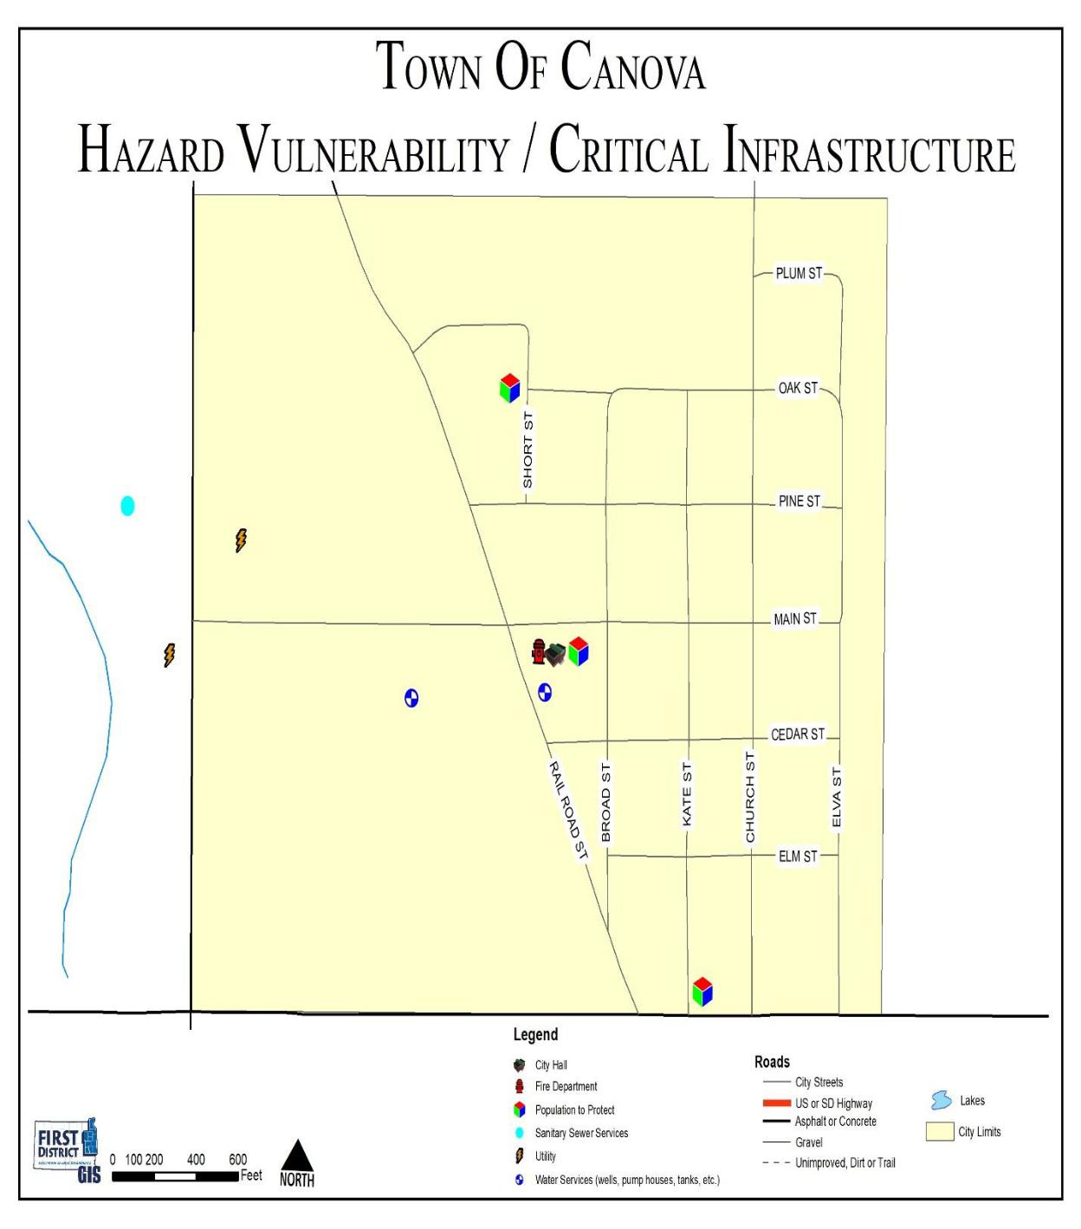

Miner County Pre-Disaster Mitigation Plan Page 59

Figure 4.2 Town of Carthage Hazard Vulnerability Map
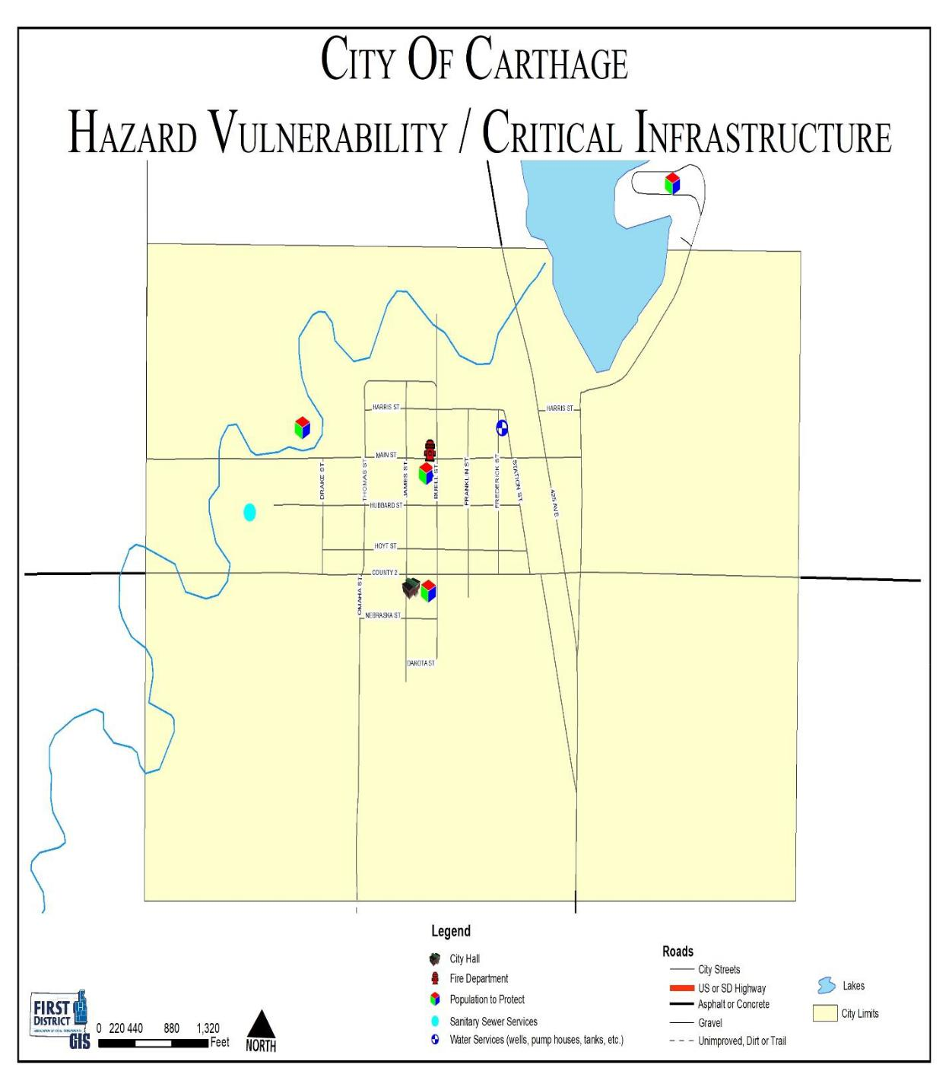

Miner County Pre-Disaster Mitigation Plan Page 60

Figure 4.3 City of Howard Hazard Vulnerability Map
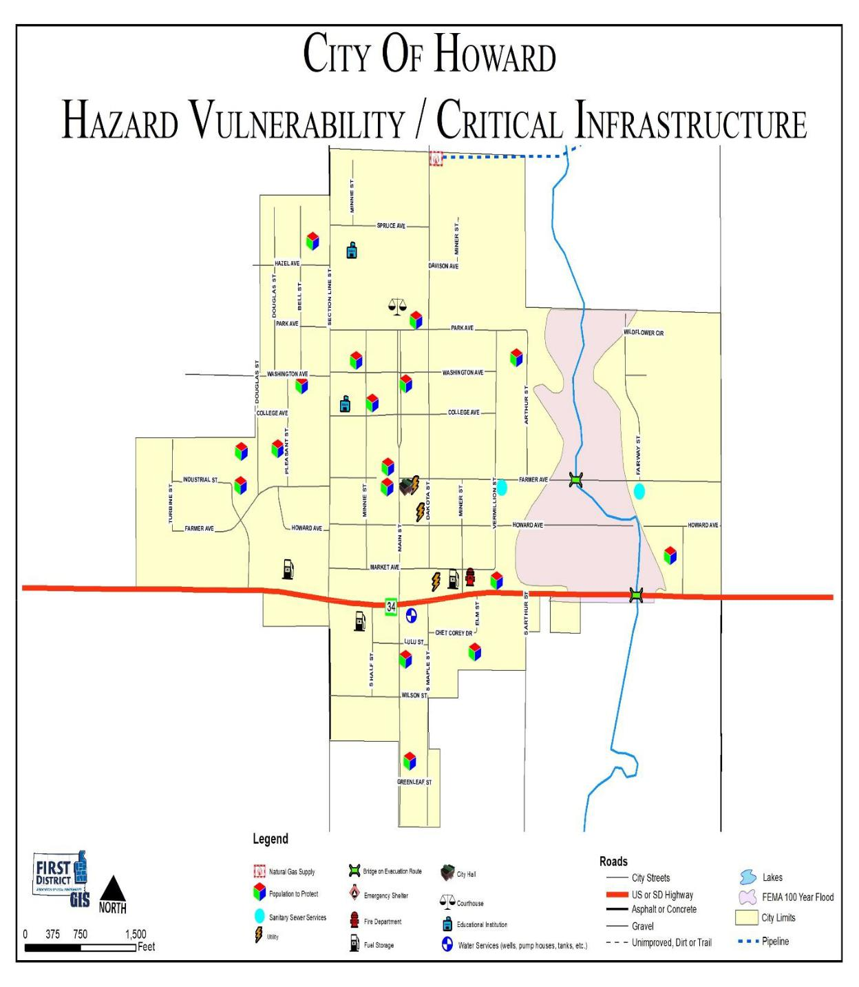

Miner County Pre-Disaster Mitigation Plan Page 61

Figure 4.4: Miner County Hazard Vulnerability Map
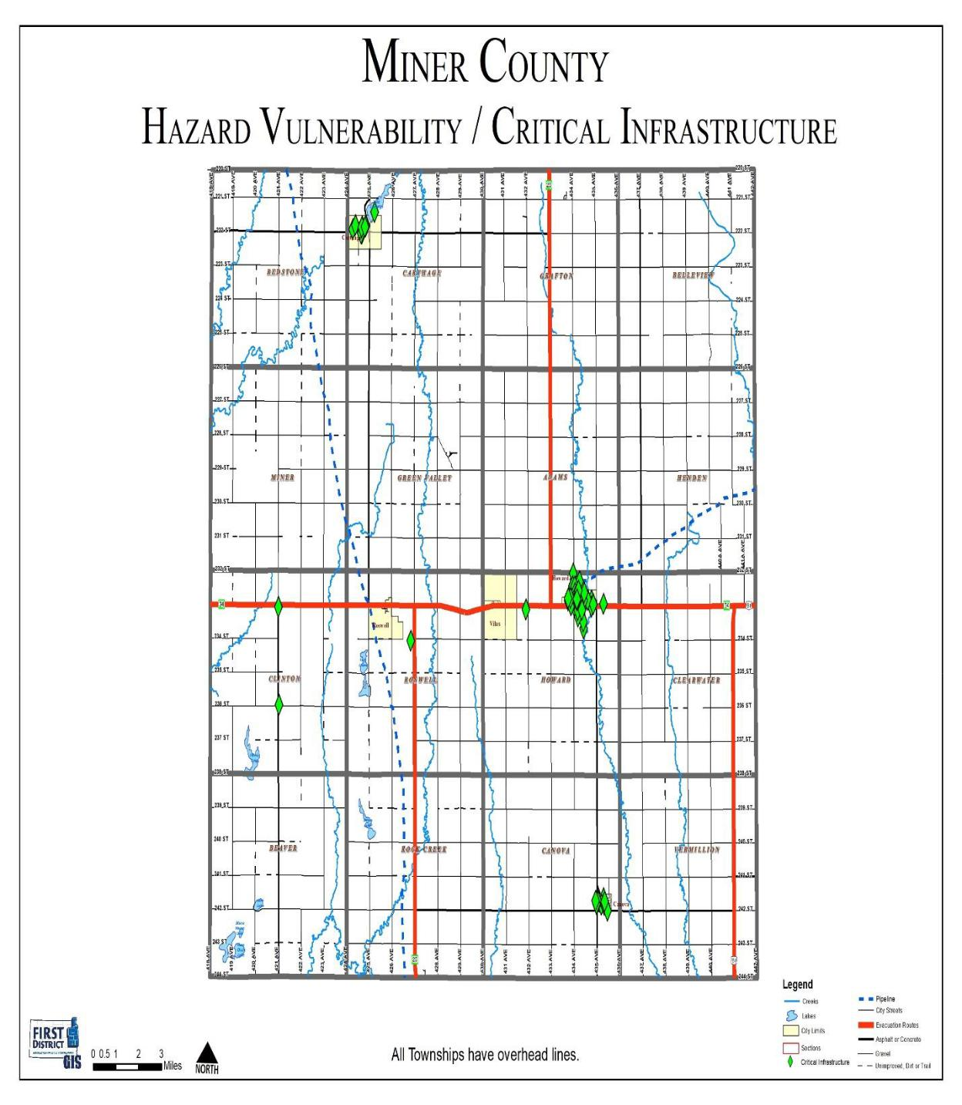

Miner County Pre-Disaster Mitigation Plan Page 62

CHAPTER 5
MITIGATION STRATEGY

MITIGATION OVERVIEW

Requirement 201.6(c)(3)(i). Local Mitigation Plan Review Tool – C3.

Requirement 201.6(c)(3)(ii). Local Mitigation Plan Review Tool – C4.

Requirement 201.6(c)(3)(iii) & (iv). Local Mitigation Plan Review Tool – C5.

Requirement 201.6(d)(3). Local Mitigation Plan Review Tool – D3.

The State Hazard Mitigation Plan addresses several mitigation categories including warning and forecasting, community planning, and infrastructure reinforcement. The County and participating entities’ greatest needs are mitigating flood hazards, backup generators for critical infrastructure, construction of storm shelters, and public awareness.

After the completion of the risk assessment (identification of hazards, probability of hazards and vulnerability to hazards), it was the mutual consensus of the PDM Planning Team that mitigation strategies of the PDM should focus on the following hazards: winter storms, severe summer storms, flooding, wildfires (urban/rural)

The PDM Planning Team completed the goal identification process by considering the county’s and participating jurisdictions’ vulnerability to each identified hazard, and the severity of the threat posed by each hazard. Much of the discussion focused on damage caused by past events, and what could be done to ensure that future damage will be lessened or eliminated. By reviewing each jurisdiction’s Comprehensive Land Use Plan (if available), the participants also considered how future development might affect the county’s and participating jurisdictions’ vulnerability to the hazards they face. When identifying goals, numerous activities or projects were identified with broadly defined benefits to numerous jurisdictions within the County. Numerous actions were agreed by the PDM Planning Team to have broad reaching benefits but due to scope or varying levels of importance to individual jurisdictions no specific cost, timeframe, or priority was assigned. Likewise many infrastructure projects and policies throughout all communities would mitigate hazards but were not located in the most vulnerable areas. Those activities/policies are listed below with the goals and priorities for each of the hazards as determined by the PDM Planning Team. For example all communities benefit from flood-proofing lift stations or burying above ground electric utility lines. Specific projects are listed in Table 5.1 and represented in Figures 5.1 through 5.7).

Miner County Pre-Disaster Mitigation Plan Page 63

Principle Goals

- Reduce the loss of life, property, infrastructure, critical facilities, cultural resources and impacts from severe weather, flooding and other natural disasters.

- Improve public safety during severe weather, flooding and other natural disasters.

- Improve the County’s Emergency Preparedness and Disaster Response and Recovery capabilities.

Mitigation Activities for Flooding Hazards

Goal #1: Protect specific areas of Miner County from flooding.

Goal #2: Educate and inform Miner County residents regarding flooding safety.
Goal #3: Reduce the extent to which utility mishaps affect areas during flooding events.

- Actions/Projects to reduce risk through policy implementation

- Actions/Projects to change the characteristics or impacts of hazards

- Actions to reduce loss potential of infrastructure to hazards

Mitigation Activities for Severe Weather Hazards (summer and winter)

Goal #1: Increase public awareness and education on severe weather issues.

Goal #2: Improve public safety during severe weather.

Goal #3: Reduce the extent to which utility mishaps affect areas during severe weather situations.

Goal #4: Reduce crippling effects of winter storms, especially regarding smaller communities.

- Actions/Projects to reduce risk through policy implementation

- Actions/Projects to change the characteristics or impacts of hazards

- Actions/Projects to reduce loss potential of infrastructure to hazards

Miner County Pre-Disaster Mitigation Plan Page 64

Table 5.1: Actions/Projects to Reduce Risk through Policy Implementation
 | Problem Statements | Actions | Canova | Carthage | Howard | Vilas | Miner County
 |  | Public education. Disseminate
 |  | information regarding how to
 |  | deal with flooding. This would
 |  | include transportation issues, | X | X | X | X | X
 | Public is unaware of | home protection strategies,
 | scope of flood risk and | safety issues, and how to move
 | existing emergency plans | forward after a flooding
 |  | situation.
 |  | Encouraging homeowners in
 |  | flood-prone areas to purchase | X | X | X | X | X
 |  | flood insurance.
 | Jurisdiction is unaware | Conduct necessary studies
 | potential hydrologic
 |  | addressing drainage (storm
 | impacts of drainage/
 |  | water flow/runoff, etc.).
 | development projects
 | Residents are not eligible | Begin participation in the
 |  | National Flood Insurance |  | X |  | X
 | for flood insurance
 |  | Program.
 | Failure to comply with | Ensure continued National
 | NFIP programs makes the
 |  | Flood Insurance Program
 | community ineligible for |  | X |  | X |  | X
 |  | compliance by enforcing flood
 | flood insurance and
 |  | plain management ordinance.
 | certain funding
 | Jurisdiction has no legal | Adoption and enforcement of
 | mechanism to regulate |  |  |  |  | X
 |  | land use regulation.
 | land use
 | Need to continue to
 | regulate minimum land | Continue enforcement of zoning | X | X | X |  | X
 | use and development | and subdivision ordinances.
 | standards
 | Jurisdiction has little legal | Developing a county/city
 | mechanism to regulate |  | X | X | X | X | X
 |  | drainage ordinance.
 | drainage

Miner County Pre-Disaster Mitigation Plan Page 65

Problem Statements | Actions | Canova | Carthage | Howard | Vilas | Miner County
Need to continue to | Continue enforcement of
regulate minimum
 | building codes.
construction standards
No technical analysis or | Identify and prioritize
 | capital/structural mitigation
identification of specific |  | X | X | X | X | X
 | projects that are cost effective
mitigation projects
 | and technically feasible.

Miner County Pre-Disaster Mitigation Plan Page 66

Table 5.2: Actions/Projects to Change the Characteristics or Impacts Hazards

Problem Statements | Actions | Canova | Carthage | Howard | Vilas | Miner
 |  |  |  |  |  | County
Portions of storm sewer | Installing or upgrading storm
system is not designed |  | X | X | X
 | sewer piping.
to 100-year flood event
Drainage patterns have
changed; culverts are | Installing or enlarging drainage | X | X | X
inadequate for | culverts.
conveyance of water
Certain streets have | Curbing and guttering of city
substandard or no curb | streets to improve storm water | X | X | X
and gutter | flow.
Capacity of rivers,
streams, and retention | Clean out debris in drainage
areas is decreased due | areas, tributaries, etc. to | X | X | X |  | X
to accumulation of | improve water flow
debris
Sanitary and/or storm | Install valves, plugs in sanitary
sewer are vulnerable to |  | X | X | X
 | and storm sewer system.
back-up in flood event
 | Preservation and expansion of
 | open space along the river and
 | enhancement of existing berm
Potential for | areas.
development in flood | Work with property owners to
prone areas. | implement deed restrictions for
 | open lots/vacant properties in |  |  | X
 | the flood hazard areas to
 | prevent development.

Miner County Pre-Disaster Mitigation Plan Page 67

Table 5.3: Actions/Projects to Reduce Loss Potential of Infrastructure to Hazards

Problem Statements | Actions | Canova | Carthage | Howard | Vilas | Miner County
Many roads and bridges | Replace and raise bridges |  |  |  |  | X
were built prior to
identification of flood | Elevating roads in flood-prone | X | X | X | X | X
hazard areas | areas
Structures constructed
in the floodplain prior to | Making structural retrofits to | X | X | X | X | X
identification of flood | infrastructure
hazard areas

Miner County Pre-Disaster Mitigation Plan Page 68

Table 5.4: Actions/Projects to Reduce Severe Weather Risk through Policy Implementation

Problem | Actions | Canova | Carthage | Howard | Vilas | Miner County
Statements
 | Public education. Disseminate information regarding
Public is | how to deal with severe weather (summer/winter). Some
 | of the issues that may be addressed within the
unfamiliar
 | information would include: safety issues on downed
with certain
 | power lines, electrical and fire dangers, the necessity for | X | X | X | X | X
disaster
 | generators and advice on using them, protecting
preparation
 | property, survival strategies during storms, and
measures
 | purchasing of back-up power for various household and
 | farming operations.
Lack of data
regarding | Gather data to create a more precise loss estimate for
vulnerability |  | X | X | X | X | X
 | winter storms.
to winter
storms
Lack of data
regarding | Gather data to create a more precise loss estimate for
vulnerability |  | X | X | X | X | X
 | summer storms.
to summer
storms

Miner County Pre-Disaster Mitigation Plan Page 69

Table 5.5: Actions/Projects to Change the Characteristics or Impacts of Severe Weather Hazards

Problem | Actions | Canova | Carthage | Howard | Vilas | Miner County
Statements
 | Construct tornado safe rooms or | X | X | X | X | X
Certain areas and | community shelters.
populations are not | Construct storm shelters at |  |  | X
served by storm | manufactured home parks
shelters | Construct storm shelters at RV |  | X | X
 | parks.
Critical facilities
are vulnerable to | Install backup generators |  | X |  | X | X
power failure
Certain areas are | Survey areas in need of snow
 | shelterbelts and plant trees |  |  |  |  | X
susceptible to
 | accordingly.
snow drifting
 | Install or plant living snow fences |  |  |  |  | X
Certain areas of
town cannot hear | Construct new or improve existing
storm sirens and |  | X | X | X | X | X
 | warning systems
other emergency
warning systems

Miner County Pre-Disaster Mitigation Plan Page 70

Table 5.6: Actions/Projects to Reduce Loss Potential of Infrastructure to Severe Weather Hazards

Problem | Actions | Canova | Carthage | Howard | Vilas | Miner County
Statements
 | Upgrading of utility lines. | X | X | X | X | X
 | Burial of utility lines when needed. | X | X | X | X | X
 | Require upgrading of overhead lines
 | when age or disasters provide an | X | X | X | X | X
Utility lines and | opportunity.
 | Removal of trees near power lines. | X | X | X | X | X
structures are
subject to failure in
 | Attachment of guy wires to dead-end | X | X | X | X | X
high wind, heavy
 | poles.
rain, ice events
 | Testing integrity of poles | X | X | X | X | X
 | Usage of anti-galloping devices | X | X | X | X | X
 | Making structural retrofits to facilities. | X | X | X | X | X

Miner County Pre-Disaster Mitigation Plan Page 71

Mitigation Activities for Fire and Drought Hazards

Goal #1: Increase fire-fighting capabilities.
Goal #2: Reduce the negative effects droughts have on Miner County.
Goal #3: Reduce the negative effects wildfires have on Miner County.

- Actions/Projects to reduce risk through policy implementation

- Actions/Projects to reduce loss potential of infrastructure to hazards

- Actions/Projects to change the characteristics or impacts of hazards

General Mitigation Activities

Technological (See Table 5.10)

Planning (See Table 5.11)

Administration/Coordination (See Table 5.12)

- Identify and pursue funding that builds local capacity and supports grant-writing for mitigation actions identified in the PDM.

- Increase communication /coordination between federal, state, regional, county, municipal, private, and non-profit agencies in the area of pre-disaster mitigation.

- Maintain and enhance working relationships with the utilities.

Miner County Pre-Disaster Mitigation Plan Page 72

Table 5.7: Actions/Projects to Reduce Fire and Drought Risk through Policy Implementation

Problem | Actions | Canova | Carthage | Howard | Vilas | Miner
Statements |  |  |  |  |  | County
Community becomes | Find funding sources to pay for
vulnerable to fire | persons to fill positions while | X | X | X | X | X
hazard while staff is | individuals are at training
being trained. | courses.
 | Adoption and enforcement of
Potential for | property regulations in areas | X | X | X | X | X
development in areas | vulnerable to wildfire.
vulnerable to wildfire
 | Establish/require minimum fire
or urban fire
 | suppression standards for | X | X | X | X | X
 | subdivisions
Community has no | Develop water rationing
plan/policy for water | measures that will be | X | X | X | X | X
rationing in | implemented during a drought
emergency | situation.
Public is unaware of | always Educate residents on the
benefits of | benefits of conserving water , not | X | X | X | X | X
conserving water | just during a drought.

Table 5.8: Actions/Projects to Reduce Loss Potential of Infrastructure to Fire and Drought Hazards
Problem | Actions | Canova | Carthage | Howard | Vilas | Miner County
Statements
Firefighting | Ensure that fire departments are
equipment
 | adequately equipped to respond to | X | X | X | X | X
becomes out of
 | wildfires
date quickly
Fire hydrants | Have rural fire departments locate |  |  | X
become unusable | dry fire hydrants.

Miner County Pre-Disaster Mitigation Plan Page 73

Table 5.9: Actions/Projects to Change the Characteristics or Impacts of Fire and Drought Hazards
Problem | Actions | Canova | Carthage | Howard | Vilas | Miner County
Statements
Dead or dry plant
material creates fire | Burn areas to ensure a fire break
hazard/ location |  |  |  |  |  | X
 | rather than ignition fuel.
changes seasonally
and annually
 | Educate farmers on the benefits
Local economy is | of a diversified crop protection | X | X | X | X | X
very dependent on | plan in the event of a drought
corn/soybean
 | Work with local farmers to
production
 | investigate the use of more | X | X | X | X | X
 | drought resistant crops.

Table 5.10: Technological Activities

Problem | Actions | Canova | Carthage | Howard | Vilas | Miner County
Statements
 | Continue utilizing a working
 | computer aided mapping project
 | for the County. This includes |  |  |  |  | X
Current data and | using overlays of GIS data,
 | HazMat, and Roads.
software can become
 | Enhance existing computer aided
obsolete or out of |  | X | X | X | X | X
 | dispatch.
date
 | Use HAZUS software to estimate
 | losses in flooding situations. | X | X | X | X | X
 | Information may also be able to
 | be used for other hazard areas.

Miner County Pre-Disaster Mitigation Plan Page 74

Table 5.11: Planning Activities

Problem | Actions | Canova | Carthage | Howard | Vilas | Miner County
Statements
Maintenance of a
mitigation plan is | Find funding to review and update the
beyond the economic | regional and local disaster mitigation | X | X | X | X | X
capability of this | plans on a five-year cycle.
community
 | Incorporate disaster mitigation actions
 | into appropriate local and regional plans
 | – Master Plans, land use, | X | X | X |  | X
 | transportation, open space, and capital
 | programming.
Disaster mitigation | Integrate disaster mitigation concerns
projects have not | into subdivision, site plan review, and
always been | other zoning reviews. In particular | X | X | X |  | X
incorporated into | require the consideration of downstream
other plans | flooding impacts caused by new
 | projects.
 | Integrate disaster mitigation concerns
 | into transportation projects (e.g. | X | X | X |  | X
 | drainage improvements, underground
 | utilities, etc.).
This community's | Develop a means for sharing
mitigation projects
 | information on a regional basis about
are not coordinated |  | X | X | X | X | X
 | successful disaster mitigation planning
with other
 | and programs.
communities' projects

Miner County Pre-Disaster Mitigation Plan Page 75

Table 5.12: Administration/Coordination Activities

Problem | Actions | Canova | Carthage | Howard | Vilas | Miner County
Statements
This community is
not staffed nor does it | Identify and pursue funding that builds
have funding
 | local capacity and supports grant-writing
mechanisms to apply |  | X | X | X | X | X
 | for mitigation actions identified in the
for and administer
 | PDM.
funding sources for
mitigation projects
Need to improve | Increase communication /coordination
 | between federal, state, regional, county,
coordination of
 | municipal, private, and non-profit | X | X | X | X | X
activities with other
 | agencies in the area of pre-disaster
governmental
 | mitigation.
jurisdictions and
 | Maintain and enhance working
utility providers |  | X | X | X | X | X
 | relationships with the utility providers.

Miner County Pre-Disaster Mitigation Plan Page 76

After meetings with the local jurisdictions and opportunities for public input, a series of mitigation goals were devised to best aid the County in reducing and lessening the effects of hazards. Projects previously identified in the 2014 PDM were analyzed and discussed to determine which of the projects had enough merit to be included in the updated PDM and to determine if the projects meet the hazard mitigation needs of the county. These projects were evaluated based on a cost/benefit ratio and priority. Although this PDM focuses on disaster mitigation rather than disaster preparedness, some communities discussed disaster preparedness projects as well. It was difficult for individual communities to recognize the difference between providing storm shelters and making sure the storm shelters function properly (for example). Actions considered in this category included the acquisition of emergency generators, and erecting or replacing warning sirens in areas that currently are not well served.

Most of the mitigation actions proposed by the jurisdictions were identified by city council members, public works personnel, or PDM Planning Team members from the jurisdiction. Some actions were also proposed by townships and utility providers do to the direct impact of disasters on infrastructure and services they provide. Once each jurisdiction had its list of proposed actions complete, it was submitted to the Emergency Management Director. At the third PDM Planning Team meeting a final opportunity was given for the jurisdictions to add any additional actions.

Although in some cases additional data will be necessary, a timeframe for completion, oversight, funding sources, and any other relevant issues were addressed. These implementation strategies are geared toward the specific goal and area. Often, these projects will not encounter any resistance from environmental agencies, legal authorities, and political entities. Table 5.13 is a presentation of the mitigation actions proposed by the PDM Planning Team, County, communities, townships, and utility providers. In addition to identifying the proposed actions, the table includes additional information about each action. Elected officials and staff of each municipality and the county were responsible for providing most of this information for actions in their community, but the other planning participants helped in this process. The following information is provided for each action:

- A statement regarding the specific problem the proposed action will mitigate.

- The local priority rating (discussed in the next section).

- The time frame to accomplish the action – “Short” means actions that are intended to be initiated within two years, “Medium” is for actions that should be started within five years, and “Long” is for actions that are not anticipated to be started for at least five years.

- The party(s) primarily responsible for implementing the action.

- The estimated cost - estimates for many of the actions were obtained from knowledgeable sources based on current information. Estimates are subject to change due to specific details of specific projects.

- Potential sources of funding (discussed below).

- The primary hazard being addressed.

- The goal corresponding to the action.

As mentioned above, jurisdictions and entities integrally involved in the planning for disasters due to wide ranging implications to them. Utility providers were represented on the PDM Planning Team. Each utility provider was asked individually to submit their own mitigation actions. The main mitigation activity proposed by utility providers was the burying of overhead lines in rural areas of the county. The Appendix includes maps of vulnerable sites and potential mitigation actions proposed by the townships in the County.

Miner County Pre-Disaster Mitigation Plan Page 77

Particular attention needs to be paid to sources of funding for the actions. Given the existing financial reality of very tight county and municipal budgets, some of the proposed actions realistically cannot be implemented without substantial grant assistance. With such assistance, it is likely that many of the high priority projects can be undertaken without placing an onerous burden on local budgets. Resources for some of the actions available from FEMA through the South Dakota Office of Emergency Management include the Hazard Mitigation Grant Program, Pre-Disaster Mitigation grant program, and Flood Mitigation Assistance grant programs. Other possible sources of funding include:

Grant and loan programs/sources

- Community Development Block Grant program

- Economic Development Administration

- FEMA Assistance to Firefighters Grant program

- South Dakota Dept of Environment and Natural Resources

- South Dakota Dept of Transportation

- US Department of Agriculture Rural Development Office

Local resources

- General obligation bonds

- Revenue bonds

- Tax Increment Financing (TIF) districts

Miner County Pre-Disaster Mitigation Plan Page 78

Table 5.13: Proposed Mitigation Activities
MINER |  | COUNTY |  |  |  |  |  | FUNDING
ACTIONS |  |  | RATING | TIMEFRAME | CONTACT |  | COST | SOURCE | HAZARD |  | GOAL
Replace | undersized or |  |  |  | Miner | County
deteriorating |  | culverts |  |  | Highway |  | $10,000.00 per |  |  |  | Protect | Specific | Areas of
throughout the county |  |  | High | Short | Superintendent |  | location | HMGP | Flooding |  | Miner County from floods.
Repair or improve roads |  |  |  |  | Miner | County
that receive |  | damage |  |  | Highway |  | $200,000.00 |  |  |  | Protect | Specific | Areas of
from flood events |  |  | Medium | Medium | Superintendent |  | per mile | HMGP | Flooding |  | Miner County from floods.
TOWN | OF | CANOVA |  |  |  |  |  | FUNDING
ACTIONS |  |  | RATING | TIMEFRAME | CONTACT |  | COST | SOURCE | HAZARD |  | GOAL
 |  |  |  |  |  |  |  |  |  |  | Reduce the extent to which
Purchase of Back-up |  |  |  |  |  |  |  |  | Severe | Weather | utility mishaps affect areas
Generator |  | for |  |  |  |  |  |  | Hazards | (Summer | during | severe | weather
emergency shelter. |  |  | High | Short | Finance Officer |  | $50,000.00 | HMGP/OEM | and Winter) |  | situations.
Supplies | for emergency |  |  |  |  |  |  |  | Severe | Weather
shelter | (cots, | blankets, |  |  |  |  |  |  | Hazards | (Summer | Improve | public | safety
first aid, etc.) |  |  | High | Short | Finance Officer |  | $1,000.00 | OEM | and Winter) |  | during severe weather.
Construction of Tornado |  |  |  |  |  |  |  |  |  |  | Improve | public | safety
Shelter. |  |  | Medium | Short | Finance Officer |  | $100,000.00 | HMGP | Tornado |  | during severe weather.
Construction |  | of Water |  |  |  |  |  |  |  |  | Increase | fire-fighting
Tower/Tank. |  |  | Medium | Long | Finance Officer |  | UNKNOWN | CDBG/RD | Fire |  | capabilities.
Replace | undersized or
deteriorating |  | culverts |  |  |  |  | $10,000.00 per |  |  |  | Protect | Specific | Areas of
throughout the town |  |  | Medium | Medium | Finance Officer |  | location (4) | HMGP | Flooding |  | Canova from floods.

Miner County Pre-Disaster Mitigation Plan Page 79

CITY | OF |  | CARTHAGE |  |  |  |  |  | FUNDING
ACTIONS |  |  |  |  | RATING | TIMEFRAME | CONTACT | COST | SOURCE | HAZARD |  | GOAL
Rip Rap sanitary |  |  |  | sewer |  |  |  |  |  |  |  | Protect | Specific |  | Areas |  | of
lagoons |  |  |  |  | Medium | Long | Finance Officer | $65,000.00 | DENR | Flooding |  | Carthage from floods.
Additional |  |  | hose, | pump
truck |  | supplies, |  | and
equipment |  |  | for | fire |  |  |  |  |  |  |  | Increase |  | firefighting
department. |  |  |  |  | High | Short | Fire Department | $20,000.00 | FIRE | Fire |  | capabilities.
Training and Continuing
Education |  |  |  | for |  |  | Fire |  |  |  |  | Increase | firefighting |  |  |  | and
Firefighters |  |  | and | EMT |  |  | Department/Finance |  |  | Fire/Emergency |  | emergency |  | responders
professionals |  |  |  |  | High | Long | Officer | $20,000.00 | FIRE/HMGP | Response |  | capabilities
 |  |  |  |  |  |  |  |  |  |  |  | Reduce the extent to which
 |  |  |  |  |  |  |  |  |  |  |  | utility mishaps affect areas
Reline | degrading |  |  | sewer |  |  |  |  |  |  |  | during | severe |  | weather
lines along Drake Street |  |  |  |  | Medium | Medium | Finance Officer | $100,000.000 | HMGP/DENR | Flooding |  | situations.
CITY |  |  |  | OF |  |  |  |  | FUNDING
HOWARD ACTIONS |  |  |  |  | RATING | TIMEFRAME | CONTACT | COST | SOURCE | HAZARD |  | GOAL
 |  |  |  |  |  |  |  |  |  | Severe | Weather
 |  |  |  |  |  |  |  |  |  | Hazards | (summer | Improve | public |  |  | safety
Upgrade Siren System |  |  |  |  | Medium | Short | Finance Officer | $30,000.00 | HMGP | and winter) |  | during severe weather.
 |  |  |  |  |  |  |  |  |  |  |  | Increase capabilities of city
 |  |  |  |  |  |  |  |  |  |  |  | staff to | recognize flood
Integrate |  |  | GIS services |  |  |  |  |  |  | Hazard |  | zones | in |  |  | future
into City office’s |  |  |  |  | Medium | Long | Finance Officer | UNKNOWN | HMGP/OEM | Mitigation/Flooding |  | development
 |  |  |  |  |  |  |  |  |  |  |  | Reduce the extent to which
 |  |  |  |  |  |  |  |  |  |  |  | utility mishaps affect areas
Upgrade Water Tower |  |  |  |  |  |  |  |  |  |  |  | during severe weather
 |  |  |  |  |  |  |  |  |  | Hazard
 |  |  |  |  | Medium | Long | Finance Officer | Unknown | HMGP/DENR | Mitigation/Fire
 |  | Miner County Pre-Disaster Mitigation Plan |  |  |  |  |  |  |  |  |  |  | Page 80

CENTRAL |  |  |  |  |  |  |  |  | FUNDING
ELECTRIC ACTIONS |  |  |  |  | RATING | TIMEFRAME | CONTACT | COST | SOURCE | HAZARD |  | GOAL
Burial of Overhead Lines |  |  |  |  |  |  |  |  |  |  |  | Reduce the extent to which
(Fedora |  | Substation) |  | 7 |  |  |  |  |  |  |  | utility mishaps affect areas
miles | of | #6 | Copper |  |  |  |  |  |  | Severe | Weather | during | severe | weather
overhead line |  |  |  |  | High | Short | Central Electric | $242,000.00 | HMGP | Hazards (winter) |  | situations.
Burial of Overhead Lines |  |  |  |  |  |  |  |  |  |  |  | Reduce the extent to which
(Fedora | Substation) 2.9 |  |  |  |  |  |  |  |  |  |  | utility mishaps affect areas
miles | of | #6 | Copper |  |  |  |  |  |  | Severe | Weather | during | severe | weather
overhead line |  |  |  |  | High | Short | Central Electric | $70,000.00 | HMGP | Hazards (winter) |  | situations.
Burial of Overhead Lines |  |  |  |  |  |  |  |  |  |  |  | Reduce the extent to which
(Howard |  | Substation) |  | 9 |  |  |  |  |  |  |  | utility mishaps affect areas
miles | of | #6 | Copper |  |  |  |  |  |  | Severe | Weather | during | severe | weather
overhead line |  |  |  |  | High | Short | Central Electric | $431,000.00 | HMGP | Hazards (winter) |  | situations.
Burial of Overhead Lines |  |  |  |  |  |  |  |  |  |  |  | Reduce the extent to which
(Howard Substation) 3.9 |  |  |  |  |  |  |  |  |  |  |  | utility mishaps affect areas
miles of #8 Copper single |  |  |  |  |  |  |  |  |  | Severe | Weather | during | severe | weather
phase OVH radial line |  |  |  |  | High | Short | Central Electric | $89,700.00 | HMGP | Hazards (winter) |  | situations.
Burial of Overhead Lines |  |  |  |  |  |  |  |  |  |  |  | Reduce the extent to which
(Howard |  | Substation) |  | 2 |  |  |  |  |  |  |  | utility mishaps affect areas
miles of #8 Copper single |  |  |  |  |  |  |  |  |  | Severe | Weather | during | severe | weather
phase OVH radial line |  |  |  |  | High | Short | Central Electric | $48,000.00 | HMGP | Hazards (winter) |  | situations.

Miner County Pre-Disaster Mitigation Plan Page 81

CENTRAL ELECTRIC ACTIONS |  |  |  |  | RATING | TIMEFRAME | CONTACT | COST | FUNDING SOURCE | HAZARD |  | GOAL
Burial of Overhead Lines |  |  |  |  |  |  |  |  |  |  |  | Reduce the extent to which
(Howard |  | Substation) |  | 3 |  |  |  |  |  |  |  | utility mishaps affect areas
miles of #8 Copper single |  |  |  |  |  |  |  |  |  | Severe | Weather | during | severe | weather
phase OVH radial line |  |  |  |  | High | Short | Central Electric | $72,000.00 | HMGP | Hazards (winter) |  | situations.
Burial of Overhead Lines |  |  |  |  |  |  |  |  |  |  |  | Reduce the extent to which
(Howard |  | Substation) |  | 3 |  |  |  |  |  |  |  | utility mishaps affect areas
miles | of | #6 | Copper |  |  |  |  |  |  | Severe | Weather | during | severe | weather
overhead radial line |  |  |  |  | High | Short | Central Electric | $72,000.00 | HMGP | Hazards (winter) |  | situations.
Burial of Overhead Lines
(Howard Substation) 5.9 |  |  |  |  |  |  |  |  |  |  |  | Reduce the extent to which
miles | of | #6 | Copper |  |  |  |  |  |  | Severe | Weather | utility mishaps affect areas
overhead radial line |  |  |  |  | High | Short | Central Electric | $141,000 | HMGP | Hazards (winter) |  | during flooding events
Burial of Overhead Lines |  |  |  |  |  |  |  |  |  |  |  | Reduce the extent to which
(Howard |  | Substation) |  | 5 |  |  |  |  |  |  |  | utility mishaps affect areas
miles | of | #6 | Copper |  |  |  |  |  |  | Severe | Weather | during | severe | weather
overhead radial line |  |  |  |  | High | Short | Central Electric | $120,000.00 | HMGP | Hazards (winter) |  | situations.
Burial of Overhead Lines
(Howard Substation) 5.8
miles | of | #8 | Copper |  |  |  |  |  |  |  |  | Reduce the extent to which
overhead |  | single | phase |  |  |  |  |  |  | Severe | Weather | utility mishaps affect areas
line |  |  |  |  | High | Short | Central Electric | $134,400 | HMGP | Hazards (winter) |  | during flooding events

Miner County Pre-Disaster Mitigation Plan Page 82

Figure 5.1 Miner County Mitigation Activity Sites
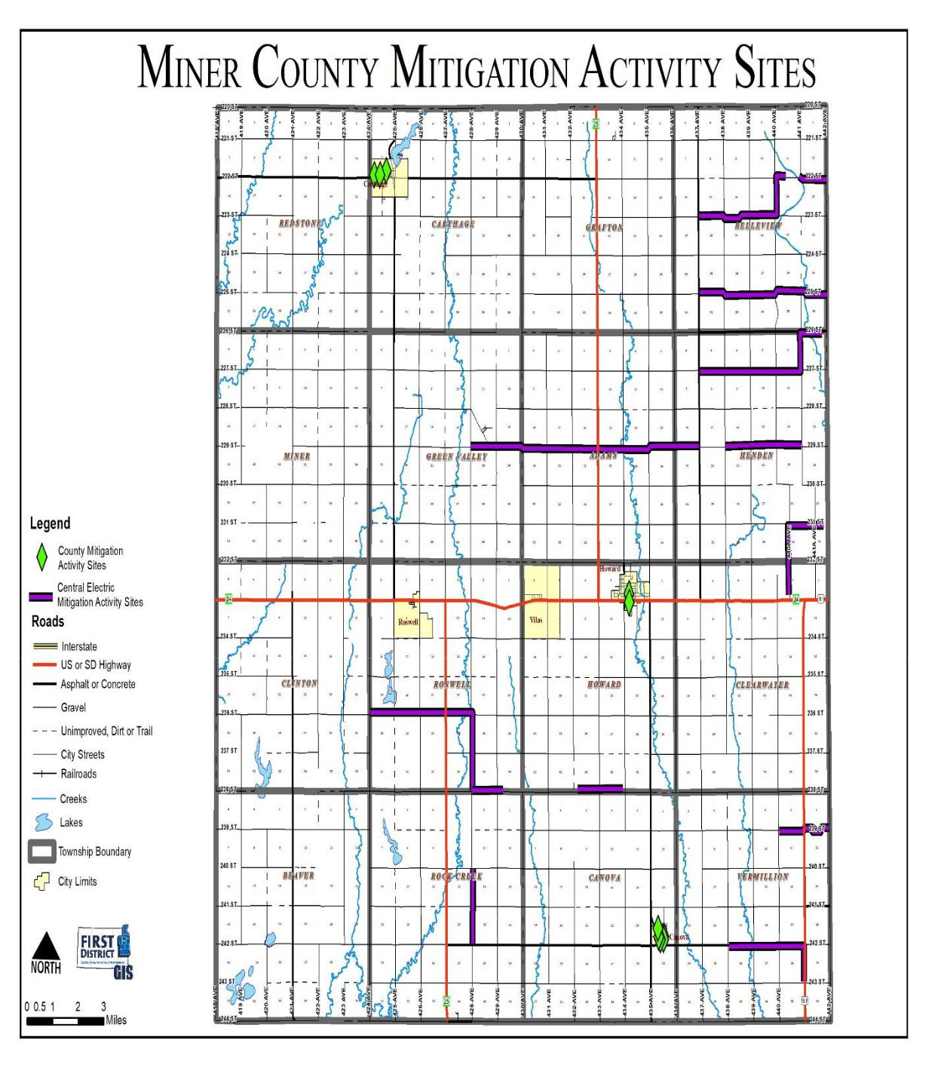

Miner County Pre-Disaster Mitigation Plan Page 83

Figure 5.2 Town of Canova Mitigation Activity Sites
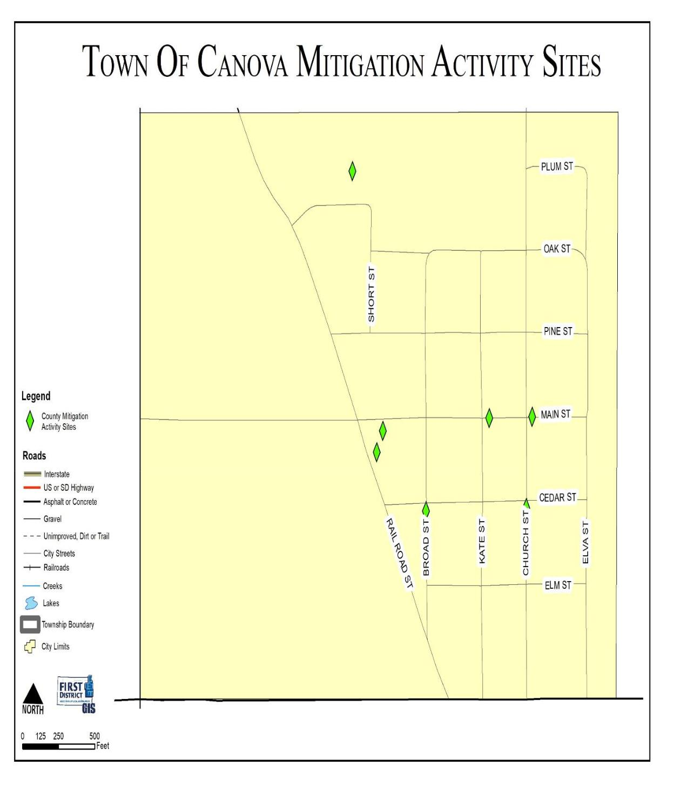

Miner County Pre-Disaster Mitigation Plan Page 84

Figure 5.3 City of Carthage Mitigation Activity Sites
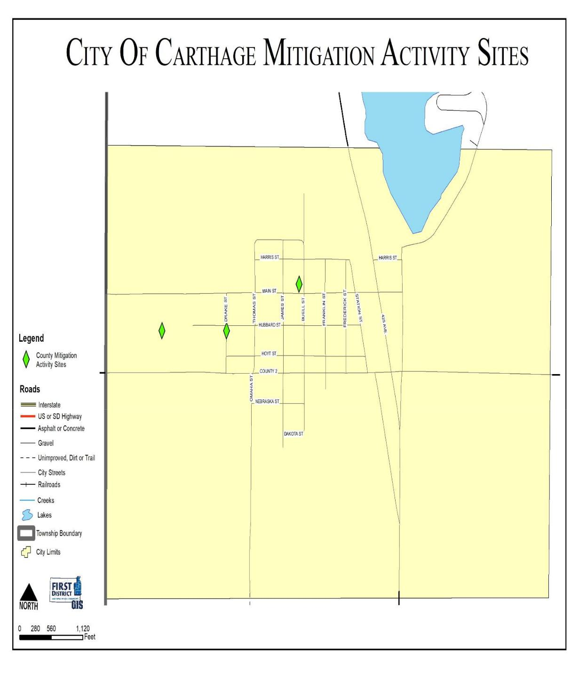

Miner County Pre-Disaster Mitigation Plan Page 85

Figure 5.4 City of Howard Mitigation Activity Sites
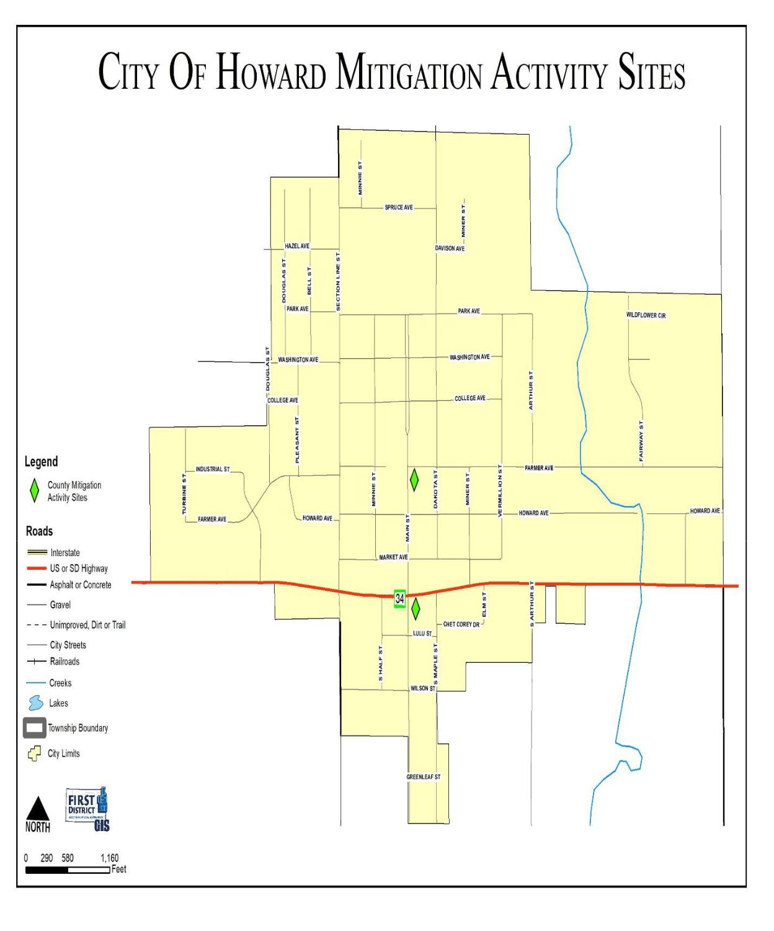

Miner County Pre-Disaster Mitigation Plan Page 86

IMPLEMENTATION OF MITIGATION ACTIONS

Requirement 201.6(c)(4)(ii). Local Mitigation Plan Review Tool – C6.

Requirement 201.6(d)(3). Local Mitigation Plan Review Tool – D3.

Upon adoption of the updated Miner County PDM, each jurisdiction will become responsible for implementing its own mitigation actions. The planning required for implementation is the sole responsibility of the local jurisdictions and private businesses that have participated in the PDM update. All of the municipalities have indicated that they do not have the financial capability to move forward with projects identified in the PDM at this time, however, all will consider applying for funds through the State and Federal Agencies once such funds become available. If and when the municipalities are able to secure funding for the mitigation projects, they will move forward with the projects identified. A benefit cost analysis will be conducted on an individual basis after the decision is made to move forward with a project.

Miner County Pre-Disaster Mitigation Plan Page 87

CHAPTER 6
PLAN MAINTENANCE

MONITORING, EVALUATING, AND UPDATING THE PLAN

Requirement 201.6(c)(4)(ii). Local Mitigation Plan Review Tool – C6.

The County and all of the participating local jurisdictions thereof will incorporate the findings and projects of the PDM in all planning areas as appropriate. Periodic monitoring and reporting of the PDM is required to ensure that the goals and objectives for the County PDM are kept current and that local mitigation efforts are being carried out. Communities will establish an annual review of projects and infrastructure listed in the plan. As funding becomes available, projects are completed, or the inevitable new project needs to be added, communities will report to the Miner County Emergency Management Director. Communities should adopt a schedule which corresponds with the annual report of the Emergency Management Director to the County Commissioners in November of each year.

During the process of implementing mitigation strategies, the county or communities within the county may experience lack of funding, budget cuts, staff turnover, and/or a general failure of projects. These scenarios are not in themselves a reason to discontinue and fail to update the PDM. A good plan needs to provide for periodic monitoring and evaluation of its successes and failures and allow for appropriate changes to be made.

CONTINUED PUBLIC PARTICIPATION/INVOLVEMENT

Requirement 201.6(c)(4)(iii). Local Mitigation Plan Review Tool – A5

Requirement 201.6(c)(4)(ii). Local Mitigation Plan Review Tool – C6.

During interim periods between the five year re-write, efforts will be continued to encourage and facilitate public involvement and input. The PDM will be available for public view and comment at the Miner County Emergency Management Office located in the Miner County Courthouse and the First District Association of Local Governments office. The PDM will also be available for review on the web at the Miner County website (www.minercountysd.org) and at the First District Association of Local Governments homepage (www.1stdistrict.org). Comments will always be received whether orally, written or by e-mail.

All ongoing workshops and trainings will be open to the public and appropriately advertised. Ongoing press releases and interviews will help disseminate information to the general public and encourage participation.

As implementation of the mitigation strategies continues in each local jurisdiction, the primary means of public involvement will be the jurisdiction’s own public comment and hearing process. State law as it applies to municipalities and counties requires this as a minimum for many of the proposed implementation measures. Effort will be made to encourage cities, towns and counties to go beyond the minimum required to receive public input and engage stakeholders.

Miner County Pre-Disaster Mitigation Plan Page 88

ANNUAL REPORTING PROCEDURES

Requirement 201.6(c)(4)(ii). Local Mitigation Plan Review Tool – C6.

The PDM shall be reviewed annually, as required by the County Emergency Management Director, or as the situation dictates such as following a disaster declaration. The Miner County Emergency Management Director will review the PDM annually in November and ensure the following:

- The County Elected body will receive an annual report and/or presentation on the implementation status of the PDM;

- The report will include an evaluation of the effectiveness and appropriateness of the mitigation actions proposed in the PDM; and

- The report will recommend, as appropriate, any required changes or amendments to the PDM.

FIVE-YEAR PDM REVIEW

Requirement 201.6(c)(4)(i). Local Mitigation Plan Review Tool – A6.

Requirement 201.6(c)(4)(ii). Local Mitigation Plan Review Tool – C6.

Every five years the PDM will be reviewed and a complete update will be initiated. All information in the PDM will be evaluated for completeness and accuracy based on new information or data sources. New property development activities will be added to the PDM and evaluated for impacts. New or improved sources of hazard related data will also be included.

In future years, if the County relies on grant dollars to hire a contractor to write the PDM update, the County will initiate the process of applying for and securing such funding in the third year of the PDM to ensure the funding is in place by the fourth year of the PDM. The fifth year will then be used to write the PDM update, which in turn will prevent any lapse in time where the county does not have a current approved PDM on file.

The goals, objectives, and mitigation strategies will be readdressed and amended as necessary based on new information, additional experience and the implementation progress of the PDM. The approach to this PDM update effort will be essentially the same as the one used for the original PDM development.

The Emergency Management Director will meet with the PDM Planning Team for review and approval prior to final submission of the updated PDM.

PLAN AMENDMENTS

Requirement 201.6(c)(4)(ii). Local Mitigation Plan Review Tool – C6.

PDM amendments will be considered by the Miner County Emergency Management Director, during the PDM’s annual review to take place the end of each county fiscal year. All affected local jurisdictions (cities, towns, and counties) will be required to hold a public hearing and adopt the recommended amendment by resolution prior to considerations by the PDM Planning Team

Miner County Pre-Disaster Mitigation Plan Page 89

INCORPORATION INTO EXISTING PLANNING MECHANISMS

Requirement 201.6(B)(3). Local Mitigation Plan Review Tool – A4.

All towns with existing comprehensive land use plans will review mitigation projects annually when reviewing their comprehensive land use plan, as is recommended in each of their plans. In addition all municipalities, including the towns without comprehensive land use plans, will consider the mitigation requirements, goals, actions, and projects when it considers and reviews the budget and other existing planning documents. Preparation of the budget is an opportune time to review the plan since municipalities are required by state law to prepare budgets for the upcoming year and typically consider any expenditure for the upcoming year at that time.

The local jurisdictions will post a permanent memo to their files as a reminder for them to incorporate their annual review of the mitigation actions identified into the budget preparation process. This does not require the projects be included in the budget, it merely serves as a reminder to the City officials that they have identified mitigation projects in the PDM that should be considered if the budget allows for it.

POTENTIAL FUNDING SOURCES

Although all mitigation techniques will likely save money by avoiding losses, many projects are costly to implement. None of the local jurisdictions have the funds available to more forward with mitigation projects at this time; thus, the Potential Funding Sources section was included so that the local jurisdictions can work towards securing funding for the projects. Inevitably, due to the small tax base and small population most of the local jurisdictions do not have the ability to generate enough revenue to support anything beyond the basic needs of the community. Thus mitigation projects will not be completed without a large amount of funding support from State or Federal programs.

The County jurisdictions will continue to seek outside funding assistance for mitigation projects in both the pre- and post-disaster environment. Primary Federal and State grant programs have been identified and briefly discussed, along with local and non-governmental funding sources, as a resource for the local jurisdictions

Miner County Pre-Disaster Mitigation Plan Page 90

Federal

The following federal grant programs have been identified as funding sources which specifically target hazard mitigation projects:

Title: Pre-Disaster Mitigation Program

Agency: Federal Emergency Management Agency

Through the Disaster Mitigation Act of 2000, Congress approved the creation of a national program to provide a funding mechanism that is not dependent on a Presidential Disaster Declaration. The Pre-Disaster Mitigation (PDM) program provides funding to states and communities for cost-effective hazard mitigation activities that complement a comprehensive mitigation program and reduce injuries, loss of life, and damage and destruction of property.

The funding is based upon a 75% Federal share and 25% non-Federal share. The non-Federal match can be fully in-kind or cash, or a combination. Special accommodations will be made for “small and impoverished communities”, who will be eligible for 90% Federal share/10% non-Federal.

FEMA provides PDM grants to states that, in turn, can provide sub-grants to local governments for accomplishing the following eligible mitigation activities: State and local hazard mitigation planning, Technical assistance (e.g. risk assessments, project development), Mitigation Projects, Acquisition or relocation of vulnerable properties, Hazard retrofits, Minor structural hazard control or protection projects Community outreach and education (up to 10% of State allocation)

Title: Flood Mitigation Assistance Program

Agency: Federal Emergency Management Agency

FEMA’s Flood Mitigation Assistance program (FMA) provides funding to assist states and communities in implementing measures to reduce or eliminate the long-term risk of flood damage to buildings, manufactured homes and other structures insurable under the National Flood Insurance Program (NFIP). FMA was created as part of the National Flood Insurance Reform Act of 1994 (42 USC 4101) with the goal of reducing or eliminating claims under the NFIP.

FMA is a pre-disaster grant program, and is available to states on an annual basis. This funding is available for mitigation planning and implementation of mitigation measures only, and is based upon a 75% Federal share/25% non-Federal share. States administer the FMA program and are responsible for selecting projects for funding from the applications submitted by all communities within the state. The state then forwards selected applications to FEMA for an eligibility determination. Although individuals cannot apply directly for FMA funds, their local government may submit an application on their behalf.

Miner County Pre-Disaster Mitigation Plan Page 91

Title: Repetitive Flood Claims Program

Agency: Federal Emergency Management Agency

FEMA’s Repetitive Flood Claims (RFC) grant program was authorized by the Bunning-Bereuter-Blumenauer Flood Insurance Reform Act of 2004 (P.L. 108–264), which amended the National Flood Insurance Act (NFIA) of 1968 (42 U.S.C. 4001, et al).

Up to $10 million is available annually for FEMA to provide RFC funds to assist States and communities reduce flood damages to insured properties that have had one or more claims to the National Flood Insurance Program (NFIP).

FEMA may contribute up to 100 percent of the total amount approved under the RFC grant award to implement approved activities, if the Applicant has demonstrated that the proposed activities cannot be funded under the Flood Mitigation Assistance (FMA) program.

Title: Hazard Mitigation Grant Program

Agency: Federal Emergency Management Agency

The Hazard Mitigation Grant Program (HMGP) was created in November 1988 through Section 404 of the Robert T. Stafford Disaster Relief and Emergency Assistant Act. The HMGP assists states and local communities in implementing long-term mitigation measures following a Presidential disaster declaration.

To meet these objectives, FEMA can fund up to 75% of the eligible costs of each project. The state or local cost-share match does not need to be cash; in-kind services or materials may also be used. With the passage of the Hazard Mitigation and Relocation Assistance Act of 1993, federal funding under the HMGP is now based on 15% of the federal funds spent on the Public and Individual Assistance programs (minus administrative expenses) for each disaster.

The HMGP can be used to fund projects to protect either public or private property, so long as the projects in question fit within the state and local governments overall mitigation strategy for the disaster area, and comply with program guidelines. Examples of projects that may be funded include the acquisition or relocation of structures from hazard-prone areas, the retrofitting of existing structures to protect them from future damages; and the development of state or local standards designed to protect buildings from future damages.

Eligibility for funding under the HMGP is limited to state and local governments, certain private nonprofit organizations or institutions that serve a public function, Indian tribes and authorized tribal organizations. These organizations must apply for HMPG project funding on behalf of their citizens. In turn, applicants must work through their state, since the state is responsible for setting priorities for funding and administering the program.

Miner County Pre-Disaster Mitigation Plan Page 92

Title: Public Assistance (Infrastructure) Program, Section 406

Agency: Federal Emergency Management Agency

FEMA’s Public Assistance Program, through Section 406 of the Robert T. Stafford Disaster Relief and Emergency Assistance Act, provides funding to local governments following a Presidential Disaster Declaration for mitigation measures in conjunction with the repair of damaged public facilities and infrastructure. The mitigation measures must be related to eligible disaster related damages and must directly reduce the potential for future, similar disaster damages to the eligible facility. These opportunities usually present themselves during the repair/replacement efforts.

Proposed projects must be approved by FEMA prior to funding. They will be evaluated for cost effectiveness, technical feasibility and compliance with statutory, regulatory and executive order requirements. In addition, the evaluation must ensure that the mitigation measures do not negatively impact a facility’s operation or risk from another hazard.

Public facilities are operated by state and local governments, Indian tribes or authorized tribal organizations and include:

*Roads, bridges & culverts

*Water, power & sanitary systems

*Draining & irrigation channels

*Airports & parks

*Schools, city halls & other buildings

Private nonprofit organizations are groups that own or operate facilities that provide services otherwise performed by a government agency and include, but are not limited to the following:

*Universities and other schools

*Power cooperatives & other utilities

*Hospitals & clinics

*Custodial care & retirement facilities

*Volunteer fire & ambulance

*Museums & community centers

Title: SBA Disaster Assistance Program

Agency: US Small Business Administration

The SBA Disaster Assistance Program provides low-interest loans to businesses following a Presidential disaster declaration. The loans target businesses to repair or replace uninsured disaster damages to property owned by the business, including real estate, machinery and equipment, inventory and supplies. Businesses of any size are eligible; along with non-profit organizations.SBA loans can be utilized by their recipients to incorporate mitigation techniques into the repair and restoration of their business.

Title: Community Development Block Grants

Agency: US Department of Housing and Urban Development

The community Development Block Grant (CDBG) program provides grants to local governments for community and economic development projects that primarily benefit low- and moderate-income people. The CDBG program also provides grants for post-disaster hazard mitigation and recovery following a Presidential disaster declaration. Funds can be used for activities such as acquisition, rehabilitation or reconstruction of damaged properties and facilities and for the redevelopment of disaster areas.

Miner County Pre-Disaster Mitigation Plan Page 93

Local

Local governments depend upon local property taxes as their primary source of revenue. These taxes are typically used to finance services that must be available and delivered on a routine and regular basis to the general public. If local budgets allow, these funds are used to match Federal or State grant programs when required for large-scale projects.

Non-Governmental

Another potential source of revenue for implementing local mitigation projects are monetary contributions from non-governmental organizations, such as private sector companies, churches, charities, community relief funds, the Red Cross, hospitals, Land Trusts and other non-profit organizations.

Miner County Pre-Disaster Mitigation Plan Page 94

APPENDIX

Appendix A - Resolution of Adoption by Jurisdiction

Appendix B - PDM Planning Team Agendas, Sign-in Sheets, and Minutes Appendix C - Community Meeting Agendas, Sign-in Sheet, and Minutes Appendix D - Hazard Identification/Vulnerability Worksheets

Appendix E - Township Vulnerable and Potential Mitigation Project Site Maps Appendix F - Comprehensive Land Use Maps

Appendix G - Review of 2013 PDM Mitigation Project Implementation Appendix H - References

Miner County Pre-Disaster Mitigation Plan Page 95

Appendix A

Resolution of Adoption by Jurisdiction

Miner County Pre-Disaster Mitigation Plan Page 96

Miner County Resolution
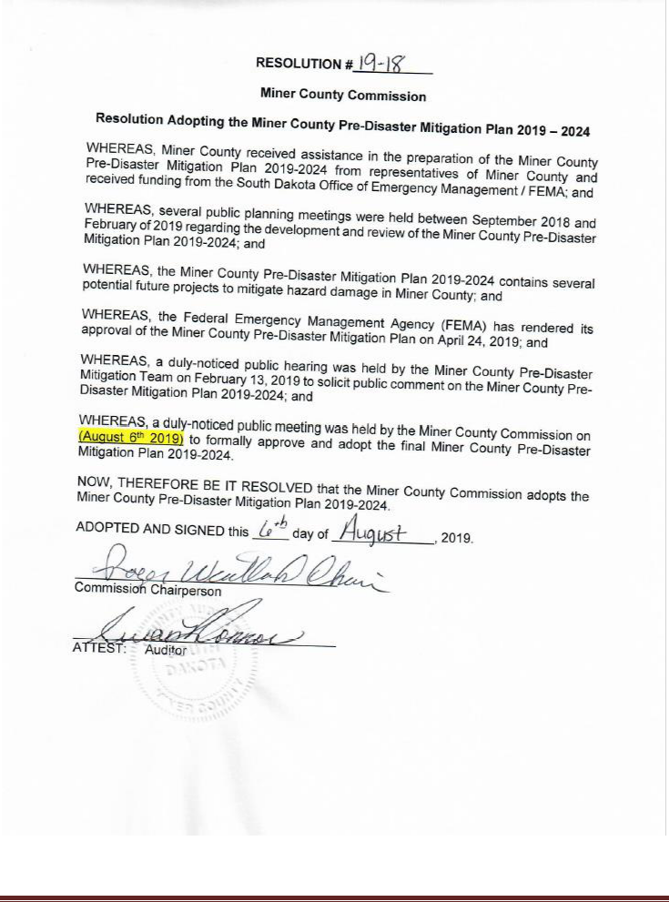

Miner County Pre-Disaster Mitigation Plan Page 97

Town of Canova Resolution
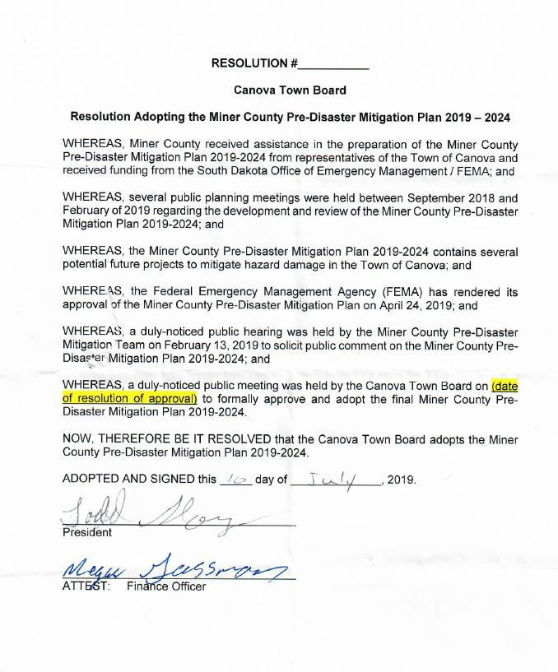

Miner County Pre-Disaster Mitigation Plan Page 98

City of Carthage Resolution
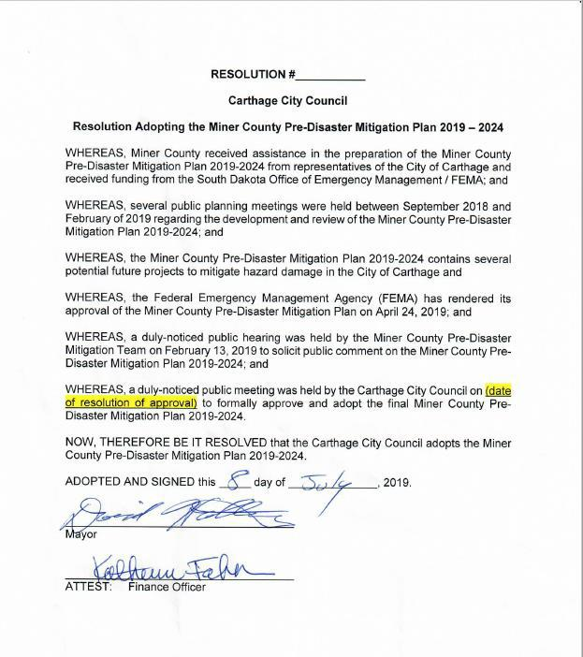

Miner County Pre-Disaster Mitigation Plan Page 99

City of Howard Resolution
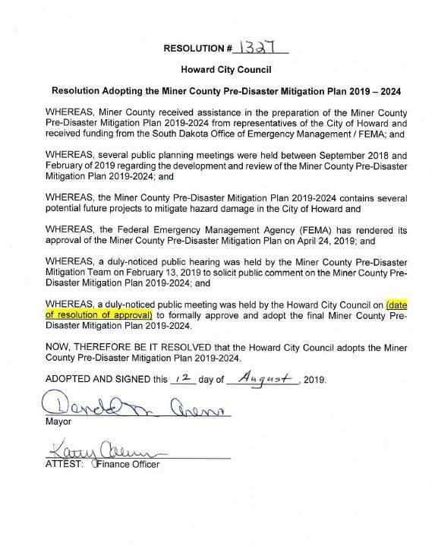

Miner County Pre-Disaster Mitigation Plan Page 100

Appendix B
PDM Planning Team Agendas, Minutes, and Sign-in Sheets

Miner County Pre-Disaster Mitigation Plan Page 101

PDM Kickoff Meeting Agenda

Miner County
Pre-disaster Mitigation Plan Kickoff Meeting
7:00 p.m. Tuesday, September 25, 2018
Miner County 4-H Building

Agenda

- Introduction of team members

- What is mitigation planning

- Why is Miner County updating the Pre-Disaster Mitigation Plan

- Review plan components

- Review timeline/scope

Miner County Pre-Disaster Mitigation Plan Page 102

PDM Kickoff Meeting Minutes

Miner County Pre-Disaster Mitigation Plan Team Kick-Off Meeting 09/25/2018

Miner County 4-H Building
7:00 p.m.

Seven individuals were in attendance:

- Bob Calmus, Miner County Emergency Manager

- Ron Krempges, Miner County Highway Department

- Henry Rentschler, Howard Fire Department

- Craig Hanson, Vilas

- Pat Maroney, Miner County Commission

- Ron Miller, Canova

- Thomas Nealon, First District Association of Local Governments

- Todd Kay, First District Association of Local Governments

Miner County Emergency Management Director Bob Calmus welcomed those in attendance and had Team members introduce themselves and what entity they represented. Calmus then introduced Todd Kays from the First District Association of Local Governments.

Kays provided an overview of what is mitigation planning and why the county is required to update their Pre-Disaster Mitigation (PDM) Plan. Kays also provided a review of the components to be included within the plan (risk assessment, vulnerability, proposed mitigation actions).

Planning Team representatives provided information regarding mitigation activities within their own respective entities. A general review of the existing Pre-Disaster Mitigation Plan started by defining work responsibilities, having the First District doing background and research, and the PDM Team providing oversight and guidelines throughout the process. The timeline and scope of project were reviewed.

Meeting adjourned at 7:45 p.m. Date and time for the next meeting to be determined.

Minutes recorded by Thomas Nealon

Miner County Pre-Disaster Mitigation Plan Page 103

PDM Kickoff Sign in Sheet
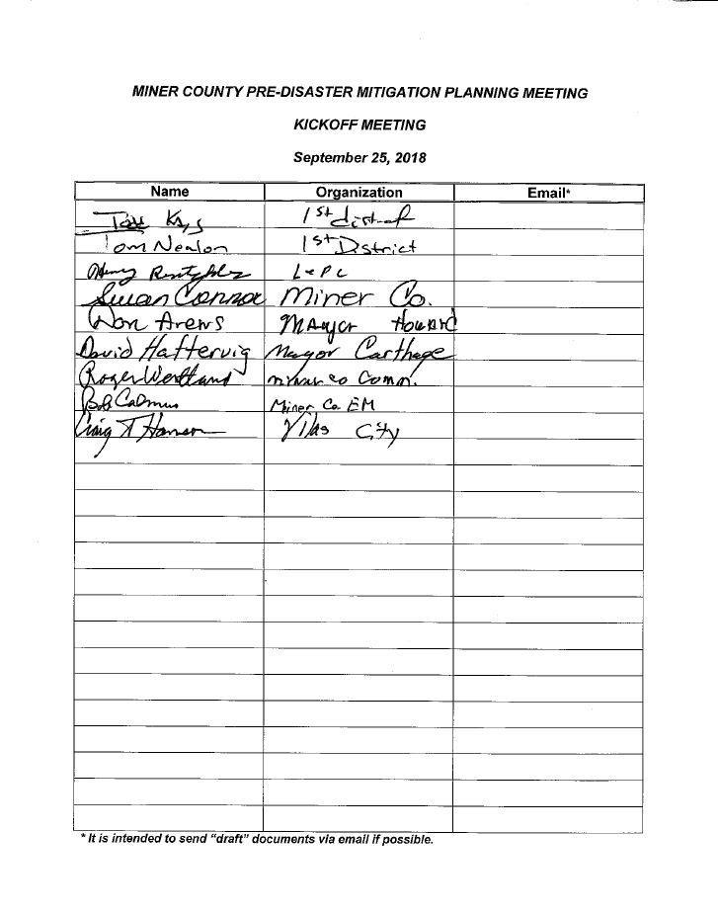

Miner County Pre-Disaster Mitigation Plan Page 104

Second PDM Meeting Agenda

Miner County Pre-Disaster Mitigation Plan
Mitigation Planning Team Meeting
7:00PM Wednesday February 13, 2019
Miner County 4-H Building

Agenda

- Introduction

- Review of Previous Meetings and Plan Development History

- Review of PDM Preliminary Draft

  - Plan Authority and Purpose o Community Profile

o Plan Process

o Risk Assessment/Critical Infrastructure o Review of Goals and Objectives

o Project Identification o Plan Maintenance

- Questions

- Next Steps in PDM Draft Process

Miner County Pre-Disaster Mitigation Plan Page 105

Second PDM Meeting Minutes

Miner County Pre-Disaster Mitigation Team Meeting Minutes

February 13, 2019

Miner County 4-H Building

7:00 p.m.

Three team members were in attendance. Team meeting began with introductions.

Thomas Nealon of the First District provided a brief review of previous meetings and plan development activities conducted since the last Team meeting in September 2018.

Nealon provided a summary and review of the draft Miner County Pre-Disaster Mitigation Plan.

Nealon discussed plan authority and purpose. He provided an overview of the community profile information and information sources. Nealon covered the multi-jurisdictional plan and plan participation requirements. The plan development process was discussed in more detail.

Nealon provided an in-depth discussion of risk assessment and vulnerability in Miner County. He covered the risk assessments conducted with the communities of Carthage, Canova, and Howard. The risk assessment review with those entities dealt with identification of potential hazards, generating a hazard profile, and vulnerability assessment. Nealon discussed vulnerabilities and potential losses in the county. He went over the administrative and technical capabilities within Miner County.

The Team reviewed and revised goals and objectives of the previous PDM Plan. The Team agreed to incorporate the new goals and objectives into the updated plan.

Goals and Objectives

- Reduce the loss of life, property, infrastructure, critical facilities, cultural resources and impacts from severe weather, flooding and other natural disasters.

- Improve public safety during severe weather, flooding and other natural disasters.

- Improve the County’s emergency preparedness, disaster response and recovery capabilities.

Severe Weather, Flooding, Fire and Drought Administration.

Nealon discussed potential mitigation projects throughout the county and communities.

Nealon explained the plan maintenance requires for the next five years.

Discussion and questions occurred during and after the summary process.

Consensus of the Team was to spend more time on individual review of the document and to provide First District staff with any corrections/updates.

Meeting adjourned at 7:35 p.m., with a tentative date of the final meeting to be in February 26th, 2018. Minutes recorded by Thomas Nealon

Miner County Pre-Disaster Mitigation Plan Page 106

Second PDM Meeting Sign-in Sheet
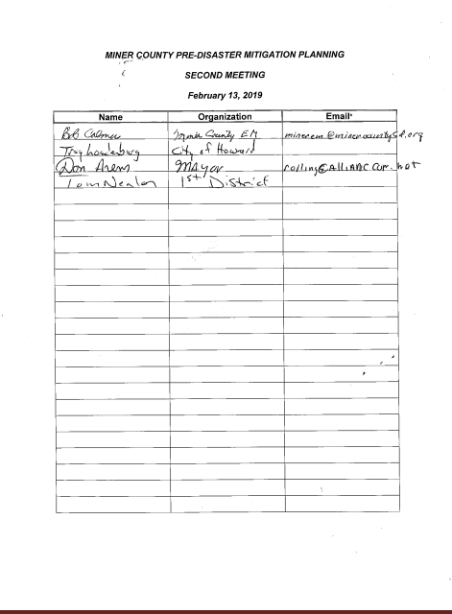

Miner County Pre-Disaster Mitigation Plan Page 107

Third PDM Meeting Agenda

Miner County Pre-Disaster Mitigation Plan

Mitigation Planning Team Meeting #3

7:00 p.m. February 26, 2019

Miner County 4-H Building

Agenda

- Final Review of PDM Plan

- Recommendation of Approval and Submission to FEMA

Miner County Pre-Disaster Mitigation Plan Page 108

Third PDM Meeting Minutes
Miner County Pre-Disaster Mitigation Team
PDM Meeting #3

February 26, 2019
Miner County 4-H Building
7:00 p.m.

Five people were in attendance:

- Four PDM team members

- Thomas Nealon, First District Association of Local Governments

Thomas Nealon of First District provided an overview of the changes to the Pre-Disaster Mitigation Plan received since the last meeting. The draft plan was posted on the First District and Miner County websites on January 11, 2019. Plan discussion and comments were received from those in attendance.

Motion by Arens, second by Calmus to approve the final draft of the plan and submit to State of South Dakota and FEMA for their review. Motion passed unanimously.

Nealon reviewed the community and county adoption process after approval by FEMA.

Meeting adjourned at 7:20 p.m.

Minutes recorded by Thomas Nealon

Miner County Pre-Disaster Mitigation Plan Page 109

Third PDM Meeting Sign-in Sheet
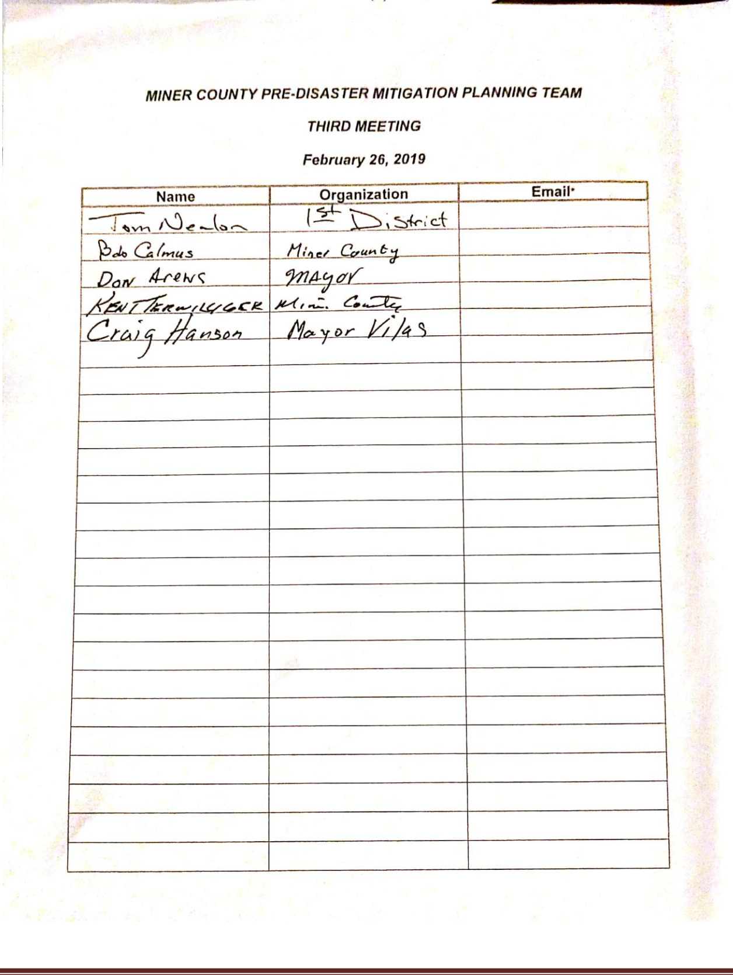

Miner County Pre-Disaster Mitigation Plan Page 110

Appendix C
Community Meeting Agendas, Minutes, and Sign-in Sheets

Appendix C includes Agendas and “Sign-in Sheets” from the initial meetings held at the community level for the Miner County Pre-Disaster Mitigation Plan. Meetings were held at the regular monthly meetings for the following Towns:

Town
Canova

Carthage

Howard

Date
October 15, 2018
December 10, 2018
December 10, 2018

At all of the previously described meetings each individual in attendance was asked to identify the probability of each specific hazard’s occurrence. Following discussion on each individual hazard, Board members categorized these hazards as high probability to occur, low probability to occur, or unlikely to occur. The result was recorded on a master sheet for each town. Next, each individual in attendance was asked to identify the town’s vulnerability to each specific hazard.

Following discussion on each individual hazard, Board members classified the town’s vulnerability to each hazard as high vulnerability, low vulnerability, or noted that the hazard was not a hazard in the jurisdiction. The result was recorded on a master sheet for each town. Following the hazard identification and vulnerability exercises the governing body was asked to rate the level to which they agree with the goals of the Pre-Disaster Mitigation Plan. The result was recorded on a master sheet for each town.

Finally, the Town Board was asked to identify critical infrastructure within the community. All master sheets and infrastructure lists compiled at those meetings can be found in Appendix E. A master infrastructure list was compiled for each town in Table 4.16.

Attendance sign-in sheets and Agendas for each of the above described meetings are included below.

Miner County Pre-Disaster Mitigation Plan Page 111

Town of Canova Agenda
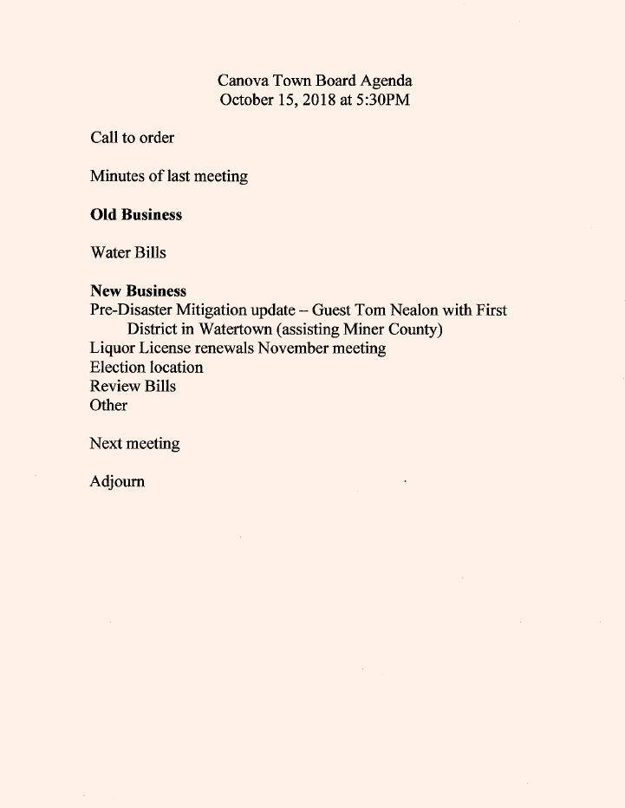

Miner County Pre-Disaster Mitigation Plan Page 112

Town of Canova Sign in Sheet
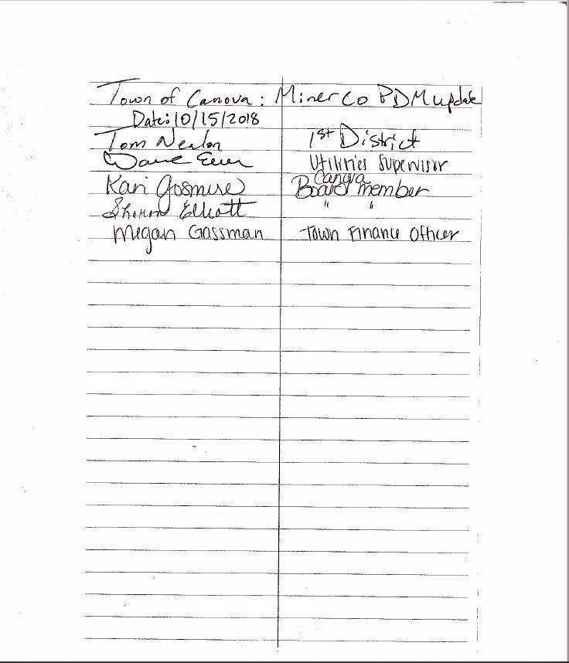

Miner County Pre-Disaster Mitigation Plan Page 113

Town of Canova Minutes

Miner County Pre-Disaster Mitigation Plan Page 114

City of Carthage Agenda
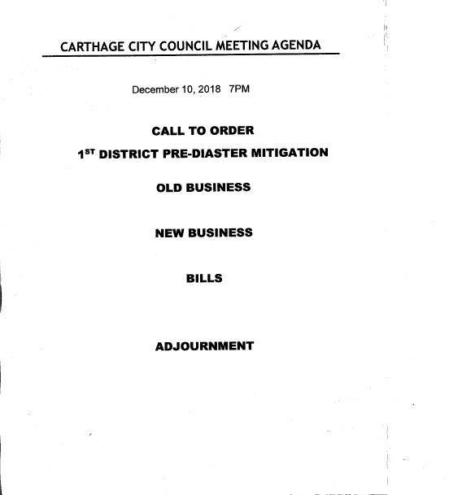

Miner County Pre-Disaster Mitigation Plan Page 115

City of Carthage Sign in Sheet
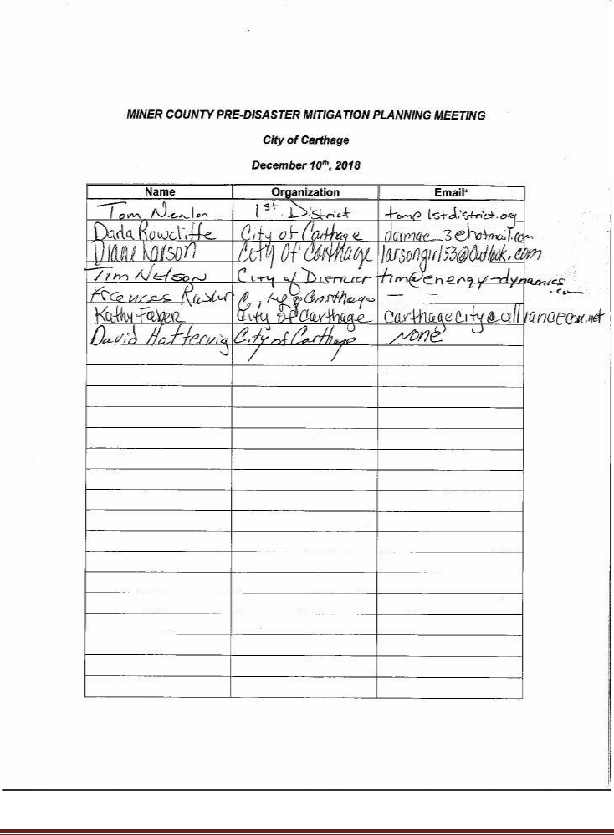

Miner County Pre-Disaster Mitigation Plan Page 116

City of Carthage Minutes

Miner County Pre-Disaster Mitigation Plan Page 117

City of Howard Agenda
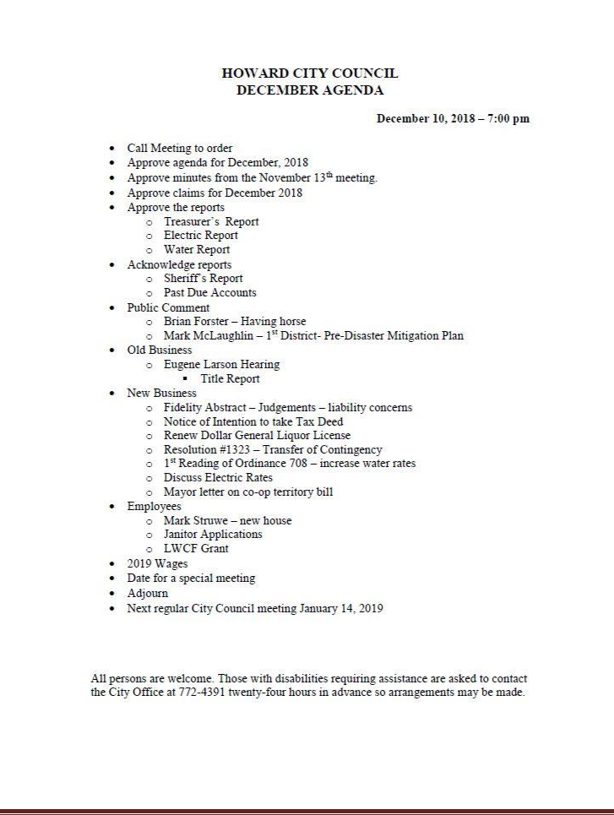

Miner County Pre-Disaster Mitigation Plan Page 118

City of Howard Sign in Sheet
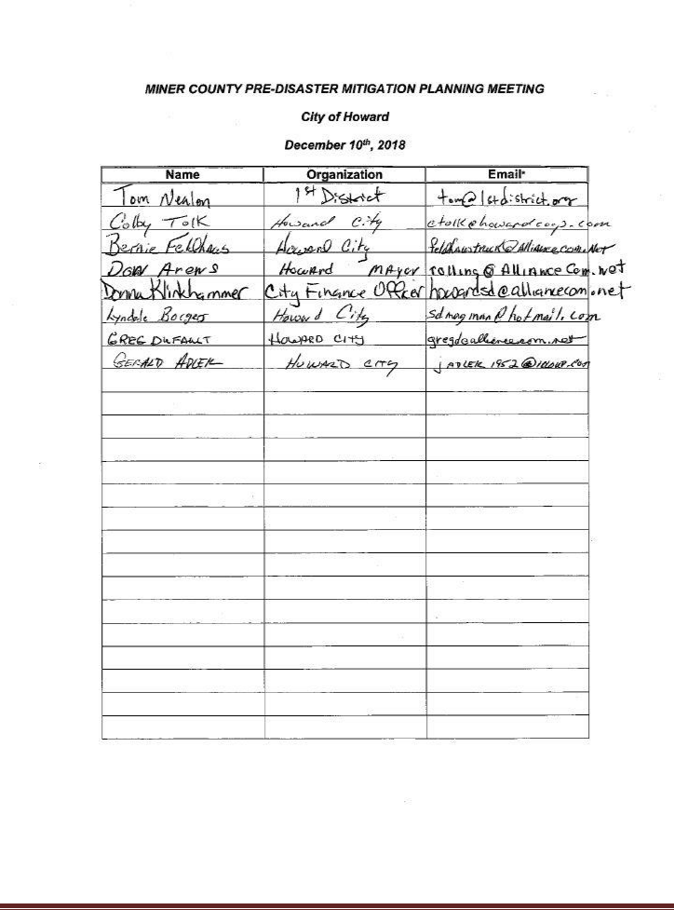

Miner County Pre-Disaster Mitigation Plan Page 119

City of Howard Meeting Minutes
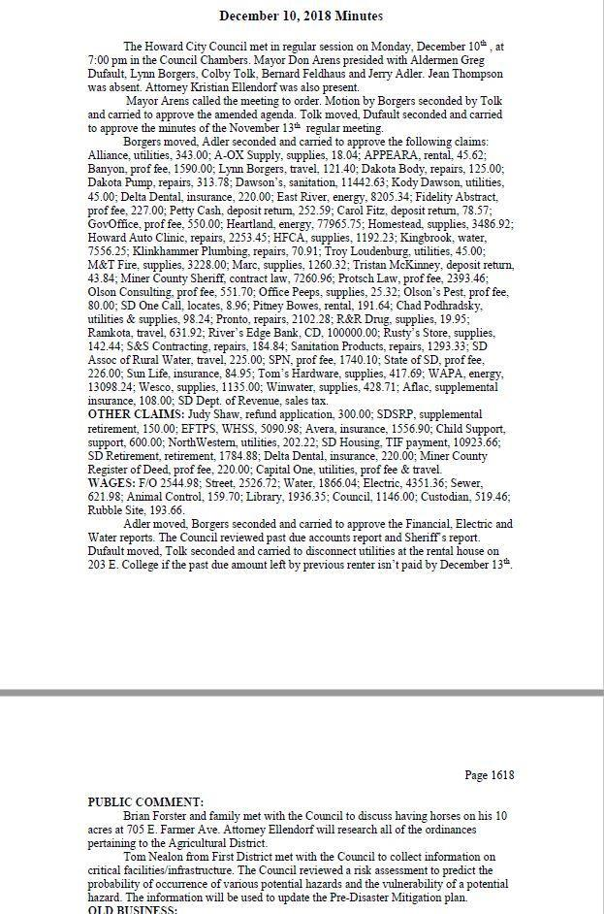

Miner County Pre-Disaster Mitigation Plan Page 120

Appendix D
Hazard Identification/Vulnerability Worksheets

Appendix E includes master worksheets for Hazard Identification and Vulnerability for jurisdictions compiled as described in Appendix D. Lists were gathered at meetings as described below:

Entity

Town of Canova

City of Carthage

City of Howard
Village of Vilas

Date

October 15, 2018
December 10, 2018
December 10, 2018
December 12, 2018

Master worksheets for Hazard Identification and Vulnerability for jurisdictions below.

Miner County Pre-Disaster Mitigation Plan Page 121

Town of Canova
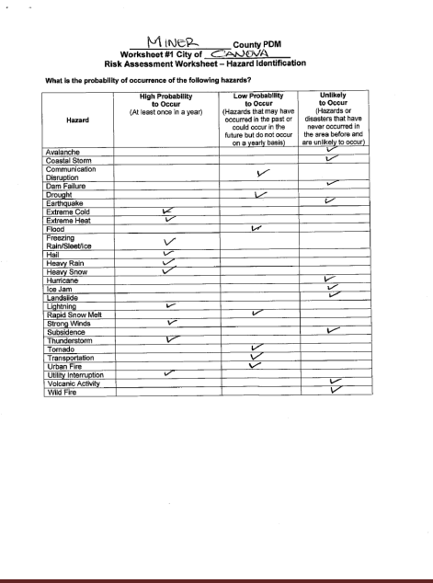

Miner County Pre-Disaster Mitigation Plan Page 122

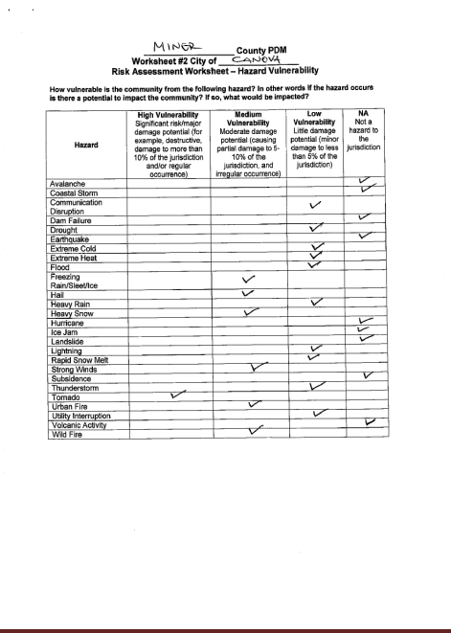

Miner County Pre-Disaster Mitigation Plan Page 123

City of Carthage
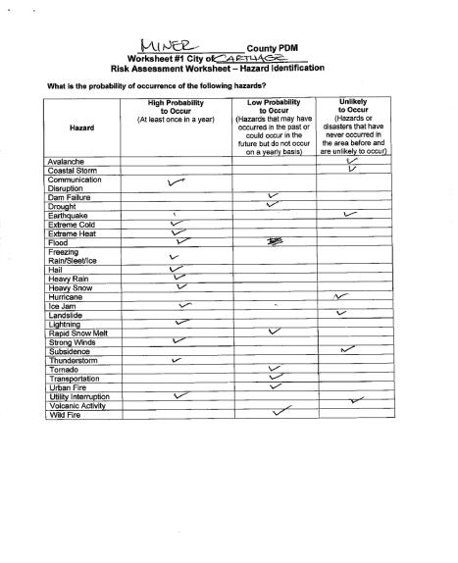

Miner County Pre-Disaster Mitigation Plan Page 124

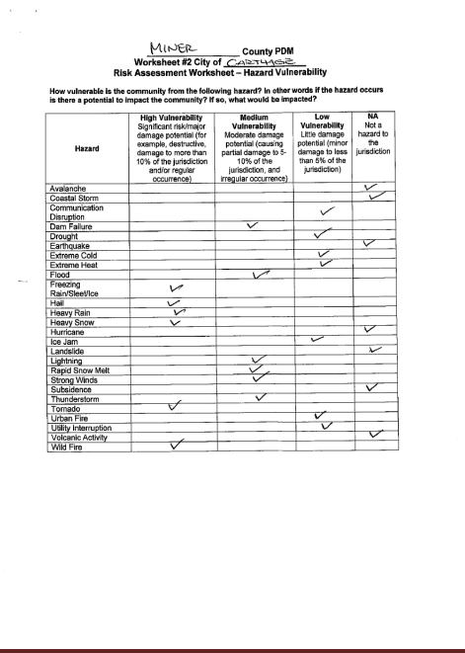

Miner County Pre-Disaster Mitigation Plan Page 125

City of Howard
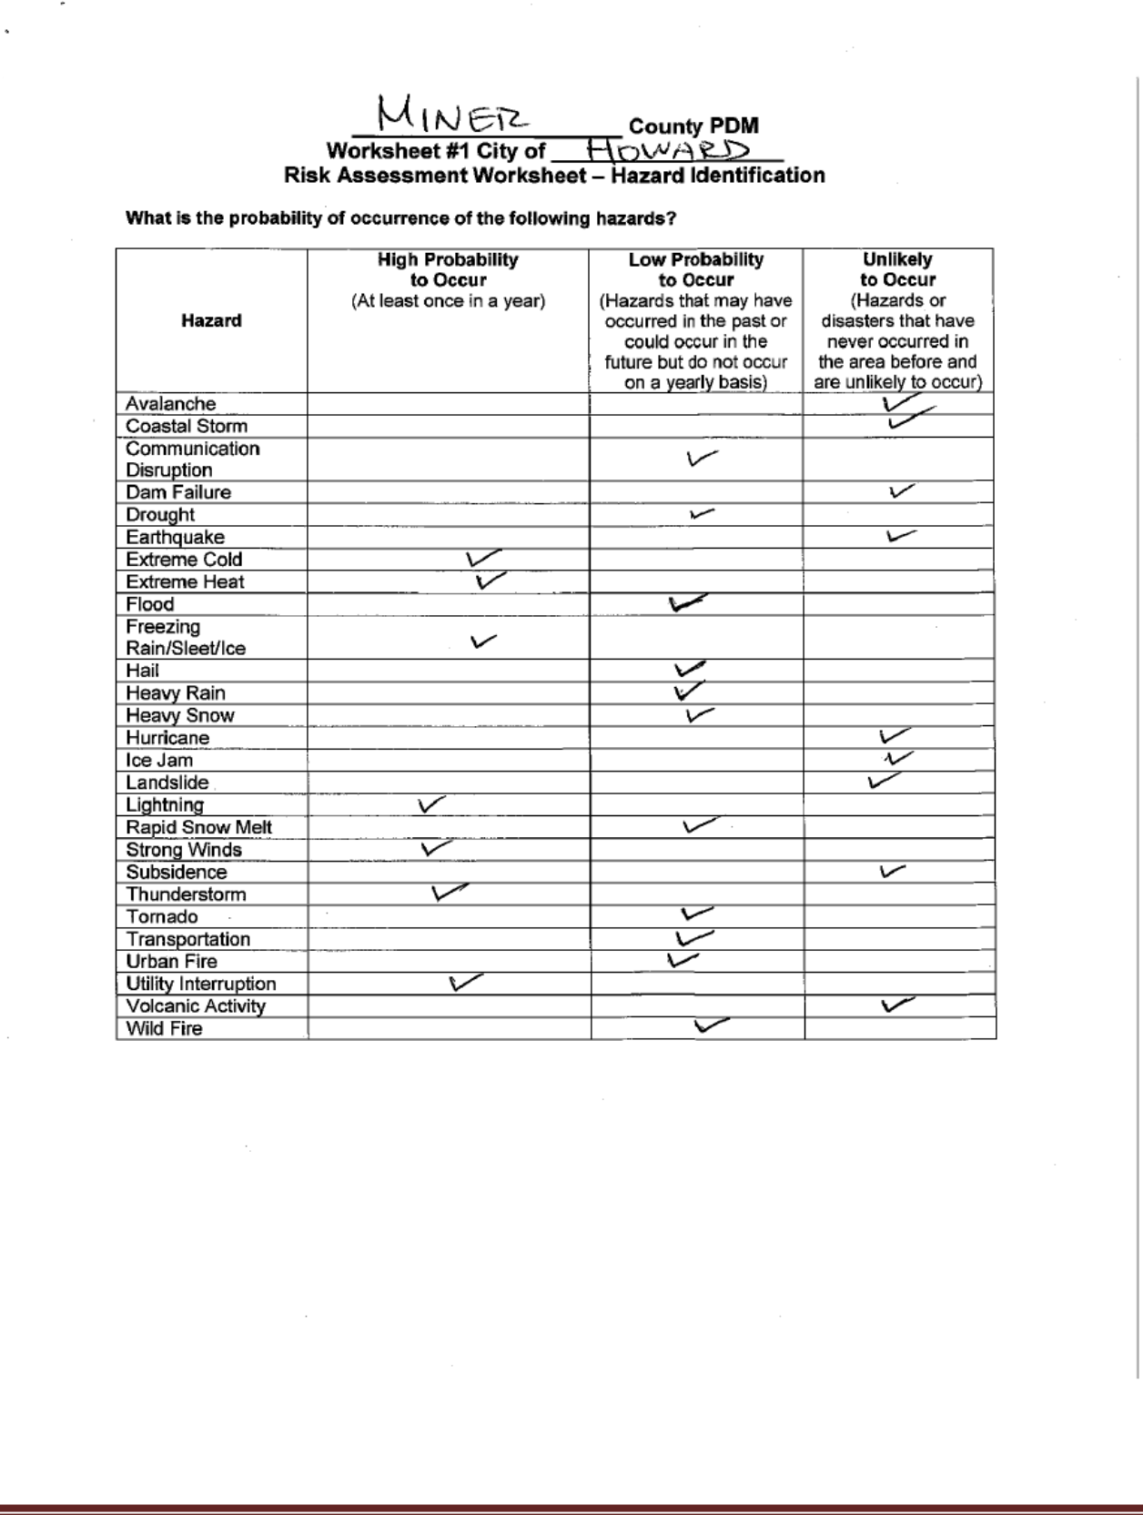

Miner County Pre-Disaster Mitigation Plan Page 126

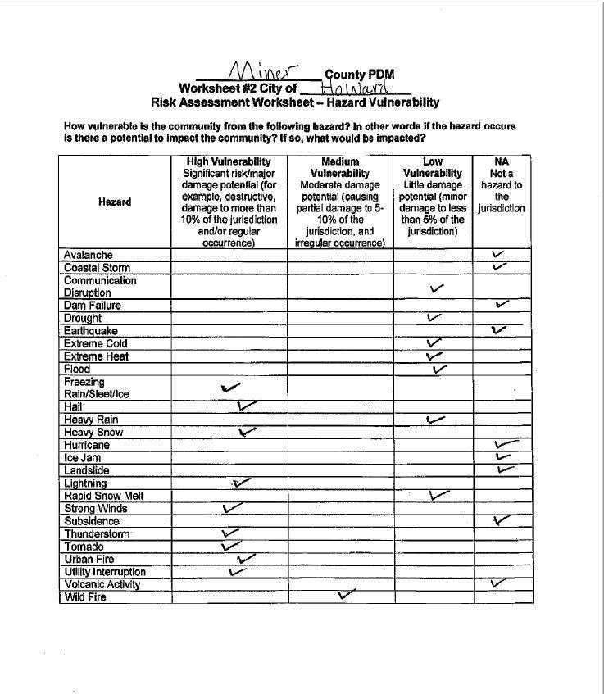

Miner County Pre-Disaster Mitigation Plan Page 127

Village of Vilas
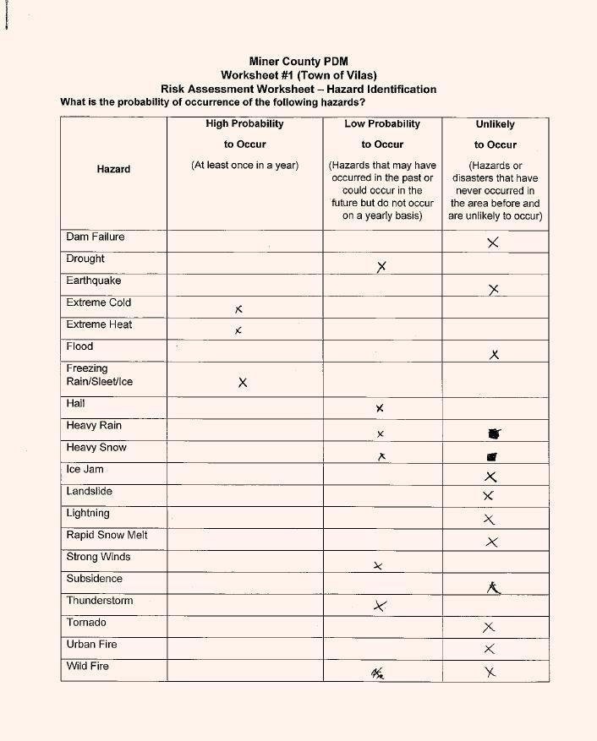

Miner County Pre-Disaster Mitigation Plan Page 128

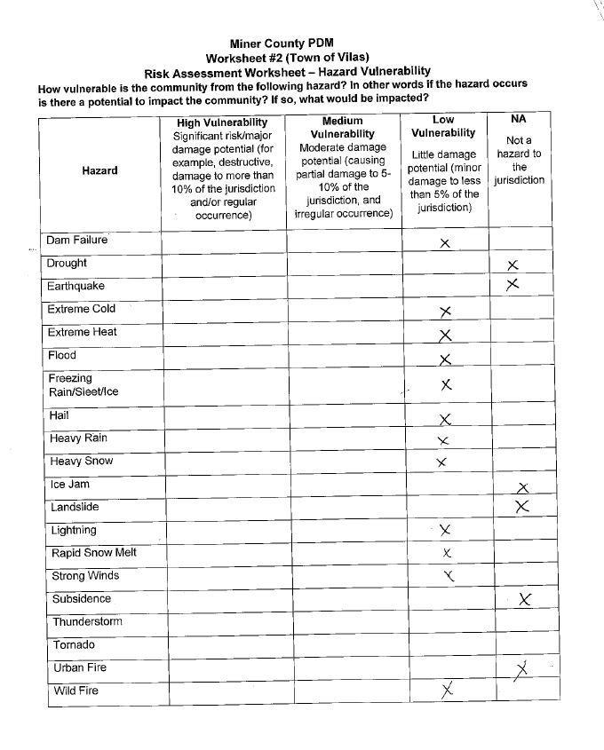

Miner County Pre-Disaster Mitigation Plan Page 129

Appendix E
Township Vulnerable and Potential Mitigation Project Site Maps

In October of 2018 First District mailed a request to the Township Clerk or Road Supervisor of every township in Miner County. They were requested to list any critical infrastructure and identify (on a map) any areas which are most vulnerable to natural hazards, specifically flooding. It was assumed that any townships which did not respond to the information request had no critical infrastructure or vulnerable areas which may require mitigation activities. Of the sixteen requests sent, eleven were returned with vulnerable areas identified (see table below).

 | Township Name |  |  |  | Response
 | Adams Township |  |  |  | Not returned/ No vulnerabilities
 | Beaver Township |  |  |  | Identified vulnerabilities
 | Belleview Township |  |  |  | Identified vulnerabilities
 | Canova Township |  |  |  | Identified vulnerabilities
 | Carthage Township |  |  |  | Identified vulnerabilities
 | Clearwater Township |  |  |  | Not returned/ No vulnerabilities
 | Clinton Township |  |  |  | Identified vulnerabilities
 | Grafton Township |  |  |  | Not returned/ No vulnerabilities
 | Green Valley Township |  |  |  | Identified vulnerabilities
 | Henden Township |  |  |  | Identified vulnerabilities
 | Howard Township |  |  |  | Identified vulnerabilities
 | Miner Township |  |  |  | Identified vulnerabilities
 | Redstone Township |  |  |  | Not returned/ No vulnerabilities
 | Rock Creek Township |  |  |  | Not returned/ No vulnerabilities
 | Roswell Township |  |  |  | Identified vulnerabilities
 | Vermillion Township |  |  |  | Identified vulnerabilities

Maps identifying vulnerable areas for those townships which identified such areas are shown in the following pages.

Miner County Pre-Disaster Mitigation Plan Page 130

Adams Township
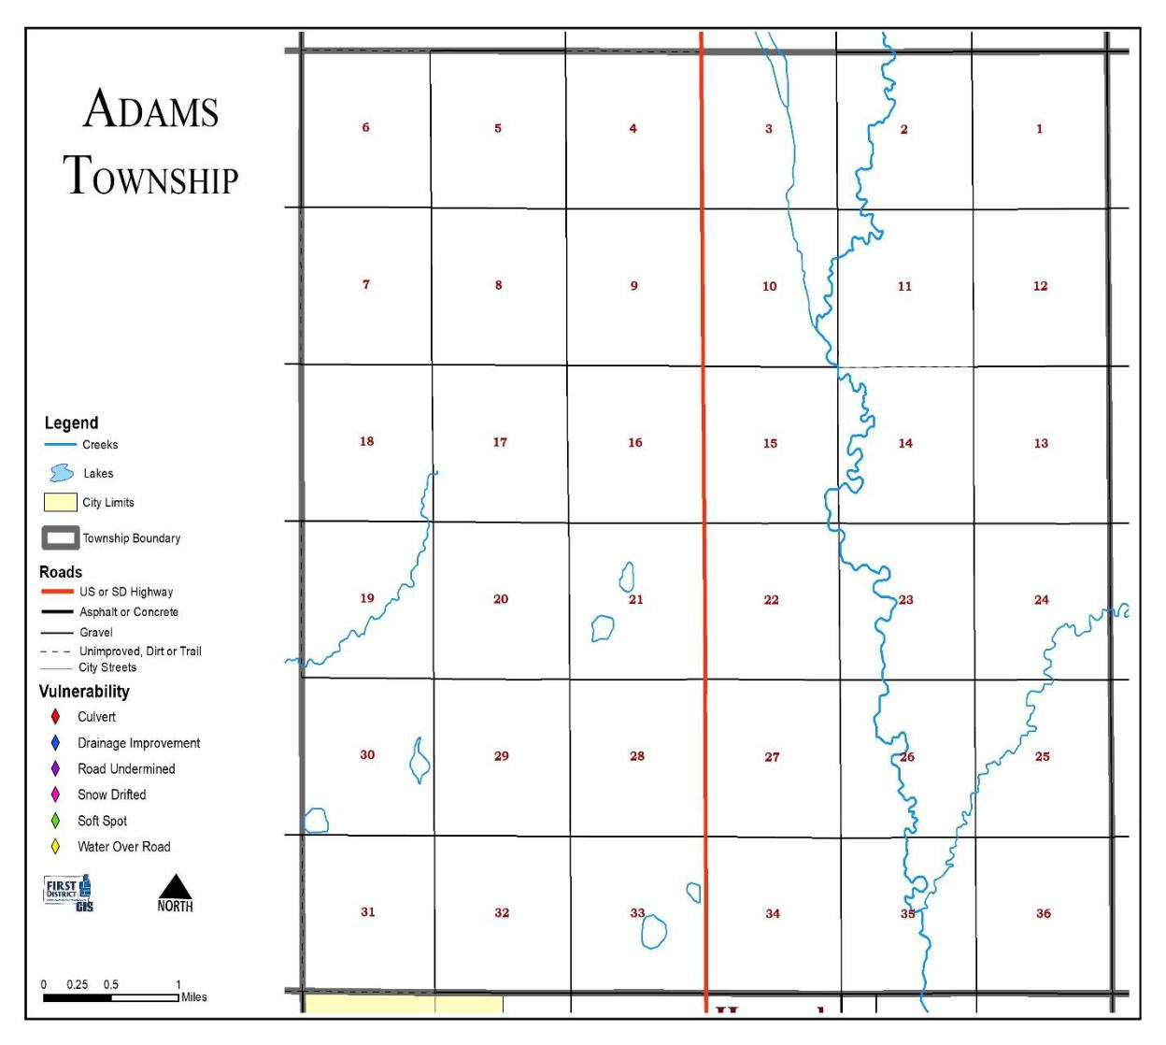

Miner County Pre-Disaster Mitigation Plan Page 131

Beaver Township
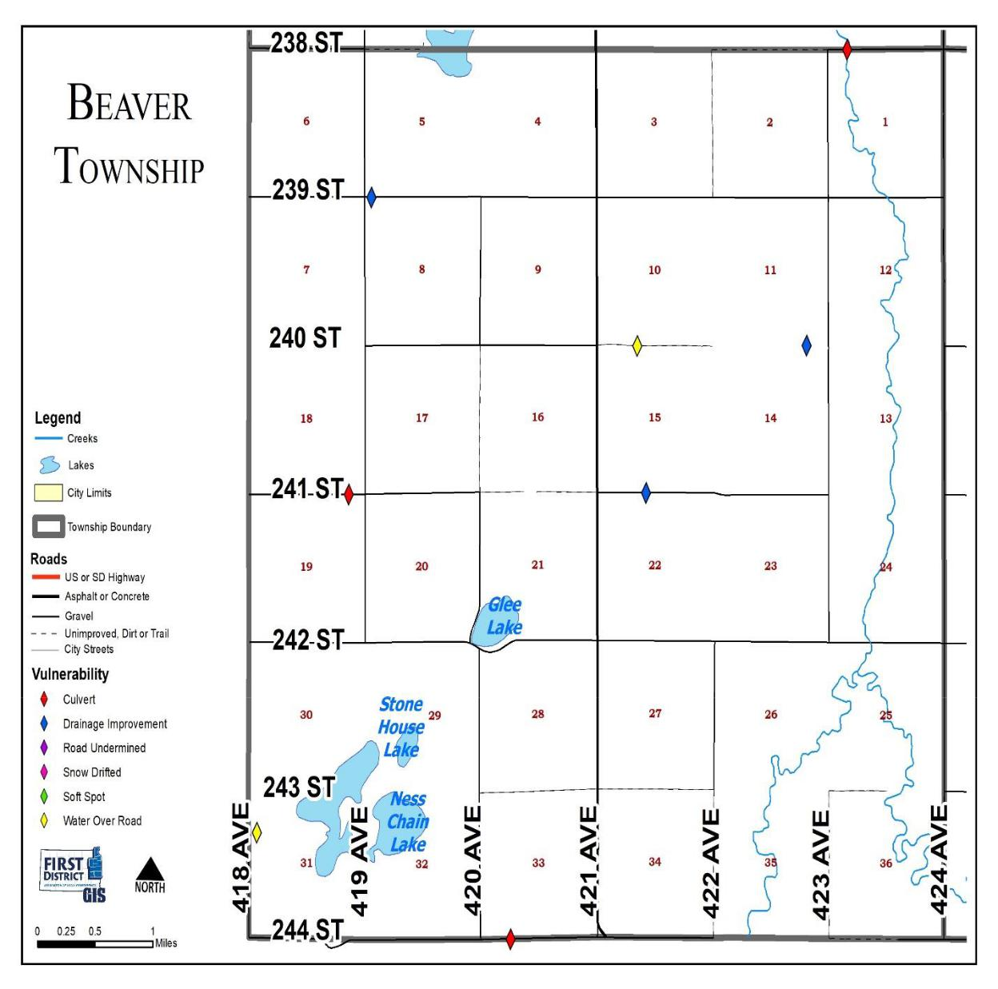

Miner County Pre-Disaster Mitigation Plan Page 132

Belleview Township
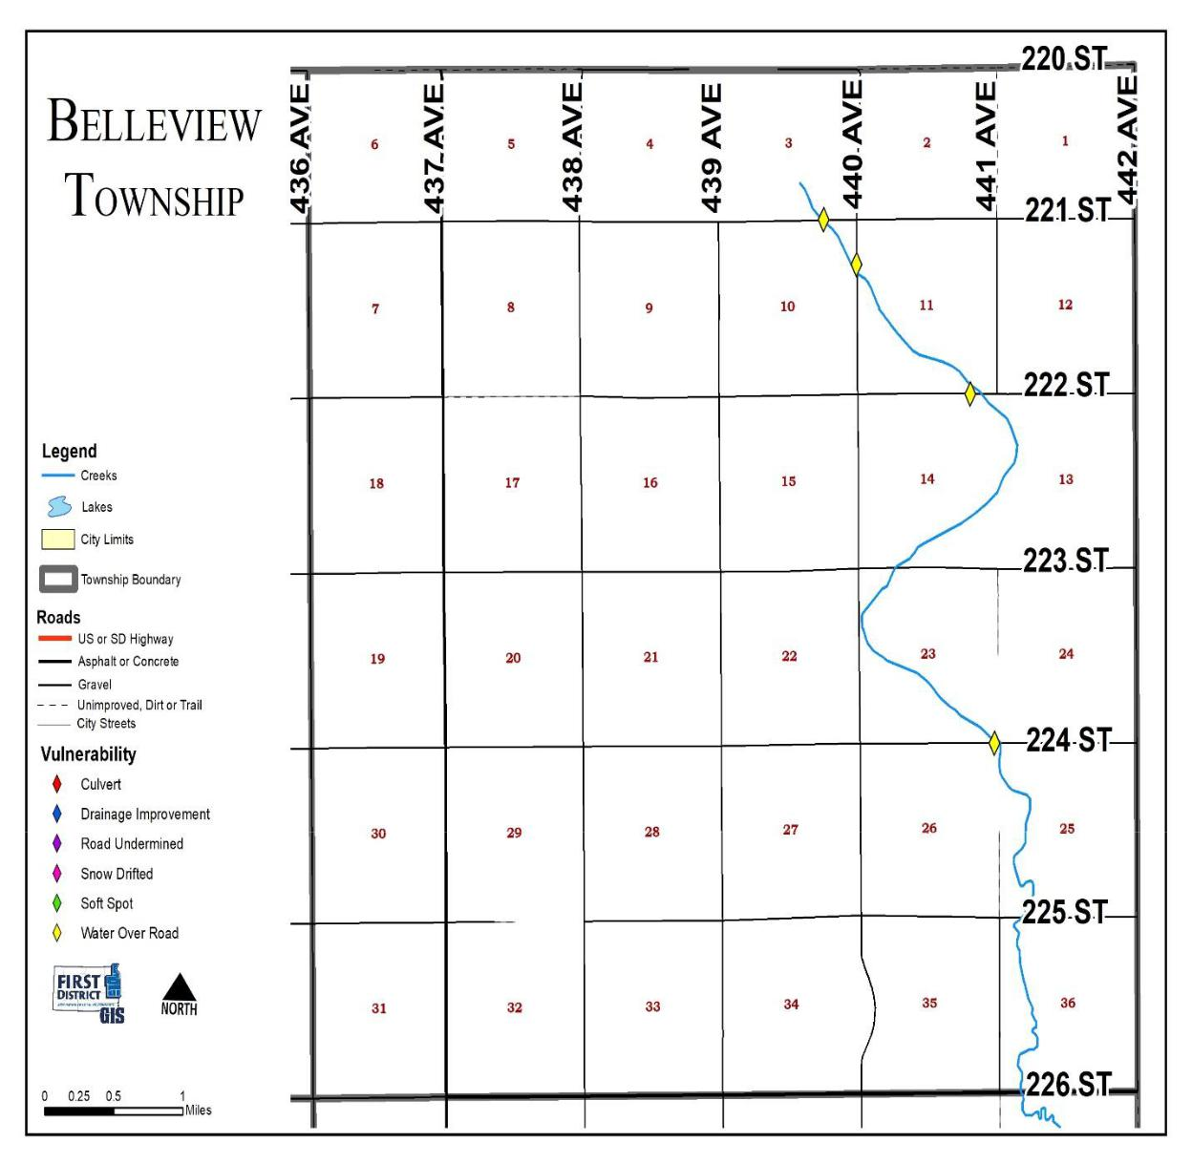

Miner County Pre-Disaster Mitigation Plan Page 133

Canova Township
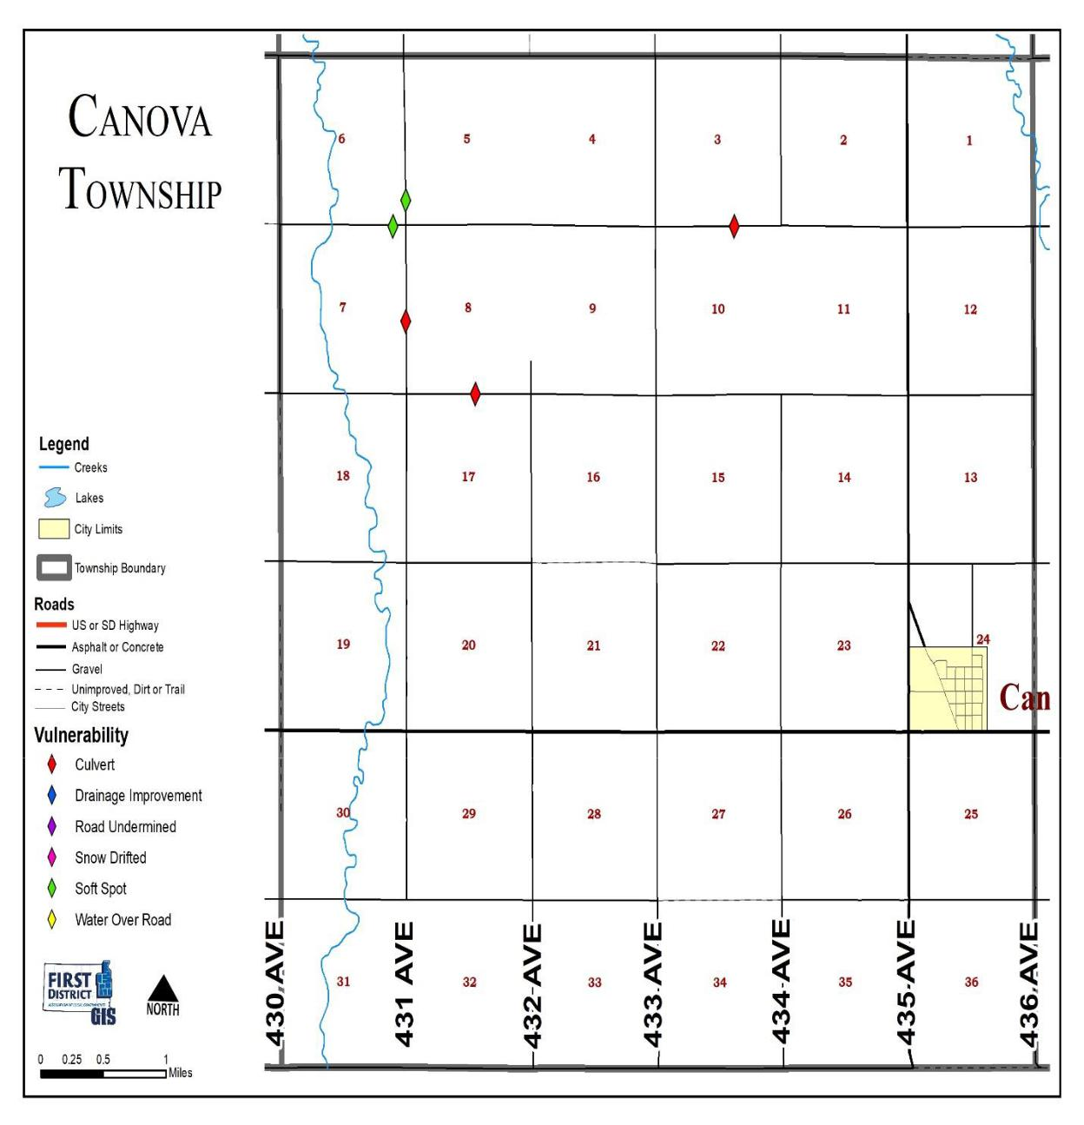

Miner County Pre-Disaster Mitigation Plan Page 134

Carthage Township
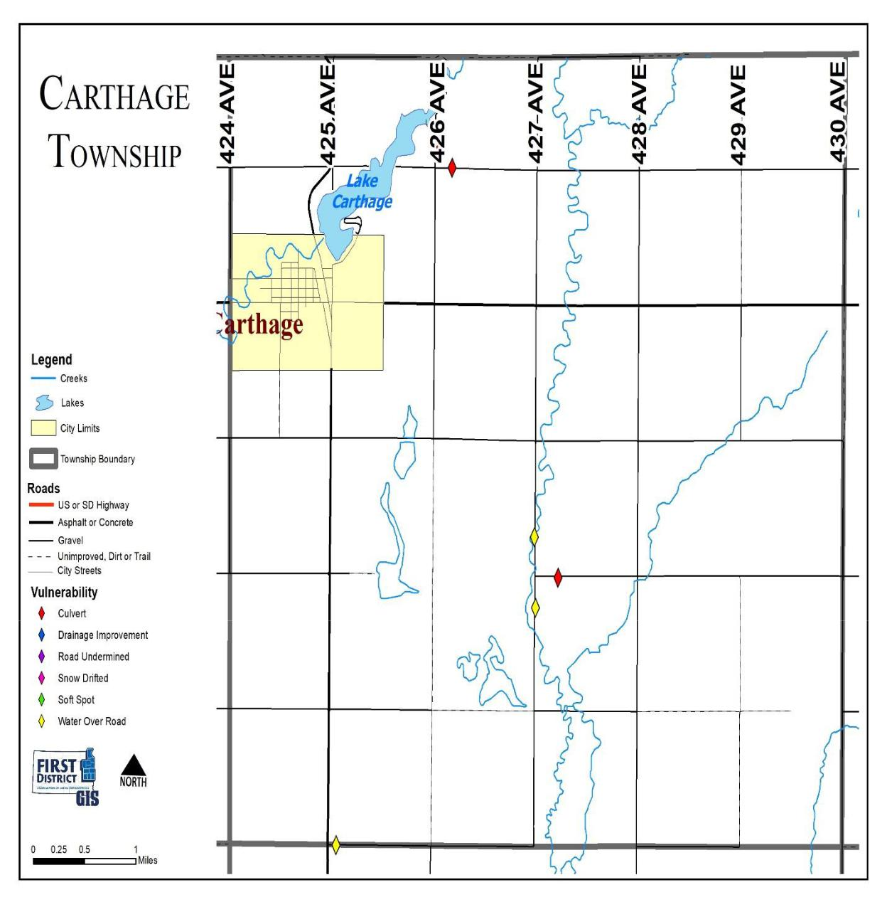

Miner County Pre-Disaster Mitigation Plan Page 135

Clearwater Township
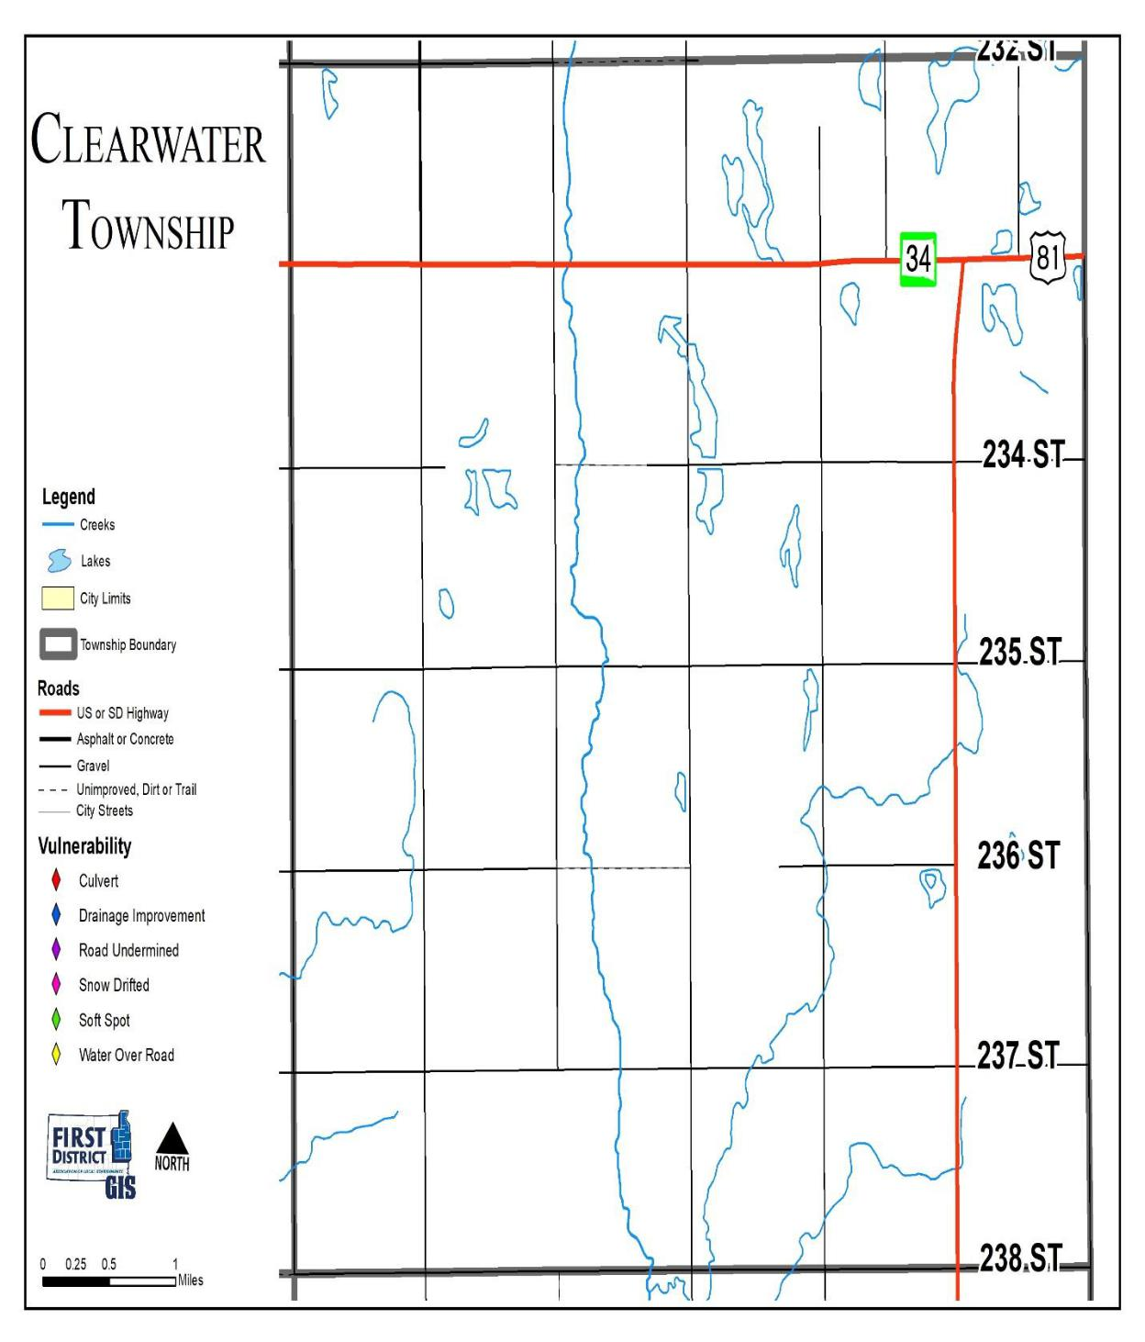

Miner County Pre-Disaster Mitigation Plan Page 136

Clinton Township
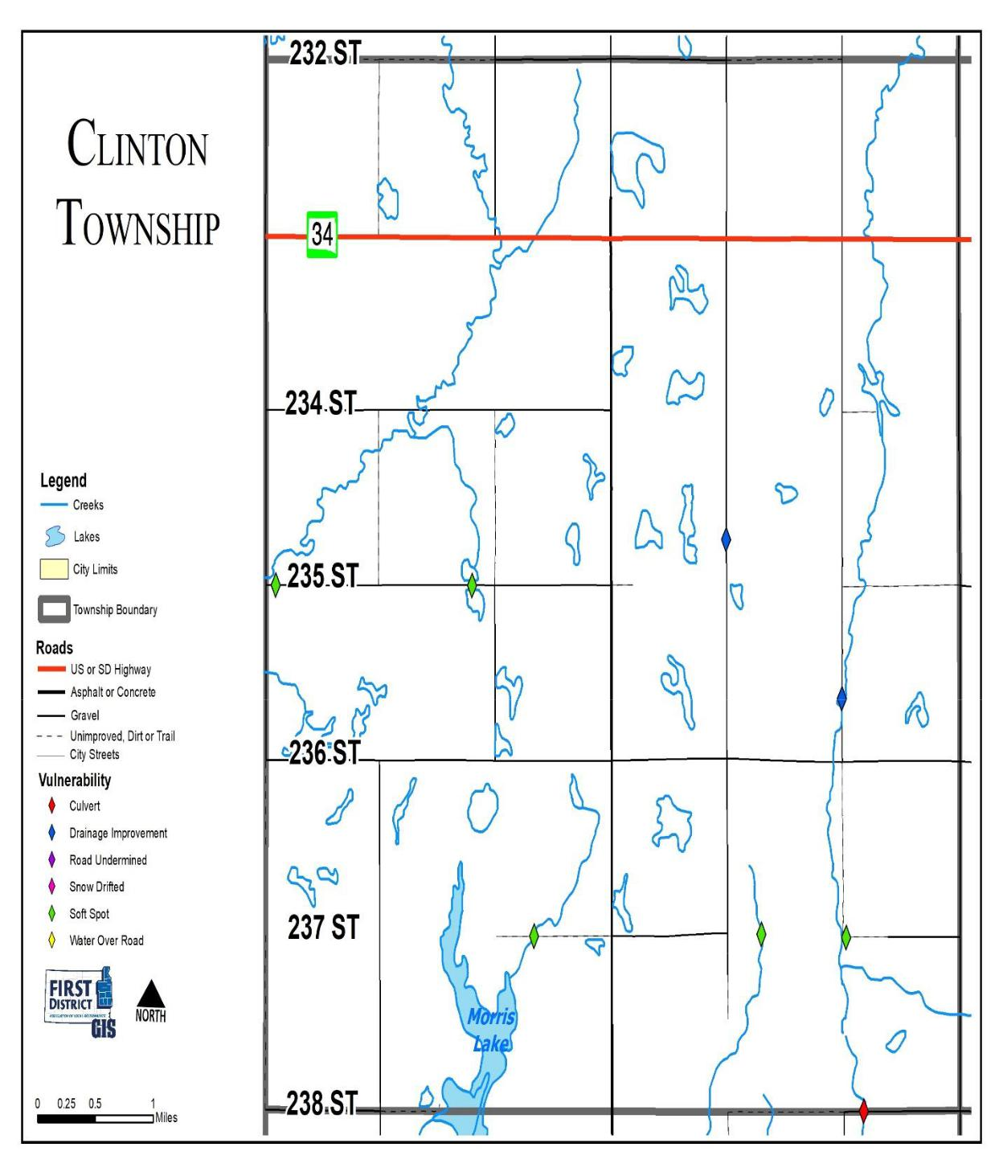

Miner County Pre-Disaster Mitigation Plan Page 137

Grafton Township
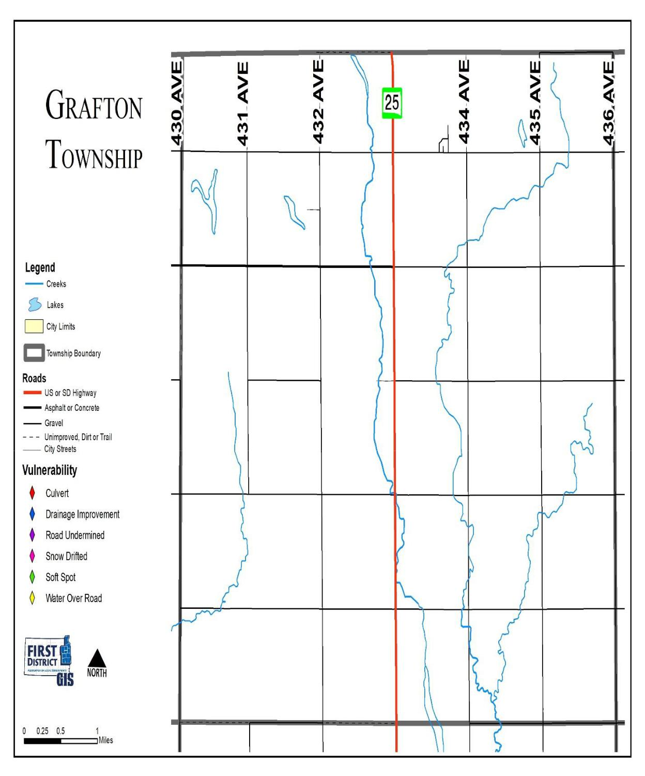

Miner County Pre-Disaster Mitigation Plan Page 138

Green Valley Township
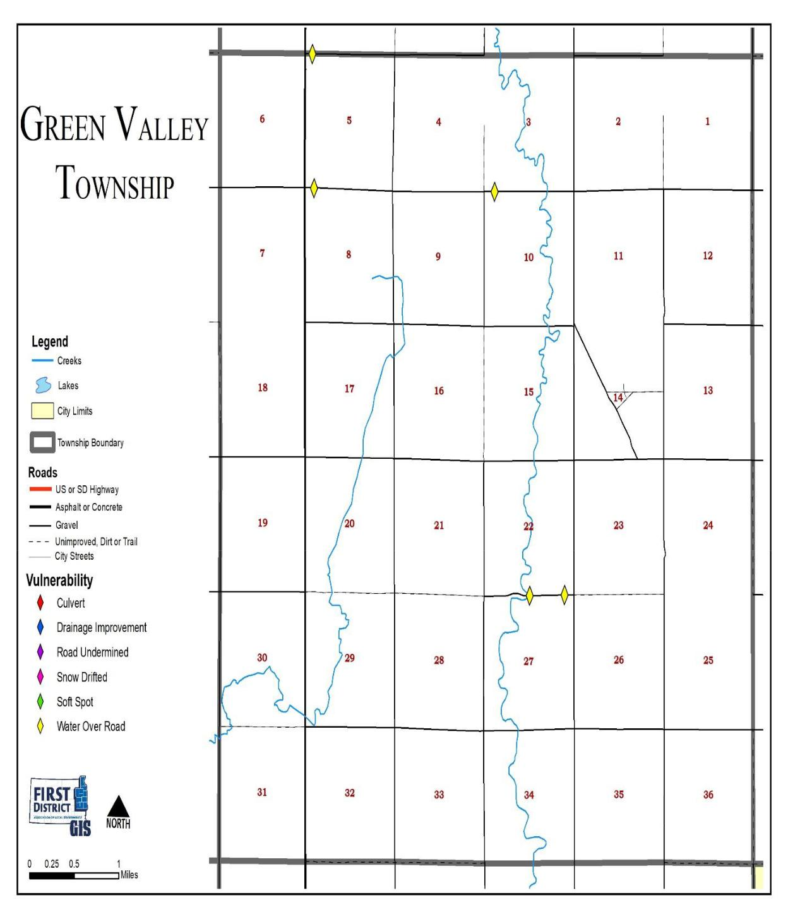

Miner County Pre-Disaster Mitigation Plan Page 139

Henden Township
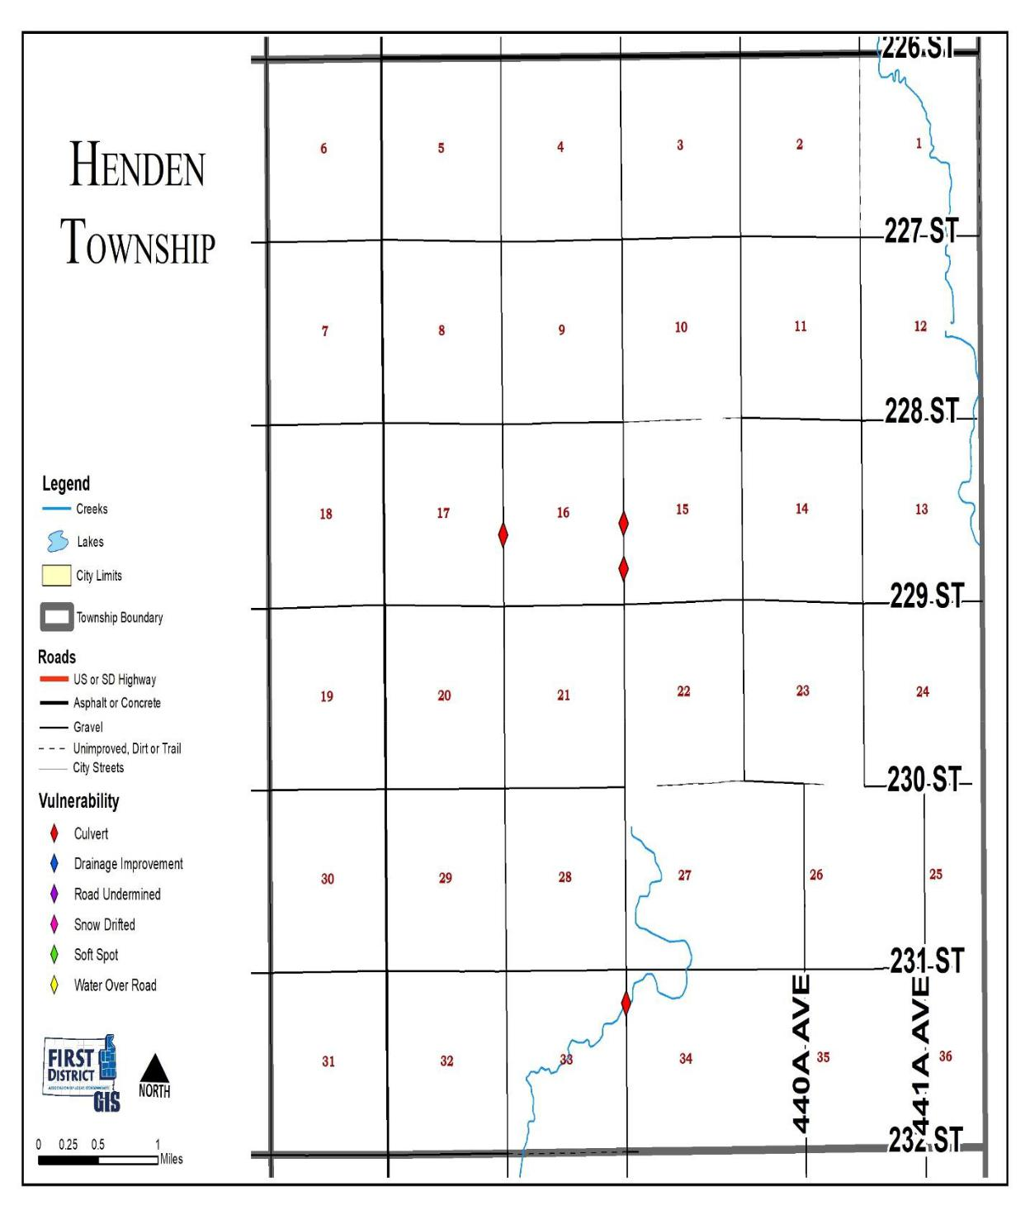

Miner County Pre-Disaster Mitigation Plan Page 140

Howard Township
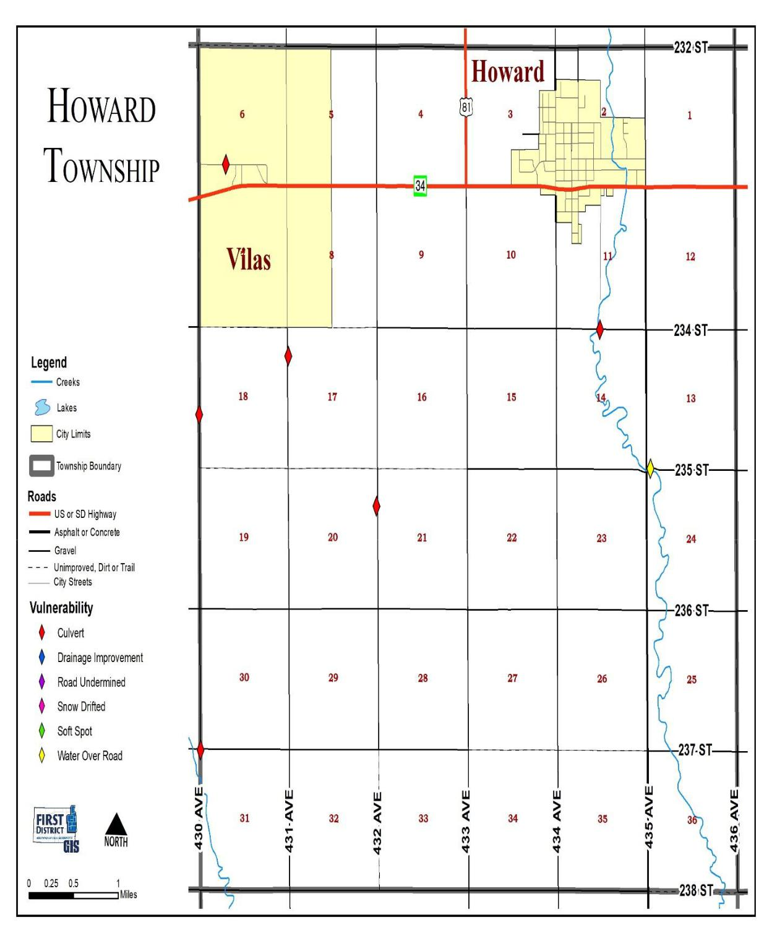

Miner County Pre-Disaster Mitigation Plan Page 141

Miner Township
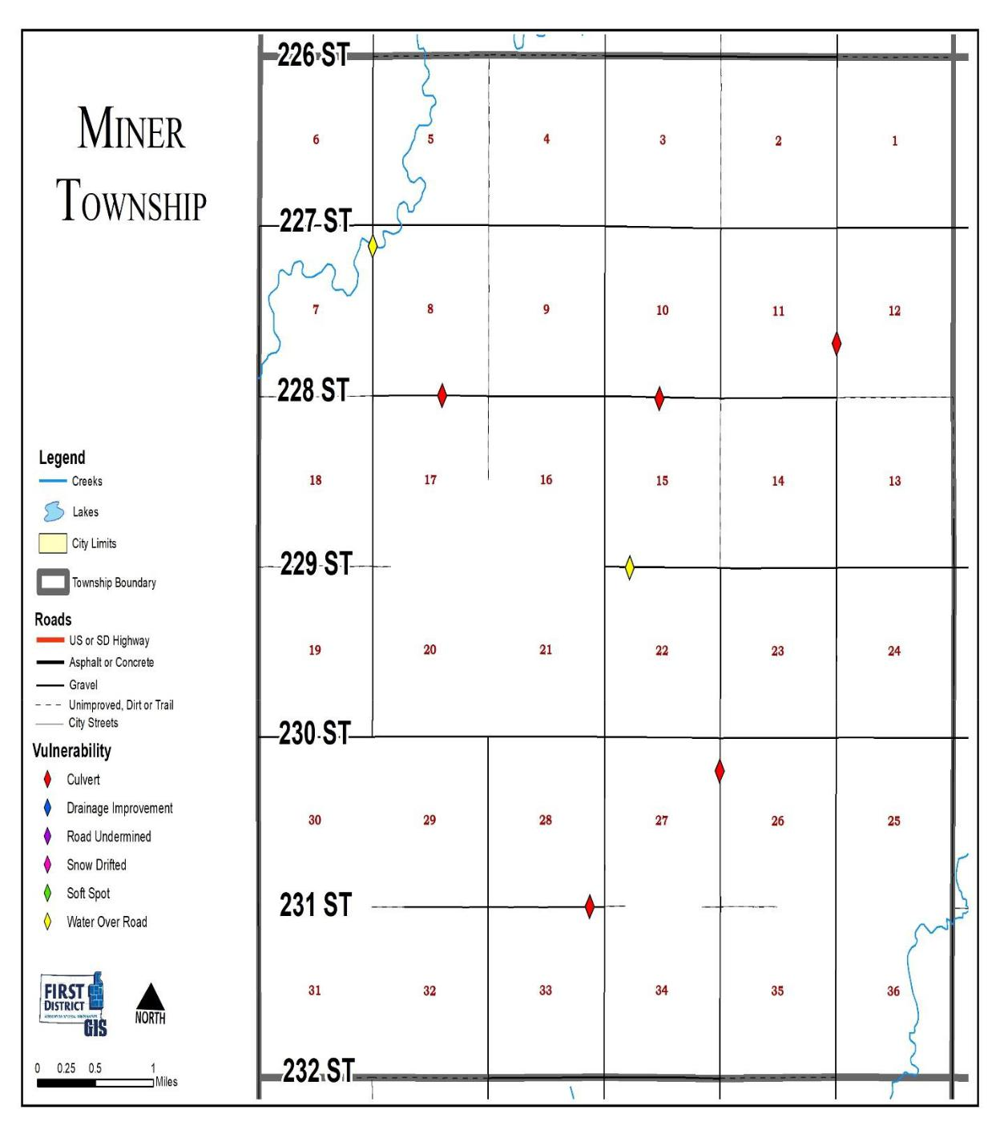

Miner County Pre-Disaster Mitigation Plan Page 142

Redstone Township
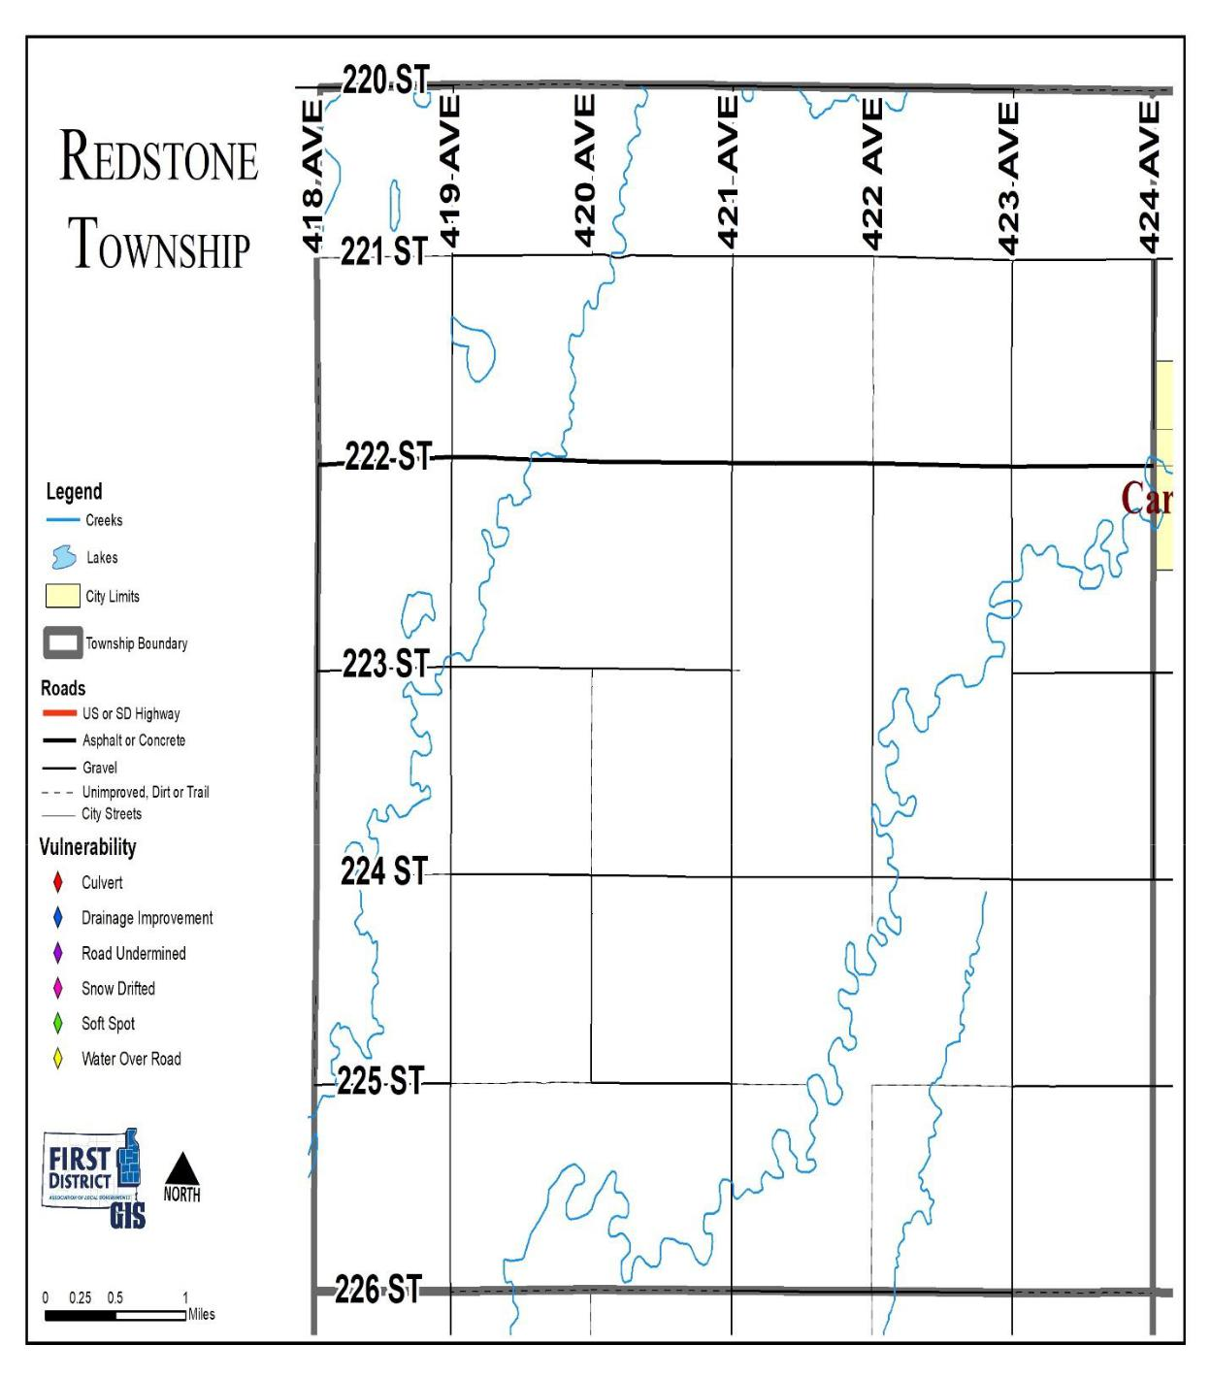

Miner County Pre-Disaster Mitigation Plan Page 143

Rock Creek Township
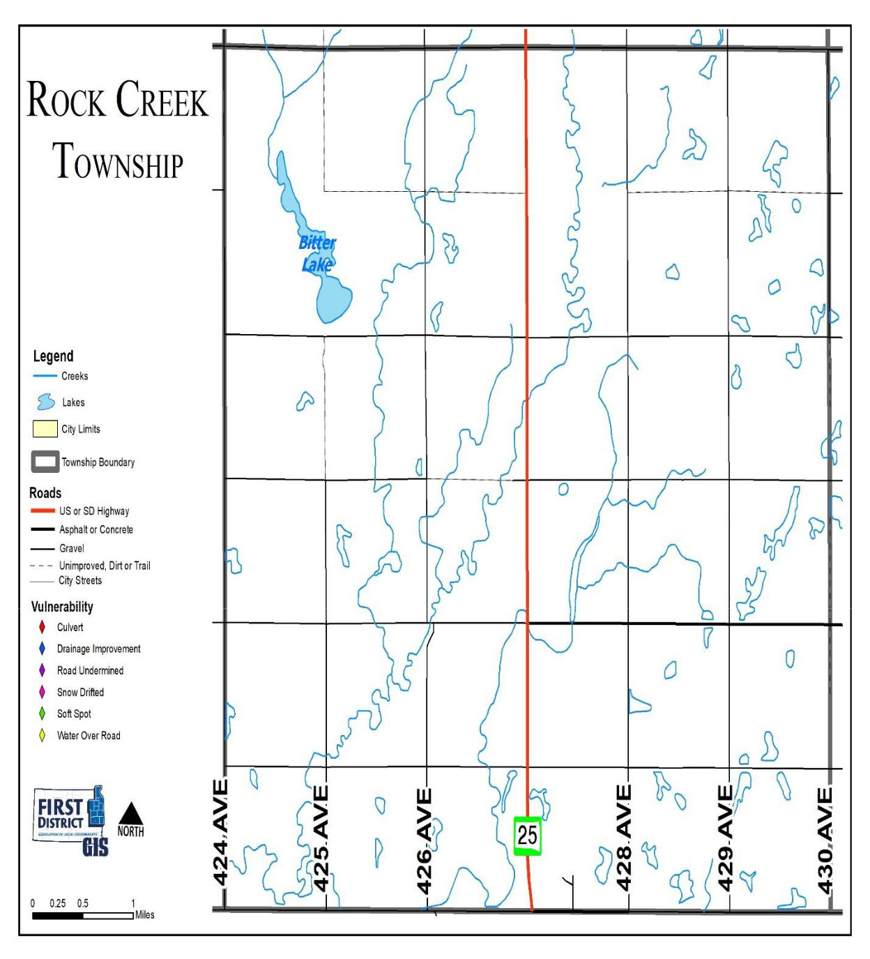

Miner County Pre-Disaster Mitigation Plan Page 144

Roswell Township
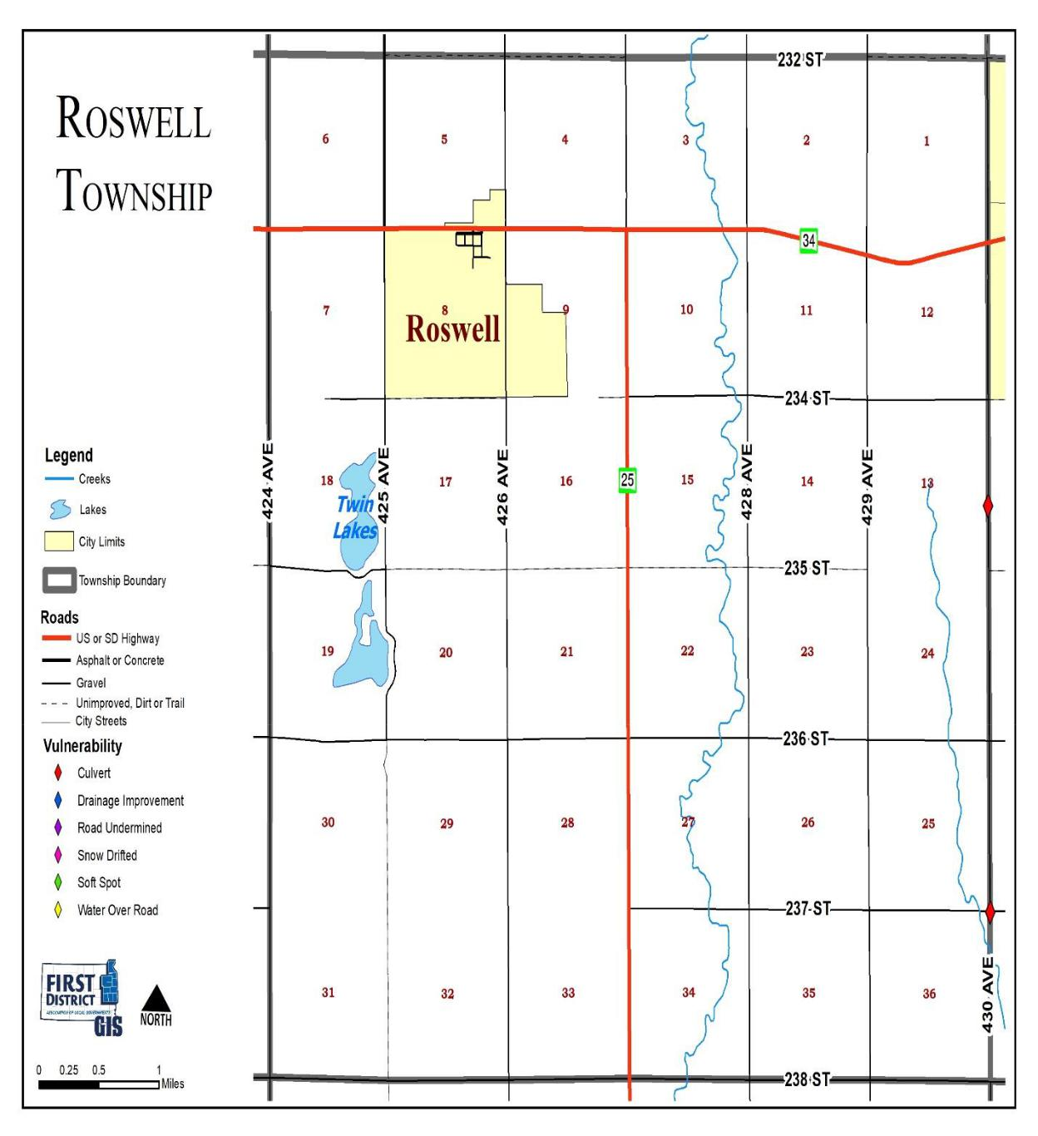

Miner County Pre-Disaster Mitigation Plan Page 145

Vermillion Township
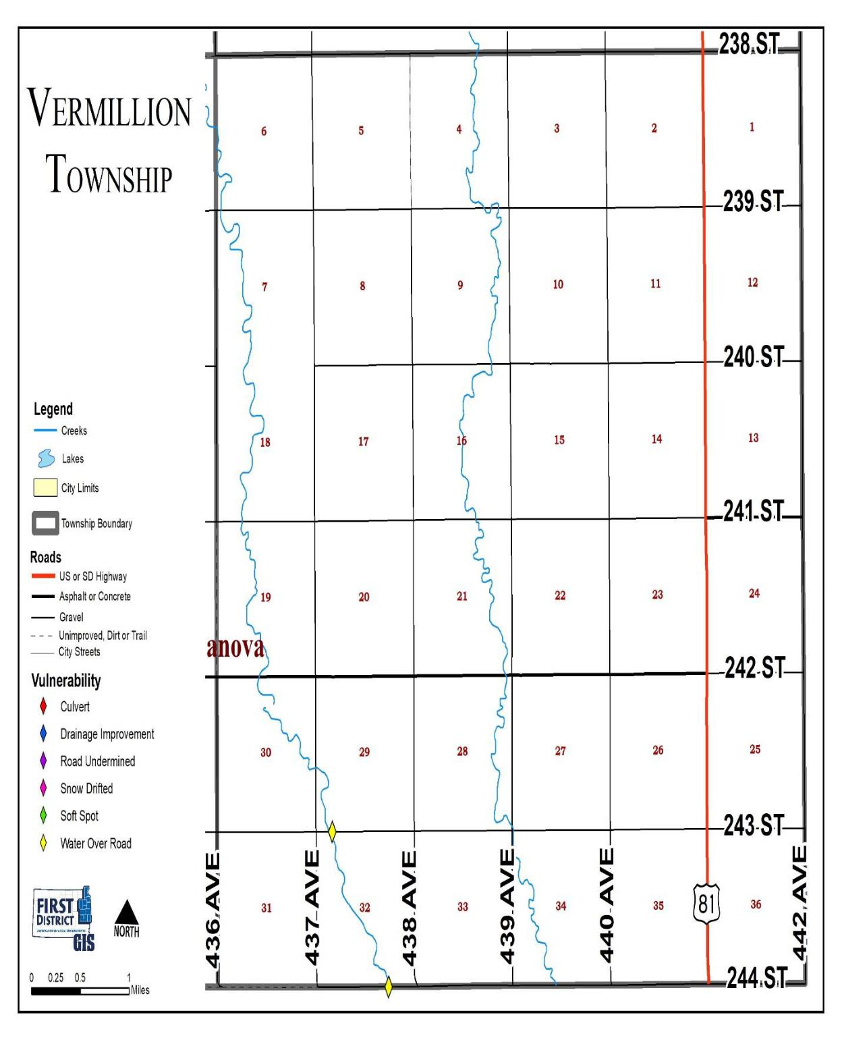

Miner County Pre-Disaster Mitigation Plan Page 146

Appendix G
Comprehensive Land Use Maps

Miner County Pre-Disaster Mitigation Plan Page 147

Miner County Future Land Use Map

 |  |  |  |  |  |  |  |  |  |  |  |  |  |  |  | 4 | 3 | 2 | 1 |  | 6 |  | 5 | 4 | 3 |  | 2 | 1
 |  |  |  |  |  |  |  |  |  |  |  |  |  | 6 | 5
 |  |  |  |  |  |  |  |  |  | 3 | 2 |  | 1
 |  |  |  |  |  | 6 |  | 5 | 4
6 | 5 | 4 | 3 | 2 | 1
 |  |  |  |  |  | C |  |  |  |  |  |  |  |  | 8 | 9 | 10 | 11 | 12 |  | 7 |  | 8 | 9 | 10 |  | 11 | 12
 |  |  |  |  |  |  |  |  |  | 10 | 11 |  | 12 | 7
 |  |  |  |  | 12 | 7 |  | 8 | 9
 | 8 | 9 | 10 | 11
7
 |  |  |  |  |  |  |  |  |  |  |  |  |  |  |  | 16 | 15 | 14 | 13 |  | 18 |  | 17 | 16 | 15 |  | 14 | 13
 |  |  |  |  |  |  |  |  |  |  | 14 |  | 13 | 18 | 17
 |  |  |  |  |  | 18 |  | 17 | 16 | 15
 |  |  | 15 | 14 | 13
18 | 17 | 16
 |  |  |  |  |  |  |  |  |  |  |  |  |  |  | 20 | 21 | 22 | 23 | 24 |  | 19 |  | 20 | 21 | 22 |  | 23 | 24
 |  |  |  |  |  |  |  |  |  |  | 23 |  | 24 | 19
 |  |  |  |  |  | 19 |  | 20 | 21 | 22
 |  |  | 22 | 23 | 24
19 | 20 | 21
 |  |  |  |  |  |  |  |  |  |  |  |  |  |  |  |  | 27 | 26 | 25 |  | 30 |  | 29 | 28 | 27 |  | 26 | 25
 |  |  |  |  |  |  |  |  |  | 27 | 26 |  | 25 | 30 | 29 | 28
 |  |  |  |  | 25 | 30 |  | 29 | 28
 |  | 28 | 27 | 26
30 | 29
 |  |  |  |  |  |  |  |  |  |  |  |  |  |  |  |  | 34 | 35 | 36 |  | 31 |  | 32 | 33 | 34 |  | 35 | 36
 |  |  |  |  |  |  |  |  |  | 34 | 35 |  | 36 | 31 | 32 | 33
 |  |  |  |  | 36 | 31 |  | 32 | 33
 |  | 33 | 34 | 35
31 | 32
 |  |  |  |  |  |  |  |  |  |  |  |  |  |  |  |  | 3 | 2 | 1 |  | 6 |  | 5 | 4 | 3 |  | 2 | 1
 |  |  |  |  |  |  |  |  |  | 3 | 2 |  | 1 | 6 | 5 | 4
 |  |  |  |  | 1 | 6 |  | 5 | 4
 |  | 4 | 3 | 2
6 | 5
 |  |  |  |  |  |  |  |  |  |  |  |  |  |  | 8 | 9 | 10 | 11 | 12 |  | 7 |  | 8 | 9 | 10 |  | 11 | 12
 |  |  |  |  |  |  |  |  |  |  | 11 |  | 12 | 7
 |  |  |  |  | 12 | 7 |  | 8 | 9 | 10
 |  | 9 | 10 | 11
7 | 8
 |  |  |  |  |  |  |  |  |  |  |  |  |  |  |  |  |  | 14 | 13 |  | 18 |  | 17 | 16 | 15 |  | 14 | 13
 |  |  |  |  |  |  |  |  |  | 15 | 14 |  | 13 | 18 | 17 | 16 | 15
 |  |  |  |  | 13 | 18 |  | 17 | 16
 |  | 16 | 15 | 14
18 | 17
 |  |  |  |  |  |  |  |  |  |  |  |  |  |  |  |  |  | 23 | 24 |  | 19 |  | 20 | 21 | 22 |  | 23 | 24
 |  |  |  |  |  |  |  |  |  | 22 | 23 |  | 24 | 19 | 20 | 21 | 22
 |  |  |  |  | 24 | 19 |  | 20 | 21
 |  | 21 | 22 | 23
19 | 20
 |  |  |  |  |  |  |  |  |  |  |  |  |  |  |  |  |  | 26 | 25 |  | 30 |  | 29 | 28 | 27 |  | 26 | 25
 |  |  |  |  |  |  |  |  |  | 27 | 26 |  | 25 | 30 | 29 | 28 | 27
 |  |  |  |  | 25 | 30 |  | 29 | 28
 |  | 28 | 27 | 26
30 | 29
 |  |  |  |  |  |  |  |  |  |  |  |  |  |  |  |  |  | 35 | 36 |  | 31 |  | 32 | 33 | 34 |  | 35 | 36
 |  |  |  |  |  |  |  |  |  |  |  |  |  | 31 | 32 | 33 | 34
 |  |  |  |  |  |  |  |  |  | 34 | 35 |  | 36
 |  |  |  |  | 36 | 31 |  | 32 | 33
 |  | 33 | 34 | 35
31 | 32
 |  |  |  |  |  |  |  |  |  |  |  |  |  |  |  |  |  | 2 |  | 1 |  | 6 | 5 | 4 |  | 3 | 2 | 1
 |  |  |  |  |  |  |  |  |  |  |  |  |  | 6 | 5 | 4 | 3
 |  |  |  |  |  |  |  |  |  | 3 | 2 |  | 1
 |  |  |  |  | 1 |  | 6 | 5 | 4
 |  |  | 3 | 2
6 | 5 | 4 |  |  |  |  |  | R |  |  |  | V
 |  |  |  |  |  |  |  |  |  |  |  | lasi |  |  |  |  | H |  |  | 12 |  | 7 | 8 | 9 |  | 10 | 11 | 12
 |  |  |  |  |  |  | 7 | 8 | 9 | 10 | 11 |  | 12 | 7 | 8 | 9 | 10 | 11
7 | 8 | 9 | 10 | 11 | 12
 |  |  |  |  |  |  |  |  |  |  |  |  |  |  |  |  | 15 | 14 |  | 13 |  | 18 | 17 | 16 |  | 15 | 14 | 13
 |  |  |  |  |  |  | 18 | 17 | 16 | 15 | 14 |  | 13 | 18 | 17 | 16
18 | 17 | 16 | 15 | 14 | 13
 |  |  |  |  |  |  |  |  |  |  |  |  |  |  |  |  | 22 | 23 |  | 24 |  | 19 | 20 | 21 |  | 22 | 23 | 24
 |  |  |  |  | 24 |  | 19 | 20 | 21 | 22 | 23 |  | 24 | 19 | 20 | 21
19 | 20 | 21 | 22 | 23
 |  |  |  |  |  |  |  |  |  |  |  |  |  |  |  |  | 27 | 26 |  | 25 |  | 30 | 29 | 28 |  | 27 | 26 | 25
 |  |  |  |  |  |  | 30 | 29 | 28 | 27 | 26 |  | 25 | 30 | 29 | 28
30 | 29 | 28 | 27 | 26 | 25
 |  |  |  |  |  |  |  |  |  |  |  |  |  |  |  |  | 34 | 35 |  | 36 |  | 31 | 32 | 33 |  | 34 | 35 | 36
 |  |  |  |  |  |  | 31 | 32 | 33 | 34 | 35 |  | 36 | 31 | 32 | 33
31 | 32 | 33 | 34 | 35 | 36
 |  |  |  |  |  |  |  |  |  |  |  |  |  |  |  |  |  | 2 |  | 1 |  | 6 | 5 | 4 |  | 3 | 2 | 1
 |  | 4 | 3 | 2 | 1 |  | 6 | 5 | 4 | 3 | 2 |  | 1 | 6 | 5 | 4 | 3
6 | 5
 |  |  |  |  |  |  |  |  |  |  |  |  |  |  |  |  |  | 11 |  | 12 |  | 7 | 8 | 9 |  | 10 | 11 | 12
 |  |  |  |  | 12 |  | 7 | 8 | 9 | 10 | 11 |  | 12 | 7 | 8 | 9 | 10
7 | 8 | 9 | 10 | 11
 |  |  |  |  |  |  |  |  |  |  |  |  |  |  |  |  |  |  |  |  |  | 18 | 17 | 16 |  | 15 | 14 | 13
 |  |  |  | 14 | 13 |  | 18 | 17 | 16 | 15 | 14 |  | 13 | 18 | 17 | 16 | 15 | 14 |  | 13
18 | 17 | 16 | 15
 |  |  |  |  |  |  |  |  |  |  |  |  |  |  |  |  |  |  |  | 24 |  | 19 | 20 | 21 |  | 22 | 23 | 24
 |  |  |  |  |  |  |  |  | 21 | 22 | 23 |  | 24 | 19 | 20 | 21 | 22 | 23
19 | 20 | 21 | 22 | 23 | 24 |  | 19 | 20
 |  |  |  |  |  |  |  |  |  |  |  |  |  |  |  |  |  | 26 |  | 25 |  | 30 | 29 | 28 |  | 27 | 26 | 25
 |  |  |  |  |  |  | 30 | 29 | 28 | 27 | 26 |  | 25 | 30 | 29 | 28 | 27 | Canova
30 | 29 | 28 | 27 | 26 | 25
 |  |  |  |  |  |  |  |  |  |  |  |  |  |  |  |  |  | 35 |  | 36 |  | 31 | 32 | 33 |  | 34 | 35 | 36
 |  |  |  |  | 36 |  | 31 | 32 | 33 | 34 | 35 |  | 36 | 31 | 32 | 33 | 34
31 | 32 | 33 | 34 | 35 |  |  |  |  |  | EpiphanyA
 |  |  | F
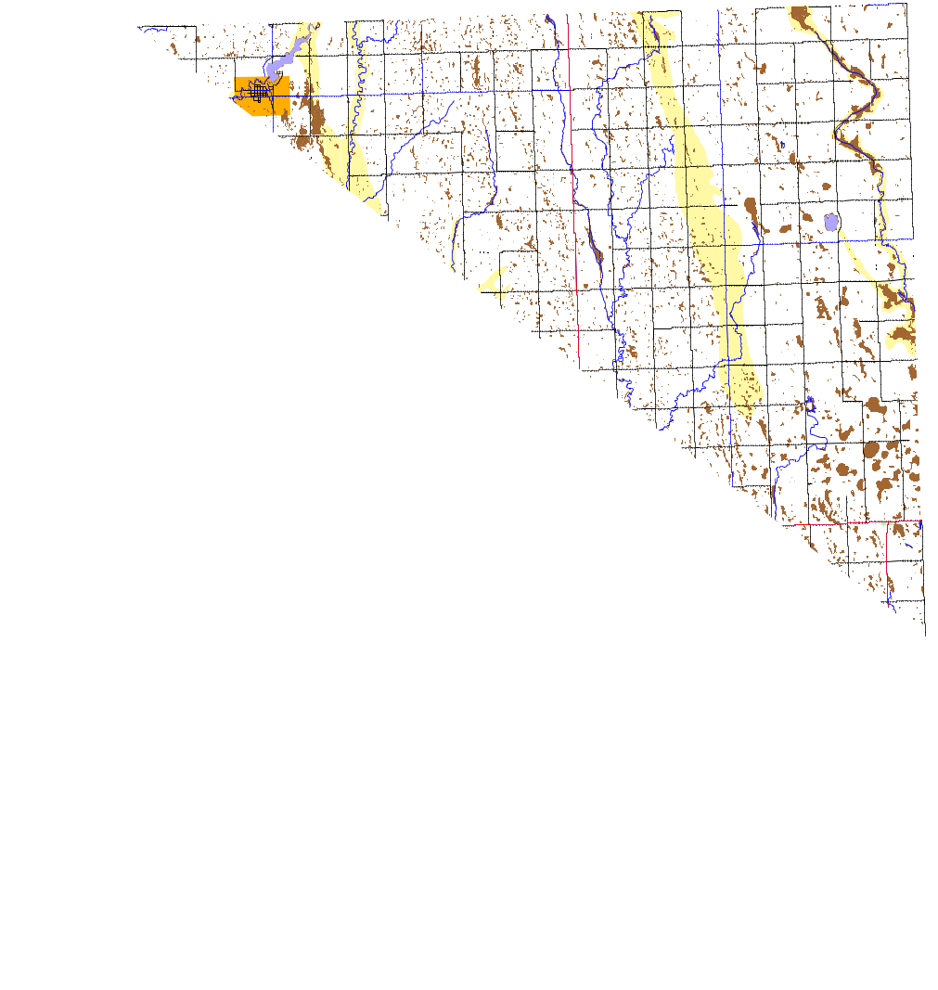
edora | arthage | gonner
 | oswell |  | oward

Miner County
Comprehensive Land Use Plan

Future Land Use Map

Area of De velopm en t O p portu nity

Area of De velopm en t Tran sit io n

Area of De velopm en t S tab ility

Area of De velopm en t L im it ation - S hallow A qu if er

Area of De velopm en t L im it ation - W etlan d

Lakes

Stre am

Pa ve d S ta te Hig hwa y

Pa ve d C oun ty Ro ad

Gra vel Ro ad

Unimp roved Ro ad

Page 148

N

Miner County Pre-Disaster Mitigation Plan

Town of Canova Future Land Use Map
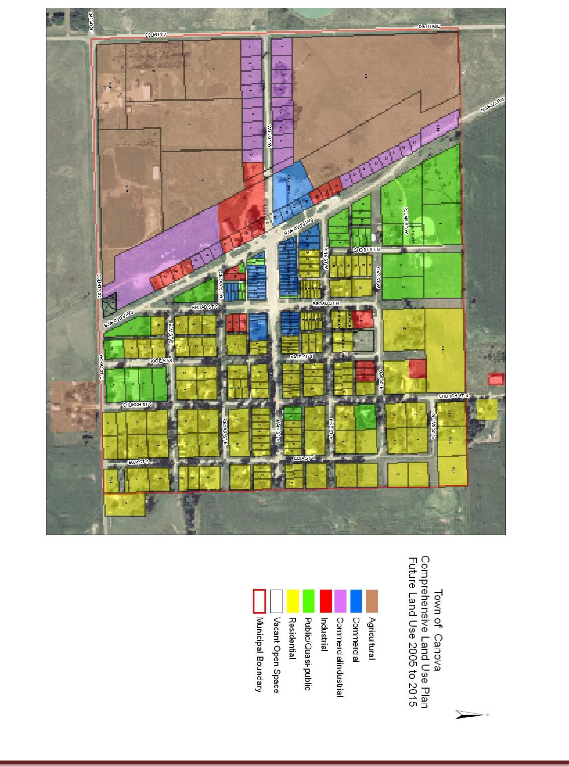

Miner County Pre-Disaster Mitigation Plan Page 149

City of Carthage Future Land Use Map
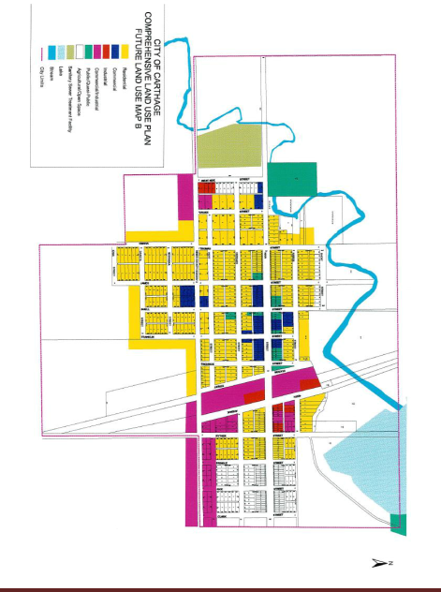

Miner County Pre-Disaster Mitigation Plan Page 150

City of Howard Future Land Use Map
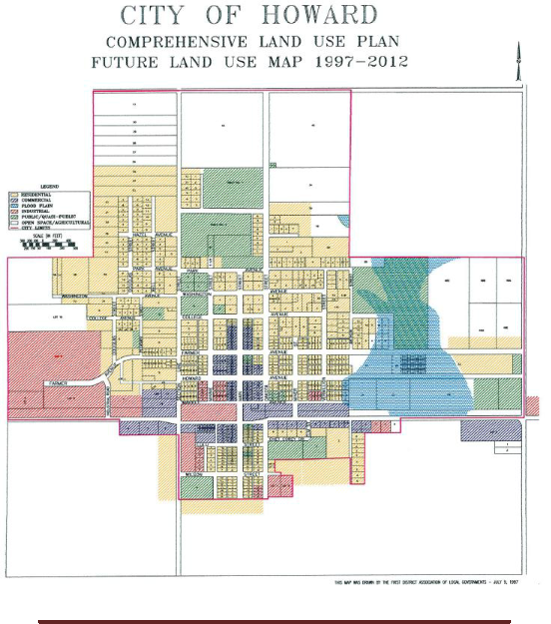

Miner County Pre-Disaster Mitigation Plan Page 151

Appendix G – Review of 2013 PDM Mitigation Project Implementation

 |  |  |  |  | POTENTIAL |  |  |  |  |  | INCLUDED IN
 |  | COMMUNITY |  |  | MITIGATION |  |  | HAZARD |  |  |  |  |  | STATUS
 |  |  |  |  |  |  |  |  |  |  | 2019 PLAN?
 |  |  |  |  | PROJECTS
 |  |  |  |  | Replace undersized
 |  | Miner |  |  | or deteriorating |  |  | Flooding |  |  | Yes |  |  | Ongoing
 |  | County |  |  | culverts throughout
 |  |  |  |  | the county
 |  |  |  |  | Repair or improve
 |  | Miner |  |  | roads that receive |  |  | Flooding |  |  | Yes |  |  | Ongoing
 |  | County |  |  | damage from flood
 |  |  |  |  | events
 |  | Town of |  |  | Purchase of Back-up
 |  | Canova |  |  | Generator for |  |  | All Hazards |  |  | Yes |  |  | Ongoing
 |  |  |  |  | emergency shelter
 |  | Town of |  |  | Purchase of supplies
 |  | Canova |  |  |  |  |  | All Hazards |  |  | Yes |  |  | Ongoing
 |  |  |  |  | for emergency shelter
 |  | Town of |  |  | Construction of |  |  | Severe
 |  | Canova |  |  |  |  |  |  |  |  | Yes |  |  | Ongoing
 |  |  |  |  | Tornado Shelter |  |  | Weather
 |  | Town of |  |  | Construction of Water
 |  | Canova |  |  |  |  |  | All Hazards |  |  | Yes |  |  | Ongoing
 |  |  |  |  | Tower/Tank
 |  | City of |  |  | Purchase back-up
 |  | Carthage |  |  | generator for Lift |  |  | All Hazards |  |  | No |  |  | Completed
 |  |  |  |  | Station
 |  | City of |  |  | Construction of |  |  | Severe
 |  | Carthage |  |  |  |  |  |  |  |  | No |  |  | Completed
 |  |  |  |  | Tornado Shelter |  |  | Weather
 |  | City of |  |  | Rip Rap sanitary
 |  | Carthage |  |  |  |  |  | Flooding |  |  | Yes |  |  | Ongoing
 |  |  |  |  | sewer lagoons
 |  | City of |  |  | Additional hose and |  |  | Fire/Severe
 |  | Carthage |  |  | pump truck supplies |  |  |  |  |  | Yes |  |  | Ongoing
 |  |  |  |  |  |  |  | Weather
 |  |  |  |  | for fire department
 |  | City of |  |  | Upgrade Siren |  |  | Severe
 |  | Howard |  |  |  |  |  |  |  |  | Yes |  |  | Ongoing
 |  |  |  |  | System |  |  | Weather
 |  | City of |  |  | Purchase of back-up
 |  | Howard |  |  | generator for |  |  | All Hazards |  |  | No |  |  | Completed
 |  |  |  |  | emergency shelter
 |  | City of |  |  | Construction of |  |  | Severe
 |  | Howard |  |  |  |  |  |  |  |  | No |  |  | Completed
 |  |  |  |  | Tornado Shelter |  |  | Weather
Miner County Pre-Disaster Mitigation Plan |  |  |  |  |  |  |  |  |  |  |  |  |  | Page 152

 |  |  |  | POTENTIAL |  |  |  |  |  | INCLUDED IN
 | COMMUNITY |  |  | MITIGATION |  |  | HAZARD |  |  |  |  |  | STATUS
 |  |  |  |  |  |  |  |  |  | 2019 PLAN?
 |  |  |  | PROJECTS
 | City of |  |  | Zoning Regulations |  |  | All Hazards |  |  | No |  |  | Completed
 |  |  |  | update
 | Howard
 | Central |  |  | Burial of Overhead |  |  | Severe
 | Electric |  |  | Lines in designated |  |  |  |  |  | Yes |  |  | Ongoing
 |  |  |  |  |  |  | Weather
 | Action |  |  | spots

Miner County Pre-Disaster Mitigation Plan Page 153

Appendix H
References

Miner County Comprehensive Land Use Plan - First District Association of Local Governments, 2004

Miner County Mitigation Plan, 2006 & 2013

Miner County Hazardous Materials Plan – 2012

Federal Emergency Management Agency. 2011. Local Multi-Hazard Mitigation Planning Guidance.

NFIP Flood Insurance Rate Maps

State of South Dakota Hazard Mitigation Plan. South Dakota Office of Emergency Management.

2011.

Town of Canova Comprehensive Land Use Plan, Zoning and Subdivision Ordinances – First District Association of Local Governments, 2006

City of Carthage Comprehensive Land Use Plan and Zoning Ordinance – First District Association of Local Governments, 2002

City of Howard Comprehensive Land Use Plan and Zoning Ordinance – First District Association of Local Governments, 1997

Miner County Pre-Disaster Mitigation Plan Page 154

