**Hamlin County Planning Commission & Board of Adjustment**

**Staff Report**

**Monday – November 26th, 2018 – 7:00PM**

**Planning Commission**

**Item # 1: Rezone**

**Applicant(s): Kevin Gruenwaldt**

**Property Description(s):**

* Portion of Hudy Addition in SE ¼ of Section 36, Township 113N, Range 53W of the 5th P.M., Hamlin County, South Dakota (Norden Township).
* Government Lot 7 EXCEPT Lots 1, 2, 3 and Block 1, Peterson Addition in Section 36, Township 113N, Range 53W of the 5th P.M., Hamlin County, South Dakota (Norden Township).
* Portion of S ½ & SE ¼ and NE ¼ & SE ¼ EXCEPT Lot 1 Dollar General, Block 1 Spilde Addition, and Block 1 Bjorklund Addition of the 5th P.M., Hamlin County, South Dakota (Norden Township).

**Action Item:** Rezoning – Section 4.04.03 (Zoning Amendments)

**Zoning Designation:** A – Agricultural

**Request:** Staff is seeking to rezone property situated between Lake Poinsett and Lake Albert from AG to LP1.

History/Issues:

1. General Location:

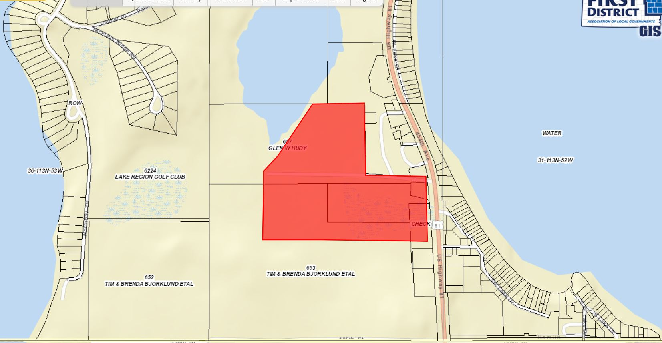

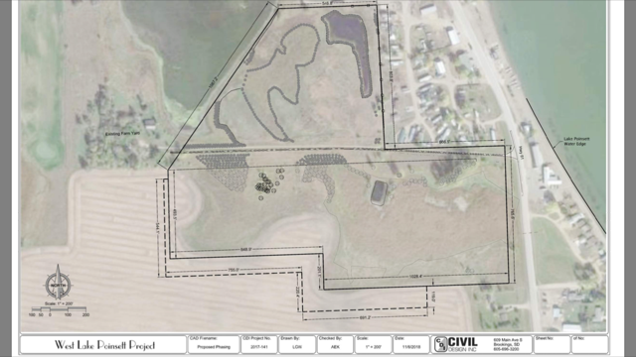

**(Perimeter plan submitted by the applicant)**

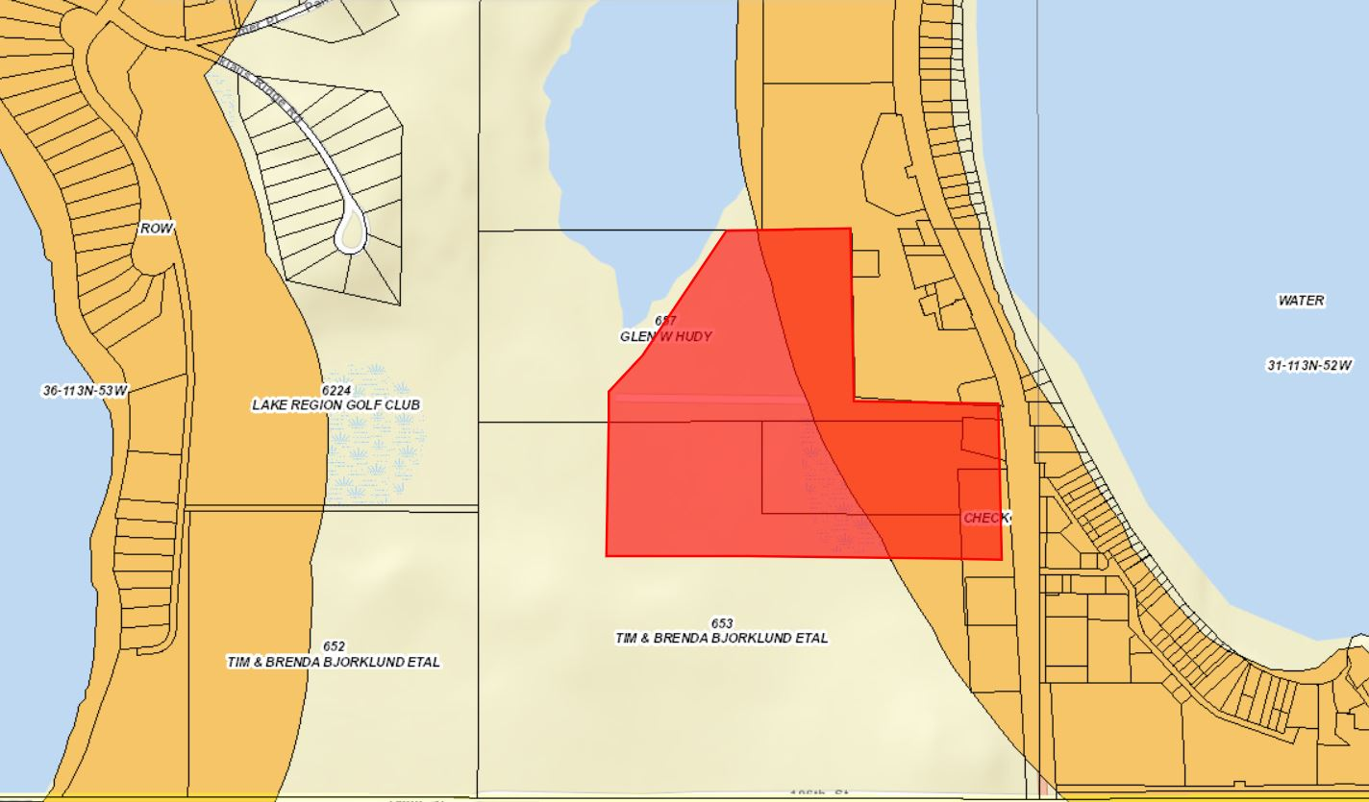

**(Proposed area to be rezoned with Lake Park 1 Zoning District layer)**

1. Kevin Gruenwaldt seeks to rezone portions of his property that he seeks to construct a Private Park/RV Campground upon. The submitted plans include 199 camper pads, 15 cabins, and 5 tent spots on the property.
2. Portions of the property sited for the campground fall within the Lake Park 1 District, yet not the entirety of the proposed site, thus to be compliant with the Zoning Ordinance the applicant must rezone all property to be within the Lake Park 1 zoning district.
3. Staff recommends **approval** based upon:
   1. The comprehensive land use plan identifies this area as an area of development transition. Policies or issues to consider in the development of lake property include in areas of development transition adjacent to lakes, the subdivision and development of land will not be permitted without approved water and sanitary sewer services.
4. Staff Notes
   1. The Planning Commission will consider the impact upon county and township roads servicing any future proposed lake development. This area is assumed to be included in the Lake Park Zoning District being between two lakes (Both Lake Park 1 Zoning District) yet the 1,000 ft perimeter does not include the middle portions of the area between Lake Poinsett and Albert
      1. Spilde Addition, Northbay, and Gruenwaldt properties all required rezoning amendments.

**Planning Commission Action:** **The Commission may: 1) Postpone the decision or 2) Recommend Approval to County Commission or 3) Recommend Denial to County Commission.**

Item #2: Public Hearing: Ordinance #06-18 Agri-Business Activities

Background: The Board had discussion on this topic last month concerning the addition of an Agri-Business ordinance to allow certain agriculturally related commercial operations to be in the Ag District. Staff presented the Board with options for an Agri-Business ordinance ranging from simple definitions to add or a broader ordinance with performance standards and supplemental information to be qualified to construct and operate such business. The Board instructed Staff to come back the following month with sample language with a wider scope of regulation and as such below is the recommended route for the Ordinance Amendment.

Ordinance Amendment: 2018-06

**Chapter ­­____ Agribusiness Activities**

Section _____. Intent

Agribusiness activities include identified commercial activities involving the handling, storage, processing and shipping of farm products. Agribusiness activities are operated as a principle use on a property, and are not operated accessory to residential uses. Agribusiness Activities may be operated as extended home occupations, when such activities are accessory to the residential use of the lot. The following commercial activities may be considered agribusiness activities if operated in accordance with the requirements contained in Section _____:

1. Custom fertilizer/herbicide application;
2. Custom planting;
3. Custom harvesting;
4. Grain storage;
5. Processing of products raised or grown by the landowner or operator.

*Supplemental Regulations/Requirements*

Section _____Requirements

1. **Agribusiness activities must have access to a concrete or bituminous asphalt, or county gravel street.**
2. **Operators of agribusiness activities shall enter into and comply with a haul road agreement for the applicable streets if deemed necessary by the applicable road authority for the maintenance of identified haul routes attendant to the operation of the proposed business.**
3. **Lighting on the site shall be limited to downward directed lights or other lighting customarily used for agricultural operations.**
4. **The number, size, and illumination standards for signs shall be determined by the Board of Adjustment.**
5. **No equipment or process shall be used in such extended home occupation which creates noise, vibration, glare, fumes, odors, or electrical interference detectable to the normal senses off the lot. In the case of electrical interference, no equipment or process shall be used which creates visual or audible interference in any radio or television receivers off the premises, or causes fluctuations in line voltage off the premises.**
6. **All vehicles and equipment stored outside shall be operable.**
7. **Permits for Agribusiness activities are specific to a single use listed in Section. An agribusiness activity may only be changed to another agribusiness activity if specifically authorized by the Board of Adjustment.**
8. **Permits for Agribusiness activities may be transferred, unless otherwise stated by the Board of Adjustment.**

**Section____: Applications.**

1. **Application for Agribusiness activities shall be filed with the zoning officer. The application shall contain the following:**
2. **The address of the property and the legal description.**
3. **The name of the project and/or business.**
4. **Physical dimensions and locations of the property, existing structures, and proposed structures**
5. **A detailed description of what activities will occur on the entire property**
6. **Distance from all building lines to the property lines at the closest points**
7. **Maximum number of employees expected to be employed at the site.**
8. **Hours of operation. (If it is expected that hours of operation will vary depending upon the season, the applicant should state minimum and maximum hours of operation and when those minimum and maximum hours are expected.)**
9. **Number and type of vehicles expected to use the site each day.**
10. **Parking lots or spaces; designate each space, give dimensions of the lot, stalls and aisles (if applicable).**
11. **Names and locations of proposed haul roads.**
12. **Proposed grading and drainage pattern.**
13. **Phasing plan for development (if more than one phase is planned).**
14. **Any other information required to determine compliance with this Chapter**

**Board of Adjustment**

OLD BUSINESS:

**Item #1: Variance Request**

**Owner/Applicant:** Thomas & Megan Kreutner

**Property Description:** S ½ of Lot 5 Saaranen’s Beach in Govt Lot 1 in NE ¼ of Section 16, Township 113N, Range 52W of the 5th P.M., Hamlin County, South Dakota (Norden Township)

##### **Action Item –Variance:** Lake Area Regulations: Front Yard Setback **(3.7.10)**

**Zoning Designation:** LP1 – Lake Park District

**Request:** The applicant is requesting a variance to construct the attached garage closer to the road ROW from 30’ to 12’.

Staff Review of Application

General Location

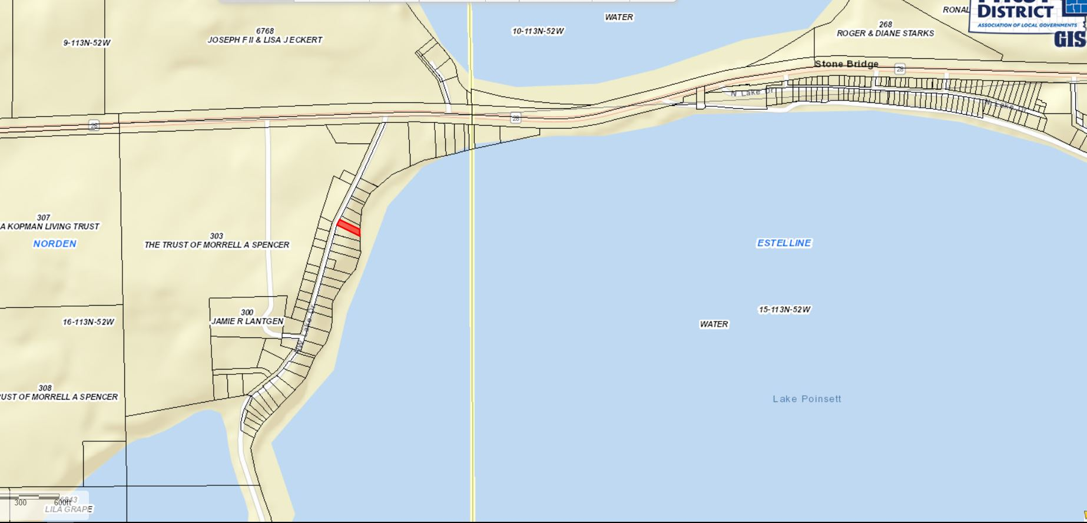

* 1. The required front yard setback along the ROW is 30’. The applicant is seeking to a 18’ variance in the construction of a new garage and house addition.
     1. The existing garage placement is closer than proposed new setback. The new setback would accommodate parking easier with the use of the garage.
     2. The proposed construction does not further encroach into the existing rear yard (lake front) setback or side yard setbacks. The addition would be a second level to the dwelling and a new garage.
     3. Though it may be the intent of Section 3.02.06 (Continuation of Nonstandard Uses) to allow for in line additions to nonconforming structures. The language does not specifically allow for the zoning officer to issue this permit without a variance issued by the Board. An ordinance amendment to allow for the Zoning Officer to issue these without Board approval would reduce the number of variance requests to the Board and ensure the intentions of the Comprehensive Plan and Zoning Ordinance are met.

2. **Staff recommendations** – Staff recommends **approval** based upon the following:

* + - * 1. The board finds that it is the intent of Section 3.02.06 to allow for a nonconforming addition to be made on a nonconforming structure provided the addition is no closer to the property line (lake) than the current structure.
        2. The Board finds that the proposed construction does not further encroach upon the rear yard lake front setback.
        3. At the time of this report, staff has received no complaints from adjoining landowners.
        4. Standard findings of fact being met:

i. That special conditions and circumstances exist which are peculiar to the land, structure or building involved, and which are not applicable to other land, structures, or buildings in the same district;

a. Shape of the lot, proposed plan fixes a safety issue to the best possible layout while meeting all 3 other setbacks.

**Board Action:** Front Yard Setback Variance: The Board may: 1) Postpone the decision 2) Deny the Request 3) Approve the request with or without conditions.

NEW BUSINESS

**Item #2: Conditional Use**

**Applicant/Owner: Riverview LLP**

**Property Description**: SE ¼ in Section 15, Township 113N, Range 55W of the 5th P.M., Hamlin County, South Dakota (Garfield Township).

**Action Items: Conditional Use –** Accessory Agricultural Housing (5.25.06)

**Zoning Designation:** A - Agricultural

**Request:** Riverview Dairy requests to construct two multi-unit dwellings to house 48 on-site employees.

**REPORT:**

Location:

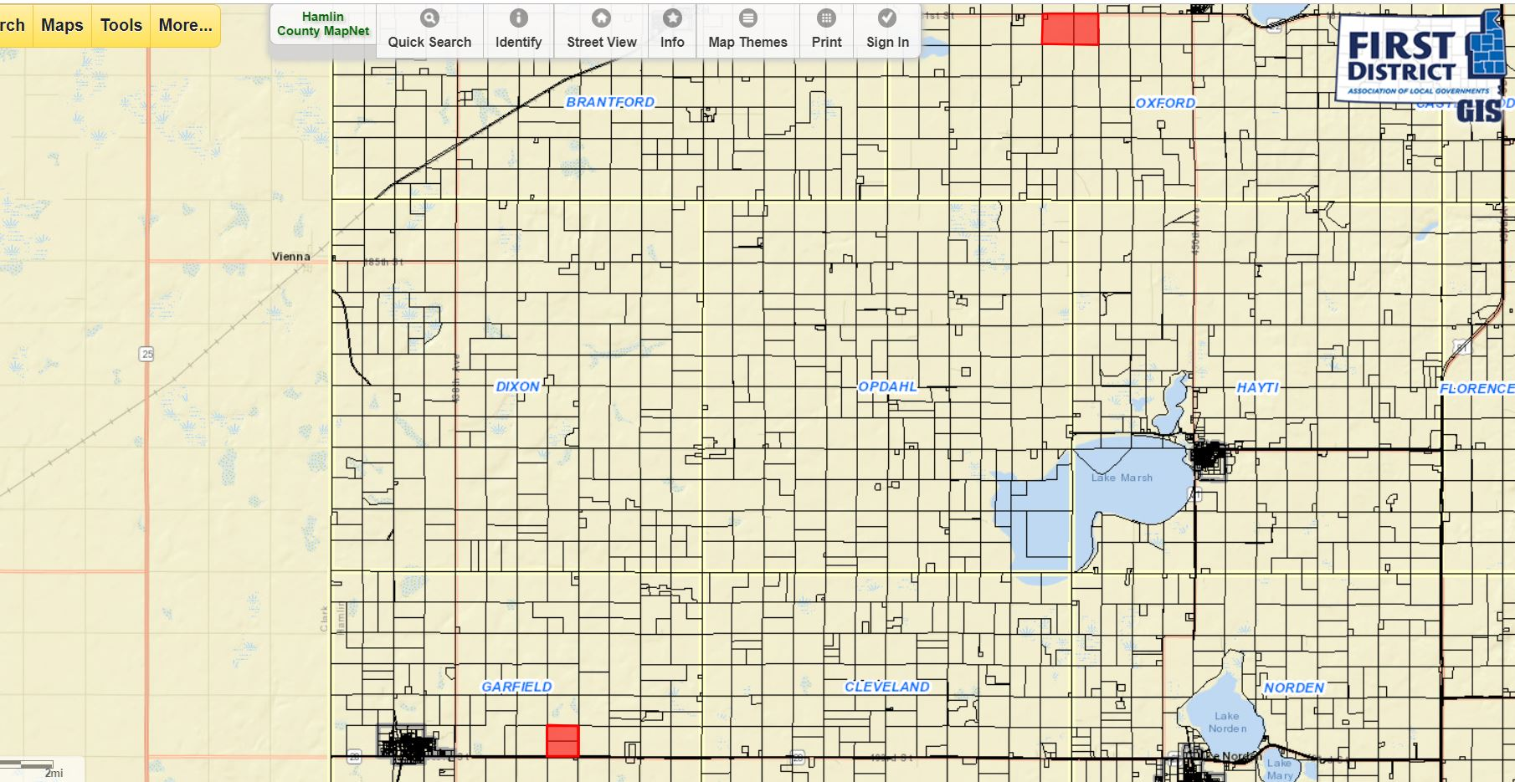

(Proposed) Oxford Dairy Site Location (1.5 miles west of Thomas)

Garfield Dairy Site Location

*Ordinance and Comprehensive Land Use Plan regarding this request:*

1. In 2017 the Zoning Ordinance was amended to allow for “Accessory Agricultural Housing” as a conditional Use. In 2018, after the initial application Drumgoon Dairy submitted it was determined they could not proceed with the proposed use and the Accessory Agricultural Housing Section of the Zoning Ordinance needed to be amended. The newly updated section was adopted on July 21st, 2018 ­­and came into force 20 days later. The requirements for Acccessory­ Agricultural Housing are listed under Section 5.25.06
2. Drumgoon operates a Class A CAFO on the above described property. They were permitted for 4,900 head of mature dairy cattle and 200 heifers in May of 2017.
3. Site location of the accessory housing will be on the same section of land as the permitted CAFO
4. The farm owner does not live on the same lot (not required by ordinance)
5. The lot contains 160 acres (minimum 2 acres required.)
6. This request will allow for a total of two multi-unit dwellings one accommodating 48 individuals.
   1. See reference pictures on Presentation.
7. Proposed plan meets the matrix in the Ordinance listing the number of Animal Units, Maximum number of dwellings, and Maximum number of persons living in the structures.
8. The proposed structure will be required to meet building code in accordance with SD Codified Law.
9. Sanitary sewer is required to be installed in accordance with SDDENR standards.

*Staff Summary and Recommendation*

Conditional Use Permit – ***Accessory Agricultural Housing***: The Board may postpone the request if it is generally felt more information or time to deliberate is needed; deny the request; or approve the request. If approved, the staff recommends, at a minimum, the following conditions:

1. This Conditional Use Permit authorizes the use of this property for accessory agricultural housing providing residence for up to forty-eight (48) farm employees with:
   1. Two structures, each accommodating 24 farm employees.
2. As a condition of obtaining a conditional use permit to establish accessory agricultural housing on the above property the Grantors, their heirs, successors, and assigns agree that no further residential development shall be allowed on the above described property unless in accordance with the terms of this permit or the Hamlin County Zoning Ordinance at the time of development. Residential development to be defined as a “dwelling” per the Hamlin County Zoning Ordinance.
3. Prior to occupying the accessory agricultural structure, the grantor shall provide documentation of compliance with the most recently adopted version of the International Building Code in accordance with SDCL 11-10-6 for any dwelling structure with two or more dwelling units or housing more than three unrelated individuals.
4. Prior to occupying the accessory agricultural housing dwelling/shared dwelling, the applicant shall provide documentation of compliance with any South Dakota Administrative Rules 74:53.
5. The dwelling(s) shall be occupied by the agricultural labor force, or a family member of the agricultural employer.
6. The dwelling/shared dwelling shall be removed or renovated into a single-family dwelling in the event the permit for the concentrated animal feeding operation becomes void.
7. The grantor agrees to notify the zoning officer if either structure becomes unoccupied. In the event the accessory agricultural housing dwelling/shared dwelling remains unoccupied for a period of one (1) year; or is not used in conformance with this Chapter, the accessory agricultural housing dwelling/shared dwelling shall be removed or with permission of the Board of Adjustment may be used for any use accessory to the Concentrated Animal Feeding Operation.
8. Violation of the terms of this conditional use permit will be determined by the Hamlin County Zoning Officer.
9. The first violation substantiated by the Zoning Officer of this conditional use permit may result in a notification letter stating the violation and a prescribed period of time to remove the violation. A second violation will result in a hearing to review the validity of the conditional use permit and may result in revocation of the conditional use permit.
10. The applicant may make appeal from the decision of the Zoning Officer or other agent of the Hamlin County Board of Adjustment to the Hamlin County Board of Adjustment.  The applicant shall file with the Zoning Officer a notice of appeal specifying the grounds thereof.  The Zoning Officer shall forthwith transmit to the Board of Adjustment all papers constituting the record upon which the action appealed from was taken.  Such appeal shall be taken within thirty (30) days.  Appeals from the Board of Adjustment shall be taken to Circuit Court.
11. Failure to comply with the decision of the Zoning Officer or other agent of the Hamlin County Board of Adjustment may be deemed a separate violation.
12. All of the terms and conditions herein shall extend to and be binding upon the heirs, assigns, or successors in interest of the Grantor, and are to be deemed a covenant running with the above-described property. Furthermore, it is agreed that, in accepting title to the above-described property any grantee, heir, assign, or successor in interest to the undersigned expressly agrees to be bound by the terms of this agreement which shall, upon its execution, be recorded with the Hamlin County Register of Deeds Office.

**Staff Report**

No permitted special uses permitted in November.

Upcoming meeting dates discussion

Building Permit update