Hamlin County Planning Commission & Board of Adjustment
Staff Report
Monday – September 24th, 2018 – 7:00PM

Planning Commission

Item #1 Plat
Applicant/Owner(s): Wayne & Doug Thue
Property Description: Thue Addition in NE ¼ of Section 14, Township 114N, Range 54W of the 5th P.M., Hamlin County, South Dakota (Opdahl Township)

Action Item: Plat Approval

Zoning Designation: Agricultural

Request: The Thue’s seek to plat out their feedlot site.

Staff Review
- Plat meets the minimum lot area requirements and access requirements.
  - Access Easement provides access to Lot(s) 2 & 3.
- Staff recommends approval

Planning Commission Action: The Commission may: 1) Postpone the decision or 2) Recommend Approval to County Commission or 3) Recommend Denial to County Commission.

Item #2 Board Discussion: Agribusiness Ordinance Amendment

- What does the Board think of the document sent to them earlier this month on proposed ordinance language for rules on Agribusiness?
- Is there anything you would like to add to the detailed language of Codington and Grant county? Or is there anything you would take away from this in the writing of a new ordinance?

Item #3 Board Discussion:

Spidle Campground & Lake Poinsett Sanitary District

Item # 4 Lake Norden TIF with Toby Morris:

Board of Adjustment

ITEM #1: Variance

Applicant/Owner: Gordon and Delores Kangas

Property Description: E 573’ of N 551’ of NW ¼ of Section 20, Township 113N, Range 53W of the 5th P.M., Hamlin County, South Dakota. (Norden Township)

Action Item: Intensity of Use in the Agricultural District (Section 3.04.06.2)

Zoning Designation: Agricultural

Request: The applicant is requesting a variance to place a single-family dwelling on a quarter quarter section where there is no development right.

Staff Review of the Application
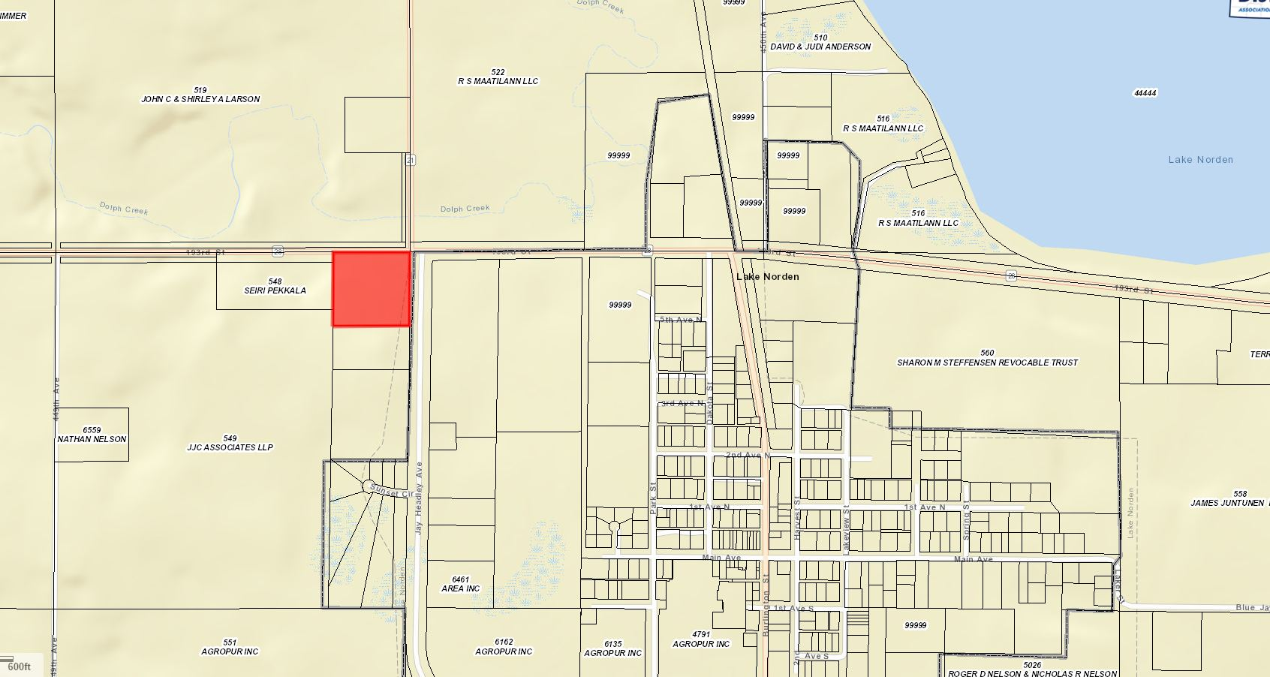
- General Location

- The applicant(s) are seeking to construct a single-family dwelling on the property legally described above.
- Per Section 3.04.06.2 Intensity of Use, buildable lots are required to have a minimum of 2 acres (Property is 7.5 acres) and there are to be no more than 1 dwelling per ¼ ¼. Currently there are three houses in the ¼ section (2 Houses in the NE ¼ ¼) with a portion of the section already within Lake Norden City Limits.
- With 3 dwellings in the ¼ section, there is a development right available in the Northwest or Southeast ¼ ¼, all owned by JJC Associates LLP. As it stands, they would be the only landowner with the right to construct a home.
- The Kangas’ did possess a development right for the Northeast ¼ ¼, unfortunately this was used (knowingly or unknowingly) when they subdivided their property and Eric and Janelle Kangas constructed a home in 2014.
- Section 3.04.06.3 allows for the transfer of development rights on property under contagious ownership.
  - There are no development rights to be transferred on property owned by the Kangas’.
- Hamlin County Comprehensive Plan: The area encompassing the house is defined in the Future Land use Map as an area of Development Advantage. As defined in the Comprehensive Plan, these areas are placed here because they are immediately adjacent to municipalities and lakes that can provide adequate infrastructure for development. Under policies of the Development Advantage area, the County is to encourage annexation of potential development sites within fringe municipal areas. Another policy is to discourage premature development which is defined as development that could limit future land use options and opportunities to locate and finance public infrastructure improvements.
  - The Kangas’ property falls under the development advantage with its proximity to The City of Lake Norden.
- Update: With the postponement of a decision being rendered by the Board of Adjustment at the August 2018 meeting, this discussion is a continuation of the previous public hearing. The Board decided to wait until the City of Lake Norden could discuss this issue of annexation of the Kangas’ property into City Limits. Staff was informed that Lake Norden denied the Kangas’ annexation request for this property on September 4th.
Staff recommendations – Staff recommends denial based upon the following:
  - The board has not, based upon Zoning Office records, granted a variance to allow for more than 1 house per ¼ ¼ section where there was no other avenue to constructing a second home (3.04.06.03 Transfer of Development Rights)
    - As of the date of this application, the Board in January 2018 turned down Mr. Schooley to transfer a development right where there was none available and the Board stated they would not change the ordinance (Density Standards of 1 house per ¼ ¼) to accommodate this request.
    - An approval of this variance would allow for further applications to increase the residential density to be submitted and approved based upon precedent of this decision.
  - Staff finds that there is no hardship applicable to the granting of this variance based upon the conditions stipulated in the Zoning Ordinance and By-laws adopted to provide justification for the application.
  - The Kangas’ do not have a development right on their property as it is currently zoned Agricultural under the Counties jurisdiction.
  - The granting of this variance would constitute a change to the residential development policy of the Zoning Ordinance through a quasi-judicial process and not a legislative process. (BOA does not have authority to grant this variance.)

Board Action: Intensity of Use in the Agricultural District: The Board may: 1) Postpone the decision 2) Deny the Request 3) Approve the request with or without conditions.

Item #2: Conditional Use

Applicant/Owner(s): Mike Hausman/Blue Dog Rentals LLC

Property Description: Lot 18 Block 2 of Sunset Parks Estates Addition in Government Lot 1 in Section 26, Township 113N, Range 52W of the 5th P.M., Hamlin County, South Dakota (Estelline Township).

Action Item: Conditional Use – Conditional Uses in the LP1 Lake Park District (3.07.05.7)

Zoning Designation: LP1 – Lake Park District

Request: Mr. Hausman is seeking to construct an unattached garage with sidewalls greater than 10 ½ feet and dimensions greater than 36 feet x 42 feet.

Staff Review of the Application:

- General Location:
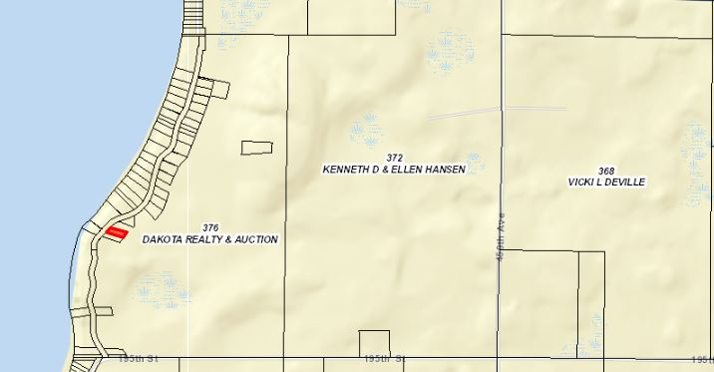

- Mr. Hausman wishes to construct a 38’x60’ unattached garage with 14’ sidewalls on his backlot property.
- Ordinance requires a conditional use for detached garages with sidewalls greater than 10.5’
- The site location of the garage meets all setbacks from the side yard and front yard to the road ROW.
- This proposed structure does fit into (dimensions and design), in the opinion of staff, with similar buildings on backlots along Sunset Park Drive.

Staff recommendation – Staff recommends approval based upon the following:
1. The garage meets all necessary setback regulations
2. Approve If there are no objections from adjoining property owners

Board Action: Conditional Use: Garage with sidewalls greater than 10 ½ feet and dimensions greater than 36 feet x 42 feet: The Board may: 1) Postpone the decision 2) Deny the Request 3) Approve the request with or without conditions.

