Hamlin County Planning Commission & Board of Adjustment
Staff Report
Tuesday – June 26, 2018 – 7:00PM

Hamlin County Planning Commission

Item # 1: Rezone – Northbay

Property Description(s): Northbay Addition Lot(s) 84, 86, 87, 88, 89, 90, 91, 92, 93, 95, 96, 101A, 102, 103, 104, 128, 134, 135, 136, 145, 154 In Section 36, Township 113N, Range 53W of the 5th P.M., Hamlin County, South Dakota (Norden Township).
Northbay 5th Addition Lot(s) 3, 4, 5, 6, 7, 8 In Section 36, Township 113N, Range 53W of the 5th P.M., Hamlin County, South Dakota (Norden Township).
Northbay 6th Addition Lot(s) 2, 3, 4, 5, 6 In Section 36, Township 113N, Range 53W of the 5th P.M., Hamlin County, South Dakota (Norden Township).
Northbay 11th Addition Lots 121-127 In Section 36, Township 113N, Range 53W of the 5th P.M., Hamlin County, South Dakota (Norden Township).
PIER 81 LAGOON ADDITION IN SW ¼ In Section 36, Township 113N, Range 53W of the 5th P.M., Hamlin County, South Dakota (Norden Township).
PIER 81 LAGOON 2ND ADDITION IN SW ¼ In Section 36, Township 113N, Range 53W of the 5th P.M., Hamlin County, South Dakota (Norden Township).
E 780' OF S 1230' OF E ½ and SW1/4 LESS EXC In Section 36, Township 113N, Range 53W of the 5th P.M., Hamlin County, South Dakota (Norden Township).
S 1230’ of E ½ and SW ¼ LESS EXC In Section 36, Township 113N, Range 53W of the 5th P.M., Hamlin County, South Dakota (Norden Township).
Action Item: Rezoning – Section 4.04.03 (Zoning Amendments)

Zoning Designation: A – Agricultural

Request: Staff is seeking to rezone portions of North Bay Residential Development from AG to LP1.

History/Issues:
- General Location:

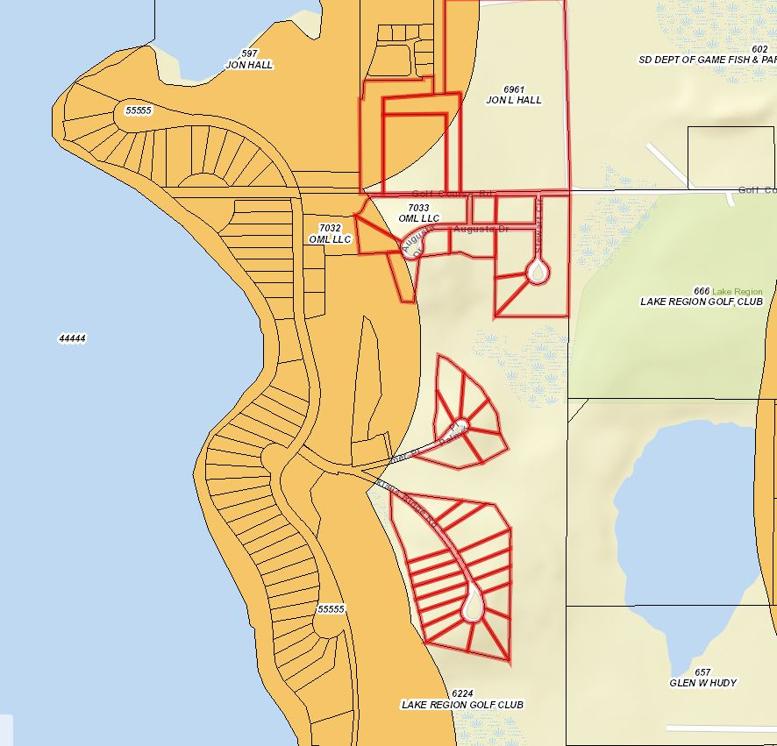

- Staff became aware in April 2018 to the lack of proper zoning designation when working on a Plat for Todd Voss and Bob Winters. In review of documents in the Zoning Office concerning the initial development of North Bay, no formal re-zoning process occurred to change properties that lay outside of the existing LP1 District (1,000’ from Lake Albert).
- The properties selected were derived from a map surveyed by Sayre Associates to layout a “master plan” for the development area. While there is no evidence that this master plan has been adopted by the Planning Commission or County Commission, Staff is using this map as a basis for the rezoning process.
- This Rezoning will allow for the Zoning Officer to grant building permits using the Lake Park 1 Zoning District.
- Properties proposed to be rezoned north of Golf Course road include Lake Poinsett Sanitary Sewer District sewer lagoons and the lot owned by Right Angle Construction (primarily access road) – Significant portions of the both of these properties are already zoned Lake Park. The property owned by Jon Hall, while noticed to be rezoned, should remain agricultural until a master plan has been completed
- Staff recommends approval based upon:
  - The comprehensive land use plan identifies this area as an area of development transition. Policies or issues to consider in the development of lake property include in areas of development transition adjacent to lakes, the subdivision and development of land will not be permitted without approved water and sanitary sewer services.
  - Staff further recommends approval of all advertised parcels to be rezoned with the exception of Jon Hall property for reasons described above.
  - Staff further recommends adding the use “Domestic Sanitary Sewer Treatment Plant/Facility” as a conditional use to the LP 1 Lake Park Zoning District thru a subsequent Ordinance Amendment at the next meeting of the Planning Commission.

Planning Commission Action: The Commission may: 1) Postpone the decision or 2) Recommend Approval to County Commission or 3) Recommend Denial to County Commission.

Item #2: Ordinance #03-18

History/Issue: In February 2018, Drumgoon Dairy applied for a conditional use permit to construct a multi-unit dwelling to house dairy employees on site. During the application discussion, State’s Attorney John Delzer noted transfer of development rights issues concerning the plan of Drumgoon and established that contiguous pieces of property did not constitute property owned by Drumgoon across US HWY 81. The Board postponed a decision on Drumgoon’s application and instructed Staff to review the Accessory Agricultural Housing section of the Zoning Ordinance and propose changes. Staff over the past few months has reworked the policy with input from the Board through public hearings and from the public comments of Ben Stout with Riverview Dairy and Rodney Elliot of Drumgoon Dairy.

As it reads today, current zoning regulations allow for the construction of accessory agricultural housing. A single structure can be built to house up to 24 individuals with either 8 dwelling units housing 3 individuals each or 24 individual units or a combination thereof.

Listed below are the primary changes to be made to the Accessory Agricultural Housing policy:

- Accessory Ag Housing is restricted to Class A CAFOs.
- Accessory Agricultural Housing has to be requested with a CAFO application. Existing Class A CAFO’s will be allowed 1 year to apply.
- Accessory Agricultural Housing is only allowed within the same section of land as the CAFO.
- The maximum number of individuals residing in Accessory Agricultural Housing is based upon size of CAFO and limited to 48 individuals.
- There is no transfer of development rights associated with this ordinance.
- Accessory Agricultural Housing will conform with State Approved Building Codes and Sanitary Sewer Standards.

Action Item: Recommend approval to the Hamlin County Commission

ORDINANCE 03-18,
AN ORDINANCE AMENDING #2011-2, AN ORDINANCE AMENDING ORDINANCE #2005-1, AN ORDINANCE ESTABLISHING COMPREHENSIVE ZONING REGULATIONS FOR HAMLIN COUNTY, SOUTH DAKOTA, AND PROVIDING FOR THE ADMINISTRATION, ENFORCEMENT, AND AMENDMENT THEREOF, PURSUANT TO SDCL 11-2, 1967, AND AMENDMENTS THEREOF, AND FOR THE REPEAL OF ALL RESOLUTIONS AND/OR ORDINANCES IN CONFLICT HEREWITH.

BE IT ORDAINED by the Hamlin County, South Dakota that Article II “Definitions” be amended by including the following definitions:

Section 202A. Accessory Agricultural Housing. Any dwelling, pursuant to Chapter 5.35 occupied by employees of a Concentrated Animal Feeding Operation which has been issued a Conditional Use permit by Hamlin County

Section 264A. Shared Dwelling. One room, or rooms, connected together, constituting a shared, housekeeping establishment for Accessory Agricultural Housing that may provide living accommodations for more than three (3) unrelated individuals and contain shared cooking, bathing, sleeping and/or common living areas.

Section 379 A. Section of Land. A division or parcel of land, delineated by the United States Public Land Survey, comprising of approximately one square mile or 640 acres.

BE IT ORDAINED by the Hamlin County, South Dakota that Section 3.04.04 “Conditional Uses” be amended to read as follows:

Agricultural District (Section 3.04.04: Conditional Uses):

5. Transfer of Eligible Building Site (See Section 3.04.05.3 4.04.05.4)

35. Transfer of Eligible Building Site (See Section 3.04.05.3)

BE IT ORDAINED by the Hamlin County, South Dakota that Section 3.04.06 Area Regulations be amended to delete the following language

Conditions Regulating Accessory Agricultural Housing.
In any district allowing accessory agricultural housing, the Board of Adjustment may, by Conditional Use, approve accessory agricultural housing provided the following conditions are met:

1. Minimum lot area shall consist of at least two (2) acres per dwelling unit, including the residence of the agricultural employer if on the same lot,

2A. The dwelling shall include not more than eight (8) dwelling units housing three occupants per unit.

B. Or the dwelling shall include not more than twenty-four (24) individual units housing twenty four (24) single occupants.

3. The total number of dwelling unit, not exceeding eight (8), will be limited by building site eligibility. The transfer of eligible building site from one (1) quarter-quarter section to the quarter-quarter section for the accessory agricultural housing shall meet the following conditions.

- There are no dwellings on the quarter-quarter section from which the building eligibility is being transferred.
- The transfer of building eligibility shall occur only between contiguous parcels under the same ownership
- An affidavit documenting the transfer of the residential building right shall be recorded in the office of the Hamlin County Register of Deeds prior to the issuance of a building permit.

4. Prior to occupying the Accessory agricultural structure, the applicant shall provide documentation of compliance with the most recently adopted version of the International Building Code in accordance with SDCL-11-10-6 for any dwelling structure with two (2) or more dwelling units.

5. The dwelling unit shall be occupied by the agricultural labor force, or a family member of the agricultural employer.

6. When not occupied by the labor force, agricultural workforce housing may be used for any uses accessory to a primary agricultural use.

7. The dwelling structure shall renovated into a single-family dwelling when the agricultural operations cease.

8. The dwelling structure shall be removed if it remains unoccupied for a period of one (1) year.

9. If dwelling is not used in conformance with the Conditions in section 3.04.05 the dwelling units must be removed.

BE IT ORDAINED by the Hamlin County, South Dakota that Chapter 5.25 be amended to include the following new section:

Section 5.25.06: Accessory Agricultural Housing

- Accessory Agricultural Housing is a permitted accessory use to Class A Concentrated Animal Feeding Operations.

- Accessory Agricultural Housing must be approved by the Board of Adjustment.

  - Any Class A Concentrated Animal Feeding Operation, permitted after April 1st, 2018 is required to submit a request for accessory agricultural housing at the time of the initial Concentrated Animal Feeding Operation application.

  - Any Class A Concentrated Animal Feeding Operation, permitted before April 1st, 2018 may submit a request for Accessory Agricultural Housing if such request is made prior to April 1st, 2019.
- Accessory Agricultural Housing shall be located within the same section of land as the permitted Class A Concentrated Animal Feeding Operation, provided the property is owned by the permit-holder.

- Minimum lot area shall consist of at least two (2) acres per accessory agricultural housing dwelling, including the residence of the agricultural employer if on the same lot.

- Accessory agricultural housing shall be in accordance with the following table:

Number of Animal Units | Maximum Number of Dwellings | Maximum number of persons in Accessory Agricultural Housing
1,000 to 5,999 AU’s | 1 | 18
6,000 to 8,999 AU’s | 2 | 27
9,000 to 12,999 AU’s | 3 | 39
Over 13,000 AU’s | 4 | 48

- Prior to occupying the accessory agricultural housing dwelling/shared dwelling, the applicant shall provide documentation of compliance with the most recently adopted version of the International Building Code in accordance with SDCL-11-10-6 for any dwelling structure with two (2) or more dwelling units.

- Prior to occupying the accessory agricultural housing dwelling/shared dwelling, the applicant shall provide documentation of compliance with any South Dakota Administrative Rules 74:53.

- The dwelling/shared dwelling shall be removed or renovated into a single-family dwelling in the event the permit for the concentrated animal feeding operation becomes void.

- In the event the accessory agricultural housing dwelling/shared dwelling remains unoccupied for a period of one (1) year; or is not used in conformance with this Chapter, the accessory agricultural housing dwelling/shared dwelling shall be removed or with permission of the Board of Adjustment may be used for any use accessory to the Concentrated Animal Feeding Operation.

Planning Commission Action: The Commission may: 1) Postpone the decision or 2) Recommend Approval to County Commission or 3) Recommend Denial to County Commission.

Item #3 Plat

Owner/Applicant: Ken Hanson
Property Description: Lot 5 Block 1 and Lot 5 Block 2 Sunset Park Estates Addition in Govt Lot 2 Section 26-113-52
Action Item – Plat Approval
Zoning Designation: Lake Park 1
Request: Mr. Hanson seeks to plat a lake front lot and back lot for future development.

History/Issue(s)/Recommendation

1. Proposed Plat meets minimum lot area and lot widths.
2. Staff recommends approval

Planning Commission Action: The Commission may: 1) Postpone the decision or 2) Recommend Approval to County Commission or 3) Recommend Denial to County Commission.

Item #4 Plat
Owner/Applicant: Jerry Runia
Property Description: Lot 7A Grape First Addition in Gov’t Lots 4 & 5 of Section 16, Township 113N, Range 52W of the 5th P.M., in Hamlin County, South Dakota.
Action Item – Plat Approval
Zoning Designation: Lake Park 1
Request: Mr. Runia seeks to plat a piece of property as a backlot in congruence with the lake front property.
History/Issue(s)/Recommendation
- Proposed plat meets minimum lot area and lot widths.
- Staff recommends approval based upon the following:
  - Subject to the landowner signing a letter of assurance to be attached to the plat concerning land utilization (1 primary structure on lake front and back lot when under the same ownership).

Planning Commission Action: The Commission may: 1) Postpone the decision or 2) Recommend Approval to County Commission or 3) Recommend Denial to County Commission.

Item #5 Plat

Owner/Applicant: Jerry Runia
Property Description: Lot 8A Grape First Addition in Gov’t Lots 4 & 5 of Section 16, Township 113N, Range 52W of the 5th P.M., in Hamlin County, South Dakota.
Action Item – Plat Approval
Zoning Designation: Lake Park 1
Request: Mr. Runia seeks to plat a piece of property as a backlot in congruence with the lake front property.
History/Issue(s)/Recommendation

- Proposed plat meets minimum lot area and lot widths.
- Staff recommends approval based upon the following:
  - Subject to the landowner signing a letter of assurance to be attached to the plat concerning land utilization (1 primary structure on lake front and back lot when under the same ownership).

Planning Commission Action: The Commission may: 1) Postpone the decision or 2) Recommend Approval to County Commission or 3) Recommend Denial to County Commission.

Item #6 Plat
Owner/Applicant: Robert Kneip/Thomas Salonen
Property Description: Lot 6C in Lot 8 in Block 2 Lynmar Subdivision in Gov’t Lots 1 and 2 in Section 31, Township 113N, Range 52W of the 5th P.M., Hamlin County, South Dakota
Action Item: Plat Approval
Zoning Designation: Lake Park 1
Request: Mr. Kneip seeks to plat a piece of property to record before transfer of ownership to Thomas Salonen.

Issue(s):

- Mr. Kneip is in the process of selling proposed Lot 6C to Mr. Salonen. Lot 6C will not have any building rights due to the insufficient lot area.
- Salonen currently owns Lots 6A and 6B
- Lot 6C is proposed to be added to Lot 6A and Lot 6 B with a subsequent plat.
- Staff recommends approval subject to:
  - A replat (Lot 6A, 6B, and 6C) will occur within 6 months and for the Zoning Officer to approve the new plat administratively.
  - No building permits will be granted until the replat of Lots 6A, 6B, and 6C.

Planning Commission Action: The Commission may: 1) Postpone the decision or 2) Recommend Approval to County Commission or 3) Recommend Denial to County Commission.

ITEM #7 Plat

Owner/Applicant: Ottertail Power Company
Property Description: Lot 7 of Railroad Addition A Part of Lot 5 of the Plat of Lots 5 and 6 of Railroad Addition, in the South Half of Section 33, Township 114 N, Range 51W, of the 5th P.M., Dempster, Hamlin County, South Dakota
Action Item: Plat Approval
Zoning Designation: Town District
Request: Ottertail Power Company seeks to plat of a section of property in order to construct a pole substation.

History/Issue(s)

      - Ottertail seeks to plat a portion of property (80x30) for the installation of a pole substation
      - Ottertail has provided documentation of an access easement agreement between Ottertail and Larry Rust (Owner of Lot 1 & 5) that would provide necessary access to Lot 7.
      - Ordinance Amendment #02-18, adding “Essential Public Services” was passed by the County Commission and will come into effect on July 9th.
      - Staff recommends approval
        - Access issues have been solved.
        - Proposed use will be an allowed use by July 9th.

Planning Commission Action: The Commission may: 1) Postpone the decision or 2) Recommend Approval to County Commission or 3) Recommend Denial to County Commission.

Hamlin County Board of Adjustment

Item #1: Conditional Use

Applicant/Owner(s): Brian Callahan

Property Description: Lot 7 Block 2 of Sunset Parks Estates Addition in Government Lot 1 in Section 26, Township 113N, Range 52W of the 5th P.M., Hamlin County, South Dakota (Estelline Township).

Action Item: Conditional Use – Conditional Uses in the LP1 Lake Park District (3.07.05.7)

Zoning Designation: LP1 – Lake Park District

Request: Mr. Callahan is seeking to construct an unattached garage with sidewalls greater than 10 ½ feet.

Staff Review of the Application:

- General Location:

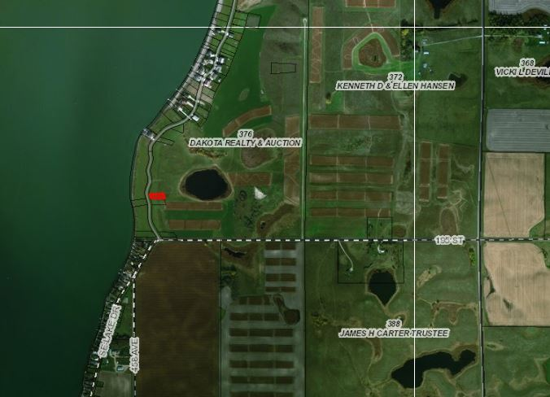

- Mr. Callahan wishes to construct a 36’x40’ unattached garage with 16’ sidewalls on his backlot property.
- Ordinance requires a conditional use for detached garages with sidewalls greater than 10.5’
- The site location of the garage meets all setbacks from the side yard and front yard to the road ROW.

Staff recommendation – Staff recommends approval based upon the following:
1. The garage meets all necessary setback regulations
2. Approve If there are no objections from adjoining property owners

Board Action: Conditional Use: Garage with sidewalls greater than 10 ½ feet: The Board may: 1) Postpone the decision 2) Deny the Request 3) Approve the request with or without conditions.

Item # 2: Conditional Use and Variance

Applicant/Owner(s): David Sogn
Property Description: Lake View Park: Lots 30, 30A, & 30B in Section 15, Township 113N, Range 52W of the 5th P.M., Hamlin County, South Dakota.

Action Item: Conditional Use: Conditional Uses in the LP1 Lake Park District (3.07.05.7)
Variance: Lake Park Area Regulations (3.07.10)
Zoning Designation: LP1 – Lake Park 1
Request: Mr. Sogn is requesting to place a 30’x52’ unattached garage with side yard setbacks of 5’ instead of 8’.
Staff Review of Application:
- General Location
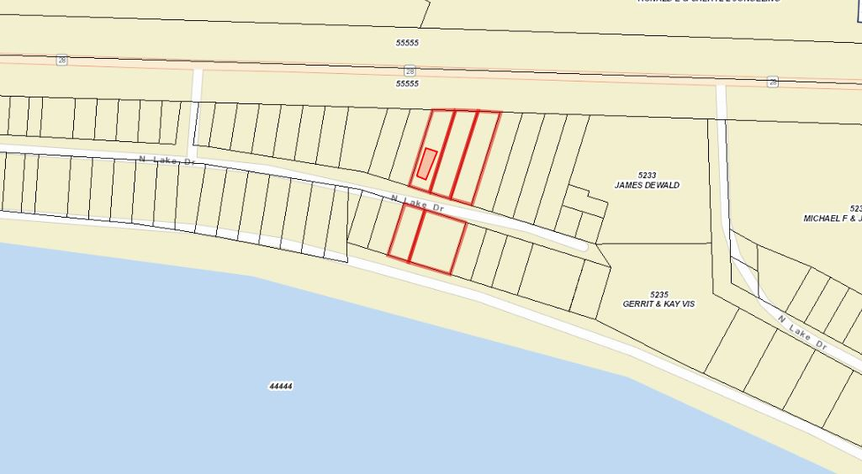

- Variance
  - Mr. Sogn is requesting a reduction of 3’ from each side yard setback to place an unattached garage on his back-lot property. The ordinance requires 8’ on side yards.
  - The lot is 40’ wide x 150’ long and in order for Mr. Sogn to build a garage to suit his preferences (Storage for RV’s, Boats, etc) he is seeking extra space to build a 30’ wide garage.
  - Mr. Sogn owns the property to the east and he has spoken to the property owner to the West and has received no complaints about the proposal.
- Staff recommendation – Approve if there are no objections from adjoining property Owners
Board Action:
The Board may: 1) Postpone the decision 2) Deny the Request 3) Approve the request with or without conditions.

- Conditional Use:
  - The proposed structure is 30’ x 52’
  - Ordinance requires a conditional use for attached garages with dimensions greater than 36’ x 42’.
  - If the variance, above is granted - Site location meets all setback requirements.
Staff recommendation – Approve with the following condition:
  - Subject to the landowner signing a letter of assurance to be recorded with the plat stating that lots 28, 29, 30, 28A, 29A, and 30A are required to be transferred together as long as there is an accessory structure located on lot 30 A.

Board Action:
The Board may after consideration of testimony and staff report: 1) Postpone the decision 2) Deny the Request 3) Approve the request with or without conditions.
Item # 3: Conditional Use
Applicant/Owner: Herb Wollman/ Poinsett Hutterian Bretheren Inc.
Property Description: E ½ and the NW ¼ and the W ½ and SW ¼ of Section 36, Township 114N, Range 51W of the 5th P.M., Hamlin County, South Dakota (Dempster Township).
Action Item: Conditional Use – Section 3.04.04.34 – Religious Farming Community
Zoning Designation: AG – Agricultural
Request: Poinsett Hutterian Colony seeks a conditional use permit to be listed as a Religious Farming Community to be in compliance with the Zoning Ordinance.
Staff Review of Application:
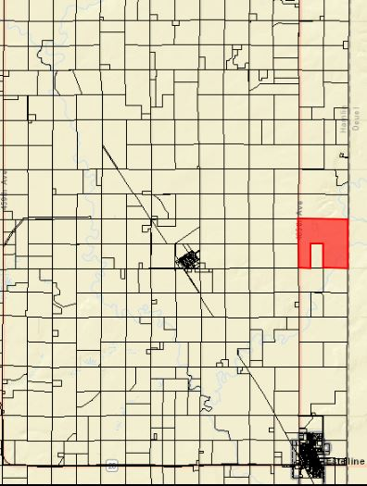
- General Location

- Herb Wollman of Poinsett Hutterian Colony approached Staff in late May seeking to reconstruct barns that were burned down a few years ago.
- Upon further review of Office records on Poinsett Colony is was discovered they had never obtained a conditional use permit to operate as a “Religious Farming Community”.
- The Zoning Officer is not allowed to issue building permits on property that requires a conditional use permit but has not yet received said permit.
- Poinsett Hutterian Colony meets the zoning ordinance definition of a Religious Farming Community (Section 369)
- Herb Wollman has provided a detailed map of the current structures on site with the application.
- Staff received calls from Dempster Township Officials and Estelline School District concerning the tax assessment status of the colony with this application. As a point of clarification, this application does not have any affect on how the Director of Equalization will assess their property.
- The issuance of this permit would not impact taxation but would only authorize the issuance of future building permits in accordance with the conditional use permit. Denial of the permit would allow the colony to continue but the issuance of future building permits would not be allowed
Staff recommendation – Staff recommends approval
Board Action:
The Board may after consideration of testimony and staff report: 1) Postpone the decision 2) Deny the Request 3) Approve the request with or without conditions.

