Hamlin County
Planning Commission & Board of Adjustment
Staff Report
Monday – April 23, 2018 – 7:00PM

Hamlin County Board of Adjustment

Item #1: Variance

Applicant: Page Koistinen

Owner(s): Harold and Richard Koistinen

Property Description: W ½ NW ¼ less Block 1 Jensen Addition Section 24, Township 114N, Range 53W (Hayti Township)

Action Item: Variance Request – Shelterbelt Setback Requirements (5.18)
Zoning Designation: Agricultural

Request: Page Koistinen requests to place a shelterbelt 50’ closer to the ROW.

Staff Review of the Application:

- General Location:
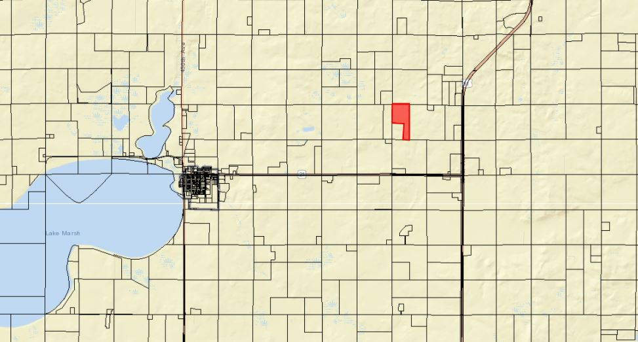

- Mr. Koistinen wishes to place 5 rows of trees on the North and West sides of a portion of the land (3 acres) to use as a shelterbelt for future residential development on the property.
- The proposed setback will be 50’ from the 187th Street (where 100’ is required)
- He seeks the variance because of the physical conditions of the portion of property where he intends to build a home, there are identifiable wetlands on the southern edge of the property which inhibit the applicant’s available land to place the home.

Staff Recommendation:

If the Board denies the request, the following findings may be used:

- A written comment has been received from the Hayti Township Board of Supervisors stating their opposition to the variance on the basis of snow removal and road maintenance concerns.

If approved the Board must establish justification for overriding the recommendation of the Township Board in order to determine what makes this proposal unique.

Board Action: Shelterbelt Setback Variance: The Board may: 1) Postpone the decision 2) Deny the Request 3) Approve the request with or without conditions.

ITEM #2 Conditional Use and Variance

Applicant/Owner: Roe Farms LLC

Property Description: SE ¼ Section 27-Township 115N-Range 54W (Oxford Township)

Action Items: Conditional Use - Class B CAFO (Section 3.04.04.9)
Variance – Required Setbacks and Separation Distances for CAFOs (5.25.05.6)

Zoning Designation: Agricultural

Request: The applicant seeks to permit his existing CAFO (cattle) and opportunity to expand to 999 Animal Units and construct new confinement building which is less than the required setback from 446th Ave.

History/Issue(s):
- General Location:
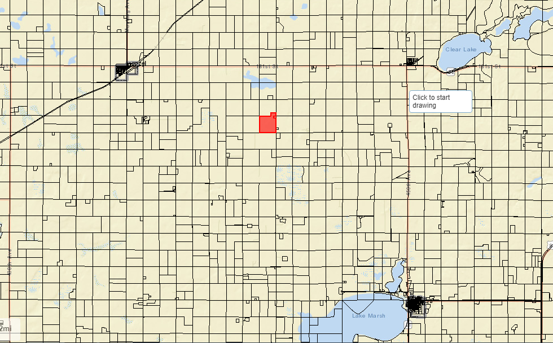

- The Roe’s have an existing non-permitted Class B cattle feeder operation with an open lot located approximately 250’ from 446th Avenue.
- The Roe’s plan to abandon the current open lot setup. They will construct a new confinement barn 250’ south of the existing lot. At its closest point it will be approximately 200’ from 446th Avenue. (300’ required by Ordinance). They also plan to remove a section of the shelterbelt to provide an access road from the existing lot to the new location.
- The Ordinance allows the Board to decrease setbacks of an existing operation where:
  - The producer does not have a history of complaints; and/or
  - The expansion will improve manure handling facilities; and/or
  - The affected parties do not object to the expansion.
- The Comprehensive land use plan supports the development of special agricultural uses such as CAFO’s subject to rules for the protection of environmentally sensitive areas (Aquifer Protection and Floodplain Regulations); protection of water features (supported by requirements for CAFO’s to be reviewed by NRCS and/or State of South Dakota); to avoid conflict with urban areas (establishment of and ability for communities to waive setback requirements.)
- The site is not located over the aquifer protection district.
- The applicant will be submitting an engineered manure management plan and nutrient management plan designed to NRCS standards.
- The Board shall consider the following in determining whether the proposed CAFO will create a significant contribution of pollution:
  - Since waters of the state are under the jurisdiction of SDDENR, Hamlin County relies upon them to determine and enforce matters resulting in pollution of waters of the state.
  - Size of feeding operation and amount of manure reaching waters of the state
    - Manure will be contained inside the barn until moved to a concrete stacking pad with a 4- foot berm.
    - The manure management facilities are being designed by an engineer to meet NRCS and SDDENR standards.
  - Location of feeding operation in relation to waters of the state
    - A USGS “Blue-line” (waters of the state) passes through the property. The “Blue-line” is located 700’ West of the proposed Barn.
    - Water drains south from the proposed new Barn through an established shelterbelt to a low area near the intersection of 446th Avenue and 183rd Street.
  - Means of conveyance of manure and process wastewater into waters of the state
    - See items b. and c.
    - This project is being designed by an NRCS engineer to meet the State General Permit requirements.
  - The slope, vegetation, rainfall and other factors affecting the likelihood or frequency of discharge of animal wastes and process wastewater into waters of the state.
    - Property in all directions from this site is used for crops.
    - Established shelterbelt surrounds the new barn on three sides.
    - Rainfall for this area is similar to the rest of the county.
    - A vegetated treatment area for runoff is located around the manure stacking pad.
5. A nutrient management plan is required.
a. Nutrient management plan has been prepared by NRCS and submitted with all necessary documents and forms listed in Section 5.25.05.3.d
b. Fields in the nutrient management plan are expected to change (per the applicant and based upon the zoning ordinance.)
c. The agronomist certifies that the land currently used for spreading is sufficient for spreading the manure generated.

6. A manure management plan is required
a. NRCS prepared the manure management plan. It included all items required by ordinance.
7. A management plan for fly and odor control.
a. The new barn is surrounded on 3 sides by an established shelterbelt. Immediately across the road, Mr. Roe maintains a shelterbelt as well.
b. Trees will only be removed from the existing shelterbelt, south of the current feedlot location to provide road access to the new location.
c. It is the intent to avoid spreading manure on weekends, holidays, and evenings on warm days.
d. It is the intent to avoid spreading on calm and humid days.
- The site is greater than suggested separation distances for Churches, businesses, commercially zoned areas, Town Districts, Incorporated municipalities, private wells and established residences other than the operator’s, and lakes and streams classified as fisheries.
- The Board has historically accepted proposed setbacks of facilities where they can meet minimums or variances have been issued.
- Review of Specifications and nutrient management plan by NRCS.
a. Applicant is required to keep and maintain records of fields to receive manure, utilize adequate acres for the spreading of manure in accordance with state general permit standards, and adhere to minimum manure application setbacks.
- All information required of the applicant in Section 5.25.05.10 were provided.
- Information on soils, shallow aquifers, wellhead protection areas and floodplain (provided)
- The primary haul route is intended to be 446th Avenue (County Road)
- Staff notified Hamlin County Highway Department, in charge of maintenance of 446th Avenue.
- Staff notified Sioux Rural Water of the request. (Rural Water Supplier.)
- The zoning office notified owners of property within a quarter mile (1/4) of the site.

Staff Recommendation

Variance Request - Reduced Setbacks and Separation Distances for CAFOs: The board, utilizing one motion could approve, deny or table the variance requests. If approved the Board may use the following findings:

- The Board reviewed the requirements of Section 5.25.05.7.e.ii and finds satisfactory provision to those requirements has been made. Specifically:
1. The Board reviewed past management practices and proposed improvements to waste handling facilities.
2. Due to the type of waste handling and management of the CAFO little or no impact on adjacent property is expected.
3. Due to topography and/or prevailing wind direction little or no impact on adjacent property is expected.
4. Due to the limited number of animal units no adverse impacts are expected.

Conditional Use Permit – Class B CAFO: The Board may table the request, deny the request or approve the request. If approved, the staff recommends, at a minimum, the following conditions to be included in a letter of assurance.

- This Conditional Use Permit authorizes the use of this property for a Concentrated Animal Feeding Operation (Feeder Cattle) consisting of up to nine hundred and ninety-nine (999) animal units. Expansion over nine hundred and ninety nine (999) animal units will require a new conditional use permit action.
- The proposed manure stacking pad shall be designed to provide primary containment for nine hundred and ninety-nine (999) Feeder Cattle (999 animal units). Prior to stocking, final manure management plan, nutrient management plan, and fly and odor management plans will be submitted to the Zoning Officer.
- The applicant agrees to comply with the submitted nutrient management plan, fly and odor management plan, and manure management plan.
- The conditional use permit shall be in effect only as long as sufficient land specified for spreading purposes is available for such purposes and other provisions of the permit are adhered to.
- Applicant shall provide updated information regarding fields included in the nutrient management plans upon request by the Zoning Officer.
- Haul road agreements with Hamlin County Highway Department shall be provided for the use of 446th Avenue as the primary haul route. Unless otherwise agreed to between the applicable road authorities and the applicant, Hamlin County requires the Grantor to abide by the following terms to be included in the Agreements:
- The Grantor shall be responsible for any costs associated with the upgrading of 446th Avenue and the proposed entrance to the property to standard agreed upon by the Hamlin County Highway Department and the applicant.
- The Grantor shall be responsible for any costs associated with the extraordinary maintenance and graveling on the portion of 446th Avenue and the proposed entrance to the property, which is hereby designated as the primary haul roads, and
- All road work whether customary or extraordinary shall be done under the authority and supervision of the applicable road authority and meet its specifications. The work shall be done through the applicable contractor unless the Grantor receives prior authorization from the applicable road authority to conduct its own repairs or maintenance.
- Unless otherwise agreed upon by the applicable road authority prior to hauling manure upon any streets. This approval is not to be construed as authorization or licensure to occupy any right-of-way without obtaining proper permits, licenses, or other authorization for such use of right-of-way.
- The Grantor acknowledges that, to the extent already provided for by the law, and further acknowledges that it shall be responsible for any and all damages to applicable road authority roads or road right-of-ways due to the result of the Grantor’s operations (i.e. Delivery of feed, or manure disposal). Work will be done on the same basis as specified hereinabove. However, no unique standard or obligation not otherwise provided for by law is created by this acknowledgment.
- The county and applicant may review and assign new haul routes on an annual basis.
- In the event the haul road agreements hereinbefore described are not executed, the grantor, his heirs, assigns or successors in interest of the Grantor agree that all of the terms and conditions of Item “6” are to be deemed a covenant running with the above-described property. Furthermore, it is agreed that, in accepting title to the above-described property any grantee, heir, assign, or successor in interest to the undersigned expressly agrees to be bound by the terms of Item “6”.
- The Grantor shall comply with established minimum manure application setbacks when spreading manure generated from the CAFO.
- The Conditional Use Permit is transferable. Subsequent owners/operators will be required to agree to the terms of this permit.
- Violation of the terms of this conditional use permit will be determined by the Hamlin County Zoning Officer.
- The first violation substantiated by the Zoning Officer of this conditional use permit may result in a notification letter stating the violation and a prescribed period-of-time to remove the violation. A second violation occurring within one calendar year of the previous violation may result in a review of the validity of the conditional use permit and potential revocation of said permit. A third violation within one calendar year of the initial violation may result in revocation of the conditional use permit and cessation of all feeder operations within forty-five days (45) of notice of revocation.
- The applicant may make appeal from the decision of the Zoning Officer or other agent of the Hamlin County Board of Adjustment to the Hamlin County Board of Adjustment. The applicant shall file with the Zoning Officer a notice of appeal specifying the grounds thereof. The Zoning Officer shall forthwith transmit to the Board of Adjustment all papers constituting the record upon which the action appealed from was taken. Such appeal shall be taken within thirty (30) days. Appeals from the Board of Adjustment shall be taken to Circuit Court.
- Failure to comply with the decision of the Zoning Officer or other agent of the Hamlin County Board of Adjustment may be deemed a separate violation.
- All of the terms and conditions herein shall extend to and be binding upon the heirs, assigns, or successors in interest of the Grantor, and are to be deemed a covenant running with the above-described property. Furthermore, it is agreed that, in accepting title to the above-described property any grantee, heir, assign, or successor in interest to the undersigned expressly agrees to be bound by the terms of this agreement which shall, upon its execution, be recorded with the Hamlin County Register of Deeds Office.

Planning Commission

ITEM #1 Plat

Owner/Applicant: Todd Voss & Bob Winters

Property Description: Lots 121-127, North Bay Eleventh Addition in the W ½ of Section 36, Township 113N, Range 53W of the 5th P.M., Hamlin County, South Dakota

Action Item: Plat Approval

Zoning Designation: Agricultural

Request: Mr. Voss and Mr. Winters requests to plat 4 acres into The North Bay Eleventh Addition.

History/Issue(s)

- Property is currently zoned Ag, it is currently platted as lot 7 which is a four-acre section on the East side of the North Bay neighborhood and directly west of the Lake Region Golf Course.
- They intend to plat seven 20,000-30,000 sq. ft. lots for residential development. Each lot meets the required minimum lot areas and widths for access for the Lake Park District.
- Staff is unable to determine whether or not the property is adequately zoned Lake Park.

Planning Commission Action: The Commission may: 1) Postpone the decision with permission of the applicant or 2) Recommend approval subject to Deed Restriction stating no building or use permits allowed with the lot and unless property is determined to be adequately zoned or 3) Recommend Denial to County Commission.

ITEM #2 Plat

Owner/Applicant: Ottertail Power Company

Property Description: Lot 7 of Railroad Addition A Part of Lot 5 of the Plat of Lots 5 and 6 of Railroad Addition, in the South Half of Section 33, Township 114 N, Range 51W, of the 5th P.M., Dempster, Hamlin County, South Dakota

Action Item: Plat Approval

Zoning Designation: Town District

Request: Ottertail Power Company seeks to plat of a section of property in order to construct a pole substation.

History/Issue(s)

      - Ottertail seeks to plat a portion of property (80x30) for the installation of a pole substation
      - There is no platted access to this lot
      - A pole substation is not an allowed use in the Town District. An Ordinance Amendment is required.
      - Staff recommends subsequent application to amend the zoning regulations, conditional use application with site plan.

Planning Commission Action: The Commission may: 1) Postpone the decision with permission of the applicant or 2) Recommend subject to Deed Restriction stating no building or use permits allowed with the lot and an access easement to be provided or 3) Recommend Denial to County Commission.

Item #3 Board Discussion: Accessory Agricultural Housing

Current zoning regulations allow for the construction of accessory agricultural housing. A single structure can be built to house up to 24 individuals with either 8 dwelling units housing 3 individuals each or 24 individual units or a combination thereof.

On March 26th, The Planning Commission held a public hearing on an Ordinance Amendment concerning Accessory Agricultural Housing. The Planning Commission instructed Staff to return in April with a different approach. The updated proposal addresses the following:

- Accessory Ag Housing is restricted to Class A CAFOs.
- Accessory Agricultural Housing has to be requested with a CAFO application. Existing Class A CAFO’s will be allowed 1 year to apply.
- Accessory Agricultural Housing is only allowed within the same section of land as the CAFO.
- The maximum number of individuals residing in Accessory Agricultural Housing is based upon size of CAFO and limited to 48 individuals.
- There is no transfer of development rights associated with this ordinance.
- Accessory Agricultural Housing will conform with State Approved Building Codes and Sanitary Sewer Standards.

New proposed Ordinance Language:

Remove Section 3.04.06 Conditions Regulating Accessory Agricultural Housing

Definitions (all new language):

Section 202A. Accessory Agricultural Housing. Any dwelling, pursuant to Chapter 5.35 occupied by employees of a Concentrated Animal Feeding Operation which has been issued a Conditional Use permit by Hamlin County. (New- Currently no definition)

Section 264A. Shared Dwelling. One room, or rooms, connected together, constituting a shared, housekeeping establishment for Accessory Agricultural Housing and may contain shared cooking, bathing, sleeping and/or common living areas. (New - Currently no definition)

Section 379 A. Section of Land. A division or parcel of land, delineated by the United States Public Land Survey, comprising of approximately one square mile or 640 acres. (New - Currently no definition)

Agricultural District (Section 3.04.04: Conditional Uses):

5. Transfer of Eligible Building Site (See Section 3.04.05.3 4.04.05.4)
35. Transfer of Eligible Building Site (See Section 3.04.05.3) Accessory Agricultural Housing.
(This removes duplicitous language and formally lists Accessory Agricultural housing)

CHAPTER 5.25 CONCENTRATED ANIMAL FEEDING OPERATION REGULATIONS

Section 5.25.06: Accessory Agricultural Housing (new section)

- Accessory Agricultural Housing is a permitted accessory use to Class A Concentrated Animal Feeding Operations.
- Accessory Agricultural Housing must be approved by the Board of Adjustment.
  - Any Class A Concentrated Animal Feeding Operation, permitted after April 1st, 2018 is required to submit a request for accessory agricultural housing at the time of the initial Concentrated Animal Feeding Operation application.
  - Any Class A Concentrated Animal Feeding Operation, permitted before April 1st, 2018 may submit a request for Accessory Agricultural Housing if such request is made prior to April 1st, 2019.
- Accessory Agricultural Housing shall be located within the same section of land as the permitted Class A Concentrated Animal Feeding Operation, provided the property is owned by the permit-holder.
- Minimum lot area shall consist of at least two (2) acres per dwelling unit, or for every 3 individuals in the accessory agricultural housing, including the residence of the agricultural employer if on the same lot. (this same as existing rules)
- Accessory agricultural housing shall be in accordance with the following table: (new language)

Number of Animal Units | Maximum Number of Dwellings | Maximum Number of Dwelling Units (if not a shared dwelling) | Maximum Number of Persons per Dwelling Unit | Maximum Number of Persons in Accessory Agricultural Housing*
0 to 999 Animal Units | Not Allowed | Not Allowed | Not Allowed | Not Allowed
1,000 to 2,999 Animal Units | 1 | 2 | 3 | 6
3,000 to 3,999 Animal Units | 1 | 4 | 3 | 12
4,000 to 4,999 Animal Units | 1 | 5 | 3 | 15
5,000 to 5,999 Animal Units | 1 | 6 | 3 | 18
6,000 to 6,999 Animal Units | 1 | 7 | 3 | 21
7,000 to 7,999 Animal Units | 2 | 8 | 3 | 24
8,000 to 8,999 Animal Units | 2 | 9 | 3 | 27
9,000 to 9,999 Animal Units | 3 | 10 | 3 | 30
10,000 to 10,999 Animal Units | 3 | 11 | 3 | 33
11,000 to 11,999 Animal Units | 3 | 12 | 3 | 36
12,000 to 12,999 Animal Units | 4 | 13 | 3 | 39
13,000 to 13,999 Animal Units | 4 | 14 | 3 | 42
14,000 to 14,999 Animal Units | 4 | 15 | 3 | 45
Over 15,000 Animal Units | 4 | 16 | 3 | 48
*This column represents the maximum total number of employees allowed to reside in Accessory Agricultural Housing which is subordinate to a permitted Class A Concentrated Animal Feeding Operation

- Prior to occupying the accessory agricultural housing dwelling/shared dwelling, the applicant shall provide documentation of compliance with the most recently adopted version of the International Building Code in accordance with SDCL-11-10-6 for any dwelling structure with two (2) or more dwelling units. (same as existing language)
- Prior to occupying the accessory agricultural housing dwelling/shared dwelling, the applicant shall provide documentation of compliance with any South Dakota Administrative Rules 74:53. (new language)
- The dwelling/shared dwelling shall be removed or renovated into a single-family dwelling in the event the permit for the concentrated animal feeding operation becomes void. (similar to existing language)
- In the event the accessory agricultural housing dwelling/shared dwelling remains unoccupied for a period of one (1) year; or is not used in conformance with this Chapter, the accessory agricultural housing dwelling/shared dwelling shall be removed or with permission of the Board of Adjustment may be used for any use accessory to the Concentrated Animal Feeding Operation. (similar to existing language)

Planning Commission Action:

- Recommend Approval of Ordinance as presented last month.
- Withdraw initiation of previous Ordinance and retain existing regulation
- Postpone action until
  - Notice for hearing on today’s language at next month’s meeting
  - Additional discussion

