Hamlin County
Planning Commission & Board of Adjustment
Staff Report

Monday – February 26, 2018 – 1:00PM

Hamlin County Planning Commission

ITEM#1 Conditional Uses in the Lake Park District

Specifics of Request: In the Zoning office, I received a phone call from a representative of the Lake Norden Baptist Church. She was seeking information on a building permit to place a garden shed on the church’s cemetery east of the City of Lake Norden on Lake Mary. In further research, I discovered Churches and Cemeteries were not listed as a Permitted Use or as a Conditional Use in the Lake Park District. – Staff is looking for direction in this matter

Hamlin County Board of Adjustment

ITEM#1 Conditional Use

Applicant: Martin Prouty

Owner: Marcia Prouty

Property Description: N 53.33 Rods of SE ¼ of Cleveland Township in Section 17-113N-54W of the 5th P.M. in Hamlin County, South Dakota.

Request: Martin Prouty seeks a Class A CAFO permit to construct and operate a 1,760 AU wean to finish swine operation

Action Item: Conditional Use Permit – Class A Concentrated Animal Feeding Operation (3.04.04.9)

Zoning Designation: Agricultural

History/Issue(s):
- Specifics of Request:
  - Martin Prouty is proposing to construct an operate a 4,400 head wean to finish swine operation in Cleveland township, 6 miles west of Lake Norden on SD HWY 28.
  - The property is owned by his mother Marcia Prouty. Martin lives in the residence on the southern portion of the SE quarter of section 17.
  - Martin currently manages Dolph Creek Pork, a 3,300 head operation, and has since 2015.
  - Proposed location:

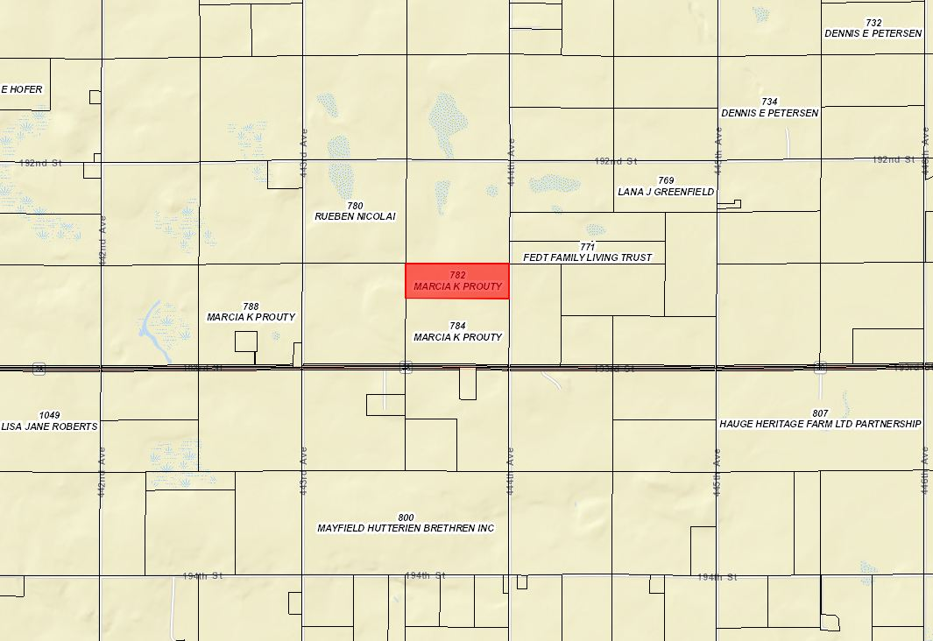

Ordinance and Comprehensive Land Use Plan regarding this request:

- The Comprehensive land use plan supports the development of special agricultural uses such as CAFO’s subject to rules for the protection of environmentally sensitive areas (Aquifer Protection and Floodplain Regulations); protection of water features (supported by requirements for CAFO’s to be reviewed by DENR); to avoid conflict with urban areas (establishment of and ability for communities to waive setback requirements.)
- The site is not located over the aquifer protection district.
- The applicant will be submitting engineering and nutrient management plan to SDDENR for a State General Permit pending review decision of this Board
- The Board shall consider the following in determining whether the proposed CAFO will create a significant contribution of pollution:
  - Size of feeding operation and amount of manure reaching waters of the state
    - Historically the Board has relied in determination of SDDENR in reference to this question since waters of the state are under their jurisdiction.
  - Location of feeding operation in relation to waters of the state
    - A USGS “Blue-line” (waters of the state) passes through the lot. The “Blue-line” is located in the south portion of the SE ¼.
  - Means of conveyance of manure and process wastewater into waters of the state
    - See items a. and b.
    - Typically, the Boards rely on determination of SDDENR in reference to this question since waters of the state are under their jurisdiction and this is a component of the State General Permit review.
  - The slope, vegetation, rainfall and other factors affecting the likelihood or frequency of discharge of animal wastes and process wastewater into waters of the state.
    - Property in all directions from this site is used for crops. Manure will be pumped from barns into an above ground slurry store in the NW portion of the lot daily.
    - Drainage flows east of the site into the ditch on 444th Avenue and flows down toward the “Blue-Line.” Measured from the southern edge of the proposed lot to the “Blue-Line is 735’.
    - Rainfall for this area is similar to the rest of the county
    - The applicant’s site is designed to be a zero discharge operation.
5. A nutrient management plan is required.
a. Nutrient management plan has been prepared by a licensed Agronomist and submitted with all necessary documents and forms listed in Section 5.25.05.3.d
a.i. ProAg Engineering out of Jackson, MN.
b. Fields in the nutrient management plan are expected to change (per the applicant and based upon the zoning ordinance.)
c. The agronomist certifies that the land currently used for spreading is sufficient for spreading the manure generated.
c.i. The applicant has signed manure agreements on 1,482 acres of land within 4 ½ miles of the proposed location for 10 years for spreading purposes.
6. A manure management plan is required
a. The applicant’s agronomist and registered professional engineer prepared the manure management plan. It included:
a.i. A site plan
a.ii. Operation procedures and maintenance of manure facilities for proposed facilities.
a.iii. Verified containment is intended to store waste for at least 270 days. Manure intended to be pumped daily as stated before.
a.iv. Verified that no containment is intended to store waste for more than two years
a.v. The County acknowledges DENR approval of Final as-built plans as a pre-requisite for approval.
a.vi. Plans specifying records on manure application will be kept by the applicant and document that acceptable manure and nutrient management practices have been followed.
7. A management plan for fly and odor control.
a. Complete
a.i. Applicant has an enclosed containment site on the lot for death loss which will be screened by trees and out of sight from adjacent landowners.
b. Trees will be planted on the North and West sides of the site.
c. Manure and odor plan plans for removing manure from barns and a bio cover will be blown on the liquid manure in storage at a minimum once a year.
d. It is the intent to avoid spreading manure on weekends, holidays, and evenings on warm days.
e. It is the intent to avoid spreading on calm and humid days.
- The site is greater than suggested separation distances for Churches, businesses, commercially zoned areas, Town Districts, Incorporated municipalities, private wells other than the operator’s, and lakes and streams classified as fisheries.
- The proposed location in the SE 1/4 meets or exceeds all required setbacks.
- The Board has historically accepted proposed setbacks of facilities where they can meet suggested minimums or variances have been issued.
- Review of Specifications and nutrient management plan by DENR.
a. Applicant is required to keep and maintain records of fields to receive manure, utilize adequate acres for the spreading of manure in accordance with state general permit standards, and adhere to minimum manure application setbacks.
- All information required of the applicant in Section 5.25.05.10 were provided.
- Information on soils, shallow aquifers, wellhead protection areas and floodplain (provided)
- The primary haul route is intended to be 444th Avenue (Cleveland) a township road.
- Staff notified Cleveland Township, in charge of maintenance of 444th Avenue.
- Staff notified Sioux Rural Water of the request. (Rural Water Supplier.)
- The zoning office notified owners of property within one-mile of the site.

Staff Recommendation
Conditional Use Permit – Class A CAFO: The Board may table the request, deny the request or approve the request. If approved, the staff recommends, at a minimum, the following conditions to be included in a letter of assurance.

- This Conditional Use Permit authorizes the use of this property for a Concentrated Animal Feeding Operation (wean to finish Swine) consisting of one thousand seven hundred and sixty (1,760) animal units. Expansion over one thousand seven hundred and sixty (1,760) animal units will require a new conditional use permit action.
- The proposed slurry storage shall be designed to provide primary containment for greater than four thousand four hundred (4,400) wean to finish Swine (1,760 animal units). Prior to stocking documentation of approval of minimum design requirements shall be submitted to the Zoning Officer.
  - Applicant may stock with the maximum number of animals for which the slurry storage is designed provided documentation is provided by SDDENR that such designs are approved for said animals.
  - In no case shall it be implied that this permit authorizes greater than 1,760 animal units.
- The applicant agrees to comply with the submitted nutrient management plan, fly and odor management plan, and manure management plan.
- The conditional use shall be in effect only as long as sufficient land specified for spreading purposes is available for such purposes and other provisions of the permit are adhered to.
- Applicant shall provide updated information regarding fields included in the nutrient management plans upon request by the Zoning Officer.
- Haul road agreements with Cleveland Township shall be provided for the use of 444th Avenue as the primary haul route. Unless otherwise agreed to between the applicable road authorities and the applicant, Hamlin County requires the Grantor to abide by the following terms to be included in the Agreements:
- The Grantor shall be responsible for any costs associated with the upgrading of 444th Avenue and the proposed entrance to the property to standard agreed upon by the Cleveland Township and the applicant.
- The Grantor shall be responsible for any costs associated with the extraordinary maintenance and graveling on the portion of 444th Avenue and the proposed entrance to the property, which is hereby designated as the primary haul roads, and
- All road work whether customary or extraordinary shall be done under the authority and supervision of the applicable road authority and meet its specifications. The work shall be done through the applicable contractor unless the Grantor receives prior authorization from the applicable road authority to conduct its own repairs or maintenance.
- Unless otherwise agreed upon by the applicable road authority prior to hauling manure upon any streets or the laying of any pipes intended to transport liquid manure within any right-of-way. This approval is not to be construed as authorization or licensure to occupy any right-of-way without obtaining proper permits, licenses, or other authorization for such use of right-of-way.
- The Grantor acknowledges that, to the extent already provided for by the law, and further acknowledges that it shall be responsible for any and all damages to applicable road authority roads or road right-of-ways due to the result of the Grantor’s operations (i.e. Delivery of feed, or manure disposal). Work will be done on the same basis as specified hereinabove. However, no unique standard or obligation not otherwise provided for by law is created by this acknowledgment.
- The township and applicant may review and assign new haul routes on an annual basis.
- In the event the haul road agreements hereinbefore described are not executed, the grantor, his heirs, assigns or successors in interest of the Grantor agree that all of the terms and conditions of Item “6” are to be deemed a covenant running with the above-described property. Furthermore, it is agreed that, in accepting title to the above-described property any grantee, heir, assign, or successor in interest to the undersigned expressly agrees to be bound by the terms of Item “6”.
- The Grantor shall comply with established minimum manure application setbacks when spreading manure generated from the CAFO.
- The Conditional Use Permit is transferable. Subsequent owners/operators will be required to agree to the terms of this permit.
- Violation of the terms of this conditional use permit will be determined by the Hamlin County Zoning Officer.
- The first violation substantiated by the Zoning Officer of this conditional use permit may result in a notification letter stating the violation and a prescribed period-of-time to remove the violation. A second violation occurring within one calendar year of the previous violation may result in a review of the validity of the conditional use permit and potential revocation of said permit. A third violation within one calendar year of the initial violation may result in revocation of the conditional use permit and cessation of all feeder operations within forty-five days (45) of notice of revocation.
- The applicant may make appeal from the decision of the Zoning Officer or other agent of the Hamlin County Board of Adjustment to the Hamlin County Board of Adjustment. The applicant shall file with the Zoning Officer a notice of appeal specifying the grounds thereof. The Zoning Officer shall forthwith transmit to the Board of Adjustment all papers constituting the record upon which the action appealed from was taken. Such appeal shall be taken within thirty (30) days. Appeals from the Board of Adjustment shall be taken to Circuit Court.
- Failure to comply with the decision of the Zoning Officer or other agent of the Hamlin County Board of Adjustment may be deemed a separate violation.

- All of the terms and conditions herein shall extend to and be binding upon the heirs, assigns, or successors in interest of the Grantor, and are to be deemed a covenant running with the above-described property. Furthermore, it is agreed that, in accepting title to the above-described property any grantee, heir, assign, or successor in interest to the undersigned expressly agrees to be bound by the terms of this agreement which shall, upon its execution, be recorded with the Hamlin County Register of Deeds Office.

ISSUE #2 CONDITIONAL USE
Applicant/Owner: Drumgoon Dairy

Property Description: NW1/4, Section 6-T113N-R52W, Hamlin County, South Dakota. (Norden Township)

Action Items: Conditional Use – Accessory Agricultural Housing

Zoning Designation: A – Agricultural

Request: Drumgoon Dairy requests to build a second dwelling to house an additional 8 employees for a total of 24 employees housed on site.

History/Issue(s):

General Location:
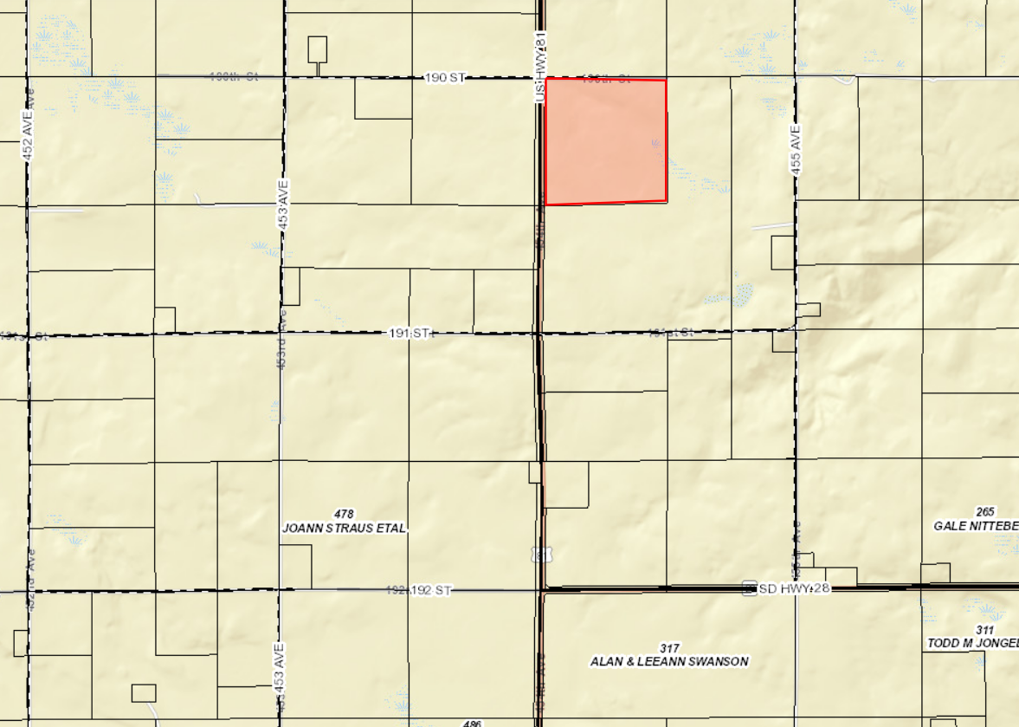

Specifics of Request:

- Drumgoon operates a Class A CAFO on the above described property. They were permitted for 4,900 head of mature dairy cattle and 200 heifers in May of 2017.
- Drumgoon constructed a dormitory-style “farm dwelling” for up to 16 employees in 2017. There is no record of county approval for the existing 16 employee structure.
- The applicant requests to build a second dwelling for up to 8 additional employees. The structure will have steel siding and be constructed more like a 4-plex with 2 bedroom units and central corridor with a washroom and utility room.

Ordinance and Comprehensive Land Use Plan regarding this request:

- In 2017 the Zoning Ordinance was amended to allow for “Accessory Agricultural Housing” as a conditional Use.
- The farm owner does not live on the same lot (not required by ordinance)
- The lot contains 160 acres (minimum 2 acres required.)
- This request will allow for a total of two dwellings one accommodating 16 individuals and the other (new structure) accommodating 8 individuals.
  - The ordinance references “dwelling” rather than more than “dwellings”. The board will have to determine whether the intent was to limit the numbers AND the number of structures; or to specifically limit the number of residents only.
  - The Board will have to determine whether vertical steel siding is appropriate for the siding of the structure.
- Section 3.04.05 requires transfer of building site eligibility related to Accessory Agricultural Housing. The reference to eight (8) dwelling units in section 3.04.05.3 of the ordinance is implied to equal 24 unrelated individuals as is requested here. Currently there is one multi-family farm dwelling on the NW ¼ Section 6-113-53, and none on the NE1/4 of Section 1-113-53 (across the road).
  - In order to meet the building site eligibility requirements, the board will have to determine that “contiguous ownership” for the purposes of this ordinance includes “across the road.”
  - Applicant agrees to file a document transferring building site eligibility rights from the applicable quarter-quarter sections to this location if approved.
- The proposed structure will be required to meet International Building Code in accordance with SDCL 11-10-6
- Sanitary sewer is required to be installed in accordance with SDDENR standards.

Issue #3: Variance

Applicant: Casey Witt

Owner: Steve and Aryls Sikorski

Property Description: Nitteberg Beach Lot 26 in Section 20-113N-R52W of the 5th P.M. in Hamlin County, South Dakota.

Action Item: Rear Yard Lake Front Setback (3.07.09)

Zoning Designation: Lake Park 1

Request: Mr. Witt is requesting a reduced setback to build a deck on the lake front for the Sikorski’s house.
- Staff Review of the Application
  - General Location

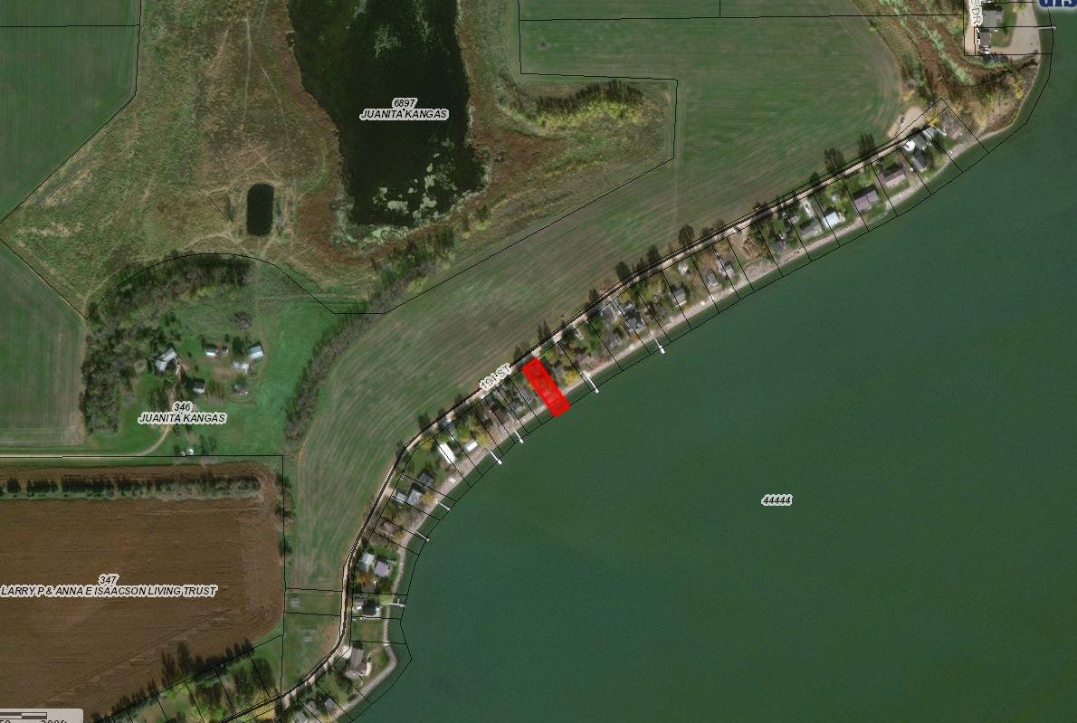

  - The Sikorski’s acquired a building permit in November 2017 to build a house/garage on the same address and legal description. Witt Construction built the house to the required setbacks (30’ front yard, 50’ rear yard from OHM, 8’ side yard”)
  - The Sikorski’s are proposing to build a 12’x30’ elevated deck with a 4’x20’ “L” along the west portion of the house.
  - The required setback for the rear yard on the lake front is 50’ from the ordinary high-water mark (which is 1651.5’)
  - The ordinance allows ´an open, unenclosed porch/deck which is in excess of two (2) feet above the floor level of the ground (first) story to project into a required front yard or rear yard for a distance not exceeding ten (10) feet.” Thereby requiring a two foot variance.
- Staff recommendations – Staff recommends approval based upon the following:
    - The deck is elevated greater than 2 feet above the floor level of the ground (at least 6ft)
    - The proposed deck would not extend any further than the deck/garage located on the neighbors on the West
    - At the time of this report, staff has received no complaints from adjoining landowners.
    - There have been examples of the County issuing similar variances in the Lake Park District.
- Board Action: Rear Yard Lake Front Variance: The Board may: 1) Postpone the decision 2) Deny the Request 3) Approve the request with or without conditions.

