City of Clark Annexation Study - 2016

First District Association of Local Governments

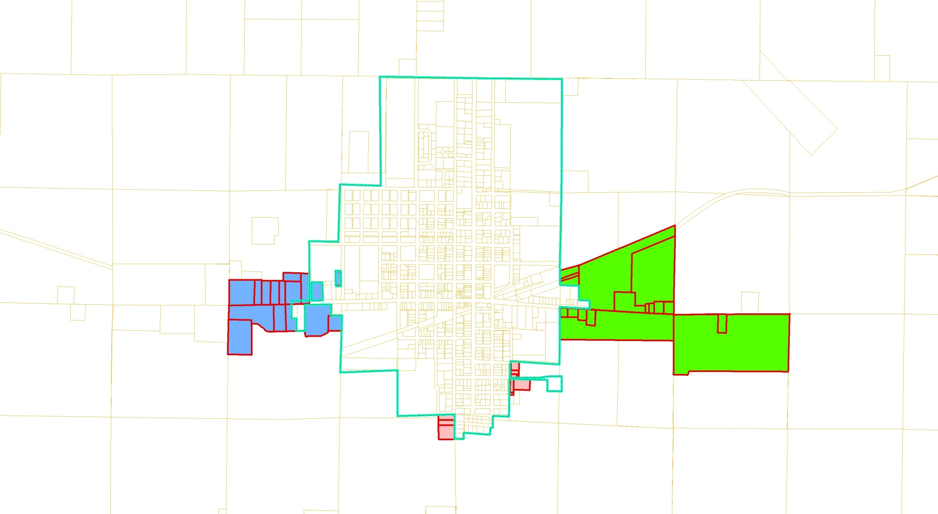

TABLE OF CONTENTS

SECTION 1 – PROJECT OVERVIEW 2
- Introduction 2
- Methodology 2
- Purpose 2

SECTION 2 – REVIEW AND EVALUATION OF EXISTING SOCIO-ECONOMIC CONDITIONS 3
- Demographics 3
- Land Use 4

SECTION 3 – REVIEW AND EVALUATION OF FUTURE GROWTH SCENARIOS 5

- Land Use Consumption and Projections 5

SECTION 4 – Review of Annexation Issues and Impacts 7
- Annexation Issues 7
- Comparison of Public Services Inside/outside of City Limits 9
- Summary of Municipal Utility Conditions 9
- Summary of Economic Impacts of Future Annexations 10
- Potential Annexation Areas 11
  - Area A 16
  - Area B 20
  - Area C 23
- Tax Impacts on Other Jurisdiction 27

SECTION 5 – CONCLUSIONS AND RECOMMENDATIONS 29

APPENDIX 32

Section 1. Project Overview

Introduction

Petitions to annex are currently submitted by landowners on a voluntary basis according to South Dakota Codified Laws (SDCL 9-4-1). Specifically, the petition must be signed by not less than three-fourths of the registered voters and by the owners of not less than three-fourths of the value of the territory sought to be annexed. A resolution of intent to annex, provided for by SDCL 9-4-4.2, allows municipalities to extend their boundaries after a study is conducted to determine the need for contiguous territory and to identify resources necessary to extend municipal boundaries.

In March of January 2016, the Clark City Council directed the First District Association of Local Governments (District) to assist in the development of an annexation study to satisfy the requirements of SDCL 9-4-4.2. The City Council defined a proposed annexation area and requested the District to analyze the government services, land use and fiscal implications of annexation.

Methodology

This project included the following steps:

- Data collection and analysis
- Review and evaluation of future growth scenarios
- Analysis of impacts on future annexations
- Conclusion and recommendations

Purpose

The purpose of this study is twofold: First it is intended to provide the Clark Planning Commission, Clark City Council, and other interested parties with important information regarding the area(s) proposed to be annexed. Second it is intended to fulfill the requirements of SDCL 9-4-4.2, which requires the City to included detailed information justifying annexation of the area in a resolution of intent to annex. The information included in this document may be incorporated into such a resolution.

Section 2. Review and Evaluation of Existing Socio-economic Conditions

The City of Clark is located along U.S. Highway 212 in Clark County, in the northeast South Dakota, approximately 33 miles west of Watertown, South Dakota. The City is governed by a mayor and six city council-persons. The City provides a variety of municipal services including water and sanitary sewer for customers within the corporate limits of the City. Under special arrangements with higher user rates, some customers have been provided with water and sanitary sewer service outside of city limits.

Demographics

Clark is a community comprised of 1,139 residents (2010 Census). Table 1 provides information on the population trends of Clark since 1970. While Clark has experienced a gradual annual population loss of 0.4% since 1970, it should be noted that since 1990 the City experienced annual population increases of 1.3%; however since 2000 the City experienced an annual decrease in population of 1.1%. The City’s expects to maintain and perhaps expand its population over the next ten years. This maintenance and potential expansion may be enhanced by economic development efforts, existing industry, and proximity to other growing communities such as Watertown and Brookings. The City’s proportion of the total County population has increased from 24.6% in 1970 to 30.9% in 2010.

Clark’s population density has been relatively constant over the past twenty years. In contrast, household size has been declining steadily from 2.3 in 1990 to 2.1 in 2010.

Table 1
City of Clark Population and Land Use

 | 1970 | 1980 | 1990 | 2000 | 2010
Population | 1,356 | 1,351 | 1,292 | 1,285 | 1,142
Households | NA | NA | 568 | 558 | 552
Persons per Household | NA | NA | 2.3 | 2.3 | 2.1
City % of County Population | 24.6 | 27.6 | 29.3 | 31.0 | 30.9
Land Area (Acres) | NA | NA | NA | 832 | 832
Persons per Acre | NA | NA | NA | 1.5 | 1.4

The City’s 2000 Comprehensive Land Use Plan (Plan) provided for population growth projections. Clark’s low, medium, and high growth calculations were based upon projections of .5%, .75%, and 1.0% annual expansion levels respectively. Using the medium projection of .75% per year, Clark could experience a population increase equal to approximately four families (8.6 persons) per year (resulting in a population of approximately 1,300 by the year 2030). This projection is higher than housing and economic development trends of recent years.

Land Use

In order to determine the need for future land within the City limits to accommodate expected growth, this study relied on information provided in the Plan. In 2000 the Clark City Council adopted the Plan which contained goals and objectives intended to result in future living and working conditions desired by the majority of the citizens the following are examples of the “General Community Goals”:

- To promote the economic growth and social development of Clark and the surrounding area as a partner in cooperation with the private sector.
- To promote cooperation and coordination between the City and the County in the development of land and utilities within three miles of Clark’s corporate limits.

- To provide ample opportunities for public participation at all stages of the planning and implementation process, including annual reviews of the plan and public awareness campaigns.

- Continue an active program that will maintain and enhance the community’s ability to implement the comprehensive land use plan while retaining flexibility within the planning and zoning process so as to readily cope with changing social and economic conditions.

The Plan identified over fifty policy guidelines regarding land use development. The primary focus of the Plan was in the area of future development, within the existing urban area and on lands along the urban fringe.

Four specific objectives found under the Land Use Goal of the Plan are particularly relevant to this study:

Land Use Goal Objectives

- Maintain an adequate supply of development land within the city all times.

- Encourage compact, contiguous growth along the city’s fringe.

- Establish land use patterns that will discourage leapfrog development on land, which cannot be economically provided with public services and facilities.

- Encourage annexation of the land adjacent to the city’s corporate limits prior to development.

While there is not a formal joint jurisdictional zoning ordinance with Clark County for areas outside of Clark Corporate Limits, the County and the City have both adopted comprehensive land use plans and zoning ordinances which deal with the development of those areas. The land within the City is zoned for various uses as summarized below:

A Agricultural District
R1 Single Family Residential District
R2 General Residential District
R3 Combined Residential District
C1 General Commercial District
HC Highway Commercial District
I Industrial District

Section 3. Review and Evaluation of Future Growth Scenearios

The City includes the following developed areas of land use (Table 2) within the City limits. Currently there are over three hundred acres of undeveloped land within the City most of which is zoned for agricultural purposes. It should be noted that many of the undeveloped acres within the community have development constraints such as topography, flood plain and proximity to water and sanitary sewer infrastructure.

Table 2
City of Clark Land Use
LAND USE | NUMBER OF ACRES | PERCENT OF DEVELOPED AREA | DEVELOPED ACRES PER 100 PERSONS*
SINGLE FAMILY | 171.1 | 36.8 | 15.0
MULTIPLE-FAMILY | 11.4 | 2.5 | 1.0
MANUFACTURED HOUSING | 10.4 | 2.2 | 0.9
TOTAL RESIDENTIAL | 192.9 | 41.5 | 16.9
COMMERCIAL | 22.0 | 4.7 | 1.9
INDUSTRIAL | 45.5 | 9.8 | 4.0
PUBLIC/QUASI-PUBLIC | 81.0 | 17.4 | 7.1
PUBLIC RIGHTS-OF-WAY | 123 | 26.5 | 10.8
TOTAL DEVELOPED AREA | 464.4 | 100 | 40.7
SOURCE: CITY OF CLARK LAND USE INVENTORY, 2009.
(*) BASED ON ASSUMED URBAN AREA POPULATION OF 1,142

Land Use Consumption and Projections

The Plan provided a proportionate amount of new urban development required to accommodate future population growth. Using generally accepted land use consumption statistics approximately seventy three acres of additional land development will be required to serve a population exceeding 1,325. These projections are only estimates and therefore are to be used only as a guide. It is very possible that there may be a need for additional acres in any of the designated land uses through the year 2030.

The number of acres that will be needed to accommodate new development is further analyzed in Tables 3 and 4. The calculations show assumptions used to estimate the land needs of each land use type throughout the planning period. The estimates for each land use category include a multiplier based on the amount of development land considered necessary to meet market demands.

Table 3
Land Consumption Projections
2010-2030

Single-family Residential 40 units @ 2.5 units/acre + 50% multiplier = 24 acres
Multiple-family Residential 36 units @ 12 units/acre + 50% multiplier = 4.5 acres
Manufactured Home Residential 16 units @ 2.75 units/acre + 50% multiplier = 8.7 acres
Commercial 0.25 acres per year +100% multiplier = 10 acres
Industrial 0.33 acres per year +100% multiplier = 13.2 acres
Public/Quasi-Public 0.07 acres/person = 12.9 acres

Table 4
Future Development Land
Projected Supply And Demand (In Acres)

 | Needed | Available (With Infrastructure)
Single-Family | 24 | ----
Multiple Family | 4.5 | ----
Manufactured Housing | 8.7 | ----
Total Residential | 37.2 | 18.75
Commercial | 10 | 0.95
Industrial | 13.2 | 14.74
Public/Quasi-Public | 12.9 | Sufficient acres available in existing parks to accommodate in-fill growth
 | 73.3 acres | 34.4 of 73.3 needed acres are available

In order for Clark to accommodate future development, sufficient land area must be designated for both residential and nonresidential development. Based on housing projections nearly seventy three acres of development land area will be needed to accommodate a population of 1,300. Over thirty seven acres is needed for future residential uses. Presently there are approximately nineteen acres currently available for residential development (Table 4). In addition, there appears to be sufficient acres available to meet the projected need for additional land to accommodate future public/quasi-public uses such as parks, churches, schools, government buildings, etc.

A projected demand of approximately eight acres of land is anticipated to provide for the expected economic growth until 2030. Presently there is approximately one acre currently available for commercial development and fifteen acres available for industrial development (Table 4). It should be noted that the above projections are only estimates and therefore are to be used only as a guide. It is very possible that there may be a need for additional acres in any of the designated land uses.

Section 4. Review of Annexation Issues and Impacts

This study is focused on the issue of annexation: Whether more land should be annexed into the City (either at the City’s or landowners initiation); and if so, where, how much and when.

Annexation Issues

Several problems generally arise if development around a city is not regulated in some manner. First, the City may be asked to provide services in all directions instead of in a defined, compact direction which is generally achieved with controlling regulations and criteria. Second, without a systematic plan for annexation and development, uncontrolled development will encroach on valuable irreplaceable farmland. Finally, if and when annexation does occur, the City may be faced with the problem of replacing substandard water, sanitary sewer, streets, and drainage facilities with adequate structure.

Although it is difficult to specify the most appropriate time for a city to initiate annexation, the most common reasons for annexation relate to: the need for additional developable land within the city boundaries; or development occurring in the fringe area outside the city boundaries and the corresponding expectation that the city will provide certain services to that area. In most annexation proposals, one of the following two situations applies:

- Fringe area development has already occurred, and the city is providing limited services to the area.

Common examples of fringe area development include businesses and small clusters of residences that spring up along the highway leading out of the city. The city may already provide water, police protection, and other services to these developments, leaving little reason for property owners to desire annexation since they are already receiving many of the benefits yet paying lower taxes than city residents.

- Fringe area development has already occurred, but no city services are being provided to the area.

This situation occurs when individuals desire at minimum, some of the city’s services. Even if the development is self-sufficient at present, it is likely that city services will be requested sometime in the future. This commonly occurs for a variety of reasons including: (1) the development’s septic tanks may begin to fail or are polluting ground water; (2) the growing population may require additional police protection; (3) fire protection may be less costly within city boundaries; (4) provision of utility and other services may be less costly within the city limits; and (5) street maintenance may be of a higher standard, and snow removal more timely.

Even in cases where no direct services are provided beyond city boundaries, cities generally incur additional costs as a result of development along the fringe of the city limits. Residents outside the city often use city streets, parks, libraries, and other facilities as much as city residents but do not pay municipal taxes that pay for the cost of these facilities.

The discussion above is not meant to imply that the City of Clark should actively pursue annexations. What it should indicate is that annexations are generally initiated in response to fringe area development either existing or expected. Ideally, cities should annex territory in advance of development so that city regulations (zoning ordinance, street and drainage specifications, and building codes, etc.) can be used to ensure the types and standards of development the city desires. The following is a discussion of the case for and against the aggressive and conservative approaches to annexation.

The Case For Annexation

City Reasons

- Provides assurance that any future development is accomplished in an efficient and organized manner, and according to City standards, in terms of streets, water, wastewater, drainage, etc. Also requires existing developments in the fringe areas to upgrade infrastructure to City standards.

- Provides opportunity to gain additional property tax revenue from existing developments immediately and any future development as it occurs.

- Industrial and commercial properties that are already annexed and zoned represent an additional incentive to locate facilities in the City.

- Defines the future City limits to facilitate comprehensive planning.

County/Township Reasons
- Reduces area of responsibility and costs for street maintenance and other services provided by County and/or townships, but property tax revenue to County remains in place. Alternatively, County taxes could be reduced in proportion to additional City taxes required to support additional service provision.

Homeowner Reasons

- Provides for sanitary sewer and street maintenance.

- Reduces cost of private trash collection.

- May require upgrade of infrastructure to City standards which will increase value/sale-ability.

The Case Against Annexation

City Reasons

- Requires the City to provide basic services to much larger new areas.

County/Township District Reasons
- Townships would lose property tax revenue from all annexed areas.

Homeowner/Business Reasons

- Immediately increases annexed owners’ property taxes by $13.72 per $1,000 of assessed valuation, or about $1,372 per year for a $100,000 home, to pay for the additional City services, but increase would be offset by elimination of Township property taxes, which are $0.388 (Day) and $0.041(Lincoln) per $1,000 of assessed valuation, respectively.

- Will require businesses to pay city sales tax.
- Eliminates the “rural” lifestyle of living outside the City limits specifically chosen by annexed landowners.

- City zoning/land use restrictions may eliminate current uses or require special permit (e.g., fireworks sales, salvage yard, etc.), and may disallow farm animals and control the number of “pets” allowed.

- May require the developer or homeowners to upgrade substandard streets, water lines to fire flow standard, add wastewater collection/distribution system to replace septic systems, etc., at considerable cost.

Comparison of Public Services Inside/Outside of City Limits

The City of Clark provides the typical services allowed under state statute, including taxing authority, finance and accounting, fire protection, police protection, planning, street maintenance, trash collection, cultural and recreational facilities within the City Limits. The City provides water and wastewater services within the City Limits.

Clark County provides street maintenance for roadways in the County, and public safety services through the County sheriff. Persons living or businesses operating in the County receive water service from the Clark Rural Water System, electric service from Codington- Clark and Northwestern Energy and telephone service from Interstate Telecommunications Cooperative and typically have septic systems. Several of the properties within the study area do receive water, sanitary sewer and garbage services from the City of Clark. The City utilizes two rate categories for water and sanitary sewer services. The City charges $13 line fee plus $4.50/1000 gallons for water and $26 for sewer plus $1.50/1000 gallons over 8,000 gallons for residents within the City and $13.50/1,000 gallons per month for water and $42 for sewer for less than 8,000 gallons/month users outside of the City.

Summary of Municipal Utility Conditions

Water System

Clark maintains and makes improvements to the water system from revenues generated from water fees. Improvements are made to the water distribution system and water tower when funds are available.

Clark obtains its water from the Clark Rural Water System. Currently the city is using approximately 150,000 gallons per day with peak usage occurring during the summer months. The city utilizes a 110,000 gallon elevated storage facility and a 120,000 gallon underground reservoir for providing a reserve supply of water in addition to maintaining distribution pressures. The city is fortunate to have an excellent water source and capacity for future growth does not appear to be a major concern. However, over time here will be a need for comprehensive improvements to the city’s distribution system.

Sanitary Sewer System

The principle mission of the wastewater system is to collect and treat wastewater from residential, commercial, and industrial customers within the corporate limits of Clark. The collection system utilizes an assortment of clay and PVC lines to transport wastewater primarily by gravity flow and lift stations. There are three (3) lift stations located in the throughout the city. Clark maintains and makes improvements to the sanitary sewer system from revenues generated from sanitary sewer fees. Improvements are made when funds are available. The City is beginning a multiple-year comprehensive project that will relocate the current sanitary sewer lagoons and make other improvements to the collection system.
The improvements to the existing sanitary sewer collection and treatment system will continue to be an important locational factor in regard to future development. With adequate maintenance and replacement of lines which experience infiltration problems, and any future treatment facility improvements, Clark should be able to accommodate the wastewater collection and treatment needs of its citizenry and industry for the near and intermediate future.

Social and Economic Impacts of Future Annexations

There are social and economic impacts or ramifications associated with annexation of land into a city, whether initiated by the landowners or by the city. This section provides a discussion of those impacts.

Community/social services – Cultural amenities, parks and recreational facilities, hospital, libraries, public safety, and governmental functions such as planning, zoning, and public works are community/social services generally associated with city living and quality of life. Persons living in the fringe area outside of the City limits do have ample opportunity to enjoy cultural amenities, parks and recreational facilities, libraries, etc that are supported primarily by tax revenues paid by City residents. A more equitable funding arrangement may be appropriate, and annexation of the developed fringe areas may be one method of achieving this.

City general fund and enterprise funds impacts – Annexation of additional land into the City will have varying impacts on the City General Fund revenues and expenses, and the intent is to achieve a financial advantage to the City. Generally, commercial and industrial land generates more revenue than it requires expense for City services, in contrast to residential land. The key will be to balance the need for additional land, maximize the revenue/expense or benefit/cost ratio of any potential annexations, and consider both General Fund and Enterprise Fund impacts.

Township and County impacts – Annexation of land into the City of Clark would have no impact on Clark County or the Clark School District property tax revenues. However, annexation of land into the City would reduce Clark Township property tax revenues.

Potential Annexation Areas
The potential annexation areas are summarized in Table 5 below and shown in Figure 1 on the following pages.

Table 5
City of Clark
Potential Annexation Areas
Area | Record Number | Description | Owner |  | Adjacent to City Water | Adjacent to City Sewer | Existing Land Use
Sub Area A1 | 2484 | OL 69 12-116-58 | Robert Carlson Trustee |  | YES | NO  (85’) | Residential
Sub Area A1 | 2485 | S 125' OF N 249 16/35' OF E 393' IN SE1/4  12-116- 58 | Tyler & Erin Snaza |  | YES | NO  (220’) | Residential
Sub Area A1 | 2486 | S 125' OF N 374 16/35' OF E 393' & S 200' OF N 574 16/35' OF E 393' OF SE1/4 12-116-58 | Delane & Joanne Isaak |  | YES | NO  (370’) | Residential
Sub Area A2 | 2253 | LOTS 1-2 OLSONS ADDN IN NW1/4 7-116-57 | Jerry Bowers |  | YES | YES | Residential  Cold Storage
Sub Area A2 | 2254 | LOT 3 OLSONS ADDN IN NW1/4 7-116-57 | City of Clark |  | YES | YES | Vacant
Sub Area A2 | 2255 | EAST 36.5' OF LOT 4 OLSONS ADDN IN NW1/4 7-116-57 | Gerald & Dianne Olson |  | YES | YES | Garage
Sub Area A2 | 2256 | EXCEPT THE E 36.5' OF LOT 4 OLSONS ADDN IN NW1/4 7-116-57 | Hanes & Janet Hurlbut |  | YES | YES | Residential
Sub Area A3 | 2257 | N240' OL 71 AND LOT 1 VANDERVORST'S ADDN IN SE1/4 NW1/4 7-116-57 (4J 210,4M 494) | Dan Gehrke |  | YES | YES | Residential
Sub Area A3 | 2258 | O L 73 LESS N 286' & LESS S 340' IN NW1/4  7-116-57 | Steven Nelson |  | YES | YES | Residential
Sub Area A3 | 2259 | OL 72 & N 286' OF OL 73 IN NW1/4 7-116-57 | Steven Nelson |  | YES | YES | Vacant
Sub Area B1 | 2417 | WEST 563.4' OF SOUTH 472.5' OF SW1/4  1-116-58 | Kyle & Trudi Gaikowsk |  | NO  (575’) | NO  (1,025’) | Commercial  212 Truck & Trailer
Sub Area B1 | 2418 | E 473.40' OF W 773.40' OF N 224.46' OF S 696.96' OF SW1/4  1-116-58 | Kyle & Trudi Gaikowski |  | NO | NO | Commercial  Cold Storage
Sub Area B1 | 2419 | E 210' OF W 773.4' OF S 472.5' IN SW1/4  1-116-58 | Wilfred & Patricia Gruenwald |  | NO  (400’) | NO  (850’) | Commercial Gruenwald Electric
Sub Area B1 | 2424 | W 207' OF HOPPERS OUTLOT IN SW1/4  1-116-58 | Justin& Jerry Bowers |  | NO  (200’) | NO  (650’) | Commercial  JB Repairs
Area | Record Number | Description |  | Owner | Adjacent to City Water | Adjacent to City Sewer | Existing Land Use
Sub Area B1 | 2414 | E 293' OF HOPPERS OL LOTS H2 & H3 IN SW1/4 1-116- 58 |  | William & Angeline Wolf | YES | YES | Commercial  Cold Storage
Sub Area B1 | 2420 | E 662' OF W 1935.4' OF S 470' LESS LJ'S COUNTRY- SIDE OUTLOT 2 & LESS LOT H2 OF SW1/4 1-116-58 |  | Leo & Jeanne Werdel | YES | YES | Industrial  Clark Concrete Products
Sub Area B1 | 8123 | LJ'S COUNTRYSIDE OUTLOTS 1 & 2 IN SW1/4 1-116-58 |  | Leo & Jeanne Werdel | YES | YES | Industrial  Clark Concrete Products
Sub Area B1 | 7698 | N 226.96' OF E 612' OF W 1935.4' OF S 696.96' LESS LJ'S COUNTRYSIDE OL 1 OF SW1/4  1-116-58 |  | Leo & Jeanne Werdel | NO | NO | Industrial  Clark Concrete Products
Sub Area B1 | 2416 | CENEX SECOND ADDITION LOT 2  1-116-58 |  | Clark County | YES | YES | Industrial  Clark County Farmers Elevator
Sub Area B1 | 2415 | NIPE ADDITION IN SW1/4 1-116-58 |  | John & Jackie Latrell | YES | YES | Residential/Home Occupation
Sub Area B2 | 8185 | CLARK COUNTY FARMERS ELEVATOR OUTLOT 1 IN NW1/4  12-116-58 |  | Clark County Farmers Elevator | NO  (1,200’) | NO  (1,800’) | Industrial  Clark County Farmers Elevator
Sub Area B2 | 2480 | W 260' OF LOT A  12-116-58 |  | Cross Country Veterinarians | YES | NO  (150’) | Commercial  Cross Country Veterinarians
Sub Area B2 | 2481 | W 120' OF E 240' & S 300' OF E 120' OF LOT A OF NW1/4 12-116-58 |  | Bob Bjerke | YES | NO  (100’) | Commercial  (New Dimensions, LLC)
Sub Area B2 | 7881 | S 355' OF N 650' OF E 240' OF NW1/4  12-116-58 |  | John & Brenda Yost | YES | YES | Residential
Sub Area B2 | 2479 | Approximate 8 acres site in with home in NW1/4 INC 12.9 AC RR & LESS TRACTS & LOT H-1 & S 355' OF N 650' OF E 240' & LESS CLARK COUNTY FARMERS ELEVATOR OL1 12-116-58 |  | Kenneth Bell | YES | YES | Residential
Sub Area B2 | 2479 | Approximate 9 acre site located in NW1/4 INC 12.9 AC RR & LESS TRACTS & LOT H-1 & S 355' OF N 650' OF E 240' & LESS CLARK COUNTY FARMERS ELEVATOR OL1 12-116-58 |  | Kenneth Bell | NO  (150’) | NO  (150’) | Vacant/Agricultural
Area | Record Number | Description |  | Owner | Adjacent to City Water | Adjacent to City Sewer | Existing Land Use
Sub Area C1 | 2250 | W 250' OF N 232' IN N1/2NW1/4NE1/4  7-116-57 |  | Theodore Warkenthien | YES | YES | Commercial  Clark Vet Service
Sub Area C1 | 2248 | E 272' OF W 522' OF N 232' LESS LOT H-3 IN NW1/4NE 1/4 7-116-57 |  | Theodore Warkenthien | YES | YES | Commercial  Clark Vet Service
Sub Area C1 | 2249 | E 193' OF W 715' OF N 258' LESS LOT H-3 IN N1/2NW1 /4NE1/4  7-116-57 |  | Clark Community Oil | YES | YES | Vacant – will become new Gas Station
Sub Area C1 | 2251 | E 200' OF W 915' OF N 300' LESS LOTS H4 & H5 OF N1 /2NW1/4NE1/4  7-116-57 |  | Clark Community Oil | No  (150’) | YES | Vacant – Was Greenfield Short Stop -will become new Gas Station
Sub Area C1 | 2246 | Approximate 30 acres of the 91 acres described as E1/2NE1/4 LESS RD & PART OF N1/2NW1/4NE1/4 (NNN 482 & RRR 198)  7-116-57 |  | Jason McHenry | NO | NO | Vacant/Agricultural
Sub Area C2 | 2229 | PORTION IN SE1/4 6-116-57 (REFER 4V 300-2; TRACTS 1-8 LESS EAST PASTURE ADDN) |  | Ray Kasel LLC | No  (300’) | YES | Industrial  Natures Deli
Sub Area C2 | 2234 | HALLBERG ADDITION IN SE1/4 6-116-57 |  | Ray Kasel LLC | NO | NO | Vacant
Sub Area C2 | 2236 | LOT A SUBDIVISION OF POTATO PRODUCTS ADDN IN 6-116 -57 |  | Ray Kasel LLC | NO | NO | Vacant
Sub Area C2 | 2237 | W 118' OF E 573' OF S 250' IN SE1/4 6-116-57 |  | Joel & Jill Huber |  |  | Residential
Sub Area C2 | 2238 | W 222' OF E 455' OF S 300' OF SE1/4SE1/4  6-116-57 |  | Ryab & Karla Claussen |  |  | Residential
Sub Area C2 | 2239 | E 233' OF S 300' IN SE1/4SE1/4 LESS RD  6-116-57 |  | Dan & Clarice Duenwald | NO  (2,075) | NO  (1,775) | Residential
Sub Area C2 | 2243 | HALLBERGS SECOND ADDITION LOT 1 IN  6-116-57 |  | Ray Kasel LLC | NO | NO | Vacant
Sub Area C2 | 2244 | W 82' OF E 655' OF S 250' OF SE1/4 6-116-57 |  | Marvin & Jessie Boss | NO  (1,575) | NO  (1,275) | Residence  Home Occupation  Boss Construction
Sub Area C2 | 7813 | LOT 1 MUSSER ADDN IN SE1/4 6-116-57 |  | David & Caroline Musser | NO  (925) | NO  (625) | Residential
Sub Area C2 | 7903 | EAST PASTURE ADDN IN SE1/4 6-116-57 |  | City of Clark | NO | NO | Vacant/Agricultural
Area | Record Number | Description |  | Owner | Adjacent to City Water | Adjacent to City Sewer | Existing Land Use
Sub Area C3 | 7862 | CLARK INDUSTRIAL PARK LESS LOT 1 BLOCK 2 IN NW1/4 8-116-57 |  | Clark Industrial Development Corp | NO  (3,850) | NO  (3,550) | Industrial Park  Vacant land and land associated with existing industrial structures
Sub Area C3 | 7954 | LOT 1 BLOCK 2 CLARK INDUSTRIAL PARK IN NW1/4 8-116 -57 |  | M & K Rentals | NO | NO | Commercial  (USDA)
Sub Area C3 | 8011 | LEASED BLDNG ON LOTS 1 & 2 BLOCK 3 IN CLARK INDUSTRIAL PARK |  | Clark Industrial Development Corp | NO | NO | Industrial  P4
Sub Area C3 | 8012 | LEASED BLDNG ON LOT 5 & E 1/2 LOT 4 BLOCK 1 IN CLARK INDUSTRIAL PARK |  | Clark Industrial Development Corp | NO | NO | Industrial  Dura Lite Trailer
Sub Area C3 | 8013 | LEASED BLDNG ON LOT 3 & W 1/2 LOT 4 BLOCK 1 IN CLARK INDUSTRIAL PARK |  | Clark Industrial Development Corp | NO | NO | Industrial  Agri-Products
Sub Area C3 | 8132 | LEASED BLDNG ON LOT 4 BLOCK 3 IN CLARK INDUSTRIAL PARK |  | Clark Industrial Development Corp | NO | NO | Industrial  Dakota Style

Figure 1
Study Area Map
Area A

Study Area A consists of three sub-areas containing ten parcels.

If all three Sub-Areas of Area A were annexed into the City, sanitary sewer would need to be provided to Sub-area A1. The estimated cost of providing sanitary sewer service to Sub-Area A1 lots not currently served would be approximately $52,300. It is expected that Area A would initially generate annual water and sanitary sewer user fee losses of $1,368.

The 2016 taxable valuation of Area A is $383,149. If Area A was annexed into the City, the City could anticipate receiving $5,414 in property taxes from Area A.

Figure 2 – Study Area A Map

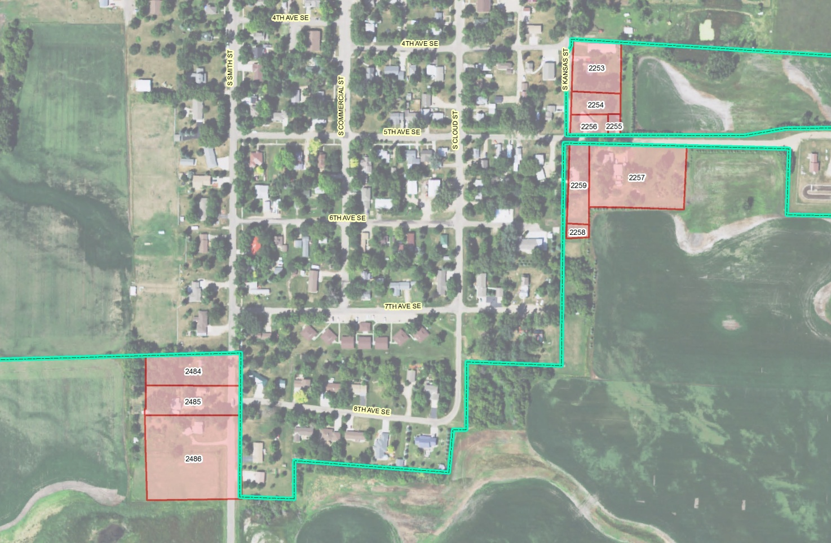

Sub-Area A1

Sub-Area A1 consists of three lots located in Section 12 of the Northeast Quarter Section in Lincoln Township. The properties are adjacent to the western side of Summit Street and south of 7th Avenue South. There are three residences located on these lots.

Currently the City provides water and garbage service to Sub-Area A1 Parcels 2485 and 2486. Those uses pay a monthly water fee of $67.50 for $5,000 gallons or $810 per year. Monthly garbage service fees are $14.06 per container. If Sub Area-A1 was annexed into the City, and sanitary sewer (based on 5,000 gallons per month) was provided, it is expected that Sub-Area A1 would initially generate additional annual sanitary sewer revenues of $936. The estimated cost of providing sanitary sewer service to Sub-Area A1 lots not currently served would be approximately $52,300

The 2016 assessed taxable valuation of Sub-Area A1 was $85,551. The total tax levy (based on 2015 tax levies) for each individual parcel with Sub-area A1 is dependent upon the property class and ranges between $12.347 and $17.889, outside of city limits ($26.067 and $31.609 inside city limits) per $1,000 of valuation. The present property taxes collected in Area A are $1,089. If Sub-Area A1 was annexed into the City, projected property taxes for Sub-Area A1 would be $2,263, a combined increase of $1,174. The City could anticipate receiving $1,209 in property taxes from Sub-Area A1.

Figure 3 – Sub-Area A1 Map

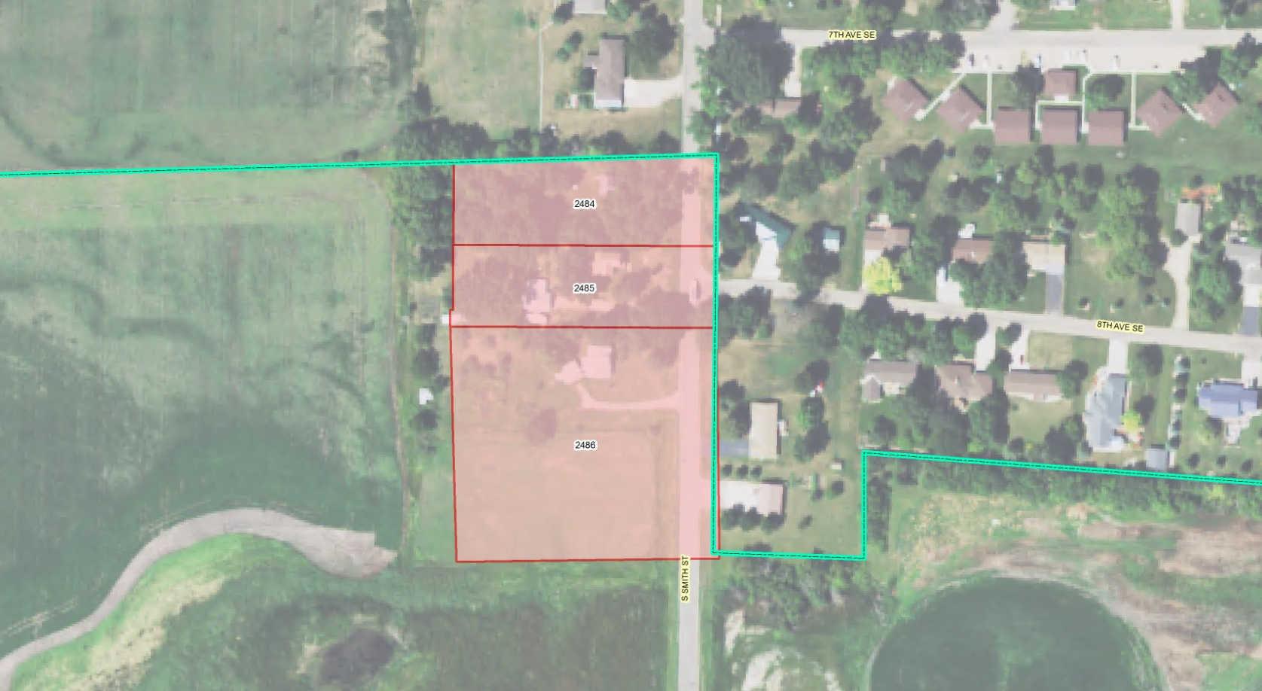
Sub-Area A2

Sub-Area A2 consists of four lots located in Section 7 of the Northwest Quarter Section in Day Township. The properties are adjacent to the eastern side of Kansas Street and south of 4th Avenue South. There are two lots with residences, one vacant lot and one lot with a garage.

Currently the City provides water, sewer, and garbage service to Sub-Area A2 Parcels 2453 and 2256. Those uses pay a monthly water fee of $67.50 for $5,000 gallons or $810 per year and a monthly sewer fee of $42 for $5,000 gallons or $504 per year. Monthly garbage service fees are $14.06 per container. If Sub-Area A3 was annexed into the City, with water and sanitary sewer service (based on 5,000 gallons per month) provided, it is expected that Sub-Area A3 would initially experience an annual loss of water and sanitary sewer revenues of $1,152.

The 2016 assessed taxable valuation of Sub-Area A2 was $207,126. The total tax levy (based on 2015 tax levies)for each individual parcel with Sub-area A2 is dependent upon the property class and ranges between $12.325 and $17.867, outside of city limits ($26.067 and $31.609 inside city limits) per $1,000 of valuation. The present property taxes collected in Area A are $2,591. If Sub-Area A2 was annexed into the City, projected property taxes for Sub-Area A2 would be $5,437, a combined increase of $2,846. The City could anticipate receiving $2,927 in property taxes from Sub-Area A2.

Figure 4 – Sub-Area A2 Map

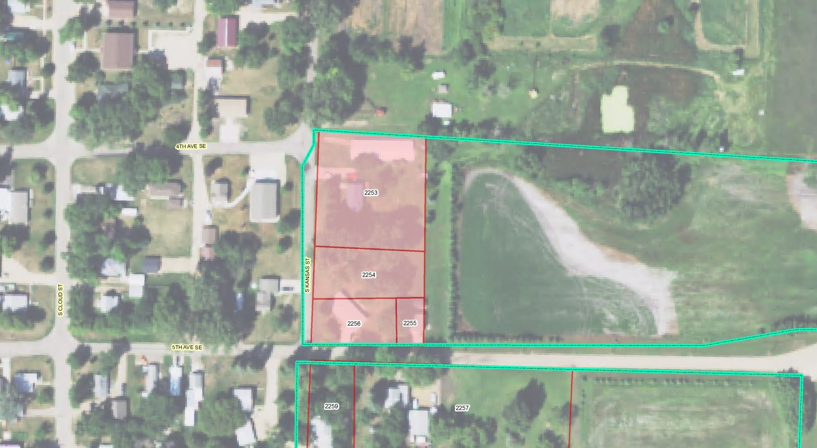

Sub-Area A3

Sub-Area A3 consists of three lots located in Section 7 of the Northwest Quarter Section in Day Township. The properties are adjacent to the eastern side of Kansas Street and south of 5th Avenue. There are two lots with residences and one vacant lot.

Currently the City provides water, sewer, and garbage service to Sub-Area A3 Parcels 2257, 2258, and 2259. Those uses pay a monthly water fee of $67.50 for $5,000 gallons or $810 per year and a monthly sewer fee of $42 for $5,000 gallons or $504 per year. Monthly garbage service fees are $14.06 per container. If Sub-Area A3 was annexed into the City, with water and sanitary sewer service (based on 5,000 gallons per month) provided, it is expected that Sub-Area A3 would initially experience an annual loss of water and sanitary sewer revenues of $1,152.

The 2016 assessed taxable valuation of Sub-Area A3 was $90,472. The total tax levy (based on 2015 tax levies)for each individual parcel with Sub-Area A3 is $12.325, outside of city limits ($26.067 inside city limits) per $1,000 of valuation. The present property taxes collected in Area A3 are $1,115. If Sub-Area A3 was annexed into the City, projected property taxes for Sub-Area A3 would be $2,358, a combined increase of $1,243. The City could anticipate receiving $1,278 in property taxes from Sub-Area A3.

Figure 5 – Sub-Area A3 Map

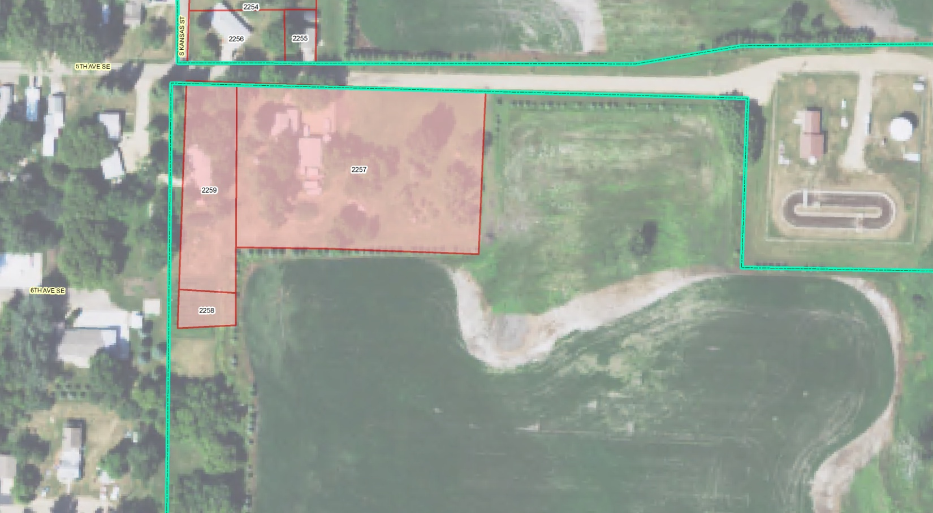
Area B

Area B consists of two sub-areas containing sixteen parcels.

If Area B was annexed into the City, Water and sanitary sewer would need to be provided to Sub-Areas B1 and B2. The estimated cost of providing sanitary sewer service to Sub-Area B1 and B2 lots not currently served would be approximately $320,000. It is expected that Area B would initially generate annual water and sanitary sewer user fee gains of $3,318, and could potentially see an additional long term annual water and sewer fee gain of $2,952.

The 2016 taxable valuation of Area A is $383,149. If Area B was annexed into the City, the City could anticipate receiving $15,327 in property taxes from Area B.

Figure 6 – Study Area B Map

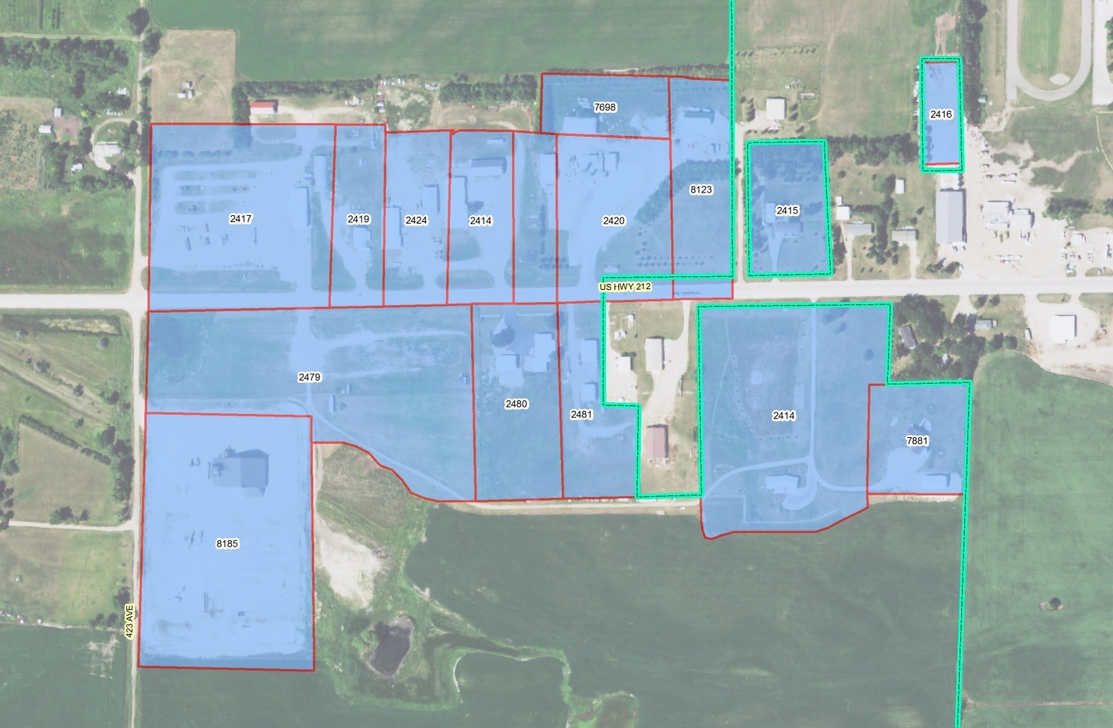

Sub-Area B1

Sub-Area B1 consists of eleven lots located in the Southeast Quarter of Section 1 in Lincoln Township. The properties are adjacent to the north side of U.S. Highway 212. There are six commercial/industrial uses, one residential/home occupation use and one vacant use located on these lots.

Currently the City provides water service to five of the parcels (2414, 2419, 2420, 2424) and garbage service to one of the parcels (2415). Those uses pay a monthly water fee of $67.50 for $5,000 gallons or $810 per year. Monthly garbage service fees are $14.06 per container. If Sub Area-B1 was annexed into the City, with water and sanitary sewer service (based on 5,000 gallons per month) provided, it is expected that Sub-Area B1 would initially generate additional annual water and sanitary sewer revenues of $2,298. However the City would experience a loss in annual water revenues of $1,920. Thus resulting in a net gain in water and sewer fees of $378.

The 2016 assessed taxable valuation of Sub-Area B1 was $454,283. The total tax levy (based on 2015 tax levies) for each individual parcel with Sub-area B1 is dependent upon the property class and ranges between $4.641 and $17.889, outside of city limits ($18.361 and $31.609 inside city limits) per $1,000 of valuation. The present property taxes collected in Area B1 are $6,683. If Sub-Area B1 was annexed into the City, projected property taxes for Sub-Area B1 would be $12,916, a combined increase of $6,233. The City could anticipate receiving $5,399 in property taxes from Sub-Area B1.

Figure 7 – Sub-Area B1 Map

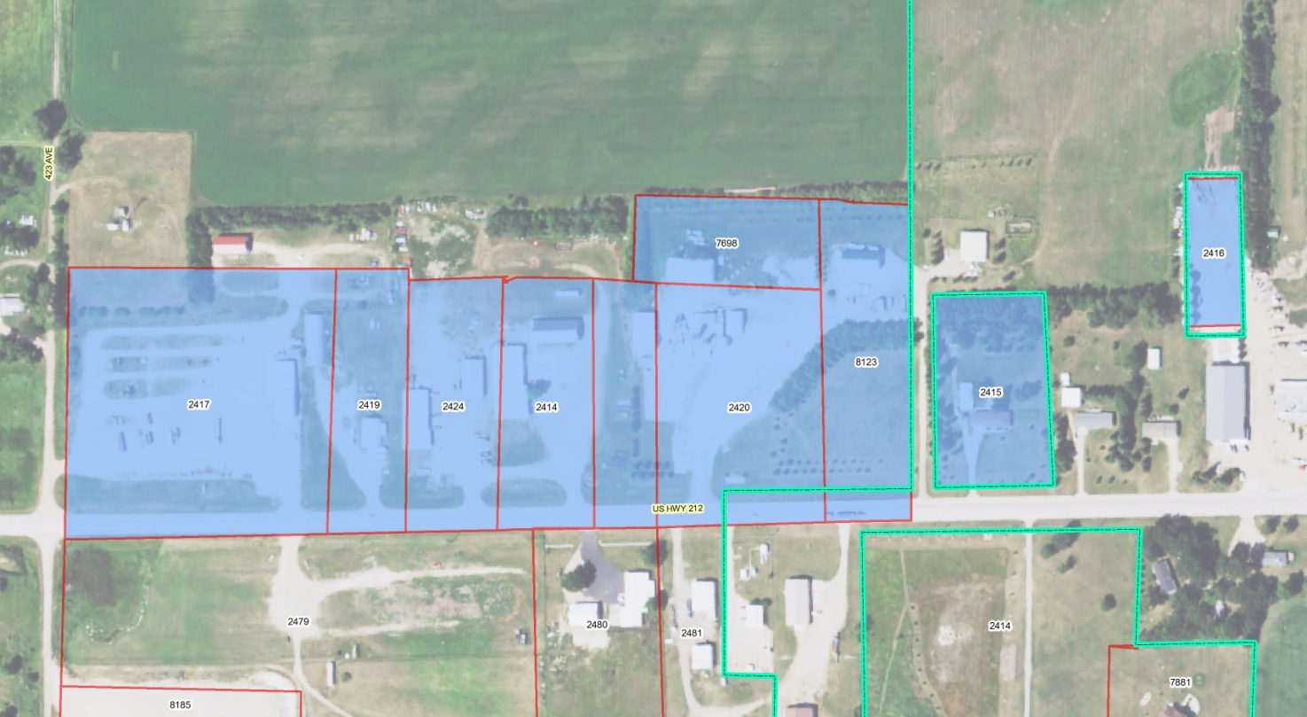

Sub-Area B2

Sub-Area B2 consists of five lots located in the Northwest Quarter of Section 12 in Lincoln Township. The properties are adjacent to the south side of U.S. Highway 212. There are three commercial/industrial uses, two residential uses and one vacant/agricultural use located on these lots.

Currently the City provides water service to Sub-Area B2 Parcels 2480. That use pays a monthly water fee of $67.50 for $5,000 gallons or $810 per year. If Sub-Area B2 was annexed into the City, and sanitary sewer (based on 5,000 gallons per month) was also provided, it is expected that Sub-Area B2 would initially generate additional annual water and sanitary sewer revenues of $1,560 and $1,380, respectively. Additionally with full development of Sub-Area B2, the City could anticipate three to four additional water and sanitary sewer users which would generate an annual additional $2,952 of water and sanitary sewer revenue (based on current fee structure).

The 2016 assessed taxable valuation of Sub-Area B2 was $702,604. The total tax levy (based on 2015 tax levies) for each individual parcel with Sub-area B2 is dependent upon the property class and ranges between $9.360 and $17.867, outside of city limits ($23.080 and $31.609 inside city limits) per $1,000 of valuation. The present property taxes collected in Area B2 are $10,520. If Sub-Area B2 was annexed into the City, projected property taxes for Sub-Area B2 would be $20,160, a combined increase of $9,640. The City could anticipate receiving $9,928 in property taxes from Sub-Area B2.

Figure 8 – Sub-Area B2 Map

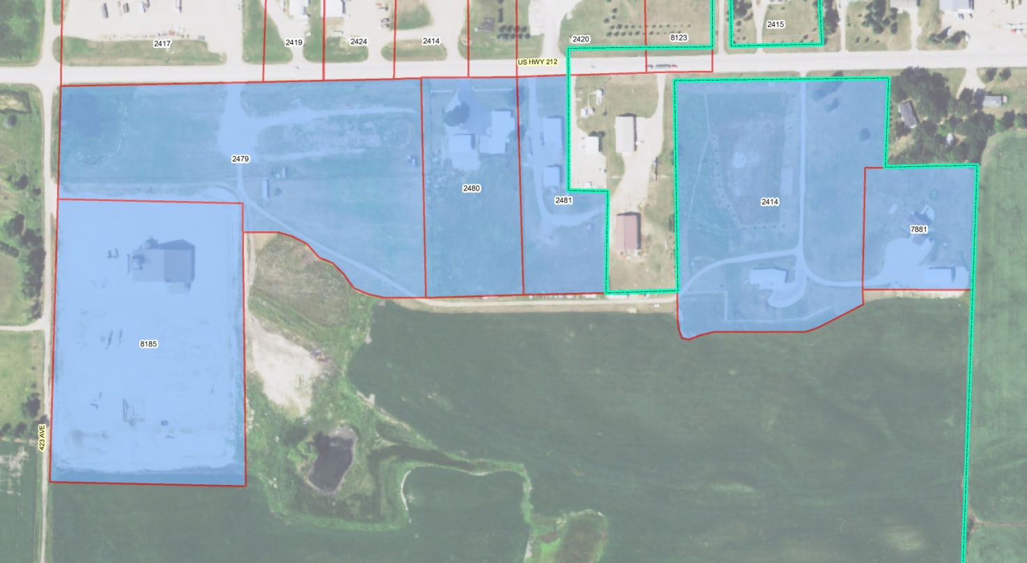

Area C

Area C consists of two sub-areas containing seventeen parcels.

If Area C was annexed into the City, Water and sanitary sewer would need to be provided to Sub-areas C1, C2 and C3. The estimated cost of providing water and sanitary sewer services to said areas not currently served would be approximately $828,800. It is expected that Area C would initially generate annual water and sanitary sewer user fees of $10,332.

The 2016 taxable valuation of Area C is $2,977,093. If Area C was annexed into the City, the City could anticipate receiving $43,047 in property taxes from Area C.

Figure 9 – Study Area C Map

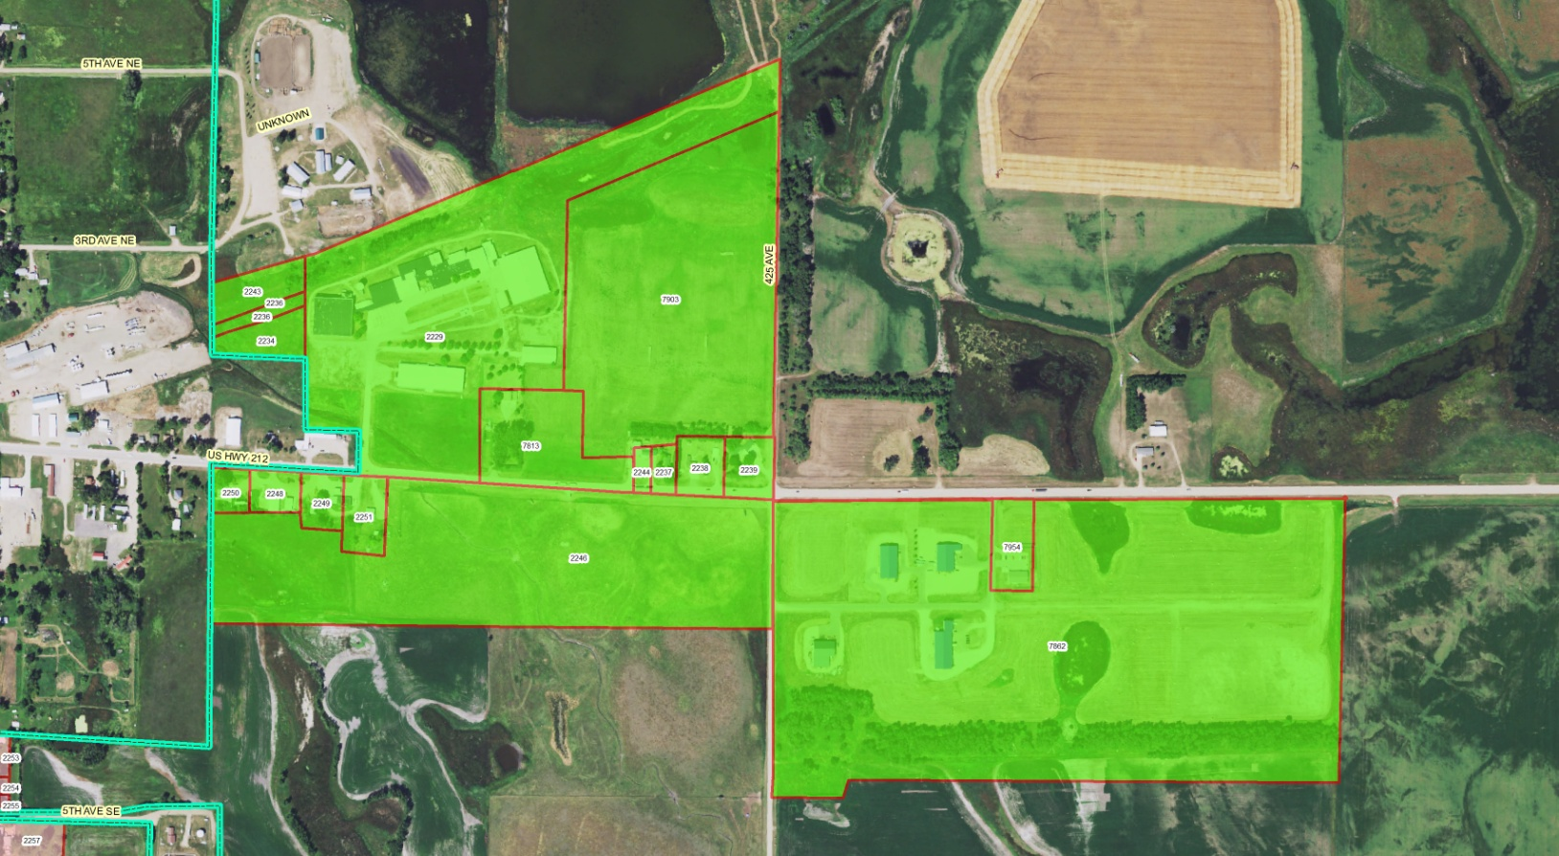

Sub-Area C1

Sub-Area C1 consists of five lots located in the Northeast Quarter of Section 7 in Day Township. The properties are adjacent to the south side of U.S. Highway 212. There are four commercial/industrial uses, one vacant/agricultural use located on these lots.

Currently the City does not provide water, sewer or garbage services to the parcels. If Sub Area-C1 was annexed into the City, with water and sanitary sewer service (based on 5,000 gallons per month) provided, it is expected that Sub-Area C1 would initially generate additional annual water and sanitary sewer revenues of $2,214.

The 2016 assessed taxable valuation of Sub-Area C1 was $151,970. The total tax levy (based on 2015 tax levies) for each individual parcel with Sub-area C1 is $17.867, outside of city limits ($31.609 inside city limits) per $1,000 of valuation. The present property taxes collected in Area Sub-Area C1 are $3,112. If Sub-Area C1 was annexed into the City, projected property taxes for Sub-Area C1 would be $5,785, a combined increase of $2,673. The City could anticipate receiving $3,128 in property taxes from Sub-Area C1.

It should be noted that a multi-million dollar commercial project is being proposed on parcels 2249 and 2251 which would increase the potential property tax received by the City. Further it is possible that the 30 acre portion of parcel 2246 could have multiple commercial/industrial development projects which would enhance utility, sales and property taxes.

Figure 10 – Sub-Area C1 Map

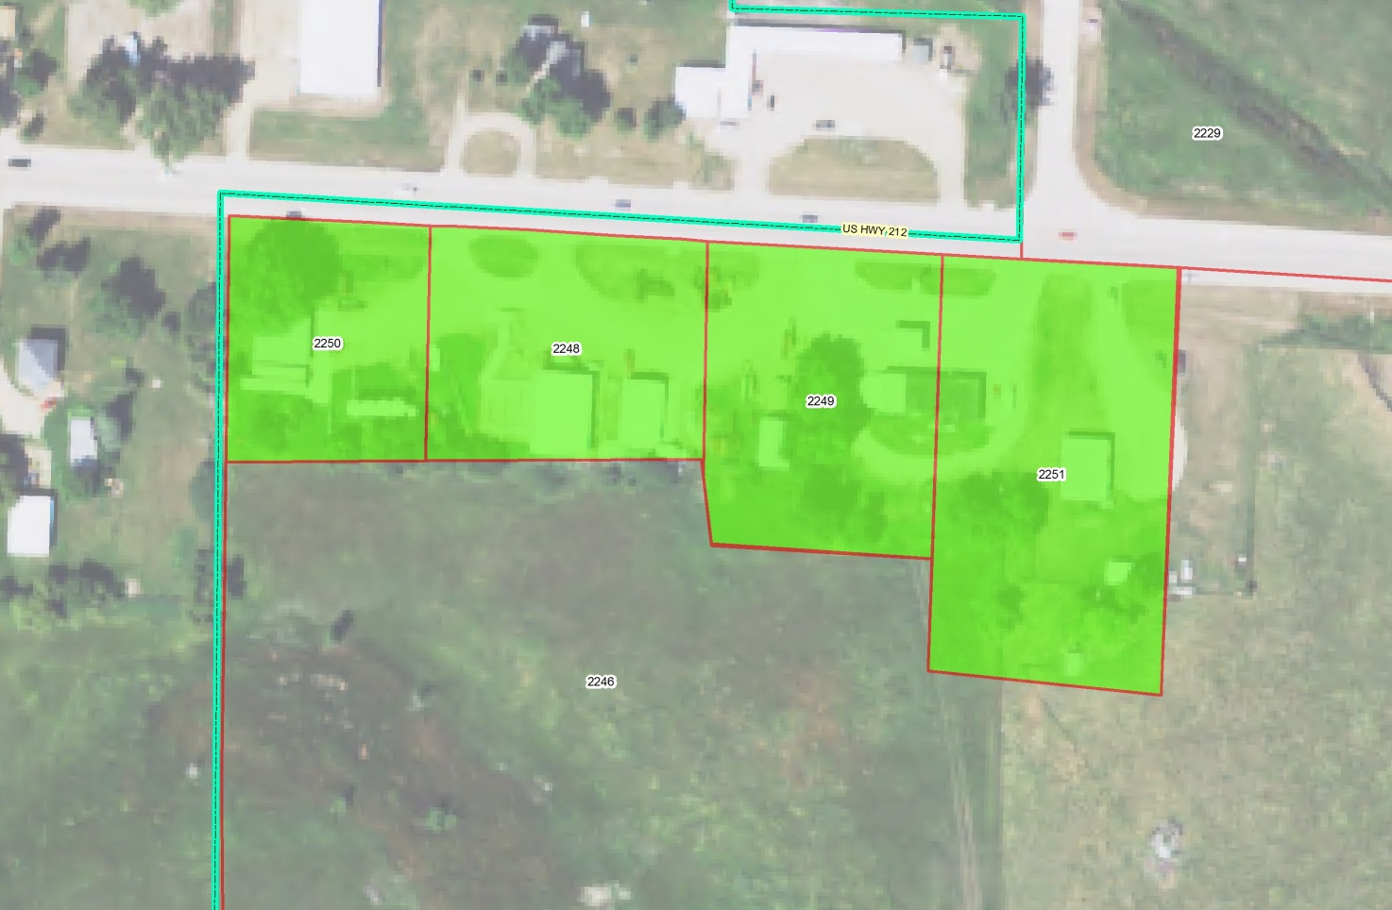
Sub-Area C2

Sub-Area C2 consists of ten lots located in the Southeast Quarter of Section 6 in Day Township. The properties are adjacent to the north side of U.S. Highway 212. There is one Industrial use, five residential uses, one home occupation and 4 vacant lots.

Currently the City does not provide water, sewer or garbage services to the parcels. If Sub-Area C2 was annexed into the City, and water/sanitary sewer services (based on 5,000 gallons per month) were provided, it is expected that Sub-Area C2 would initially generate additional annual sanitary sewer revenues of $4,428.

The 2016 assessed taxable valuation of Sub-Area C2 was $1,975,213. The total tax levy (based on 2015 tax levies) for each individual parcel with Sub-area C2 is $17.867, outside of city limits ($31.609 inside city limits) per $1,000 of valuation. The present property taxes collected in Area Sub-Area C2 are $34,056. If Sub-Area C1 was annexed into the City, projected property taxes for Sub-Area C2 would be $61,199, a combined increase of $27,143. The City could anticipate receiving $27,910 in property taxes from Sub-Area C2.

Figure 11 – Sub-Area C2 Map

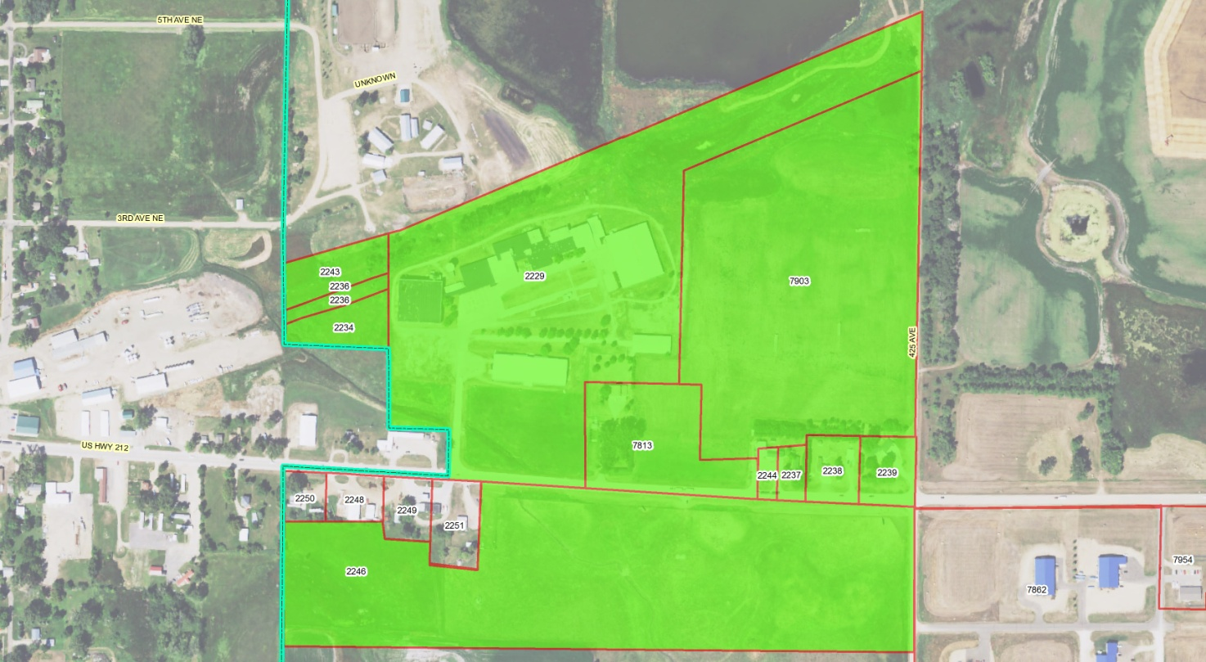

Sub-Area C3

Sub-Area C3 consists of two lots located in the Northwest Quarter of Section 8 in Day Township. The properties are adjacent to the south side of U.S. Highway 212. There are five commercial/industrial uses and a large of development land within the Clark Industrial Park.

Currently the City does not provide water, sewer or garbage services to the parcels. If Sub-Area C1 was annexed into the City, and water/sanitary sewer services (based on 5,000 gallons per month) were provided, it is expected that Sub-Area C3 would initially generate additional annual sanitary sewer revenues of $3,690. With additional development of the industrial park (where there are existing roads), the City could anticipate three to four additional water and sanitary sewer users which would generate an annual additional $2,952 of water and sanitary sewer revenue (based on current fee structure). However, It should be noted that water, sewer, and street improvement costs within the existing developed portions of the park alone are estimated to be approximately $415,000.

The 2016 assessed taxable valuation of Sub-Area C3 was $849,910. The total tax levy (based on 2015 tax levies) for each individual parcel with Sub-area C3 is $17.867, outside of city limits ($31.609 inside city limits) per $1,000 of valuation. The present property taxes collected in Area Sub-Area C3 are $15,185. If Sub-Area C1 was annexed into the City, projected property taxes for Sub-Area C3 would be $26,865, a combined increase of $11,680. The City could anticipate receiving $12,009 in property taxes from Sub-Area C3.

Figure 12 – Sub-Area C3 Map
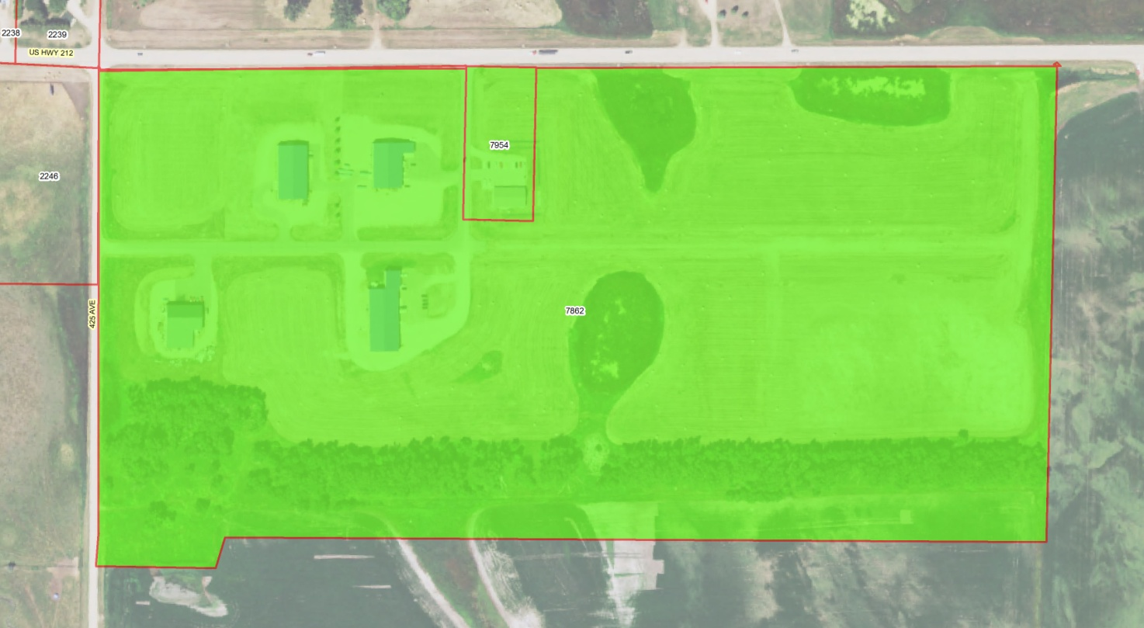

Tax Impacts on Other Jurisdictions

The increases in revenue the City of Clark can expect as a result of annexation come from two primary sources: general property tax and general sales tax.

General Property Taxation and Revenue

The annexation of the proposed areas will have either a minimal or zero effect on tax revenues generated for specific entities. Neither the Clark School District nor Clark County will be impacted from a tax revenue standpoint. However, Day and Lincoln Townships will lose $1,788 and $509 in tax revenues, respectively.

The proposed annexation will result in additional property tax revenues for the City, projected at $63,787 based on 2016 property valuations. (See Appendix)

The following information is included in the Appendix:

- Names of owners of taxable parcels, which would be annexed
- Acreage of parcels, their classifications, and most recent valuations
- Property tax levies School District, County, Township, School Bond, and City
- Total property tax levies for property within and outside city limits of Clark.
- Projected annual property taxes for property within and outside city limits of Clark.

Sales Tax Revenues

The City has a two cent sales tax. There are eight businesses in the study area B which would be impacted by annexation. They include:
- New Dimensions LLC - 1103 1st Ave W, Clark SD 57225
- Clark Concrete Products - 1032 1st Ave W, Clark SD 57225
- Cross Country Veterinarians- 1121 1st Ave W, Clark SD 57225
- 212 Truck and Trailer Repair- 1318 1st Ave W, Clark SD 57225
- JBs Repair- 1212 1st Ave W, Clark SD 57225
- Gruenwald Electric- 1234 1st Ave W, Clark SD 57225
- SciDogz LLc
- Clark County Farmers Elevator Building (Ferilizer Plant)
There are eight businesses in the study area C which would be impacted by annexation. They include:

- Greenfield’s Short Stop – 431 1st Ave E, Clark, SD 57225
- Clark Veterinary Services - 715 1st Ave E, Clark, SD 57225
- Colorado Naturals Natures Deli – 814 1st Ave E, Clark SD 57225
- P4 – 103 Industrial Dr, Clark, SD 57225
- Duralite Trailers - 100 Warren Dr, Clark, SD 57225
- Dakota Style – 211 Industrial Dr, Clark SD 57225
- Agri-products - 204 Industrial Dr, Clark SD 57225
- USDA Service Center – 101 Warren Road Clark SD 57225
According to the South Dakota Department of Revenue, (SDDOR) “based on a 3-year average (2013-2015), the estimated amount of annual tax at 2% from the businesses in Study Area B and C, combined would be would be $16,300 and $1,750, respectively.

Utility Revenues

As described above, with annexation it is estimated that the City could experience additional annual water and sanitary sewer revenues of $17,354.

Table 6 provides a summary of potential tax and utility revenue as well as estimated water and sanitary sewer improvement costs based upon each individual study area.

Table 6
Potential Annual Revenue and Sanitary Sewer Expense

Area | Property Tax | Water and Sanitary Sewer Revenue | Subtotal | Sales Tax* | Adjusted Annual  Total | Sanitary Sewer Improvement Costs**
Area A | $ 5,414 | ($1,368) | $ 4,046 | --- |  | $ 52,000
Area B | $15,327 | $ 3,318 | $18,645 | $16,300 |  | $ 320,000
Area C | $43,047 | $10,332 | $53,379 | $ 1,750 |  | $ 828,800
Total | $63,788 | $12,282 | $76,070 | $18,050 | $94,120 | $1,200,000

* Sales tax information derived South Dakota Department of Revenue based upon taxes paid between 2013 and 2015 by13 existing businesses in proposed annexation study area.

**Sanitary Sewer Improvement costs were based upon an estimated cost of $26,500 per 400 feet of sanitary sewer, manholes and other appurtenances. It does not include any assumptions regarding the need for potential lift stations.

Water Improvement costs were based upon an estimated cost of $22,000 per 400 feet of 6 inch main, 1 fire hydrant, valves, service lines, curb stops, and other appurtenances

Asphalt surface restoration costs were based upon an estimated cost of $30,000 per 400 feet of new or additional base course, 3 inches of asphalt concrete to restore area with both water and sewer construction. (This is not a price for new street construction, only to restore street after utility construction)
Section 5. Conclusions and Recommendations

Similar to many of the communities in South Dakota and neighboring states, the City of Clark has recognized the need to analyze the impacts of future growth. The following conclusions and recommendations are based on the analysis detailed in this report.

- Clark has proceeded with this annexation study because of the uncontrolled growth and development along the fringe areas of the City which has and will continue to impact the long-range development of the City.

- Job growth and commercial/industrial development are key to population growth and financial health of the City.

- The City is pursuing new commercial/industrial development which could result in more and higher paying jobs.

- The City’s projected growth rate can reasonably be expected to occur, with population growth from 1,142 persons in 2010 to 1,300 persons by the year 2030. The City will continue to aggressively pursue new commercial and industrial development in the City to promote economic development and job growth.

- There appears to be sufficient residential land within the current City limits to accommodate half of the projected population growth, based on historic trend rates, through at least the year 2030.

- There is currently a shortage of available land zoned for commercial uses and within ten years, there may be a shortage of available land zoned for industrial uses within the City limits, depending on the amount of new development.

- Ideally, cities should annex territory in advance of development so that city regulations can be used to ensure the types and standards of development that the city desires.

- For the City, annexation represents costs of providing additional services, as well as additional revenues from taxes and fees. The question is one of balancing the costs and revenues at worst, or realizing a net increase in revenues at best.

- For individual homeowners within the City limits, annexation represents little or no economic or social change, as long as it occurs in conjunction with citizen input and based on a fair assessment of the benefits and costs.

- For individual homeowners and business owners in the County (outside the City limits), annexation raises issues of (possibly undesired) urbanization of their chosen “rural” lifestyle, increases in their property and sales taxes, and the potential benefits of additional City services.

- Generally, annexation of commercial and industrial land has a higher benefit/cost ratio than residential land, due to the higher tax revenue/economic benefit and lower cost of City services required.

- The City should consider ways to provide sanitary sewer and eliminate the potential environmental impacts associated with current septic systems.

- The challenge for Clark will be the ongoing planning and redevelopment efforts to ensure evolution of the community in the most orderly and advantageous manner, to achieve the type, size and scale of community most desired by the residents and supported by policy decisions.

- Potential annexations should be evaluated in terms of the following criteria: net annual revenue gain/loss; ownership; contiguity with City limits; infrastructure which meets City standards; ease of utility extensions; homeowner cost impact; and general desirability.

- If areas identified in this study are to be annexed, the City will need to identify the cost and timeline for the provision of sanitary sewer services.

- It is generally accepted that the easiest way to address annexation is when residential and commercial areas are annexed at the owner’s request, after infrastructure has been upgraded to City Standards. While it is difficult to specify the appropriate time for a city to initiate annexation, the most common reasons for annexation relate to: The need for additional developable land; or development occurring in the fringe area outside of city boundaries which is impacting the community’s growth; or to preserve land from the potential ill-effects of future development.

- In the case of Clark, there are several reasons for the annexation of the property detailed in this report.

  - Many of the proposed areas to be annexed have for many years been, functionally, a part of the City. Residents and businesses outside of the City have benefitted from the provision of city services i.e., water, sanitary sewer, police protection and access to city facilities such as streets, parks, and libraries.

  - Annexation would ensure future development could be properly managed and conducted in a fashion which would enhance the development of the City.

  - Annexation would provide for regular and non-arbitrary boundaries.

  - Annexation would provide additional annual property and sales tax revenue for the City - $63,788 and $18,050, respectively.

  - Annexation would provide additional annual water and sanitary sewer user revenue for the City - $12,282.
- In terms of the potential areas of annexation, Area A and Sub-areas B1 (parcels 2414, 2415, 2416, 2419, 2420, 2424, 8014, 8123), B2 (parcels 2480, 2481, 7881 and portion of 2479 with residence), C1 (parcels 2248, 2249, 2250, 2251), and C2 (parcel 2229) likely represent the best annexation opportunities for the City based on current conditions.

- The City of Clark can use the information developed in this report to assess the specific merits of annexing these areas or smaller sub-areas as the need arises in the future. The City may wish to consider re-evaluating the potential annexation areas on an annual basis. If the evaluation indicate that it would be in the best interest of the community for specific areas to be annexed prior to development or prior to property owner petition, then a city-initiated annexation may be appropriate. Such city-initiated annexations may assist the City in extending utilities and streets in a more cost efficient and orderly manner, and to ensure appropriate growth patterns for the community.
Appendix

Proposed Timeline to Annex Property

Projected Taxes on Property to Be Annexed

City of Clark Existing Land Use Map

City of Clark Future Land Use Map

Study Area A Water and Sewer Services Map

Study Area B Water and Sewer Services Map

Study Area C Water and Sewer Services Map

Proposed Timeline to Annex Property

The following timeline assumes the weekly publication falls on “Wednesday’s” and that the monthly meeting of the Clark City Council is on the first Monday of the month. (Reference SDCL 9-4)

September 13, 2016 to
September 23, 2016 Send by Certified Mail to County Commissioners and affected landowners the proposed resolution of intent to annex property and the notice of Public Hearing of the City Council Regarding the Adoption of the Resolution of intent to annex prescribed property (Not less than 10 and not more than 20 days prior to public hearing).

September 21, 2016 Publication of Notice of Public Hearing of the City Council regarding the Adoption of a Resolution of intent to annex prescribed property.

October 3, 2016 City Council: Public Hearing and Adoption of Resolution of Intent to Annex specified property. If approved continue with the following timeline – Public Hearing on formal Annexation has to occur within 60 days of the adoption of the Resolution of Intent to Annex

October 12, 2016 Publish Minutes including resolution of intent

October 29, 2016 to
November 8, 2016 Send by Certified Mail to County Commissioners and affected landowners copy of approved Resolution of Intent to Annex adopted on October 3, 2016 and notice of Joint Public Hearing of the Planning Commission and City Council Regarding the Adoption of a Resolution Annexing prescribed property (ies) and affixing Zoning Designation(s) to specified property (ies).

November 23, 2014 Publication of Notice of Joint Public Hearing of the Planning Commission and City Council Regarding the Adoption of a Resolution Annexing prescribed property and affixing Zoning Designation(s) to specified property (ies)

November 28, 2016
(Special Meeting) Joint Public Hearing of the Planning Commission and City Council Regarding the Adoption of Resolution Annexing prescribed Property and affixing Zoning Designation(s) to specified property (ies).
-Plan Commission: Recommendation of approval of Annexation
-Plan Commission: Recommendation of approval of Zoning Designations
-City Council: Announce that the Resolution of Annexation will be considered at the January 2, 2017 meeting of the City Council
-City Council: 1st Reading of Ordinance affixing Zoning Designation to property.

January 2, 2017 -City Council: Adoption of Resolution Annexing prescribed Property
-City Council: 2nd Reading of Ordinance affixing zoning designation to property

January 10, 2017 -Publication of Resolution of Annexation in newspaper
-Publication of Notice of adoption of zoning amendment (assigning zoning designations).

(Less than 20 days after
Publication of resolution)
January 30, 2017 Last date by which petition referring Resolution of Annexation to vote of the people may be filed (assuming publication date of January 10, 2017)

(Less than 10 days
After receipt of petition)
March 1, 2017 Last date for City Council to set date for special election (assuming petition received on January 30, 2017)

February 28, 2017 to
March 31, 2017 Referred Annexation Election for City of Clark to occur in this time frame (assuming petition received on January 30, 2017)

(send with first letter to affected property owners and County Commissioners)

RESOLUTION ________
RESOLUTION OF INTENT TO ANNEX LAND TO THE
CITY OF CLARK, SOUTH DAKOTA

WHEREAS, SDCL 9-4 authorizes municipalities the ability to annex contiguous land, and

WHEREAS, under SDCL 9-4-4.1 the City of Clark, has conducted an Annexation Study to determine the need for the contiguous territory and to identify the resources necessary to extend the municipal boundaries; and

WHEREAS, as prescribed in SDCL 9-4-4.2 the Annexation Study has determined that:

- Ample and suitable resources exist to accommodate the orderly growth or development of the contiguous territory;
- Municipal utilities and a major street network are currently in place within the proposed boundary extension; or A major street network is currently in place but municipal utilities will need to be constructed within the proposed boundary extension
- There is no cost to extend utility services to the residents of the contiguous territory and the municipality; or There will be a hook up fee assessed to residents of the contiguous territory to assist in defraying the cost to extend utility services.
- The estimated difference in tax assessment rate for the residents in the contiguous territory to be annexed is 13.248 to 13.720 mils. 2015 tax assessment rate outside of Clark City Limits 4.641 to 17.889 mils, inside Clark City Limits 18.361 to 31.609 mils;
- Exclusions and irregularities in boundary lines are not the result of arbitrariness;
- There is reasonable present or demonstrable future need for annexing the contiguous territory; and
- Population and census data indicate that the municipality has or may experience growth or development beyond its present boundaries.

WHEREAS, said annexation would be in the best interest of the City of Clark and the inhabitants of the area to be annexed, and

WHEREAS, copies of the resolution of intent with a notice of time and place of the public hearing were forwarded by certified mail to the affected landowners and the county auditor as provided SDCL 9-4-4.3;

WHEREAS, The City of Clark City Council held a public hearing on October 3, 2016;

NOW, THEREFORE, BE IT RESOLVED BY THE CITY COUNCIL OF THE CITY OF CLARK, SOUTH DAKOTA, AS FOLLOWS:

- INTENTION TO ANNEX: Pursuant to SDCL 9-4, the City Council hereby expresses its intent to annex land contiguous to the City of Clark described as follows:

- Legal Descriptions to be annexed

(Mail this letter between September 13, 2016 and September 23, 2016)

Letter to Property Owners:

Dear _______;

As owner of property described as ______________________ and in conformance with South Dakota Codified Law 9-4-4.3, you are being notified that the City Council of the City of Clark City will be holding a public hearing on October 3, 2016 to consider a resolution of intent to annex your above described property into the City of Clark.

An Annexation Study as required by SDCL 9-4-4.2, has been prepared and is on file with the City Finance Officer. Said report shall be available to the public at the office of the City Finance Officer during normal business hours.

The public hearing on the proposed resolution of intent to annex has been scheduled for October 3, 2016 at _____p.m. in the Clark City Hall, located at 120 N. Commercial Street, Clark, SD. The City Council may approve the Resolution with or without amendment.

Sincerely,

Larry Dreher
Mayor

Attachment: Resolution of Intent to Annex
(Mail this letter between September 13, 2016 and September 23, 2016

Letter to County Auditor:

Dear _______;

As provided in South Dakota Codified Law 9-4-4.3, the Clark County Board of County Commissioners are being notified that the City Council of the City of Clark City will be holding a public hearing on October 3, 2016 to consider a resolution of intent to annex the following properties into the City of Clark.

- Legal Descriptions to be annexed

An Annexation Study as required by SDCL 9-4-4.2, has been prepared and is on file with the City Finance Officer. Said report shall be available to the public at the office of the City Finance Officer during normal business hours.

The public hearing on the proposed resolution of intent to annex has been scheduled for October 3, 2016 at _____p.m. in the Clark City Hall, located at 120 N. Commercial Street, Clark, SD. The City Council may approve the Resolution with or without amendment.

Sincerely,

Larry Dreher
Mayor

Attachment: Resolution of Intent to Annex

Notice to be published September 21, 2016

NOTICE OF PUBLIC HEARING OF THE CLARK CITY COUNCIL REGARDING THE RESOLUTION OF INTENT TO ANNEX REAL PROPERTY INTO THE CITYOF CLARK

Notice is hereby given that on October 3, 2016 at TIME o'clock in the City Hall in the City of Clark, South Dakota, is the time and place when and where all persons interested therein may appear and be heard before the City Council concerning the proposed Resolution of Intent to annex the following real property described as:

- Legal Descriptions to be annexed

Any persons wishing to present testimony may appear at said hearing or may file written comments with the Finance Officer at 120 N. Commercial Street, Clark, SD prior to said hearing.

Published once at a cost of ______

(Mail this letter between October 29, 2016 to November 8, 2016)

Letter to Property Owners:

Dear _______;

As owner of property described as ______________________ and in conformance with South Dakota Codified Law 9-4-4.4, you are being notified that the City Council of the City of Clear on October 3, 2016 adopted a Resolution of Intent to annex your property into the City of Clark.

Further, the City of Clark will now be holding a public hearing on November 28, 2016 to consider a resolution to annex your above described property into the City of Clark.

An Annexation Study as required by SDCL 9-4-4.2, has been prepared and is on file with the City Finance Officer. Said report shall be available to the public at the office of the City Finance Officer during normal business hours.

The public hearing on the proposed resolution of intent to annex has been scheduled for November 28, 2016 at _____p.m. in the Clark City Hall, located at 120 N. Commercial Street, Clark, SD. The City Council may approve the Resolution to annex your property with or without amendment.

Sincerely,

Larry Dreher
Mayor

Attachment: Adopted Resolution of Intent to Annex
(Mail this letter between October 29, 2016 to November 8, 2016)

Letter to County Auditor:

Dear _______;

As provided in South Dakota Codified Law 9-4-4.3, the Clark County Board of County Commissioners are being notified that the City Council of the City of Clear on October 3, 2016 adopted a Resolution of Intent to annex the following described real property into the City of Clark.

- Legal Descriptions to be annexed

Further, the City of Clark will now be holding a public hearing on November 28, 2016 to formally consider a resolution to annex the above described property into the City of Clark.

An Annexation Study as required by SDCL 9-4-4.2, has been prepared and is on file with the City Finance Officer. Said report shall be available to the public at the office of the City Finance Officer during normal business hours.

The public hearing on the proposed resolution of intent to annex has been scheduled for November 28, 2016 at _____p.m. in the Clark City Hall, located at 120 N. Commercial Street, Clark, SD. The City Council may approve the Resolution with or without amendment.

Sincerely,

Larry Dreher
Mayor

Attachment: Adopted Resolution of Intent to Annex

Notice to be published November 23, 2016

NOTICE OF JOINT PUBLIC HEARING OF THE CLARK PLANNING COMMISSION AND CLARK CITY COUNCIL REGARDING THE RESOLUTION TO ANNEX REAL PROPERTY INTO THE CITY OF CLARK AND ASSINGN ZONING DESIGNATIONS

Notice is hereby given that on November 28, 2016, at TIME o'clock in the City Hall in the City of Clark, South Dakota, is the time and place when and where all persons interested therein may appear and be heard before the Planning and Zoning Commission and City Council concerning the proposed annexation and zoning the real property described as:

- Legal description to be annexed

The Planning and Zoning Commission will submit to the City Council their recommendation as to whether or not recommend annexation, and whether the associated ordinance amending zoning district boundaries should be passed by the City Council. Following recommendation by the Planning and Zoning Commission, the City Council will have the first reading of Ordinance [new ordinance number] which establishes zoning designations as described above and set January 2, 2017 as the time and date for the 2nd reading of the proposed ordinance. On January 2, 2017 the City Council may refuse or adopt Resolution [resolution to annex property] to annex the above described real property and Ordinance [new ordinance number] with or without amendment. The proposed ordinance will be made available for public inspection at the Clark City Hall during regular business hours. Any persons wishing to present testimony may appear at said hearing or may file written comments with the Finance Officer at 120 N. Commercial Street prior to said hearing. (Pursuant to Section 11-6-17, 11-6-24, and 11-6-27 SDCL and amendments thereto)

Published once at a cost of ______

Resolution of Annexation (to be adopted on January 2, 2017)

Notice of Hearing
Date of Hearing
Date Adopted
Date Published
Date Effective

RESOLUTION NO. ______

A RESOLUTION OF ANNEXATION INCLUDING CERTAIN CONTIGUOUS TERRITORY WITHIN THE CORPORATE LIMITS OF THE CITY OF CLARK, CLARK COUNTY, SOUTH DAKOTA.

WHEREAS, there has been a Resolution of Intent to Extend the Boundaries approved by the City Council as required by SDCL 9-4-4.2 and 9-4-4.3.

WHEREAS, a public hearing has been held to provide public testimony to the Resolution of Annexation as required by SDCL 9-4-4.4.

WHEREAS, a copy of the adopted resolution of intent and a notice of public hearing giving the time and place of the public hearing on the resolution of annexation was forwarded by certified mail to the Minnehaha County Commissioners and the affected landowners.

NOW, THEREFORE, BE IT RESOLVED BY THE CITY OF CLARK, SD:

That the following described properties be and the same hereby are included within the corporate limits of the City of Clark, and the boundary of the City is hereby extended to include such territory as allowed by SDCL 9-4-4.4.

- Legal descriptions to be annexed

Date adopted: .

Mayor

ATTEST:

City Finance Officer

Zoning Ordinance Amendment (to be adopted on January 2, 2017)

Ordinance ______

AN ORDINANCE ENTITLED, AN ORDINANCE TO AMEND SECTION 1.03.01 OF (zoning ordinance number), AN ORDINANCE ESTABLISHING ZONING REGULATIONS FOR THE CITY OF CLARK, SOUTH DAKOTA, AND PROVIDING FOR THE ADMINISTRATION, ENFORCEMENT, AND AMENDMENT THEREOF, IN ACCORDANCE WITH THE PROVISIONS OF CHAPTERS 11-4 AND 11-6, 1967 SDCL, AND AMENDMENTS THEREOF, AND FOR THE REPEAL OF ALL ORDINANCES IN CONFLICT HEREWITH.

Be it ordained by the City Council of the City of Clark, South Dakota:

That Section 1.03.01 adopted by (adoption date of zoning ordinance), as amended, of the Zoning Ordinance of the City of Clark be amended to classify the following legally described property to be zoned (zoning district):
- Legal descriptions to be rezoned

Passed and adopted this 2nd day of January 2017.

__________________ __________________
Mayor Finance Officer

Notice to be published on January 11, 2017

NOTICE OF ADOPTION

ORDINANCE NO. _____

ORDINANCE ____, AN ORDINANCE AMENDING (Zoning ordinance number) AN ORDINANCE ESTABLISHING ZONING REGULATIONS FOR THE CITY OF CLARK, SOUTH DAKOTA, AND PROVIDING FOR THE ADMINISTRATION, ENFORCEMENT, AND AMENDMENT THEREOF, IN ACCORDANCE WITH THE PROVISIONS OF CHAPTERS 11-4 AND 11-6, 1967 SDCL, AND AMENDMENTS THEREOF, AND FOR THE REPEAL OF ALL ORDINANCES IN CONFLICT HEREWITH.

Notice is hereby given that Ordinance No. ___, an ordinance amending (Zoning ordinance number), an ordinance establishing zoning regulations for the City of Clark, South Dakota, and providing for the administration, enforcement, and amendment thereof, in accordance with the provisions of chapters 11-4 and 11-6 1967 SDCL, and amendments thereof, and for the repeal of all ordinances in conflict herewith, was duly adopted, as amended, by the City Council on the 2nd day of January 2017, and will become effective on the 1st day of February 2017.
Ordinance ______

AN ORDINANCE ENTITLED, AN ORDINANCE TO AMEND SECTION 1.03.01 (Original zoning ordinance) AN ORDINANCE ESTABLISHING ZONING REGULATIONS FOR THE CITY OF CLARK, SOUTH DAKOTA, AND PROVIDING FOR THE ADMINISTRATION, ENFORCEMENT, AND AMENDMENT THEREOF, IN ACCORDANCE WITH THE PROVISIONS OF CHAPTERS 11-4 AND 11-6, 1967 SDCL, AND AMENDMENTS THEREOF, AND FOR THE REPEAL OF ALL ORDINANCES IN CONFLICT HEREWITH.

Be it ordained by the City Council of the City of Clark, South Dakota:

That Section 1.03.01 adopted by (Original zoning ordinance) as amended, of the Zoning Ordinance of the City of Clark be amended to classify the following legally described property to be zoned Zoning District:

- Legal Description to be rezoned

Passed and adopted this 2nd day of January 2017.

__________________ __________________
Mayor Finance Officer

Projected Taxes on Property to be Annexed

Property Information |  |  |  |  |  | 2015 Total Tax Levies (per $1,000 Valuation) |  |  |  |  |  |  |  |  |  |  | Projected Taxes
Area | Owner | Record # | Legal Description | Class | 2016 Taxable Valuation | School (AG) 4.719 | School (NA OO) 7.706 | School (NA) 13.248 | County 3.692 | City Ag 24.75 | City Non AG 14.130 | City Owner (OO) 14.130 | Township 1.006 | Clark School Bond 0.539 | Outside City 4.641 to 17.889 | Inside City 18.361 to 31.609 | If outside City Limits | If in City Limits | Difference | City Share of Taxes
Sub Area A1 | Robert Carlson Trustee | 2484 | OL 69 12-116-58 | NAG | $5,958.00 | ---- | ---- | 13.248 | 3.692 | ---- | 14.130 | ---- | 0.410 | 0.539 | 17.889 | 31.609 | $106.58 | $188.33 | $81.74 | $84.19
Sub Area A1 | Tyler & Erin Snaza | 2485 | S 125' OF N 249 16/35' OF E 393' IN SE1/4 12-116- 58 | OO | $41,767.00 | ---- | 7.706 | ---- | 3.692 | ---- | ---- | 14.130 | 0.410 | 0.539 | 12.347 | 26.067 | $515.70 | $1,088.74 | $573.04 | $590.17
Sub Area A1 | Delane & Joanne Isaak | 2486 | S 125' OF N 374 16/35' OF E 393' & S 200' OF N 574 16/35' OF E 393' OF SE1/4 12-116-58 | OO | $37,826.00 | ---- | 7.706 | ---- | 3.692 | ---- | ---- | 14.130 | 0.410 | 0.539 | 12.347 | 26.067 | $467.04 | $986.01 | $518.97 | $534.48
Sub Area A2 | Jerry Bowers | 2253 | LOTS 1-2 OLSONS ADDN IN NW1/4 7-116-57 | OO | $125,037.00 | ---- | 7.706 | ---- | 3.692 |  |  | 14.130 | 0.388 | 0.539 | 12.325 | 26.067 | $1,541.08 | $3,259.34 | $1,718.26 | $1,766.77
Sub Area A2 | City of Clark | 2254 | LOT 3 OLSONS ADDN IN NW1/4 7-116-57 | ---- | $0.00 | ---- | ---- | ---- | ---- | ---- | ---- | ---- | ---- | ---- | 0.000 | 0.000 | $0.00 | $0.00 | $0.00 | $0.00
Sub Area A2 | Gerald & Dianne Olson | 2255 | EAST 36.5' OF LOT 4 OLSONS ADDN IN NW1/4 7-116-57 | NAG | $6,867.00 | ---- | ---- | 13.248 | 3.692 | ---- | 14.130 | ---- | 0.388 | 0.539 | 17.867 | 31.609 | $122.69 | $217.06 | $94.37 | $97.03
Sub Area A2 | Hanes & Janet Hurlbut | 2256 | EXCEPT THE E 36.5' OF LOT 4 OLSONS ADDN IN NW1/4 7-116-57 | OO | $75,222.00 | ---- | 7.706 | ---- | 3.692 | ---- | ---- | 14.130 | 0.388 | 0.539 | 12.325 | 26.067 | $927.11 | $1,960.81 | $1,033.70 | $1,062.89
Sub Area A3 | Dan Gehrke | 2257 | N240' OL 71 AND LOT 1 VANDERVORST'S ADDN IN SE1/4 NW1/4 7-116-57 (4J 210,4M 494) | OO | $54,019.00 | ---- | 7.706 | ---- | 3.692 | ---- | ---- | 14.130 | 0.388 | 0.539 | 12.325 | 26.067 | $665.78 | $1,408.11 | $742.33 | $763.29
Sub Area A3 | Steven Nelson | 2258 | O L 73 LESS N 286' & LESS S 340' IN NW1/4 7-116-57 | OO | $484.00 | ---- | 7.706 | ---- | 3.692 | ---- | ---- | 14.130 | 0.388 | 0.539 | 12.325 | 26.067 | $5.97 | $12.62 | $6.65 | $6.84
Sub Area A3 | Steven Nelson | 2259 | OL 72 & N 286' OF OL 73 IN NW1/4 7-116-57 | OO | $35,969.00 | ---- | 7.706 | ---- | 3.692 | ---- | ---- | 14.130 | 0.388 | 0.539 | 12.325 | 26.067 | $443.32 | $937.60 | $494.29 | $508.24
Property Information |  |  |  |  |  | 2015 Total Tax Levies (per $1,000 Valuation) |  |  |  |  |  |  |  |  |  |  | Projected Taxes
Area | Owner | Record # | Legal Description | Class | 2016 Taxable Valuation | School (AG) 4.719 | School (NA OO) 7.706 | School (NA) 13.248 | County 3.692 | City Ag 24.75 | City Non AG 14.130 | City Owner (OO) 14.130 | Township 1.006 | Clark School Bond 0.539 | Outside City 4.641 to 17.889 | Inside City 18.361 to 31.609 | If outside City Limits | If in City Limits | Difference | City Share of Taxes
Sub Area B1 | Kyle & Trudi Gaikowski (212 Truck & Trailer Repair) | 2417 | WEST 563.4' OF SOUTH 472.5' OF SW1/4 1-116-58 | NAG | $33,964 | ---- | ---- | 13.248 | 3.692 | ---- | 14.130 | ---- | 0.410 | 0.539 | 17.889 | 31.609 | $607.58 | $1,073.57 | $465.99 | $479.91
Sub Area B1 | Kyle & Trudi Gaikowski (212 Truck & Trailer Repair) | 2418 | E 473.40' OF W 773.40' OF N 224.46' OF S 696.96' OF SW1/4 1-116-58 | NAG | $17,140 | ---- | ---- | 13.248 | 3.692 | ---- | 14.130 | ---- | 0.410 | 0.539 | 17.889 | 31.609 | $306.62 | $541.78 | $235.16 | $242.19
Sub Area B1 | Wilfred & Patricia Gruenwald (Gruenwald Electric) | 2419 | E 210' OF W 773.4' OF S 472.5' IN SW1/4  1-116-58 | NAG | $27,220 | ---- | ---- | 13.248 | 3.692 | ---- | 14.130 | ---- | 0.410 | 0.539 | 17.889 | 31.609 | $486.94 | $860.40 | $373.46 | $384.62
Sub Area B1 | Justin& Jerry Bowers (JB Repairs) | 2424 | W 207' OF HOPPERS OUTLOT IN SW1/4  1-116-58 | NAG | $86,861 | ---- | ---- | 13.248 | 3.692 | ---- | 14.130 | ---- | 0.410 | 0.539 | 17.889 | 31.609 | $1,553.86 | $2,745.59 | $1,191.73 | $1,227.35
Sub Area B1 | William & Angeline Wolf | 2414 | E 293' OF HOPPERS OL LOTS H2 & H3 IN SW1/4 1-116- 58 | AG Commercial | $72,214 | ---- | ---- | ---- | 3.692 | ---- | 14.130 | ---- | 0.410 | 0.539 | 4.641 | 18.361 | $335.15 | $1,325.92 | $990.78 | $0.00
Sub Area B1 | Leo & Jeanne Werdel (Clark Concrete Products) | 2420 | E 662' OF W 1935.4' OF S 470' LESS LJ'S COUNTRY- SIDE OUTLOT 2 & LESS LOT H2 OF SW1/4 1-116-58 | NAG | $72,305 | ---- | ---- | 13.248 | 3.692 | ---- | 14.130 | ---- | 0.410 | 0.539 | 17.889 | 31.609 | $1,293.46 | $2,285.49 | $992.02 | $1,021.67
Sub Area B1 | Leo & Jeanne Werdel (Clark Concrete Products) | 8123 | LJ'S COUNTRYSIDE OUTLOTS 1 & 2 IN SW1/4 1-116-58 | NAG | $32,070 | ---- | ---- | 13.248 | 3.692 | ---- | 14.130 | ---- | 0.410 | 0.539 | 17.889 | 31.609 | $573.70 | $1,013.70 | $440.00 | $453.15
Sub Area B1 | Leo & Jeanne Werdel (Clark Concrete Products) | 7698 | N 226.96' OF E 612' OF W 1935.4' OF S 696.96' LESS LJ'S COUNTRYSIDE OL 1 OF SW1/4 | NAG | $1,800 | ---- | ---- | 13.248 | 3.692 | ---- | 14.130 | ---- | 0.410 | 0.539 | 17.889 | 31.609 | $32.20 | $56.90 | $24.70 | $25.43
Property Information |  |  |  |  |  | 2015 Total Tax Levies (per $1,000 Valuation) |  |  |  |  |  |  |  |  |  |  | Projected Taxes
Area | Owner | Record # | Legal Description | Class | 2016 Taxable Valuation | School (AG) 4.719 | School (NA OO) 7.706 | School (NA) 13.248 | County 3.692 | City Ag 24.75 | City Non AG 14.130 | City Owner (OO) 14.130 | Township 1.006 | Clark School Bond 0.539 | Outside City 4.641 to 17.889 | Inside City 18.361 to 31.609 | If outside City Limits | If in City Limits | Difference | City Share of Taxes
Sub Area B1 | Clark County Farmers Elevator | 2416 | CENEX SECOND ADDITION LOT 2 1-116-58 | NAG | $16,805 | ---- | ---- | 13.248 | 3.692 | ---- | 14.130 | ---- | 0.410 | 0.539 | 17.889 | 31.609 | $300.62 | $531.19 | $230.56 | $237.45
Sub Area B1 | John & Jackie Latrell | 2415 | NIPE ADDITION IN SW1/4 1-116-58 | NAG | $6,082 | ---- | ---- | 13.248 | 3.692 | ---- | 14.130 | ---- | 0.410 | 0.539 | 17.889 | 31.609 | $108.80 | $192.25 | $83.45 | $85.94
Sub Area B1 | John & Jackie Latrell | 2415 | NIPE ADDITION IN SW1/4 1-116-58 | OO | $87,822 |  | 7.706 | ---- | 3.692 | ---- | ---- | 14.130 | 0.410 | 0.539 | 12.347 | 26.067 | $1,084.34 | $2,289.26 | $1,204.92 | $1,240.92
Sub Area B2 | Clark County Farmers Elevator | 8185 | CLARK COUNTY FARMERS ELEVATOR OUTLOT 1 IN NW1/4 12-116-58 | NA Commercial | $230,478 | ---- | ---- | 13.248 | 3.692 | ---- | 14.130 | ---- | 0.410 | 0.539 | 17.889 | 31.609 | $4,123.02 | $7,285.18 | $3,162.16 | $3,256.65
Sub Area B2 | Cross Country Veterinarians | 2480 | W 260' OF LOT A 12-116-58 | NAG | $89,500 | ---- | ---- | 13.248 | 3.692 | ---- | 14.130 | ---- | 0.410 | 0.539 | 17.889 | 31.609 | $1,601.07 | $2,829.01 | $1,227.94 | $1,264.64
Sub Area B2 | Bob Bjerke (New Dimensions, LLC) | 2481 | W 120' OF E 240' & S 300' OF E 120' OF LOT A OF NW1/4 12-116-58 | NAG | $33,005 | ---- | ---- | 13.248 | 3.692 | ---- | 14.130 | ---- | 0.410 | 0.539 | 17.889 | 31.609 | $590.43 | $1,043.26 | $452.83 | $466.36
Sub Area B2 | John & Brenda Yost | 7881 | S 355' OF N 650' OF E 240' OF NW1/4 12-116-58 | OO | $188,762 | ---- | 7.706 | ---- | 3.692 | ---- | ---- | 14.130 | 0.410 | 0.539 | 12.347 | 26.067 | $2,330.64 | $4,920.46 | $2,589.81 | $2,667.21
Property Information |  |  |  |  |  | 2015 Total Tax Levies (per $1,000 Valuation) |  |  |  |  |  |  |  |  |  |  | Projected Taxes
Area | Owner | Record # | Legal Description | Class | 2016 Taxable Valuation | School (AG) 4.719 | School (NA OO) 7.706 | School (NA) 13.248 | County 3.692 | City Ag 24.75 | City Non AG 14.130 | City Owner (OO) 14.130 | Township 1.006 | Clark School Bond 0.539 | Outside City 4.641 to 17.889 | Inside City 18.361 to 31.609 | If outside City Limits | If in City Limits | Difference | City Share of Taxes
Sub Area B2 | John & Brenda Yost | 7881 | S 355' OF N 650' OF E 240' OF NW1/4 12-116-58 | OO | $8,961 | ---- | 7.706 | ---- | 3.692 | ---- | ---- | 14.130 | 0.410 | 0.539 | 12.347 | 26.067 | $110.64 | $233.59 | $122.94 | $126.62
Sub Area B2 | Kenneth Bell | 2479 | NW1/4 INC 12.9 AC RR & LESS TRACTS & LOT H-1 & S 355' OF N 650' OF E 240' & LESS CLARK COUNTY FARMERS ELEVATOR OL1 12-116-58 | OO | $114,600 | ---- | 7.706 | ---- | 3.692 | ---- | ---- | 14.130 | 0.410 | 0.539 | 12.347 | 26.067 | $1,414.97 | $2,987.28 | $1,572.31 | $1,619.30
Sub Area B2 | Kenneth Bell | 2479 | 17 acres of the 136 acres described as NW1/4 INC 12.9 AC RR & LESS TRACTS & LOT H-1 & S 355' OF N 650' OF E 240' & LESS CLARK COUNTY FARMERS ELEVATOR OL1 12-116-58 | AG | $37,298 | 4.719 | ---- | ---- | 3.692 | 14.130 | ---- | ---- | 0.410 | 0.539 | 9.360 | 23.080 | $349.11 | $860.84 | $511.73 | $527.02
Sub Area C1 | Theodore Warkenthien (Clark Vet Service) | 2250 | W 250' OF N 232' IN N1/2NW1/4NE1/4 7-116-57 | NAG | $27,530 | ---- | ---- | 13.248 | 3.692 | ---- | 14.130 | ---- | 0.388 | 0.539 | 17.867 | 31.609 | $491.88 | $870.20 | $378.32 | $389.00
Sub Area C1 | Theodore Warkenthien (Clark Vet Service) | 2248 | E 272' OF W 522' OF N 232' LESS LOT H-3 IN NW1/4NE 1/4 7-116-57 | NAG | $52,100 | ---- | ---- | 13.248 | 3.692 | ---- | 14.130 | ---- | 0.388 | 0.539 | 17.867 | 31.609 | $930.87 | $1,646.83 | $715.96 | $736.17
Property Information |  |  |  |  |  | 2015 Total Tax Levies (per $1,000 Valuation) |  |  |  |  |  |  |  |  |  |  | Projected Taxes
Area | Owner | Record # | Legal Description | Class | 2016 Taxable Valuation | School (AG) 4.719 | School (NA OO) 7.706 | School (NA) 13.248 | County 3.692 | City Ag 24.75 | City Non AG 14.130 | City Owner (OO) 14.130 | Township 1.006 | Clark School Bond 0.539 | Outside City 4.641 to 17.889 | Inside City 18.361 to 31.609 | If outside City Limits | If in City Limits | Difference | City Share of Taxes
Sub Area C1 | Clark Community Oil | 2249 | E 193' OF W 715' OF N 258' LESS LOT H-3 IN N1/2NW1 /4NE1/4 7-116-57 | NAG | $52,300 | ---- | ---- | 13.248 | 3.692 | ---- | 14.130 | ---- | 0.388 | 0.539 | 17.867 | 31.609 | $934.44 | $1,653.15 | $718.71 | $739.00
Sub Area C1 | Clark Community Oil (Was Greenfield Short Stop) | 2251 | E 200' OF W 915' OF N 300' LESS LOTS H4 & H5 OF N1 /2NW1/4NE1/4 7-116-57 | NAG | $20,040 | ---- | ---- | 13.248 | 3.692 | ---- | 14.130 | ---- | 0.388 | 0.539 | 17.867 | 31.609 | $358.05 | $633.44 | $275.39 | $283.17
Sub Area C1 | Jason McHenry | 2246 | Approximate 30 acres of the 91 acres described as E1/2NE1/4 LESS RD & PART OF N1/2NW1/4NE1/4 (NNN 482 & RRR 198) 7-116-57 | AG | $42,500 | 4.719 | ---- | ---- | 3.692 | 14.130 | ---- | ---- | 0.388 | 0.539 | 9.338 | 23.080 | $396.87 | $980.90 | $584.04 | $980.90
Sub Area C2 | Ray Kasel LLC (Natures Deli) | 2229 | PORTION IN SE1/4 6-116-57 (REFER 4V 300-2; TRACTS 1-8 LESS EAST PASTURE ADDN) | NA Commercial | $1,649,379 | ---- | ---- | 13.248 | 3.692 | ---- | 14.130 | ---- | 0.388 | 0.539 | 17.867 | 31.609 | $29,469.45 | $52,135.22 | $22,665.77 | $23,305.73
Sub Area C2 | Ray Kasel LLC (Natures Deli) | 2234 | HALLBERG ADDITION IN SE1/4 6-116-57 | NAG | $1,480 | ---- | ---- | 13.248 | 3.692 | ---- | 14.130 | ---- | 0.388 | 0.539 | 17.867 | 31.609 | $26.44 | $46.78 | $20.34 | $20.91
Sub Area C2 | Ray Kasel LLC (Natures Deli) | 2236 | LOT A SUBDIVISION OF POTATO PRODUCTS ADDN IN 6-116 -57 | NAG | $510 | ---- | ---- | 13.248 | 3.692 | ---- | 14.130 | ---- | 0.388 | 0.539 | 17.867 | 31.609 | $9.11 | $16.12 | $7.01 | $7.21
Sub Area C2 | Joel & Jill Huber | 2237 | W 118' OF E 573' OF S 250' IN SE1/4 6-116-57 | OO | $41,572 | ---- | 7.706 | ---- | 3.692 | ---- | ---- | 14.130 | 0.388 | 0.539 | 12.325 | 26.067 | $512.37 | $1,083.66 | $571.28 | $587.41
Property Information |  |  |  |  |  | 2015 Total Tax Levies (per $1,000 Valuation) |  |  |  |  |  |  |  |  |  |  | Projected Taxes
Area | Owner | Record # | Legal Description | Class | 2016 Taxable Valuation | School (AG) 4.719 | School (NA OO) 7.706 | School (NA) 13.248 | County 3.692 | City Ag 24.75 | City Non AG 14.130 | City Owner (OO) 14.130 | Township 1.006 | Clark School Bond 0.539 | Outside City 4.641 to 17.889 | Inside City 18.361 to 31.609 | If outside City Limits | If in City Limits | Difference | City Share of Taxes
Sub Area C2 | Ryab & Karla Claussen | 2238 | W 222' OF E 455' OF S 300' OF SE1/4SE1/4 6-116-57 | NAG | $6,283 | ---- | ---- | 13.248 | 3.692 | ---- | 14.130 | ---- | 0.388 | 0.539 | 17.867 | 31.609 | $112.26 | $198.60 | $86.34 | $88.78
Sub Area C2 | Ryab & Karla Claussen | 2238 | W 222' OF E 455' OF S 300' OF SE1/4SE1/4 6-116-57 | OO | $95,763 | ---- | 7.706 | ---- | 3.692 | ---- | ---- | 14.130 | 0.388 | 0.539 | 12.325 | 26.067 | $1,180.28 | $2,496.25 | $1,315.98 | $1,353.13
Sub Area C2 | Dan & Clarice Duenwald | 2239 | E 233' OF S 300' IN SE1/4SE1/4 LESS RD 6-116-57 | NAG | $74,643 | ---- | ---- | 13.248 | 3.692 | ---- | 14.130 | ---- | 0.388 | 0.539 | 17.867 | 31.609 | $1,333.65 | $2,359.39 | $1,025.74 | $1,054.71
Sub Area C2 | Ray Kasel LLC (Natures Deli) | 2243 | HALLBERGS SECOND ADDITION LOT 1 IN 6-116-57 | NAG | $1,520 | ---- | ---- | 13.248 | 3.692 | ---- | 14.130 | ---- | 0.388 | 0.539 | 17.867 | 31.609 | $27.16 | $48.05 | $20.89 | $21.48
Sub Area C2 | Marvin & Jessie Boss (Boss Constrution) | 2244 | W 82' OF E 655' OF S 250' OF SE1/4 6-116-57 | NAG | $15,881 | ---- | ---- | 13.248 | 3.692 | ---- | 14.130 | ---- | 0.388 | 0.539 | 17.867 | 31.609 | $283.75 | $501.98 | $218.24 | $224.40
Sub Area C2 | David & Caroline Musser | 7813 | LOT 1 MUSSER ADDN IN SE1/4 6-116-57 | OO | $85,525 | ---- | 7.706 | ---- | 3.692 | ---- | ---- | 14.130 | 0.388 | 0.539 | 12.325 | 26.067 | $1,054.10 | $2,229.38 | $1,175.28 | $1,208.47
Sub Area C2 | David & Caroline Musser | 7813 | LOT 1 MUSSER ADDN IN SE1/4 6-116-57 | NAG | $2,657 | ---- | ---- | 13.248 | 3.692 | ---- | 14.130 | ---- | 0.388 | 0.539 | 17.867 | 31.609 | $47.47 | $83.99 | $36.51 | $37.54
Property Information |  |  |  |  |  | 2015 Total T1ax Levies (per $1,000 Valuation) |  |  |  |  |  |  |  |  |  |  | Projected Taxes
Area | Owner | Record # | Legal Description | Class | 2016 Taxable Valuation | School (AG) 4.719 | School (NA OO) 7.706 | School (NA) 13.248 | County 3.692 | City Ag 24.75 | City Non AG 14.130 | City Owner (OO) 14.130 | Township 1.006 | Clark School Bond 0.539 | Outside City 4.641 to 17.889 | Inside City 18.361 to 31.609 | If outside City Limits | If in City Limits | Difference | City Share of Taxes
Sub Area C2 | City of Clark | 7903 | EAST PASTURE ADDN IN SE1/4 6-116-57 | ---- | $0 | ---- | ---- | ---- | ---- | ---- | ---- | ---- | ---- | ---- | 0.000 | 0.000 | $0.00 | $0.00 | $0.00 | $0.00
Sub Area C3 | Clark Industrial Develompent Corp | 7862 | CLARK INDUSTRIAL PARK LESS LOT 1 BLOCK 2 IN NW1/4 8-116-57 | NAG | $39,790 | ---- | ---- | 13.248 | 3.692 | ---- | 14.130 | ---- | 0.388 | 0.539 | 17.867 | 31.609 | $710.93 | $1,257.72 | $546.79 | $562.23
Sub Area C3 | M & K Rentals (USDA) | 7954 | LOT 1 BLOCK 2 CLARK INDUSTRIAL PARK IN NW1/4 8-116 -57 | NAG | $186,720 | ---- | ---- | 13.248 | 3.692 | ---- | 14.130 | ---- | 0.388 | 0.539 | 17.867 | 31.609 | $3,336.13 | $5,902.03 | $2,565.91 | $2,638.35
Sub Area C3 | Clark Industrial Develompent Corp (P4) | 8011 | Leased Bldng on Lots 1& 2 Block 3 in Clark Industrial Park | NAG | $130,400 | ---- | ---- | 13.248 | 3.692 | ---- | 14.130 | ---- | 0.388 | 0.539 | 17.867 | 31.609 | $2,329.86 | $4,121.81 | $1,791.96 | $1,842.55
Sub Area C3 | Clark Industrial Develompent Corp (Dura Lite Trailer) | 8012 | Leased Bldng on Lot 5 & E 1/2 Lot 4 Block 1 in Clark Industrial Park | NAG | $131,000 | ---- | ---- | 13.248 | 3.692 | ---- | 14.130 | ---- | 0.388 | 0.539 | 17.867 | 31.609 | $2,340.58 | $4,140.78 | $1,800.20 | $1,851.03
Sub Area C3 | Clark Industrial Develompent Corp (Agri-Products) | 8013 | Leased Bldng on Lot 3 & W 1/2 Lot 4 Block 1 in Clark Industrial Park | NAG | $162,000 | ---- | ---- | 13.248 | 3.692 | ---- | 14.130 | ---- | 0.388 | 0.539 | 17.867 | 31.609 | $2,894.45 | $5,120.66 | $2,226.20 | $2,289.06
Sub Area C3 | Clark Industrial Develompent Corp (Dakota Style) | 8132 | Leased Bldng on Lot 4 Block 3 in Clark Industrial Park | NAG | $200,000 | ---- | ---- | 13.248 | 3.692 | ---- | 14.130 | ---- | 0.388 | 0.539 | 17.867 | 31.609 | $3,573.40 | $6,321.80 | $2,748.40 | $2,826.00

